CHALLENGE-4

<html>

<body>

<script type="text/javascript">

var str = prompt("Enter the Input","");

if(isNaN(str))

{

str = str.toUpperCase();

function vowels(string) {

var vowels = 'AEIOUaeiou';

var count = 0;

for (i = 0; i < string.length; i++) {

if (vowels.indexOf(string[i]) !== -1) {

count += 1;

}

}

return count;

}

n = vowels(str)

alert("The number of vowels in the string ’"+str+”’ is “+n)

}

else

{

var num,rev=0,remainder;

num = parseInt(str);

while(num!=0) {

remainder = num%10;

num = parseInt(num/10);

rev = rev * 10 + remainder;

}

alert("Reverse of "+str+" is "+rev+" and thier product is " +(str*rev));

}

</script>

</body>

</html>

OUTPUT SCREENSHOT:

With integers: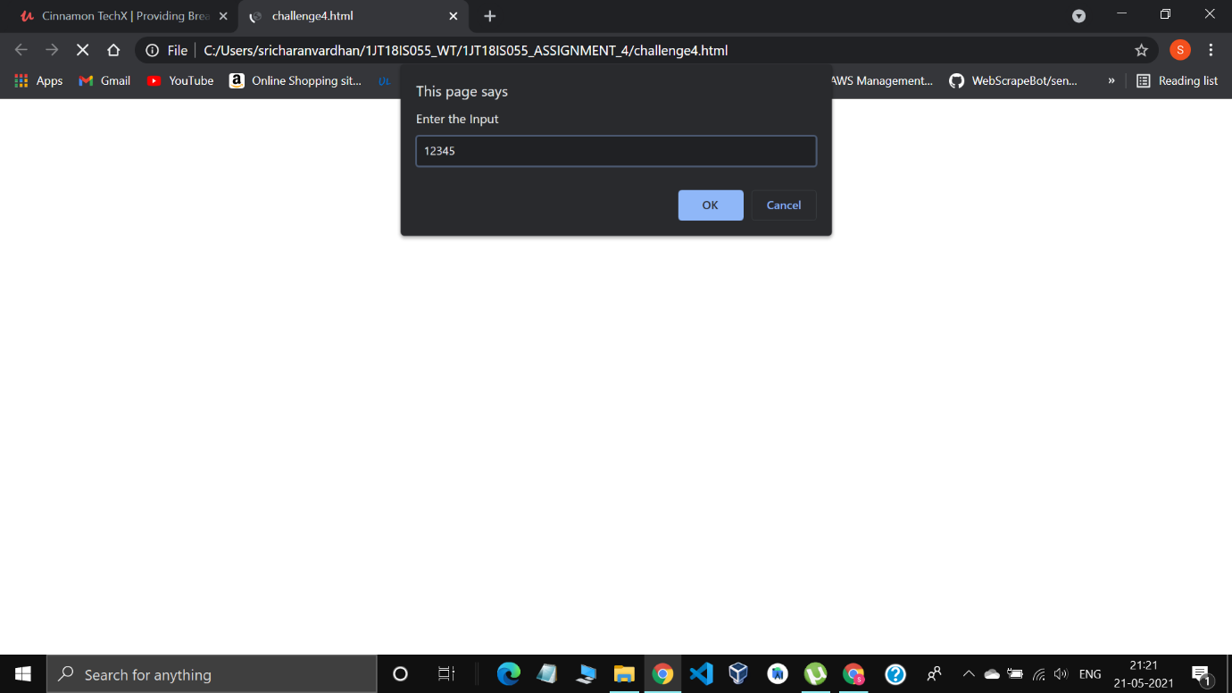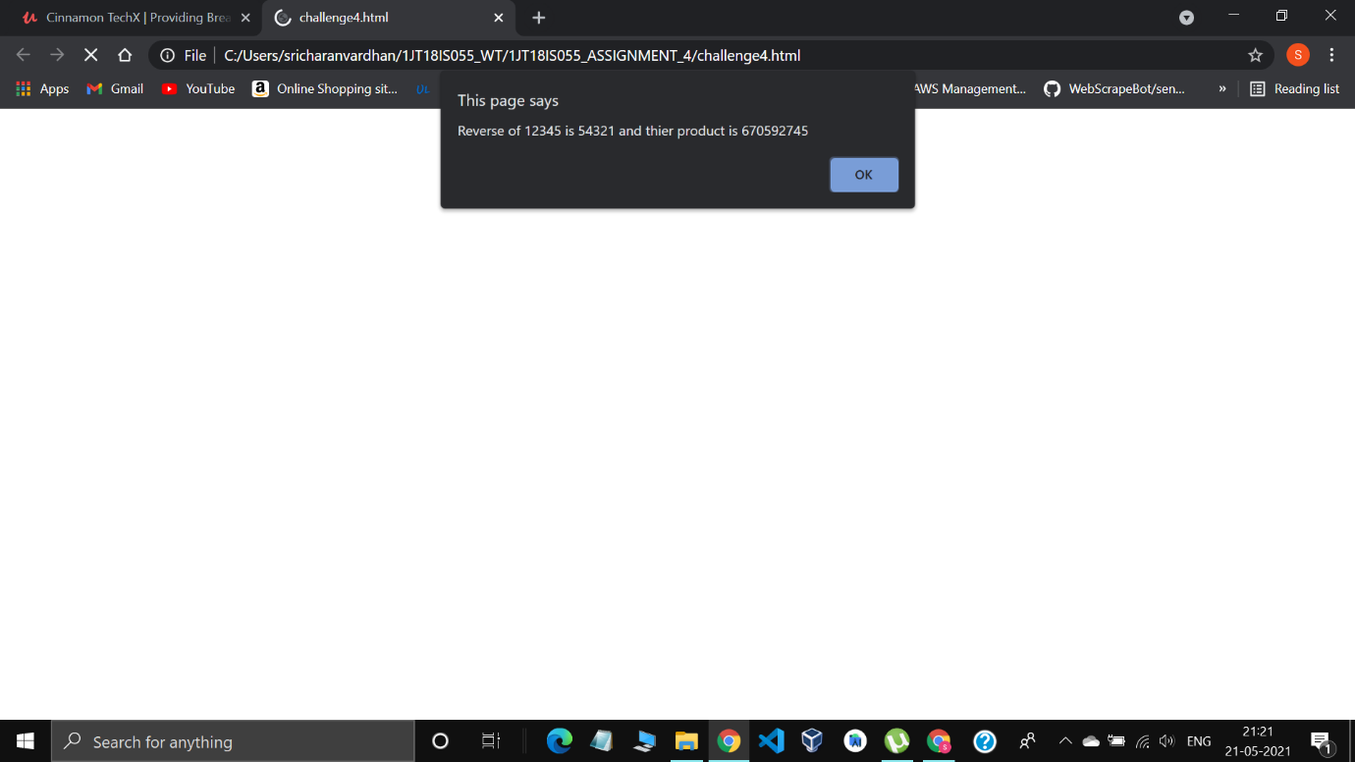

With Strings:

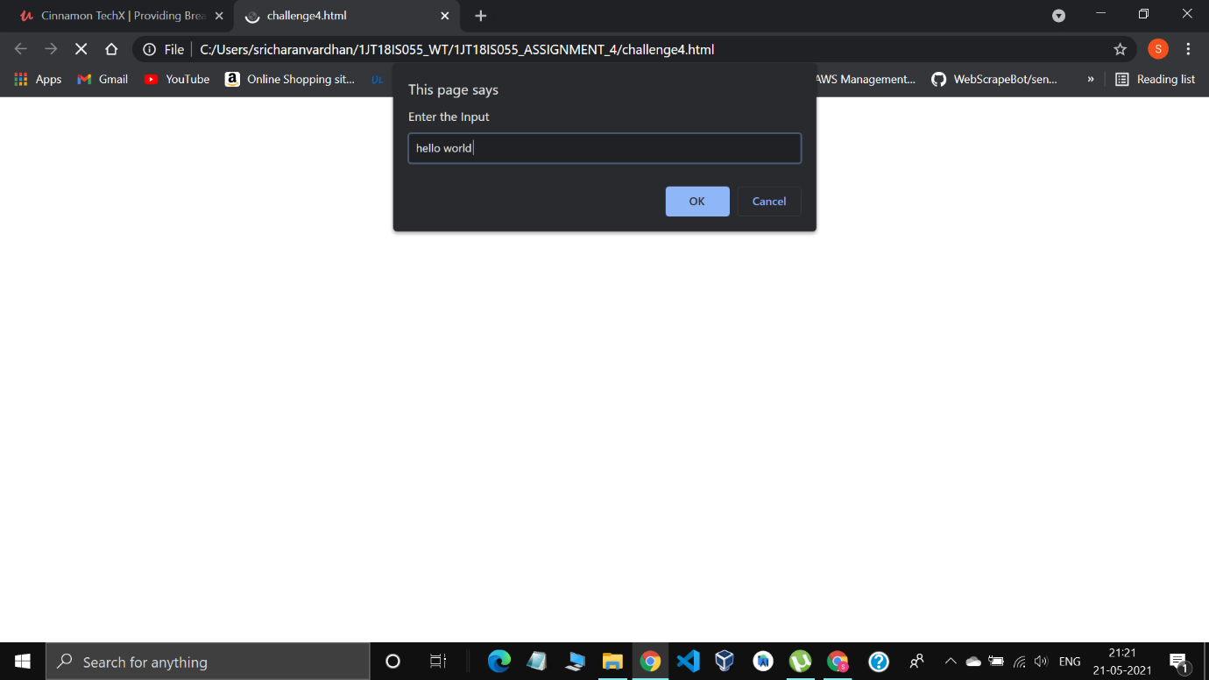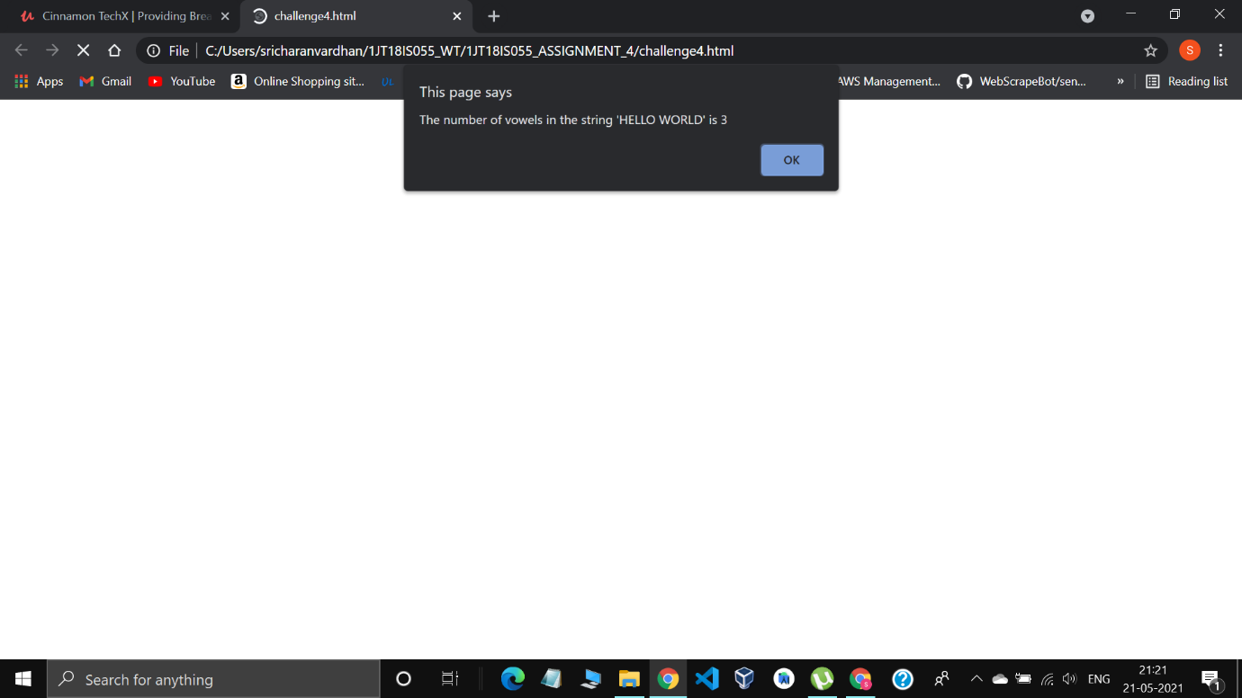

3. TEST CASES

|  |  |  |  |
| --- | --- | --- | --- |
| **Test no** | **Test Case** | **Expected output** | **Actual Output** |
| **1** | a. Integer Value: 1234  b. Text Value:  ABCDEFGHIJKLMNOPQRSTUVWXYZ | a. Reverse of 1234 is 4321 and their product is 5332114  b. The given string ABCDEFGHIJKLMNOPQRSTUVWXYZ has 5 number of vowels | a. Reverse of 1234 is 4321 and the product is 5332114  b. The given string ABCDEFGHIJKLMNOPQRSTUVWXYZ has 5 number of vowels |
| **2** | a. Negative Integer value: -96  b. Text Value: -abc | a. Reverse of -96 is -69 and their product is 6624  b. The given string -ABC has 1 number of Vowels | a. Reverse of -96 is -69 and the product is 6624  b. The given string -ABC has 1 number of vowels |
| **3** | Alpha numerical value: 12abc | The given string 12ABC has 1 number of Vowels | The given string 12ABC has 1 number of Vowels |
| **4** | Non vowel string: bcd | The given string BCD has 0 number of Vowels | The given string BCD has 0 number of Vowels |