CASE STUDY, SYSTEMS THINKING AND DESIGN, IIIT HYDERABAD, SEPTEMBER TO OCTOBER 2026
The Breakfast Paradox
A systems study of breakfast registration and food waste in the hostel dining halls
COURSE | Systems Thinking and Design (PD2.405), IIIT Hyderabad. Faculty: Prof. Raman Saxena
TEAM | Team Invictus: Sricharan Peri, Prathyusha Kalluri and Neha Susan Manoj. All three worked on every phase.
DURATION | About six weeks, from 3 September to early October 2026
QUESTION | Why does breakfast registration not reflect who eats, and what could a student team propose to change that?
SCOPE | Breakfast in four dining halls (Kadamba, Palash, Bakul and Yuktāhār), from registration to disposal, with lunch as the comparison
EVIDENCE | Six student voices, the head of facilities, three kitchens, Yuktāhār’s registers, and 32,162 Kadamba registrations with scan times (April 2026)
STATUS | Recommendation and pilot plan tested on paper and on recorded data; nothing piloted on campus

Summary
Hostel students at IIIT Hyderabad are registered for every meal automatically and billed for it. For breakfast, about two thirds of those registrations go unused: 62.9 per cent at Kadamba in April 2026 and about 72 per cent at Yuktāhār in September. Lunch at Yuktāhār, under the same rules, was used at 56 to 89 per cent. The kitchens cook anyway, each by its own rule of thumb, and the surplus leaves by informal routes that no office tracks.
The course brief attributes the problem to early classes colliding with late nights. The fieldwork and the records did not support that as the main cause. They showed a default registration with a narrow exit, billing at the registration and not at the meal, and a gap that two sets of records measure every day but that reaches nobody who sets the rules.
The team recommends three things together: building the missing route for those records, opening a Sunday skip that removes the charge on a fixed date, and calibrating the kitchens’ first batch in the meantime. Replayed on Kadamba’s April records, the kitchen changes alone cut surplus from 362 to 91 portions a day (a projection). Only the rule change reduces what students pay.
Contents
1 Background 4
1.1 Context 4
1.2 The brief 4
1.3 Problem statement and aim 4
1.4 Scope and boundary 4
2 Approach 5
2.1 Framework and plan 5
2.2 Research design and methods 6
2.3 Evidence gathered 7
2.4 Handling the evidence 8
3 Understanding the System 9
3.1 System boundary and symptoms 9
3.2 Stakeholders 11
3.3 Power, interest and leverage 12
3.4 The existing process 14
3.5 Behaviour over time 16
3.6 What changed when the records arrived 19
4 Modelling the System 20
4.1 System map and feedback loops 20
4.2 Patterns and root causes 22
4.3 Reframing the problem 23
5 Finding Where to Intervene 25
5.1 Leverage points 26
5.2 Design principles 28
5.3 Choosing a test slice 28
6 Designing and Testing Interventions 29
6.1 Concepts 29
6.2 Scenario model and results 30
6.3 Evaluation: gates and scores 32
6.4 Recommendation and plan 34
7 What the Findings Mean for the Institution 37
8 Limitations and Open Questions 37
8.1 Limits of the evidence and the method 37
8.2 Open questions 38
9 Reflections 39
9.1 What worked 39
9.2 What the team would do differently 39
9.3 Next steps 39
10 Questions for Discussion 39
Key decisions
1 Study breakfast only, with lunch as the control 5
2 Interviews and records instead of a survey 6
3 Trust records over recall, and say how sure each finding is 8
4 Governance bodies kept apart until confirmed 12
5 Judge power decision by decision, and keep it apart from leverage 13
6 Trace each caterer as its own system 16
7 Draw a loop only where the closing link has direct evidence 21
8 Reject the first reframing 23
9 Rank levers by depth and then feasibility, and hold those that depend on the payment basis 27
10 Project the day at 9:00 and add a late batch 31
11 Keep a deliberately weak concept, and let gates overrule the score 33
12 Fix the Sunday skip at week 6, independent of the kitchen pilot 35
13 Plan the team’s own exit at week 20 36
Figures
Figure 1 Project timeline, September to October 2026 6
Figure 2 The registration dialog on the dining portal, breakfast on 9 September 2026 8
Figure 3 System boundary: three layers inside, boundary actors on the ring, and the class schedule and alternatives outside 10
Figure 4 Stakeholder map: twenty-four stakeholders in four rings, with students as the customer 11
Figure 5 Power against leverage over breakfast waste 13
Figure 6 Yuktāhār’s kitchen on the day of the visit: registers laid out beside the stock 14
Figure 7 Yuktāhār’s operator process, from the daily meeting to the Wastage Book and back, with the two-week delay 15
Figure 8 Kadamba’s operator side of the breakfast day, from planning to the bin 16
Figure 9 The crowd at Kadamba builds to one peak just before the doors close 17
Figure 10 Kadamba breakfast turnout by weekday, April 2026 18
Figure 11 Yuktāhār, 1 to 20 September: breakfast and lunch attendance under the same rules 18
Figure 12 First batch against turnout 19
Figure 13 Loop status: eighteen mechanisms tested 21
Figure 14 The same breakfast under two models 22
Figure 15 Three structural causes, two conditions that keep them unaddressed, and the mechanism beneath them 23
Figure 16 Six alternative framings scored against four tests 24
Figure 17 Why the gap holds steady: three forces create it, eight absorbers take up its cost, and only a loud signal reaches the people who set the rules 25
Figure 18 The twelve places to intervene, and where the levers sit 26
Figure 19 Shifting the burden: a better-run kitchen relieves the symptom and leaves the cause alone 28
Figure 20 The plan card and the 9:00 rule, applied to Kadamba’s vegetarian line on Sunday 19 April 2026 30
Figure 21 Kitchen rules replayed on 23 April days, both lines (projected) 31
Figure 22 One Sunday on the vegetarian line, 19 April: who arrived and what each rule would have cooked (projected) 32
Figure 23 Concepts scored against the gates and nine weighted criteria 33
Figure 24 The recommended sequence over 20 weeks, with decision points and handover 34
Figure 25 How Kadamba breakfast might respond over time under the bundle, against the baseline (projected) 37

1 Background

1.1 Context
The International Institute of Information Technology, Hyderabad, has four dining halls for its hostel students: Kadamba, Palash, Bakul and Yuktāhār. Each hall is run by a caterer appointed by the institution. The halls serve breakfast, lunch and dinner, and breakfast runs from 7:30 to 9:30, while classes begin at 8:30.
Every hostel student is registered for every meal, holidays included, and the charge follows the registration. The way out is a cancellation: five per meal type per month, each made at least four days ahead. A Skip Meal option on the portal tells the kitchen that a student will not eat, and its on-screen text says the student will still be charged. A student who has not registered and walks in pays about 70 per cent more at the posted rates. At the counter, students scan a QR code, and that scan is the institution’s record of who ate.

1.2 The brief
The course offered four campus puzzles, and the team chose the Breakfast Paradox. Its brief follows a student whose alarm goes off four times at 7:45 after a late night. He chooses sleep, and by 11:15 he is hungry and cannot concentrate. The hall serves breakfast from 7:30 to 9:30, classes start at 8:30, and only about a third of the hostel turns up. The rest of the food is thrown away.
The brief gives one cause, the clash between the early class and the late night, and a chain of consequences. The team treated the brief as a set of claims to test. In the first interviews, students confirmed the first link: late nights do lead to missed mornings. Nothing in the brief had yet been shown for the later links, that the food is wasted, that this is costly, or that the clock is the reason.

1.3 Problem statement and aim
The brief asks why students skip a meal they registered for. By the end of the first phase the team judged that question too narrow. Registration is a default that students did not choose, so not turning up cannot be read as a decision about a meal they selected. The kitchens, in turn, do not cook to the registration count; each applies its own conversion. The problem was restated as follows.
Breakfast registration at IIIT Hyderabad does not reflect who will eat, by roughly two thirds, while lunch under the same rules mostly does. Each kitchen estimates its own conversion from registrations to cooked food, the records that could calibrate that estimate are already kept, and none of those records reaches the people who set the registration and billing rules.
The aim of the project was to explain why this arrangement persists as a property of the whole system, and to recommend an intervention that could be tested on campus.

1.4 Scope and boundary
The study covers breakfast in the four halls as it is registered, billed, cooked, served and disposed of. Lunch and dinner are outside the boundary and are used as a comparison, since the same portal, rules and caterer apply to them. The class timetable is also outside the boundary but stays on the maps because it shapes the morning.
Quantitative evidence exists for two halls only: Kadamba, from a month of scan records, and Yuktāhār, from photographed attendance registers. Bakul is described from an interview with its manager and has no records. Palash is treated as a candidate kitchen that shares Bakul’s off-site kitchen, which no source has confirmed.

DECISION 1 Decision: Study breakfast only, with lunch as the control
Decision | Limit the study to breakfast and use lunch and dinner, which run under the same portal, rules and caterer, as the comparison.
Alternatives | Study the whole mess service, or study breakfast with no comparison.
Reason | If lunch under the same rules mostly works, the cause lies in something particular to breakfast and not in the registration system as a whole.
Trade-off | The findings and the design say nothing about lunch or dinner, and Yuktāhār’s lunch records were the only comparison data available.

2 Approach

2.1 Framework and plan
The course framework divides the work into four phases, ten activities and fifteen deliverables. Phase 1 describes the system, Phase 2 models it, Phase 3 identifies where it could change, and Phase 4 designs and tests interventions. The team followed that order and gave each activity its own deliverable. The nine research objectives that the team set itself were each tied to one or more activities.
Table 1. Research objectives and the activities that addressed them.
No. | Objective | Activity | Phase
1 | Fix the boundary and separate visible symptoms from underlying issues | 1 | 1
2 | Identify the people and bodies in the system and what each needs | 2 | 1
3 | Establish who holds authority, power and leverage over each decision | 3 | 1
4 | Trace how a registration becomes cooked food | 4 | 1
5 | Measure behaviour over a morning, a week and a month | 5 | 1
6 | Build a model and test which feedback mechanisms close | 6 | 2
7 | Trace events to structures and beliefs, and reframe the problem | 7 and 8 | 2
8 | Find where change could act and what any change must protect | 9 | 3
9 | Design, test and evaluate interventions | 10 | 4

The first drafts of Phases 1 and 2 were written between 3 and 14 September, mostly from interviews, posted rules and portal screens. Field evidence then arrived in three batches, on 26, 27 and 28 September, and each batch made the team revise earlier work. Three revision passes on 27 and 28 September went back through every earlier activity, and Phases 3 and 4 were written on the revised evidence.
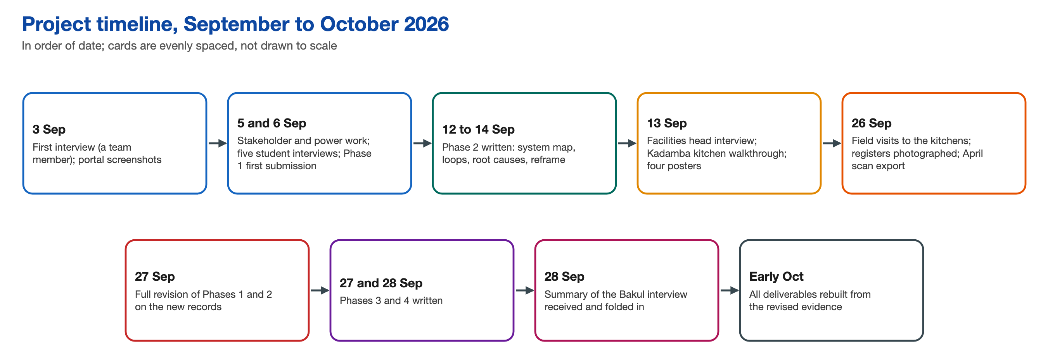
Figure 1. Project timeline, September to October 2026. The three batches of field evidence arrived on 26, 27 and 28 September.
Three working habits came out of weeks that went wrong without them. Revisions were made in dependency order, from Phase 1 through to Activity 10. Every revision started with a gap audit against the newest evidence. Each batch of evidence was written up as a single dated summary, which became the only source of facts for later revisions. Decisions were logged with a date and a reason, and a decision that changed stayed on record beside its replacement.

2.2 Research design and methods
The project is a single-case study of one institutional system: the registration, billing, cooking, serving and disposal of breakfast. Three kinds of evidence were combined. Interviews, observation and visits explained how the system works and why people act as they do. Administrative records measured it. Established frameworks from systems thinking and service design structured the analysis: system boundaries, the iceberg of events, patterns, structures and mental models, causal loops, archetypes, the power and interest grid, Meadows’s twelve places to intervene, and service blueprints. The team did not carry out a systematic literature search, and it adapted several methods to the limits of its evidence, as described below.

DECISION 2 Decision: Interviews and records instead of a survey
Decision | Use a small number of interviews to understand the mechanism, and use records to measure how often things happen.
Alternatives | A questionnaire to a larger sample of students.
Reason | The population was small and reachable, the mechanism was unfamiliar even to many students, and several did not know the rules a survey would ask about. A survey would have counted opinions about a system the respondents could not see.
Trade-off | Interviews can show how something works but not how common it is, so every claim about prevalence rests on records. Records existed for two halls in two different months only.

2.3 Evidence gathered
Sampling was purposive and driven by access. The sources, and the main limit of each, are listed below.
Table 2. Sources of evidence and their main limits.
Source | What it gave | Main limit
A team member’s own account, 3 September | The system and a student’s mornings | One person, who is also a stakeholder
Nine portal screens | Registration dialog, capacities, rates and charges | Each screen shows one day
Five student interviews, 6 September | Two daily eaters and three skippers | Four or five distinct people
Head of facilities, 13 September, with a walkthrough of Kadamba’s kitchen and four posters | Governance, menu rotation, stock, waste and food safety | One respondent; posters state intent
Operator visits to three kitchens, 26 September, and a first-hand account, 27 September | Ordering, registers, rules of thumb and surplus routes | Operators describe their own practice
Yuktāhār’s books and registers, 26 September | 26 photographs, turned into 22 tables | Some breakfast rows partly hidden by a hand
Kadamba scan export, April 2026 | Every breakfast registration with its scan time | One hall, one meal, one month

The first questionnaire, with 39 questions for five roles, was criticised as very direct and likely to lead respondents. It was rewritten under standing rules: the fact comes before the reason, every question is checked for four kinds of bias and tied to a named objective, and respondents are described by role. Three guides followed, for students, operators and governance, through six versions on 5 and 6 September. A wording review then found four questions that invited the answer they expected, for example whether Skip Meal “actually changes anything or just feels symbolic”. All four were rewritten before any real interview.
The five student interviews followed a written list of 23 questions. Two team members transcribed them independently and found a labelling gap, so the team counts four to five distinct people and relabelled nothing. The head of facilities was interviewed on 13 September, together with a walkthrough of Kadamba’s kitchen. On 26 September the team visited three kitchens, recorded eight audio files of about two hours and fifteen minutes in total, and photographed 26 pages of Yuktāhār’s registers. At Kadamba it observed the display plate and the tasting. The recordings were walkthroughs more than formal interviews: operators showed their registers and explained their routines. Transcription was by machine, with translation from Telugu; the result was reliable for Yuktāhār and gave the gist for Kadamba and Bakul. Where an observer who understood the conversation disagreed with the machine, the observer’s reading was used.
Kadamba’s export has one row for each breakfast registration from 1 to 30 April 2026: 32,162 rows giving the meal date, the line (vegetarian or non-vegetarian) and the scan time, which is blank when the person did not eat. It has no student identifier. The team built five analysis tables from it, down to arrivals per minute between 9:00 and 9:45. The Yuktāhār photographs became 22 tables, and each row was marked for how confidently it could be read. The portal sits behind single sign-on, so the team used only screens that a student captured while logged in, and no one’s credentials.
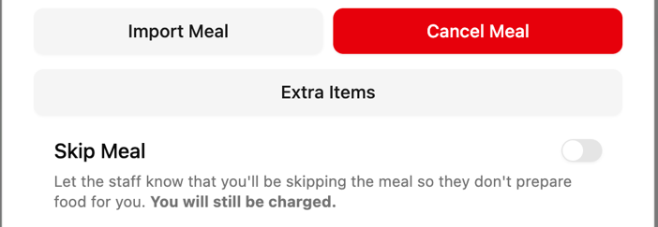
Figure 2. The registration dialog on the dining portal, breakfast on 9 September 2026. The Skip Meal text reads: “Let the staff know that you’ll be skipping the meal so they don’t prepare food for you. You will still be charged.”

2.4 Handling the evidence
Turnout was defined as scans divided by registrations, with lunch from the same register as a control. A causal loop was accepted only if the last link causes the first and every link in between is evidenced; chains with an inferred link were drawn with a dashed closing link. The scenario model replayed proposed kitchen rules over the 23 recorded days from 8 to 30 April, forecasting only from earlier days of the same weekday.
Every claim carried a label that stayed with it through later use: confirmed (read off a record, seen on site, or stated alike by independent sources), single-sourced, candidate (an inference combining sources), assumed, projected (scenario arithmetic on real records), reasoned (the team’s expectation of how a group would respond, never their feedback) and planned. In this document the labels appear in the wording of each statement. When sources conflicted, the Bakul summary of 28 September ruled on Bakul, the first-hand account of 27 September ruled on Kadamba and Yuktāhār, and machine-translated claims stayed marked as unclear until an observer confirmed them.

DECISION 3 Decision: Trust records over recall, and say how sure each finding is
Decision | Where a person’s recollection and a record disagreed, the record won, and every finding was labelled with how it was known. Evidence was frozen at a stated date for each writing, with the gaps listed.
Alternatives | Hedged wording throughout, or waiting for more records before writing up.
Reason | A reader needs each finding and how sure the team is of it. Records and contracts the team could not obtain would not have arrived by waiting, and data kept coming in batches.
Trade-off | The text carries more qualifications, and some findings stayed at candidate status for want of one link. The labels did let findings change cleanly when evidence moved. The first working figure of about 30 per cent unused breakfasts, which came from two students’ impressions, was replaced by the measured 63 and 72 per cent.

The interviews were part of a course assignment, and the project record holds no signed consent forms. Interviewees and staff are named by role only. The scan export holds no student identifier and only aggregates are reported. The team also set itself a rule that no recorded figure may be used against the person who recorded it, and carried that rule into the design as a principle.

3 Understanding the System
Phase 1 looked at breakfast from five sides: its edges, its stakeholders, its power structure, its process and its behaviour over time.

3.1 System boundary and symptoms
The system is breakfast as registered, billed, cooked and served in four halls. Three layers sit inside the boundary: registration and billing (the portal and the counter scan), the kitchens (one outside caterer per hall) and governance. The boundary ring holds people any change must allow for. At Kadamba, by the operator’s account, 30 to 50 outsiders and about half of the operator’s staff eat from the same pots, so cutting surplus also cuts food that they rely on.
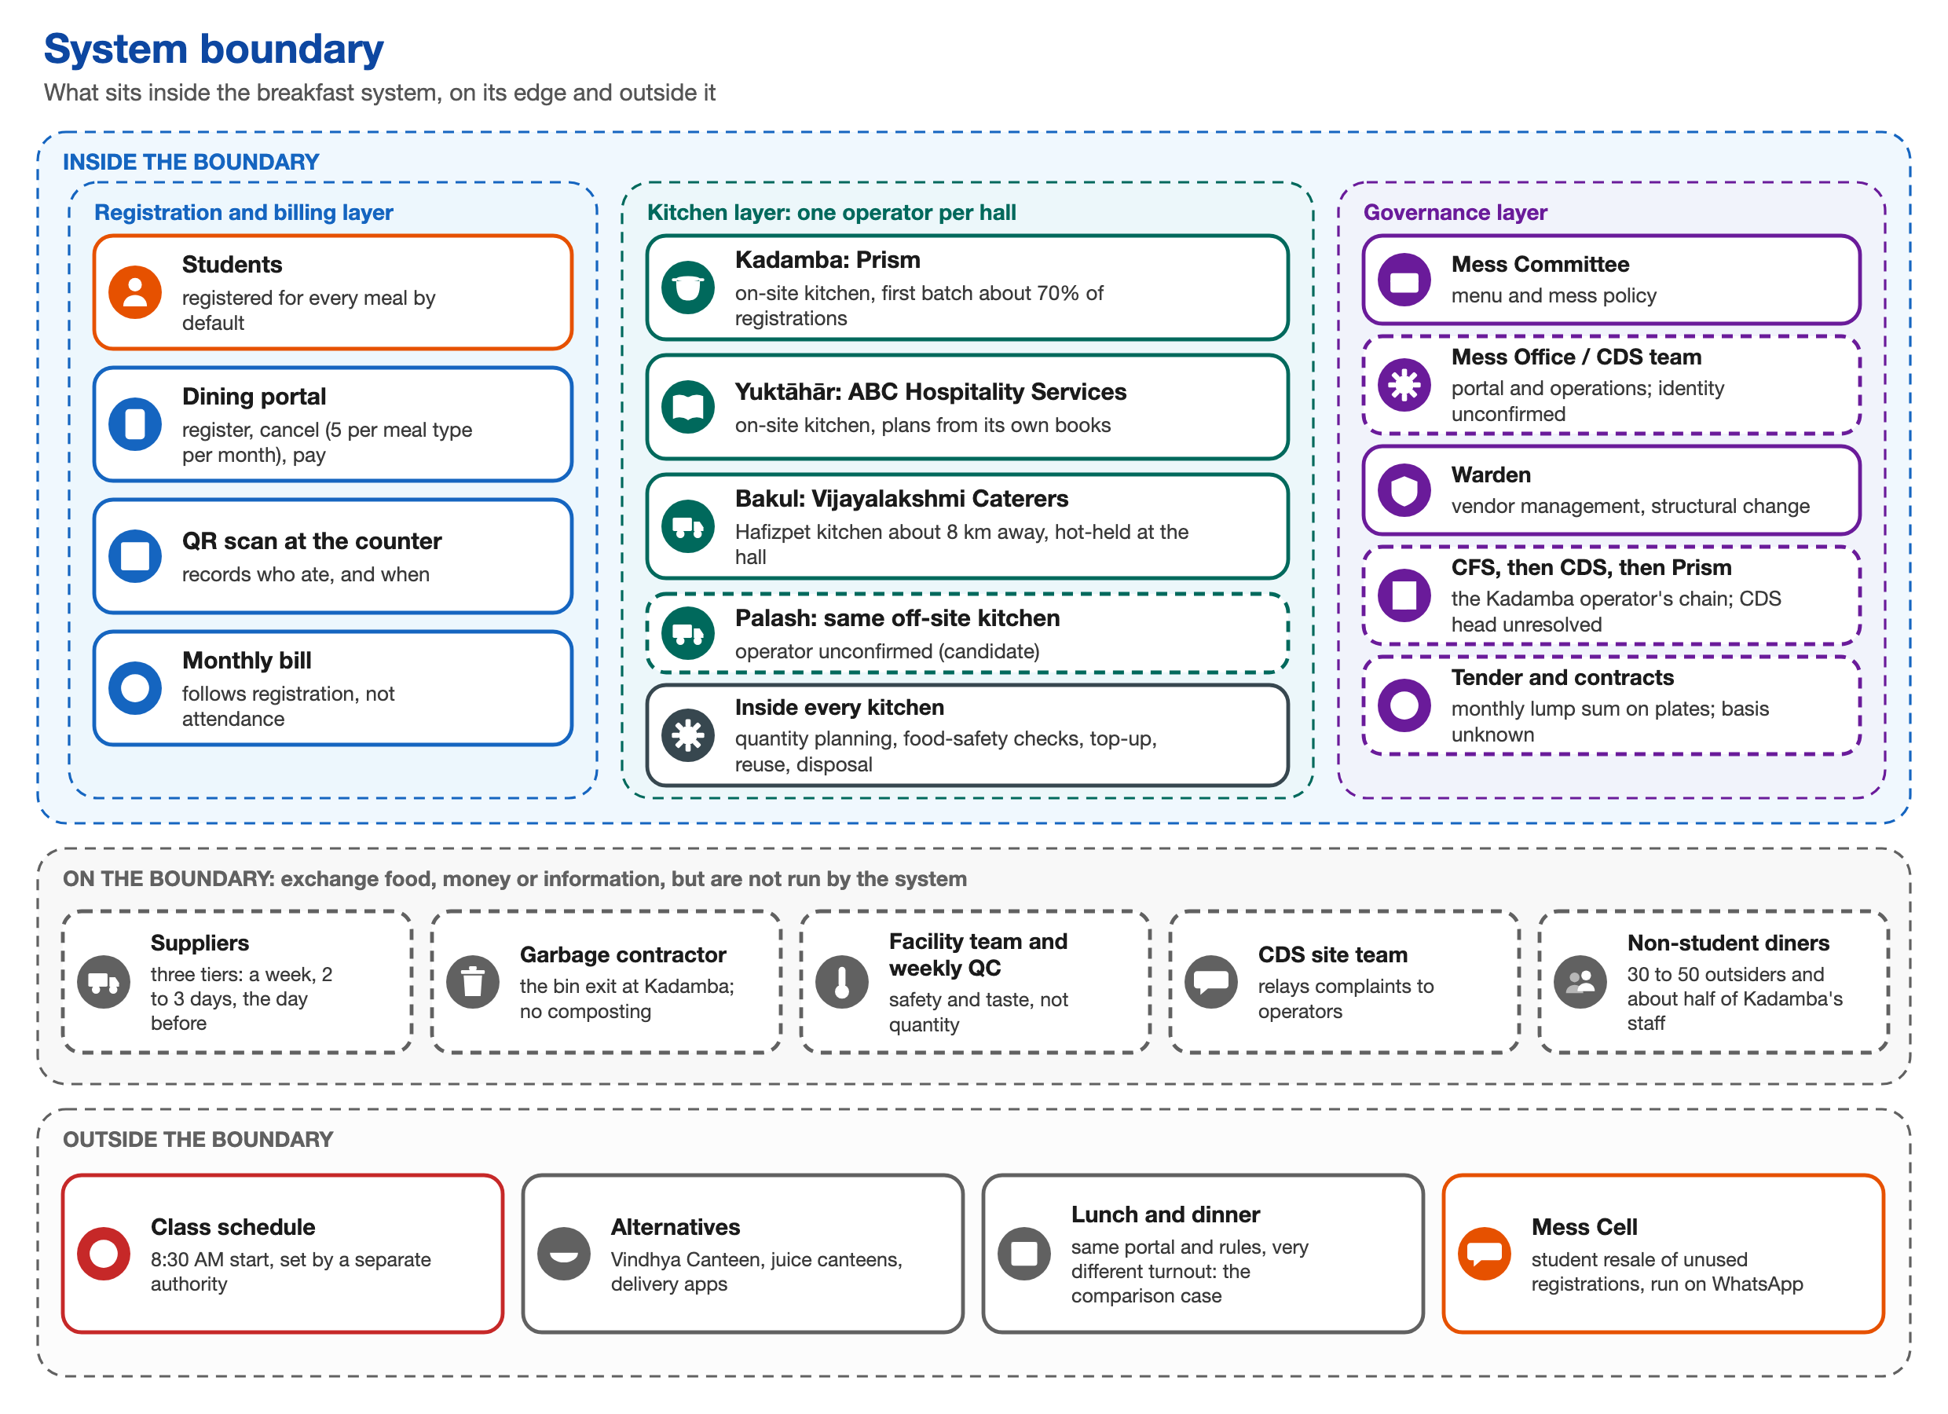
Figure 3. System boundary: three layers inside, boundary actors on the ring, and the class schedule and alternatives outside.
The institution’s stated objective includes “minimizing food wastage through advance meal planning”. That works only if registration expresses an intent to eat, and the team compared the stated design with what happens.
Table 3. Stated design compared with the actual mechanism.
Step | Stated design | Actual mechanism
What registration records | Demand, estimated in advance | A default that students do not choose, flat across the week
How kitchens plan | From the advance count | Each operator applies its own conversion to the count taken the day before
Where surplus goes | Minimised by planning | Reuse, outside diners and staff, held food (a candidate route), and the bin

Registrations overstate breakfast turnout about 2.7 times at Kadamba and 3.5 times at Yuktāhār. The gap is already measured, yet nothing carries it into the registration or billing rules. In April 2026, 20,221 registered Kadamba breakfasts were billed and not eaten. Beside this, the team recorded three further visible symptoms: Kadamba’s registrations stay flat while turnout varies by weekday, because an exit that closes four days ahead cannot follow daily variation; arrivals pile up at the close, and kitchens cook just in case and still run short; and no student could name a case in which feedback had changed registration, billing or hours.
Two resources already measure the gap: the institution’s scan record of who ate and when, and the operators’ own records, which were laid out in Yuktāhār’s kitchen on the team’s visit. Operators control quantities but never registration, billing or the menu.

3.2 Stakeholders
Seventeen lenses produced 32 candidate stakeholders, and 24 survived a test against direct evidence. Seven of them appeared only after the team had seen operator practice, among them the suppliers and the garbage contractor. Seven are primary stakeholders (students, the three operators, site management, and serving and kitchen staff), five secondary (the Mess Committee, the Mess Office, the dining services team, the Warden and the Student Parliament’s mess seats) and twelve indirect (including academic administration, suppliers, non-student diners and the informal resale market, Mess Cell).
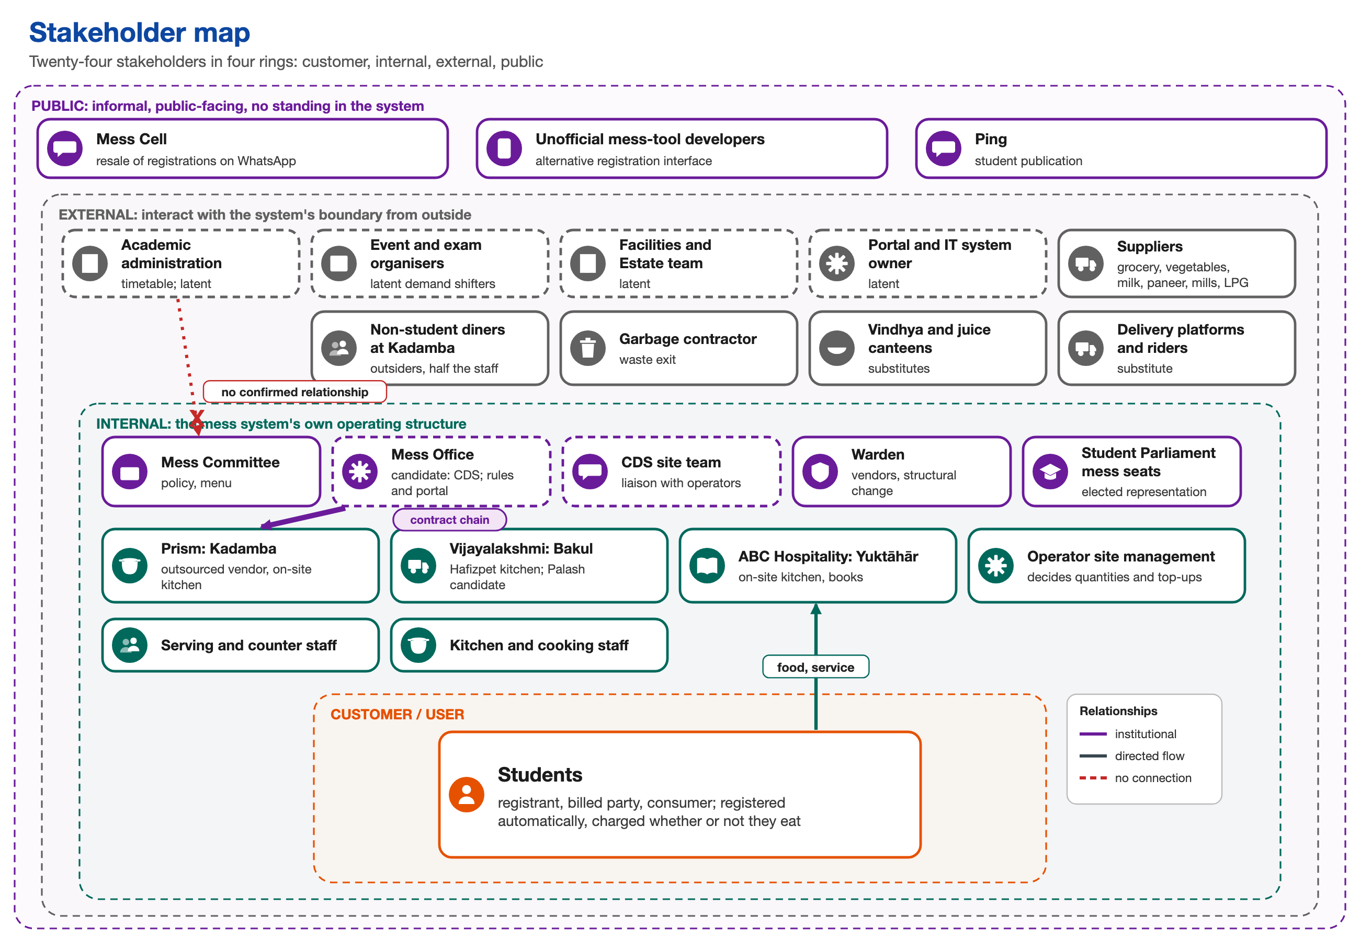
Figure 4. Stakeholder map: twenty-four stakeholders in four rings, with students as the customer.
The operators differ most from one another. Kadamba’s operator appears to treat the count as an obligation it is paid for, though no contract has been seen. Bakul’s manager holds that “there should not be a shortage of food, even if some wastage occurs.” Yuktāhār treats waste as a cost to cut. Kadamba is run as a ladder of command, Yuktāhār with no hierarchy (two project managers and about three site staff), and Bakul across two sites. Informal actors do real jobs without formal standing: Mess Cell is a resale market, and Yuktāhār’s twice-daily meeting is, in effect, its forecasting institution.
Five governance identities remain unconfirmed and apart, including who heads the dining services body, for which two different people are on record. The figures abbreviate the dining services body as CDS and its parent body as CFS.

DECISION 4 Decision: Governance bodies kept apart until confirmed
Decision | The Mess Committee and the Mess Office were separated on 5 September, and every governance identity that sources named differently was kept apart.
Alternatives | Merging bodies whose names looked alike into one actor, so that the maps would be simpler.
Reason | A mislabelled body would have sent every later claim about authority wrong.
Trade-off | The maps carry unconfirmed bodies with dashed outlines, and several conclusions about who can open the rules are conditional.

3.3 Power, interest and leverage
Authority over breakfast is split into pieces that do not touch. Kadamba’s line of command runs from the parent facilities body to the dining services body to the operator, and down the operator’s ladder to the service staff. Beside that chain sit the facility team’s side channel for food safety and Yuktāhār’s flat structure.
Table 4. Who holds each decision.
Decision | Who holds it | What is known
Class timing | Academic administration | Confirmed; no link to mess governance
Registration cut-off and cancellation limit | Mess Office; committee sign-off unclear | One case, in December 2024, from secondhand accounts
Menu | Student committee, from operator options | Confirmed in outline
Quantity, first batch, reuse | The operator | Confirmed at Yuktāhār; from the operators’ accounts elsewhere
Breakfast timing | Unknown | About 37 scans a day at or after 9:30
Food safety | Facility team, weekly quality control | Nothing covers quantity

The operator therefore holds real local authority over quantity and none over the rules that decide how many students register. Nobody has raised the 8:30 overlap with academic administration. Incentives point the same way: nothing rewards registering only if one means to eat. Skip Meal returns nothing, while resale returns value; of the students who addressed it, none had used Skip Meal for a refund, and four had used Mess Cell. The Mess Office’s reported motive in December 2024 was its own workload, and the result was a tighter cancellation rule, which left the default untouched.
Students carry high consequence and low power. The operator has the best data and no authority. Yuktāhār’s books record registered, eaten and wasted per item and weekday, and no route takes them out of the kitchen. Its own site head believed breakfast turnout was about 50 per cent, while his September register showed 17.7 to 40.2 per cent, with a mean of about 28.
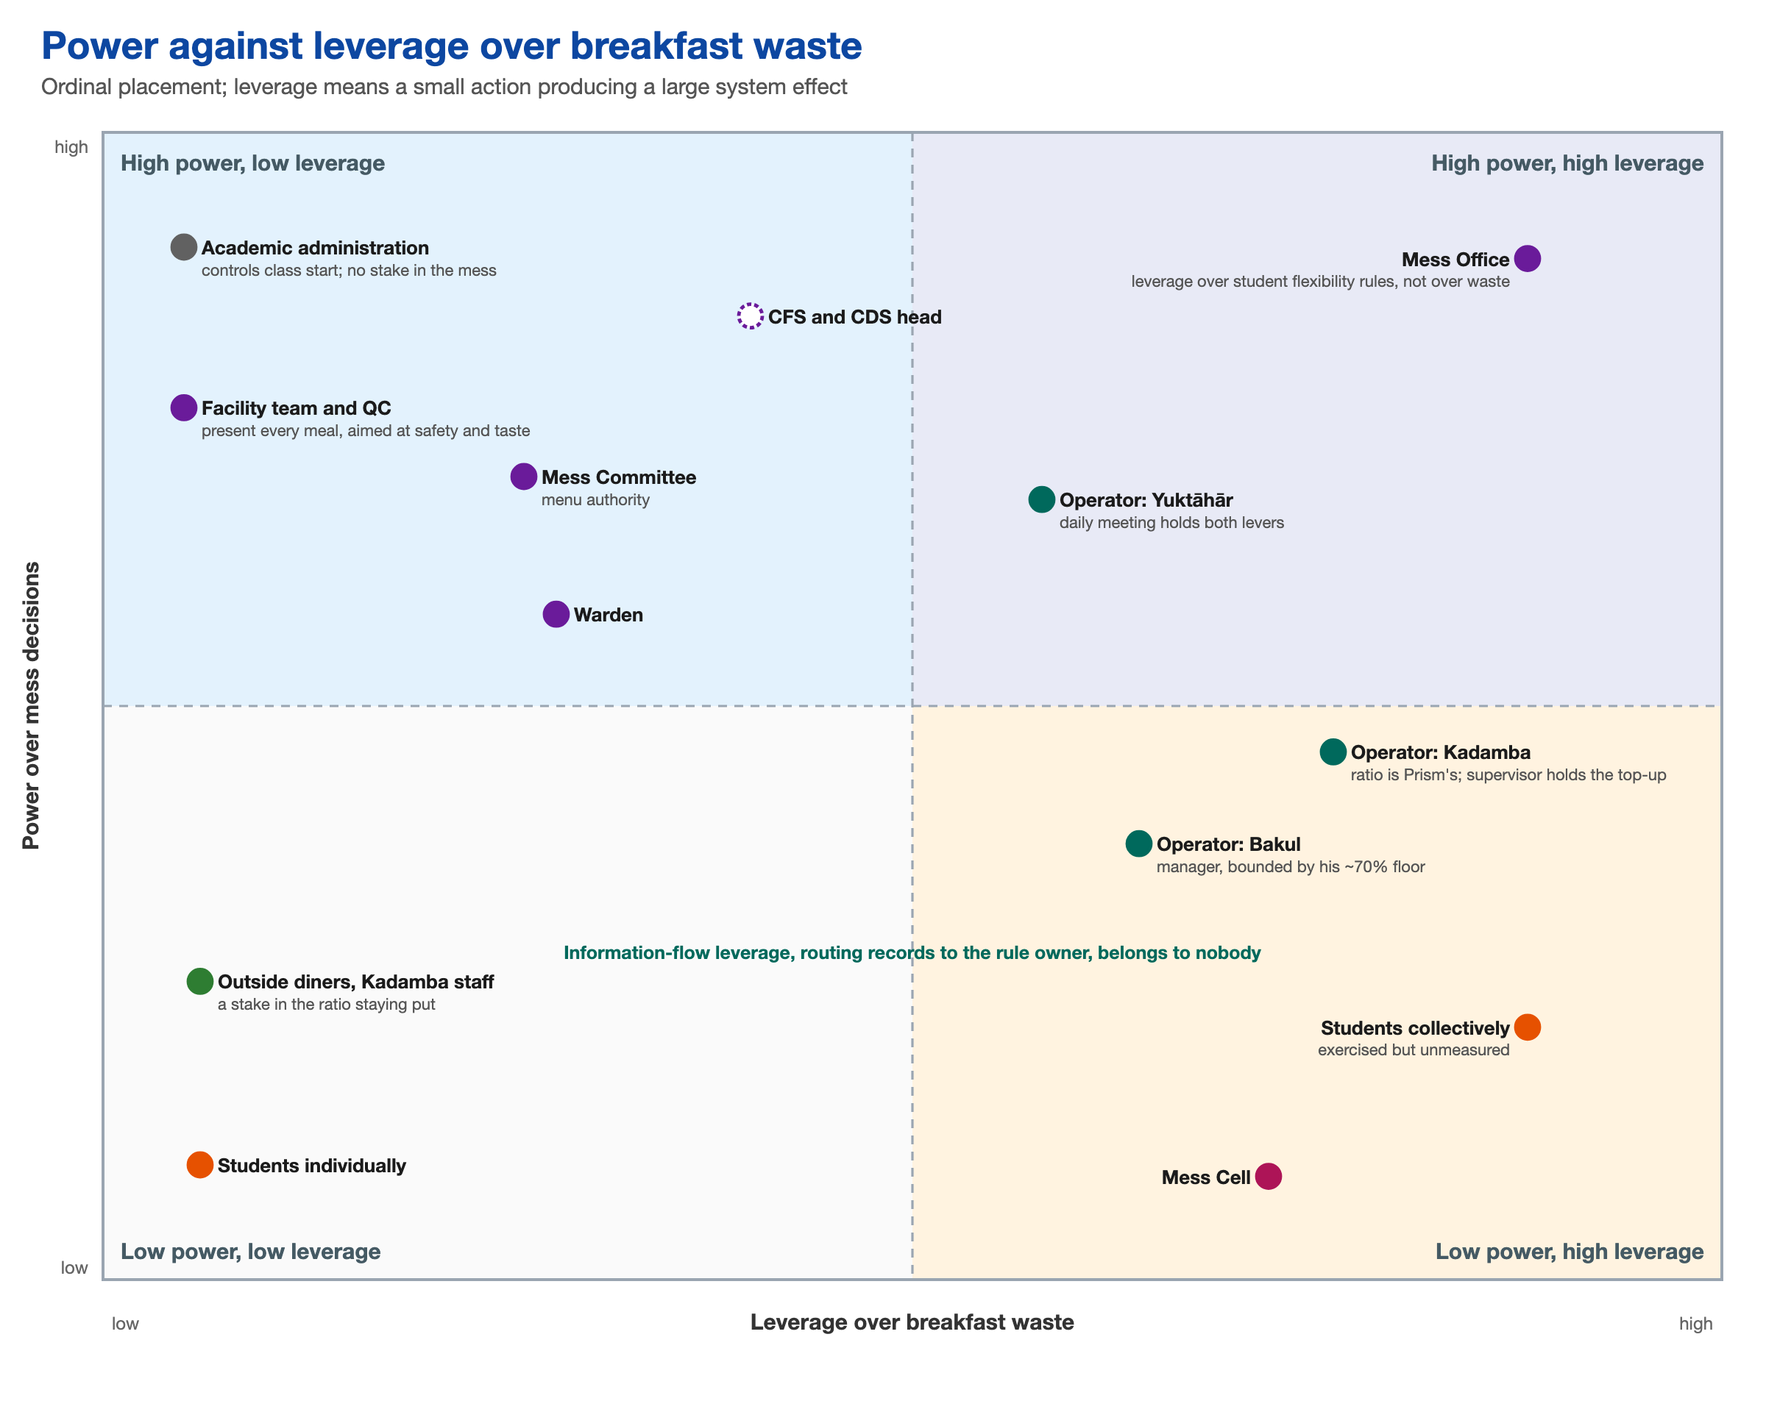
Figure 5. Power against leverage over breakfast waste. Operators have leverage over waste and no rule-making power; the Mess Office holds the rules that give students flexibility.

DECISION 5 Decision: Judge power decision by decision, and keep it apart from leverage
Decision | Authority was assessed for one decision at a time, and power over a decision was kept separate from the leverage a small action would have on the waste.
Alternatives | A single power score for each actor, on one combined grid, which is how the first version was drawn.
Reason | The same actor is decisive on one question and absent on the next. Combining power and leverage hid that the actor with most leverage over waste, the operator, has no rule-making power.
Trade-off | Two maps and a decision table instead of one grid, which is harder to read at a glance. Placement on the maps is ordinal and rests on the team’s judgement.

The payment basis of operators is the main unresolved dependency. If an operator is paid on registered plates, it keeps the margin on every no-show; if it is paid on served plates, it bears the cost of over-cooking. Bakul’s manager says served plates, and a remark by Kadamba’s operator suggests registered plates. No contract has been seen, and the team left the question open, marking dependent conclusions as candidates.

3.4 The existing process
Students register once a month, in effect, as a standing booking, and the portal locks weekly. The student’s only active step is to opt out. The daily decision, to go or to skip, is made on waking, with the 8:30 class pressing on it.
No kitchen cooks to the count. Each reads the closed count the day before and converts it by its own rule.
Table 5. How the three kitchens turn a count into a quantity.
Aspect | Kadamba | Yuktāhār | Bakul
First batch | Fixed at about 70% of registrations, by gram standard | No fixed ratio: the matching day from the previous menu cycle in the Wastage Book, the weekday register and events | 70 to 80% by item, reset weekly, with a floor of about 70%
Who decides | Operator management; a supervisor for top-ups | Storekeeper, coordinator and kitchen staff in a daily meeting | The manager alone; cooking at Hafizpet, about 8 km away
Correction in service | Top-up in 10 to 15 minutes | First-half-hour projection; re-cook on early run-out | Phone call, cooking, then a 20 to 40 minute drive
Stance | The count is an obligation the operator is paid for | Waste is a cost to cut | A shortage is the failure to avoid
Evidence | Operator’s account; scan records | Seen on site; books photographed | Manager’s account only; no records

Yuktāhār runs on paper books, each cross-checked by a peer. The production and waste sheets put what was made and what came back on one page, down to the time an item ran out and plate waste. One rule binds the books: what was issued must match what was cooked, and any mismatch is raised the same day. The rule covers materials and not diner counts, so even Yuktāhār’s books disagree about diners. On 3 September the Wastage Book records 77 breakfast diners (28 per cent) and the register records 110 (40 per cent) on a partly obscured row. Waste is weighed without blame. Staff resisted it at first, one remarking that “they are catching us”, and later reported lower waste.
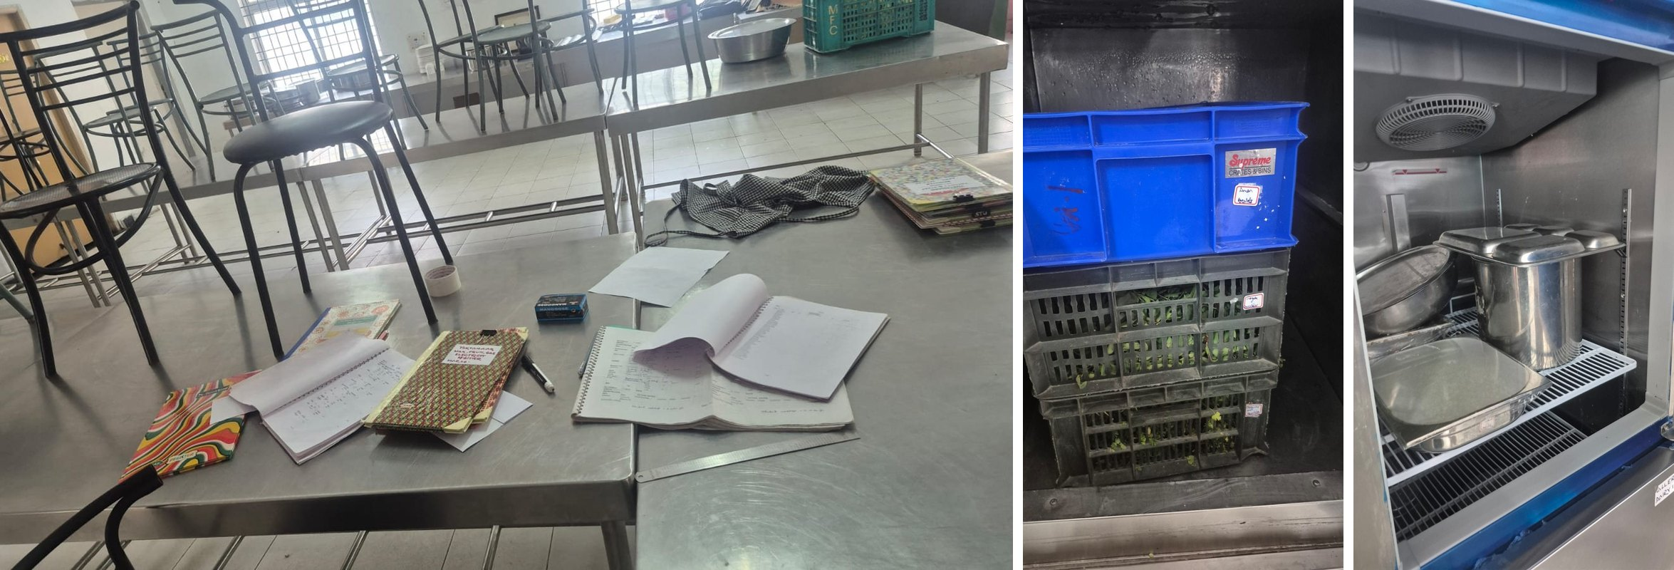
Figure 6. Yuktāhār’s kitchen on the day of the visit: registers laid out beside the stock.
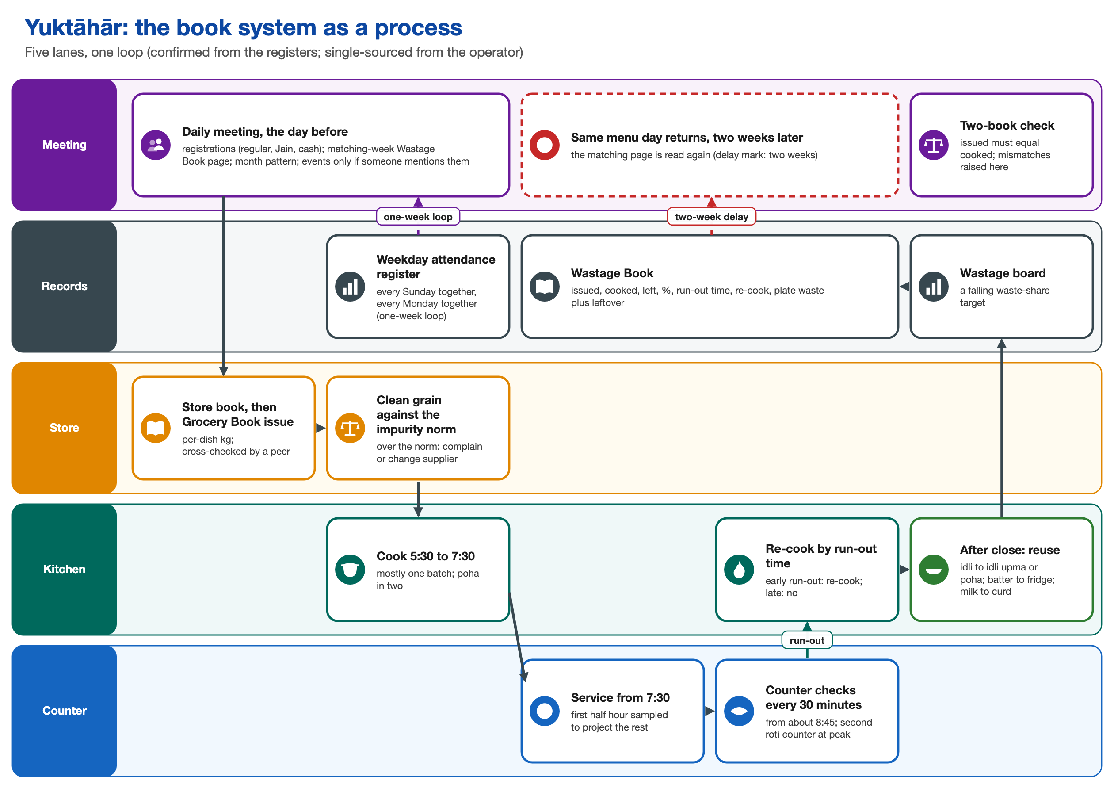
Figure 7. Yuktāhār’s operator process, from the daily meeting to the Wastage Book and back, with the two-week delay.
Kadamba’s operator process ends differently. The first batch is cooked early, about 30 portions go to outside diners, the supervisor tops up as needed, and after 9:30 latecomers enter through the back door. Before service a food-safety sequence runs, from cooking temperature and a 72-hour sample to tasting with the facility team. Every check concerns safety and taste, and all of them happen before any sign of turnout. No record carries the day’s outcome into the next first batch.
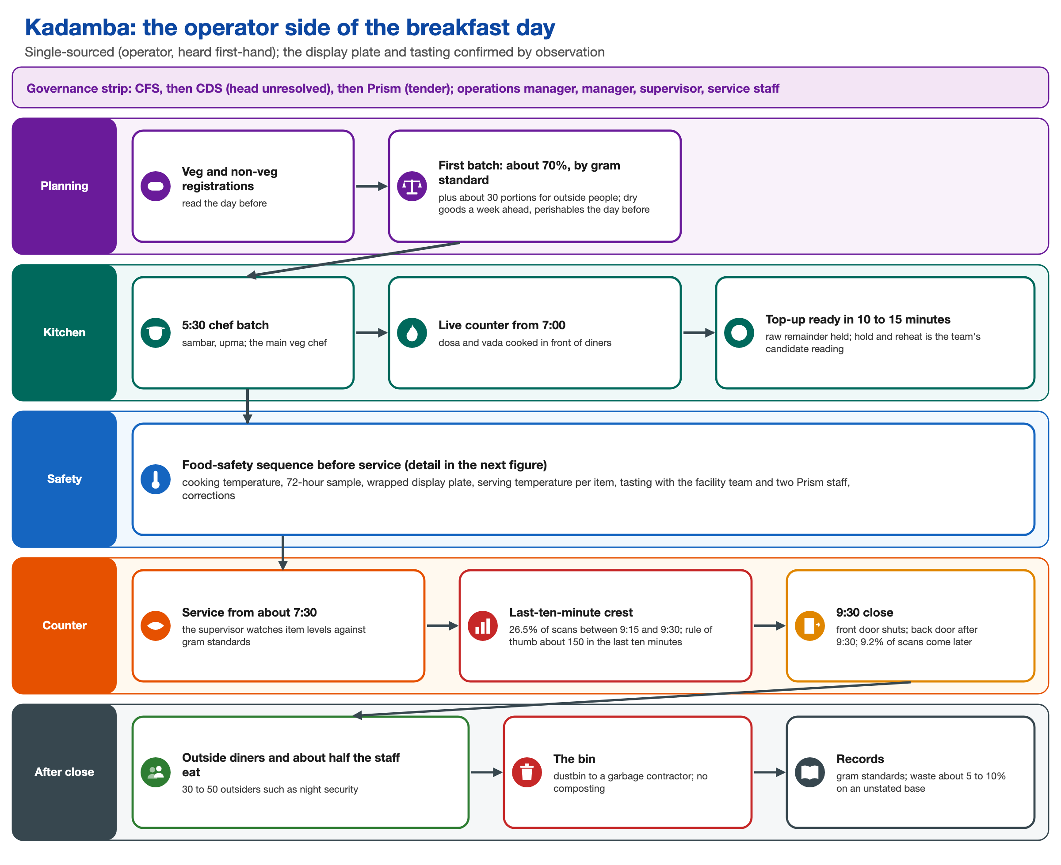
Figure 8. Kadamba’s operator side of the breakfast day, from planning to the bin.
The rules that shape the process are partly formal and partly informal. The formal ones are automatic registration, five cancellations per meal type, and Skip Meal without refund. The informal ones are each kitchen’s ratio, floor or lookup, Yuktāhār’s issued-equals-cooked rule and its blame-free weighing. None of the five other student respondents knew of anyone who had tried to change a mess rule. A complaint path works for fixes within the same incident, but no path reaches the owner of the rules. Exceptions on both sides end in workarounds that absorb the gap before it shows.

DECISION 6 Decision: Trace each caterer as its own system
Decision | Each operator was traced from registration to bin as a separate system, and the student half of the process was written before the kitchen half.
Alternatives | One generic “vendor” in the process map, and a single combined swimlane.
Reason | Asking who decides how much food appears showed three firms with three regimes. Merging them would have hidden three different forecasting logics, and the first version’s vendor findings were overturned by the operator visits.
Trade-off | Three partial pictures, each resting on different evidence, in place of one clean map. The kitchen half stayed marked as unobserved until operator evidence existed, so the first process map was incomplete for several weeks.

3.5 Behaviour over time
The team replaced the assumed typical morning with measurement wherever records existed. The records cover 30 days of Kadamba breakfast (32,162 registrations and 11,941 timestamped scans) and 20 days of Yuktāhār breakfast and lunch from 1 to 20 September, kept on one page, which gives a control within the same hall.
A morning. The kitchens start two hours before the first student arrives, and Bakul’s labour-heavy items from about 3 AM. In interviews, students described two peaks. The scans show one building crowd that crests just before 9:30: 26.5 per cent of Kadamba’s scans fall between 9:15 and 9:29, rising to about nine a minute at 9:29, and another 9.2 per cent come after 9:30. Kadamba’s operator reckons about 150 diners arrive in the last ten minutes; the records show about 79.
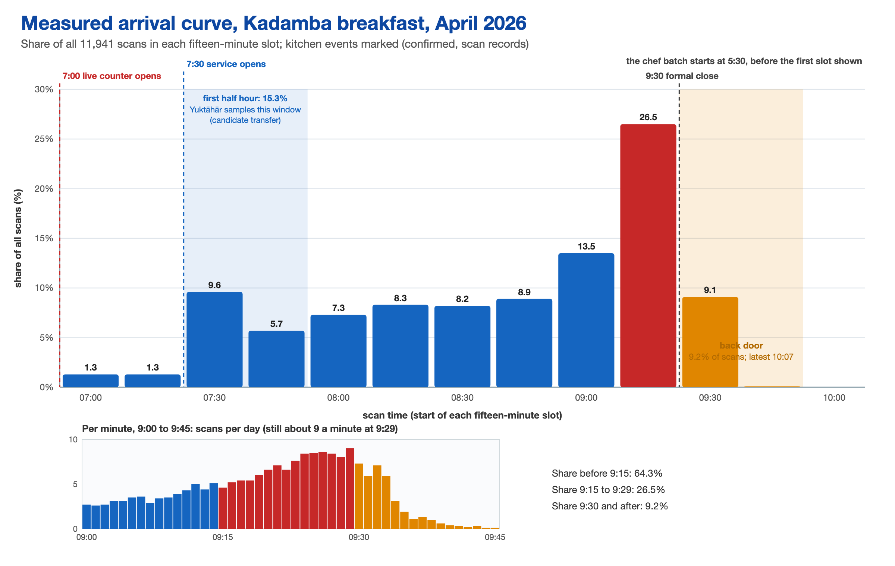
Figure 9. The crowd at Kadamba builds to one peak just before the doors close. The first batch is committed hours earlier.
A week and a month. Of the 32,162 April registrations, 37.1 per cent were scanned and 62.9 per cent were not. From 6 April registrations sit between 1,039 and 1,123 every day, Sundays included, while the share eaten runs from 42.1 per cent on Tuesdays to 27.3 per cent on Sundays. The three lowest days of the month were all Sundays. Weekdays together ran at 39.3 per cent and weekends at 31.1 per cent.
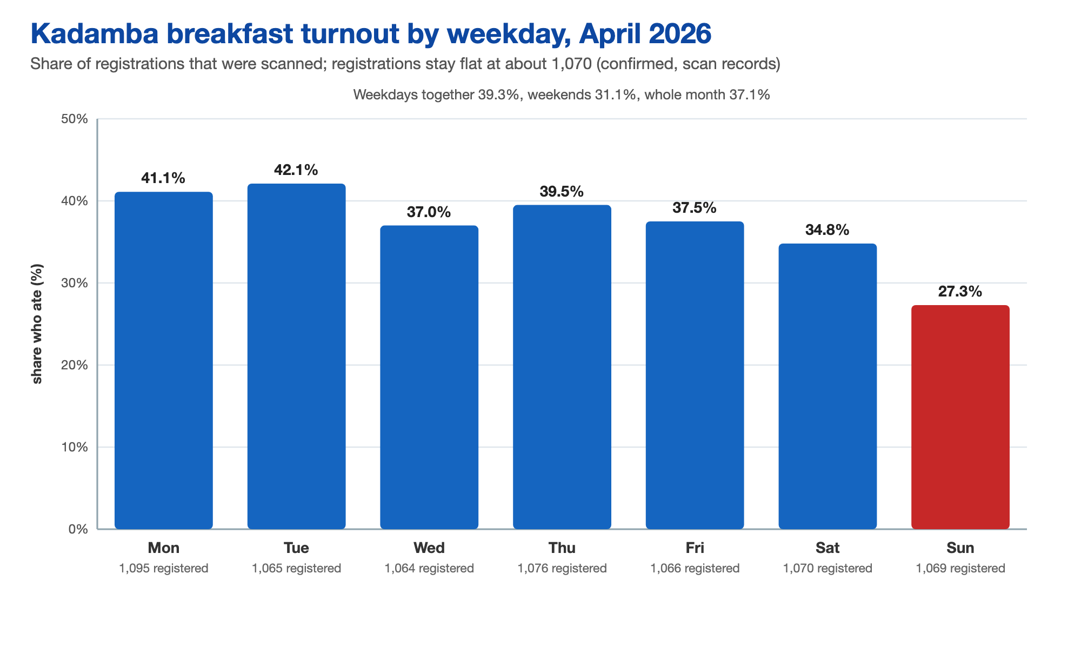
Figure 10. Kadamba breakfast turnout by weekday, April 2026. Registrations stay flat at about 1,070.
At Yuktāhār breakfast averaged about 28 per cent, against lunch at 56 to 89 per cent, and the site head’s belief sits far above the breakfast record. Lunch registrations fall on Sundays and breakfast registrations do not, so breakfast may be a standing default in a way that lunch is not, though this rests on three Sundays.
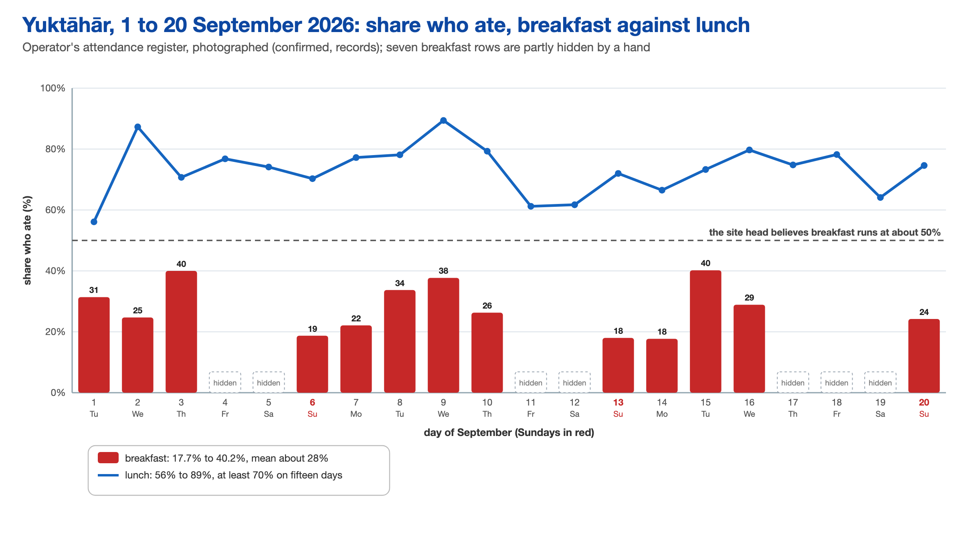
Figure 11. Yuktāhār, 1 to 20 September: breakfast and lunch attendance under the same rules. The dashed line marks what the site head believed breakfast turnout to be.
First batches. Kadamba’s first batch of about 70 per cent of roughly 1,070 registrations is some 750 portions, against about 398 eaten a day, nearly twice what was eaten and about three times on a Sunday. The same kitchen still runs short at the close: idli, puri and bhatura were reported gone by about 9:20. Every hall’s first batch sits above recorded turnout. The first batch is also the binding constraint: it can be topped up but never reduced.
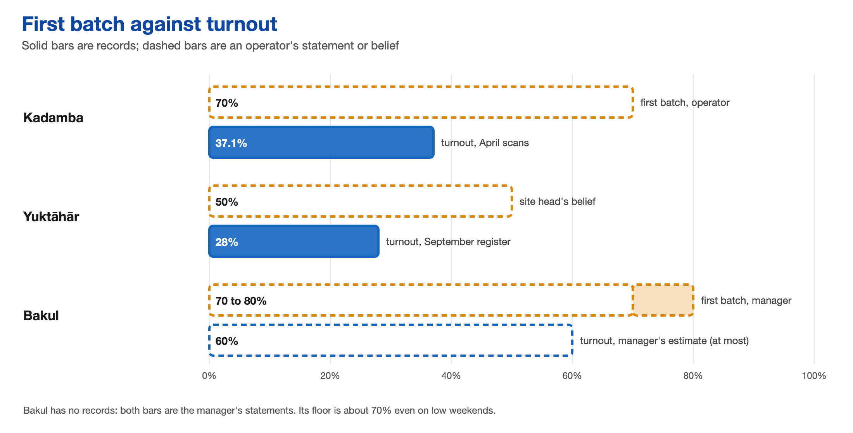
Figure 12. First batch against turnout. Solid bars are records; dashed bars are what operators say.
Part of the gap comes from timing. Yuktāhār’s matching Wastage Book page sizes a dish about two weeks ahead, cancellations close four days ahead and the first batch is fixed before service. Real-time signals arrive only after the first batch is cooked, and only Yuktāhār turns the first half hour of service into a forecast.
The dated changes to the system cluster in late 2024 and early 2025 and are secondhand. The cancellation limit was tightened in December 2024. During a cooking-gas shortage, registration stopped being compulsory and the cap rose from five to ten, and this was later reversed. As of September 2026 no change to registration or billing rules had been confirmed.

3.6 What changed when the records arrived
The first drafts of Phases 1 and 2 were written before most field evidence existed, and the team changed its mind several times. The table lists the main corrections. Each was made in every deliverable in the same pass.
Table 6. Earlier beliefs and what replaced them.
Earlier belief | What the evidence showed | What changed
About 30% of registrations go unused (two students’ impressions) | 62.9% at Kadamba and about 72% at Yuktāhār; 30% fits lunch better | Replaced everywhere; records trusted over recall
The vendors are one passive actor cooking to a forecast | Three operators, with a fixed ratio at Kadamba, a ratio by item at Bakul and a book lookup at Yuktāhār | Each caterer traced as its own system
A forecast locked four days ahead is the bottleneck | The four-day close applies to registration; kitchens set quantities the day before | The cooked first batch named as the binding constraint
Composting absorbs the surplus | Kadamba has no composting; surplus goes to outside diners, staff, reheating and the bin | Composting removed; outside diners and staff added
Bakul cooks near the airport and raised its ratio from 70 to 80% | Its kitchen is at Hafizpet, about 8 km away; the share varies by item | Raise withdrawn everywhere; Bakul became a third regime
Six feedback loops close | Three close with every link evidenced, all inside a kitchen | One scheme of eighteen mechanisms and a strict closure rule
Cuisine explains low uptake at the north Indian halls | It rested on one portal snapshot; Kadamba’s vegetarian registrants attend at 32.4%, non-vegetarian at 48.5% | Kept as one factor; the line and the item matter more
Friends pull each other to breakfast | Six respondents disconfirmed it | Dropped as a driver of attendance

Phase 1 closed with nine findings. In brief: registration is a default and not a demand signal; each kitchen guesses its own conversion and every guess is too high; the gap is measured twice and reaches neither the registration nor the billing rule owner; the binding constraint is the cooked first batch; shortage and waste happen on the same morning because a late crest meets a fixed first batch; academic administration, which sets the class start, has no link to mess governance; oversight and feedback change kitchens and not rules; surplus is absorbed out of sight, partly by real people; and the fix that respondents requested most was a longer close. Two gaps stayed open: disposal after the close was not observed and semester-level trends were not measured.

4 Modelling the System
Phase 2 turned the evidence into a model of how the system works and why it holds the gap in place.

4.1 System map and feedback loops
The system map runs from who decides, through how a breakfast happens and what it runs on, to what holds it in place. Its main finding is the location of the bottleneck: a standing booking sets a ratio, the ratio sets a first batch that cannot be reduced, and a crowd that crests in the last quarter hour meets that batch, so shortage and surplus occur on the same morning. The record of the gap stays in the kitchen.
Surplus is absorbed before the rule setters see it. The team identified eight absorbers: resale on Mess Cell; operator top-ups and discounts on the booking; reuse of leftovers; outside diners and staff who eat the same food; held and reheated food (a candidate); service through the late door; outside venues where students buy instead; and, finally, the contractor’s bin. Most of them do real good for real people, and the team treated that as a design constraint.
The loop test asked of each suspected mechanism whether every link is evidenced, whether the last link really causes the first, and what the delay is. Eighteen mechanisms were tested.
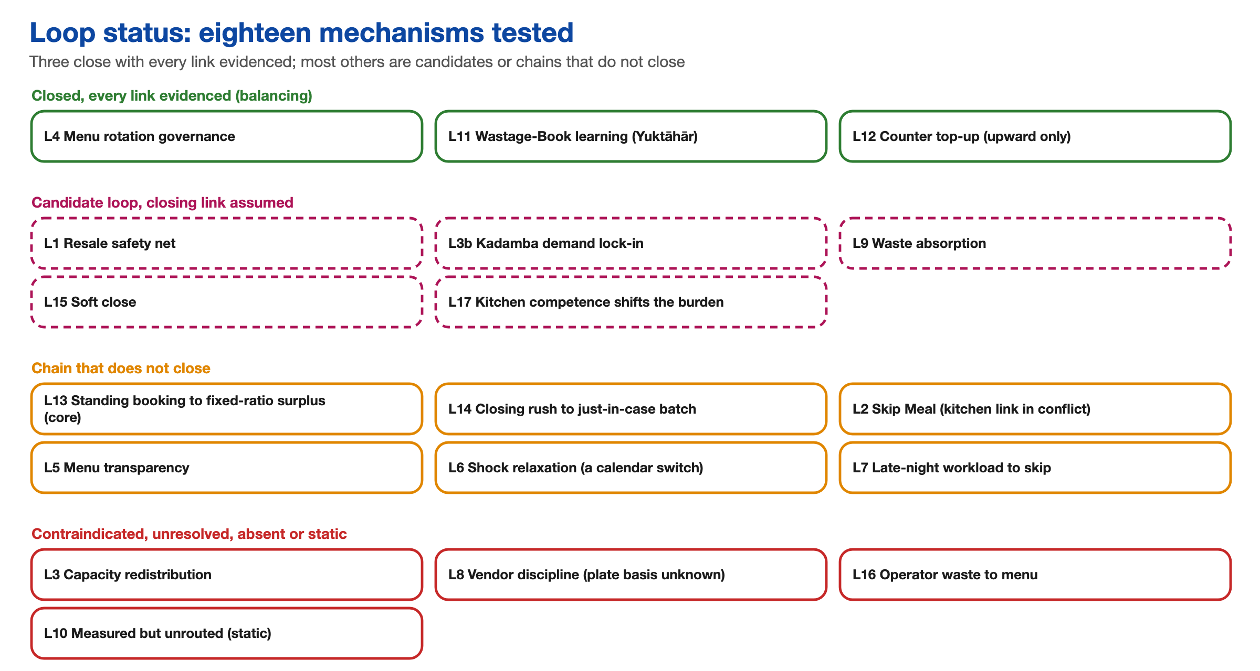
Figure 13. Loop status: eighteen mechanisms tested. Three close with every link evidenced.
Three close with every link evidenced, and all three are balancing loops: menu rotation, Yuktāhār’s Wastage Book loop, and the top-up within a meal. Menu fatigue travelled from students through the Student Council and Student Parliament to a biweekly rotation approved by the faculty committee of the dining services body, and operators’ records confirm the cycle. The Wastage Book loop lowers the next matching day’s issue when a larger leftover is recorded. The top-up runs at all three halls, and what differs is the delay: 10 to 15 minutes at Kadamba, which means a top-up asked for at the final surge lands at or after the close. Every working loop corrects the kitchen’s conversion of bookings into food. None touches the booking.
Five further mechanisms would close if their last link held, among them resale on Mess Cell and the possibility that a better-run kitchen shifts the burden away from fixing the booking. The core chain, from a standing booking to a fixed-ratio surplus, stays open because nothing runs back from the surplus to the booking. Skip Meal is almost unused by students, and its link to the kitchen is in open conflict: the institution’s side says declarations reach the kitchen, and Kadamba’s operator says it cooks on registrations alone.

DECISION 7 Decision: Draw a loop only where the closing link has direct evidence
Decision | A feedback loop was drawn as closed only if every link, including the last, was evidenced. Chains with an inferred link stayed open, with the inferred link dashed.
Alternatives | Drawing every plausible loop, which is how the first map was built.
Reason | Plausible loops would have implied that feedback exists where, on the evidence, none reaches the booking. Three earlier loops became open chains and one was disconfirmed.
Trade-off | Only three loops are confirmed, and real mechanisms stay as candidates because one link is missing. The count of three describes the evidence and not the system.

4.2 Patterns and root causes
The team traced seven chains through the layers of the iceberg, from a dated event to the belief that keeps it standing, each layer sourced and labelled. Two of them are worth setting out. On Sunday 6 September, 267 students were registered at Yuktāhār and 50 ate, because billing counts an automatic booking and registrations stand in for demand. And during the gas shortage, the mess cut to one item at the same price and raised the cancellation limit from five to ten a month. In holidays and long weekends, according to the chair of the parent body, students walked in and scanned, and nobody who neither registered nor came was charged. The arrangement eased the no-show problem every time and was switched off when the trigger passed, with no review. The holiday part is disputed, since the team’s own account is that students stay registered through holidays. Why it was dropped is unchecked: per-plate payment may count registrations, a default is less work, or the model reverts with the calendar.
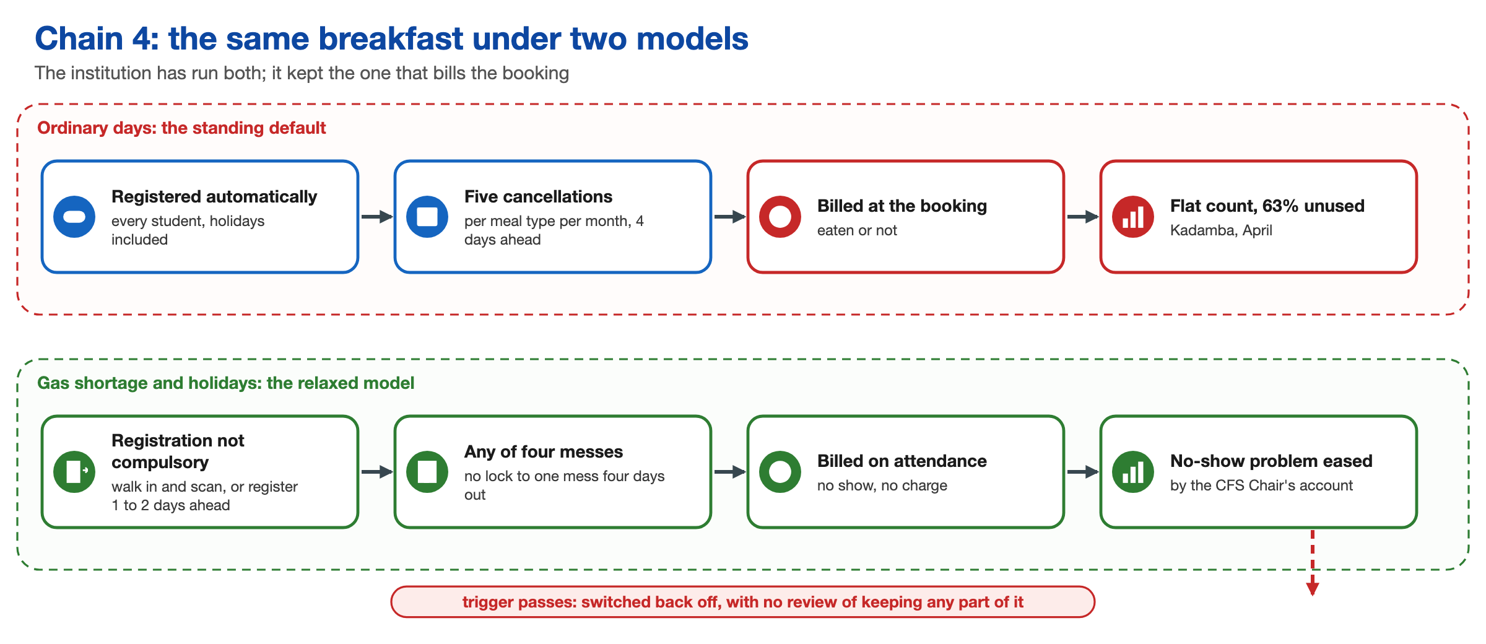
Figure 14. The same breakfast under two models. The institution has run both and kept the one that bills the booking.
Three structural causes recur and split the problem into two: students not showing up, and kitchens cooking more than is eaten. Registration is an automatic standing default with a narrow, early exit, so it cannot follow the morning’s decision. Billing fires at the booking and not at consumption, so inaccuracy costs the system nothing. And the gap is measured but unrouted: scans and Yuktāhār’s books reach no rule owner, so a fix that worked twice was never evaluated. Two conditions keep all three in place. Action follows loudness, since menu fatigue was loud and got fixed, while the larger registration gap is quiet. And the absorption layer takes up each consequence before anyone with authority sees it.
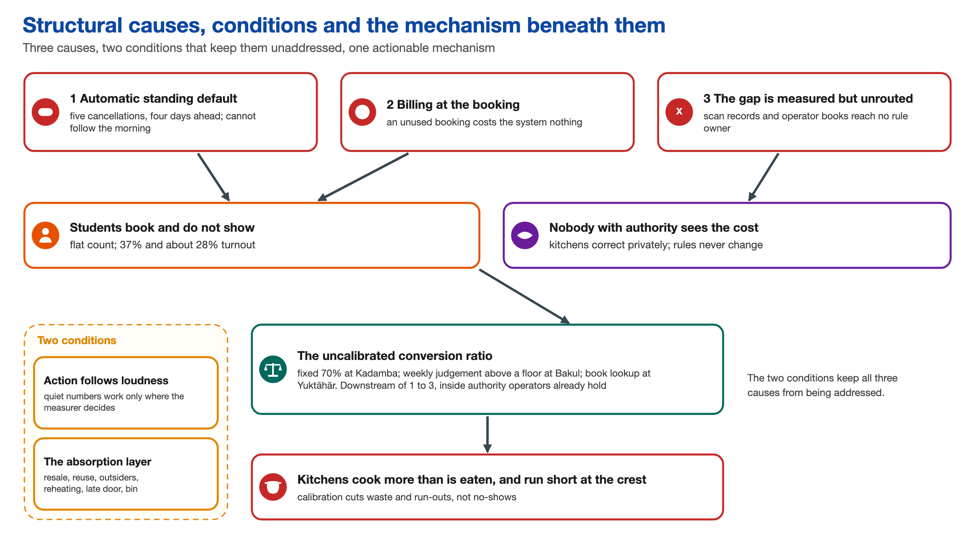
Figure 15. Three structural causes, two conditions that keep them unaddressed, and the mechanism beneath them.
Beneath the kitchen half sits the uncalibrated conversion ratio, in three regimes. It is downstream of the booking, so it is not a root cause, but it is the most actionable structure because it sits inside authority that operators already hold. Of eleven archetypes checked, five held up. Shifting the burden appears twice: resale stands in for fixing the billing, and reuse, outside diners, held food and the bin stand in for calibrating the batch. Growth hitting a ceiling fits Kadamba’s popularity, and success to the successful fits Kadamba’s scarcity feeding defensive registration while Bakul stays underfilled. One chain was kept on purpose, a student who fasts by choice: late sleep and fasting are real, and too small to explain the gap.

4.3 Reframing the problem

DECISION 8 Decision: Reject the first reframing
Decision | The first reframed problem statement, written on 14 September, was rejected and rebuilt.
Alternatives | Keeping it, and moving on to design.
Reason | It read as a consulting memo: it named a fix and an owner before asking what would make anyone want to fix the gap. The team split the work into a reframing and a separate opportunity statement.
Trade-off | It cost time in a short project, and it meant stopping before any design to rank four intervention points by depth and cost, so that Phase 3 started from a shortlist filtered against the evidence.

The team challenged five starting assumptions against the interviews, Yuktāhār’s books and the 11,941 scans. Students not showing up is a symptom and partly not a problem, because one respondent fasts by choice. Students are not careless or irrational: most never choose the booking, and the exit is narrow and early. “Nobody has solved this” fails, since attendance-tracked billing ran twice. “Nobody knows how big the gap is” fails, since it is measured in at least three places. And “this is one problem” fails, because there are three structural causes plus one thing that is no problem.
Six alternative framings were then scored on four tests: whether each explains why breakfast fails when lunch works, why the gap persists unseen, whether it reaches the booking, and whether it fits the evidence. Only one passes all four. “How do we help kitchens forecast better?” fails, for example, because operators already forecast: the best-instrumented kitchen believes up to 50 per cent where its register says 28.
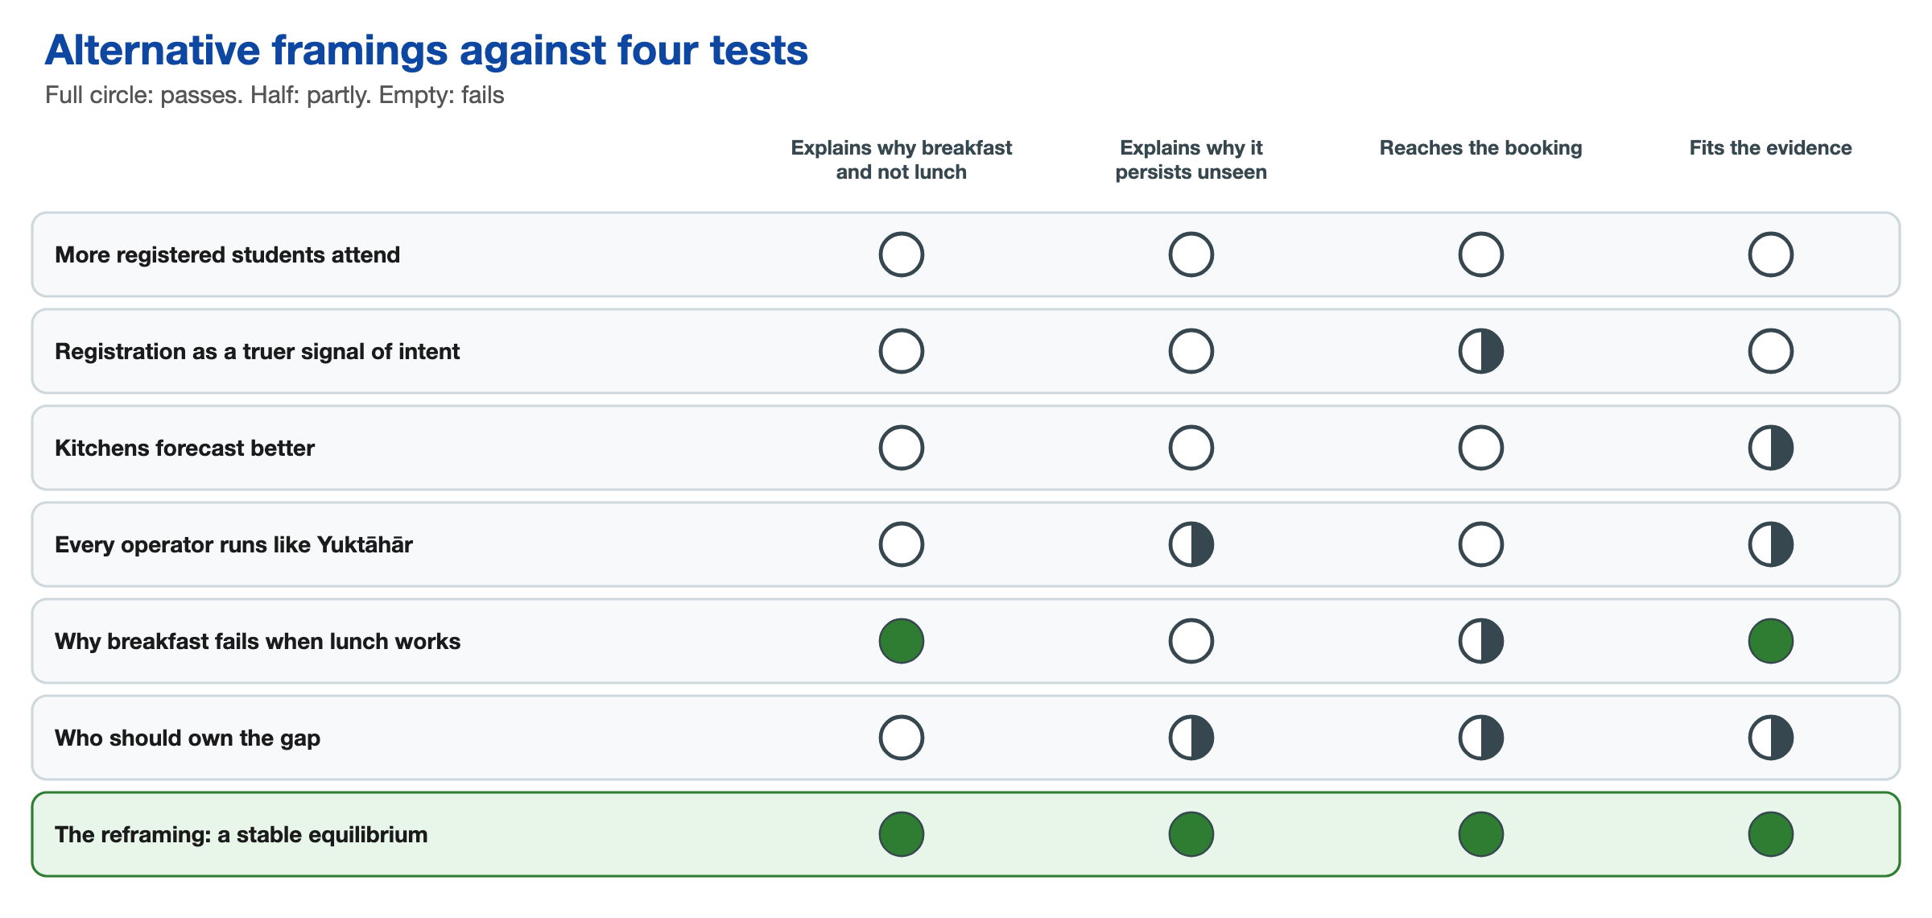
Figure 16. Six alternative framings scored against four tests.
The reframed problem is that the breakfast paradox is a stable equilibrium. The system holds the gap in place because each actor’s behaviour inside it is individually reasonable, and every consequence it produces is absorbed before it reaches anyone who sets the rules. Three forces create the gap, and eight absorbers take up its cost. Most of the absorbers help people; three protect no one (the over-cooked first batch, repeated reheating and the bin). Nothing the kitchens learn crosses upward.
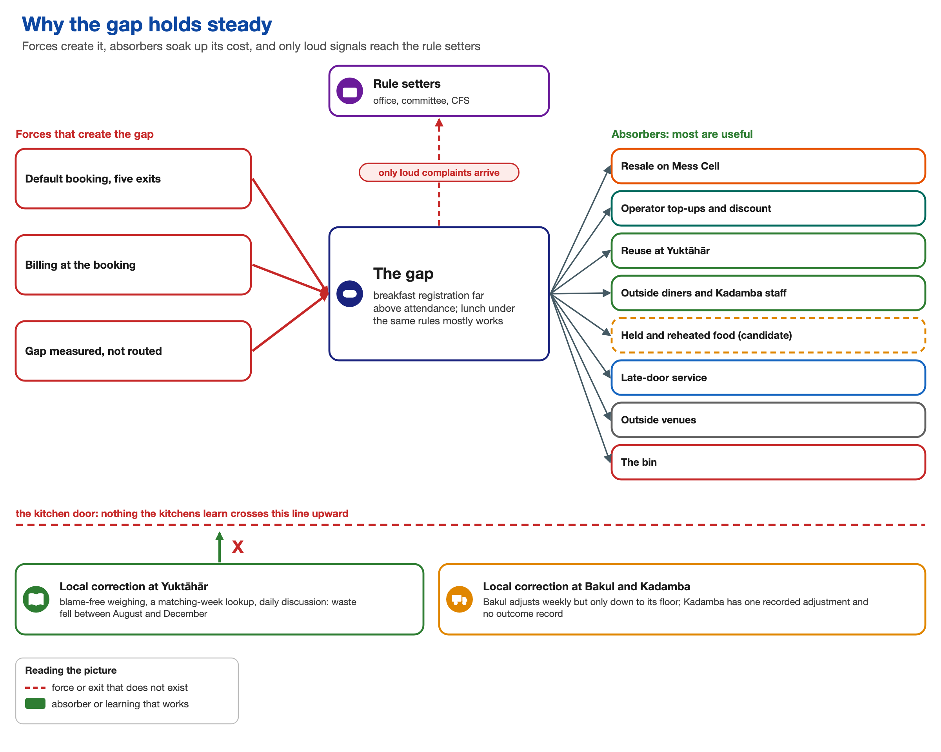
Figure 17. Why the gap holds steady: three forces create it, eight absorbers take up its cost, and only a loud signal reaches the people who set the rules. CDS is the dining services body and CFS its parent body.
No single actor feels this as their whole problem. The student feels a charge. One operator measures the gap every morning and has nobody to tell. Another cooks to the count as an obligation, and a third adjusts weekly but never below a floor held against shortage. The paradox is seen in aggregate only by the actors with the least authority over the rules.
The design opportunity that followed is to give the system a way to notice its own cost: to build the missing routes from the records that exist to the kitchen decision that fixes how much is cooked, and from the same records upward to a decision about registration and billing. Four intervention points follow, in order of depth: the kitchen, where a registration becomes a cooked quantity; the registration and billing rules; the ownership gap; and the attention mechanism, an escalation trigger on measured cost beside the complaint trigger, which is the cheapest by far. Two questions gate the deepest point. Does a plate for payment mean served, as Bakul’s manager says, or registered, as Kadamba’s operator’s remark suggests? And who set the four-day lead and the cap of five cancellations?

5 Finding Where to Intervene
Phase 3 asked where the equilibrium can change, and what any change must protect.

5.1 Leverage points
The team placed twelve levers on Meadows’s twelve places to intervene, counting from place 1, the deepest, and wrote “place n of 12” on each. Most sit between places 2 and 6, from mindset to information flows. None claims place 9 (delays). Places 11 and 12, parameters and buffers, appear only as settings inside deeper levers: cutting Kadamba’s 70 per cent ratio by decree would only move cost from surplus to run-outs.
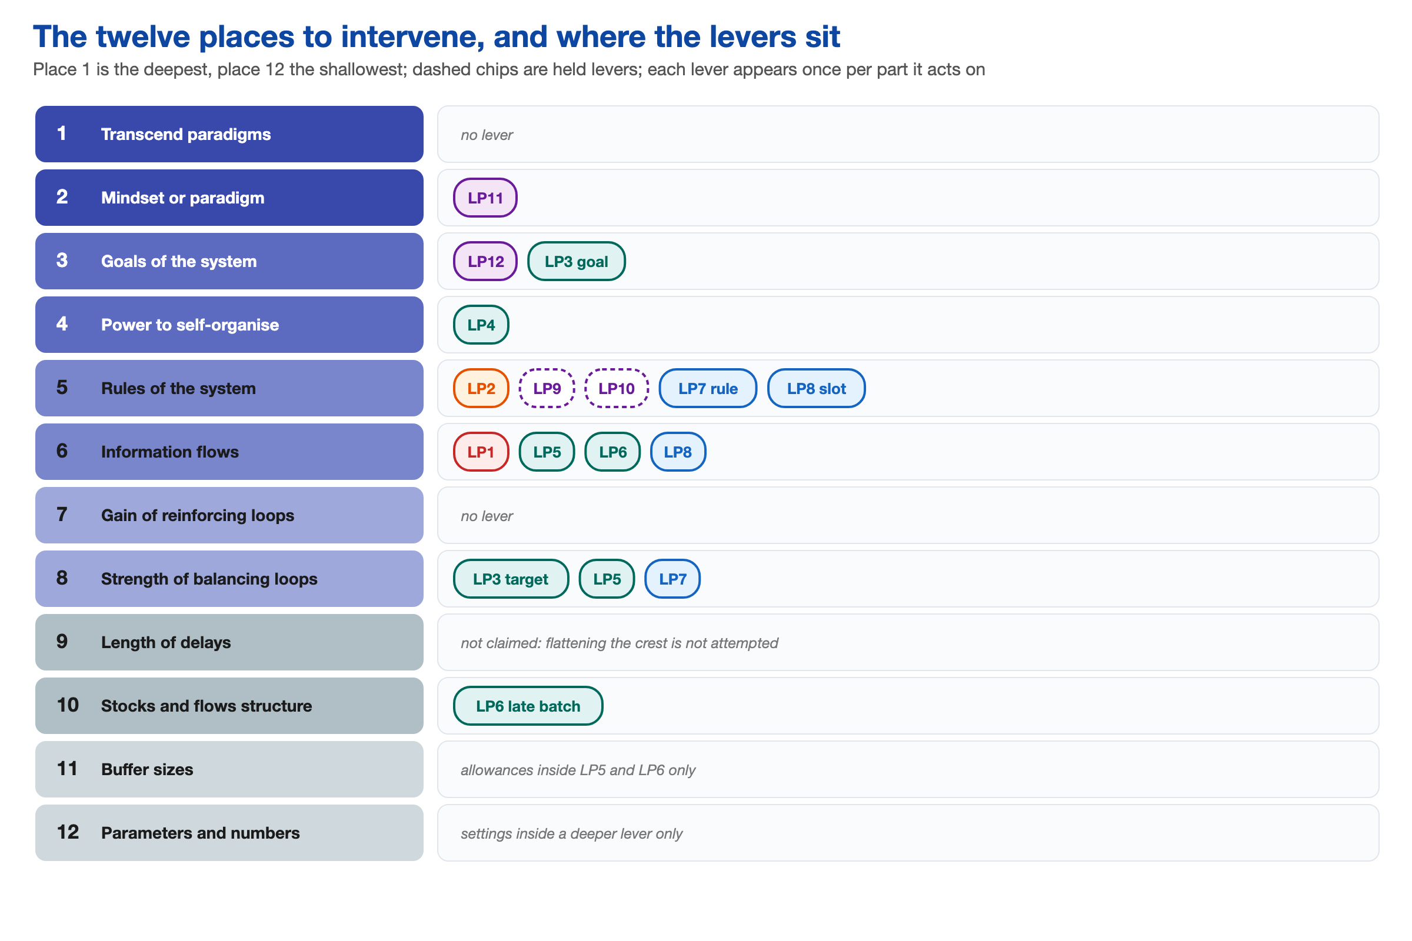
Figure 18. The twelve places to intervene, and where the levers sit.
Table 7. The twelve leverage points.
Lever | What it is | Place | Can a student team act on it?
LP1 | Build the missing routes from records to rule owners | 6 | Yes: high to prototype, medium to deliver
LP2 | Change the breakfast default and its exit | 5 | Propose only; the rule owner decides
LP3 | Make surplus a cost in the operator’s goal | 3 | Low to medium; operator management
LP4 | An operator forum that runs its own trials | 4 | Medium; operators, with the dining services body convening
LP5 | A record-calibrated first batch and a daily record | 6, 8 | Operator decides; high at Yuktāhār, medium at Kadamba, unsizeable at Bakul
LP6 | Crest-aware top-up and a staged late batch | 6, 10 | Operator decides; high at Kadamba, low at Bakul
LP7 | A cost trigger on the oversight line | 8 | Medium, after LP1
LP8 | Operator voice in the menu | 6 | Medium; the menu committee
LP9 | A named owner of booked, cooked and eaten | 5 | Held; low
LP10 | What a booking costs: billing at consumption | 5 | Held; low
LP11 | Test the governing mental models | 2 | Medium; each belief’s holder
LP12 | Change the goal actually sought | 3 | Low to medium; the parent and dining services bodies

The levers rest on records. Of Kadamba’s 32,162 April registrations, 37.1 per cent were eaten, yet no route runs from any record to any rule owner (LP1). Registrations hold near 1,070 every weekday while turnout runs from 42.1 per cent on Tuesdays to 27.3 per cent on Sundays (LP2). The 70 per cent batch is about 2.2 times what the vegetarian line ate (LP5), and 26.5 per cent of scans land between 9:15 and 9:30 (LP6). LP11 sets beliefs against records, such as the Yuktāhār site head’s “about 50 per cent” against about 28 in his own register. LP12 turns a goal that the institution’s poster already states into two working indicators: booked against eaten, and cooked against eaten.
Two levers are held. LP9 would name an owner of booked, cooked and eaten, and LP10 rests on a precedent: attendance-tracked billing ran during a gas shortage and some holiday and fest periods. Both wait until the head of the dining services body and the payment basis are known.

DECISION 9 Decision: Rank levers by depth and then feasibility, and hold those that depend on the payment basis
Decision | Levers were ranked by how deep they sit and then by whether a student team could act on them. LP9 and LP10 were left unscored until the payment basis is known. Any lever that would remove an absorber protecting someone was ruled out.
Alternatives | Choosing by depth alone, which favours beliefs and goals, or by ease alone, which favours parameter settings. Making waste visible by cutting resale, reuse or the meals of outside diners.
Reason | Beliefs and goals are beyond a student team to change, and the payment basis decides which incentive points the right way: a billing change made without knowing it could reverse the operator’s incentive. Absorbers feed real people, and the institution can already measure the gap directly.
Trade-off | The deepest levers (LP11 and LP12) are reachable only as proposals. LP1 ranks first though three levers are deeper, because every other lever needs its input. The most direct fix for students’ bills, billing at consumption, is deferred.

A check against six archetypes found three present. Shifting the burden orders the whole set: kitchen competence and resale relieve the symptom within minutes or weeks, while each route to the fundamental fix has withered, since resale replaced Skip Meal and attendance billing reverted. A better-run kitchen eases the pressure on the people who could fix the cause, although that link is assumed and not observed. LP5 and LP6 are therefore labelled the quick fix throughout. They are worth doing because students eat the food that is saved and they buy time. LP1, LP2, LP11 and LP12, with LP10 once released, are the fundamental fix.
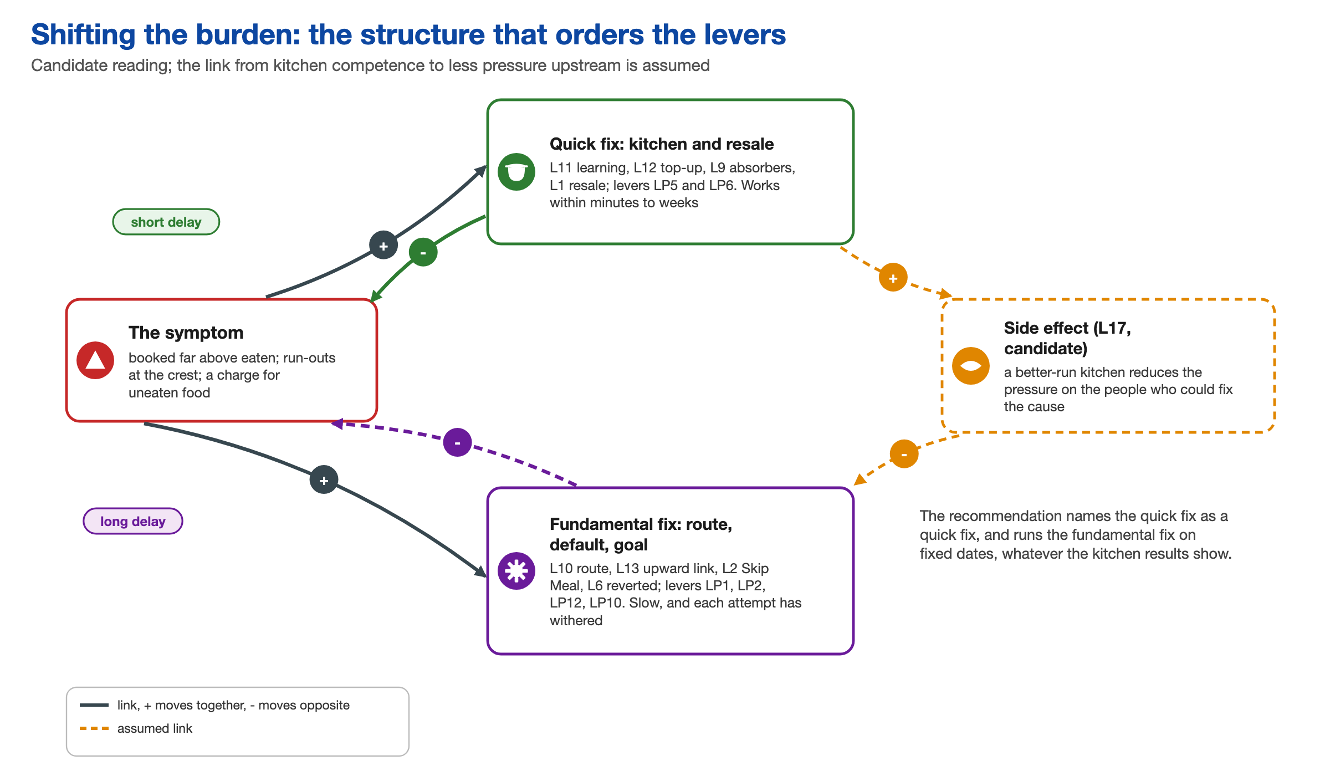
Figure 19. Shifting the burden: a better-run kitchen relieves the symptom and leaves the cause alone. The dashed link is assumed.

5.2 Design principles
Every concept developed in Phase 4 had to pass seven principles: route before you measure, and route on paper; make measurement blame-free and judge it over months; change the default, the goal and the belief and not the people; act on the first batch the day before and in the morning only through the top-up; feed the absorbers by plan and target only the over-cooked batch, repeated reheating and the bin; measure success as cooked against eaten, run-outs and food quality and not turnout; and treat measures as diagnostic and plural, never a single target. The last of these was added in revision, because a figure used against its recorder stops being recorded honestly.
The design objective is a breakfast system in which registration matches each student’s intent, the kitchen cooks to expected eaters, and the cost of any gap reaches whoever sets the rules. The status quo persists because it pays each actor: students make no decision, the Kadamba operator has few run-outs, and the dining services body keeps a low workload. So the route-building and belief levers must reach the dining services body and the Mess Office before any rule proposal.

5.3 Choosing a test slice
Kadamba and Yuktāhār share registration, billing and, as far as is known, tendered plate payment. Yet Yuktāhār plans from records and weighs without blame, while Kadamba cooks a fixed ratio. The halls part only in their planning rule, so a learning practice is possible under current rules. Five other differences separate them, so the comparison cannot prove cause.
Sunday breakfast at Kadamba is where three levers meet. It has the lowest turnout: a 70 per cent vegetarian batch is about 3.1 times what Sunday diners ate, against about 1.9 times on Tuesdays. The default and exit (LP2), the calibrated batch (LP5) and the late batch (LP6) all bite hardest there, so Kadamba’s Sunday vegetarian line became the first test slice for Phase 4.

6 Designing and Testing Interventions
Phase 4 developed and assessed interventions. No pilot was possible within the course, so model outputs are projections, the responses of other groups are reasoned and not collected, and co-design tests are planned and have not run.

6.1 Concepts
Eight concepts were developed against the levers. Seven aim at a lever. The eighth, G, is a deliberate foil.
Table 8. The eight concepts.
Concept | What it is | Levers | Where it stands
A The Breakfast Ledger | A weekly sheet for each hall of scans and books, with the charge for uneaten breakfasts | LP1, LP7 | Fundamental; top single score
B The Kitchen Learning Kit | Plan card, named allowance for outside diners and staff, daily sheet, operator forum | LP3, LP4, LP5 | Quick fix; bundled with C
C The Crest Plan | A weekday arrival card and a late batch at 9:00 | LP6 | Quick fix; bundled with B
D The Sunday Exit | A Sunday skip that removes the charge and lowers the count | LP2 | Fundamental; proposed at week 6
E The Operator Menu Slot | An operator slot at each two-week menu cycle | LP8 | Fundamental; acts on one loop only
F Billed at Consumption | The charge made on the scan | LP10 | Held behind the payment basis
G Ratio Cut to 50 Percent | First batch cut from 70 to 50% by instruction | None | Foil
H The Shared Reading | Joint sessions on each belief and on the working goal | LP11, LP12 | Fundamental; in the bundle

The prototype is the bundle across one breakfast, with each piece on paper. The ledger is one A4 page for each hall for each week; for Kadamba’s vegetarian line on Sunday 19 April 2026 it shows 817 registered, 179 eaten and 638 charged and not eaten at Rs 48, or Rs 30,624. The plan card sets each dish at the evening meeting from the gram standard, and the daily sheet logs batches, top-ups, run-out time and leftovers. The 9:00 rule divides the diners so far by the day’s usual share by then, adds 10 per cent, subtracts the first batch and cooks the difference. The Sunday exit is one Skip Meal control, open until 8 pm on Saturday. Applied to 19 April, the plan card and the 9:00 rule cook close to the 179 who ate, far below the baseline batch.
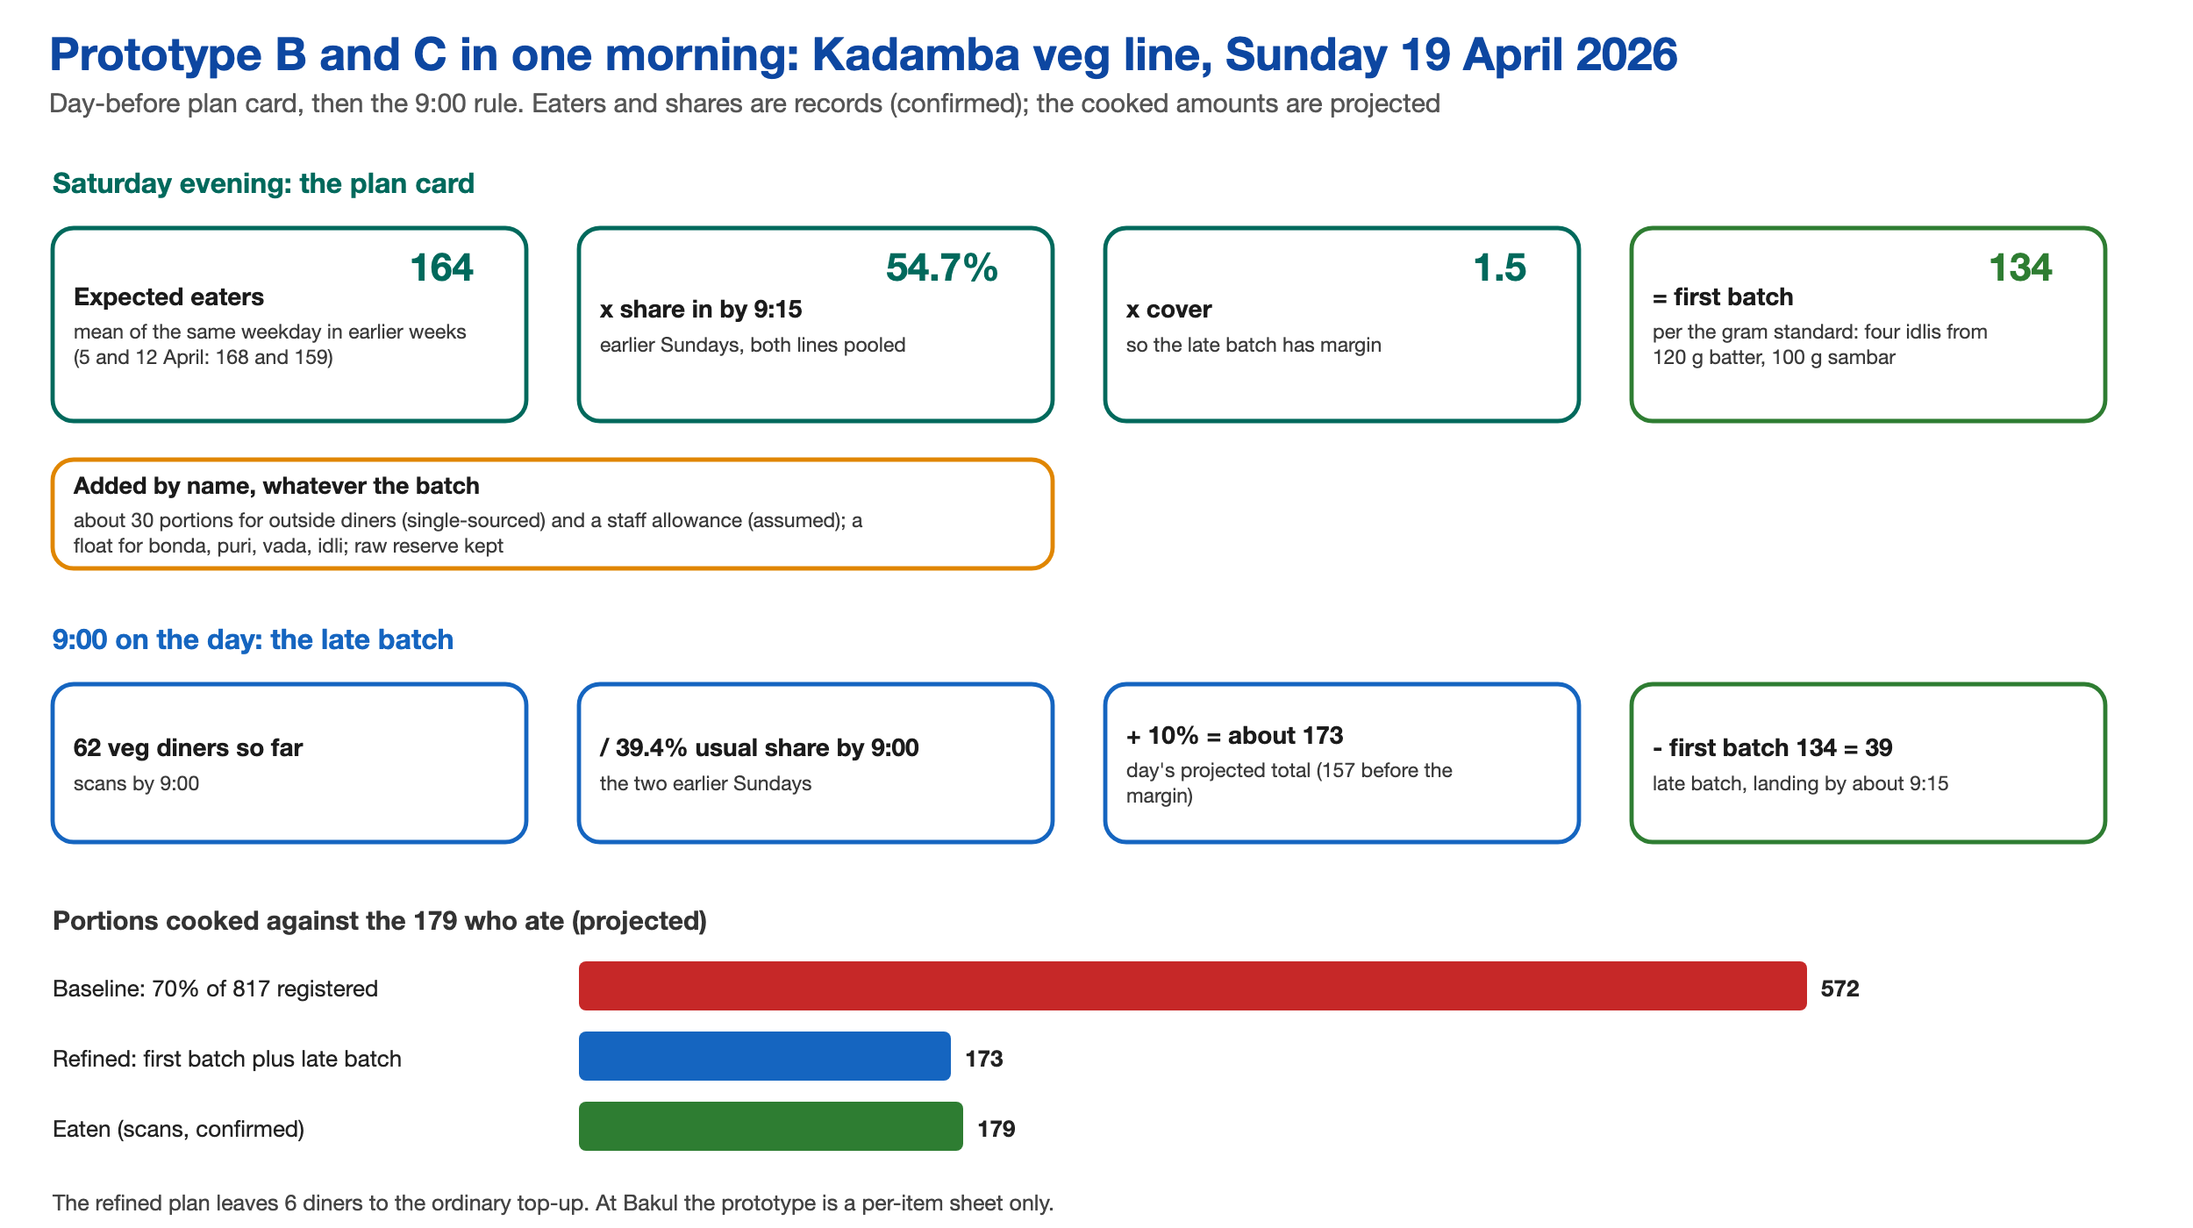
Figure 20. The plan card and the 9:00 rule, applied to Kadamba’s vegetarian line on Sunday 19 April 2026. Eaters and shares are records; the cooked amounts are projected.
Six co-design tests are planned for the first stage, because no model can catch a design nobody would use. They range from testing the skip wording with 8 to 12 students to testing the 9:00 batch with the Kadamba supervisor and cook. None has run.

6.2 Scenario model and results
The scenario model explores how the system might respond and makes no predictions. It replays Kadamba’s April 2026 records arrival by arrival over 23 out-of-sample days. Inputs include a 70 per cent first batch for each line (tested from 60 to 80 per cent), rates of Rs 48 for vegetarian and Rs 66 for non-vegetarian, and a skip uptake of 25 or 50 per cent of no-shows, which is assumed. Nothing is sized for Bakul, which has no records.
Table 9. Four kitchen rules replayed on Kadamba’s April records (projected).
Rule | Cooked a day | Surplus a day | Short a day | Line-days short (of 46)
Baseline: 70% of registrations, one batch | 759 | 362 | 0 | 0
Ratio cut to 50% | 542 | 150 | 4.5 | 7
Calibrated to the forecast plus 10%, one batch | 440 | 60 | 16.8 | 16
Calibrated plus a late batch at 9:00 | 485 | 91 | 2.6 | 7

No single kitchen rule is enough. The ratio cut leaves 150 surplus portions, 138 of them vegetarian, and runs the non-vegetarian line short on 7 of 23 days, because one flat ratio cannot serve two lines 16 points apart. A calibrated single batch cuts surplus to 60 but moves the cost to the crest: on 26 April the vegetarian line would have run out at 9:24, 45 portions short. Only the calibrated batch with the late batch keeps surplus and shortage both low.
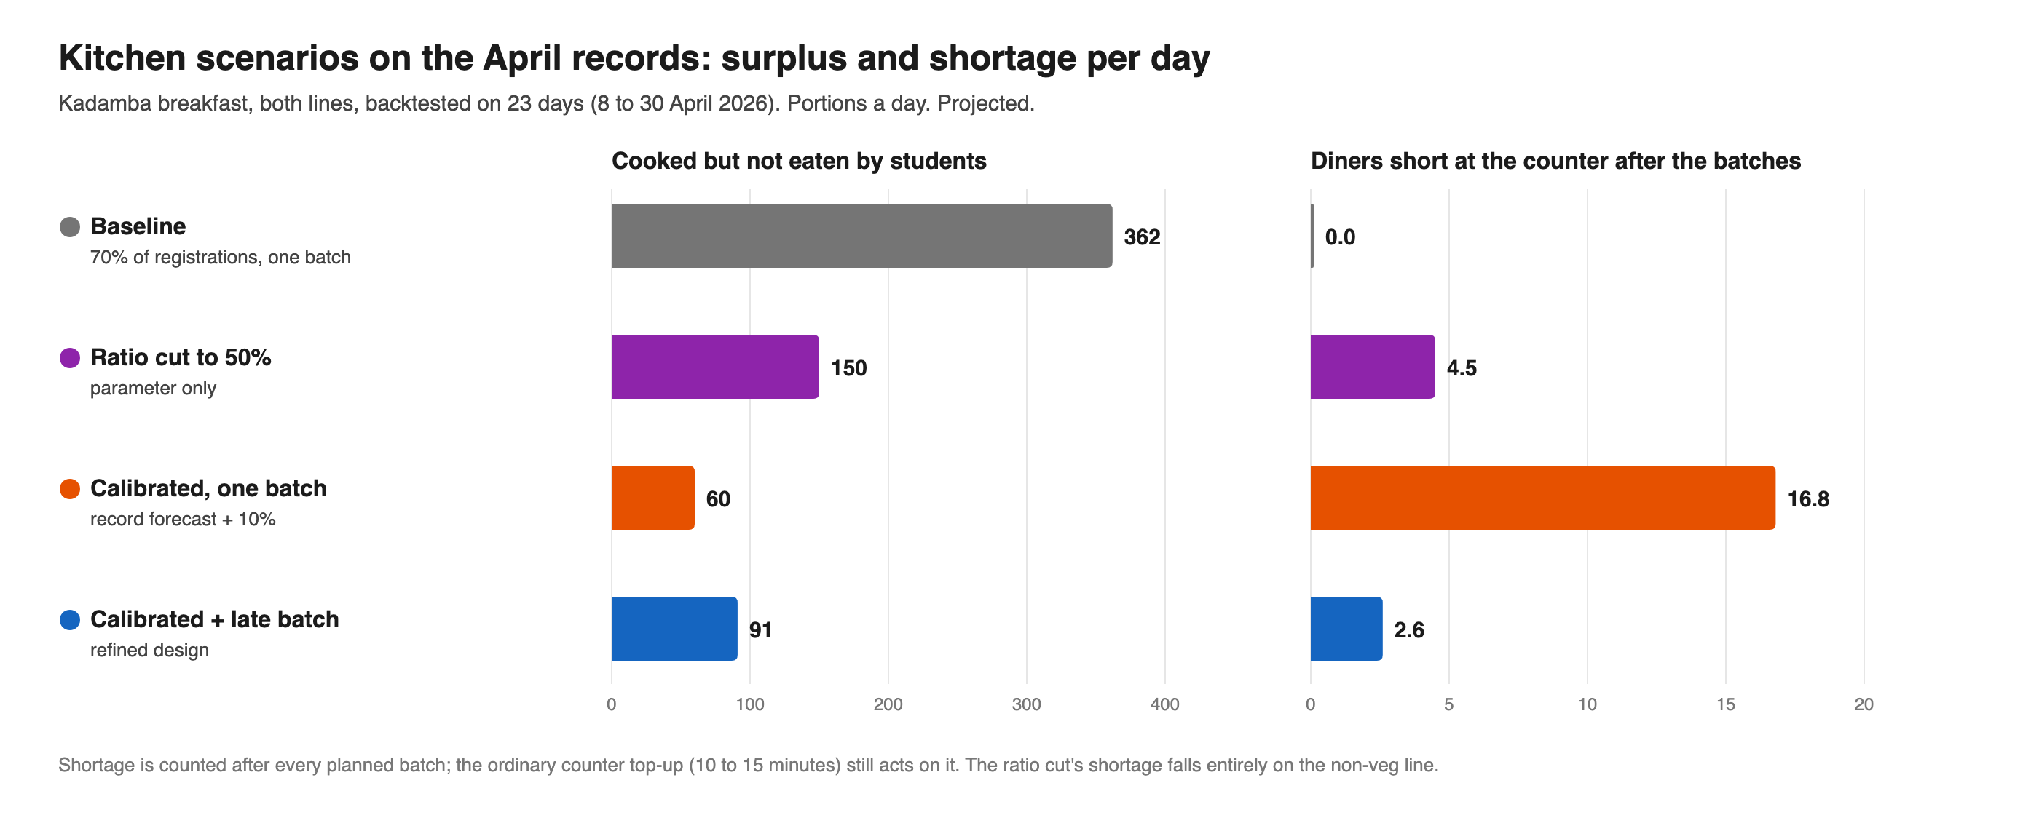
Figure 21. Kitchen rules replayed on 23 April days, both lines (projected).

DECISION 10 Decision: Project the day at 9:00 and add a late batch
Decision | The late batch is projected at 9:00, from diners so far, and cooked to land by about 9:15.
Alternatives | Projecting at 8:00, which gives more time to cook.
Reason | Only 13.5 to 22.5 per cent of diners are in by 8:00, and projecting then under-reads the day by 26.9 per cent on average. At 9:00 the error is 13 per cent, against 35 per cent for a flat projection at 8:00, and a cover of 1.5 on the late batch cut diners left waiting from about 18 a day to 3.
Trade-off | The late batch has less time to land before the crest, and whether it can arrive by 9:15 is untested. The design depends on it: if it fails, about 44 diners are short and 33 wait, which is why a raw reserve is mandatory and two failed Sundays in a row stop the pilot.

On three backtest Sundays, the baseline cooked about 563 vegetarian portions for about 190 eaten. The refined design would cook about 233, leaving about 45 surplus and about 2 short.
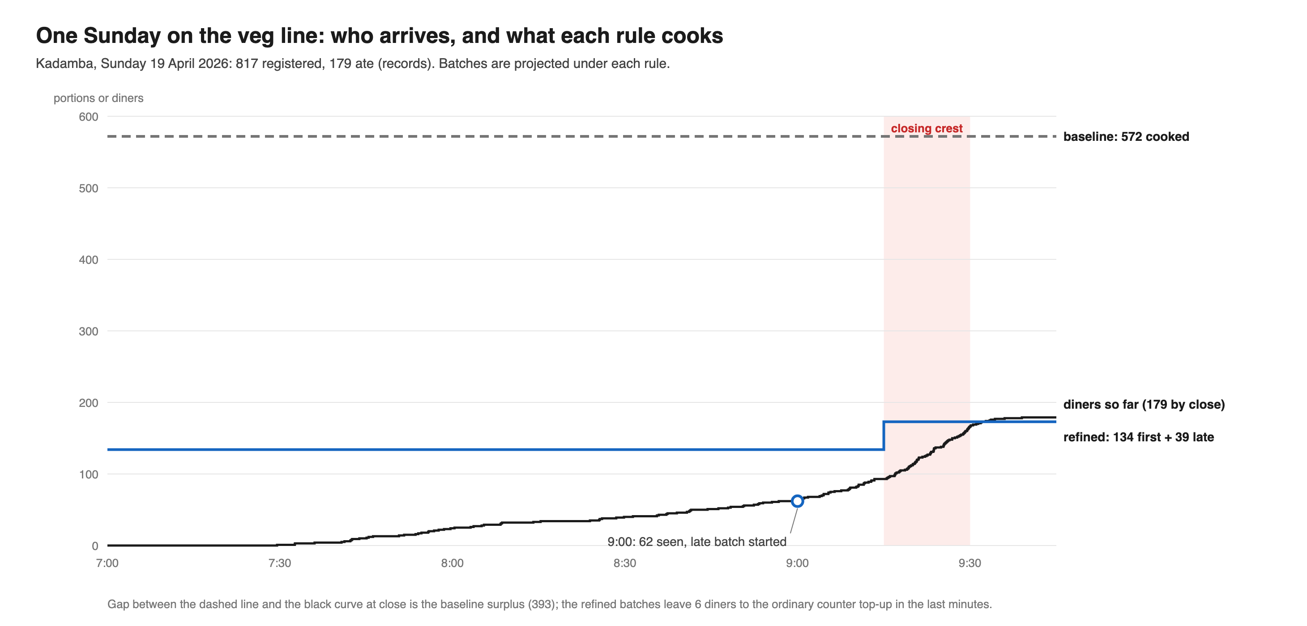
Figure 22. One Sunday on the vegetarian line, 19 April: who arrived and what each rule would have cooked (projected).
Under assumed shocks, the design fails safe toward fewer eaters and loud toward more: from the lightest to the heaviest crest, line-days short (of 46) run 2, 7, 13 and 15.
Kitchen rules leave students’ bills untouched. In April, Kadamba students were charged for 20,221 breakfasts they did not eat, which the team estimates at Rs 10.58 lakh from posted rates. A Sunday skip at 25 to 50 per cent uptake would cut that by Rs 0.40 to 0.80 lakh, and an every-day skip by Rs 2.65 to 5.29 lakh (projected). A skip that returns nothing changes nothing, which is why Skip Meal does not work today.

6.3 Evaluation: gates and scores
Four pass-or-fail gates came before any scoring, and a concept that fails one is ineligible whatever its score. G1: the absorbers that protect someone are kept (resale, reuse, meals for outside diners and staff, walk-ins and late service). G2: the food-safety sequence stays intact. G3: the concept aims at structure, neither asking students to behave better nor blaming operators, and waits on no unknown that could reverse it. G4: a quick fix is paired with a fundamental fix that lands on a date independent of kitchen performance. Concepts that passed were scored from 0 to 4 on nine criteria weighted out of 400: booked against eaten, cooked against eaten, crest service and fundamental capability weighed 15 each; fairness, food quality and desirability weighed 10; and feasibility and reversibility weighed 5. In revision, food quality rose from 5 to 10 and desirability entered at 10.
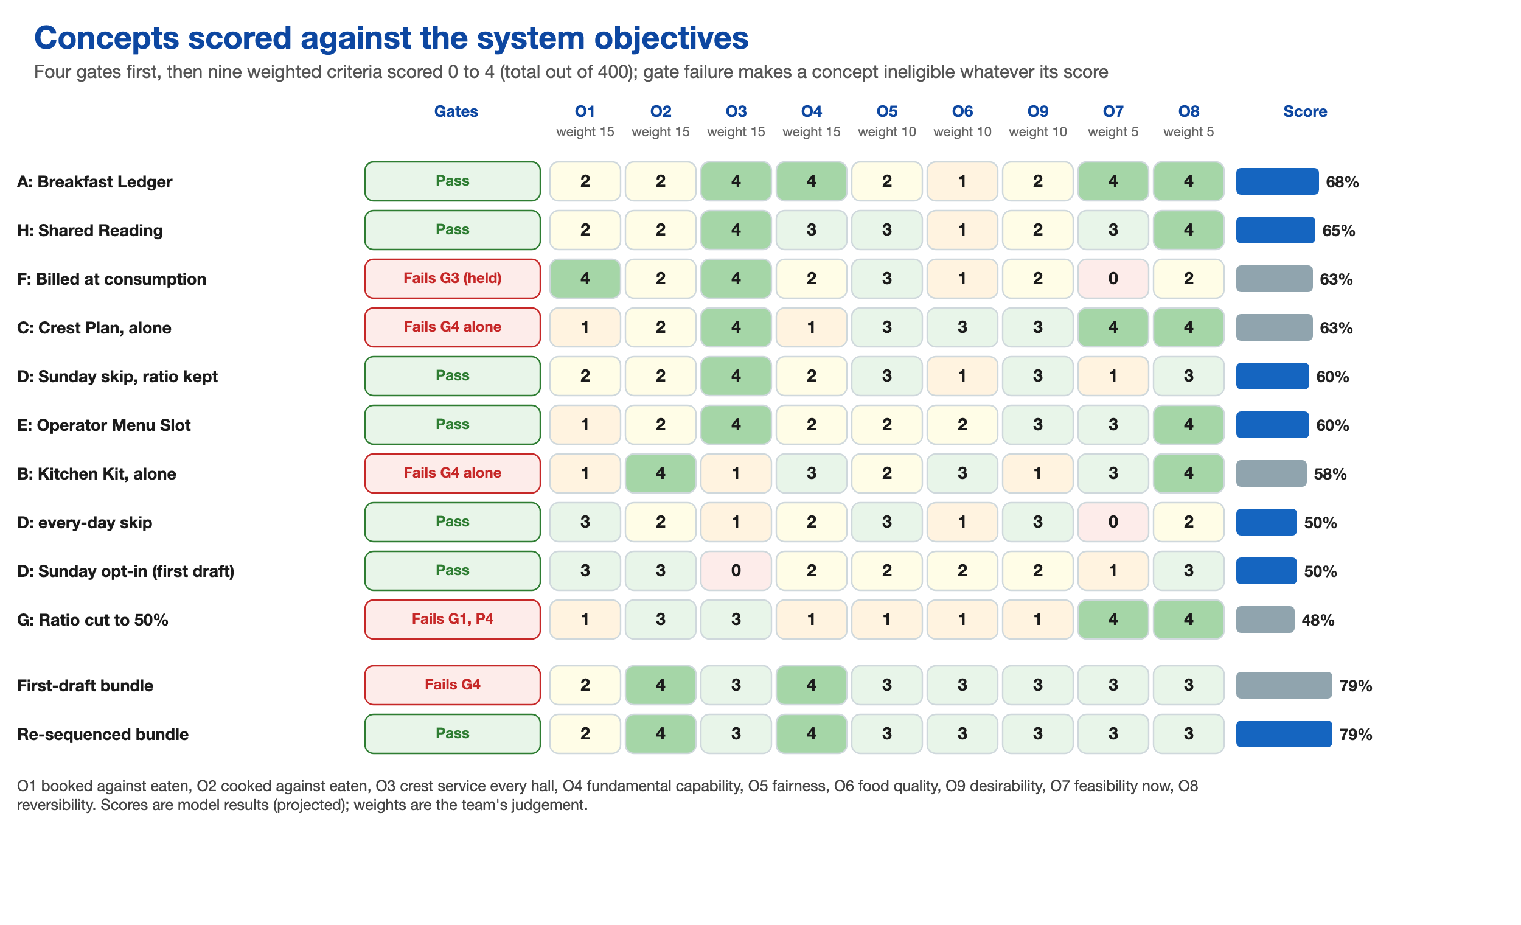
Figure 23. Concepts scored against the gates and nine weighted criteria. Scores are model results (projected).
The gate column matters more than the score bar. The Billed at Consumption concept (F) and the Crest Plan alone (C) both outscore the Sunday Exit (D) and the Menu Slot (E), yet fail a gate. The foil, the Ratio Cut (G), scores 48 per cent and fails G1 and one principle. Two bundles scored 79 per cent. The first-draft bundle proposed the Sunday skip only after the kitchen pilot had proved itself, and it fails G4. The re-sequenced bundle has the same parts, with the skip and the route on fixed dates, and passes.

DECISION 11 Decision: Keep a deliberately weak concept, and let gates overrule the score
Decision | The Ratio Cut was kept in every test as a foil, and four pass-or-fail gates were applied before scores.
Alternatives | Testing only the concepts the team believed in, and ranking by weighted score alone.
Reason | If only promising ideas are tested, every test passes. A weighted score cannot see sequencing: both bundles scored 79 per cent although the first made the fundamental fix wait on the quick fix, a small case of shifting the burden.
Trade-off | More testing effort, and a result that cannot be reduced to a single ranking. The scoring weights are the team’s own judgement, and the gates override a higher score, so some highly scored concepts are excluded.

The team reasoned how twelve stakeholder groups would respond to concepts A, B with C, D and H, from their stated positions; no actor was consulted. Opposition sits in three places. The Kadamba operator would oppose the Sunday exit if it is paid on registered plates, Bakul’s operator would resist any run-out risk, and outside diners and staff are harmed only if the allowance is left unnamed. The calibrated batch saves the Kadamba operator food cost on either payment basis, which argues against holding the Sunday proposal behind the kitchen result.
The likeliest unintended consequence is the hedge ratchet, a candidate loop. A run-out is loud and a surplus is silent, so one complaint after a cut can return the batch to its old size. Judging results over months, recording every run-out, and keeping the late batch and the raw reserve hold it down. A named allowance protects outside diners and staff, and a calendar note covers exams.

6.4 Recommendation and plan
The recommendation has three parts that run together. The first is to build the missing route: a weekly ledger of booked, cooked and eaten for each hall, with the charge for uneaten breakfasts, read jointly with operators and the dining services body. The second is to open a Sunday skip that removes the charge, on a fixed date, and to take the payment-basis question to the rule owner at the same time. The third is to calibrate the kitchen, with a plan card, a daily sheet and a late batch, which the team labels the quick fix wherever it is reported. The plan runs for 20 weeks.
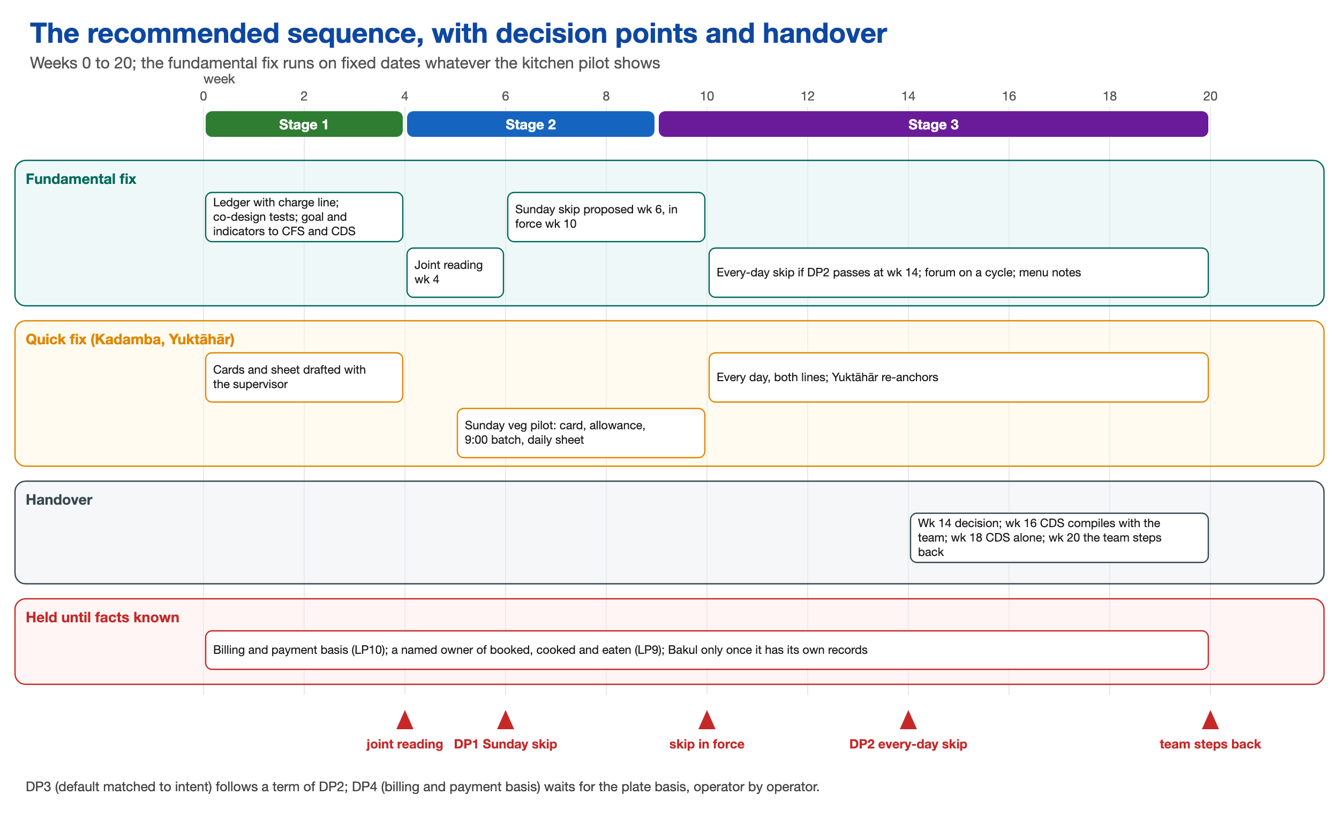
Figure 24. The recommended sequence over 20 weeks, with decision points and handover.
In the first stage, weeks 0 to 4, the ledger and its charge line are built, the co-design tests are run, and a joint reading at week 4 takes the goal and indicators to the parent body and the dining services body. In the second stage, weeks 5 to 8, the Sunday skip is proposed at week 6, together with the payment-basis question, and the Kadamba Sunday vegetarian pilot of plan card, allowance, 9:00 batch and sheet begins. In the third stage, weeks 9 to 20, the skip is in force from about week 10 if adopted, the decision on an every-day skip is taken at week 14, and handover runs from week 16 to the end at week 20.

DECISION 12 Decision: Fix the Sunday skip at week 6, independent of the kitchen pilot
Decision | The Sunday skip is proposed on a fixed date, week 6, whatever the kitchen pilot shows. It is an evening-before skip, open until 8 pm on Saturday, and not a Sunday opt-in.
Alternatives | Waiting for the kitchen to prove itself first, which is what the first draft did. A Sunday opt-in.
Reason | The student-side scenarios showed that the crest stays safe below about two thirds uptake with the ratio kept, so the wait was needless. It also risked a better kitchen making the booking look unimportant, so the exit would never open. With the ratio kept, the opt-in left the crest 23 to 65 short and charged students who forgot Rs 81.
Trade-off | The rule owner is asked to act before any kitchen result exists, and uptake is unknown: the model assumes 25 to 50 per cent of no-shows and tested 10 to 75. If the skip is declined, the Sunday charge line goes to the escalation forum.

The pilot runs on Kadamba’s vegetarian line at Sunday breakfast and is judged at week 16 against Sunday non-vegetarian, Saturday vegetarian and earlier Sundays. The Kadamba supervisor runs it, and the operator’s operations manager, the Yuktāhār operator, the parent body and the rule owner must agree. Success means that Sunday vegetarian surplus falls from about 370 to under 100 portions (the model gives about 45), no Sunday is more than 10 short, run-outs are no more frequent than on comparison days, every allowance meal is served, grams and taste hold, and every safety step is recorded. The pilot stops if shortage goes beyond one top-up on two Sundays running, if the late batch fails twice, if any allowance meal is missed, if grams fall below standard, if any figure is used against staff, or if consent is withdrawn.
Beyond the Sunday skip, the path to a booking that matches intent moves in reversible steps with stated decision points. The thresholds are the team’s judgement.
Table 10. Decision points on the path to a booking that matches intent.
Decision point | When | Rule, and what happens if the evidence goes the other way
DP1 Sunday skip | Week 6; in force about week 10 | Goes ahead on this date; if declined, the Sunday charge line goes to the escalation forum
DP2 Every-day skip | Week 14; from about week 16 | Sunday uptake at least 25 per cent and no Sunday more than 10 short; if uptake is under 10 per cent, the wording is retested
DP3 Default matched to intent | After a term of DP2 | Opt-in on the lowest-turnout days; if uptake is low and the charge stable, the skip and default stay
DP4 Billing and payment | Once the payment basis is known | Billing at consumption or payment on served plates; if plates are registered and there is no rate agreement, billing stays and the skip carries the students

DECISION 13 Decision: Plan the team’s own exit at week 20
Decision | The dining services body compiles the ledger with the team from week 16 and alone from week 18, and the team steps back at week 20.
Alternatives | The team continuing to run the ledger and the pilot.
Reason | A team that stays becomes the thing the system depends on. The aim is a route that outlives the project.
Trade-off | Less continuity and less control over how the ledger is read after handover. Each waste indicator is read beside the run-out indicator for the same hall and line, and an effective ratio that drifts back toward 70 per cent for four weeks signals that the fix is failing.

Of thirteen actions in the plan, the team can complete two alone (the ledger, cards and sheet, and the co-design tests), convene or support four, carry six as evidenced proposals, and must complete one, the handover by week 20. The Kadamba supervisor decides on the batches, and only the registration rule owner can open the Sunday exit. Bakul, a third regime with no records, joins only once it has scans, a measured top-up lead time, an item record and a kitchen lever that does not raise shortage risk.
If the plan is adopted, the model projects first-batch surplus at Kadamba falling from a range of 254 to 471 portions a day to about 69 to 120 over roughly four months. The weekly charge for uneaten breakfasts falls from about Rs 2.47 lakh to Rs 2.27 to 2.37 lakh with the Sunday skip, or Rs 1.23 to 1.85 lakh if the every-day skip follows. Surplus starts to fall with the Sunday pilot, while the charge moves only when the skip comes into force. All of these are projections under assumed adoption and uptake.
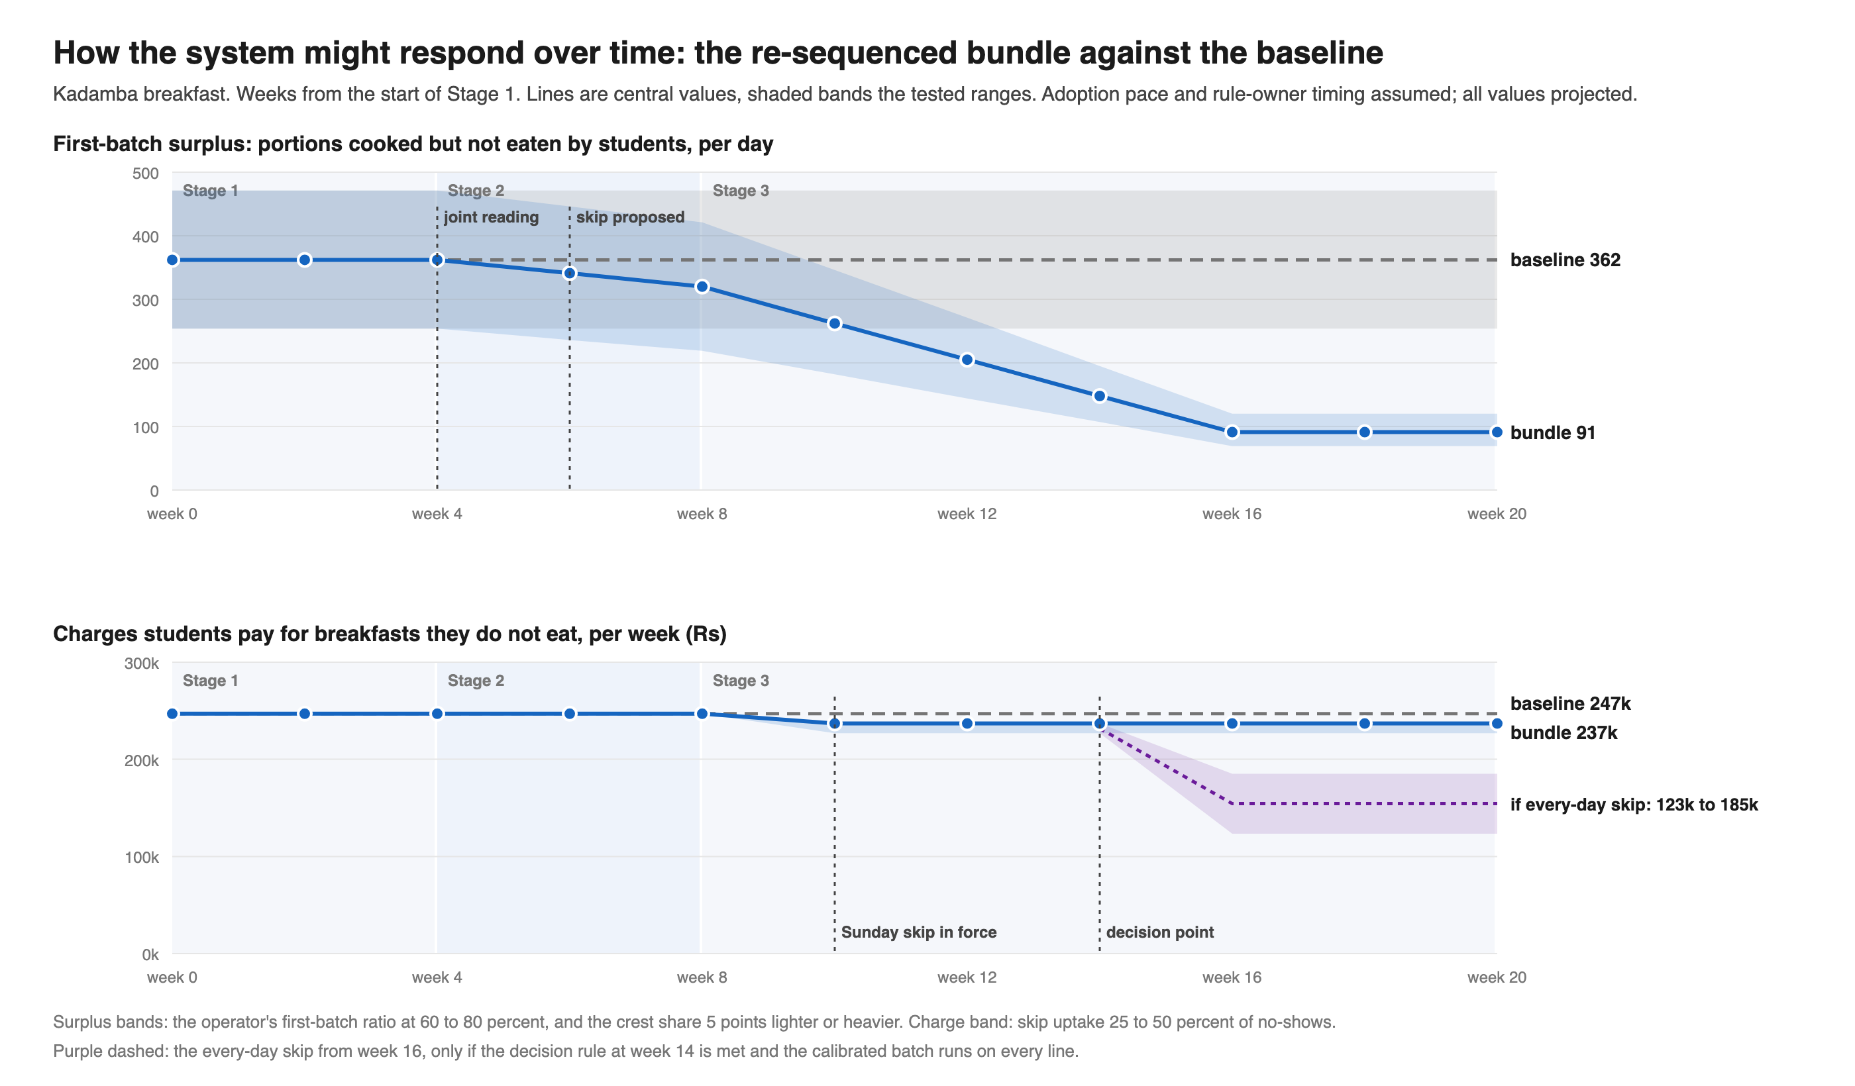
Figure 25. How Kadamba breakfast might respond over time under the bundle, against the baseline (projected).

7 What the Findings Mean for the Institution
The gap is about equally large at Kadamba and Yuktāhār, which share the rules and differ in kitchen practice. This suggests that the registration rule explains the gap, and that kitchen practice decides only how much of it becomes surplus. Every working loop sits inside a kitchen, so the system corrects itself locally and has no correction at the centre. A quick fix in the kitchen can make the central problem harder to see.
The recommendation asks little of students and a good deal of the institution. The records that would calibrate every kitchen are already kept, so the first step costs a weekly sheet and a meeting. The second step, a Sunday skip that removes the charge, is a decision for the rule owners, who today hold only fragments of the outcome. No office is responsible for the whole chain from registration to bin, and the team held back from proposing a named owner until the payment basis is known, since that basis decides who has a reason to close the gap. The institution’s posters give its aim as minimising food wastage through advance meal planning. That planning happens at the registration, which is not where the quantity of food is decided.

8 Limitations and Open Questions

8.1 Limits of the evidence and the method
The evidence has five main limits. Six students were interviewed, and one transcript set had a labelling gap, so six people are not a population. Each kitchen was visited once, and operators describe their own practice, with self-presentation as a real bias: the head of one kitchen believed turnout to be about 50 per cent where his own register shows about 28. Two sets of records cover two halls in two different months, and Bakul has none. The scenario model uses only Kadamba’s scans, and its stress tests apply assumed shocks. And the reasoned responses of other groups come from stated positions, with no feedback collected, while every co-design test is planned and none has run. Disposal after the close and the experience of a live breakfast were not directly observed.
The methods add three more limits. The loop test is strict by design, so the count of three closed loops describes the evidence and not the system. The scoring weights are the team’s judgement. And the three halls differ in five ways besides the planning rule, so the comparison shows that a learning practice is possible under today’s rules without showing why it exists at only one hall.
The interviewers were students of the institution, and the respondents were their peers and hall staff, a relationship that can shape what is said. The team therefore read operator statements about their own practice as single-sourced until a record agreed. The proposed intervention keeps every arrangement that feeds or protects someone: resale, reuse, the meals of outside diners and staff, and late service.

8.2 Open questions
Three conflicts between sources were deliberately left open. The first is who heads the dining services body: two different people are on record for the post, and the case does not choose between them. The second is whether Skip Meal lowers the count that Kadamba cooks from: the institution’s side says declarations reach the kitchen, the portal says staff are told so that they do not prepare food for the student, and Kadamba’s operator says the kitchen cooks on registrations alone. The third, and the one that matters most, is whether operators are paid on registered or on served plates.
Table 11. Open questions and who could answer them.
Question | Who could answer it
What a plate counts for in each operator’s monthly payment; no contract has been seen | The institution’s contracts or the dining services body
Whether Skip Meal lowers the count that Kadamba cooks from | The dining services body
How many students would take a Sunday skip (assumed 25 to 50% of no-shows, tested from 10 to 75) | The students
Whether a late batch cooked at 9:00 can land by about 9:15 without delaying service at the crest | The operators
What Kadamba’s stated 5 to 10% waste figure is a percentage of | The operators
Who set the four-day close and the limit of five cancellations | The institution and its contracts
Who heads the dining services body | The dining services body
Whether the April pattern holds in other months and at the halls without records | Scan exports not yet obtained

9 Reflections

9.1 What worked
Three habits held up. Stating how sure the team was from the first document meant that findings could change cleanly when the evidence moved. Treating each operator as its own system turned up the main structural fact, that the three kitchens differ in learning and not in the amount of data they hold. And keeping a deliberate foil in every test showed that a weighted score alone would have approved a plan that made its own fundamental fix wait.

9.2 What the team would do differently
For several weeks the team reasoned from the student side and the published rules, and the first honest look inside a kitchen changed more than any analysis had. With hindsight, the team would go to the kitchens first and ask for the records sooner, since they existed all along. It would also be slower to name a fix and an owner: the first reframing did so, and the first bundle of concepts made the Sunday skip wait on the kitchen. Both were reversed once the team saw it had built the burden-shifting pattern into its own plan.
The most general lesson is that measuring and routing are different things. The system measures its problem every day, and it still cannot act on it, because the measurement is not delivered to the people who could.

9.3 Next steps
The next steps are to obtain the missing records, including an item-level record for Bakul, and to settle each operator’s payment basis, which gates the held levers. After that come the planned co-design tests with a supervisor and a ledger keeper, the pilot with its stop conditions, a test of real uptake of the Sunday skip, and an extension of the analysis to lunch and dinner.

10 Questions for Discussion
- The operator at Yuktāhār keeps the best records in the system and still believes about half the students come to breakfast, while his register says about 28 per cent. Why might people hold a belief above their own record, and how would you present a number so that it is used and not feared?
- A complaint about menu fatigue became a fortnightly rotation within a term, while the registration gap, far larger, has persisted. What distinguishes a problem that reaches the rule setters from one that does not, and how would you make a quiet cost audible without removing the outlets that absorb it?
- The kitchen bundle cuts Kadamba’s projected daily surplus from 362 to 91 portions and does nothing for students’ bills. Should the team have proposed it, and what would change your answer if it were the only part the institution adopted?
- Billing on attendance ran during a cooking-gas shortage and in holidays, and was then switched off. Three explanations are possible. Which would you test first, and what evidence would settle it?
- If operators are paid on registered plates, a Sunday skip costs the operator something; if on served plates, it does not. The contract has not been seen. How should a student team proceed with a proposal whose fairness depends on a fact it cannot get?
- The team kept a deliberately weak concept in every test and let four gates overrule a weighted score. What does that suggest about testing only the ideas you believe in, and where in your own work would a foil be useful?
Charts are drawn from the team’s own analysis of the sources described in the Approach section. Figures marked projected are model results and have not been tested on campus. The full project document, with every activity and source, is available on request.

