Sasha Richardson DATA 71000
HW 2: Probabilistic Reasoning about Heart Disease

Part 1 · Marginal, joint, and conditional probability

1.1 Marginal probabilities and the 2 × 2 table
P(CHD) = 644 / 4,238 = 0.1520
Among all 4,238 people in the study, 0.1520 developed coronary heart disease within ten years of the baseline exam.
P(smoker) = 2,094 / 4,238 = 0.4941
Among all 4,238 people in the study, 0.4941 were current smokers at the baseline exam.
Counts.
 | No CHD (0) | CHD (1) | Total
Non-smoker (0) | 1,833 | 311 | 2,144
Smoker (1) | 1,761 | 333 | 2,094
Total | 3,594 | 644 | 4,238

Proportions of all 4,238 people.
 | No CHD (0) | CHD (1) | Total
Non-smoker (0) | 1,833 / 4,238 = 0.4325 | 311 / 4,238 = 0.0734 | 0.5059
Smoker (1) | 1,761 / 4,238 = 0.4155 | 333 / 4,238 = 0.0786 | 0.4941
Total | 0.8480 | 0.1520 | 1.0000

The four joint probabilities, each a share of all 4,238 people, read as follows. P(non-smoker ∩ no CHD) = 0.4325 is the share who did not smoke at baseline and did not develop CHD within ten years. P(non-smoker ∩ CHD) = 0.0734 is the share who did not smoke at baseline and did develop CHD. P(smoker ∩ no CHD) = 0.4155 is the share who smoked at baseline and did not develop CHD. P(smoker ∩ CHD) = 0.0786 is the share who smoked at baseline and did develop CHD. The four add to 1.0000 because every person falls in exactly one cell.

1.2 Independence
Smoking and CHD would be independent if the probability of both happening equals the product of the two marginal probabilities.
P(smoker ∩ CHD) = P(smoker) × P(CHD)
Observed: P(smoker ∩ CHD) = 333 / 4,238 = 0.0786
Product: P(smoker) × P(CHD) = (2,094 / 4,238) × (644 / 4,238) = 0.4941 × 0.1520 = 0.0751
Gap: 0.078575 − 0.075083 = 0.0035
The observed joint probability is 0.0035 higher than the product, so the equation does not hold and smoking and CHD are not exactly independent in this dataset. The direction is that smokers who developed CHD are slightly more common than independence predicts. In counts, independence would put 2,094 × 644 / 4,238 = 318.2 people in the smoker-with-CHD cell, and we observe 333, about 15 more. The gap is small, and Part 1 gives no way to judge whether it is larger than chance would produce. Part 3 takes up that question.
1.3 The addition rule
P(smoker ∪ CHD) = P(smoker) + P(CHD) − P(smoker ∩ CHD)
= 2,094 / 4,238 + 644 / 4,238 − 333 / 4,238 = 2,405 / 4,238 = 0.5675
The people who smoked, developed CHD, or both are the 2,094 smokers plus the 311 non-smokers who developed CHD, which is 2,405 people (equivalently, 4,238 minus the 1,833 non-smokers without CHD). Then 2,405 / 4,238 = 0.5675, matching the addition rule. Among all 4,238 people, 0.5675 were smokers at baseline, developed CHD within ten years, or both.
The intersection has to be subtracted because the 333 smokers who developed CHD are counted once among the 2,094 smokers and again among the 644 CHD cases, so adding the two marginals counts them twice.
1.4 Conditional probabilities, risk difference, and risk ratio
P(CHD | smoker) = 333 / 2,094 = 0.1590
Of the 2,094 people who smoked at the baseline exam, about 16 in 100 (0.1590) developed coronary heart disease over the next ten years.
P(CHD | non-smoker) = 311 / 2,144 = 0.1451
Of the 2,144 people who did not smoke at the baseline exam, about 14.5 in 100 (0.1451) developed coronary heart disease over the next ten years.
Risk difference = 0.159026 − 0.145056 = 0.0140
In this group of people, smokers were about 1.4 percentage points more likely than non-smokers to develop heart disease within ten years, which works out to roughly 1 or 2 extra cases for every 100 people.
Risk ratio = 0.159026 / 0.145056 = 1.0963
Smokers in this study developed heart disease at about 1.1 times the rate of non-smokers, meaning their ten-year risk was roughly 10% higher.
Part 2 · Building a sampling distribution by simulation

2.1 Population mean and standard deviation
μ = π = 644 / 4,238 = 0.1520
Direct computation with divisor N. Each of the 644 people with CHD contributes (1 − μ)², and each of the 3,594 without CHD contributes (0 − μ)².
Σ(x − μ)² = 644 × (0.848042)² + 3,594 × (0.151958)² = 463.1483 + 82.9904 = 546.1387
σ = √(546.1387 / 4,238) = √0.128867 = 0.3590
Closed-form computation.
σ = √(π(1 − π)) = √(0.151958 × 0.848042) = √0.128867 = 0.3590
The two agree to every printed digit (0.358981 in both cases). They must agree, because for a 0/1 variable the variance is π(1 − π)² + (1 − π)π², and factoring out π(1 − π) leaves π(1 − π)[(1 − π) + π] = π(1 − π).
2.2 Twenty samples of size 100
I drew 20 samples of n = 100 with replacement from the 4,238 TenYearCHD values using numpy’s random generator with seed 71000, so the draws can be reproduced. For each sample, I stored the sample proportion p̂ and the sample standard deviation s. Because these are samples, s uses the n − 1 divisor.
Sample | p̂ | s
1 | 0.20 | 0.4020
2 | 0.14 | 0.3487
3 | 0.20 | 0.4020
4 | 0.18 | 0.3861
5 | 0.14 | 0.3487
6 | 0.17 | 0.3775
7 | 0.16 | 0.3685
8 | 0.13 | 0.3380
9 | 0.15 | 0.3589
10 | 0.14 | 0.3487
11 | 0.15 | 0.3589
12 | 0.14 | 0.3487
13 | 0.16 | 0.3685
14 | 0.17 | 0.3775
15 | 0.10 | 0.3015
16 | 0.13 | 0.3380
17 | 0.19 | 0.3943
18 | 0.18 | 0.3861
19 | 0.16 | 0.3685
20 | 0.16 | 0.3685

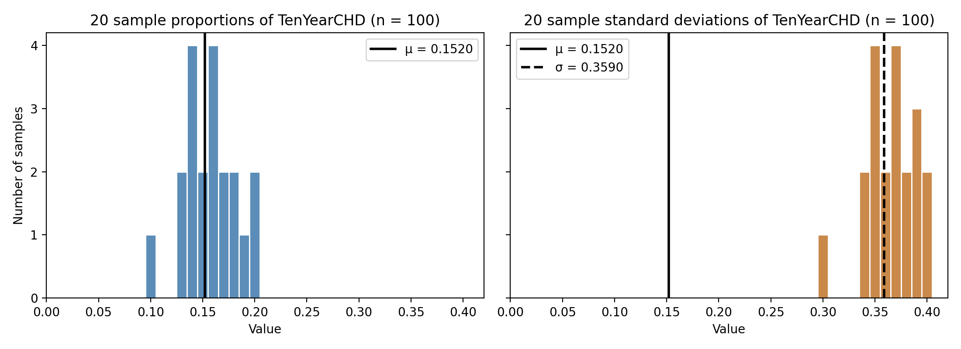
Histograms of the 20 sample proportions (left) and 20 sample standard deviations (right) on a common x-axis. The solid line marks μ = 0.1520 in both panels. The dashed line in the right panel marks σ = 0.3590.

The sample proportions range from 0.10 to 0.20 and scatter around μ. Their average is 0.1575, which sits close to the population value of 0.1520. The standard deviation of the 20 proportions is 0.0253. Theory says it should be about σ / √n = 0.3590 / √100 = 0.0359, and with only 20 draws an estimate of spread can easily be off by this much. Sixteen of the 20 proportions (80%) fall within one theoretical standard error of μ.
The sample standard deviations cluster around σ = 0.3590 rather than around μ, with an average of 0.3645 and a range of 0.3015 to 0.4020. The solid μ line in the right panel sits far from them because s estimates σ and not μ.
Part 3 · Comparing two groups with a standard error

3.1 Risk difference, standard error, ratio, and 95% interval
p̂₁ = 333 / 2,094 = 0.159026, n₁ = 2,094
p̂₀ = 311 / 2,144 = 0.145056, n₀ = 2,144
Difference = p̂₁ − p̂₀ = 0.159026 − 0.145056 = 0.0140
SE = √[ 0.159026 × 0.840974 / 2,094 + 0.145056 × 0.854944 / 2,144 ]
= √[ 0.00006387 + 0.00005784 ] = √0.00012171 = 0.0110
Ratio = 0.013970 / 0.011032 = 1.2663
95% interval = 0.013970 ± 1.96 × 0.011032 = 0.013970 ± 0.021623
= (−0.0077, 0.0356)
Quantity | Value
Risk difference (smokers − non-smokers) | 0.0140
Standard error | 0.0110
Difference / SE | 1.2663
95% interval | −0.0077 to 0.0356

3.2 Interpretation

The difference of 0.0140 is only about 1.3 standard errors from zero, and the 95% interval runs from a risk 0.8 points lower for smokers to a risk 3.6 points higher. That tells me a gap this size could easily arise from sampling alone, so these data do not provide convincing evidence that ten-year CHD risk differs between smokers and non-smokers in the wider population these people represent. The interval still allows a meaningful harmful effect, and this comparison ignores the fact that smokers here were on average about 3.7 years younger and more often male than non-smokers, which could mask an effect.

