Use B-Spline for the fitting

1. Err Function
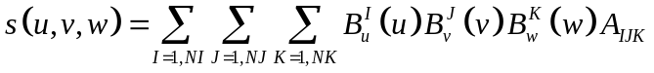 (1.1)
where
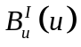 is the I-th basic function in the u-direction
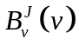 is the J-th basic function in the v-direction
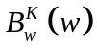 is the k-th basic function in the w-direction
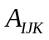: Control point to be fitted

At the data points, the fitting value is

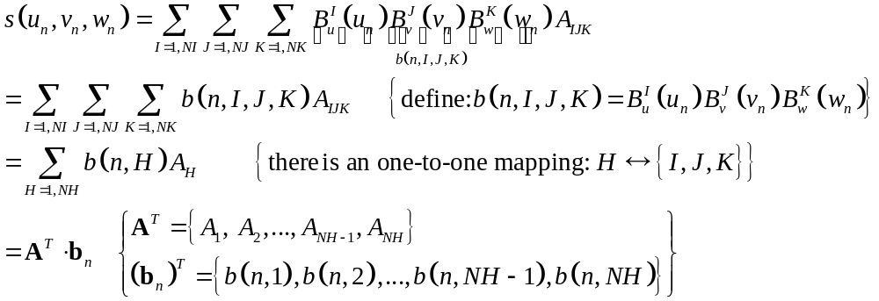 (1.2)

Therefore, the Square-err of the fitting is
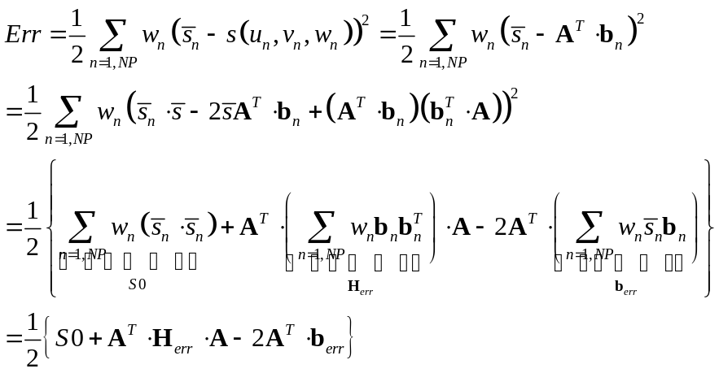 with 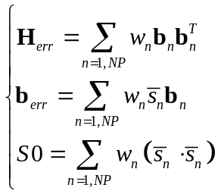 (1.3)

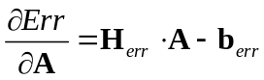, 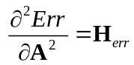, 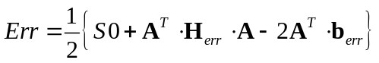 (1.4)

2. Regularization Function
(2.0)
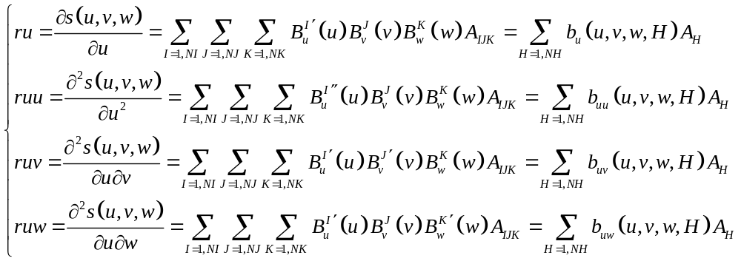 (2.1)
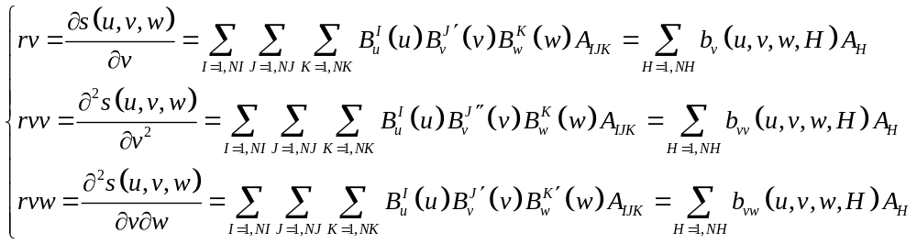 (2.2)

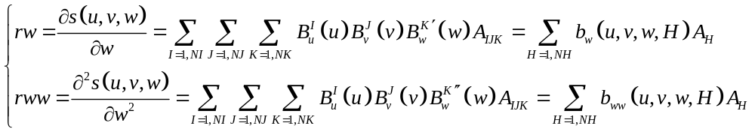 (2.3)

We will impose regularization at some points: 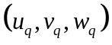 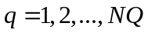. These points can be independent of the data points.

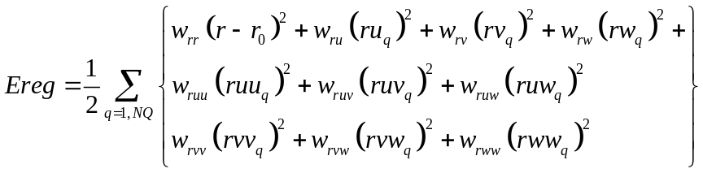 (2.4)

where
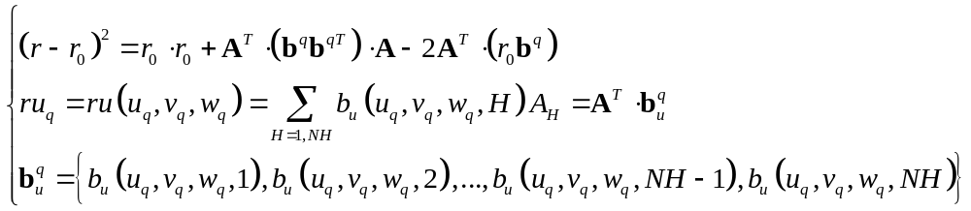 (2.5)

and similarly
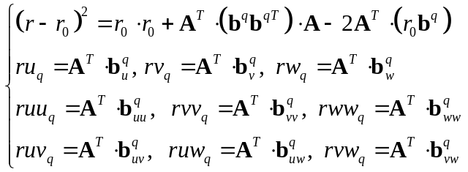 (2.6)

Thus
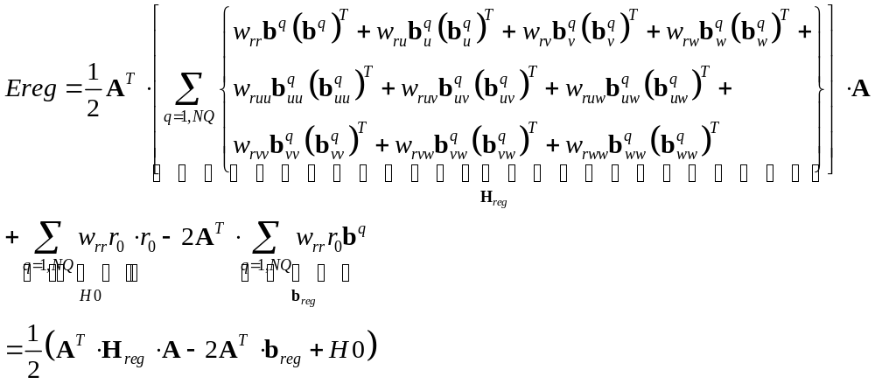 (2.7)

3. Linearly-constraint optimization.

Linear constraint on A can be written as

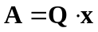 where x is unconstraint parameters (3.1)

Then
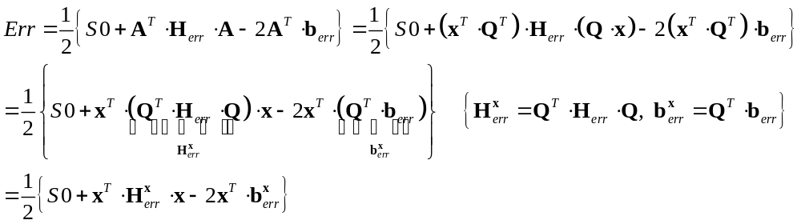 (3.2)
and
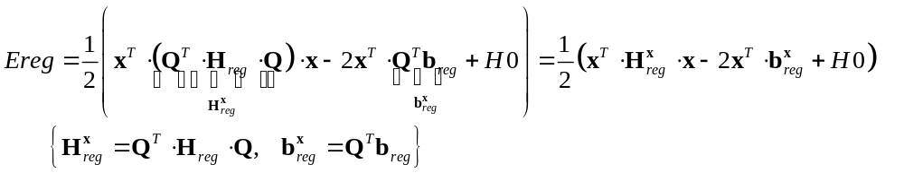 (3.3)
Such that the objective function is

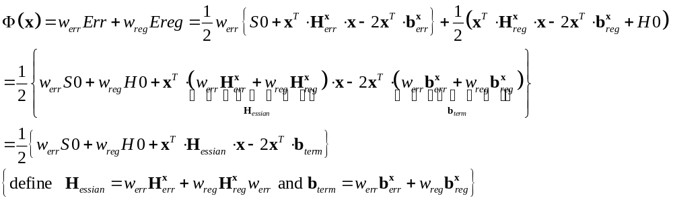 (3.4)

then 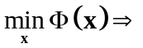

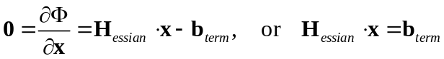 (3.5)

About Mapping 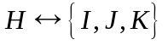
I use
H=0
Do K=1,NK
Do J=1,NJ
Do I=1,NI
H=H+1
B(H)=Bw(K)*Bv(J)*Bu(I)
A(H)=A(I,J,K)
Enddo
Enddo
Enddo

The reason for using this order is that the constraints on I are most complex, while there is no constraint on K.

Smoothness condition on the apex

