1. Displacement Shape function
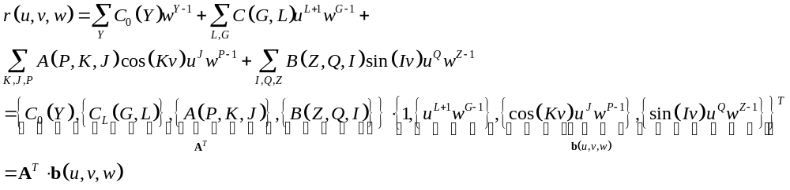 (1.1)
NOTE: (a) 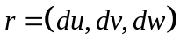
(b) 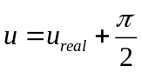, such that 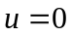 at the apex, and 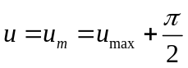 at the highest point.
(c) and 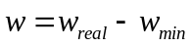, such that 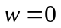 on the inner surface of the fitting volume, and 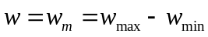 on the outer surface.

Treatments (b) and (c) are for easier formulations and slightly better computational efficiency.

Note:
- J and H must not be 0, otherwise there is singularity at the apex point
- L must not be 0, otherwise, the C⁰ smoothness at the apex point is broken
- Therefore
I=1,…NI
J=1,…NJ
K=1,...NK
L=1.,…NL
H=1,…NH
V=1,…NV
P=1,…NP
Q=1,…NQ
The total number of terms is N=NV+NL*NG+NK*NJ*NP+NI*NH*NQ
I think NQ, NG, NV=4 is about enough, NL=5, NK, NI=6. Then N=4+4*5+6*5*4+6*5*4=264 terms

We do this
NH=NV+NL*NG+NK*NJ*NP+NI*NQ*NZ, Nx=NH

M=1

Do Y=1,NY
B(M)=w**(Y-1)
Enddo

Do G=1,NG
Do L=1,NL
M=M+1
b(M)=u**(L+1)*(w**(G-1))
enddo
enddo

Do P=1,NP
Do K=1,NK
Do J=1,NJ
M=M+1
b(M)=Dcos(K*v)*(u**J)*(w**(P-1))
enddo
enddo
Enddo

Do Z=1,NZ
Do I=1,NI
Do Q=1,NQ
M=M+1
b(M)=DSin(I*v)*(u**Q)*(W**(Z-1))
Enddo
Enddo
Enddo

This is also the way to link x to C0(Y), C(G,L), A(K,J,P), B(I,Q,Z) etc.

The Error Function
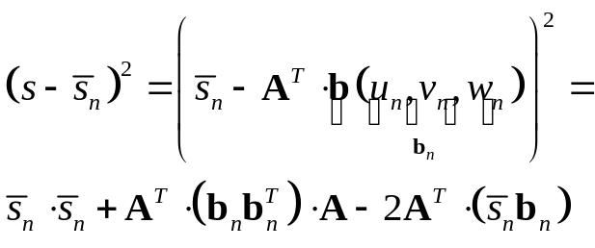 (1.2)
The fitting error is thus
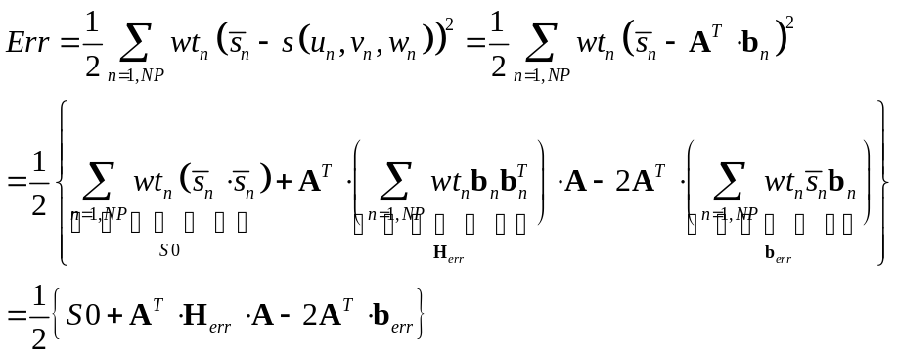 with 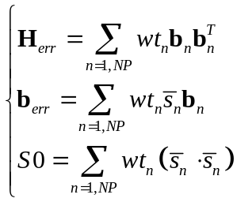 (1.3)

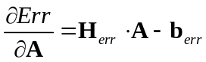, 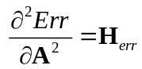, 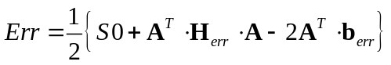 (1.4)

The regularization terms are

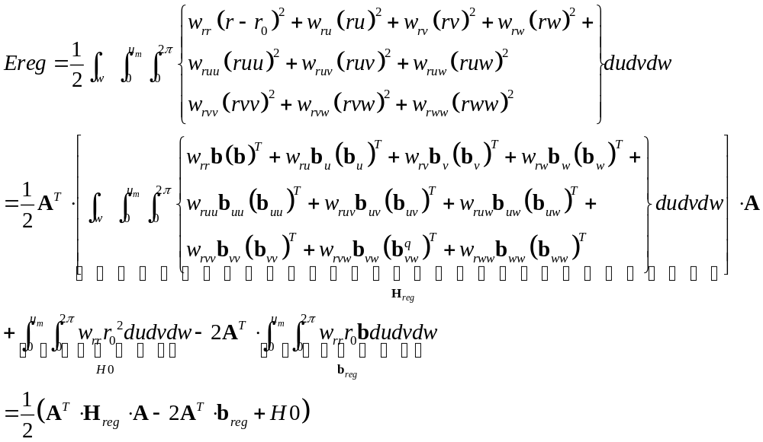 (2.4)

,
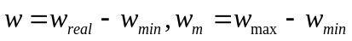

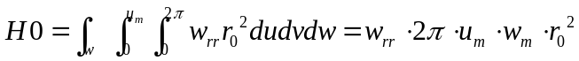
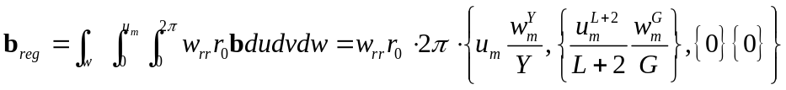

Assume 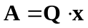, then
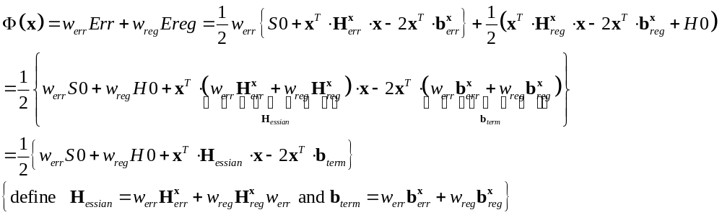 (3.4)

then 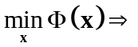

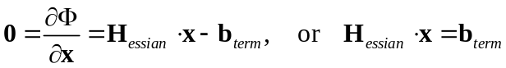 (3.5)

Now, need to deal with
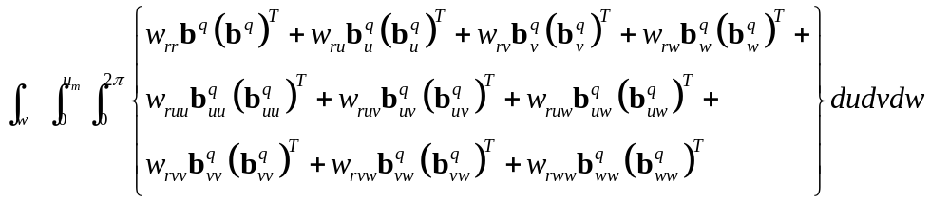
We need to use the following integrations:
