(O) Prolated spheroid Coordinate:
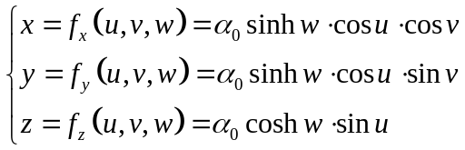 (1)
with 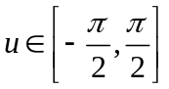 and 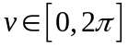
The reference coordinates are:
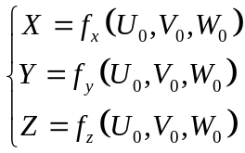 (2)
and the current coordinates are as (1), with

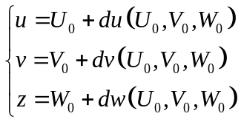 (3)

(A) Deformation gradient:
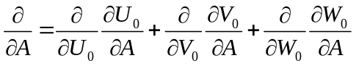 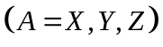 (4)
therefore,
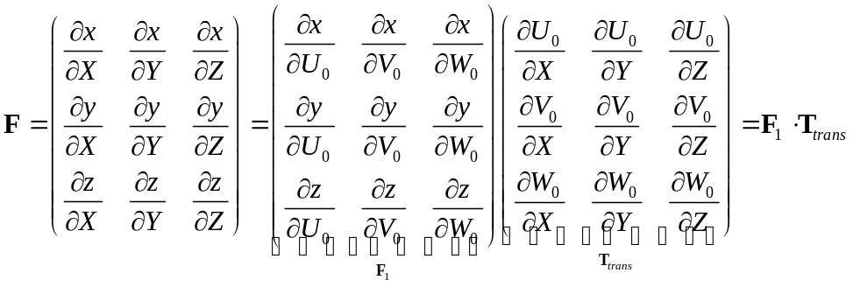 (5)
(B) First, we note that 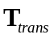 is computed on the reference coordinate. It is seen that
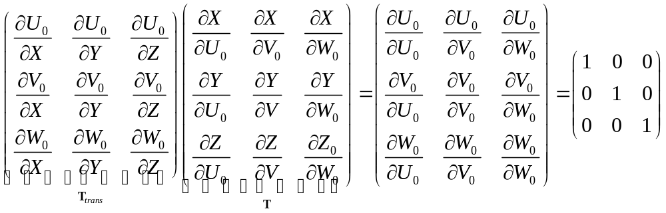 (6)
thus
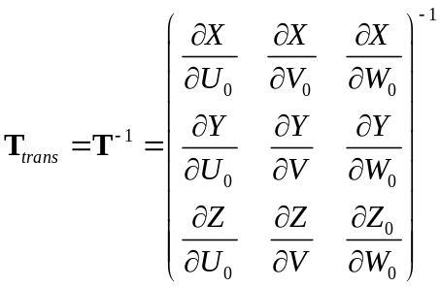 (7)
for 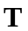:
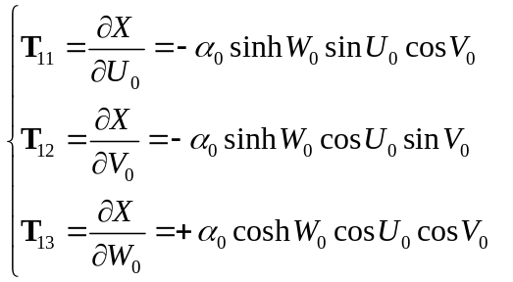 (8.1)
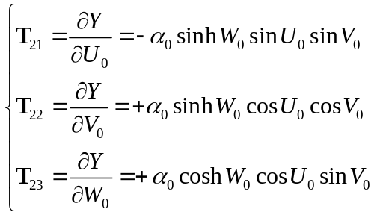 (8.2)
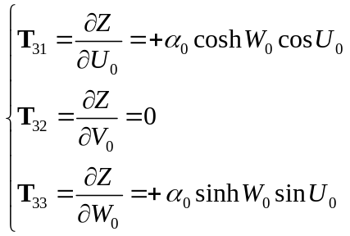 (8.3)

(C) Now, about 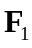.

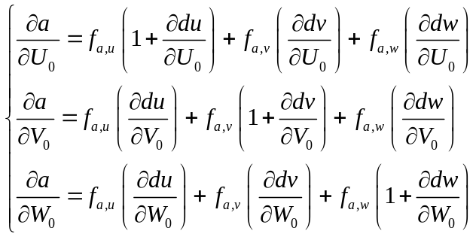 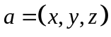 (9)
thus
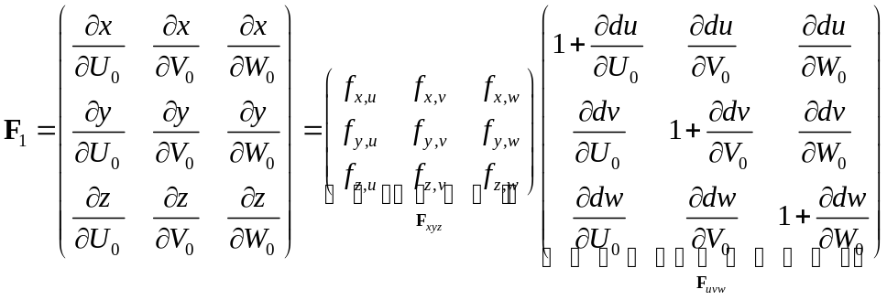 (10)
in which 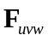 is computed by the fitting function, and 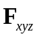 is

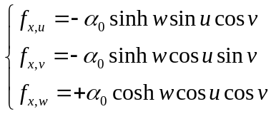 (11.1) 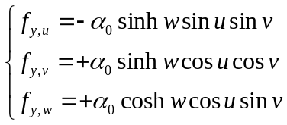 (11.2)
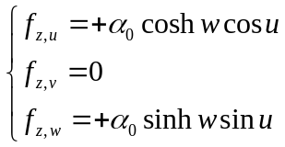 (11.3)

so far, the deformation gradient is completed.

(D) Green Strains
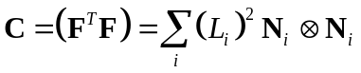 (12.1)
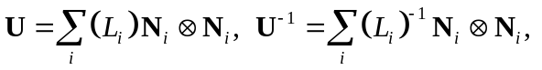 (12.2)
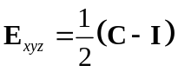 (13)
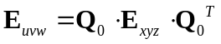 (14)
with 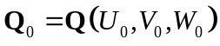 defined on the reference coordinate (see Eqs. 20~24)

(E) Almansi Strain
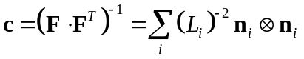 with 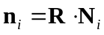 and 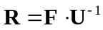 (16)
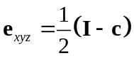 (13)
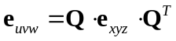 (14)
with 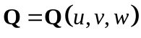 defined on the current coordinate (see Eqs. 20~24)

(I) Normal Bases

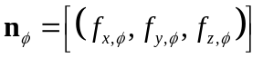 with 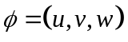 and  the normalization operator (20)
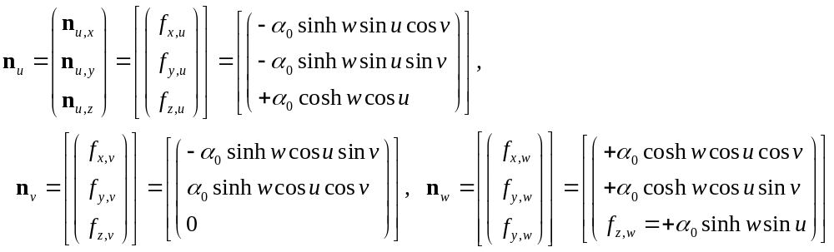 (21)

The transformation matrix between xyz and uvw coordinates derive like this:

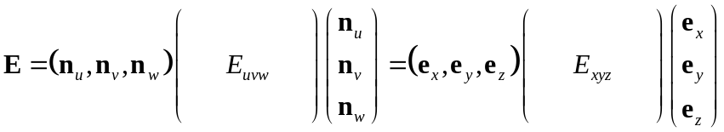 with (22)

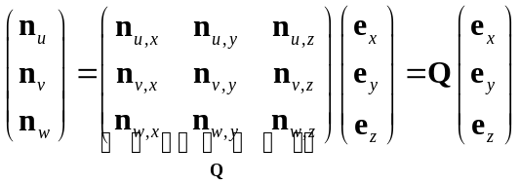 (23)
then
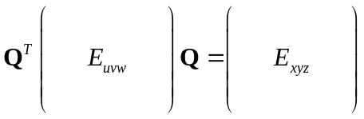 ➔ 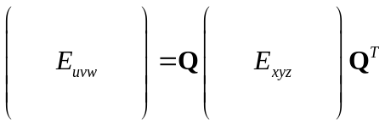 (24)

