In below screen you can see total 10 words we have added
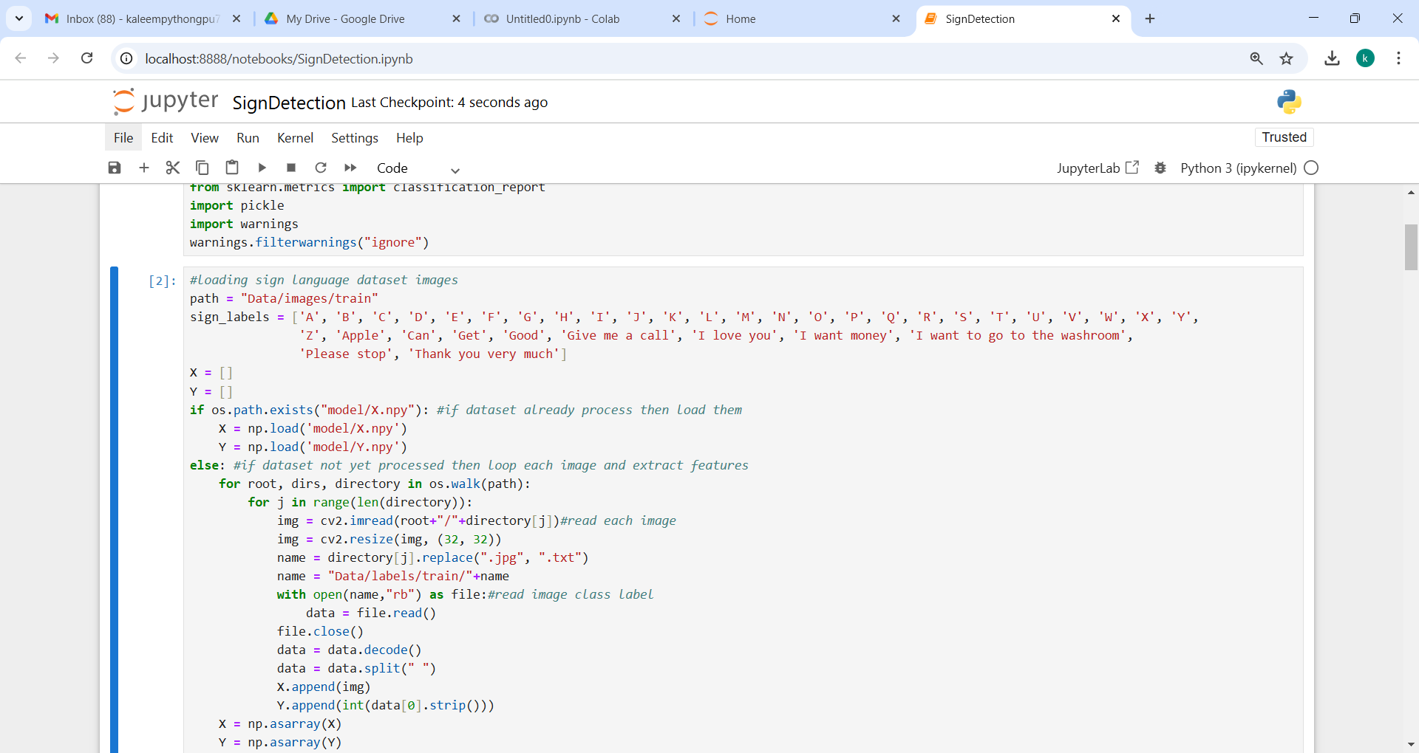
In below screen you can see we have done classification for all 10 words apart from alphabets A to Z
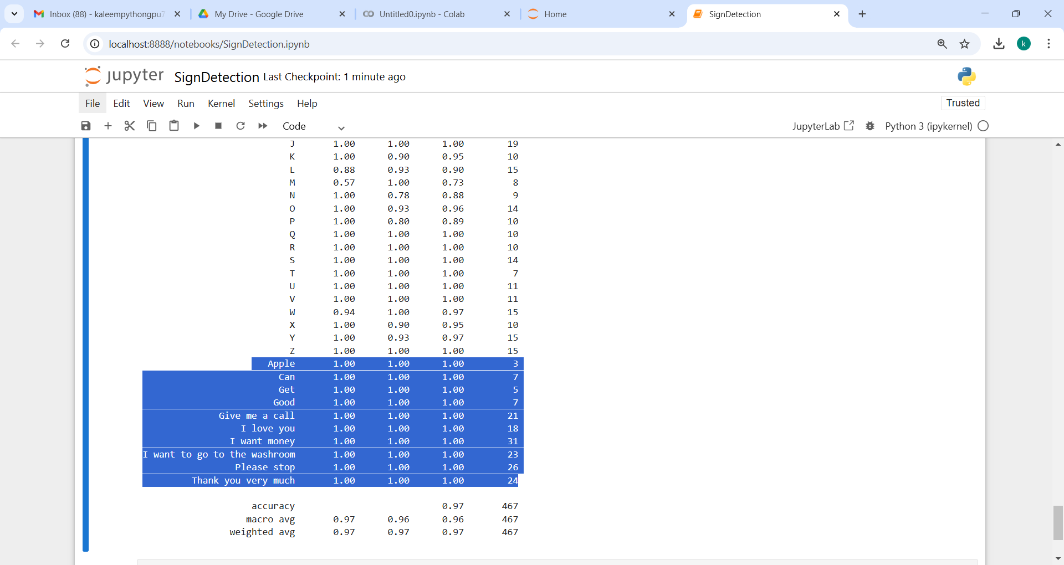
To run webcam code double click on ‘runCam.bat’ file to get below page
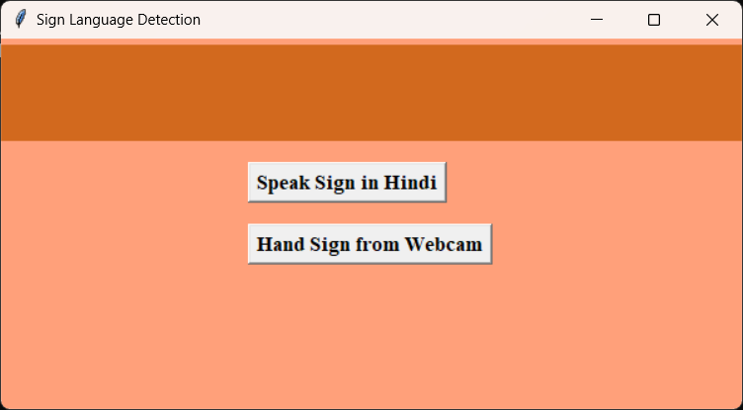
In above screen detected word will be speak in English by default and if you want to see translation in Hindi then click on first button and then in webcam detected word will speak in Hindi
Rest execution process Is same.
Note: you need to install below some extra package
pip install playsound==1.2.2
pip install gTTS
pip install googletrans==4.0.0-rc1

