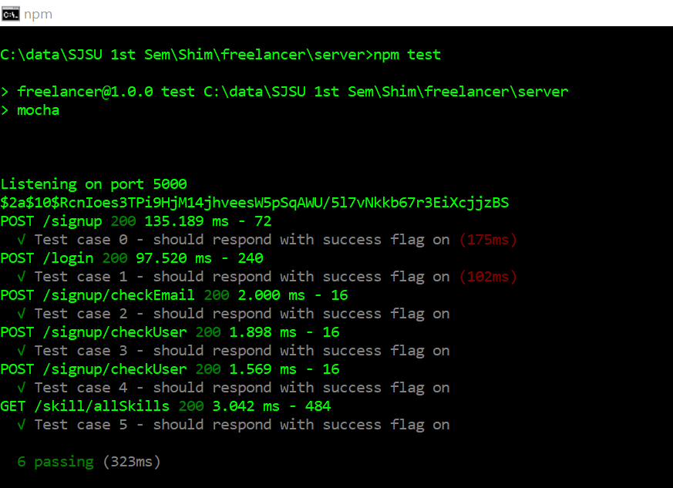

1000 calls average 0

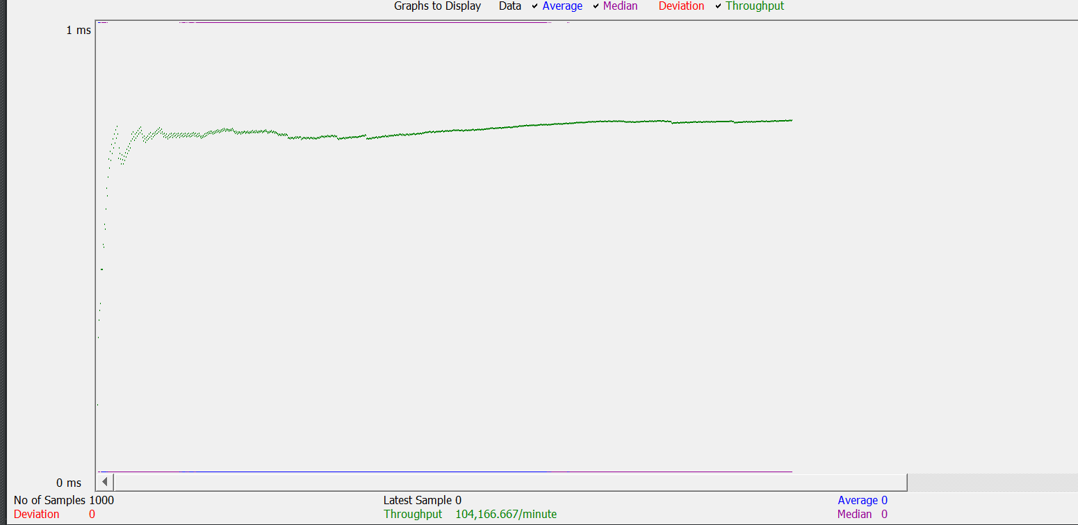

5000 calls on random task - calculator

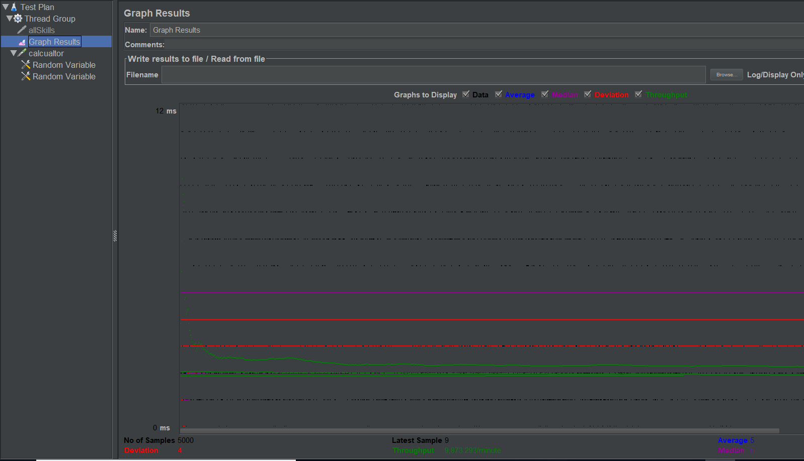

100 threads with 1000 calls calculator random – average 107

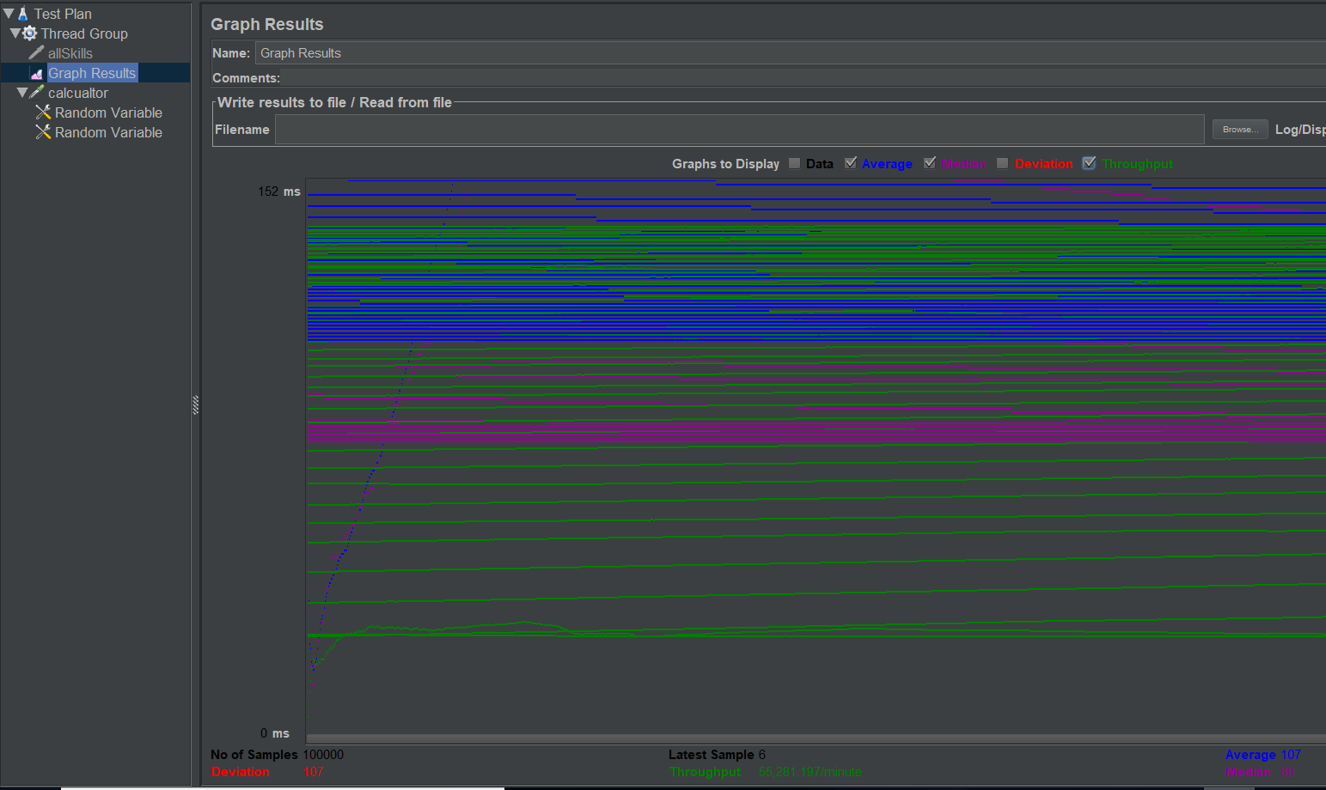

100 threads with 1000 calls calculator random – average 86

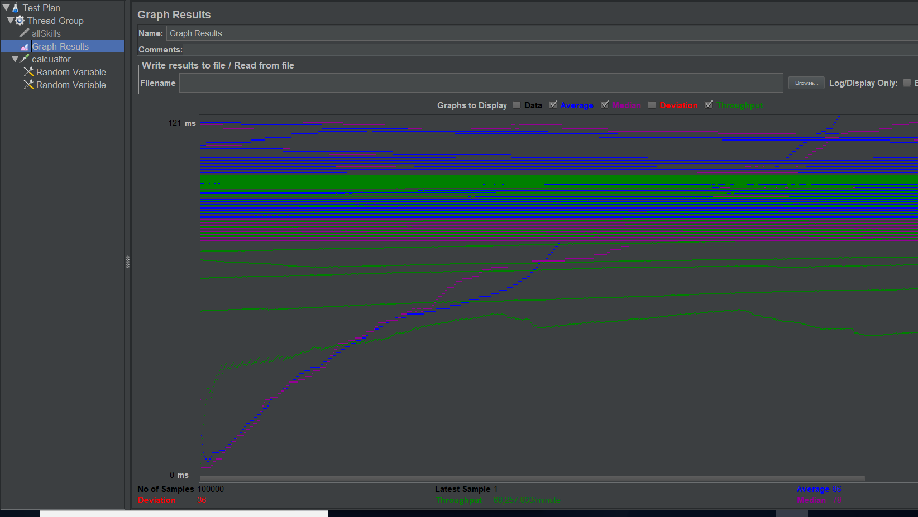

**Freelancer**

100 concurrent users /skill/allSkills

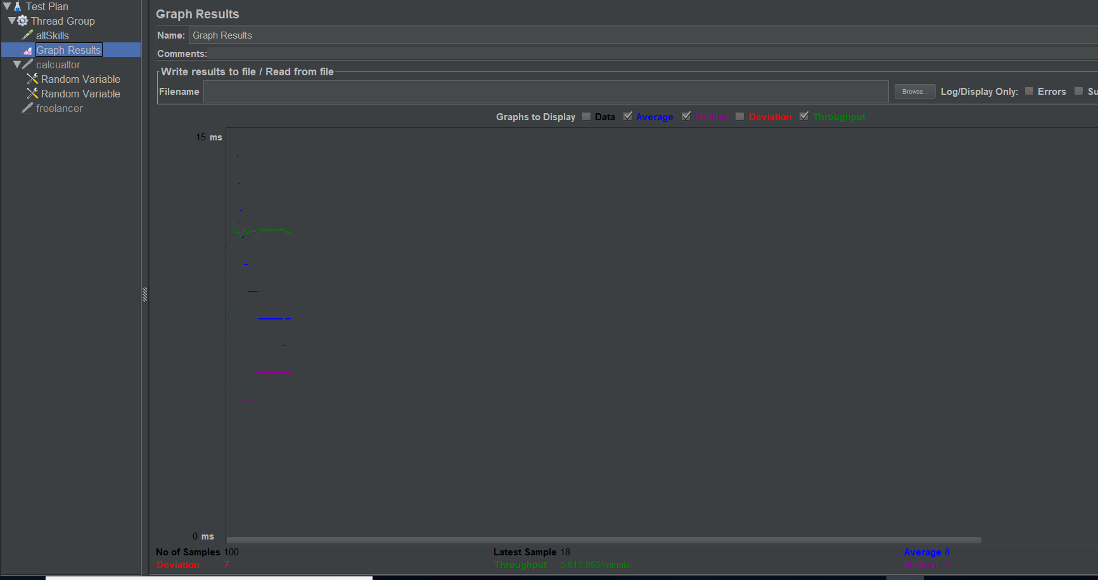

200 concurrent users skill/allCategories

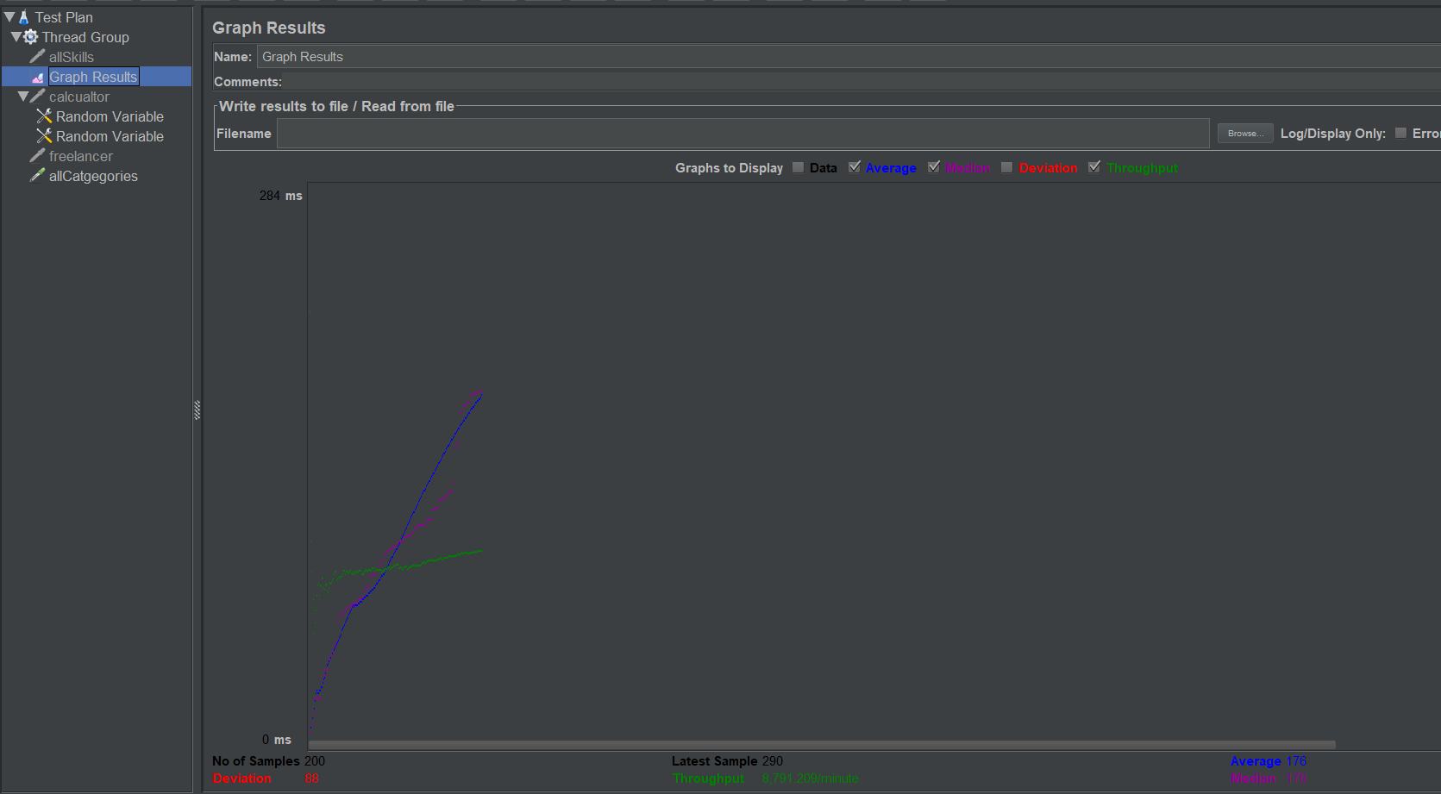

300 concurrent users /biddedprojects/1

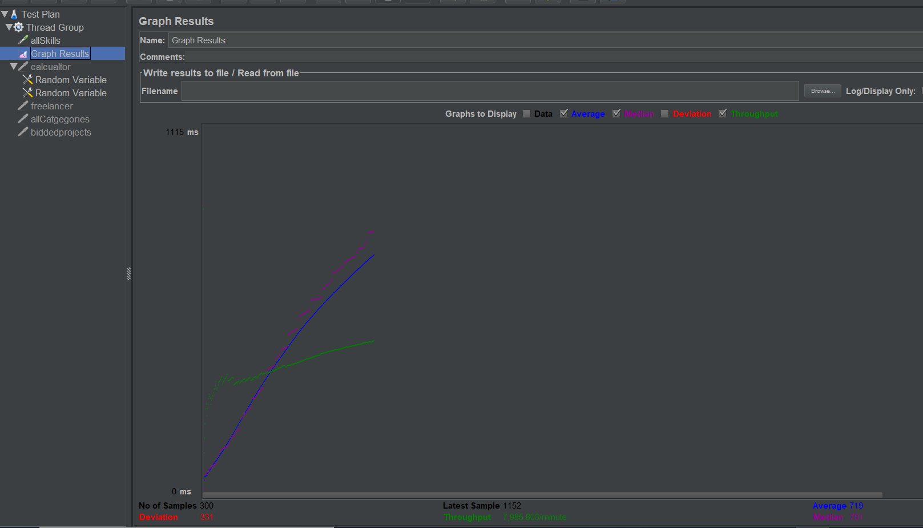

400 concurrent users /project/getWhoPostedTheProject/1

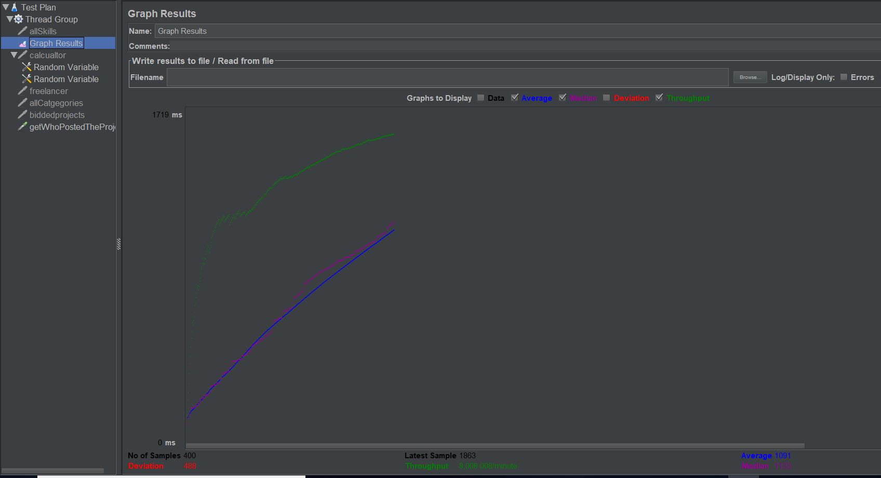

500 concurrent users

