1. Create-react-app calculator

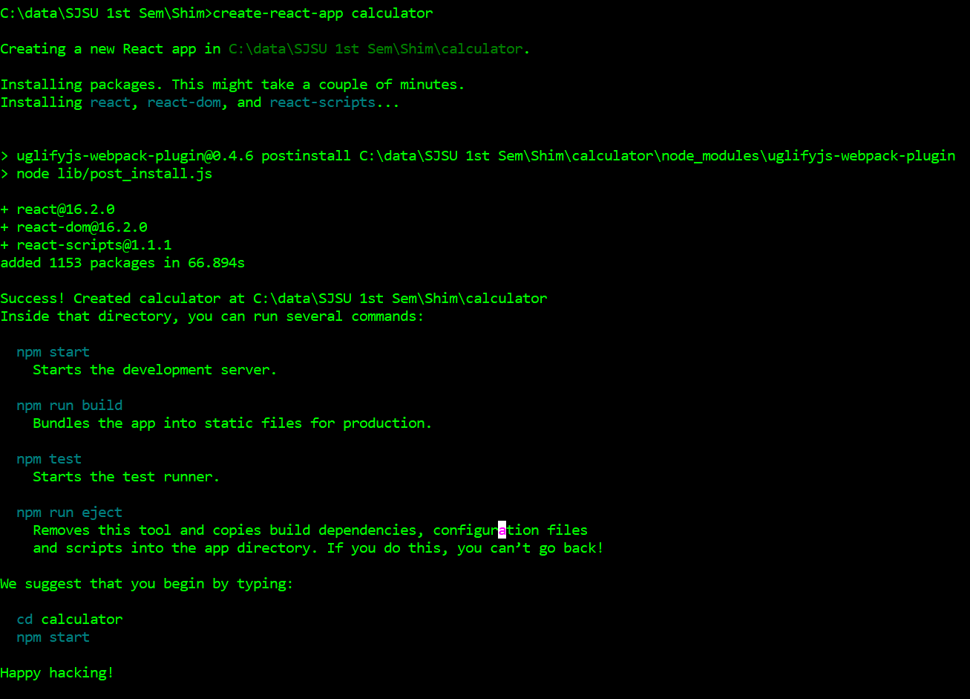

<https://codeburst.io/a-simple-calculator-app-using-react-and-node-42c9b0ea1df8>

<https://medium.freecodecamp.org/how-to-make-create-react-app-work-with-a-node-backend-api-7c5c48acb1b0>

FreeLancer:

1. **Signup : /signup**

Payload {

"username":"sri2",

"email" :"abc1@gmail.com",

"password" :"abc"

}

Response: {"success":false,"message":"This email address is already in use."} or status

1. **Login: /login**

**Payload : {**

**"useroremail":"sri",**

**"password" :"abc3"**

**}**

**<https://appdividend.com/2017/08/23/redux-tutorial-example-scratch/>**

**{"success":false,"message":"Authentication failed."} status 401**

**insert into skill_category( category_id, skill_category_name ) values ('mgmt', 'Project Management');**

**insert into skill_category( category_id, skill_category_name ) values ('web_design', 'Website Design') ;**

**insert into skill_category( category_id, skill_category_name ) values ('Backend', 'Backend') ;**

**insert into skill_category( category_id, skill_category_name ) values ('writing', 'Writing') ;**

**insert into skill(skill_id, skill_name, skill_category ) values ('JAVA', 'Java', 'web_design');**

**insert into skill(skill_id, skill_name, skill_category ) values ('XML', 'XML', 'web_design');**

**insert into skill(skill_id, skill_name, skill_category ) values ('PHP', 'PHP', 'web_design');**

**insert into skill(skill_id, skill_name, skill_category ) values ('HTML', 'HTML 5', 'web_design');**

**insert into skill(skill_id, skill_name, skill_category ) values ('EXCEL', 'MS -EXCEL', 'writing');**

**insert into skill(skill_id, skill_name, skill_category ) values ('WORD', 'MS -Word', 'writing');**