**Pointers in “C”:**

**Pointer store a address of a location.**

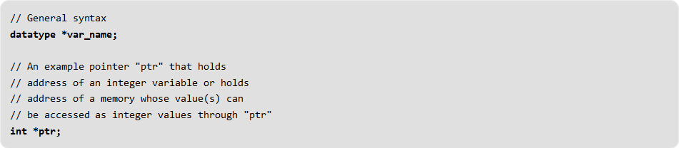

**Let ‘x’ is a variable that has some memory allocated in heap, it’ s address is given by “&x”**

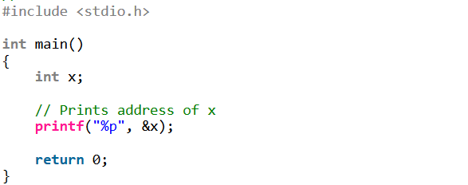

**Let’s suppose take int *var, here var represents a pointer and *var represents a variable.**

**So we can allocate value of variable to *var and address of variable to var.**

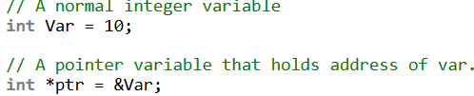

**url:**[**GeeksForGeeks**](https://www.geeksforgeeks.org/pointers-in-c-and-c-set-1-introduction-arithmetic-and-array/)