**Structures in “C”**

Structure is a custom data type that we can declare.

Ex:

struct address{

char street[100];

char city[50];

char state[20];

int pin;

char name[50];

};

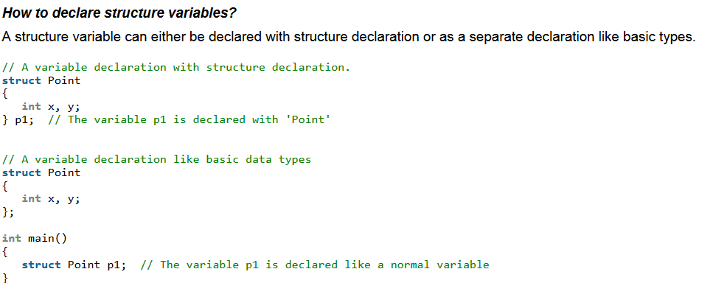

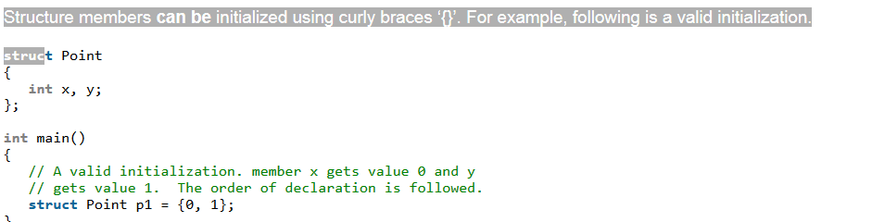

**url:** [**GeeksForGeeks**](https://www.geeksforgeeks.org/structures-c/)