1.INTRODUCTION

# How to Build an API-Driven Weather App | Nordic APIs |

# 1.1 OVERVIEW

* The day-to-day conditions of the atmosphere at a place with respect to elements like humidity, temperature, wind speed, rainfall, etc. is called the weather of that place.
* Weather can be cloudy, sunny, rainy, stormy or clear. It is a part of the natural phenomenon which maintains the equilibrium in the atmosphere.
* But conditions can be worse sometimes. When the atmospheric conditions are extreme or intense enough to cause property loss or life loss, such weather is termed as severe weather.
* These also vary according to the altitudes, latitudes, and region and pressure differences. Tornadoes, cyclones, heavy rainfall, fog, winter storms come under this category. They are disastrous and hazardous. Proper [disaster management](https://byjus.com/physics/safety-measures-technology/) and strategies are required to handle these conditions.

### Elements of Weather:

* Wind speed
* Humidity
* Temperature
* Rainfall
* Thunder
* Snow
* Lightning

### Factors Affecting Weather:

* All the changes that happen in the weather are made by the sun. Because the sun has a very high temperature and it is a huge sphere of hot gases. It is the main source of heat and light for the earth. It is even the primary [source of energy](https://byjus.com/physics/source-of-energy/) hence affects the weather.
* The energy reflected and absorbed by the earth’s surface, the oceans and the atmosphere play an important role in determining the weather at any place.
* Gases like methane, water vapour and carbon dioxide also play a role in determining the weather.

# 1.2 PURPOSE

Features of Weather App Development

#### 1. Earth Time-Lapse

The changes in the weather conditions across the globe are simply displayed by using images and pictures. This feature explains the previous climatic conditions, at the present moment and how it will be in the next consequences.

#### 2. Predictions About The Rainfall

This is another fundamental attribute that shows the forecasts for the rain. It also showcases the percentage of likelihood of the rainfall, and it is classified into various elements like cloudy, sunny, semi-cloudy, etc.

#### 3. Time of Sunrise and Sunset

This feature shows the duration of day and night. It will also mention the sunrise time and the sunset time.

#### 4. Predictions of Wind

This feature is an added benefit for the fishermen, sailors, windsurfers, para gliders. Also, people who are planning to spend their weekends in outside places are also profited. For general users, this attribute is not that useful.

#### 5. Updates About Humidity

For, the people who are planning for a long drive or to have a long journey. It is always essential to monitor the humidity level and to start the journey.

#### 6. UV Weather Map

This attribute displays the ultraviolet radiation of the sun across the globe by the Solar UV index. This is one of those unique features of the weather app development, and it is generally most helpful in summer.

#### 7. Map About Climatic Conditions

You can get a clear picture of the climate data with this feature. It comprises humidity level, the temperature of the surroundings, and level of carbon dioxide. This attribute is highly beneficial for scholarly people who are carrying out scientific experiments.

#### 8. Weather Forecast

It is a fundamental factor of any weather app. This feature displays the prevailing status of the weather on a weekly, monthly, daily and hourly basis.

2.LITERATURE SURVEY

# 2.1 EXISTING PROBLEM

There may be several reasons behind not working of Weather App.

Maybe the Weather App server is down or the app is under maintenance. Other than this, other common issues can interrupt your service.

But the most common problem is Weather App is not opening. This can be a real problem, for obvious reasons, especially for those who use it on daily basis.

If you are a Weather app user, it’s worth noting that you can get various weather information from it. For example, you can check the UV, air quality, chance of rain, wind speed, and other things.

So while traveling or even heading out, it’s important to check the app to be aware of the weather. Yet, it’s unfortunate when the Weather app stops working and you cannot access this information.

The problem can emerge because the application is running on an older version. For that, you need to update the weather application and try opening the application.

So right away, let’s get to the topic, look at the causes and discuss the methods to fix them.

The weather application may not be working on your device because of a poor internet connection. Because of that, the weather application won’t be able to gather the necessary information. Likely, other causes include:

* The device location is turned off.
* Outdated Weather Application
* Outdated System Software
* The Weather App server may be down or under maintenance.

# 2.2 PROPOSED SOLUTION

Below is the most common solution which may help to access Weather App.

* Wait for some time because the app may be in maintenance mode.
* Maybe the server is down, so wait for some time.
* Check Your Internet Connection.

If the above solutions did not work then you can try more tricks to open the App.

* Update Weather App.
* Restart Your Phone.
* Check Device Compatibility.
* Check Device date and time setting.
* Update Your Device.
* Clear App cache file from app Settings.

If this solution did not work then you can make contact with the Weather App team.

3. THEORITICAL ANALYSIS

# 3.1 BLOCK DIAGRAM

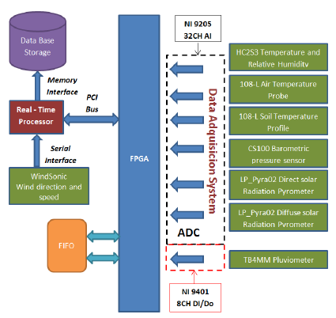

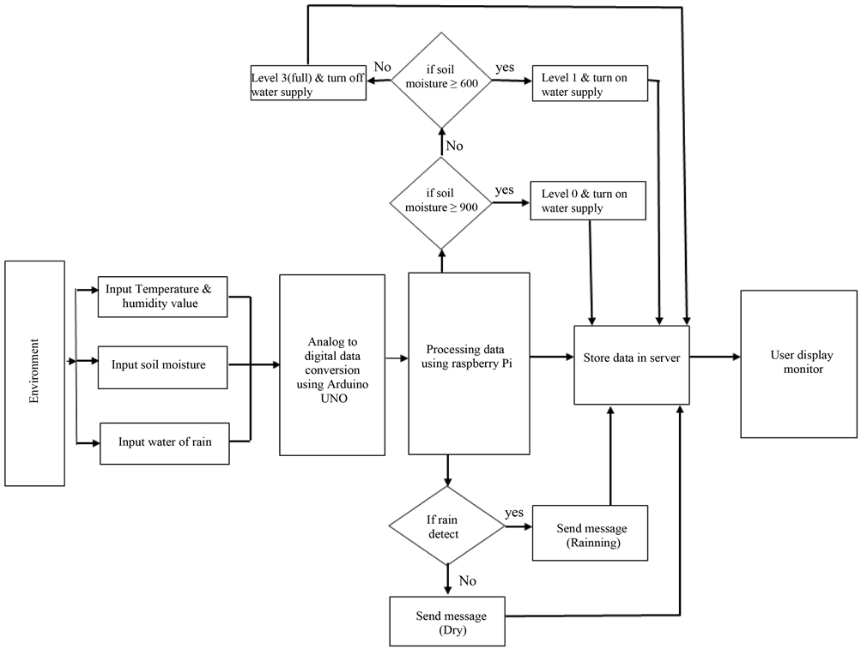

This is about the block diagram/diagrammatic overview of the weather app .

Climate conditions such as temperature and irradiation were reviewed through the actual data of the region, as shown in Figure 8. according to the operating temperature of the heated windows. The dew point (D.P) of the heated window was derived through equation (3) [39], which is a function of the relative humidity of the room (RH) and the inner surface temperature of the glass (T): ...

# 3.2 HARDWARE/SOFTWARE DESIGNING

### Hardware designing:

Monitor,mouse,keyboard,wifi…

### Software designing:

HTML,CSS,AND JAVASCRIPT.

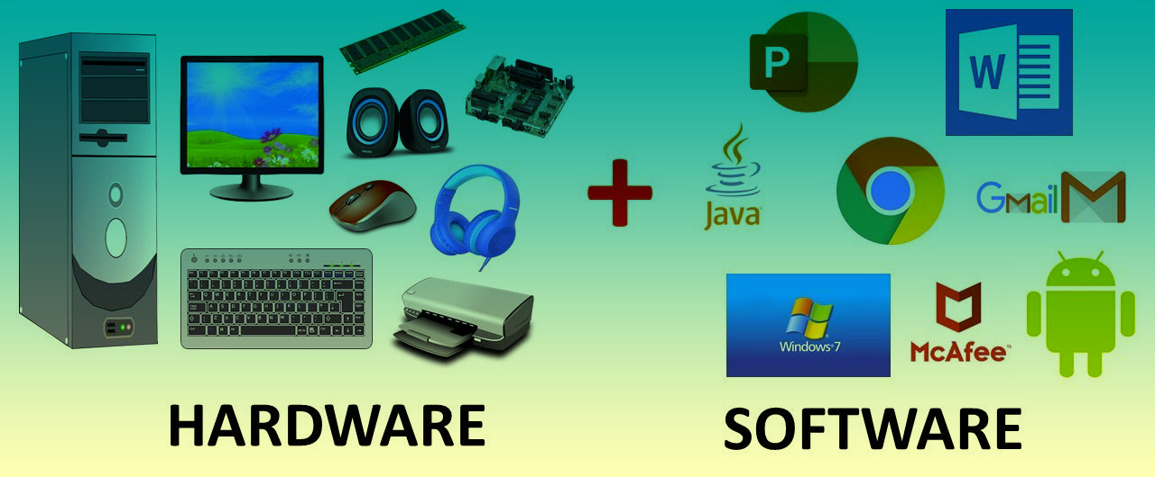

4.RESULT

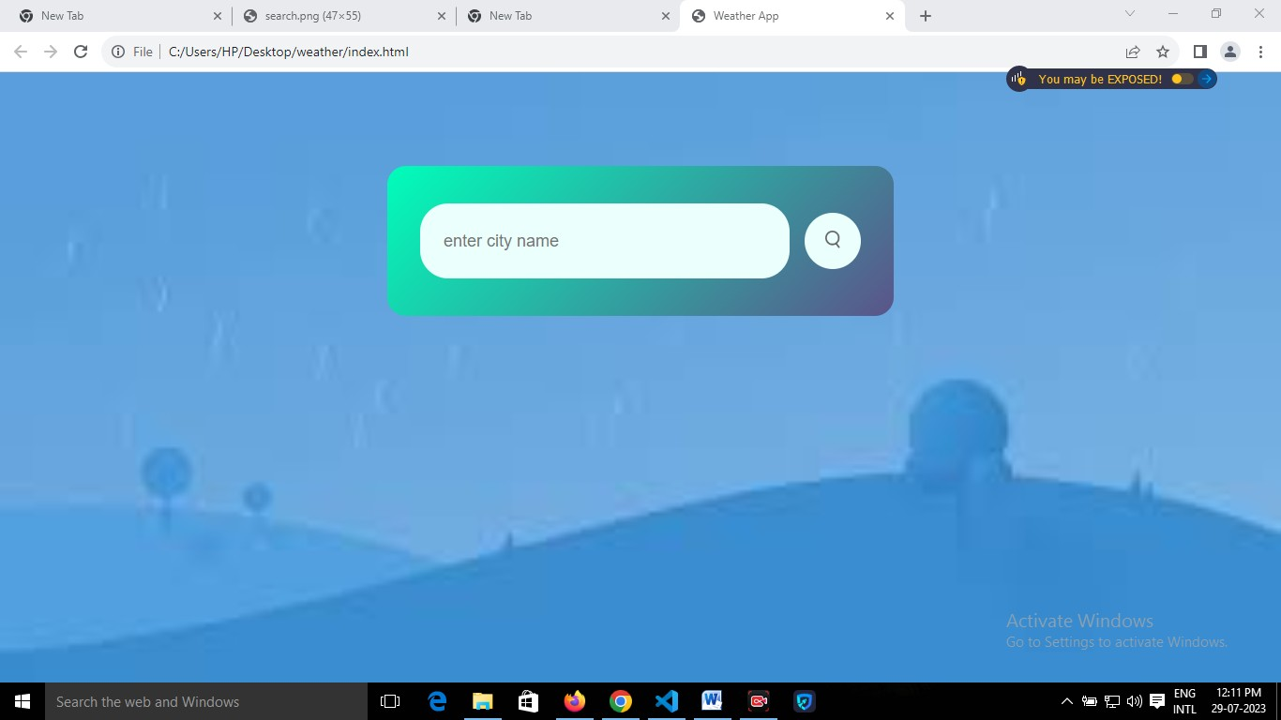

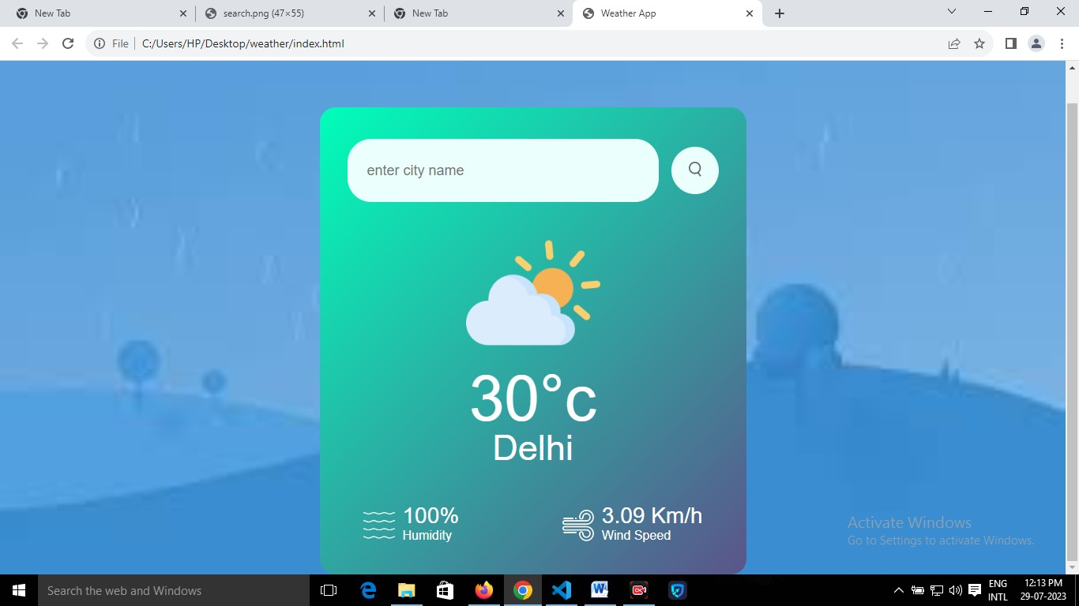

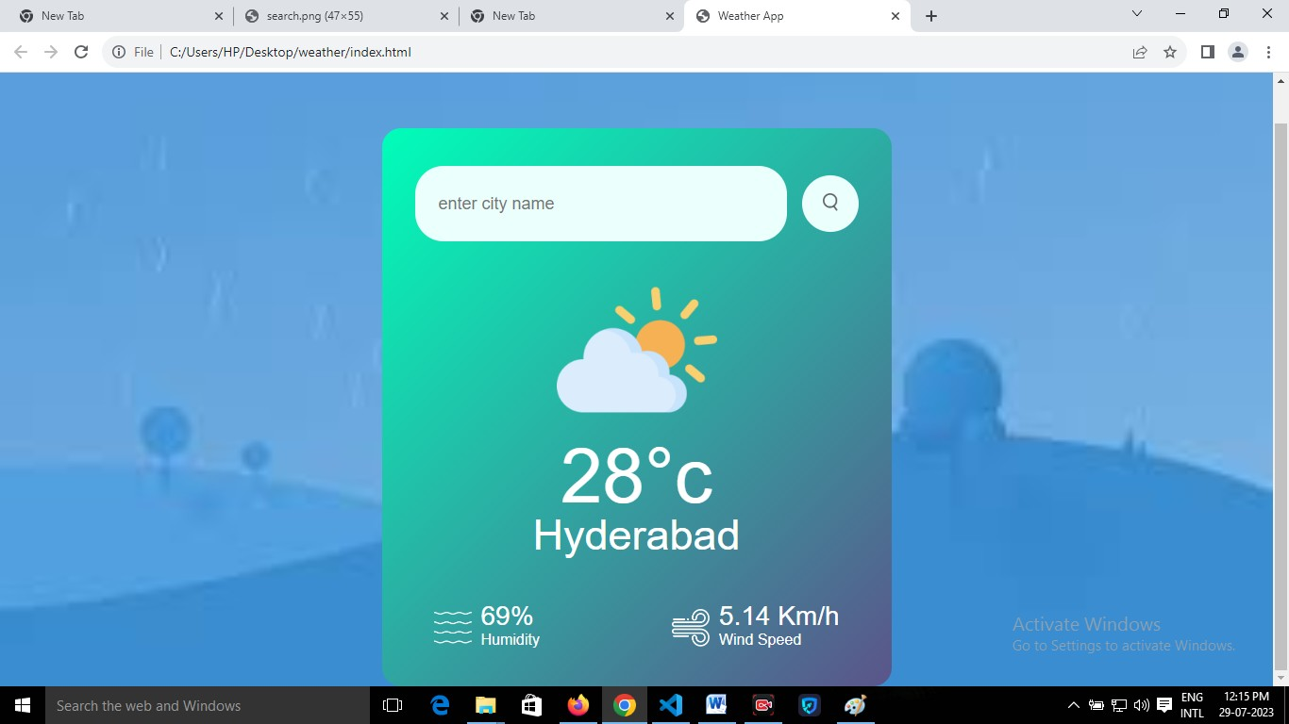

[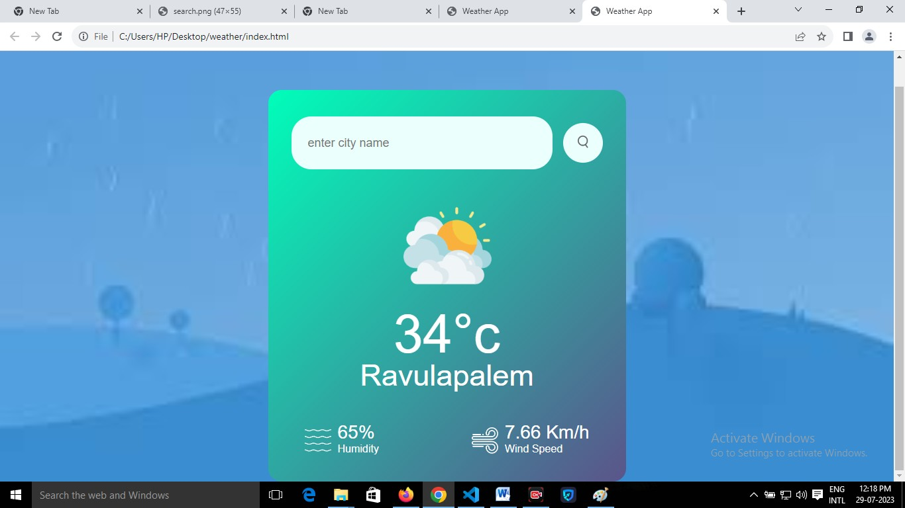5.ADVANTAGES &DISADVANTAGES](https://www.researchgate.net/figure/Comparison-of-resource-utilization_tbl4_368529697)

|  |  |
| --- | --- |
| [One of the biggest benefits of the weather station is its ability to collect accurate data. They take measurements every few minutes and record them automatically. This means you can be sure that you're getting real-time information about current conditions.](https://www.researchgate.net/figure/Comparison-of-resource-utilization_tbl4_368529697) | |
|  | [Advantages](https://www.researchgate.net/figure/Comparison-of-resource-utilization_tbl4_368529697)  * [Farmers can known when to plant or harvest their crops](https://www.researchgate.net/figure/Comparison-of-resource-utilization_tbl4_368529697) * [People cam choose where and when to take their holidays to take advantages of good weather](https://www.researchgate.net/figure/Comparison-of-resource-utilization_tbl4_368529697) * [Surfers known when large waves are expected](https://www.researchgate.net/figure/Comparison-of-resource-utilization_tbl4_368529697) * [Regions can be evacuated if hurricanes or floods are expected](https://www.researchgate.net/figure/Comparison-of-resource-utilization_tbl4_368529697) * [Aircraft and shipping rely heavily on accurate weather forecasting](https://www.researchgate.net/figure/Comparison-of-resource-utilization_tbl4_368529697) | [Disadvantages](https://www.researchgate.net/figure/Comparison-of-resource-utilization_tbl4_368529697)  * [Weather is extremely difficult to forecast correctly](https://www.researchgate.net/figure/Comparison-of-resource-utilization_tbl4_368529697) * [It is expensive to monitor-so many variables from so many sources](https://www.researchgate.net/figure/Comparison-of-resource-utilization_tbl4_368529697) * [The computers needed to perform the millions of calculations necessary are expensive](https://www.researchgate.net/figure/Comparison-of-resource-utilization_tbl4_368529697) * [The weather forecasters get blamed if the weather is different from the forecast](https://www.researchgate.net/figure/Comparison-of-resource-utilization_tbl4_368529697) |

[6.APPLICATIONS](https://www.researchgate.net/figure/Comparison-of-resource-utilization_tbl4_368529697)

We can find any area around the world in our weather app.

The weather these days is brutal. Although [the best maps and navigation apps](https://www.androidpolice.com/navigation-and-map-apps/) do alright, sometimes you need a little extra assurance under your belt, and that's where weather apps work their magic. Even though the Google Weather app is available on [the latest Android phones](https://www.androidpolice.com/best-android-phones/), the service can be temperamental at times, so it pays to have a few viable alternatives. If you feel like staying dry or avoiding the worst of the summer heat, take a look at our roundup of great weather apps designed to keep your eyes on the skies.

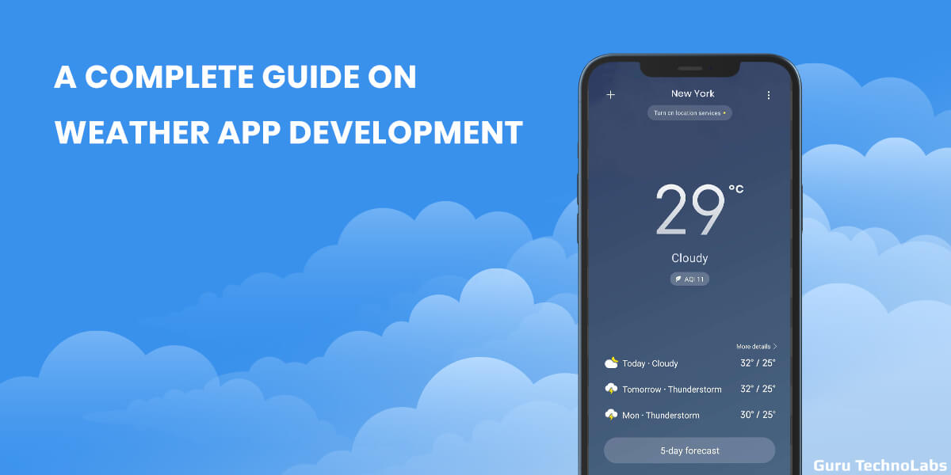

7.CONCLUSION

In summary, weather forecasts are increasingly accurate and useful, and their benefits extend widely across the economy. While much has been accomplished in improving weather forecasts, there remains much room for improvement. The forecasting community is working closely with multiple stakeholders to ensure that forecasts and warnings meet their specific needs. Simultaneously, they are developing new technologies and observational networks that can enhance forecaster skill and the value of their services to their users.

8.FUTURE SCOPE

The future of weather applications is promising, with the **increasing demand for real-time and accurate weather information**. One potential development is the improvement in accuracy through the use of advanced data collection and analysis techniques, as well as sophisticated algorithms.

Satellites and super computers have revolutionized weather forecasting. The future is exciting—**we are looking to promote kilometre-scale climate modelling to better simulate cloud physics, future flooding and drought risks and, for instance, the speed of Antarctic glacier melting.**

Predicting weather accurately doesn’t just help our daily lives but has deeper impact for food security and disaster management. Good news for monsoon-dependent India is that we are getting better at predicting. New technologies, such as Internet of Things (IoT) and Artificial Intelligence (AI) are helping meteorological experts to give better information to predict agricultural output and natural disasters.