Create an EC2 Instance:

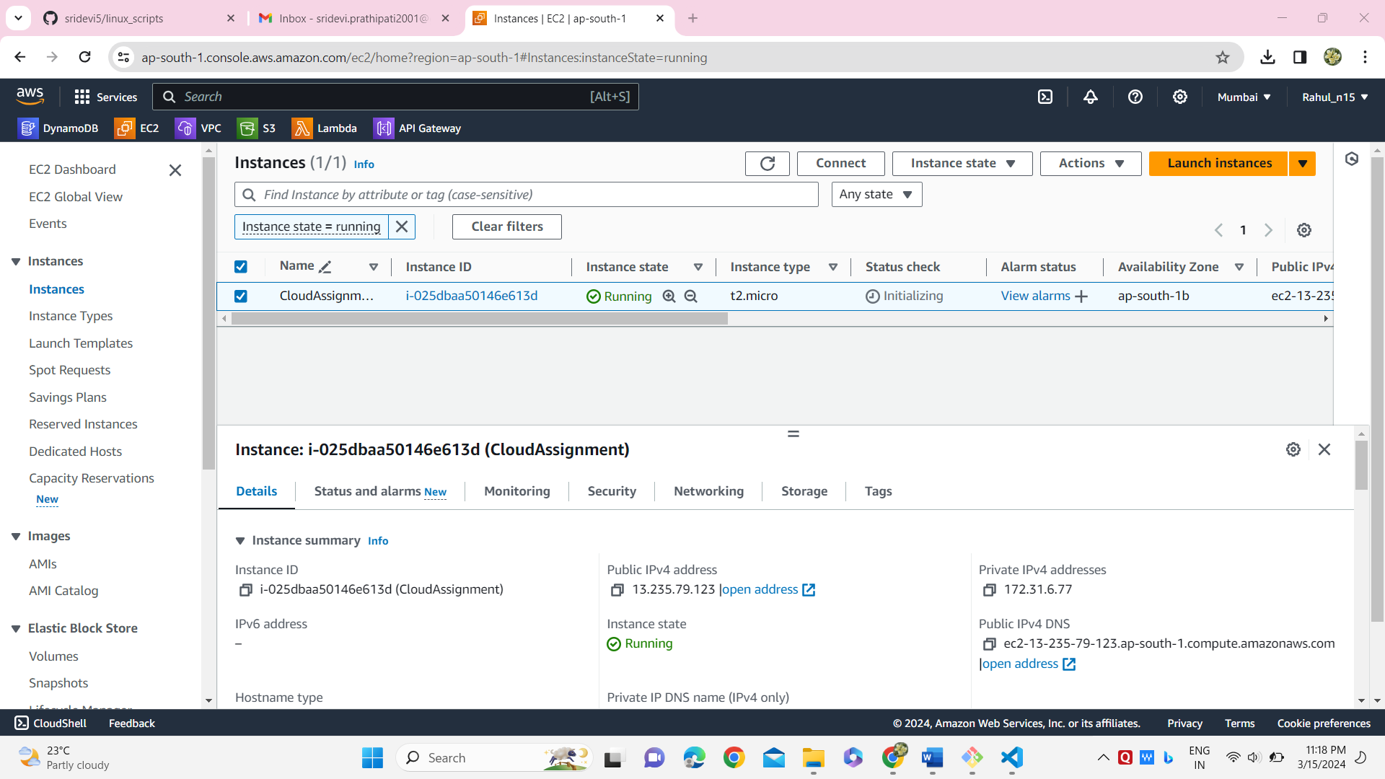

Connect to the server and install git :

And run git -v to check if git is installed or not

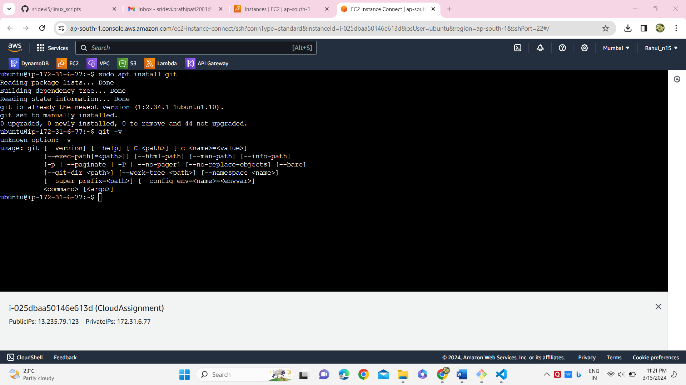

And clone the repository using git clone command:

* git clone https://github.com/sridevi5/linux_scripts.git
* and check the files in directory linux_scripts

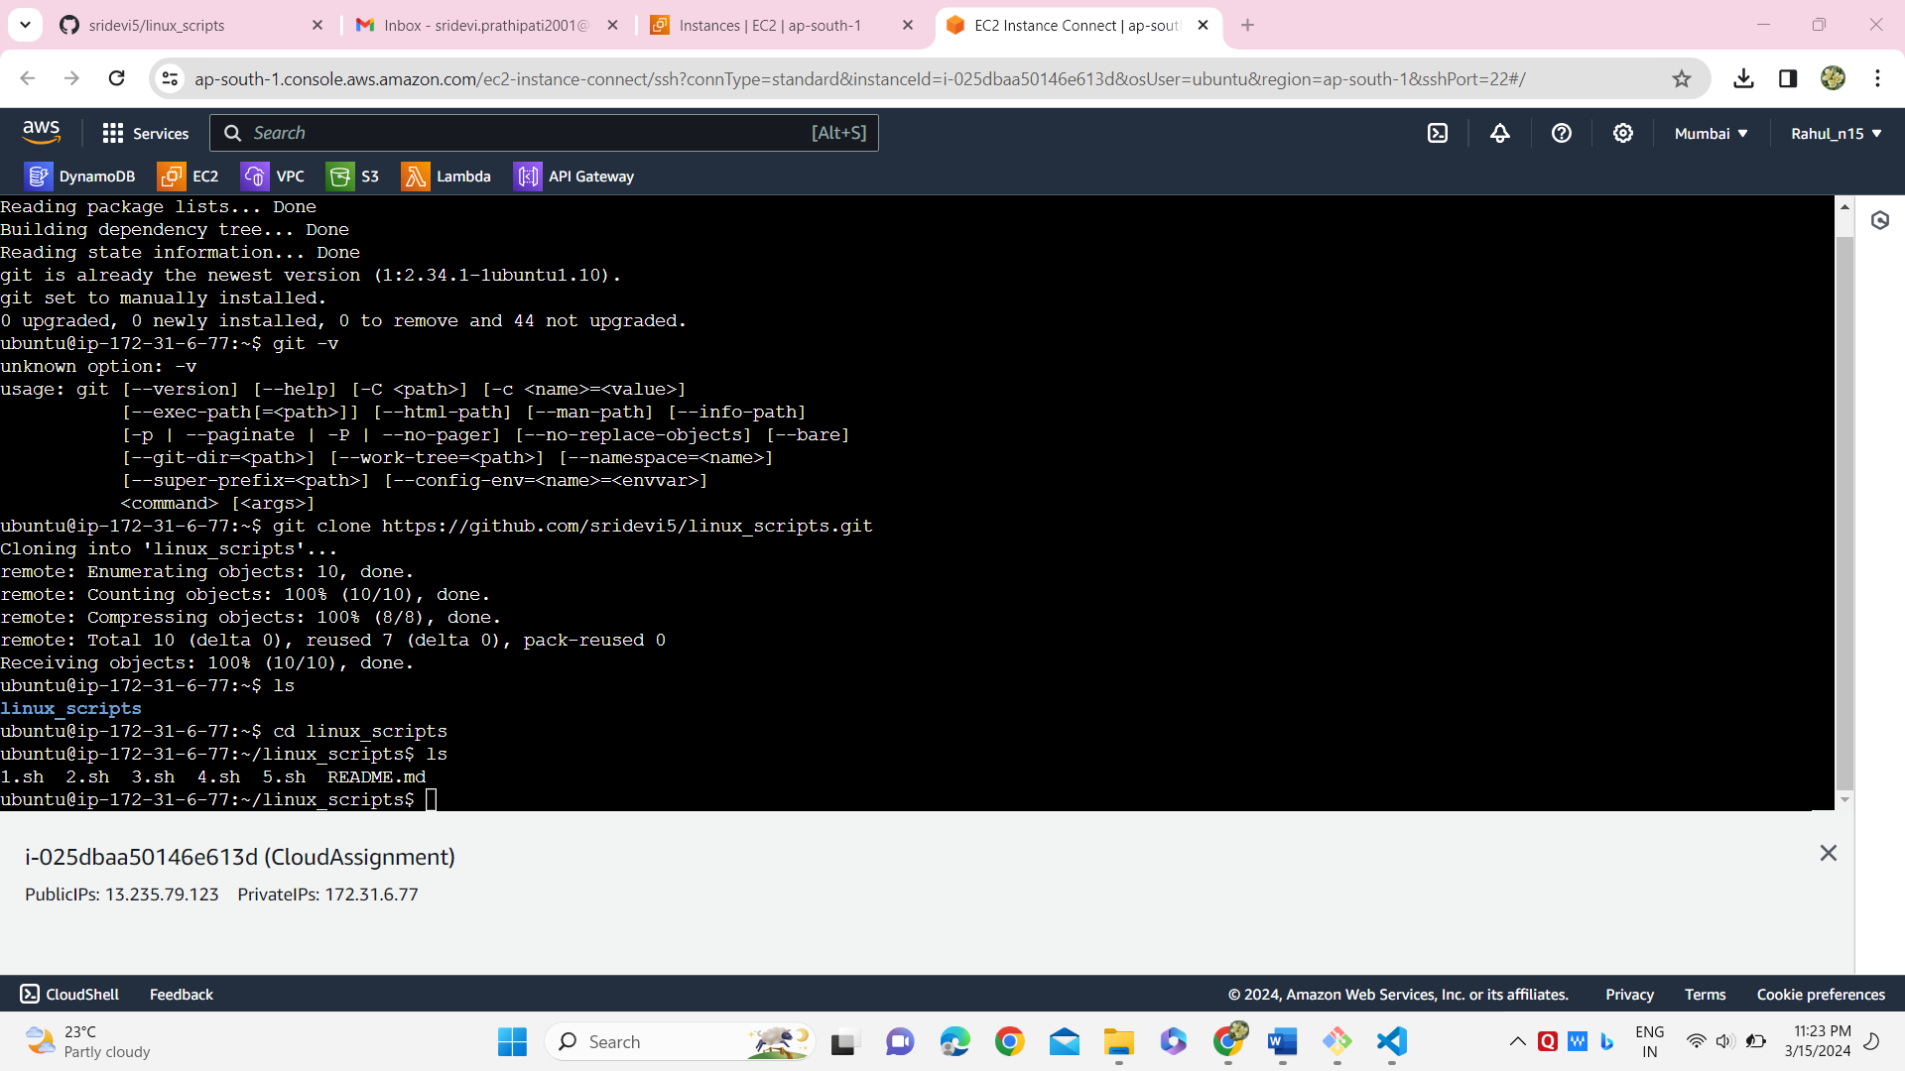

And run the shell scripts using bash command

* bash filename

