**LAB – 1**

(UNSOLVED QUESTIONS)

**Question: *Write a program to print the following details:***

***(use only variables. Do not use any inbuilt methods. Provide value for the fields in the program)***

***Roll No***

***Name***

***Address***

***Email id***

***Mobile No***

***Parents Occupation***

***Todays Date***

*Code:*

import java.util.*;

public class Lab1Q4 {

public static void main(String[] args) {

String name, std_id, address, email, occu, date;

int phno;

Scanner sc = new Scanner(System.in);

System.out.print("Enter student name: ");

name = sc.nextLine();

System.out.print("Enter student roll number: ");

std_id = sc.nextLine();

System.out.print("Enter student address: ");

address = sc.nextLine();

System.out.print("Enter student email: ");

email = sc.nextLine();

System.out.print("Enter parent's occupation: ");

occu = sc.nextLine();

System.out.print("Enter date: ");

date = sc.nextLine();

System.out.print("Enter student phone number: ");

phno = sc.nextInt();

System.out.println("Student Name: " + name);

System.out.println("Student Roll No.: " + std_id);

System.out.println("Student Address: " + address);

System.out.println("Student Email: " + email);

System.out.println("Student Phone number: " + phno);

System.out.println("Parent's occupation: " + occu);

System.out.println("Date: " + date);

}

}

*Output:*

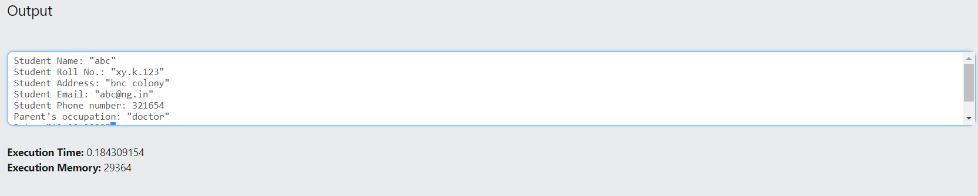

**Question: *Write a program to print the following details:***

***(use only variables. Do not use any inbuilt methods)***

***RollNo***

***Name***

***English***

***Physics***

***Chemistry***

***Average***

***Grade***

*Code:*

import java.util.*;

public class Lab1Q5 {

public static void main(String[] args) {

String name="abc";

String RollNo="a.b.c1234";

int Eng=89;

int Phy=80;

int Chem=85;

double Avg=(Eng+Phy+Chem)/3;

String Grade="A";

System.out.println("Student Name: " + name);

System.out.println("Student Roll No.: " + RollNo);

System.out.println("English Marks: " + Eng);

System.out.println("Physics Marks: " + Phy);

System.out.println("Chemistry Marks: " + Chem);

System.out.println("Average Marks: " + Avg);

System.out.println("Grade: " + Grade);

}

}

*Output:*

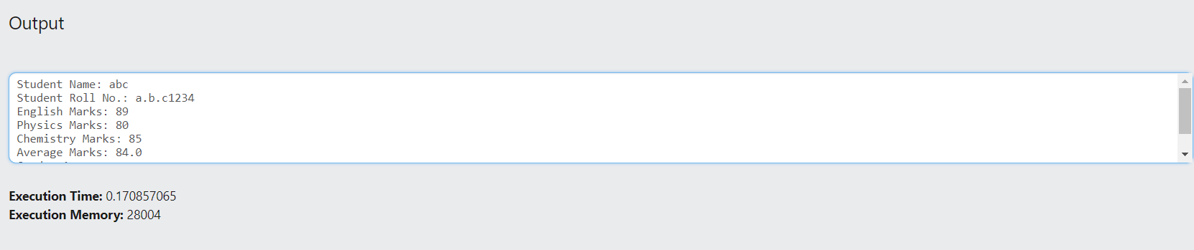

**Question: *Given principal as P,No of Years as N,Rate of intrest as R. Calculate***

Intrest =(P*N*R)/100

*Code:*

public class Lab1Q7

{

public static void main (String args[])

{ float p, r, t, si;

p = 13000; r = 12; t = 2;

si = (p*r*t)/100;

System.out.println("Simple Interest is: " +si);

}}

*Output:*

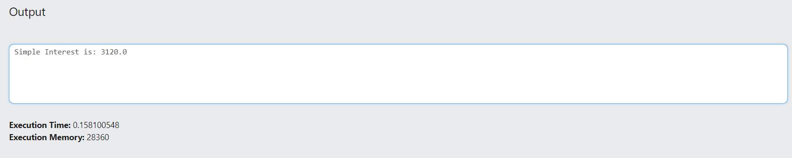

**Question: *Write a program to declare numbers of all possible numeric datatypes . Assign a value to the variable and print the same.***

*Code:*

public class Lab1Q8 {

public static void main(String args[])

{

byte a = 126;

short b = 32767;

int c = 2147483647;

long d = 9223372036854775807l;

float e = 0.9999999f;

double f = 0.999999999999999d;

System.out.println(a);

System.out.println(b);

System.out.println(c);

System.out.println(d);

System.out.println(e);

System.out.println(f);

}

}

*Output:*

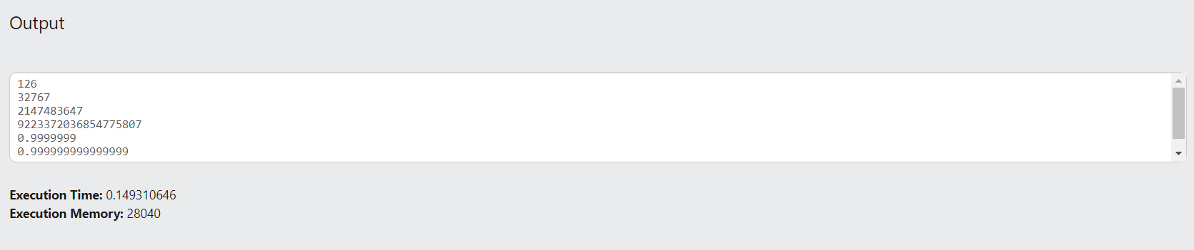

**Question: *Write a program to print following details:***

***Product id***

***Product Name***

***Product Description***

***Product Price***

***Model No***

*Code:*

import java.util.*;

public class Lab1Q9 {

public static void main(String[] args) {

int Pro_id = 12345678;

String Pro_Name = "abcd";

String Pro_Des = "Hello, World";

int Pro_Price = 999;

int Mod_No = 564654;

System.out.println("Product id: " + Pro_id);

System.out.println("Product Name: " + Pro_Name);

System.out.println("Product Description: " + Pro_Des);

System.out.println("Product Price: " + Pro_Price);

System.out.println("Model No: " + Mod_No);

}

}

*Output:*

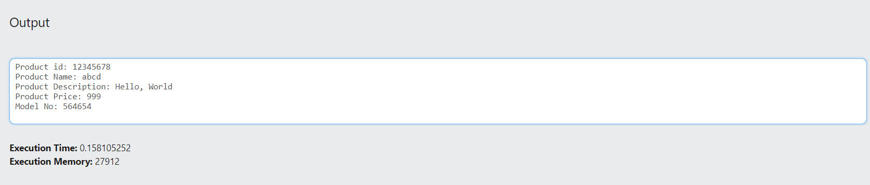

**Question: *Write a program to have two numbers. Perform the sum and difference of two numbers***

*Code:*

import java.util.Scanner;

public class Lab1Q10 {

public static void main(String[] args) {

int num1, num2, sum, diff;

Scanner sc = new Scanner(System.in);

System.out.println("Enter First Number: ");

num1 = sc.nextInt();

System.out.println("Enter Second Number: ");

num2 = sc.nextInt();

sum = num1 + num2;

diff = num1 - num2;

System.out.println("Sum of these numbers: "+sum);

System.out.println("Difference of these numbers: "+diff);

}

}

*Output:*

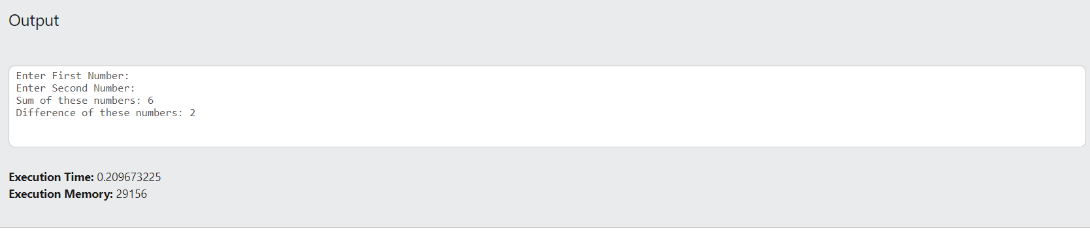

**LAB – 2**

(UNSOLVED QUESTIONS)

**Question: *Write a program to display ten proverbs on the screen***

*Code:*

import java.util.*;

public class Lab2Q1 {

public static void main(String[] args) {

System.out.println("A friend in need is a friend indeed.");

System.out.println("Better safe than sorry.");

System.out.println("Never too old to learn.");

System.out.println("Two heads are better than one.");

System.out.println("A stitch in time saves nine.");

System.out.println("Still waters run deep. ");

System.out.println("To kill two birds with one stone.");

System.out.println("When it rains, it pours.");

System.out.println("The apple doesn’t fall far from the tree.");

System.out.println("Too many cooks spoil the broth");

System.out.println("Where there’s a will, there’s a way.");

System.out.println("You can’t teach an old dog new tricks.");

}

}

*Output:*

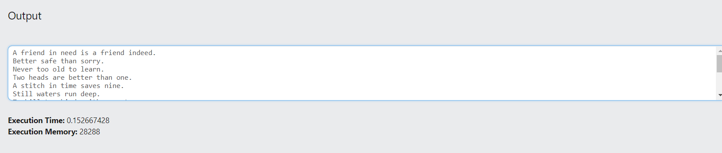

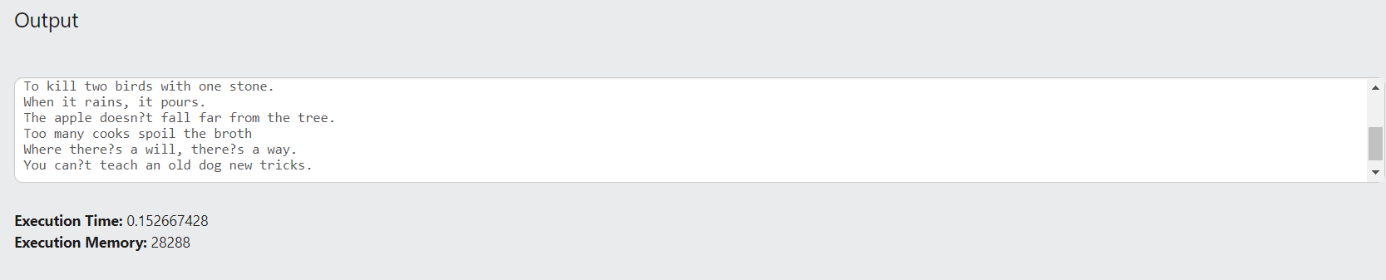

**Question: *Write a program to display the even number given the ‘n’ from the user***

*Code:*

import java.util.*;

public class Lab2Q2 {

public static void main(String args[]) {

int n;

Scanner sc = new Scanner(System.in);

System.out.print("Enter a number: ");

n = sc.nextInt();

System.out.print("Even Numbers from 1 to "+n+" are: ");

for (int i = 1; i <= n; i++) {

if (i % 2 == 0) {

System.out.print(i + " ");

}

}

}

}

*Output:*

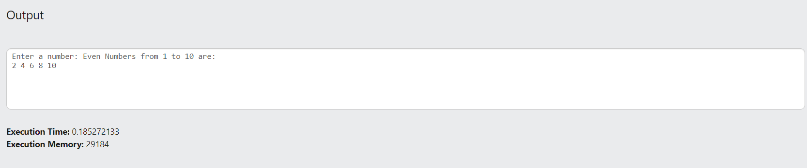

**Question: *Write a program to generate Fibonacci series***

*Code:*

class Lab2Q3{

public static void main(String args[])

{

int n1=0,n2=1,n3,i,count=10;

System.out.print(n1+" "+n2);

for(i=2;i<count;++i)

{

n3=n1+n2;

System.out.print(" "+n3);

n1=n2;

n2=n3;

}

}}

*Output:*

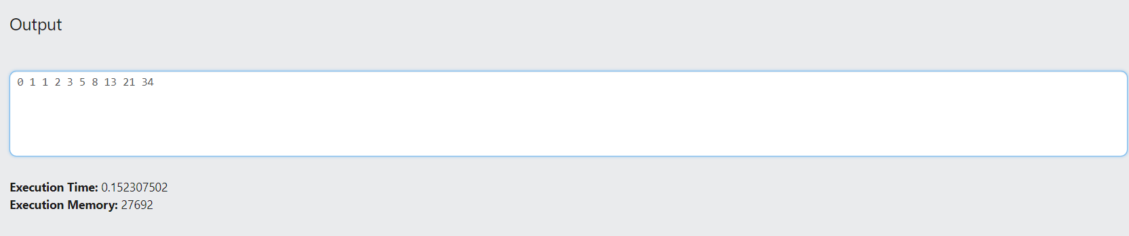

**Question: *Write a program to convert time into minute and seconds***

*Code:*

import java.util.*;

public class Lab2Q4 {

public static void main(String[] args)

{

int n;

Scanner sc = new Scanner(System.in);

System.out.print("Enter minutes: ");

n = sc.nextInt();

int seconds;

seconds = n * 60;

System.out.println( "Seconds = " + seconds);

}

}

*Output:*

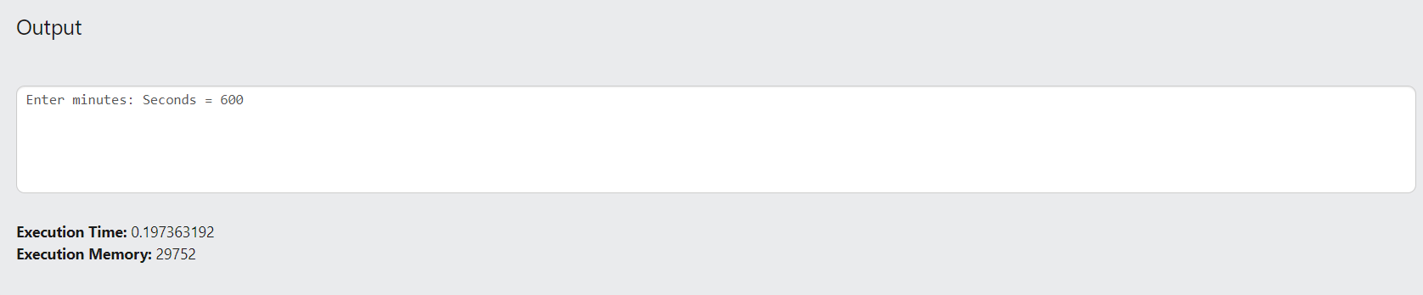

**Question: *Write a program to print a Bill as below:***

*Code:*

public class lab2Q5 {

static void Lines() {

for (int i = 0; i < 75; i = i + 1) {

System.out.print("_");

}

System.out.println();

}

public static void main(String[] args)

{

System.out.println("Bill No: 1012");

System.out.println("Date: 9-Aug-2020");

Lines();

System.out.println("ItemNo Name Quantity Amount");

System.out.println(" 1 Cinthol 12 200 ");

System.out.println(" 2 Dettol 10 100 ");

System.out.println(" 3 Oil 2 100 ");

Lines();

System.out.println(" Total 400 ");

Lines();

System.out.println();

}

}

*Output:*

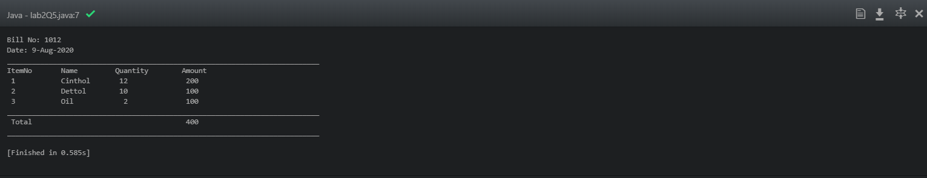

**Question:** ***Write a program to generate a EB receipt as below:***

Code:

*Output:*