Evaluation

Name: Sridhar

Roll : cb.en.u4cse19063

Set : 2

Usecase diagram :

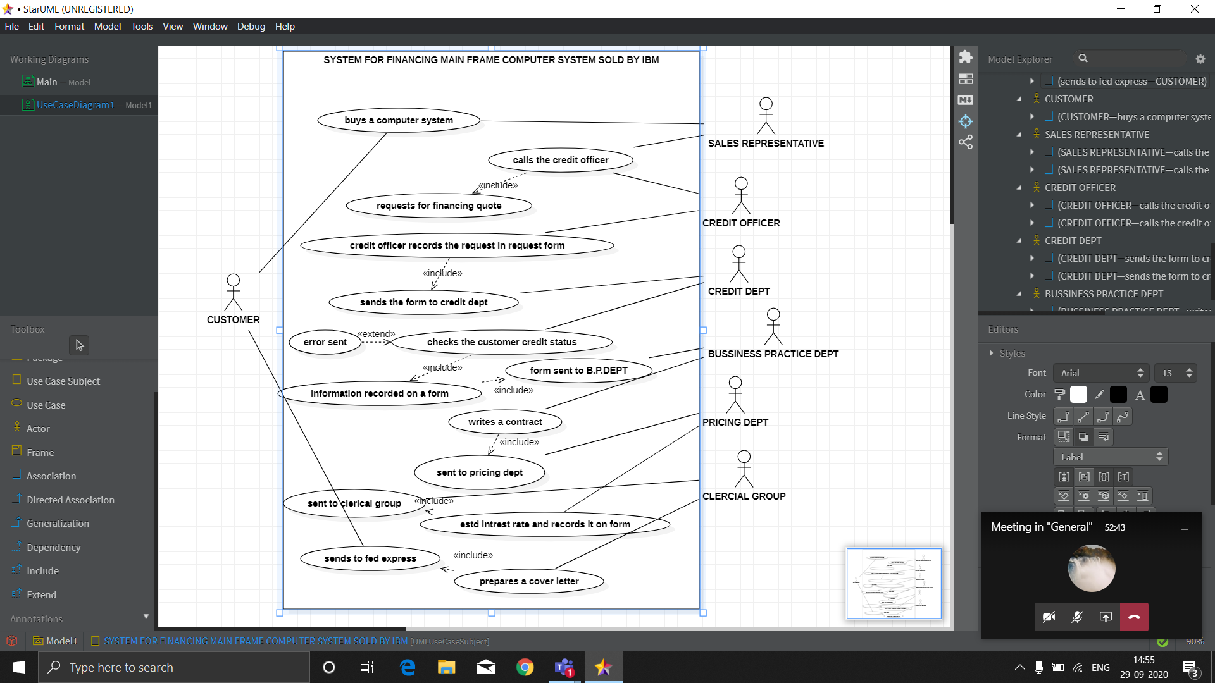

2. object model

