**Case Study 1:** We are launching a new cinema hall in Vellore CBD known as ‘PVR Cinemas’. The hall has just 1 Screen and 4 shows with capacity of 50 seats. We are planning to launch a new website/app using which our patrons can purchase tickets. In order to promote our sales we want to have 2 programs:

* PVR Lovers: If you have PVRCard you will get 5th movie ticket free of cost and you get discount of 10% on every purchase
* Super Tuesdays: The cinema tickets will be ½ the original price.

Following is a broad level design which we have in our mind:

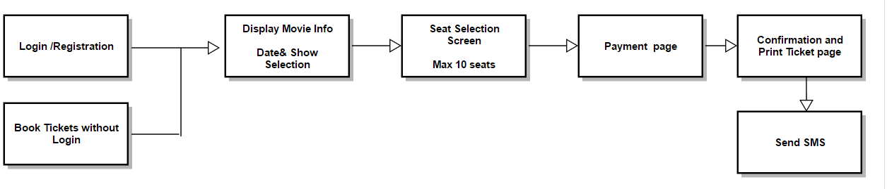

Assume you are the QA working with our development team. You are responsible for leading the QA space.

1. Design the test scenarios which you will require to test this product. Also list down the assumptions which you have made. Focus on the functional as well as non-functional requirements which you will cater to. Also what are the edge cases which we should be aware of.
2. We had a third party payment service agreement with CBA but unfortunately they don’t have a testing env for us to integrate with. What will be your approach to test it.

Bonus Question:

Assume we need to create an Automation test suite driven via the UI, which all scenarios listed in Question 1 will you automate. What tools and technology will you use. Justify your choices. Also give us a high level design overview of your automation suite.