Bird Classification using Voice Data

In this project we are using Bird Voices to identify bird species and this a web based application which you can run by double click on ‘run.bat’ file. After running batch file will get below screen

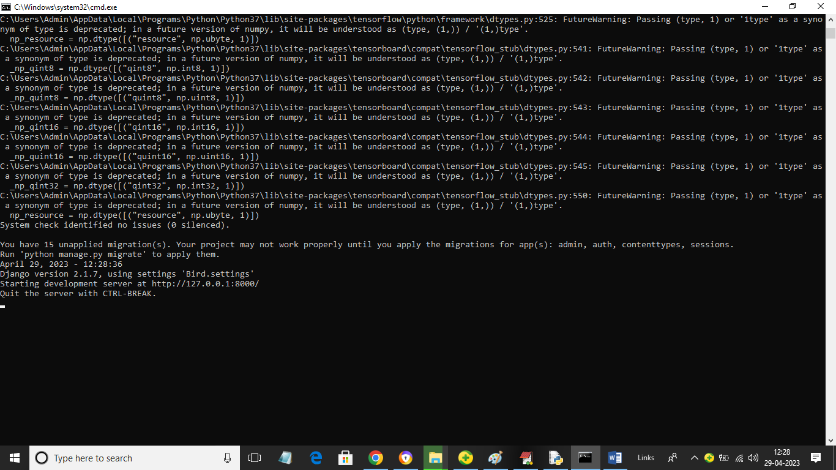

In above screen python web server started and now open browser and enter URL as <http://127.0.0.1:8000/index.html> to get below page

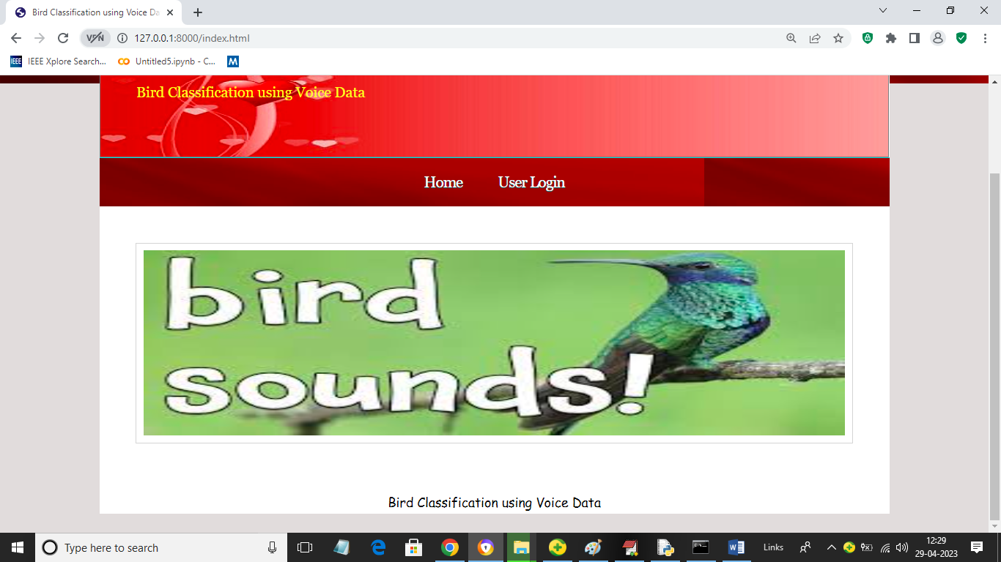

In above screen click on ‘User Login’ link to get below page

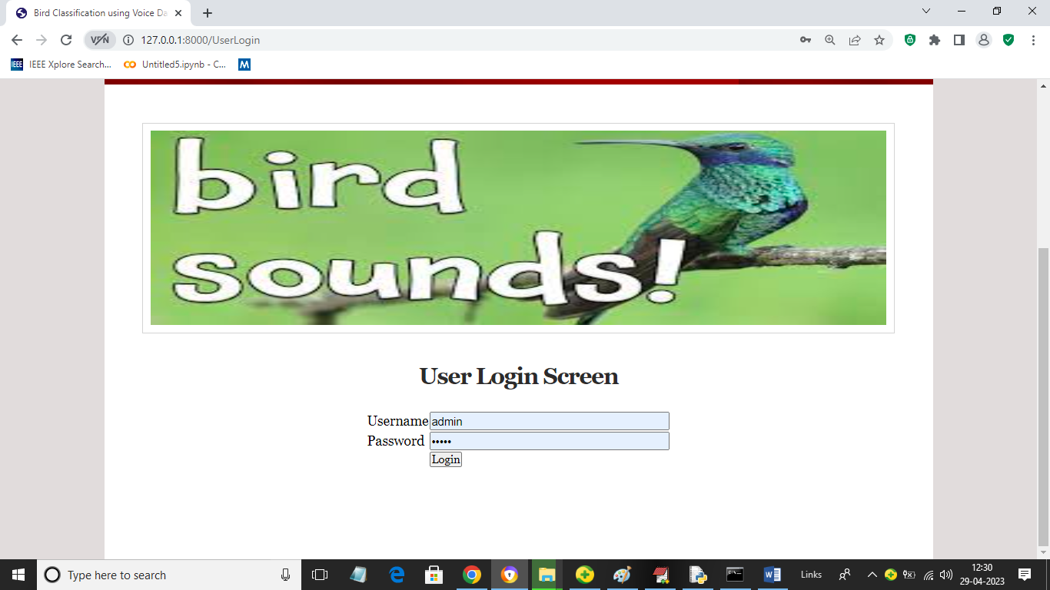

In above screen user can login to application by entering username and password as ‘admin’ and ‘admin’ and then will get below page

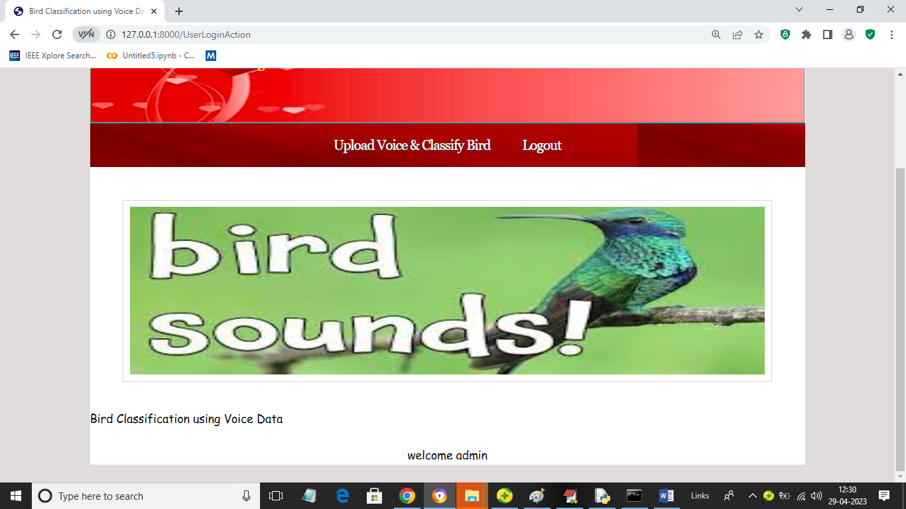

In above screen click on ‘Upload Voice & Classify Bird’ link to get below page

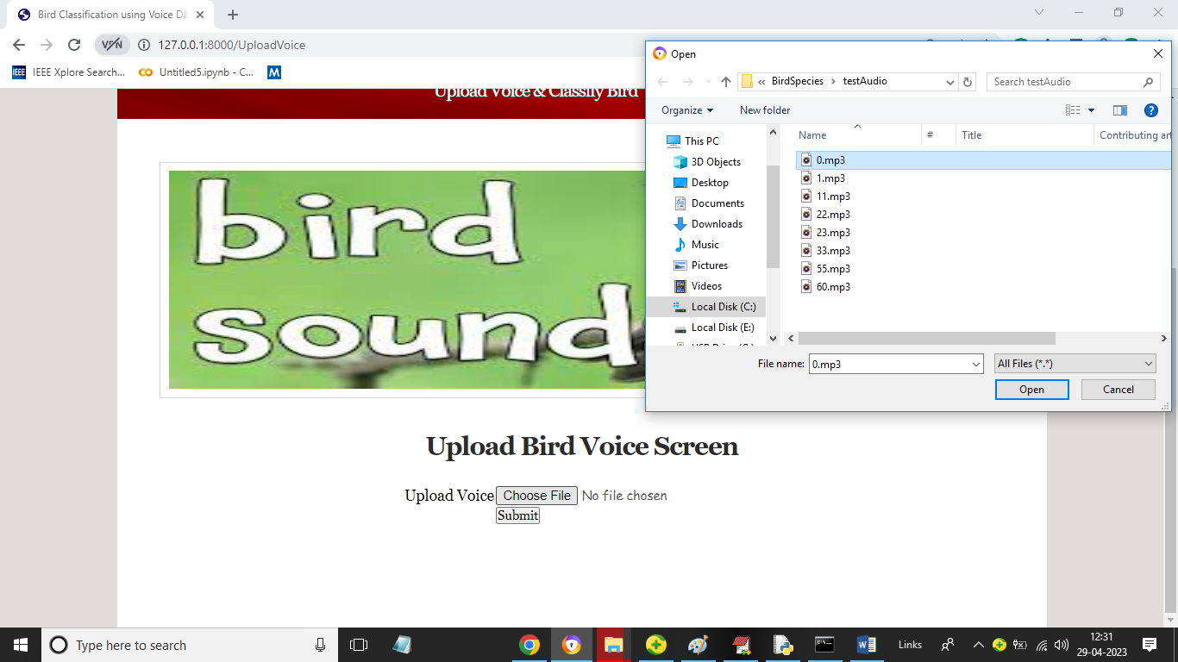

In above screen selecting and uploading voice MP3 file and then click on ‘Open’ and ’Submit’ button to get below page

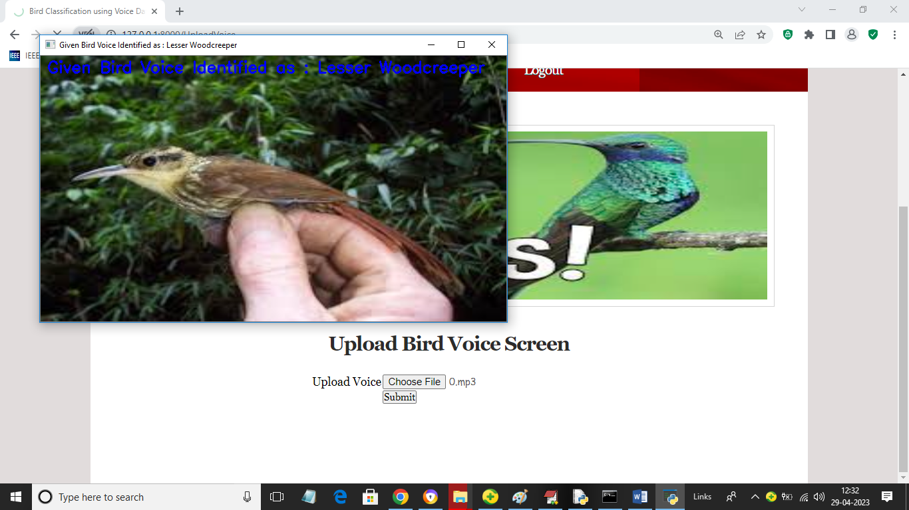

In above screen in blue colour text we can see uploaded bird voice is identified as ‘Lesser Wood creeper’ and now close above image to get below screen

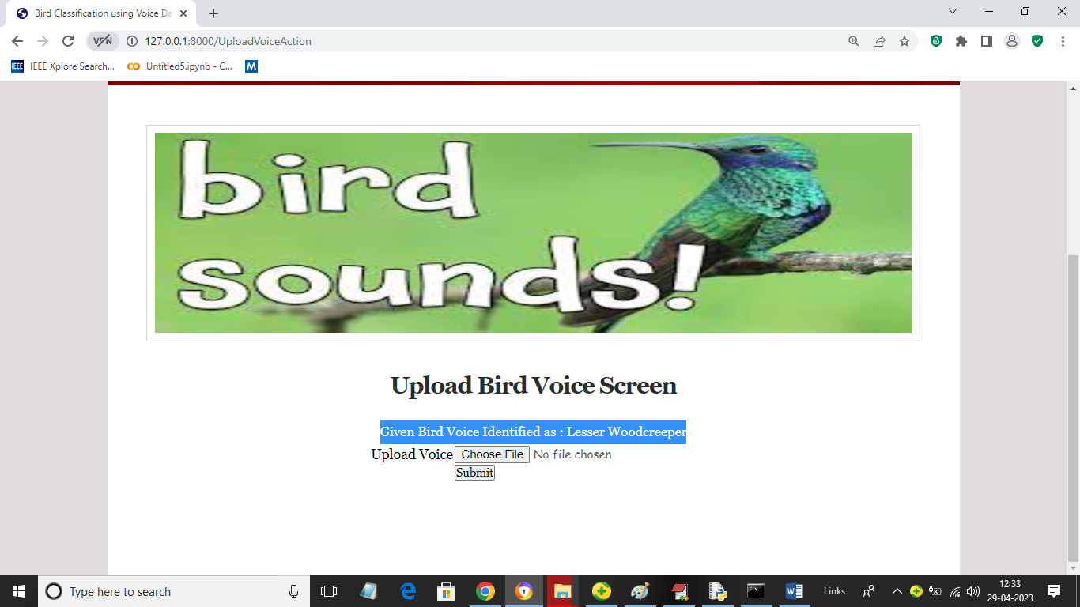

In above screen in blue colour text we can see predicted bird name from voice and similarly you can upload and test other voice files

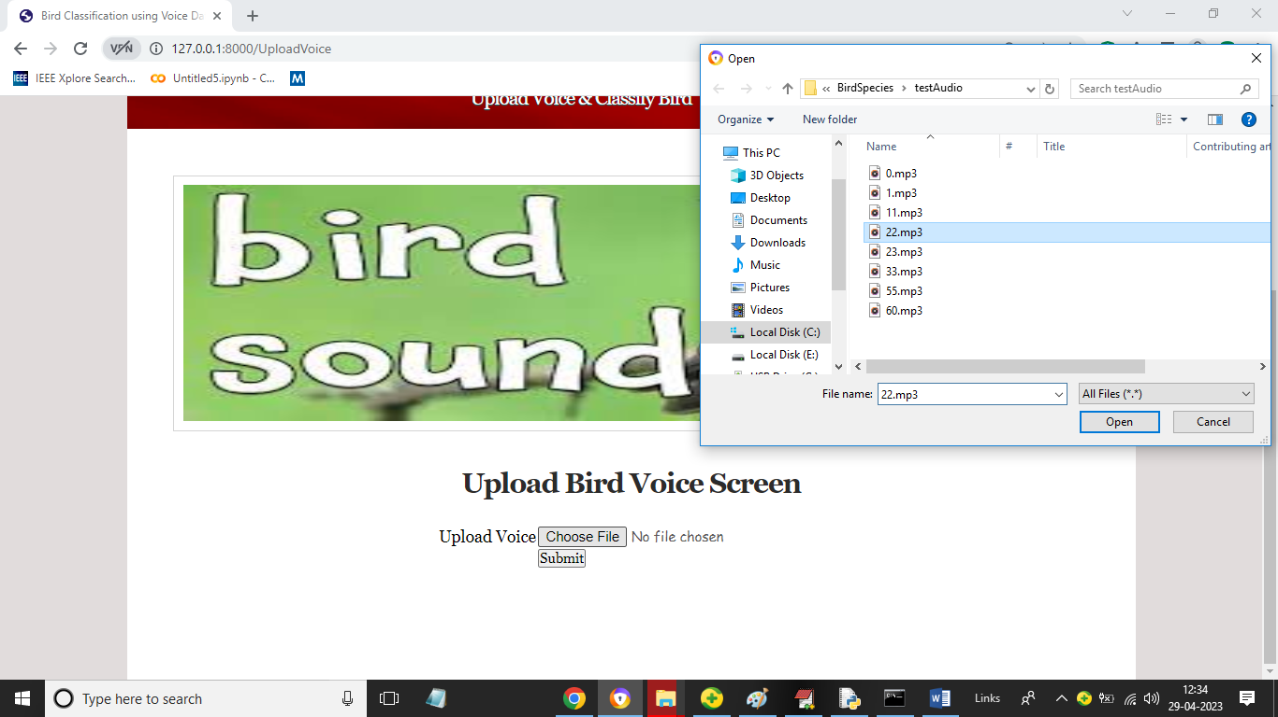

In above screen uploading another audio file and below is the output

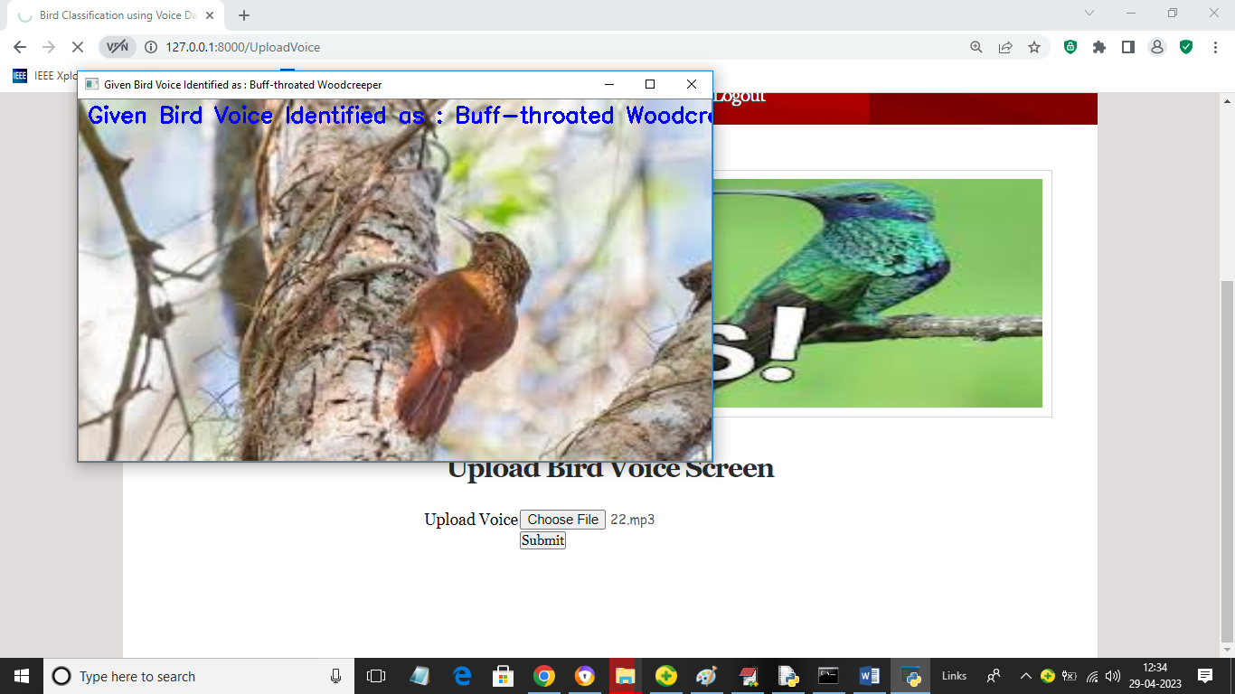

In above screen bird identified as ‘Buff throated’.