TBMI26 – Computer Assignment Reports  
Boosting

Deadline – March 15 2019

Sridhar Adhikarla (sriad858)

Naveen Gabriel(navga709)

1. **Plot how the classification accuracy on training data and test data depend on the number of weak classifiers (in the same plot). Be sure to include the number of training data (non-faces + faces), test-data (non-faces + faces), and the number of Haar-Features.**

(Train, Test): Error and Accuracy Plots -

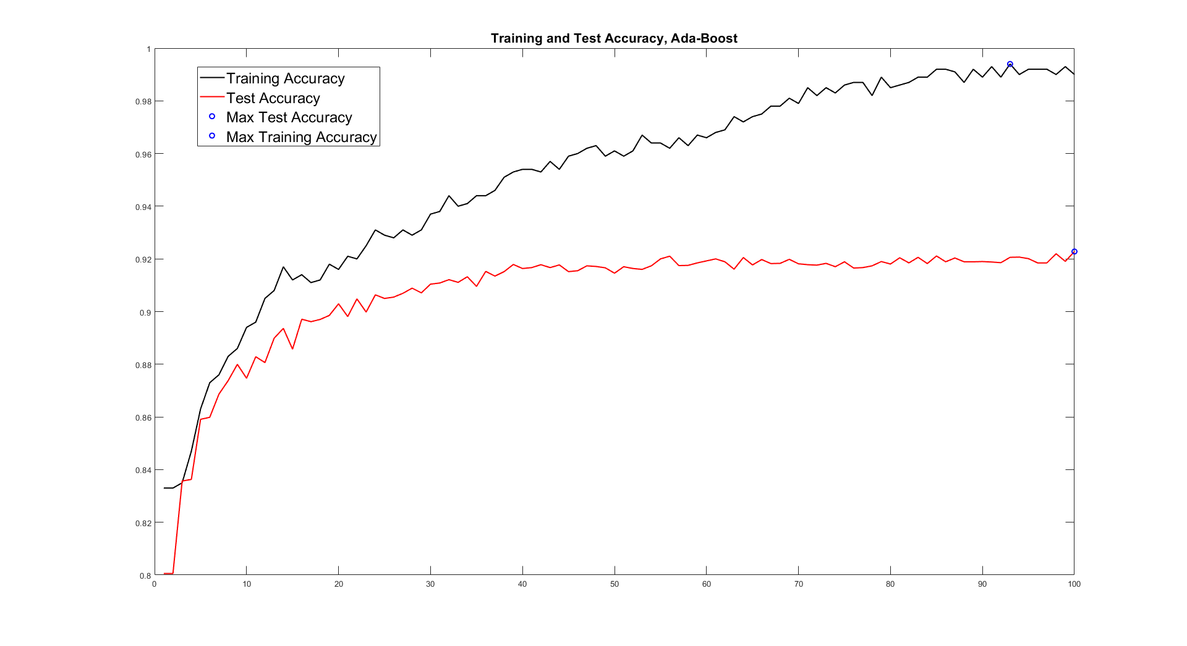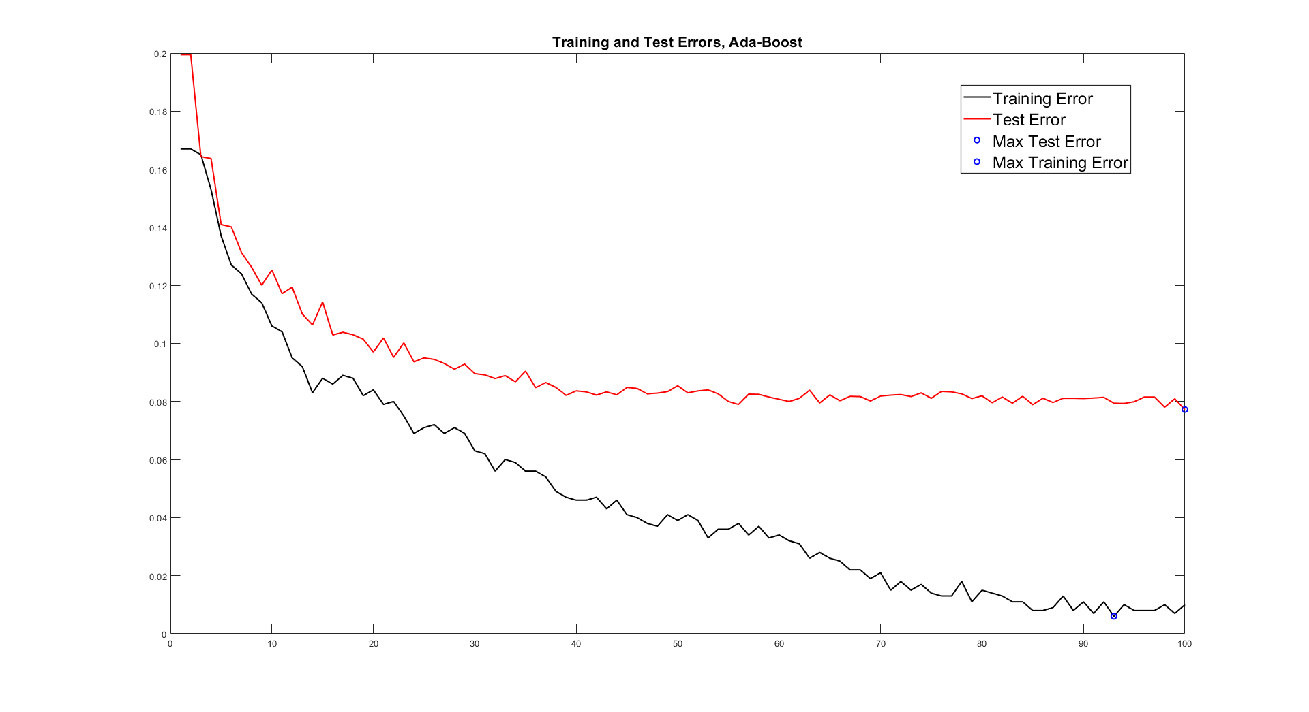

The train data has 1000 images, of which 500 are faces and 500 are non-faces.

The test data has 11788 images, of which 4416 are faces and 7372 are non-faces.

The number of Haar-Features used while training : 50

1. **How many weak classifiers did you use when training? How many of them did you use for the final strong classifier? Why?**

I used 50 Haar features while training and found that 41 of them were selected in the strong classifier (some of them were selected multiple times).

I trained 100 weak classifiers and got the best accuracy on test data using all 100 of them in the strong classifier. The accuracy on the test data increased to 90 using just 30 weak classifiers as we can see from the plot above, but the accuracy kept increasing gradually after that, and I got the maximum accuracy at 100 classifiers.

I decided on the number of weak classifiers to be used for the Strong classifier looking at the plot above. 100 weak classifiers had the best performance on the test data. The performance of the strong classifier was almost getting plateaued on using more features.

1. **What is the accuracy on the test data after applying the optimized strong classifier?**

Strong classifier on Test data

Error: 0.077197

Accuracy: 0.922803

1. **Plot the Haar-features selected by your classifier (one for each weak classifier). If you have many weak classifiers, select some representative subset.**

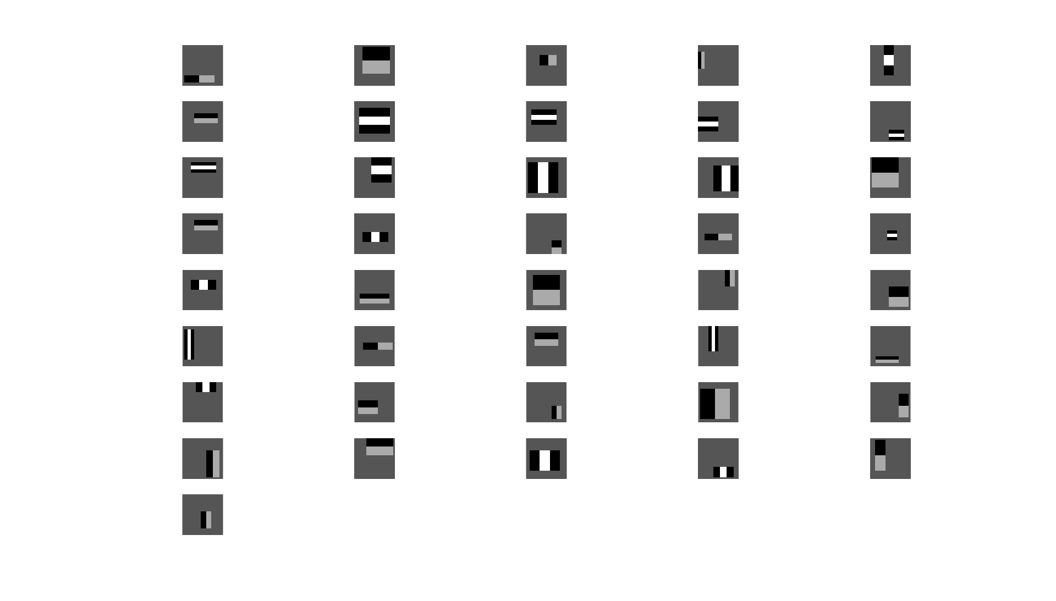

1. **Plot some of the misclassified faces and non-faces that seem hard to classify correctly. Why do you think they are difficult to classify?**

Misclassified Non-Faces –

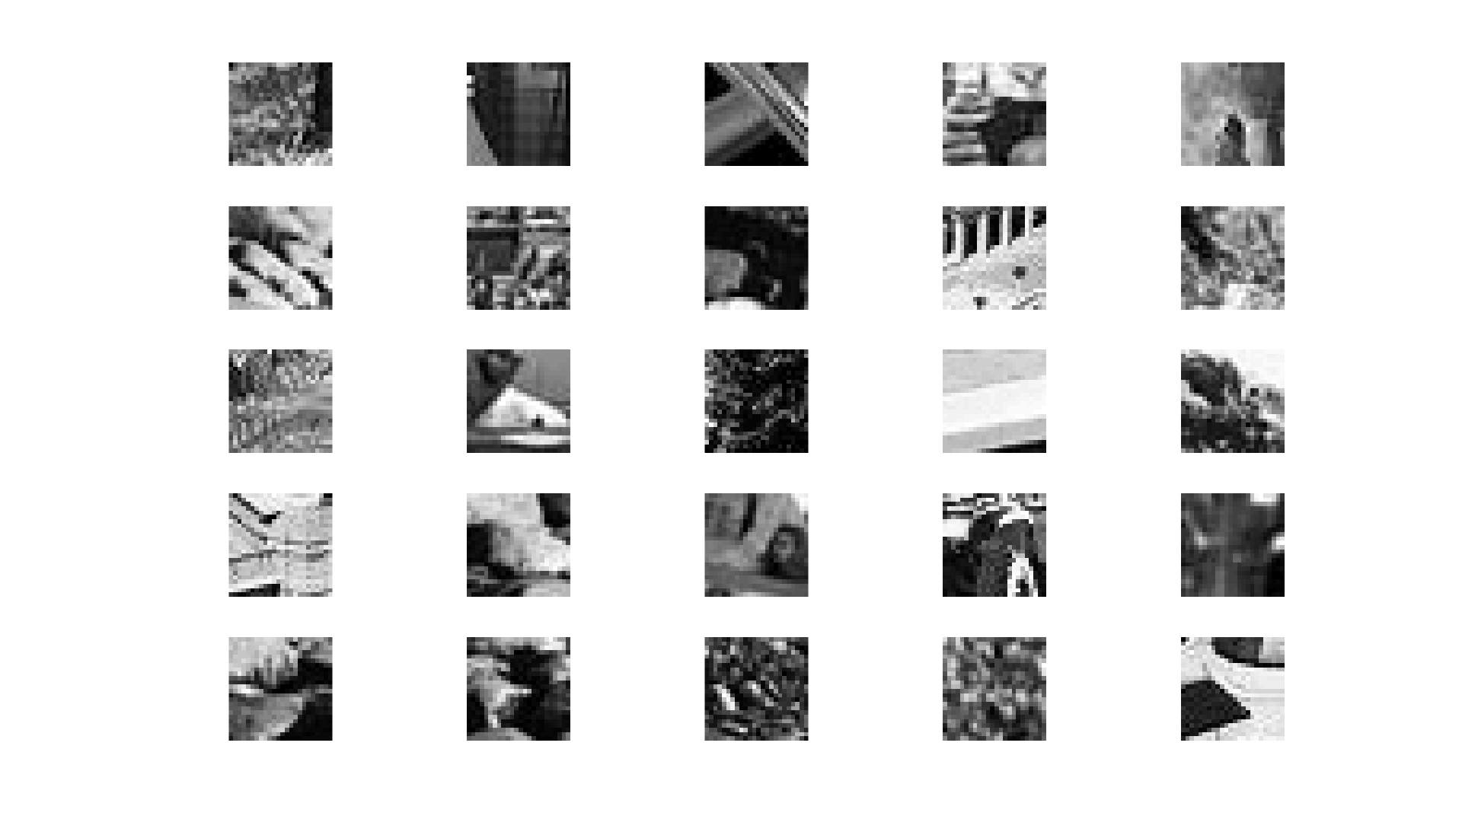

Most of the Haar features selected in the strong classifier are trying to detect Edges and Line close to the center of the image. These non-face images have edges at places that mislead the strong classifier. For example in the last image in the plot above the lines in the image may have misled the classifier on thinking that it is a eyebrow or nose.

Misclassified Faces –

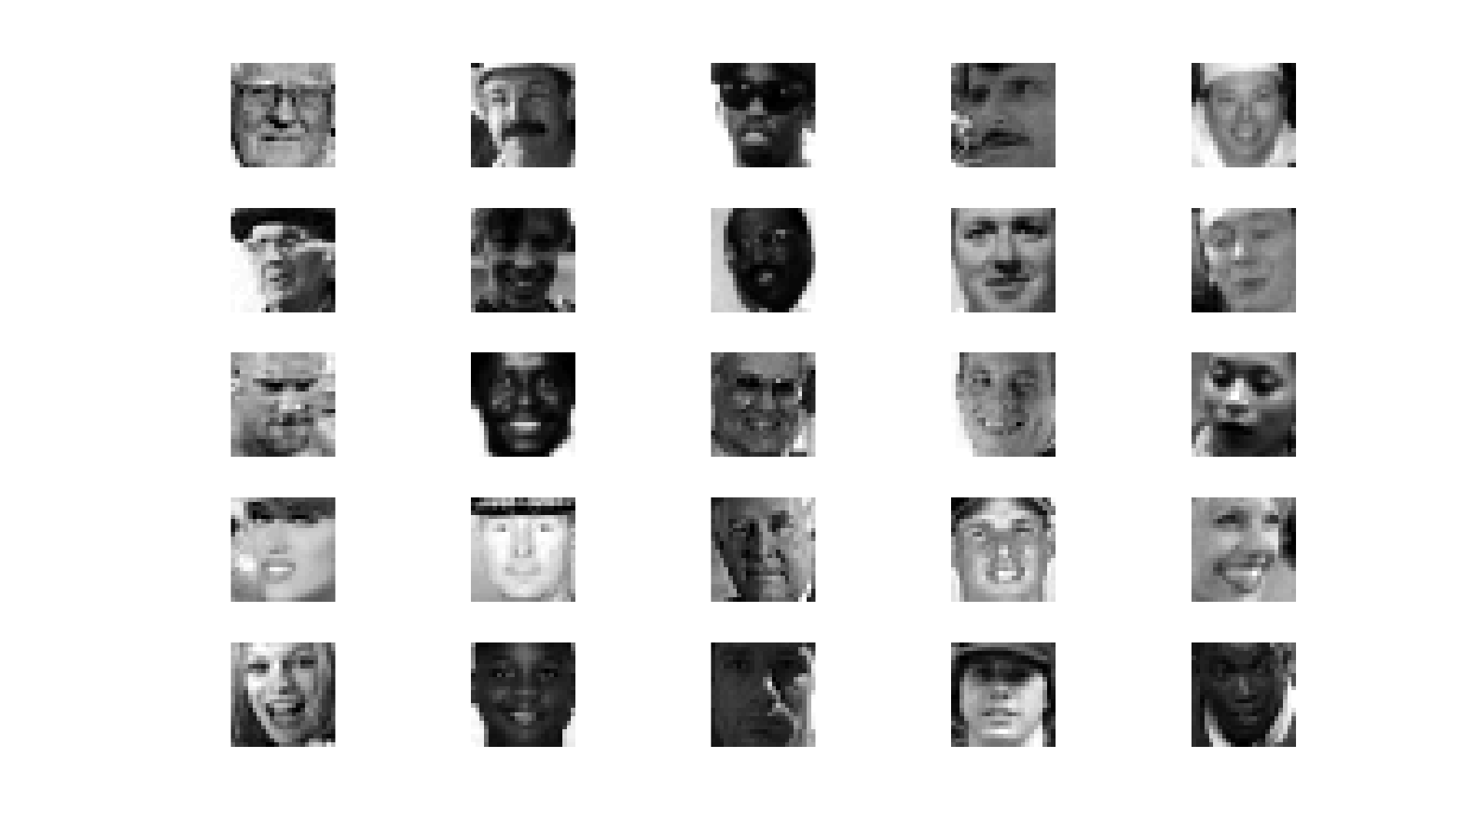

It is hard to say why these face images were misclassified. I think most of these images are mixed with the background color so the Haar feature is not able to detect the edges at the right places. In some images there is shadow that fall on their face, making it hard to distinguish them from the background. In two of the images the person is wearing a cap, that creates a shadow which covers his eyes, making it difficult for the Haar feature to detect the eyebrow and eye.

1. **Defend your results. Are they reasonable?**

Yes, I think it is reasonable.

Some of the faces that were misclassified were hard to separate from the background, due to the background color or shadow covering their face. But the overall performance of the strong classifier on the test data was really good. It got an accuracy of approximately 92% on the test data, using just simple Haar features.

1. **Can we expect perfect results? Motivate your answer.**

No, I don’t think we can expect perfect results from this Algorithm on test data. These classifiers are less computationally heavy, and this comes with a cost, its accuracy can not be perfect.

Each of the weak decision stumps we created just fits a straight line through the data, as a separation point for classification. Combining these weak classifiers, we still end up with some arbitrary sized boxes of classifiers. If the data, we are trying to separate is not separable in this manner we cannot get perfect results. The strong classifier works correctly until the test data provided to the classifier is in a similar format to the train data, and it is difficult to cover all kind of possible variations in the training data.

We can increase the accuracy of this system by increasing the training data, so that it covers most of the variations, but still I think getting perfect results is not possible on the test data.

These classifiers are used on devices that do not have much computation, like cameras, to detect faces when clicking a picture. So, detecting a face with 92% accuracy is good for the purpose. These cannot be used at places where there is too much risk associated with a wrong classification.