**AIR QUALITY MONITORING**

***Phase-2***

***Introduction:***

In this project, we're creating an IoT-based Air Pollution Monitoring System. Its main job is to keep an eye on the quality of the air around us, and it does this by using the internet to communicate the data to a web server. When the air quality gets really bad, it will sound an alarm to alert us.Now, when we talk about "bad" air quality, we mean when there are harmful gases in the air like CO2, smoke, alcohol, benzene, and NH3. These are substances that can be harmful to our health, so it's important to know when they are present in higher amounts.To make it easy for us to see what's going on, we have two ways to check the air quality. One is by looking at a screen called an LCD, which will show us the air quality in parts per million (PPM). The other way is by checking a webpage on our computer or phone. So, no matter where we are, we can keep an eye on the air we're breathing.We have chosen the MQ135 sensor because it's great at monitoring air quality. It can detect most of those harmful gases we talked about and give us accurate measurements.What's really cool is that we can use this system from anywhere. If we install it in our home, office, or any other place, we can set it up to do things when the air quality gets worse. For example, it can turn on an exhaust fan to help clear the air or send us a text message or email to let us know things aren't good.So, whether you're at home, at work, or somewhere else, this system helps you keep an eye on the air quality and take action to stay safe and healthy.

***Components required:***

* **MQ135 Gas sensor:**

The MQ135 gas sensor is a device that detects and measures various harmful gases in the air, including CO2, smoke, alcohol, benzene, and NH3,providing a valuable tool for monitoring air quality in a simplified and cost- effective manner

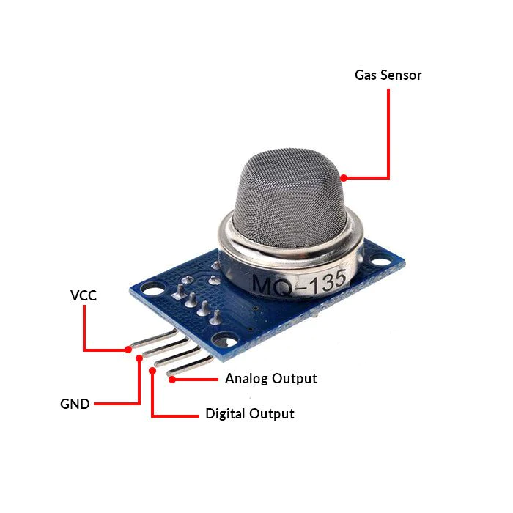

* **Arduino Uno:**

The Arduino Uno is like a tiny computer that you can use to control and interact with the physical world. It's user-friendly, comes with a bunch of connection pins, and can be connected to your computer via USB for programming. Whether you're new to electronics or a seasoned maker, the Arduino Uno is a handy tool for creating all sorts of cool projects.

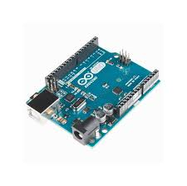

* **Wi-Fi module ESP8266**

The ESP8266 Wi-Fi module is like a small, smart component that you can add to your electronics projects. It lets your devices connect to the internet wirelessly, just like your phone connects to Wi-Fi. This module is handy for making things like smart gadgets or remote-controlled devices.

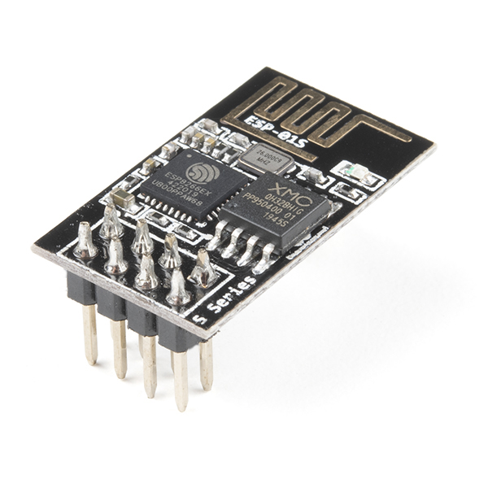

* **16X2 LCD**

A 16x2 LCD is a type of display that can show text on two lines, with each line capable of displaying up to 16 characters. It's commonly used in various electronic devices and projects to provide information or messages in a simple text format.

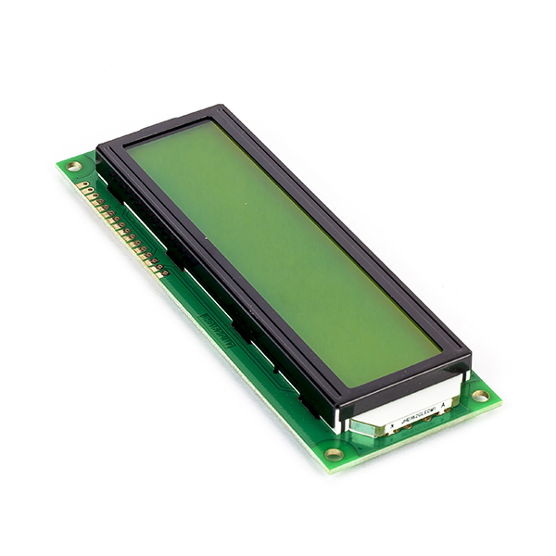

* **Breadboard**

A breadboard is a board used to connect electronic components, such as wires, resistors, capacitors, and coils, to conduct various experiments and projects.

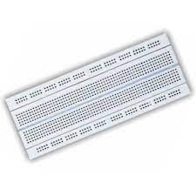

* **10K potentiometer**

A 10k potentiometer is an electronic component that can be used to control the flow of electricity through a circuit.

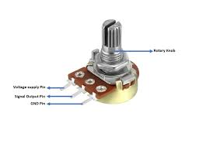

* **Resistors(1K and 220ohms)**

A resistor is an electronic component that is used to reduce the flow of electric current in a circuit. It is a passive component that is designed to resist the flow of current, and it is often used to limit the current in a circuit to protect other components from damage.

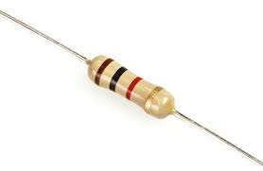 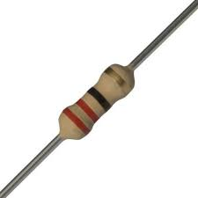

* **Buzzer**

A buzzer or beeper is an audio signaling device, which may be mechanical, electromechanical, or piezoelectric (piezo for short). Typical uses of buzzers and beepers include alarm devices, timers, train and confirmation of user input such as a mouse click or keystroke.

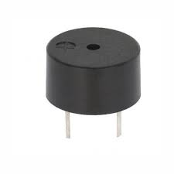

**Steps For Flowchart:**

**Step 1:** Start the program.

**Step 2:** Power up the ESP8266, MQ135 sensor, buzzer, and LCD.

**Step 3:** Collect data:

i. Read gas concentration.

ii. Measure temperature and humidity levels.

**Step 4:** Analyze data:

i. Check if gas concentration is within safe limits.

ii. Verify if temperature and humidity are within the comfort range.

**Step 5:** Display results:

i. Show gas concentration on the LCD.

ii. Display temperature on the LCD.

iii. Indicate humidity percentage on the LCD.

**Step 6:** Take action (if necessary):

i. If gas concentration exceeds safe limits, activate the alarm or ventilation system.

ii. If the temperature is outside the comfort range, adjust the heating or cooling system.

iii. If humidity levels are imbalanced, activate the dehumidifier or humidifier.

iv. If no action is needed, proceed to the next step.

**Step 7:** Pause briefly for data stability.

**Step 8:** Continuously repeat the data collection, analysis, nd action loop.

**Step 9:** Terminate the program when done or as needed.

**Flowchart:**

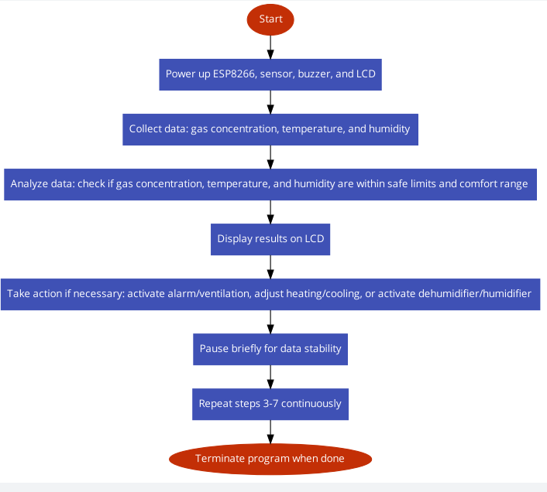

**Circuit Design:** 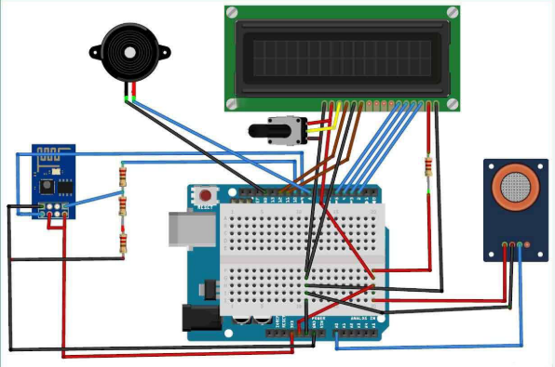

**Uses:** **1. Continuous Air Quality Oversight:** Our system works tirelessly to keep tabs on air quality, ensuring the presence of hazardous gases like CO2, smoke, alcohol, benzene, and NH3 is within safe limits. **2. Data at Your Fingertips:** You can effortlessly keep an eye on real-time data through our LCD display and web interface, granting you the power to monitor air quality, temperature, and humidity remotely. **3. Automatic Responses:** When pollution levels or environmental conditions cross predetermined thresholds, our system takes action autonomously. It can trigger alarms, activate ventilation, or adjust environmental systems to maintain a safe and comfortable environment.

**4. IoT Connectivity for Convenience:** Thanks to the ESP8266 Wi-Fi module, our project lets you stay connected from anywhere. You can conveniently access data and make informed decisions through your computer or mobile device, putting control in your hands.