DEPENDENCYTRACK RISK DASHBOARD
Multi-User Platform Migration
Architecture & Implementation Plan

Field | Value
Document | Multi-User Platform Migration — Architecture & Implementation Plan
Repository | sridhar1495/dependency-tracker
Version | 1.0
Status | Draft — for Architecture Review
Date | 2026-08-02
Audience | Architecture Review Board, Engineering, Security
Related | CLAUDE.md (coding standards), docs/INSTALLATION.md, docs/DASHBOARD_INTEGRATION.md

Purpose. This document specifies the migration of the DependencyTrack Risk Dashboard from a single-tenant, file-backed appliance to a multi-user application with authentication, per-user configuration and a PostgreSQL system of record. It is written for architectural review and sign-off prior to implementation.
Reading guide. Sections 4–8 carry the decisions requiring architectural approval. Section 11 covers the performance-by-design commitments. Section 14 carries the effort estimate. Appendix C lists the open questions requiring a decision at review.

Document Control

Revision history
Version | Date | Author | Summary of change
1.0 | 2026-08-02 | Engineering | Initial draft issued for architecture review.

Review and approval
To be completed at review. Approval of this document authorises the phased delivery described in Section 14.
Role | Name | Decision | Date
Solution Architect |  | Approve / Reject / Approve with comments
Security Architect |  | Approve / Reject / Approve with comments
Data / Platform Architect |  | Approve / Reject / Approve with comments
Engineering Lead |  | Approve / Reject / Approve with comments
Product Owner |  | Approve / Reject / Approve with comments

Table of Contents

1. Executive Summary
The DependencyTrack Risk Dashboard is today a single-tenant appliance. Every element of its state is either a process-wide variable or a JSON file on a bind-mounted Docker volume: one DependencyTrack connection shared by everyone who opens the page, one email configuration, one report schedule, one report registry and one violation cache. There is no authentication on any of its sixteen HTTP endpoints.
This plan converts it into a multi-user application. It introduces user accounts with session-based authentication, moves all configuration and generated artefacts into PostgreSQL, isolates every user's data, and re-shapes the concurrency model so that adding users does not multiply the load placed on the upstream DependencyTrack instance.

1.1 Headline decisions
Area | Decision
Database | PostgreSQL 16 (Alpine), deployed as a third container in the existing compose stack, port-exposed for external DBA tooling.
Dependencies | Exactly one new npm package (pg). Password hashing, session tokens and secret encryption use Node.js built-in crypto — no bcrypt, argon2 or JWT library.
Authentication | Opaque 256-bit bearer tokens, SHA-256 hashed at rest, with a database-enforced single active session per user and an explicit force-disconnect flow.
Report storage | Report metadata and file bytes separated: bytes held as 4 MB chunks in a dedicated table so listing never reads them and downloads stream at bounded memory.
Violation cache | Shared across users and keyed by a fingerprint of the DependencyTrack connection, so N users on one DT instance produce one crawl rather than N.
Scheduling | A single 60-second poller using FOR UPDATE SKIP LOCKED replaces the current single global timer, giving per-user isolation and replica safety.

1.2 Effort and shape of delivery
The work is estimated at 50 person-days (range 48–58 with contingency): approximately 10 weeks for one engineer or 6–7 weeks for two working in parallel across the backend and frontend streams. It is structured as eleven phases grouped into three independently demonstrable milestones, detailed in Section 14.

1.3 Security improvements delivered as a by-product
Two defects in the current system are closed by this work rather than being added to it:
- The DependencyTrack API key is currently returned in plaintext by an unauthenticated endpoint (`GET /violation-cache/config`) to any caller that can reach the service. After this migration the key is encrypted at rest and never returned to a browser.
- Secrets are currently stored in plaintext on disk — the DT API key in `.env`, the SMTP password in `app-config.json`. Both move to AES-256-GCM encrypted columns.

2. Current State Assessment
The findings below come from a full read of the existing implementation: `violation-cache/server.js` (1,930 lines), `dashboard/index.html` (3,624 lines), `install.sh`, `docker-compose.yml`, `dashboard/nginx.conf.template` and both test suites (299 passing tests).

2.1 Where state lives today
Store | Contents | Consequence for multi-user operation
/app/.env | DT API URL and API key | One connection for the whole deployment. Every user sees the same portfolio.
/data/app-config.json | maxReports, mail settings, schedule | One email configuration and one schedule for all users.
/data/reports/registry.json | Report job list | Rewritten in full after every project completion — 1,500 writes for a 500-project report.
/data/reports/*.xlsx | Generated report files | No ownership; any caller may download any report.
/data/violation-cache.json | Per-project violation counts | Single cache tied to a single DT connection.
/data/scheduled-reports/*.xlsx | Transient scheduled report | Written to disk then deleted after emailing.

2.2 Process-global mutable state
The following module-scope variables are process-wide singletons with no tenant dimension. Each one is a blocker for concurrent users:
Variable | Role | Failure mode with multiple users
jobRunning | Violation build in progress | A second user's build request is rejected as a duplicate even for a different DT instance.
jobProgress | Page counters | Two builds overwrite each other's progress readings.
reportJobs | In-memory report registry | No ownership; the report limit is global rather than per user.
_schedulerTimer | The single schedule timer | Exactly one schedule can exist for the entire deployment.
_schedulerRunning | Overlap guard | One user's running job blocks every other user's schedule.

2.3 Authentication
There is none. All sixteen routes are open, `Access-Control-Allow-Origin` is `*`, and the configuration endpoint discloses the DependencyTrack API key without any credential check.

3. Scope

3.1 In scope
- User registration, login, logout, profile maintenance and account deletion, backed by a local database.
- Session authentication on every backend endpoint, with a single active session per user and an explicit force-disconnect flow.
- An administrator login validated against an installation-local credentials file, plus a read-only administration panel.
- PostgreSQL as the system of record for users, sessions, DependencyTrack connection settings, user preferences, mail settings, schedules, reports and report files.
- Per-user DependencyTrack configuration replacing install-time `.env` configuration, including the mock-data fallback for unconfigured accounts.
- Report storage in the database, per-user quotas and recorded file sizes for storage accounting.
- A multi-tenant scheduler and a shared, fingerprint-keyed violation cache.
- Installer, Docker Compose, documentation and test-suite changes to match.

3.2 Out of scope (this delivery)
Item | Rationale
Self-service password reset | No pre-login mail route exists until a system-level SMTP configuration is designed. The link is present in the UI and reports that the feature is not yet available.
Destructive administrator actions | The administration panel is read-only. User disable/delete, password reset and forced disconnection by an administrator are deferred.
External identity providers (SSO, LDAP, OIDC) | Local accounts only, as specified. The schema does not preclude a later federated identity column.
Role-based authorisation beyond user/administrator | Two principal types only. Finer-grained roles are a later concern.
Horizontal scale-out of the service | A single service replica is the supported topology. Section 11.5 documents what would change.
Migration of existing runtime data | The database starts empty. Existing installations are single-user, so there is no meaningful per-user owner to import into.

4. Architecture Decision Record
Decisions D1 to D8 are settled and form the basis of this plan. Decisions D9 to D11 require confirmation at review; recommendations are given.

4.1 Settled decisions
Ref | Decision | Rationale and alternatives considered
D1 | PostgreSQL 16 as the database | PostgreSQL Licence (permissive, BSD-style). Provides JSONB, partial and covering indexes, TOAST compression for large values, and FOR UPDATE SKIP LOCKED for safe queue semantics. MySQL/MariaDB rejected: GPLv2, weaker JSON indexing, no partial indexes. SQLite rejected: cannot be exposed on a port for external tooling and serialises concurrent writers.
D2 | Add pg as the only new dependency | Password hashing uses built-in crypto.scrypt (an OWASP-recommended KDF), tokens use crypto.randomBytes, secrets use built-in AES-256-GCM. argon2 rejected: pulls a native build toolchain into the Alpine image. jsonwebtoken rejected: session revocation is a hard requirement, so tokens must be checked against the database regardless, which removes the only advantage of stateless tokens.
D3 | Report bytes in a dedicated chunked table | Metadata and bytes are separated so the list endpoint never reads file content. Chunking at 4 MB bounds process memory during upload and download. Single BYTEA column rejected: one careless SELECT * drags megabytes through the pool. Large Objects rejected: require explicit lo_unlink cleanup and complicate backups.
D4 | Violation cache shared and keyed by connection fingerprint | A SHA-256 of the DT URL and API key identifies a logical connection. Users sharing a DT instance share one cache and one build job. Per-user caches rejected: N identical portfolio crawls against DependencyTrack. One global cache rejected: shows one user another user's data when connections differ.
D5 | Self-service password reset deferred | A locked-out user has no mail route because SMTP settings are per-user and only exist after login. Resolving this requires a system-level SMTP owned by the administrator, which is deferred with the feature.
D6 | Read-only administration panel | Lists users, last login, active session, report count and storage consumed. Provides the storage visibility anticipated by the requirements without the risk surface of destructive administrative actions.
D7 | Sessions expire after 8 hours absolute or 2 hours idle | Both values are environment-tunable (SESSION_ABSOLUTE_HOURS, SESSION_IDLE_HOURS). Balances security against interrupting a working day. The idle clock is advanced at most once per minute to avoid a database write per request.
D8 | The database starts empty; legacy files are ignored | Existing deployments are single-user, so no per-user owner exists to import into. The installer prints a notice that files under violation-cache/data/ are obsolete and may be removed manually.

4.2 Decisions requiring confirmation at review
Ref | Question | Recommendation
D9 | Does deleting an account free its login ID and email address for re-registration? | Yes. Hard DELETE with ON DELETE CASCADE across owned data. login_audit.user_id becomes NULL while retaining the attempted login ID, preserving the audit trail. The alternative — soft deletion with a tombstone — retains the identifier forever and complicates the uniqueness constraints.
D10 | What is the permitted format of a login ID? The requirements did not specify one. | 3 to 64 characters, [A-Za-z0-9._-], no spaces, unique case-insensitively.
D11 | How are collisions with the administrator login prevented? | Registration must reject the configured administrator login ID (SCA_ADMIN_USER, default admin) together with root and system. Without this a database user can shadow the file-based administrator account.

5. Target Architecture

5.1 Container view
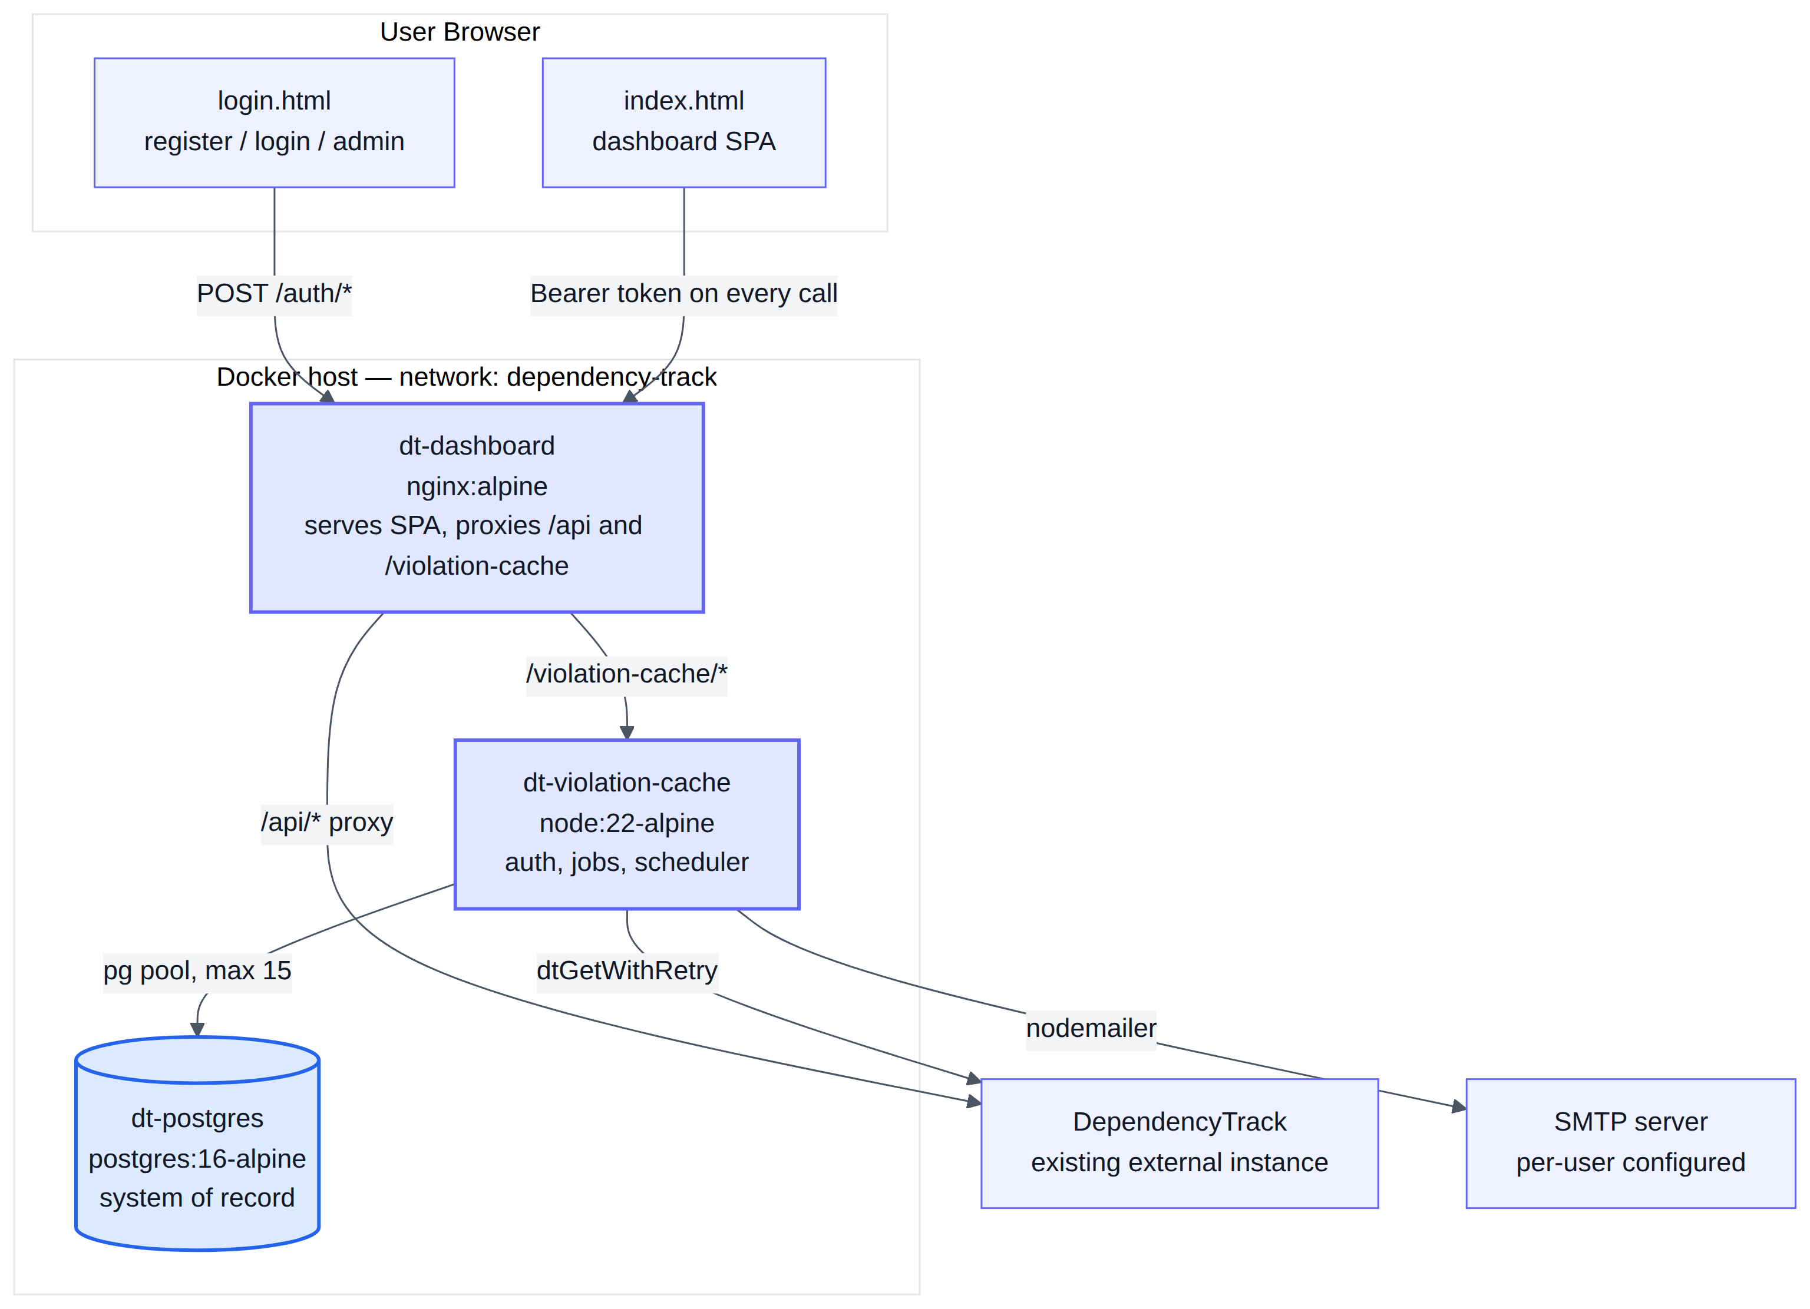
Figure 1 — Target container topology. The database is a third container on the existing private bridge network.
The nginx and Node containers keep their current responsibilities. The database is added to the same private bridge network and additionally published on a configurable host port so that database tooling can connect from outside Docker.

5.2 Backend module structure
`server.js` is 1,930 lines today and would exceed 4,000 if extended in place. It is split into modules. This is a backend-only change; the single-file frontend rule in the project coding standards is unaffected.
violation-cache/
├── server.js routing + boot only (~400 lines)
├── db/
│ ├── pool.js pg.Pool, query() and tx() helpers
│ ├── migrate.js in-house migration runner (advisory-locked)
│ └── migrations/ 001_init.sql … 00N_*.sql
├── lib/
│ ├── crypto.js scrypt, token mint/hash, AES-256-GCM
│ ├── auth.js session issue/validate/revoke, token cache, rate limit
│ ├── validate.js shared field validators (mirrored in the frontend)
│ ├── users.js settings.js reports.js caches.js schedules.js
│ └── dt-fetch.js excel.js mail.js (extracted from server.js)
└── routes/
auth.js profile.js config.js reports.js schedule.js cache.js admin.js

Dockerfile change required
The image currently copies only `package.json` and `server.js`. Any new directory is silently excluded. The build must add explicit COPY instructions for `db/`, `lib/` and `routes/`, otherwise the container starts against a missing module.

5.3 Environment configuration
`.env` is reduced to infrastructure concerns. No DependencyTrack connection value is ever written to it again — that configuration becomes per-user data held in the database.
Variable | Default | Purpose
DT_DASHBOARD_PORT | 3000 | Host port for the dashboard.
POSTGRES_USER | dtdash | Database role name.
POSTGRES_PASSWORD | generated | Generated by the installer when absent.
POSTGRES_DB | dtdash | Database name.
POSTGRES_PORT | 5432 | Host port exposed for external database tooling.
SCA_ADMIN_USER | admin | Administrator login ID written at install time.
SCA_ADMIN_PASSWORD | ScaAdmin@dt8624 | Administrator password; hashed before storage.
SECRET_ENCRYPTION_KEY | generated | AES-256-GCM key protecting DT API keys and SMTP passwords.
SESSION_ABSOLUTE_HOURS | 8 | Absolute session lifetime.
SESSION_IDLE_HOURS | 2 | Idle session lifetime.
LOG_FORMAT | text | Unchanged; json enables structured logging.

6. Third-Party Components and Licence Compliance
Every component is under a permissive licence. No copyleft obligation is introduced, and no component requires a commercial licence for redistribution.
Component | Version | Licence | Status | Notes
PostgreSQL | 16-alpine | PostgreSQL Licence | New | OSI-approved, BSD-style. No copyleft.
pg (node-postgres) | ^8.13 | MIT | New | Transitive tree — pg-pool, pg-protocol, pg-types, pgpass, postgres-array, postgres-bytea, postgres-date, postgres-interval, split2 — all MIT. No native compilation step.
exceljs | ^4.4.0 | MIT | Existing | Report generation. Unchanged.
nodemailer | ^6.10.1 | MIT | Existing | Email delivery. Unchanged.
Node.js crypto | built-in | MIT (Node.js) | Existing | scrypt, randomBytes, AES-256-GCM, timingSafeEqual. Removes the need for any authentication dependency.
node:22-alpine | 22 LTS | MIT | Existing | Runtime base image.
nginx:alpine | latest | BSD-2-Clause | Existing | Static serving and reverse proxy.

6.1 Deliberate exclusions
Rejected | Reason
bcrypt / argon2 | Native compilation in an Alpine image; crypto.scrypt is a first-class OWASP-recommended alternative already present in the runtime.
jsonwebtoken | Session revocation and the single-active-session rule both require a database lookup, eliminating the benefit of stateless tokens.
express / fastify / koa | The project mandates the raw http module; the existing routing pattern extends cleanly.
knex / zod | Parameterised SQL and hand-written validators keep the dependency tree auditable and match the existing code style.

6.2 Compliance gate
Add to the definition of done for the phase that introduces `pg`: the output of npm ls --omit=dev recorded in the pull request, and npm audit --omit=dev reporting no vulnerabilities.

7. Data Model
Twelve tables plus a migration ledger. The model is presented as two entity-relationship diagrams — identity and configuration first, then reports and scheduling — followed by column-level specifications.
Design principle. Every user row is created together with its dependent configuration rows in a single transaction at registration time. As a result no read path anywhere in the codebase needs a "row might not exist" branch, and every configuration lookup is a single indexed read.

7.1 Entity relationships — identity and configuration
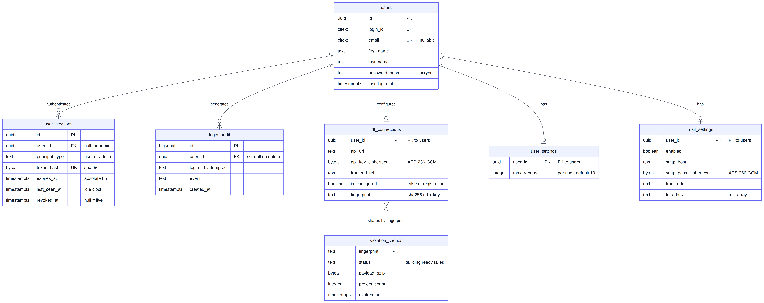
Figure 2 — Identity, session, per-user configuration and the shared violation cache.

7.2 Entity relationships — reports and scheduling
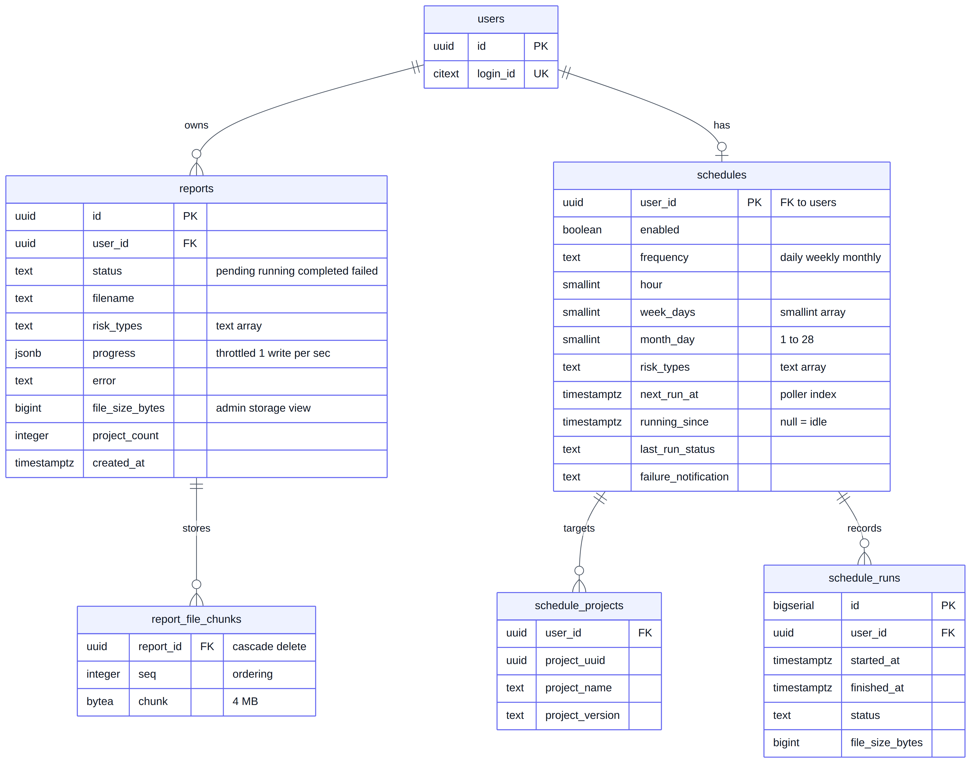
Figure 3 — Report storage and scheduling. Report bytes are held separately from report metadata.

7.3 Table specifications

users
Column | Type | Constraints | Notes
id | uuid | PRIMARY KEY | Generated with gen_random_uuid().
login_id | citext | NOT NULL, UNIQUE | Case-insensitive uniqueness without functional indexes. 3–64 characters.
email | citext | UNIQUE, nullable | Optional per requirements. Unique only among non-null values.
first_name | text | NOT NULL, CHECK length 3–128 | Letters and single internal spaces only.
last_name | text | NOT NULL, CHECK length 3–128 | Same rule as first name.
password_hash | text | NOT NULL | Format scrypt$N$r$p$salt$dk; parameters embedded so they can be raised later.
created_at | timestamptz | NOT NULL DEFAULT now()
updated_at | timestamptz | NOT NULL DEFAULT now() | Maintained by a trigger.
last_login_at | timestamptz | nullable | Surfaced in the administration panel.

user_sessions
Column | Type | Constraints | Notes
id | uuid | PRIMARY KEY
user_id | uuid | FK → users(id) ON DELETE CASCADE, nullable | Null for administrator sessions, which are file-authenticated.
principal_type | text | NOT NULL CHECK IN ('user','admin') | CHECK enforces that user_id is non-null exactly when the type is user.
token_hash | bytea | NOT NULL, UNIQUE | SHA-256 of the bearer token. The token itself is never stored.
issued_at | timestamptz | NOT NULL DEFAULT now()
expires_at | timestamptz | NOT NULL | Absolute expiry, issued_at + 8 hours by default.
last_seen_at | timestamptz | NOT NULL | Idle clock. Written at most once per minute per session.
revoked_at | timestamptz | nullable | Null means live. Set on logout and on force-disconnect.
user_agent | text | nullable | Shown in the force-disconnect prompt so the user recognises the other session.
ip_address | inet | nullable | Audit only.

The single-session rule is enforced by the database, not by application logic
CREATE UNIQUE INDEX ux_sessions_one_live_per_user
ON user_sessions (user_id) WHERE revoked_at IS NULL AND principal_type = 'user';

Two simultaneous logins therefore cannot both succeed. The loser receives a constraint violation and retries, rather than both sessions being issued because of a race in the application layer.

dt_connections
Column | Type | Constraints | Notes
user_id | uuid | PRIMARY KEY, FK → users(id) CASCADE | One connection per user.
api_url | text | NOT NULL DEFAULT '' | DependencyTrack API base URL.
api_key_ciphertext | bytea | nullable | AES-256-GCM ciphertext. Never returned to a browser.
api_key_nonce | bytea | nullable | Per-record 96-bit nonce.
frontend_url | text | NOT NULL DEFAULT '' | DependencyTrack UI base URL for deep links.
is_configured | boolean | NOT NULL DEFAULT false | False at registration. Drives the mock-data fallback.
fingerprint | text | nullable, INDEXED | SHA-256 of URL and key. Joins the user to a shared violation cache row.
updated_at | timestamptz | NOT NULL DEFAULT now()

reports and report_file_chunks
Column | Type | Constraints | Notes
id | uuid | PRIMARY KEY
user_id | uuid | NOT NULL, FK → users(id) CASCADE | Ownership. Every query is scoped by this column.
status | text | CHECK IN ('pending','running','completed','failed') | Same lifecycle as today.
filename | text | nullable | Set on completion.
risk_types | text[] | NOT NULL | Subset of security, license, operational.
progress | jsonb | NOT NULL DEFAULT '{}' | Per-risk-type counters. Written at most once per second.
error | text | nullable | Failure reason shown in the UI.
file_size_bytes | bigint | nullable | Storage accounting for the administration panel.
project_count | integer | nullable | Number of projects included.
created_at | timestamptz | NOT NULL DEFAULT now() | Sort key for the report list.
updated_at | timestamptz | NOT NULL DEFAULT now()
— report_file_chunks —
report_id | uuid | FK → reports(id) ON DELETE CASCADE | Deleting a report removes its bytes automatically.
seq | integer | NOT NULL | Chunk ordering; unique with report_id.
chunk | bytea | NOT NULL | 4 MB per row. Read in order through a cursor when streaming a download.

schedules, schedule_projects and schedule_runs
Column | Type | Constraints | Notes
user_id | uuid | PRIMARY KEY, FK → users(id) CASCADE | One schedule per user.
enabled | boolean | NOT NULL DEFAULT false
frequency | text | CHECK IN ('daily','weekly','monthly') | Unchanged semantics.
hour | smallint | CHECK 0–23 | Server local time.
week_days | smallint[] |  | 0 = Sunday. Used when frequency is weekly.
month_day | smallint | CHECK 1–28 | Capped at 28 so it is valid in every month.
risk_types | text[] | NOT NULL
next_run_at | timestamptz | nullable, INDEXED | Computed by the existing calcNextRun(). The poller's only search key.
running_since | timestamptz | nullable | Non-null marks a claimed schedule; provides per-user overlap protection.
last_run_at / last_run_status / last_run_error | timestamptz / text / text |  | Displayed in the settings panel.
failure_notification | text | nullable | Persists until the browser acknowledges it.
— schedule_projects — |  |  | Child table rather than an array: a user may select hundreds of projects, and counting or joining stays cheap.
user_id, project_uuid | uuid, uuid | UNIQUE together | Plus cached project_name and project_version.
— schedule_runs — |  |  | Execution history, retained 90 days.

violation_caches
Not owned by a user. One row represents one logical DependencyTrack connection, identified by fingerprint, and is shared by every user whose credentials produce that fingerprint.
Column | Type | Notes
fingerprint | text | PRIMARY KEY. SHA-256 of the normalised API URL and API key. The key itself is never stored here.
status | text | One of 'building', 'ready', 'failed'.
payload_gzip | bytea | The per-project count map, gzipped. Served with Content-Encoding: gzip, which reduces both table size and wire transfer for a highly repetitive JSON structure.
project_count | integer | Displayed in the dashboard banner.
failed_pipelines | integer | Surfaces partial-data warnings, as today.
generated_at / expires_at | timestamptz | TTL semantics unchanged from the current implementation.
progress | jsonb | Page counters for the build in flight.
error | text | Populated when the last build failed.

8. Security Design

8.1 Password storage
Passwords are hashed with `crypto.scrypt` at N=16384, r=8, p=1, using a 16-byte random salt and a 64-byte derived key. The encoded form embeds its parameters:
scrypt$16384$8$1$<base64 salt>$<base64 derived key>

Embedding the cost parameters allows them to be raised in future without invalidating existing credentials. Verification uses `crypto.timingSafeEqual`.
Performance note — asynchronous hashing is mandatory
At these parameters `scryptSync` blocks the event loop for roughly 100 ms per call. The asynchronous `crypto.scrypt` runs on the libuv thread pool instead, so a burst of concurrent logins cannot stall every other request in flight. This is a correctness requirement under load, not a preference.

8.2 Session tokens
Property | Design
Generation | crypto.randomBytes(32) encoded base64url — 256 bits of entropy.
Storage at rest | Only the SHA-256 of the token is stored. A database disclosure yields no usable session.
Transport | Authorization: Bearer <token> on every /violation-cache/* request.
Client storage | localStorage, which is shared across tabs of one browser but not across browsers — matching the stated requirement precisely.
Expiry | 8 hours absolute, 2 hours idle, both environment-tunable.
Revocation | Logout, force-disconnect and account deletion each set revoked_at and evict the in-process cache entry, making revocation immediate.

8.3 Administrator credentials
Written at install time to `violation-cache/data/admin-credentials.json` with mode 0600, never to the database:
{ "loginId": "admin",
"passwordHash": "scrypt$16384$8$1$…",
"createdAt": "2026-08-02T09:14:22.104Z" }

The login page carries an "Administrator login" checkbox. When ticked, credentials are validated against this file; when clear, against the `users` table. Registration must reject the configured administrator login ID — see decision D11.

8.4 Secrets at rest
The DependencyTrack API key and the SMTP password are encrypted with AES-256-GCM under `SECRET_ENCRYPTION_KEY`, with a per-record nonce and the authentication tag stored alongside. This is a material improvement on the current design, in which both values sit in plaintext on disk.

8.5 Threat mitigations
Threat | Mitigation
Credential stuffing / brute force | Per (login_id, ip) counter: five failures trigger a fifteen-minute lockout. Every attempt is written to login_audit.
User enumeration via the availability endpoint | Rate limited on the same limiter and audited. Responses never identify the account owner — the message is "already registered", never who registered it.
Session fixation / theft | Tokens are server-generated, never derived from user input, hashed at rest, and bound to an absolute and an idle deadline.
Cross-user data access | Every query is scoped by user_id. A request for another user's report returns 404, not 403, so existence is not confirmed.
SQL injection | Parameterised statements exclusively. No string concatenation into SQL anywhere.
Timing attacks on password and token comparison | crypto.timingSafeEqual for both.
Secret disclosure through the API | The DT API key is never returned in any response after this change. The UI reports only whether a key is configured.

8.6 Residual risks
- Loss of `SECRET_ENCRYPTION_KEY` renders every stored API key and SMTP password undecryptable. It must be treated as the single most important value to back up. Decryption failure surfaces to the user as "re-enter your API key" rather than as a service fault.
- The in-process token cache is not shared between replicas. A revoked token could remain valid on another replica for up to 60 seconds. Single-replica deployment is the supported topology; `LISTEN/NOTIFY` is the documented upgrade path.
- CORS remains open (`Access-Control-Allow-Origin: *`) for the documented iframe-embedding use case. Bearer-token authentication now gates the data behind it, so this is no longer an unauthenticated data exposure.

9. Functional Design

9.1 Registration and field validation
Validation rules are implemented once in `lib/validate.js` and mirrored verbatim in the frontend, so the two cannot drift. The frontend provides immediate feedback; the backend is the authority and re-validates everything.
Field | Rule | Frontend | Backend
First name | Mandatory. 3–128 characters. Unicode letters with single internal spaces. No leading or trailing space. | Format | Format
Last name | Mandatory. Identical rule to first name. | Format | Format
Login ID | Mandatory. 3–64 characters, [A-Za-z0-9._-], no spaces. Unique case-insensitively. Not a reserved name. | Format only | Format and uniqueness
Email | Optional. When supplied: valid format, no spaces anywhere, maximum 254 characters, unique case-insensitively. | Format only | Format and uniqueness
Password | Mandatory. 8–128 characters. Any character except space. | Format | Format
Confirm password | Must match the password. Added — not in the original requirement list. | Match | n/a

Uniqueness is verified only at the backend, as required, through `POST /auth/check-availability`, fired on field blur and again on submit. Registration remains wrapped in a transaction and relies on the unique constraint as the final arbiter — the blur check is a user-experience affordance, not a guarantee, because of the inherent time-of-check to time-of-use gap.
Message wording. The response never discloses the owner of an existing identifier: "This login ID is already registered." and "This email address is already registered."

9.2 Login and the single active session
When a user with a live session attempts to log in, the backend returns HTTP 409 with a distinct code and the metadata needed for an informed decision — when the other session started, when it was last active, and its user agent. The frontend renders this through the existing confirmation dialog. Choosing "no" leaves the user on the login page and revokes nothing; choosing "yes" repeats the request with a force flag, which revokes the previous session and issues a new token.

9.3 Profile and account deletion
- First name, last name and password are editable, using the same validators as registration.
- Login ID and email are rendered read-only and are never submitted. The backend additionally ignores them if present, so a crafted request cannot change them.
- Account deletion requires a typed confirmation, then cascades across sessions, configuration, schedules, reports and report bytes, logs the user out and returns them to the login page.

9.4 Per-user dashboard configuration
At registration, in the same transaction as the user row, the system seeds a `dt_connections` row with `is_configured = false` together with default `user_settings`, `mail_settings` and `schedules` rows. On login the dashboard requests its configuration:
- `is_configured = false` — the dashboard loads mock data and displays the existing demonstration-data banner.
- `is_configured = true` — the stored DependencyTrack URL and frontend URL are returned. The API key is never returned; the interface shows only that a key is configured, reusing the pattern already implemented for the current settings panel.

9.5 Reports in the database
- The `reports` table carries every field the current interface renders — identifier, status, filename, risk types, progress, error and creation time — plus the new file size and project count.
- Bytes are written as 4 MB chunks and streamed back in sequence order, so peak memory is one chunk rather than one file. This matters because the driver buffers whole values and encodes `bytea` in hexadecimal on the wire, which would otherwise roughly double the transient cost of a large download.
- The report limit is enforced per user rather than globally.
- Write amplification is corrected. The current implementation rewrites the whole registry file after every project and risk type — around 1,500 writes for a 500-project report. This becomes a single throttled row update at most once per second, with `fillfactor` 70 on the table and a lowered autovacuum threshold so heap-only-tuple updates keep bloat under control.

9.6 Multi-tenant scheduler
The existing `calcNextRun()` is a pure, well-tested function and is retained unchanged. Only its caller changes: one poller ticks every 60 seconds and claims due work using FOR UPDATE SKIP LOCKED, which provides per-user overlap protection, bounded concurrency and correctness even if the service were ever run as multiple replicas. A startup sweep clears rows orphaned by a restart, mirroring the existing behaviour that marks interrupted reports as failed.

9.7 Frontend changes
Change | Detail
New page login.html | A second standalone page — not a split of the dashboard, so the single-file rule for index.html is preserved. Three in-page views: login (with the administrator checkbox), registration, and a placeholder for password reset. Reuses the existing CSS custom properties and form classes so it is visually identical.
apiFetch() wrapper | One helper attaches the bearer token and centralises 401 handling. All 31 existing backend call sites in index.html are switched to it. Mechanical but wide-reaching; this is the single largest frontend edit.
Authentication gate | Inserted at the bootstrap tail, before theme initialisation and configuration loading. Redirects to the login page when no valid token is present.
Toolbar user menu | Added beside the existing Reports button, reusing the established dropdown pattern. Shows the display name, Profile, Logout, and Administration for administrator sessions.
Profile panel | Reuses the existing sliding settings-panel pattern rather than the modal pattern, matching the established convention for settings-style surfaces.
Browser storage | dt_session_token is added. dt_api_key, dt_api_url and dt_frontend_url are removed from the browser entirely, closing the current exposure of the API key to any script on the page.

10. Process Flows
The diagrams below specify the interaction between the browser, the service and the database for each critical path. They are the normative description of these flows.

10.1 Registration
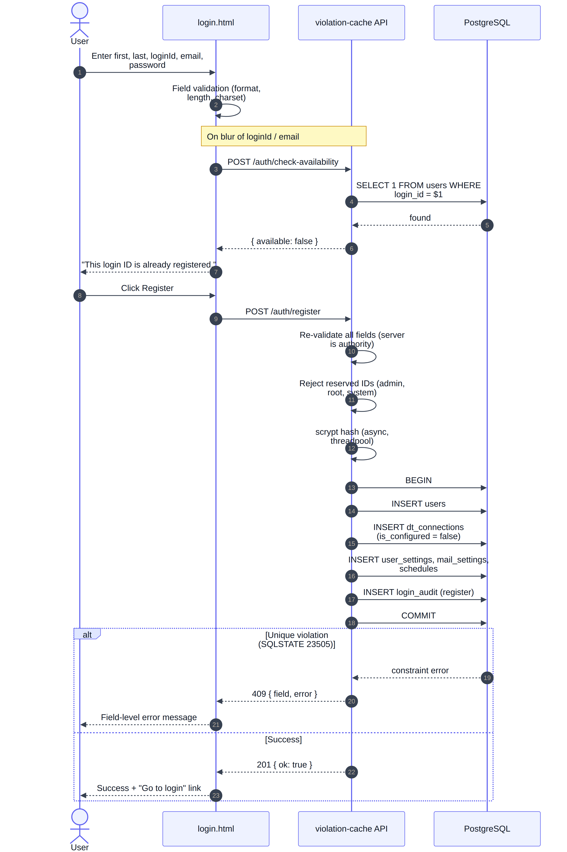
Figure 4 — Registration, including on-blur availability checking and the transactional seeding of dependent rows.

10.2 Login, including force-disconnect
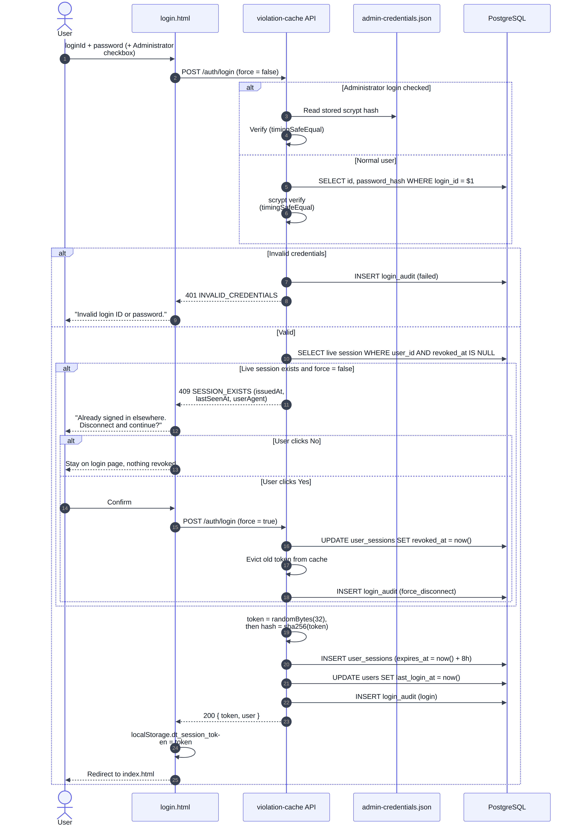
Figure 5 — Login covering administrator authentication, invalid credentials, and the single-active-session conflict.

10.3 Authenticated request and session rejection
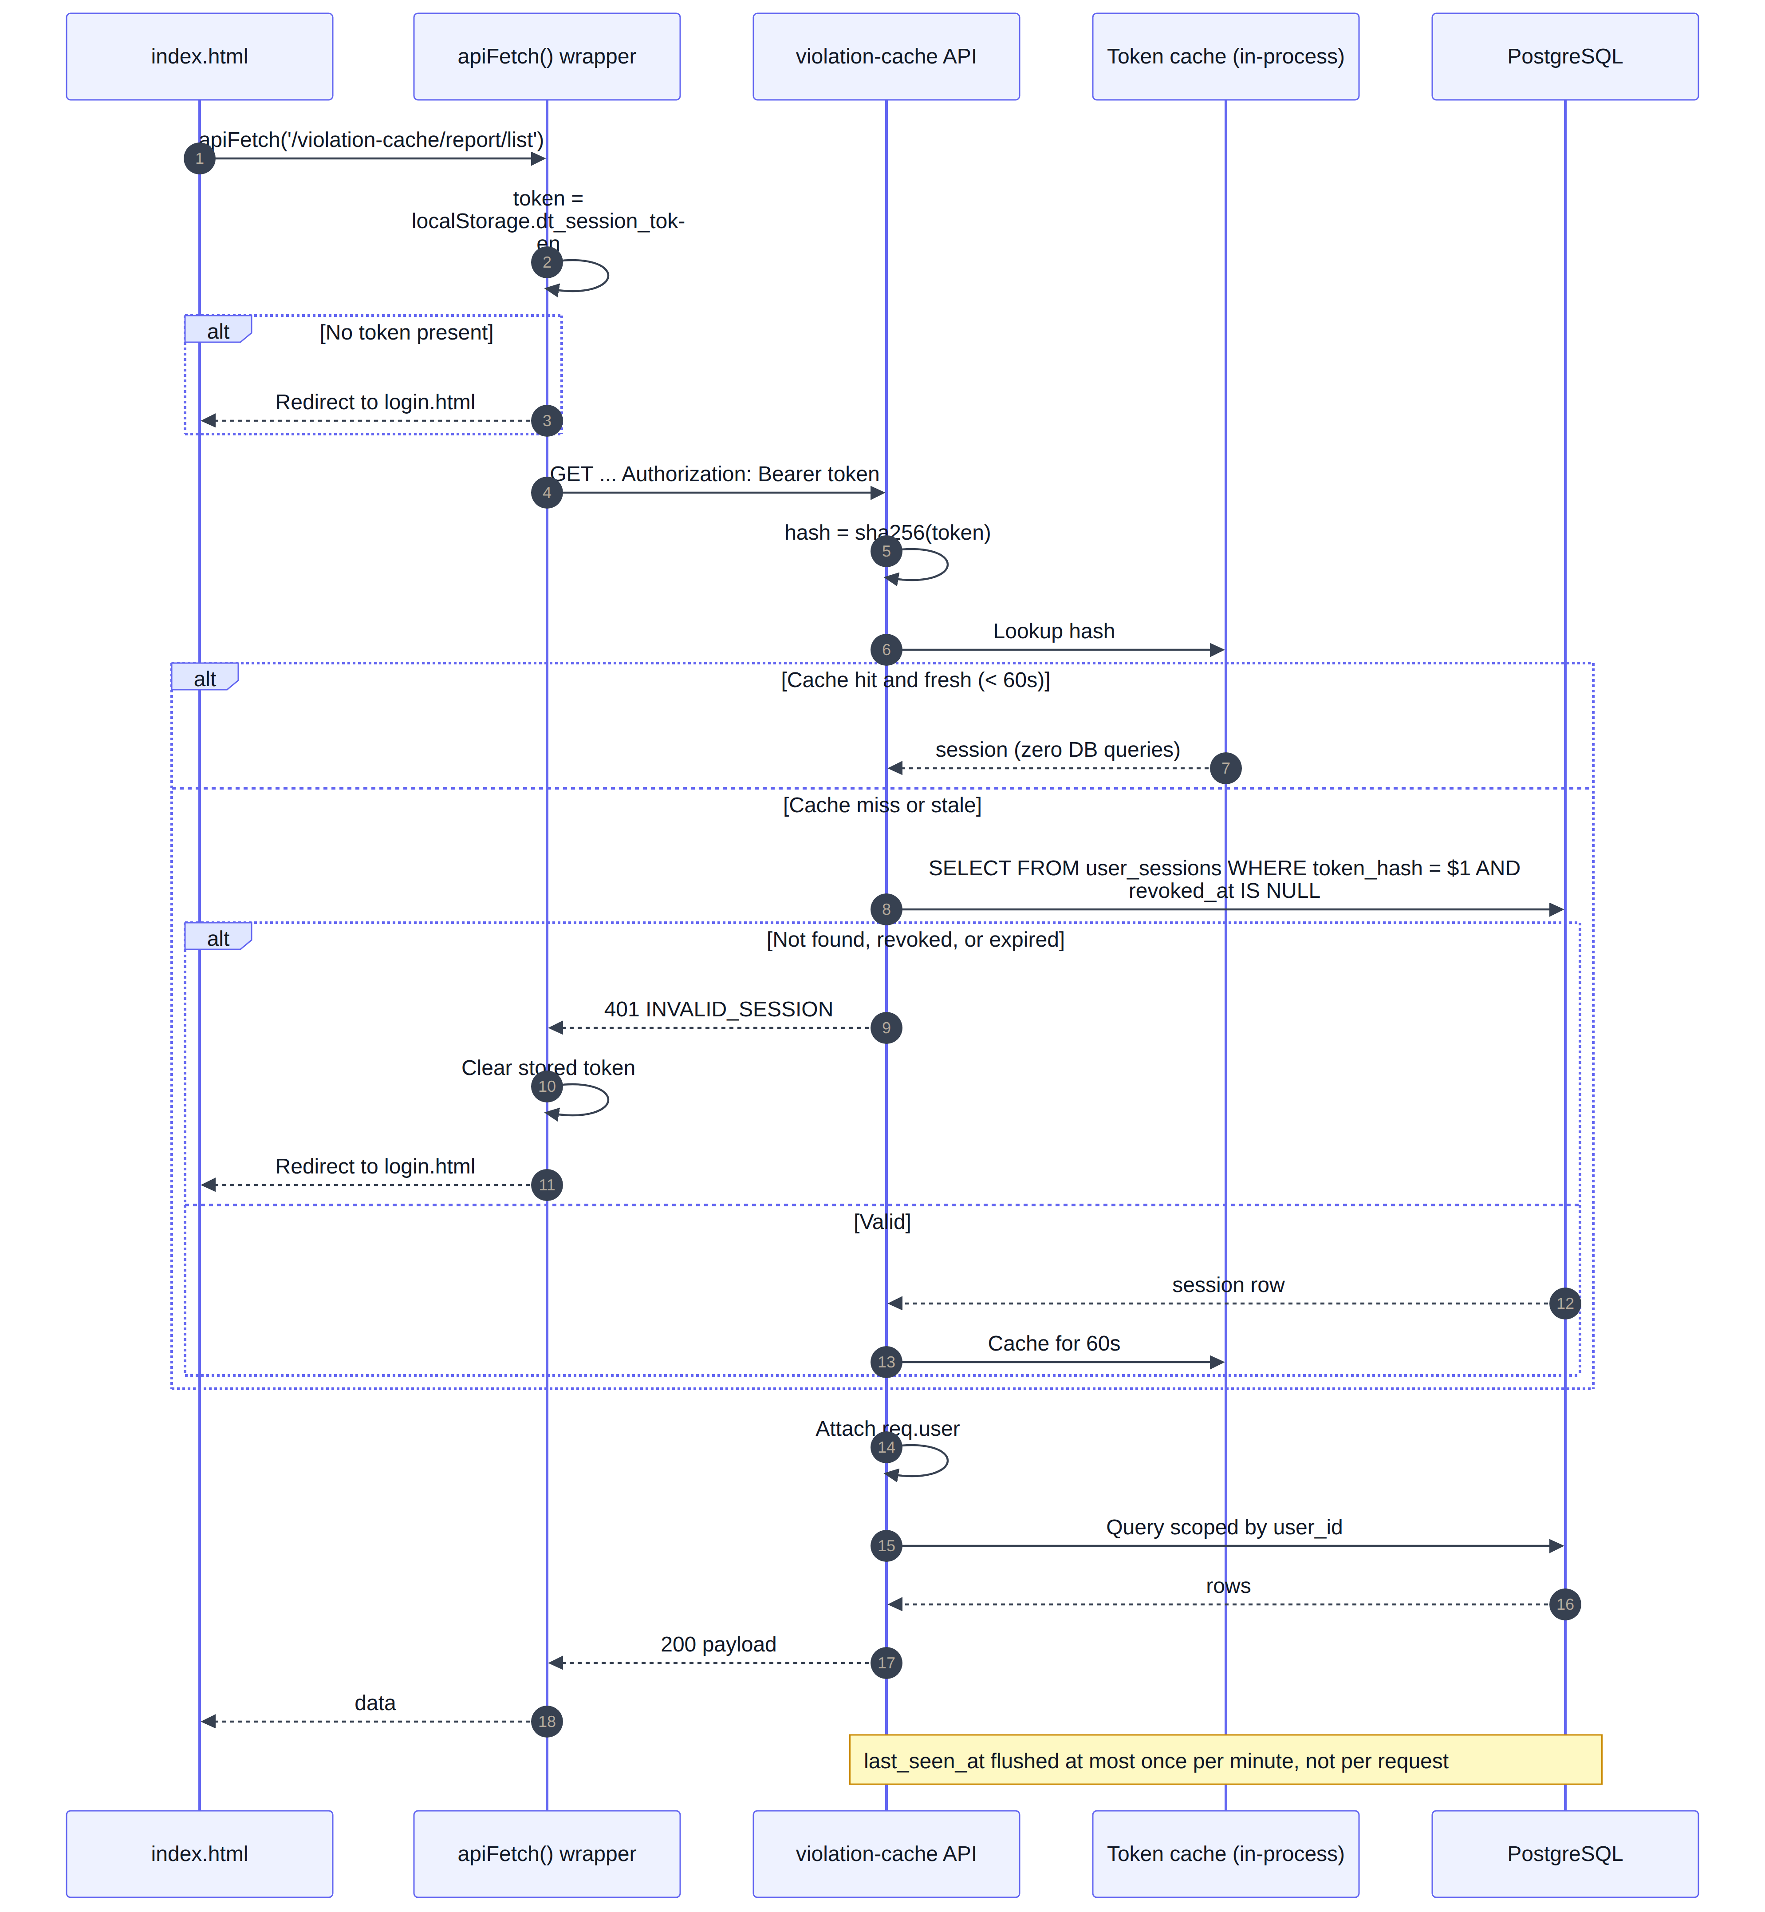
Figure 6 — The hot path. A cache hit costs no database query; an invalid session returns the browser to the login page.

10.4 Logout
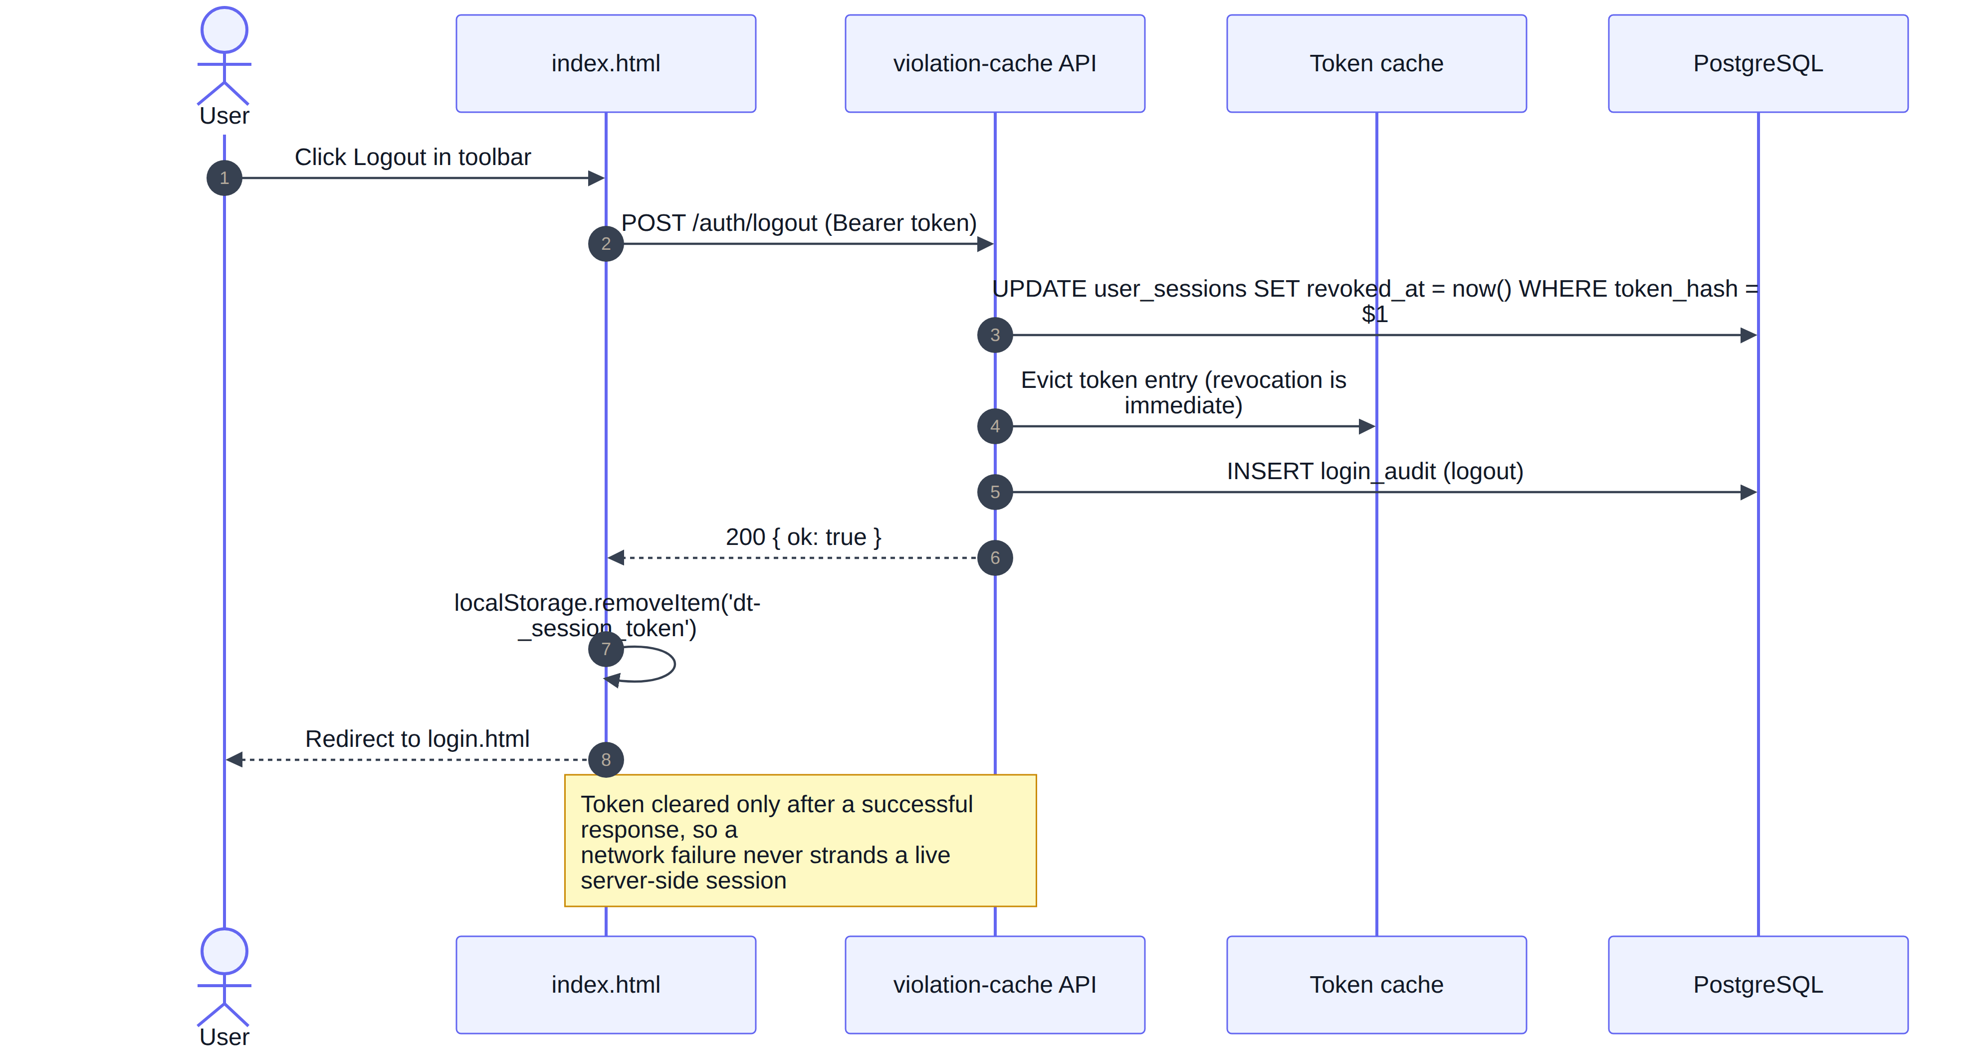
Figure 7 — Logout. The client clears its token only after the server confirms revocation.

10.5 Report generation and download
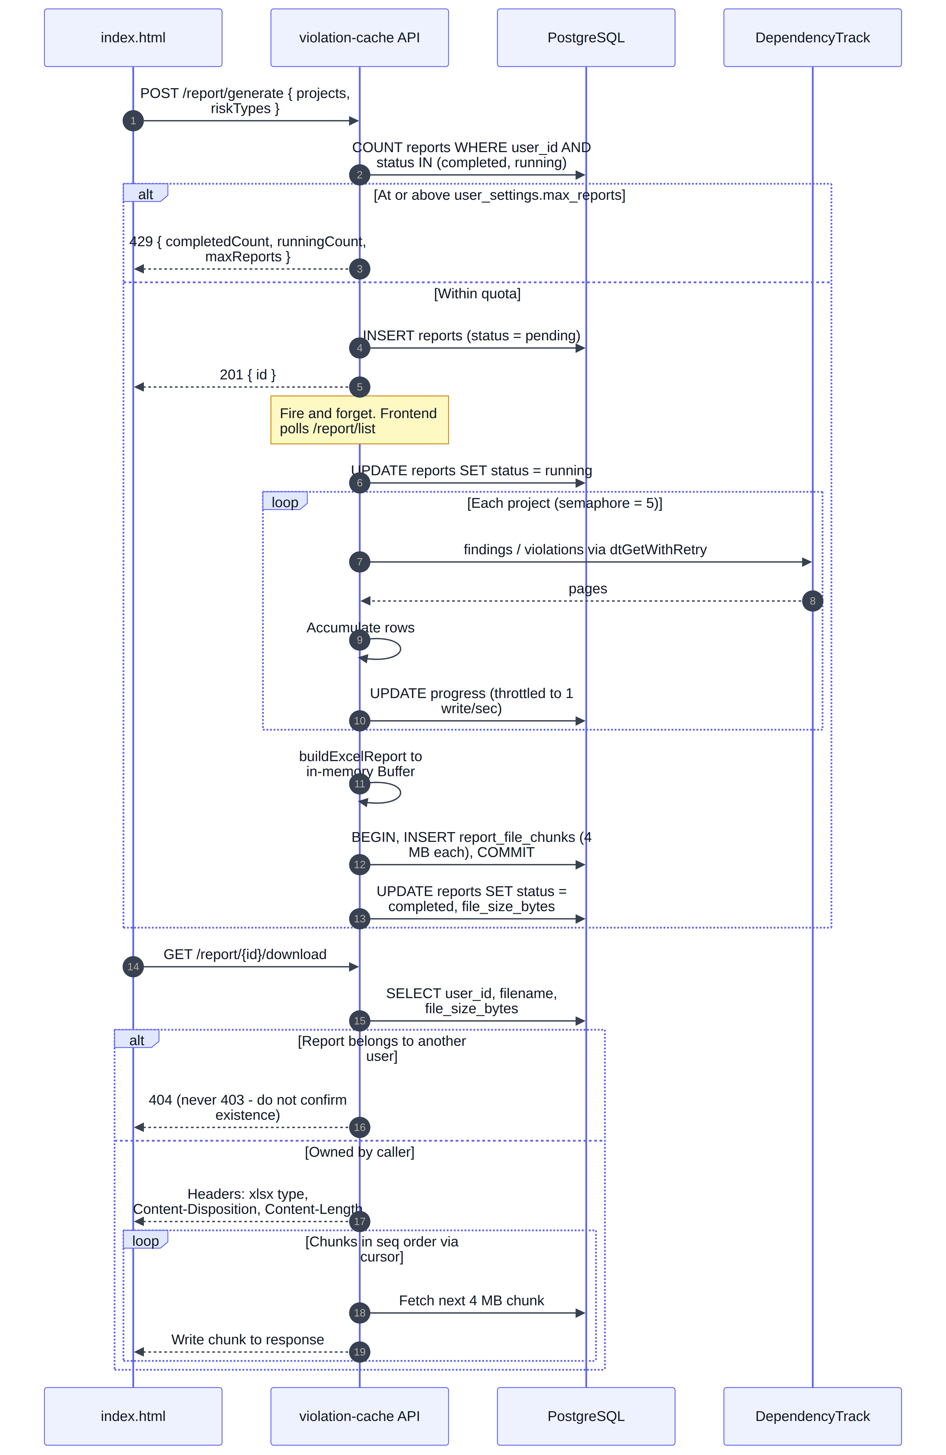
Figure 8 — Report lifecycle, per-user quota enforcement, throttled progress writes and chunked streaming download.

10.6 Scheduler tick
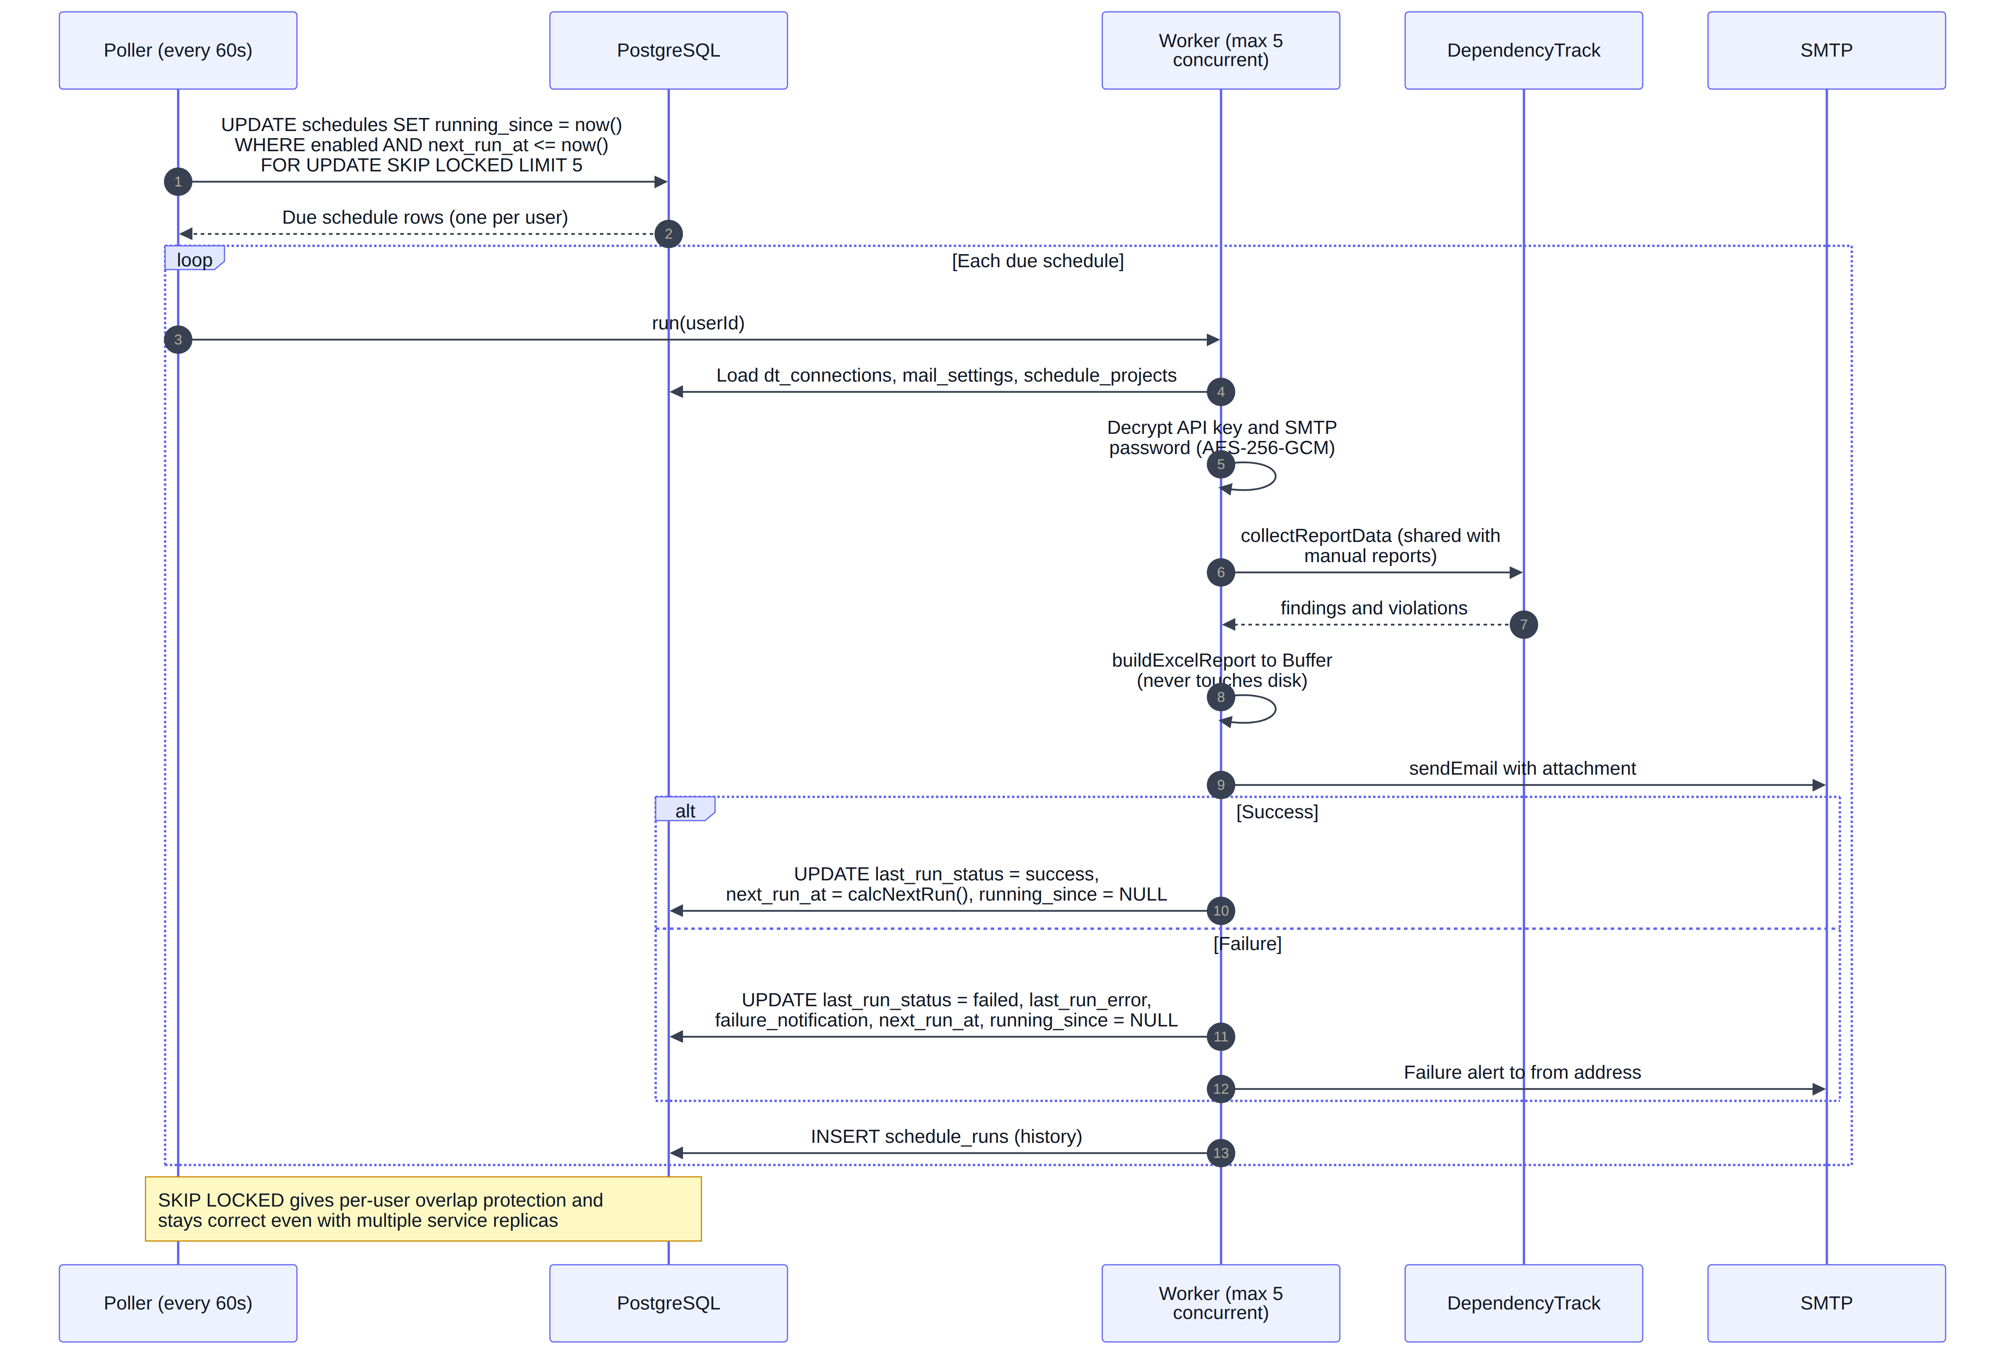
Figure 9 — The 60-second poller claiming due schedules with SKIP LOCKED and bounded worker concurrency.

10.7 Shared violation cache
This flow carries the largest single performance benefit in the migration. An advisory lock keyed on the connection fingerprint guarantees exactly one builder per DependencyTrack connection across the whole system: ten users sharing an instance trigger one crawl, and the other nine poll and receive the same result.
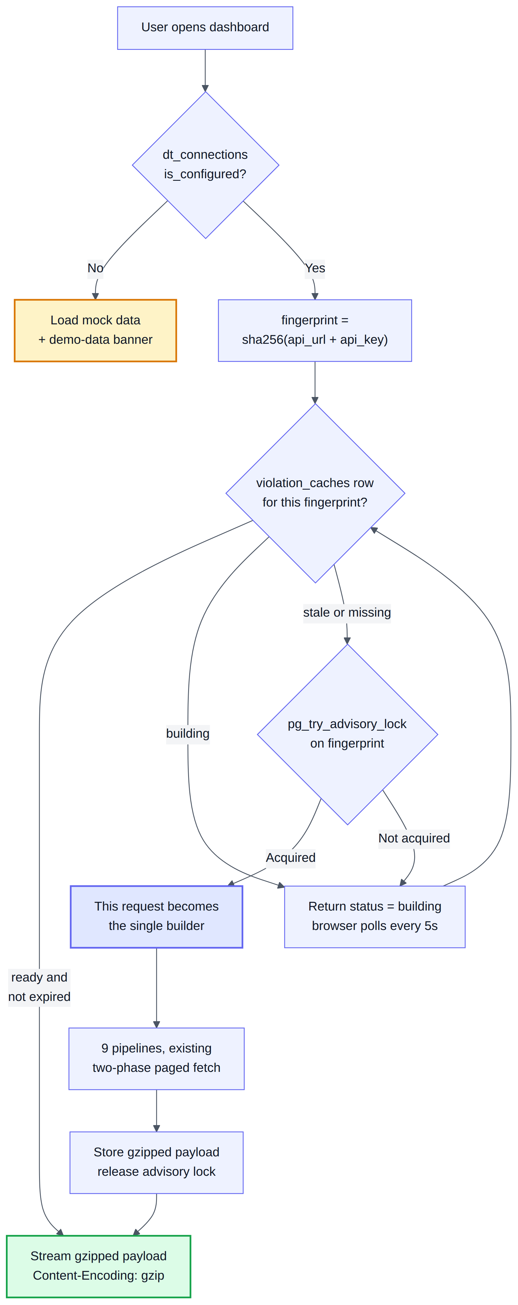
Figure 10 — Cache resolution, mock-data fallback and single-builder election.

11. Performance by Design
The requirement is that the application must not degrade as usage grows. Each risk below was identified from the current implementation and has a specific mitigation designed into the target state rather than deferred to tuning.

11.1 Load-risk register
# | Risk under load | Mitigation
1 | A database round trip to validate the token on every request | In-process token cache with 60-second revalidation and explicit eviction on revocation. A cache hit costs no query.
2 | An idle-clock write on every request | last_seen_at is flushed at most once per minute per session.
3 | Report progress write storm — around 1,500 whole-file rewrites per report today | Throttled to one row update per second, fillfactor 70, lowered autovacuum scale factor to favour heap-only-tuple updates.
4 | Memory spike when serving a large report | 4 MB chunked storage streamed through a cursor. Peak memory is one chunk.
5 | Listing reports dragging file bytes through the pool | Bytes live in a separate table. No list query joins it.
6 | N users causing N full portfolio crawls of DependencyTrack | Shared cache keyed by connection fingerprint, with an advisory lock electing a single builder.
7 | One timer per user schedule | A single poller claiming due rows with FOR UPDATE SKIP LOCKED, capped at five concurrent runs.
8 | Event-loop stalls during login bursts | Asynchronous scrypt on the thread pool; scryptSync is prohibited.
9 | Connection exhaustion | Pool capped at 15 against a server maximum of 50, with a 30-second statement_timeout.
10 | Unbounded table growth | Session sweeper every ten minutes; 90-day retention on schedule_runs and login_audit.

11.2 Index plan
Every index below is justified by a specific query in this document. No speculative indexes are created.
-- identity and authentication
CREATE UNIQUE INDEX ux_users_login_id ON users (login_id); -- citext
CREATE UNIQUE INDEX ux_users_email ON users (email) WHERE email IS NOT NULL;
CREATE UNIQUE INDEX ux_sessions_token ON user_sessions (token_hash);
CREATE UNIQUE INDEX ux_sessions_one_live_per_user
ON user_sessions (user_id) WHERE revoked_at IS NULL AND principal_type = 'user';
CREATE INDEX ix_sessions_expiry ON user_sessions (expires_at) WHERE revoked_at IS NULL;

-- reports: covers the list endpoint and the per-user quota count
CREATE INDEX ix_reports_user_created ON reports (user_id, created_at DESC);
CREATE INDEX ix_reports_user_active ON reports (user_id)
WHERE status IN ('completed', 'running');
CREATE UNIQUE INDEX ux_chunks ON report_file_chunks (report_id, seq);

-- scheduler poller: the only search key it uses
CREATE INDEX ix_sched_due ON schedules (next_run_at)
WHERE enabled AND running_since IS NULL;

-- shared cache and audit
CREATE INDEX ix_caches_expiry ON violation_caches (expires_at);
CREATE INDEX ix_audit_user_time ON login_audit (user_id, created_at DESC);

11.3 PostgreSQL tuning
Applied as command-line flags on the container so they are visible in the compose file and require no configuration file management.
Setting | Value | Reason
shared_buffers | 256MB | Approximately 25 per cent of a 1 GB container allocation.
effective_cache_size | 768MB | Informs the planner about available operating-system cache.
work_mem | 8MB | Sufficient for the sorts and aggregations in this workload without risking exhaustion across concurrent connections.
maintenance_work_mem | 64MB | Speeds index creation and vacuuming.
max_connections | 50 | Comfortably above the pool ceiling of 15, leaving headroom for administrative tooling.
random_page_cost | 1.1 | Reflects solid-state storage; encourages index scans.
checkpoint_completion_target | 0.9 | Smooths checkpoint write bursts.
wal_compression | on | Reduces write-ahead log volume, which matters given the report byte writes.
log_min_duration_statement | 500ms | Slow-query log for ongoing observability.

11.4 Evidence required before sign-off
- EXPLAIN (ANALYZE, BUFFERS) output for the five hot queries — session validation, report list, quota count, due-schedule claim and cache resolution — attached to the pull request, each demonstrating an index scan rather than a sequential scan.
- A concurrency test showing twenty simulated users on one DependencyTrack connection producing exactly one violation cache build.
- `pg_stat_activity` observed never to exceed the configured pool maximum during that test.

12. Infrastructure and Deployment

12.1 Compose additions
The database service follows the conventions already established in the compose file — the `dt-` container naming prefix, `restart: unless-stopped`, JSON file logging with rotation, and the same health-check interval, timeout and retry values.
dt-postgres:
image: postgres:16-alpine
container_name: dt-postgres
restart: unless-stopped
environment:
POSTGRES_USER: "${POSTGRES_USER:-dtdash}"
POSTGRES_PASSWORD: "${POSTGRES_PASSWORD:?set in .env}"
POSTGRES_DB: "${POSTGRES_DB:-dtdash}"
ports:
- "${POSTGRES_PORT:-5432}:5432" # external DBA tooling
volumes:
- ./violation-cache/pgdata:/var/lib/postgresql/data
command: >
postgres -c shared_buffers=256MB -c effective_cache_size=768MB
-c work_mem=8MB -c maintenance_work_mem=64MB -c max_connections=50
-c random_page_cost=1.1 -c checkpoint_completion_target=0.9
-c wal_compression=on -c log_min_duration_statement=500ms
healthcheck:
test: ["CMD-SHELL", "pg_isready -U ${POSTGRES_USER:-dtdash}"]
interval: 30s
timeout: 5s
retries: 3
start_period: 20s

The cache service gains a health-gated dependency on the database. This is a new pattern for this compose file, which uses no `depends_on` today.

12.2 Critical finding — volume destruction on uninstall
A named Docker volume would be destroyed silently by the existing uninstaller
install.sh runs `docker compose down -v` unconditionally on any uninstall, and the confirmation banner is hand-written prose that lists only the two containers and the network — it does not mention volumes at all. Today this is harmless because the compose file defines no named volumes and uses bind mounts exclusively.

A named volume for the database would therefore be deleted by `--uninstall` with no warning and no code change. This plan deliberately specifies a bind mount (./violation-cache/pgdata) instead, which survives, and additionally requires the uninstall banner and the installation documentation to name the database explicitly and add a confirmation.

12.3 Installer changes
Action | Detail
Remove DependencyTrack prompts | The API URL, frontend URL and API key prompts, together with the live API-key validation call, are removed. Those keys also leave the strip pattern and the rewrite that persists values to .env, and the closing summary that reports them.
Add administrator credential step | Prompts for an administrator login ID and password, honouring SCA_ADMIN_USER and SCA_ADMIN_PASSWORD and defaulting to admin / ScaAdmin@dt8624. The password is hashed before being written to admin-credentials.json with mode 0600.
Generate secrets | A database password and the secret encryption key are generated when absent.
Start the database | The service start step lists services explicitly and passes --no-deps; the database must be added and the flag reconsidered now that a health dependency exists.
Update the uninstall banner | Name the database container and any data directory, and confirm before destroying data.
Extend .gitignore | Neither .env nor the runtime data directory is currently ignored, so a live secret can be committed by accident today. The new credentials file and database directory must be added along with them.

12.4 Documentation impact
Document | Sections requiring rework
docs/INSTALLATION.md | Quick install prompt table, non-interactive install, the configuration reference, uninstall data-retention claims, and the troubleshooting steps that inspect DT_API_KEY.
docs/DASHBOARD_INTEGRATION.md | The network-call overview, connection methods A and C, and the statement that the SMTP password is stored in app-config.json.
README.md | Quick start, the container table, and the environment-variable table. Note that the "zero npm dependencies" claim is already inaccurate today and should be corrected in the same pass.
CLAUDE.md | The coding standards explicitly prohibit a database and any dependency beyond the two present. These rules must be updated as part of the foundation phase — this is a deliverable, not an afterthought.

13. Test Strategy
The project runs 299 tests today on the Node.js built-in test runner with no test framework installed, following a convention of duplicating the function under test rather than importing the server module, so that no test starts an HTTP listener. That convention is preserved for pure functions and extended with a second tier for database-backed code.
Tier | Trigger | Coverage
Pure unit | node --test — always runs, no database required | Every validation rule including the boundary cases in the requirements; scrypt hash and verify round-trip plus rejection of a tampered hash; token minting and hashing; AES-256-GCM round-trip and authentication-tag failure; fingerprint stability; token-cache expiry logic; and the existing calcNextRun suite, which must continue to pass unchanged.
Database integration | Runs only when TEST_DATABASE_URL is set, so the default suite stays offline | Migrations apply cleanly and are idempotent; the single-live-session partial index genuinely rejects a second session; cascade deletion removes sessions, configuration, schedules, reports and chunks; chunked byte round-trip is byte-for-byte identical; SKIP LOCKED claims each schedule exactly once under concurrency.
Route and authorisation | node --test with a stubbed data layer | Every route rejects a missing, malformed or expired token with 401; a request for another user's report returns 404; the profile endpoint ignores login ID and email even when submitted; registration rejects reserved administrator names.

Target. The 299 existing tests remain green, with approximately 120 to 150 new tests added across the three tiers.

14. Delivery Plan and Effort
Effort is expressed in person-days for one experienced engineer and includes tests and code review within each phase. Phases 2 and 3, and phases 5 and 6, may be run in parallel across two engineers.
# | Phase | Scope | Days
0 | Foundations | Database service and tuning flags, bind mount, migration runner with advisory locking, connection pool, configuration module, Dockerfile COPY changes, coding-standards update. | 4
1 | Schema and data access | All twelve tables, indexes, constraints, data-access modules, database test harness. | 5
2 | Authentication backend | scrypt, AES-GCM, token minting, session logic, token cache, rate limiter, administrator credential file, /auth/* routes, authentication middleware across all routes. | 6
3 | Authentication frontend | login.html with three views, mirrored validation, availability checks, apiFetch wrapper across 31 call sites, authentication gate, user menu, profile panel, account deletion. | 6
4 | Per-user DependencyTrack configuration | Connection table, encryption at rest, is_configured and the mock-data fallback, configuration endpoint rework, removal of API-key disclosure. | 4
5 | Per-user settings and scheduler | Settings, mail settings, schedules and their child tables; the polling scheduler; in-memory scheduled reports; failure notifications. | 6
6 | Reports in the database | Report tables and chunked storage, per-user quota, streaming download, throttled progress, size accounting. | 6
7 | Shared violation cache | Fingerprinting, cache table, advisory-lock single-builder election, gzip payload, status and polling rework. | 4
8 | Installer, infrastructure, documentation | Installer rewrite, credential and secret generation, uninstall safety, .gitignore, README and both documents. | 3
9 | Administration panel | User listing endpoint, storage aggregation, frontend panel, administrator session guard. | 3
10 | Performance validation | Query plan evidence, pool and timeout tuning, concurrent-user load test, autovacuum verification. | 3
 | Total |  | 50

14.1 Milestones
Milestone | Phases | Days | Demonstrable outcome
M1 — Authentication | 0–3 | 21 | Users can register, log in, manage their profile and log out. The dashboard is gated but still single-tenant behind it. This milestone retires the largest technical unknown first and is independently demonstrable.
M2 — Tenant isolation | 4–7 | 20 | Every user has their own DependencyTrack connection, settings, schedule and reports. The shared cache and polling scheduler are live.
M3 — Release readiness | 8–10 | 9 | Installer, documentation, administration panel and performance evidence complete.

14.2 Estimating assumptions
- One experienced engineer familiar with this codebase; add roughly 25 per cent for an engineer new to it.
- Tests are written within each phase, not deferred to the end.
- A realistic range including integration friction is 48 to 58 person-days; the table above is the central estimate.
- No external identity provider, no destructive administrative functions and no data migration are included — see Section 3.2.

15. Risk Register
# | Risk | Impact | Likelihood | Mitigation
R1 | The existing uninstaller destroys the database volume | Critical — total data loss | High if unaddressed | Bind mount rather than a named volume; uninstall banner rewritten to name the database; explicit confirmation added.
R2 | SECRET_ENCRYPTION_KEY lost or rotated without re-encryption | High — all stored API keys and SMTP passwords unrecoverable | Medium | Generated at install; documented as the primary value to back up; decryption failure surfaces as a prompt to re-enter the key rather than a fault.
R3 | Report byte storage grows without bound | High — the database volume fills and writes stop | Medium | Per-report size recorded, per-user report quota enforced, administration panel exposes totals; a global cap is a fast follow.
R4 | The apiFetch refactor misses a call site | Medium — a feature silently breaks | Medium | 31 sites enumerated and grep-verified; a missed site fails loudly with 401 rather than degrading quietly.
R5 | Coding standards contradict the plan | Medium — implementation drift and review friction | Certain | The standards document is updated in phase 0 as an explicit deliverable.
R6 | Token cache staleness across replicas | Low under the supported topology | Low | Single replica is supported and documented; LISTEN/NOTIFY is the identified upgrade path.
R7 | Availability endpoint enables account enumeration | Low | Medium | Rate limited and audited; responses never identify the owner of an identifier.
R8 | Scope growth around administrative functions | Medium — schedule slippage | Medium | The panel is explicitly read-only for this delivery; destructive actions are listed as out of scope in Section 3.2.

16. Verification and Acceptance
The following must all pass before the migration is considered complete.
# | Check | Expected result
1 | Run the default test suite | The 299 existing tests remain green alongside the new pure and route tiers.
2 | Run the integration tier against a disposable database | Migrations, constraint enforcement, cascade deletion and chunk round-trips all pass.
3 | Run the installer on a clean checkout | Three containers healthy; the credentials file created with mode 0600; no DependencyTrack value written to .env.
4 | End-to-end user journey | Register, log in, observe mock data for an unconfigured account, configure a connection, observe live data, generate and download a report, delete the account, then confirm login fails.
5 | Two-browser session test | A second login returns the session conflict; on confirmation the first browser's next request receives 401 and returns to the login page.
6 | Two-tab session test | Both tabs share the session; a logout in one is observed by the other.
7 | Query plan review | All five hot queries use index scans.
8 | Concurrency test | Twenty simulated users on one connection produce exactly one cache build; pool usage never exceeds its ceiling.
9 | Cross-user authorisation probe | A request for another user's report returns 404.
10 | Secret disclosure probe | No endpoint returns a DependencyTrack API key or SMTP password in any response.

Appendix A — API Surface

A.1 New endpoints
Method and path | Authentication | Purpose
POST /auth/register | None | Create an account and seed its configuration rows.
POST /auth/check-availability | None, rate limited | Backend uniqueness check for login ID and email.
POST /auth/login | None | Authenticate; accepts an administrator flag and a force flag.
POST /auth/logout | Bearer | Revoke the current session.
GET /auth/me | Bearer | Return the current principal for the authentication gate.
GET /profile | Bearer | Read the profile.
PUT /profile | Bearer | Update first name, last name and password only.
DELETE /auth/account | Bearer | Delete the account and all owned data.
GET /admin/users | Bearer, administrator | Read-only user listing with storage totals.

A.2 Existing endpoints
All sixteen existing routes are retained with their current shapes and status codes, with two changes: every route now requires a bearer token and returns 401 without one, and every query is scoped to the authenticated user. The configuration endpoint no longer returns the DependencyTrack API key.

Appendix B — Open Questions for Review
These require a decision at the review meeting. Recommendations are repeated from Section 4.2.
# | Question | Recommendation | Decision
D9 | Does account deletion free the login ID and email for re-registration? | Yes — hard delete with cascade.
D10 | What login ID format should be enforced? | 3–64 characters, [A-Za-z0-9._-], case-insensitive unique.
D11 | How are administrator login collisions prevented? | Reserve the configured administrator ID plus root and system.
— | Is a single service replica an acceptable supported topology for launch? | Yes for this delivery; the scale-out path is documented.
— | Is deferring self-service password reset acceptable for the first release? | Yes, provided the administrator can be contacted out of band.
— | Should a global storage ceiling be added before launch rather than as a fast follow? | Fast follow; per-user quotas and visibility ship in this delivery.

End of document.

