Land Mobile Services

User’s Guide

1. PROGRAM REQUIREMENTS

To begin the program, select LMS - Land Mobile Services from the Propagation menu

On program startup, an information dialog box is displayed describing the overall models and suggestions on selecting a model based on the input parameters. The dialog box also contains a checkbox option for not displaying on subsequent runs. Pressing the OK button will close the information dialog box and proceed to the main program.

The program is used to calculate and display loss and field strengths for the following models: ITU 529, Okumura-Hata-Davidson, and Cost 231. Chart 1 depicts the main functions.

2. CALCULATIONS

2.1 Single Calculations

Initially the user is presented with a dialog box containing input and output values (see Figure 1). To calculate model values, the user enters the following parameters:

Table 1 – Input Parameters

Parameter Range
Frequency Range 30 MHz to 2000 MHz
Distance Range 0 to 300 Km
Area Type Urban, Suburban, Rural
City Size Small / Medium, Large
Base Antenna Height 1m to 2500m
Mobile Antenna Height 1m to 10m
Power Enter in Watts or kW
Percent of Time 1% to 99%
Precent of Location 1% to 99%

If parameters are entered that fall out of the allowable range, a dialog box appears informing the user of the correct range, and the parameter is then set to a default value.

2.2 Units

Parameters can be entered using either English or Metric units. To specify the units select Units then either English or Metric.

2.3 Calculate

Pressing the calculate button causes the program to update the dB Loss and Field strength values. Values that are out of range for a model will appear with a red background. To have the out of range values blacked out, the user selects Hide out of range values from the calculate menu. To have out of range values appear in red again, select Show Out of Range Values from the calculate menu.

Table 2 – Model Ranges
Valid Model Ranges are as follows:
Model | Distance (Km) | Frequency (MHz) | Base Antenna Height (m) | Mobile Antenna Height (m)
ITU 529 | ≤ 100 | 150 to 1500 | 30 to 200 | 1 to 10
Davidson | ≤ 300 | 30 to 1500 | 20 to 2500 | 1 to 10
Cost 231 | ≤ 100 | 1500 to 2000 | 30 to 200 | 1 to 10

Every time new values are calculated with the calculate button, the new model values are updated on the screen and also saved to a report log. The report log maintains a table of values that can be viewed, printed and stored. The report can also be cleared. To view the Report Calculation Log, select Calculations, then View Output Report from the main menu.

2.4 Out of Range Parameters

To determine if the parameters entered are in a valid range for a particular model, click on the model name on the lower half of the display using the left mouse button. Text will appear below the input parameters describing the valid range for that model. In addition, the parameters that fall out of range for the model will appear with a red background. When the left mouse button is released, the display will return to normal.

2.5 The Report Calculation Log

The Report Calculation Log displays the calculation history in a scrollable list (see Figure 5). Selections are provided below the log to Clear, Print and Save the Log to a file. When saving the report log, you can choose a file type of .txt or .rtf. Selecting type .txt will save the report log as straight text loosing all formatting including underlines. Selecting the .rtf format will save the file as a rich text file that preserves all formatting. The .rtf file can be read directly into Microsoft Word. Note that values falling out of range for a model, as specified in Table 2, are displayed with an underline.

2.6 Calculate Values over Distance

A set of values can be calculated for a range of distances. This is accomplished by selecting Report for Distance Range from the Calculations main menu choice. This will bring up a dialog box providing choices for entering the start distance, end distance and step rate (see Figure 6). The step rate specifies the increments taken, as the model values are calculated from the start to the end distance. This can also be used to have the values generated in descending order by having a larger end value than start value and specifying a negative step increment.

A check box is provided indicating whether to clear the log before updating it with the calculated values. Pressing the Begin Sending Distance Range to Log button will start the process. However, if invalid start, end or step values have been specified, a dialog box will be displayed indicating the problem and the values will be automatically corrected. As the values are calculated a progress bar indicates how far along the calculation process has gone. The routine can be exited early by pressing the Exit Calculations button. The values thus far calculated will still be saved to the Report Calculation Log. If calculations are allowed to run to completion, the log will be automatically displayed. Since this is the same log used to display all calculations, resulting values will be appended to the bottom of this list. To clear the log, press the Clear button from the Report Calculation Log dialog box.

2.7 Graphing the Results

A comparison of model calculations for loss (see Figure 2) and field strength (see Figure 3) over distance can be displayed from the Graph menu choice. In the case of field strength values, the user can also select to display results for individual models in addition to the comparison (see Figure 4).

The graph is display in the upper portion of the dialog box, with the lower portion showing input parameters. The user can change the input parameters, then have the graph recalculated by pressing the Update Graph button. Note that when values have been changed, the background of the Update Graph button will change from blue to red. This is to indicate the values have changed and the graph needs to be updated. Menu choices are provided for specifying the units, and selecting the maximum calculated distance of 100 km or 300 km. In the case of field strength, additional menu choices are provided for displaying individual models and for hiding or displaying measured data.

The graph can be printed in three ways:
- Double click on the graph. This will bring up the properties dialog box. From this select the print tab. Pressing the Printer Setup button will allow you to change the selected printer and the paper orientation. To send the graph to the printer press print from the print tab.
- Select Print from the File tab. This will bring up a Print Graph dialog box containing three buttons: Printer Setup, Print and OK. Selecting the Printer Setup button will allow you to specify a printer and page orientation, Print will print out the graph and OK will close the dialog box.
- Press the Print Graph button below the graph. This will cause the above-mentioned Print Graph dialog box to appear.

The X-Y axes can be modified by double-clicking on the graph, then selecting the axis from the properties dialog box.

The graph can be saved as a Windows Meta File. The .WMF file can be read directly into Microsoft Word by selecting Insert, then Picture, then From File from the MS Word main menu.

A menu selection has been added to plot measured data with the model data. Though the option exists, it is meant for future use.

3. HELP

A series of help screens have been created to explain how to run the program. To call up the main Okumura-Hata help screen select General from the Help menu choice. The help screens also provide information on the individual models and the calculations used in the code. Pressing the F1 key will also bring up the help screen. Under the Help menu choice the user can select About for information on the program authors, or How to Use Help for general information on how to use the windows help system.

An information screen is displayed at the initial program startup. This screen contains a checkbox option to not be displayed on subsequent runs. Selecting Hide Startup Help from the Help menu will also turn off the startup information screen. Once the startup information screen has been turned of, it can be turned back on by selecting Show Startup Help from the Help menu.

4. EXITING THE PROGRAM

To exit the program, select Exit from the File menu choice. The program will automatically save the parameters displayed on the screen and recall them the next time the program is run. The values are saved in the system registry.
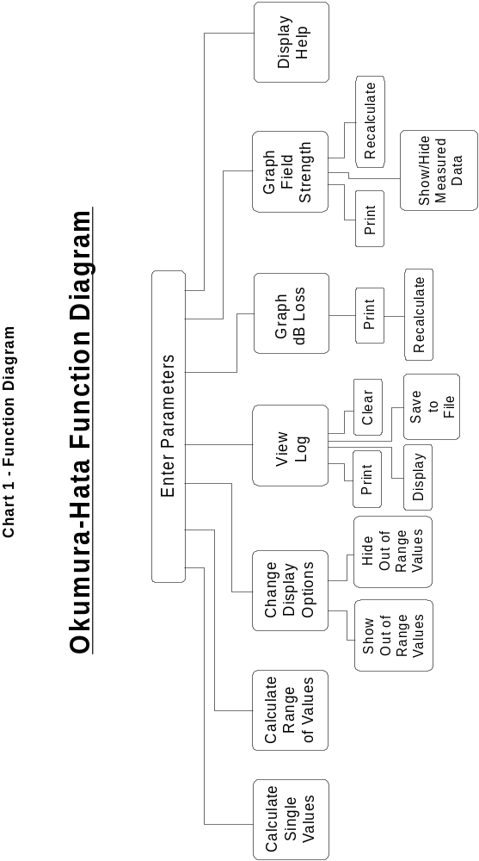

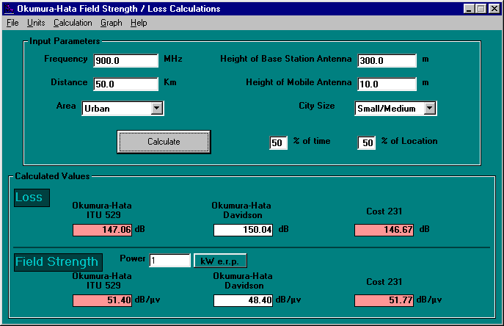
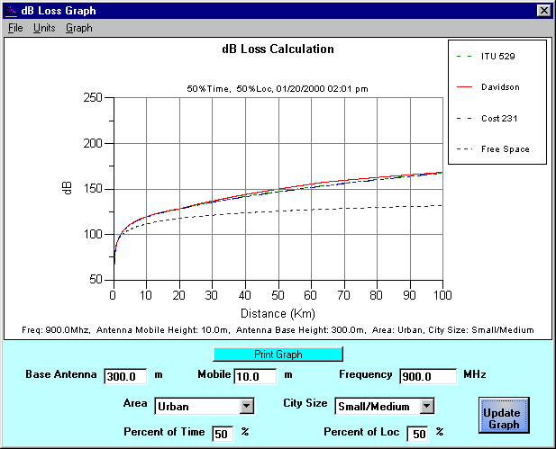
Figure 1 - Main Screen
Figure 2 - dB Loss Graph Screen
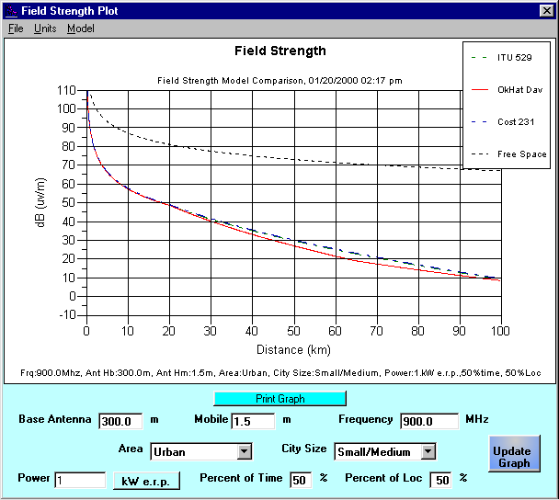
Figure 3 - Field Strength Comparison Graph
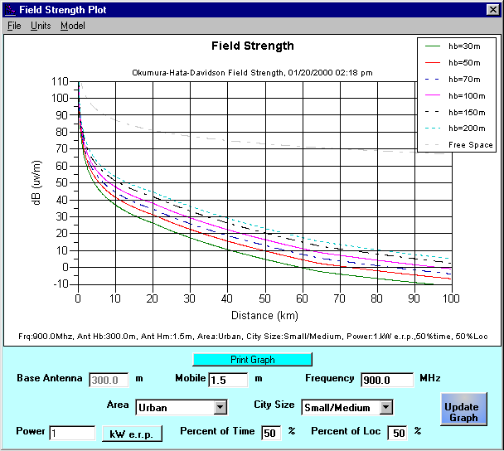
Figure 4 - Field Strength Single Model Graph Screen
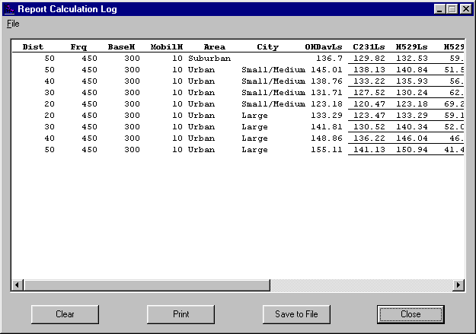
Figure 5 – Report Calculation Screen

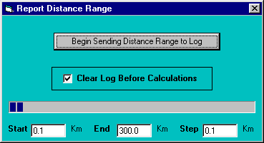
Figure 6 - Report Distance Range Screen

