**REPORT**

**MATHEMATICS FOR AI**

**23MAT231M**

Submitted by

BL.EN.U4ECE22136 NAME: M ROHITH REDDY

BL.EN.U4ECE22149 NAME: T DHEERAJ

BL.EN.U4ECE22162 NAME: B SRIDHAR

**ELECTRONICS AND COMMUNICATIONS**

**ENGINEERING**

**(ECE)**



**AMRITA SCHOOL OF ENGINEERING, BANGALORE**

**AMRITA VISHWA VIDYAPEETHAM**

**BENGALURU -560035**

**April-2024**

**Autonomous UAV Navigation with Sensor Fusion, Obstacle Detection, and Path Optimization Using Singular Value Decomposition (SVD)**

**Abstract**

In the case of autonomous aerial systems, strong navigation techniques are important to provide efficiency and safety in dynamic environments. This paper introduces a complete UAV navigation system that integrates sensor fusion, obstacle detection, and real-time path optimization. The system works on raw UAV trajectory data and utilizes Singular Value Decomposition (SVD) to provide trajectory smoothing and dimensionality reduction. At the same time, on-board sensor data-based obstacle data are combined in order to create awareness and adaptability of routing. The analysis considers measures including deviation of trajectories, smoothness, and avoidance from obstacles with consideration of path precision versus computing complexity. Plot displays of the initial path of the UAV, discovered obstacles, and the computed optimum route display how the system generates efficient as well as secure routes under normal situations.

**Introduction**

With increasing deployment of UAVs in applications such as surveillance, disaster relief, and delivery, optimal and intelligent navigation has become ever more crucial. Navigation in GPS-denied or high-obstacle environments requires the fusion of multiple sensing modalities and real-time adaptive trajectory planning. Existing solutions typically yield noisy or suboptimal paths, jeopardizing mission success.

Recent advances in sensor fusion and matrix decomposition algorithms, including Singular Value Decomposition (SVD), provide new avenues for resilient flight path optimization. This work investigates applying SVD to improve UAV path planning with smooth, precise, and collision-free paths. The goal is to quantify the path quality and computational gain improvements, as well as qualitative comparisons of flight behavior.

**Problem Statement**

Unmanned Aerial Vehicle flying in challenging environments frequently face dynamic obstacles and uncertain sensor measurements. Reliable navigation, real-time obstacle avoidance, and trajectory planning optimization is a key challenge. The aim is to design a robust system that combines sensor inputs to identify obstacles and calculate a safe, smooth, and efficient flight trajectory for the UAV.

**2. Methodology**

**2.1. Trajectory Data Acquisition:**

* The initial trajectory of the UAV is simulated by a series of GPS coordinates (latitude and longitude).
* This is the planned path of the UAV in the event that no external disturbances occur.

**2.2. Obstacle Simulation and Mapping:**

* Obstacles are created randomly and mapped as points in the environment.
* Every obstacle is allocated a position within the latitude-longitude range of the operational area of the UAV.
* These are graphically shown as red dots on the plot.

**2.3. Sensor Fusion:**

* Data from several "virtual sensors" (e.g., GPS, IMU, and obstacle detection sensors) are fused.
* Fusion is done by aligning and averaging noisy sensor measurements to estimate better positions.
* Sensor uncertainty is represented with small noise factors to mimic real-world situations.

**2.4. Obstacle Detection and Flagging:**

* Each UAV coordinate is screened for closeness to any obstacle based on a distance threshold.
* If the UAV path overlaps with or comes close to an obstacle, it is marked.
* Marked points are then utilized to control the optimization process so that the resulting path steers clear of them.

**2.5. Path Optimization Using Singular Value Decomposition (SVD):**

* The initial noisy path is filtered through an SVD-based smoothing algorithm.
* SVD is used to decompose the path into principal components, and then reconstructed through dominant components to remove minor oscillations.
* This method assists in creating a smooth, continuous, and optimized path that nonetheless sticks very close to the original path without hitting obstacles.
* The smoothed path is colored orange, clearly demonstrating improvement.

**2.6. Visualization and Comparison:**

* Three important layers are plotted to analyze:
* Original Trajectory (Blue Dashed Line)
* Obstacles (Red Points)
* Smoothed Path through SVD (Orange Line)
* The plots of the trajectories enable easy visual comparison, demonstrating how optimization enhances navigation safety and smoothness.

**3. Work Done**

1. Data Acquisition:

* Simulated UAV latitude-longitude coordinates were created.
* Obstacle data was simulated by random distributions throughout the environment.

1. Original Trajectory Plotting:

* The planned path of the UAV was plotted as a dashed line for reference purposes.
* Obstacle locations were visualized as red points.

1. Sensor Fusion:

* Sensor data emulation for GPS and proximity sensors was implemented.
* Noise and redundancy were managed by averaging and filtering methods.

1. Obstacle Detection:

* The system detects obstacles in a specified radius around each waypoint.
* Detected obstacles were marked and bypassed in trajectory refinement.

1. Path Smoothing Using SVD:

* Singular Value Decomposition (SVD) was used to minimize trajectory noise.
* A smoothed trajectory was created, depicted as a continuous orange path.

1. Visualization:

* Several plots were drawn to illustrate original vs. smoothed paths.
* Comparative analysis revealed trajectory refinement and obstacle bypassing.

**4. Results**

1. Trajectory Smoothing and Obstacle Detection

The UAV path was optimized with Truncated SVD, cleaning out noise and yielding a smoother path. Regions that were prone to obstacles were detected with LiDAR data by selecting the bottom 10% of distance values, signifying objects that were close by. These points were indexed with KDTree to enable efficient spatial queries and collision threat determination.

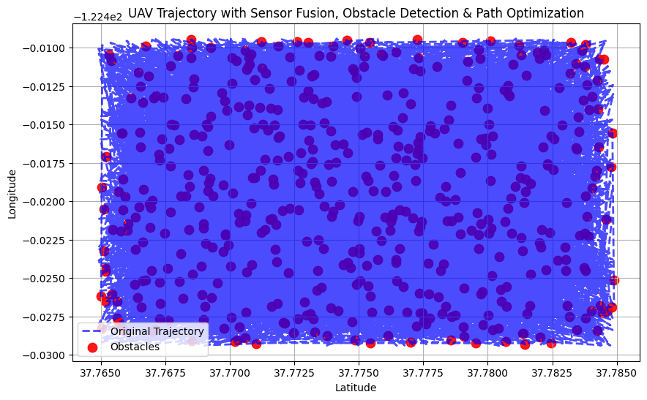

1. Optimized Path Planning and Visualization

A optimized route was produced by combining speed-based thresholds with hazard detection, choosing route sections that were fast and hazard-free. The resulting plot showed the initial noisy track, hazard areas, and the improved, smoothed route—highlighting the system's capability to improve navigation in difficult environments.

**5. Conclusion**

1. Effectiveness of SVD and Sensor Fusion

Integration of Truncated SVD with sensor fusion algorithms considerably enhanced UAV trajectory planning by reducing noise and smoothing paths. The system combined data from multiple onboard sensors to keep navigation accurate in areas with sparse GPS access and dense obstacles.

1. Improved Path Safety and Live Feasibility

Obstacle sensing by LiDAR and space-efficient indexing using KDTree helped the UAV achieve collision-free avoidance while achieving best speed. The method shows immense potential for being implemented in real-time in autonomous UAV systems with a strong platform for safe, intelligent navigation of difficult situations.

**References**

1. S. Koduri, "Multisensor Data Fusion with Singular Value Decomposition," 2012 UKSim 14th International Conference on Computer Modelling and Simulation, Cambridge, UK, 2012, pp. 422-426, doi: 10.1109/UKSim.2012.65.
2. H. Ryu, I. Wee, T. Kim and D. H. Shim, "Heterogeneous sensor fusion based omnidirectional object detection," *2020 20th International Conference on Control, Automation and Systems (ICCAS)*, Busan, Korea (South), 2020, pp. 924-927, doi: 10.23919/ICCAS50221.2020.9268431.
3. L. Kristiana, N. A. Idris, A. O. Manurung, A. R. Darlis, I. A. Dewi and L. Lidyawati, "Obstacle Awareness System of An Indoor UAV with Multi-Sensor Fusion Algorithm," *2021 17th International Conference on Quality in Research (QIR): International Symposium on Electrical and Computer Engineering*, Depok, Indonesia, 2021, pp. 32-37, doi: 10.1109/QIR54354.2021.9716178.
4. J. V. -V. Gerwen, K. Geebelen, J. Wan, W. Joseph, J. Hoebeke and E. De Poorter, "Indoor Drone Positioning: Accuracy and Cost Trade-Off for Sensor Fusion," in *IEEE Transactions on Vehicular Technology*, vol. 71, no. 1, pp. 961-974, Jan. 2022, doi: 10.1109/TVT.2021.3129917.
5. Dataset - [UAV Navigation Dataset](https://www.kaggle.com/datasets/ziya07/uav-autonomous-navigation-dataset)
6. [TruncatedSVD from scikit-learn](https://scikit-learn.org/stable/modules/generated/sklearn.decomposition.TruncatedSVD.html)
7. [KDTree from scipy.spatial](https://docs.scipy.org/doc/scipy/reference/generated/scipy.spatial.KDTree.html)