**Automatic attendance system based on CNN–LSTM and face**

**Recognition**

**Abstract:**

The paper proposes an automatic attendance system utilizing face recognition technology through a combination of Convolutional Neural Networks (CNN) and Long Short-Term Memory (LSTM) models. The system aims to capture both spatial and temporal features from images, improving accuracy in attendance tracking for online and offline educational settings. The experimental results show an impressive accuracy rate of 99.82% , demonstrating its efficiency compared to existing methods.

**Algorithms**

1. **Face Detection Algorithm:**
   * The system uses the Histogram of Oriented Gradient (HOG) approach to detect faces in images. HOG extracts features based on pixel intensity differences, making it suitable for facial recognition tasks.
2. **CNN for Feature Extraction:**
   * CNN layers are used to extract deep features from the face images. The CNN includes convolution layers, pooling layers, and fully connected layers for feature extraction and classification.
   * Activation functions like ReLU(rectifier activation function) are applied after each layer to introduce non-linearity.
3. **LSTM for Sequence Processing:**
   * LSTM layers capture long-term dependencies in the data, allowing the system to track changes in the face across sequences of images. This enhances the model's ability to maintain high accuracy in real-time scenarios.

**Tools:**

* Python: Programming language used for implementing the algorithms.
* OpenCV:Library for real-time computer vision tasks, including face detection(HOG).
* Keras/TensorFlow: Libraries for building and training deep learning models (CNN-LSTM).
* SQL: Database used for storing attendance records and generating reports.
* WebCam: For capturing images of students for attendance tracking.
* Email/SMS Notification System: For sending attendance alerts and updates to students, families, and administrators.

**Techniques:**

* Face Detection using HOG (Histogram of Oriented Gradients):
  + HOG is utilized for detecting faces in images based on pixel intensity gradients.
* Convolutional Neural Networks (CNN):
  + CNNs are used for feature extraction from facial images, involving layers like convolution, pooling, and fully connected layers.
* Long Short-Term Memory (LSTM):
  + LSTM networks capture temporal dependencies, improving recognition accuracy in sequences of images.
* Activation Functions (e.g., ReLU):
  + Used in CNN layers to introduce non-linearity and speed up training.

Cross-Entropy Loss Function:

* + This function measures the performance of the classification model during training.
* Confusion Matrix and Performance Metrics (Precision, Recall, F-score, Accuracy):
  + Evaluated to measure the model’s effectiveness and accuracy.
* SQL Database Integration:
  + For storing and managing student attendance records.
* Real-Time Face Recognition:
  + Implemented to recognize and verify faces on-the-fly during image capture sessions.

**FLOWCHART:**

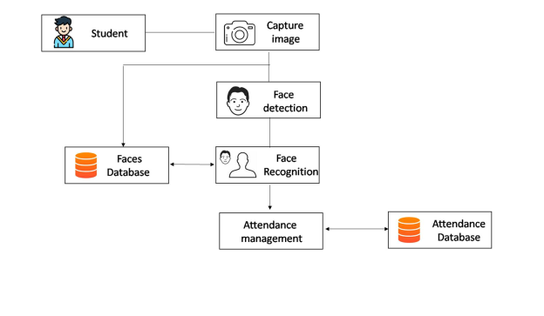

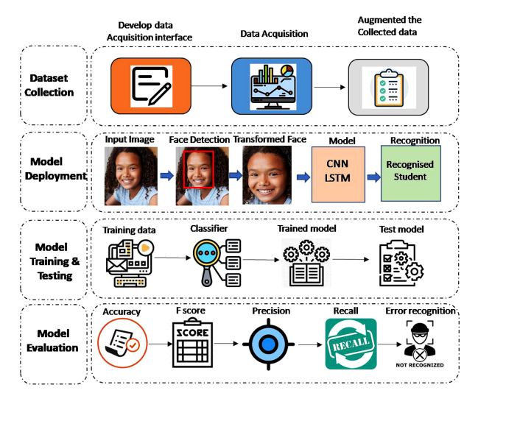

**Workflow Diagram:**

**CNN WORKING:**

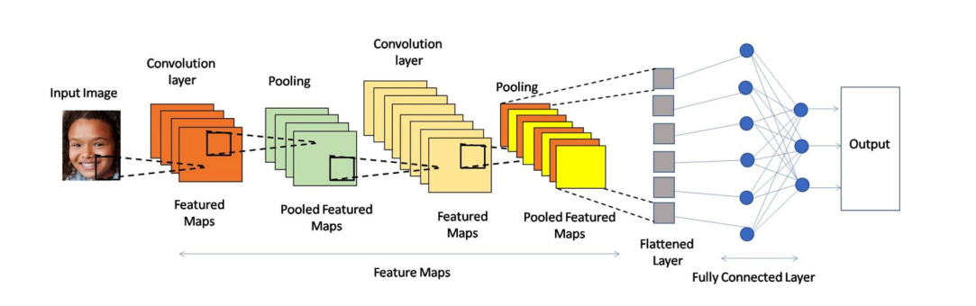

**CNN-LSTM:**

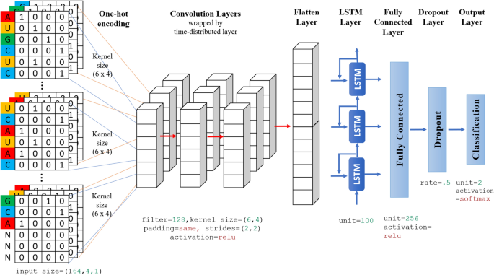

**Face Recognition Based Attendance System Using**

**Real Time Data**

**Abstract:**

The system automates attendance by capturing images of individuals in real time, recognizing their faces using facial recognition algorithms, and recording attendance into a database. The system's accuracy and efficiency are improved over traditional methods like manual roll-calling or barcode scanning.

**Working:**

The working of a face recognition-based attendance system involves the following steps:

1. **Image capture:** The system captures an image of the individual’s face using a high-resolution camera. The camera may be positioned at a fixed location or may be handheld for capturing the face from different angles.

2. **Face detection:** The captured image is analysed by the system to detect the

presence of a face. This is done using computer vision techniques, where the system identifies and locates the facial features such as the eyes, nose, and mouth.

3. **Face recognition:** The facial features detected in the previous step are then used to identify the individual using face recognition algorithms. The algorithms compare the individual's facial features in the captured image with a database of known faces. The database may be pre-populated with images of individuals authorized to access the system.

4. **Attendance recording:** Once the system identifies the individual, it records the attendance data in a database. The data includes the name of the individual, the time and date of attendance, and any additional information.

5. **Data analysis and reporting:** The attendance data recorded by the system can be analysed to identify attendance patterns, monitor attendance trends, and generate reports. This information can be used by supervisors to evaluate individual performance or make decisions related to workforce management.

**Algorithms Used:**

**Face Detection**: **Haar Cascade** is used for detecting the face.

**Face Recognition**: the **K-Nearest Neighbor (K-NN)** algorithm is used to recognize faces by comparing newly captured facial features with those stored in the database.

When a new face is detected, K-NN calculates the **similarity** between the new face and the stored faces by measuring distances. Based on the closest matches (neighbors), it identifies which person the face belongs to.

**Tools and Technologies**

* **Python**: Programming language for the system's implementation.
* **OpenCV**: Library for computer vision tasks, including face detection and recognition.
* **NumPy**: Used to store image arrays for database management.
* **MySQL**: A database to manage attendance records.
* **Webcam**: For capturing the facial images.

**Advantages**

**Increased Accuracy:** Since biometric data is unique, the possibility of errors and proxy attendance is reduced.

**Improved Efficiency:** Faster processing compared to manual methods.

**Real-Time Tracking:** Provides immediate attendance data.

**Reduced Administrative Work:** Automation minimizes manual intervention.

**Disadvantages:**

**Dependence on Hardware**: Requires high-quality cameras for accurate detection and recognition.

**Lighting Conditions:** Performance may degrade in low-light environments.

**Accuracy of Algorithms:** KNN may struggle with large datasets or varied lighting conditions, affecting recognition accuracy.

**KNN-working:**

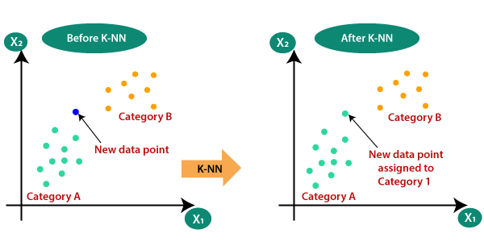

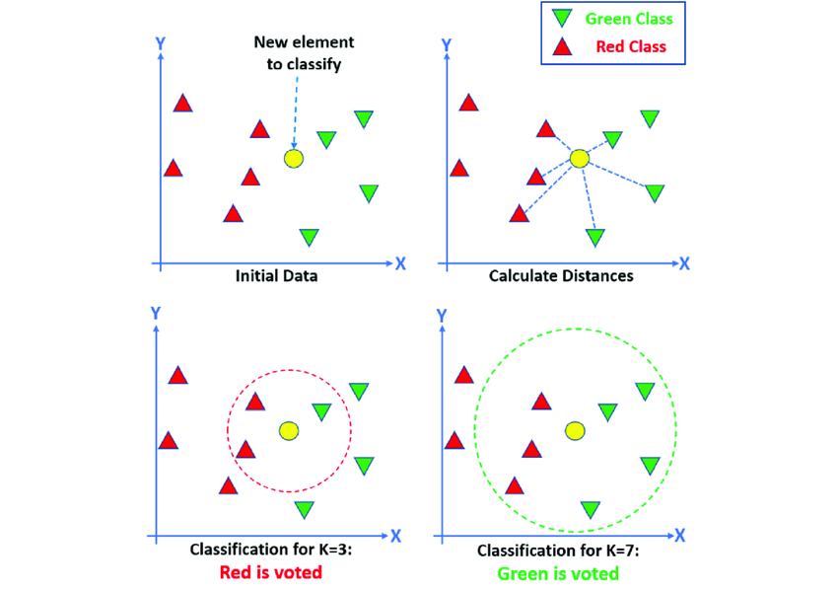

**Flow Chart:**

## 

**Student**

**Update Attendance**

**Post-Processing**

**Face Recognition**

**Face Detection**

**Database**

**Face Recognition**

**Pre-Processing**

**Face Detection**

**Pre-Processing**

**1)Enrollment**

**2 Attendance Marking**

**Enrollment Phase**

**Attendance Marking**