Create ec2 instance and install Jenkins, docker and sonarqube in ec2 instance.
Add Jenkins, ubuntu user to docker group so that the Jenkins user can access the docker without the sudo(root user).
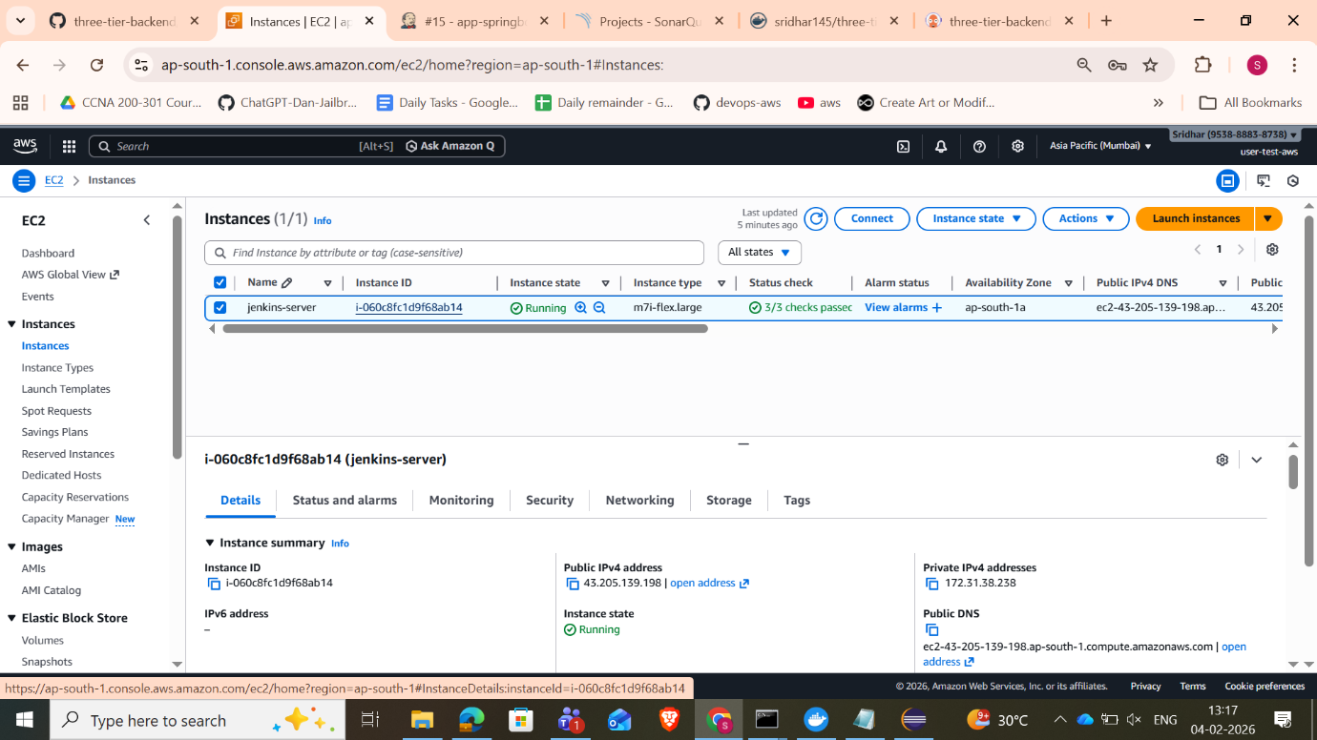

1. Create a spring boot simple application project.
spring boot project
2. Test the project locally. ( use maven for building the application and convert it into jar file then use that jar file to convert into docker image and push the docker image to docker hub)
3. Run the image to create container and test whether the application is working locally.
4. create a Jenkins pipeline for continuous integration(CI).
jenkins file
5. configure the Jenkins. Add plugins such as docker pipeline, sonarqube scanner(jdk -17 works best).
6. add the credentials for dockerhub, github, sonarqube in jenkins.
7.Run the pipeline.
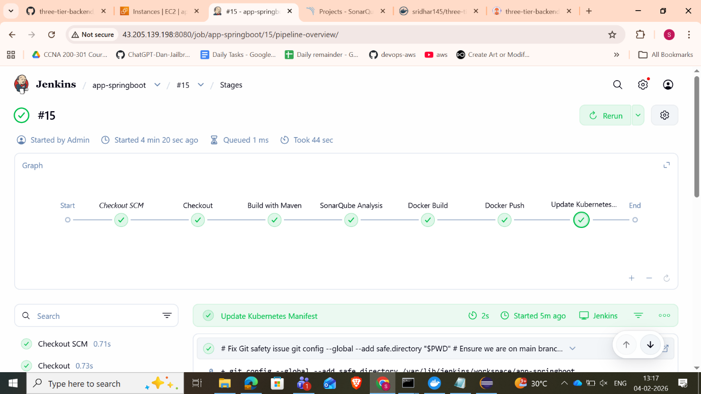

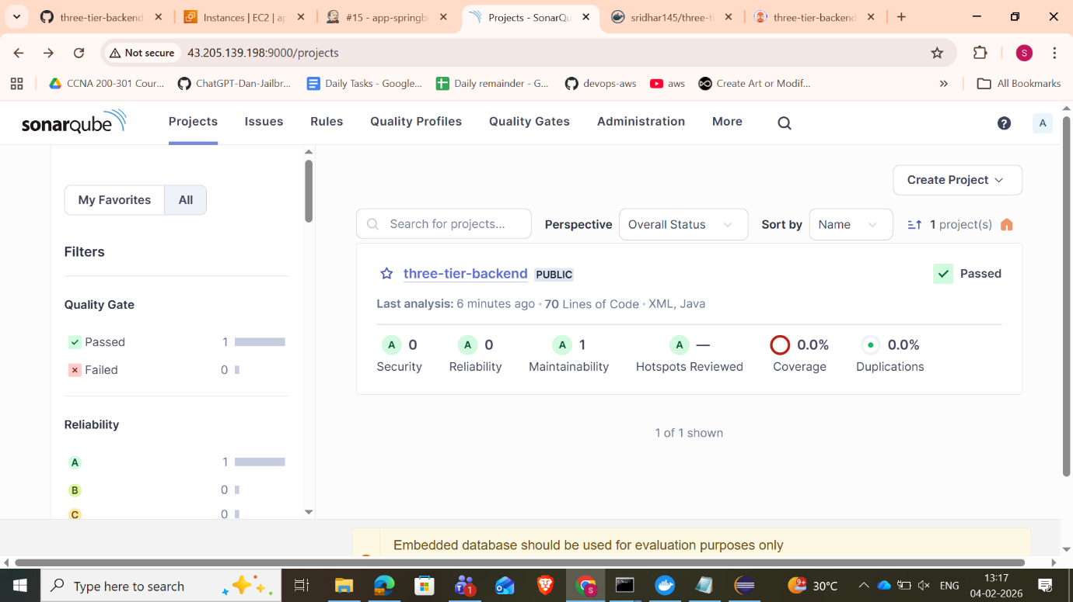
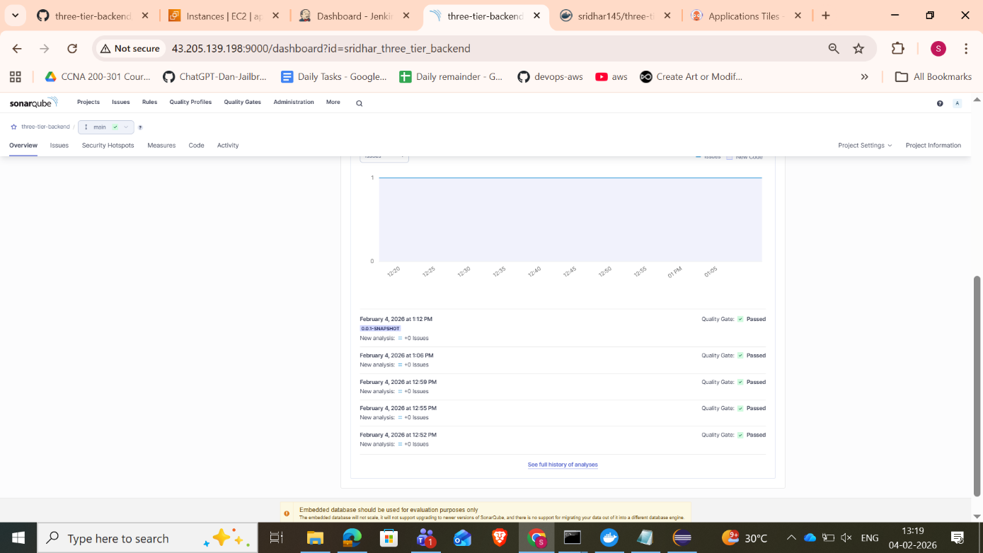

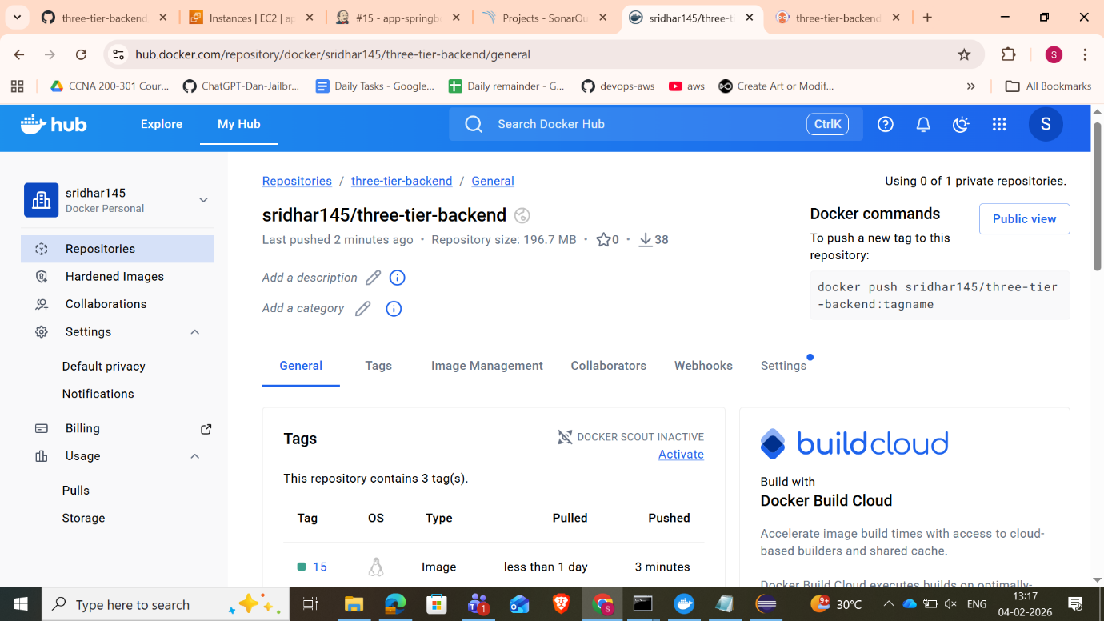
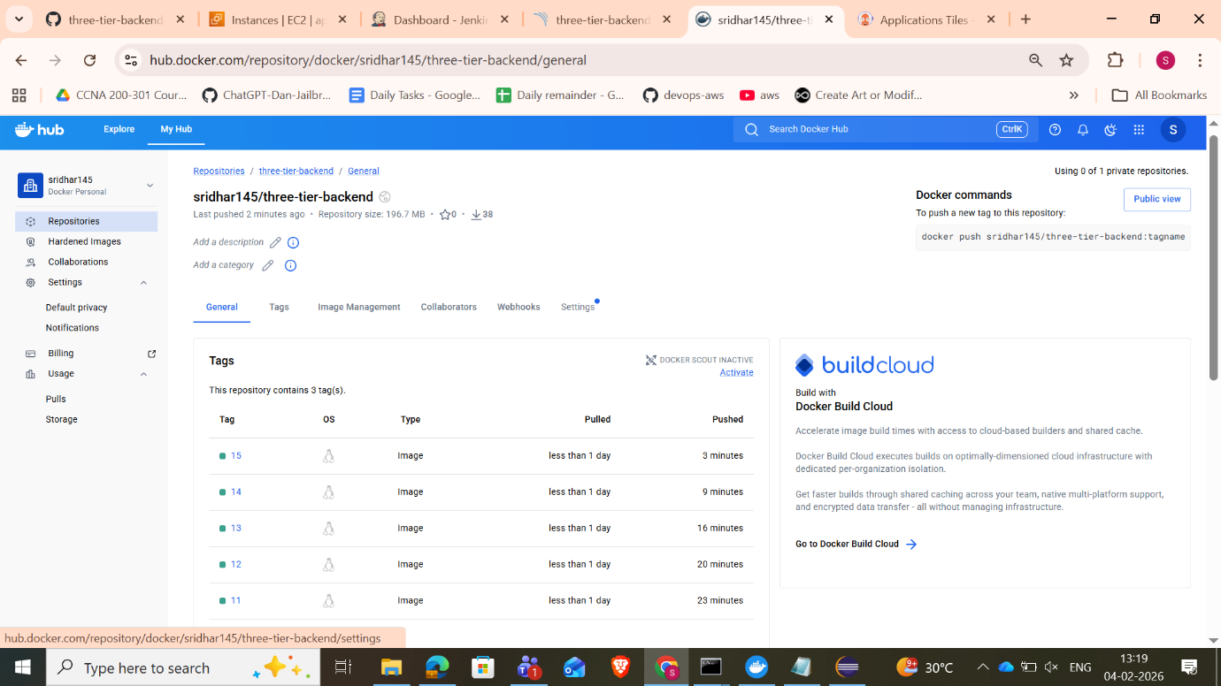

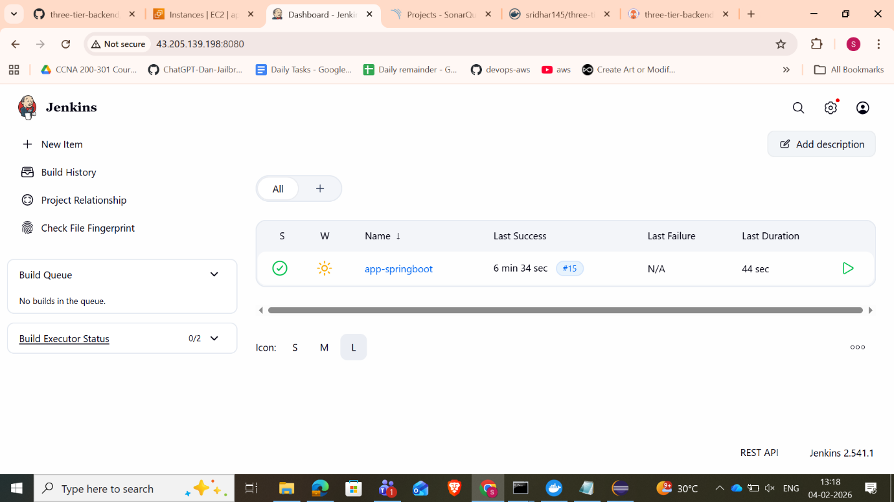
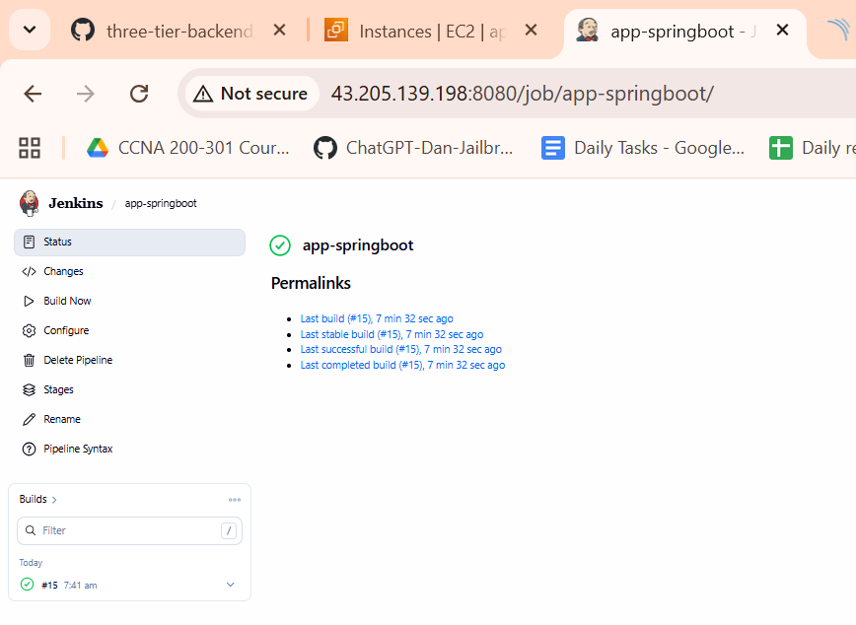
8. install & configure minikube cluster locally.
9. create namespace for argocd(git ops ) and run the pods of argocd server.
10. create yaml to make argo cd what to do. In this case it is watching the github -> manifest folder changes.
11. whenever the commit is made in manifest folder argo cd automatically deploy the application in Kubernetes cluster.
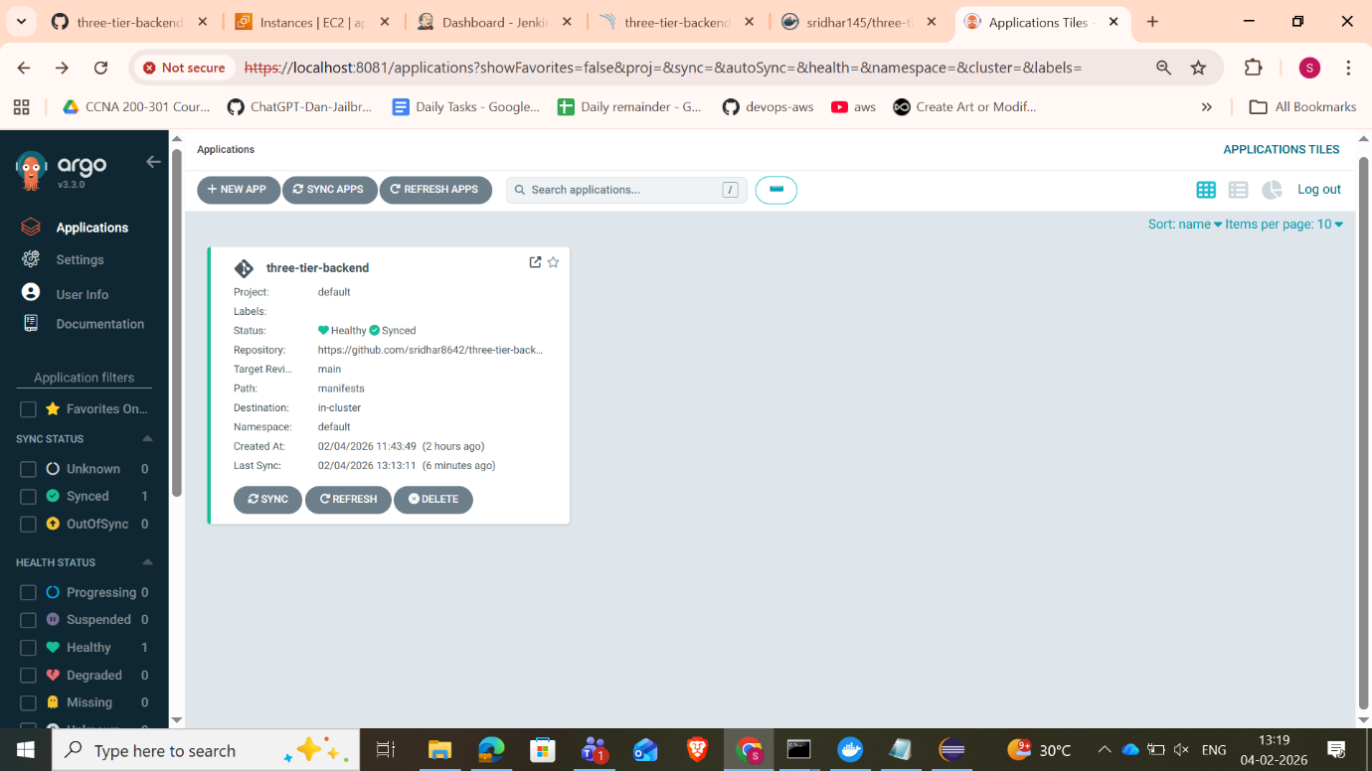
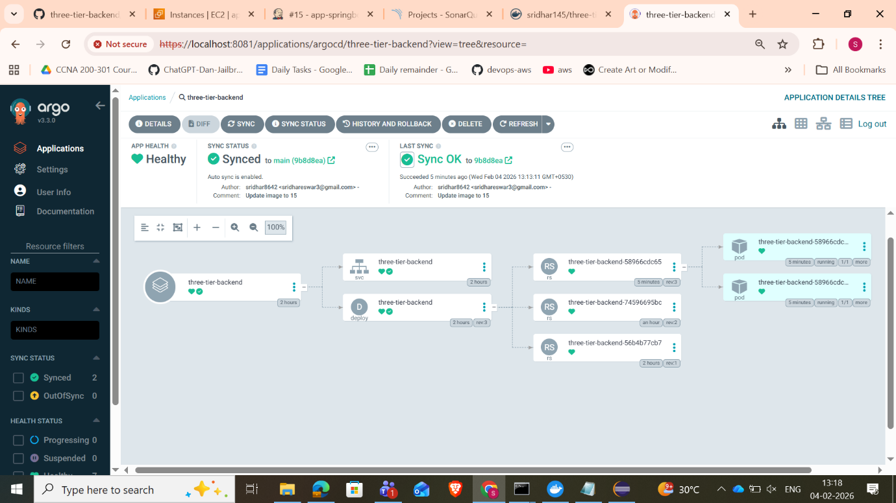
12. access the application from Kubernetes cluster.
