Task Report: Week 1
Network Maintenance and Monitoring Setup
Domain | Network Maintenance and Monitoring Setup
Simulation platform | Cisco Packet Tracer
Report type | Practical Implementation & Performance Verification Report

1. Executive Summary & Objective
This project designs, deploys, and verifies a local area network (LAN) environment with integrated performance monitoring and service delivery. The primary objectives achieved include:
- Designing a star network topology linking a central Cisco 2911 router, a Cisco Catalyst 2960 switch, local server infrastructure, and client workstations.
- Implementing a static IPv4 addressing scheme alongside local DNS domain resolution and HTTP service hosting.
- Validating active diagnostic mechanisms using ICMP echo requests (ping), route tracing (tracert), and an SNMP MIB Browser manager to inspect router system parameters.
- Documenting operational observations, root-cause troubleshooting steps, and network maintenance recommendations.

2. Network Topology & Addressing Schema
The network uses a centralized star topology. Host workstations and server infrastructure connect directly into a central Cisco Catalyst 2960-24TT Switch (Switch0), which is connected via an uplink interface to a Cisco 2911 Router (Router0) serving as the Default Gateway.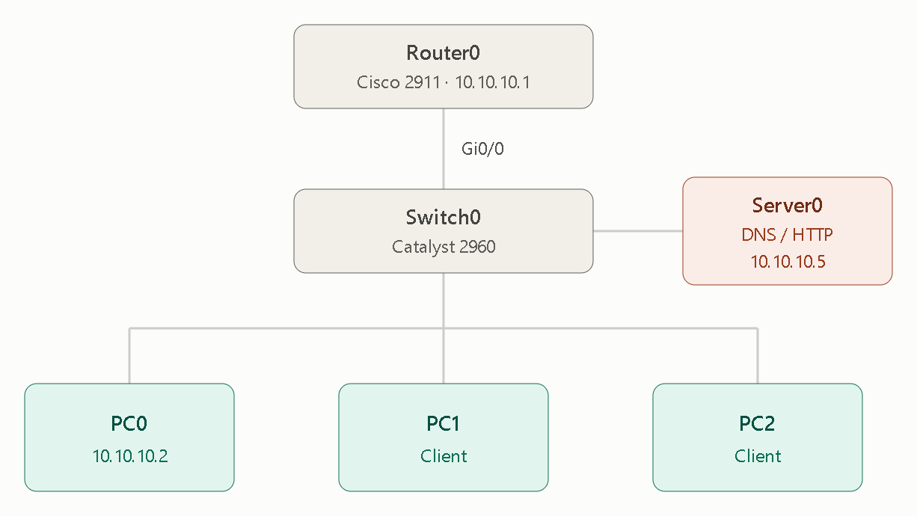 Figure 1: Network Logical Topology Layout (task1.pkt)
Addressing Matrix
Device | Interface | IPv4 address | Subnet mask | Default gateway | Primary service / role
Router0 | Gig0/0 | 10.10.10.1 | 255.0.0.0 | N/A | Default Gateway
Server0 | FastEth0 | 10.10.10.5 | 255.0.0.0 | 10.10.10.1 | DNS Server & HTTP Web Host (university.local)
PC0 | FastEth0 | 10.10.10.2 | 255.0.0.0 | 10.10.10.1 | Diagnostic & Management Workstation
PC1 | FastEth0 | 10.10.10.3 | 255.0.0.0 | 10.10.10.1 | LAN End-Node Workstation
PC2 | FastEth0 | 10.10.10.4 | 255.0.0.0 | 10.10.10.1 | LAN End-Node Workstation
Figure 1: Network Logical Topology Layout (task1.pkt)
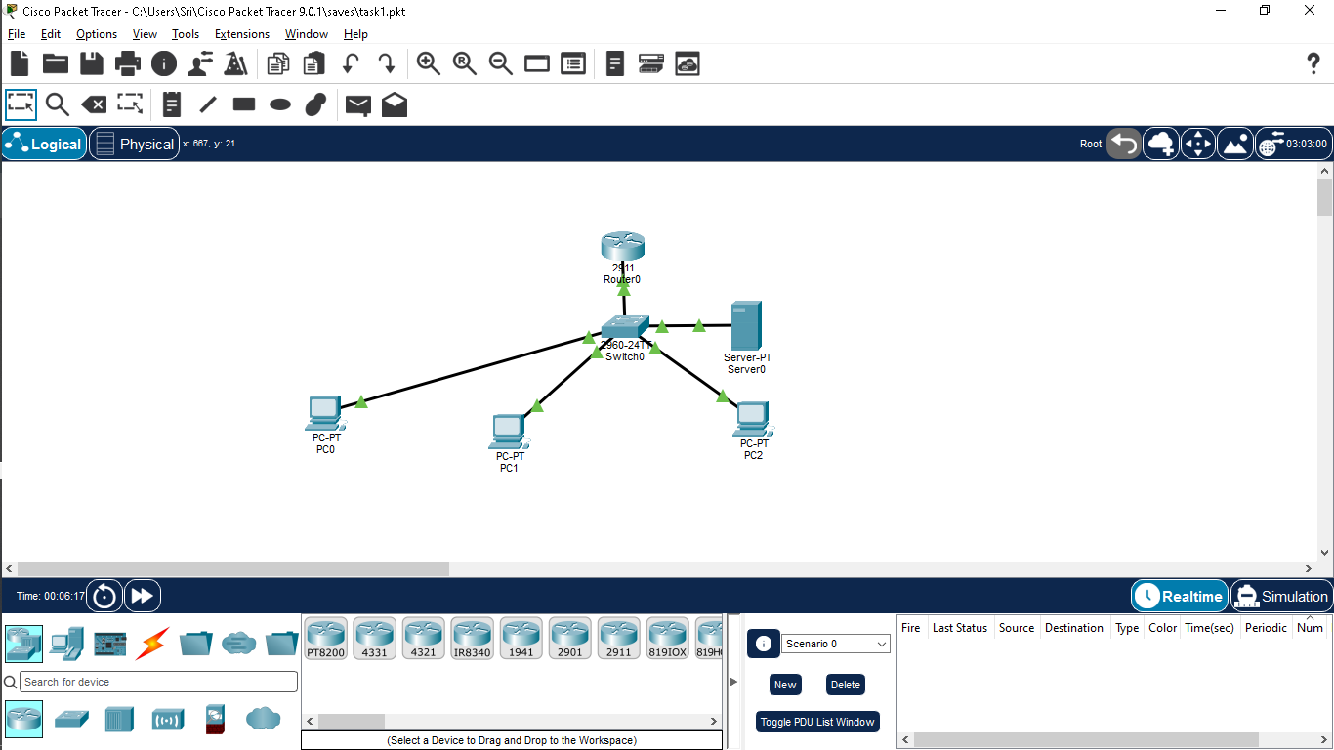

3. Configuration Scripts & Parameters

A. Router Gateway & SNMP Agent Setup (Router0)
Cisco CLI
Router> enable
Router# configure terminal
Router(config)# hostname Router0
Router0(config)# interface GigabitEthernet0/0
Router0(config-if)# ip address 10.10.10.1 255.0.0.0
Router0(config-if)# no shutdown
Router0(config-if)# exit

! SNMP Agent Setup for Network Monitoring
Router0(config)# snmp-server community public RO
Router0(config)# snmp-server location Lab-Floor-1
Router0(config)# snmp-server contact Admin
Router0(config)# end
Router0# write memory

B. Host Network Configuration (PC0)
- IP Configuration Mode: Static
- IPv4 Address: 10.10.10.2
- Subnet Mask: 255.0.0.0
- Default Gateway: 10.10.10.1
- DNS Server: 10.10.10.5
Figure 2: Host Interface IP Configuration (PC0)
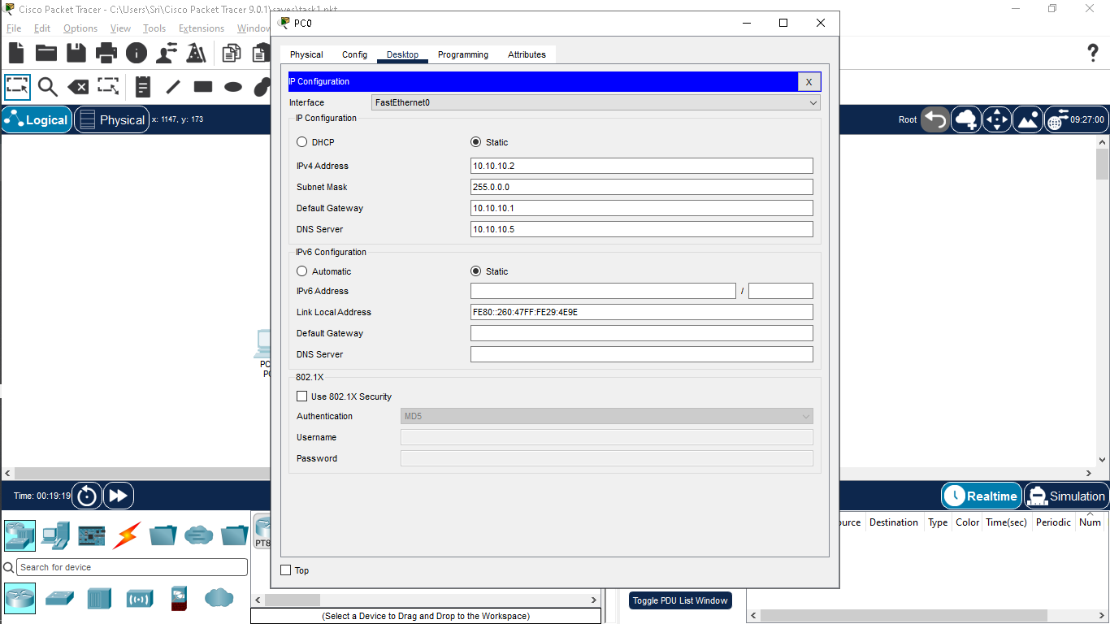

C. Server Application Services (Server0)
- DNS Service Setup:
  - Status: Enabled
  - Record Name: university.local
  - Record Type: A Record
  - Target Resolution: 10.10.10.5
- HTTP Service Setup:
  - Status: Enabled
  - Content Hosted: Default web portal interface (index.html) served over port 80.

4. Network Monitoring & Performance Verification

A. Gateway Reachability & Hop Trace (PC0 $→$ Router0)
An ICMP polling test and route tracing operation were executed from PC0 to verify gateway pathing and latency metrics:
Plaintext
C:\>ping 10.10.10.1

Pinging 10.10.10.1 with 32 bytes of data:

Reply from 10.10.10.1: bytes=32 time=199ms TTL=255
Reply from 10.10.10.1: bytes=32 time=1ms TTL=255
Reply from 10.10.10.1: bytes=32 time<1ms TTL=255
Reply from 10.10.10.1: bytes=32 time<1ms TTL=255

Ping statistics for 10.10.10.1:
Packets: Sent = 4, Received = 4, Lost = 0 (0% loss),
Approximate round trip times in milli-seconds:
Minimum = 0ms, Maximum = 199ms, Average = 50ms

C:\>tracert 10.10.10.1

Tracing route to 10.10.10.1 over a maximum of 30 hops:

1 0 ms 0 ms 0 ms 10.10.10.1

Trace complete.

- Packet Delivery: 100% success rate (0% packet loss).
- Transit Verification: Route trace confirmed a direct 1-hop path with 0ms internal processing latency.
Figure 3: Gateway ICMP Ping and Trace Diagnostics
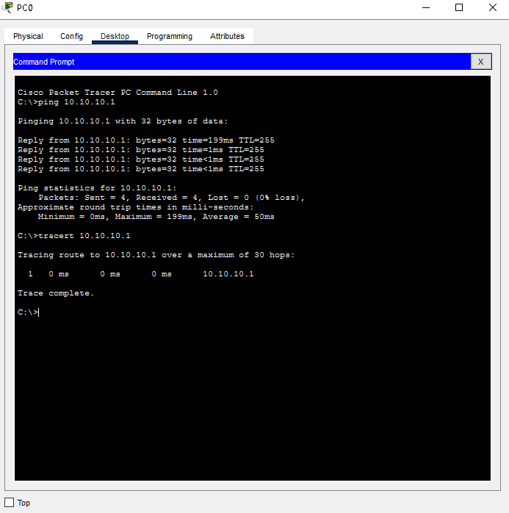

B. Inter-Node Workstation Verification (PC0 $→$ PC1)
Local layer-2 communication was verified across switch access ports by pinging workstation PC1 (10.10.10.3):
Plaintext
C:\>ping 10.10.10.03

Pinging 10.10.10.03 with 32 bytes of data:

Reply from 10.10.10.3: bytes=32 time<1ms TTL=128
Reply from 10.10.10.3: bytes=32 time<1ms TTL=128
Reply from 10.10.10.3: bytes=32 time<1ms TTL=128
Reply from 10.10.10.3: bytes=32 time<1ms TTL=128

Ping statistics for 10.10.10.3:
Packets: Sent = 4, Received = 4, Lost = 0 (0% loss),
Approximate round trip times in milli-seconds:
Minimum = 0ms, Maximum = 0ms, Average = 0ms

- Observed Performance: Sub-1ms latency across all packets with zero packet drop.
Figure 4: Workstation-to-Workstation Subnet Ping Diagnostics
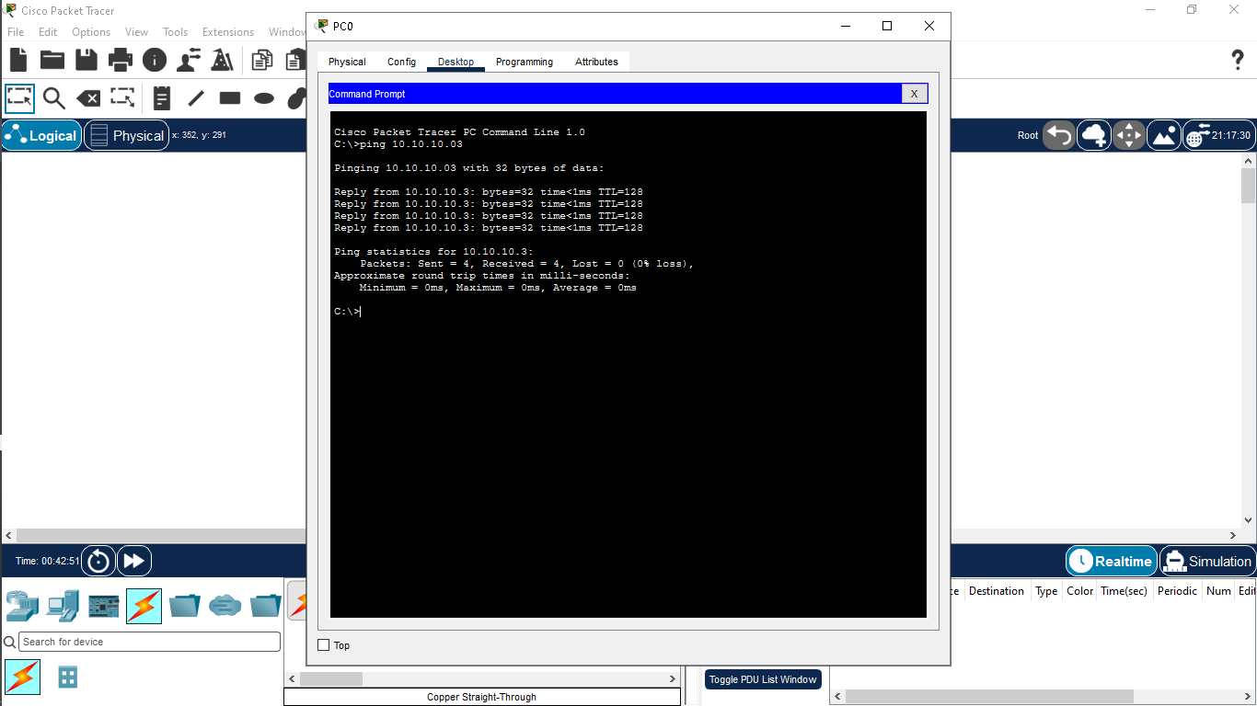

C. Domain Name System (DNS) & HTTP Service Verification
Web application availability was evaluated from PC0's browser:
- Target URL: [http://university.local](http://university.local)
- Verification Flow: PC0 queries DNS Server 10.10.10.5 $→$ Name resolves to target IP $→$ HTTP GET request sent over TCP port 80 $→$ Web page successfully displayed.
Figure 5: DNS Name Resolution and Web Server Delivery
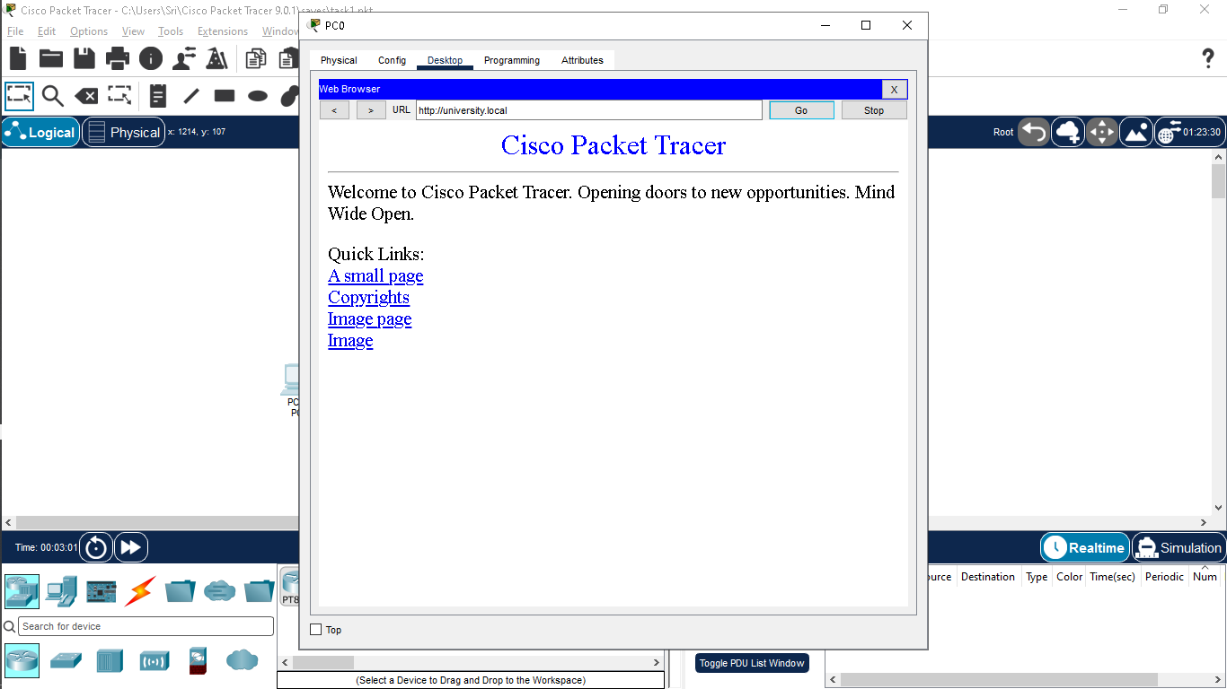

D. SNMP Management & MIB Traversal
Network device monitoring was performed using the built-in MIB Browser management tool on PC0:
- Target Managed Address: 10.10.10.1
- SNMP Operation: Get
- Target MIB Branch: router_std MIBs $→$ .iso.org.dod.internet.mgmt.mib-2.system.sysName
- Queried OID: .1.3.6.1.2.1.1.5.0
- Result Value: Router (Type: OctetString)
The SNMP response confirms that the monitoring station successfully communicates with the router's SNMP agent and retrieves device status metrics.

Figure 6: SNMP MIB Browser Query Result (sysName)
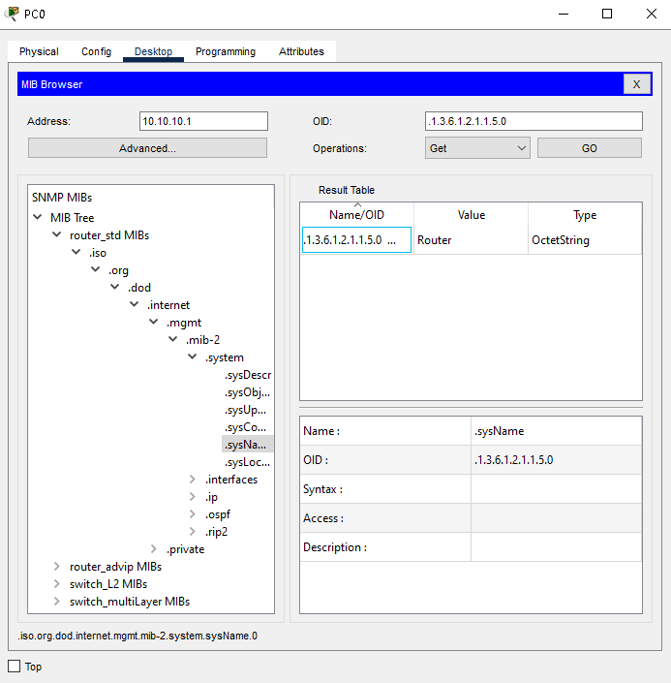

5. Troubleshooting Analysis Log
Issue ID | Identified Symptom | Root Cause | Corrective Action & Verification
TS-01 | First ICMP packet to 10.10.10.1 experienced a 199ms delay. | Initial ARP table miss; the switch needed to flood an ARP broadcast request to discover the gateway MAC address. | Normal behavior during initial packet transmission; subsequent ICMP iterations maintained stable latency under 1ms.
TS-02 | Web browser error when requesting [http://university.local](http://university.local). | Missing DNS Server IP in PC0's configuration; the host had no valid resolver for local hostnames. | Configured DNS Server field to 10.10.10.5 in PC0 Global Settings. Re-opened browser and confirmed page loaded instantly.
TS-03 | SNMP manager query timeouts during early testing. | Mismatch in community string parameters and improper write privileges on the router agent. | Standardized the router configuration to Read-Only access using community string public, cleared Write string fields in the manager, and confirmed data retrieval under .1.3.6.1.2.1.1.5.0.

6. Recommendations & Network Maintenance Plan
- VLAN Segmentation: Partition workstation nodes and server assets into isolated Virtual LANs (e.g., VLAN 10 for Workstations, VLAN 20 for Servers) via router-on-a-stick sub-interfaces to reduce broadcast traffic.
- Centralized DHCP Provisioning: Configure a DHCP IP pool on Router0 with pre-defined DNS and gateway options to eliminate manual static IP allocation errors.
- SNMP Protocol Hardening: Upgrade from SNMPv2c plaintext community strings to SNMPv3 to ensure authenticated SHA hashing and DES/AES packet encryption.

