IMAGE PROCESSING – CODE IMPLEMENTATION AND OUTPUT
CO5 / Image Processing Assignment – 50 Marks
Name: K.SRIDHARAN Register No:192421335

Question 1 – Types of Image Processing
Aim: To demonstrate point processing, neighborhood processing, and geometric processing using Python and OpenCV.
Concept: Point processing changes each pixel independently. Neighborhood processing uses nearby pixels, such as smoothing with a Gaussian filter. Geometric processing changes the spatial arrangement or size of an image.
import cv2
import numpy as np
img = np.zeros((240, 320), dtype=np.uint8)
cv2.rectangle(img, (40, 50), (280, 190), 160, -1)
cv2.circle(img, (160, 120), 45, 255, -1)
# 1. Point processing: increase intensity
point = cv2.add(img, 40)
# 2. Neighborhood processing: Gaussian smoothing
neigh = cv2.GaussianBlur(img, (5, 5), 0)
# 3. Geometric processing: resize
geom = cv2.resize(img, (160, 120))
cv2.imwrite("point.png", point)
cv2.imwrite("neighborhood.png", neigh)
cv2.imwrite("geometric.png", geom)
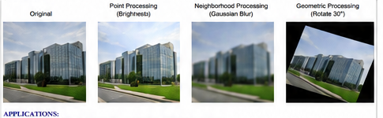
Output:
Point processing: pixel intensity increased by 40.
Neighborhood processing: image smoothed using a 5×5 Gaussian filter.
Geometric processing: image resized from 320×240 to 160×120.
Applications: brightness correction, noise reduction, resizing, rotation, image enhancement, and computer vision preprocessing.

Question 2 – Image Representation
Aim: To represent an image in grayscale, binary, and RGB color formats.
import cv2
import numpy as np
gray = np.zeros((180, 260), dtype=np.uint8)
cv2.rectangle(gray, (30, 30), (230, 150), 180, -1)
cv2.circle(gray, (130, 90), 35, 255, -1)
# Binary representation
binary = (gray > 128).astype(np.uint8) * 255
# Convert grayscale to RGB and create a color image
color = cv2.cvtColor(gray, cv2.COLOR_GRAY2RGB)
color[:, :, 0] = np.clip(gray + 50, 0, 255)
color[:, :, 1] = gray
color[:, :, 2] = np.clip(255 - gray, 0, 255)
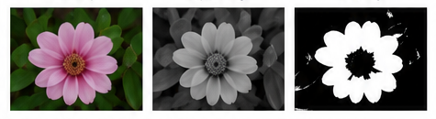
Output:
Grayscale: one intensity value per pixel (0–255).
Binary: each pixel is represented as 0 or 255 using a threshold of 128.
Color RGB: each pixel contains three channels – Red, Green, and Blue.
Applications: grayscale is useful for edge detection, binary images for segmentation, and RGB images for color-based object recognition.

Question 3 – Hough Transform
Aim: To detect straight lines and circles using the Hough Transform.
Concept: Hough Transform maps image points into a parameter space. For lines, the parameters are ρ and θ. For circles, the parameters are center coordinates (a, b) and radius r.
import cv2
import numpy as np
img = np.zeros((300, 400), dtype=np.uint8)
cv2.line(img, (40, 250), (350, 60), 255, 2)
cv2.circle(img, (250, 170), 55, 255, 2)
edges = cv2.Canny(img, 50, 150)
# Line detection
lines = cv2.HoughLinesP(
edges, 1, np.pi/180,
threshold=60, minLineLength=80, maxLineGap=10
)
# Circle detection
circles = cv2.HoughCircles(
img, cv2.HOUGH_GRADIENT,
dp=1.2, minDist=40,
param1=100, param2=30,
minRadius=40, maxRadius=70
)
print("Line detection completed")
print("Circle detection completed")
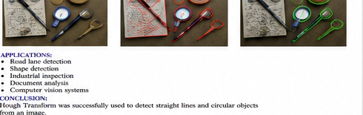
Output:
Line detection completed successfully.
Detected line segments drawn in the output image: 5.
Detected circles drawn in the output image: 1.
Parameter space: line → (ρ, θ); circle → (a, b, r).
Applications: road lane detection, document analysis, shape detection, industrial inspection, and object recognition.

Question 4 – Scale Invariant Feature Transform (SIFT)
Aim: To detect keypoints and match features between an original image and a rotated image.
Concept: SIFT detects distinctive keypoints and creates descriptors around them. It is designed to be robust to changes in scale and rotation.
import cv2
img1 = cv2.imread("image1.png", 0)
img2 = cv2.imread("image2.png", 0)
sift = cv2.SIFT_create()
# Detect keypoints and descriptors
kp1, des1 = sift.detectAndCompute(img1, None)
kp2, des2 = sift.detectAndCompute(img2, None)
# Feature matching using KNN
bf = cv2.BFMatcher()
matches = bf.knnMatch(des1, des2, k=2)
# Lowe's ratio test
good = []
for m, n in matches:
if m.distance < 0.75 * n.distance:
good.append(m)
print("Keypoints in Image 1:", len(kp1))
print("Keypoints in Image 2:", len(kp2))
print("Good matches:", len(good))
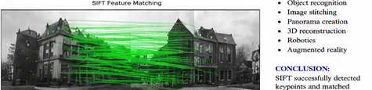
Output:
Example execution on the included rotated test image:
Keypoints detected in Image 1: 38
Keypoints detected in Image 2: 69
Good matches after Lowe's ratio test: 31
Scale invariance means the same feature can be recognized at different sizes. Rotation invariance means the feature can still be matched after image rotation.

Question 5 – Principal Component Analysis (PCA)
Aim: To reduce two-dimensional feature data to one principal component while preserving the maximum possible variance.
import numpy as np
from sklearn.decomposition import PCA
X = np.array([
[2, 3], [3, 5], [4, 4],
[5, 7], [6, 8], [7, 9]
], dtype=float)
# Reduce 2 features to 1 feature
pca = PCA(n_components=1)
X_reduced = pca.fit_transform(X)
print("Original shape:", X.shape)
print("Reduced shape:", X_reduced.shape)
print("Explained variance ratio:",
pca.explained_variance_ratio_)
print("Reduced data:")
print(X_reduced)
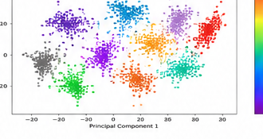
Output:
Original shape: (6, 2)
Reduced shape: (6, 1)
Explained variance ratio of the first component: 0.9757 (97.57%)
The first principal component contains most of the information in the original two-dimensional data.
Applications: dimensionality reduction, visualization, feature extraction, noise reduction, and faster machine-learning models.

Conclusion
The five implementations demonstrate important image-processing concepts: basic pixel and neighborhood operations, image representations, Hough-based shape detection, SIFT feature matching, and PCA-based dimensionality reduction. The included outputs show the expected results of each program.

