AEROCADASTRAL AI
Transforming Drone Vision into Smart Land Records
Smart India Hackathon • SIH26012 • Project Documentation
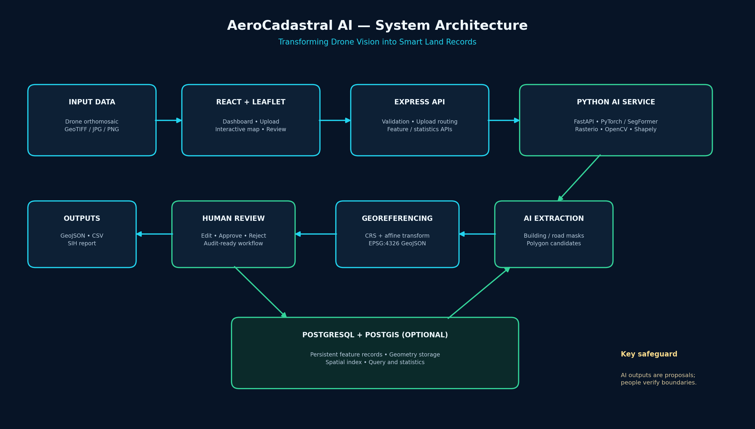

1. Executive Summary
AeroCadastral AI is an AI-assisted geospatial prototype that converts drone imagery into reviewable building, road and heuristic parcel-candidate geometries. It combines a React mapping interface, an Express API, a Python inference service and optional PostgreSQL/PostGIS persistence. The system is designed to assist land-record workflows while preserving human review as a required step.

2. Problem Statement
Urban land administration may require substantial manual effort to interpret aerial imagery, digitise visible features and prepare structured GIS layers. The project explores how computer vision and geospatial processing can accelerate initial feature extraction and make review and export more systematic.

3. Objectives
- Accept drone imagery and georeferenced GeoTIFF files.
- Extract candidate building and road masks using a pretrained segmentation model.
- Vectorise selected masks and convert image coordinates into geographic coordinates when valid CRS and affine metadata exist.
- Provide editable map geometry and a human verification workflow.
- Store feature properties and geometries in optional PostGIS.
- Generate statistics and export GeoJSON, CSV and a printable report.

4. System Architecture
Frontend: React + Vite + Leaflet + Leaflet-Geoman. Backend: Node.js + Express + Multer. AI service: Python + FastAPI + PyTorch + SegFormer. Geospatial processing: Rasterio, PyProj, OpenCV and Shapely. Optional persistence: PostgreSQL with PostGIS geometry support and a GiST spatial index.

5. Functional Modules
- Image ingestion: Checks supported file types and file size; forwards imagery to the AI service.
- AI segmentation: Runs pretrained semantic segmentation for selected visual classes, then converts masks to polygons.
- GeoTIFF georeferencing: Reads CRS and affine transform; maps polygon vertices to EPSG:4326 when metadata is valid.
- Parcel candidate generation: Creates heuristic proposals around grouped building footprints. These are not legal boundaries.
- Map editing and review: Allows geometry creation and editing, and records pending / approved / rejected statuses.
- Persistence: Uses PostGIS when DATABASE_URL is configured; otherwise uses non-persistent in-memory demo storage.
- Reporting and export: Exports GeoJSON, CSV and an HTML feature summary suitable for printing to PDF.

6. Data Flow
- Operator uploads a drone image or GeoTIFF from the React interface.
- Express validates the request and forwards the file to FastAPI.
- Python reads the image, runs segmentation and creates polygon features.
- If georeferencing metadata is present, pixel coordinates are transformed to geographic coordinates.
- Features are returned to the frontend; georeferenced results may be persisted through the backend.
- Reviewer edits, approves or rejects features and exports the feature register.

7. Technology Stack
Layer | Technologies
Frontend | React, Vite, Leaflet, Leaflet-Geoman
Backend | Node.js, Express, Multer
AI inference | Python, FastAPI, PyTorch, SegFormer
Geospatial | Rasterio, PyProj, OpenCV, Shapely
Database | PostgreSQL + PostGIS (optional)
Exports | GeoJSON, CSV, HTML report

8. Windows Setup
Install Node.js 20+, Python 3.10–3.12, VS Code and (optionally) Docker Desktop. Open three VS Code terminals from the extracted project.

Python AI service
cd ai-engine\npython -m venv .venv\n.\\.venv\\Scripts\\Activate.ps1\npython -m pip install --upgrade pip\npip install -r requirements.txt\nuvicorn app.main:app --reload --port 8000

Express backend
cd server\nnpm install\nnpm run dev

React frontend
cd client\nnpm install\nnpm run dev

Optional PostGIS
docker compose up -d postgis\n# Configure DATABASE_URL in server/.env and restart backend

9. SIH Demo Plan
- Show the dashboard and clarify which sample features are illustrative.
- Upload a GeoTIFF with a known CRS and affine transform.
- Run inference and explain the segmentation overlay and feature counts.
- Edit a polygon on the map and save the review decision.
- Show pending, approved and rejected statistics.
- Export GeoJSON, CSV and the HTML SIH report.
- Explain the human verification requirement and limitations.

10. Validation Plan
Evaluate on a labelled, representative dataset. Report precision, recall and F1 for detection; polygon IoU and boundary displacement for geometry; coordinate residuals for georeferencing; and processing and reviewer-correction times for workflow efficiency. Do not report accuracy values until they have been measured on suitable reference data.

11. Limitations and Responsible Use
- The pretrained general-scene model is not a cadastral-specific model and may miss, merge or misclassify features.
- Heuristic parcel candidates are convenience proposals only; they do not establish legal property boundaries or ownership.
- Only images with valid CRS and affine geotransform metadata can be georeferenced by this workflow.
- Pixel-to-map accuracy must be validated against control points and authoritative reference layers.
- Without PostGIS, the backend uses in-memory demo storage and changes are lost on restart.
- Use authoritative cadastral records, survey evidence and qualified human review before any operational land-administration use.

12. Future Enhancements
- Fine-tune a segmentation model on labelled cadastral and drone orthomosaic datasets.
- Integrate official parcel, survey and control-point layers.
- Add user authentication, roles, audit history and reviewer sign-off.
- Add area/perimeter calculations in an appropriate projected CRS.
- Add batch imagery processing, confidence calibration and quality-control dashboards.
- Deploy with secure secrets, monitoring, backups and access controls.

Appendix: Project folders
client/ — React user interface and map tools
server/ — Express API and optional PostGIS integration
ai-engine/ — Python FastAPI model and geospatial processing
database/ — PostGIS schema and seed SQL
SIH-Package/ — presentation, architecture diagram, documentation and demo plan

