Accessing a register's content via inline assembly

x86_64 has several registers; let's just go with the ordinary RCX register for this
example. We do make use of an interesting trick: the x86 ABI calling convention states
that the return value of a function will be the value placed in the accumulator, that is,
RAX for the x86_64. Using this knowledge, we write a function that uses inline
assembly to place the content of the register we want into RAX. This ensures that this
is what it will return to the caller!

#include <stdio.h>
#include <unistd.h>
#include <stdlib.h>
typedef unsigned long u64;
static u64 get_rcx(void)
{
/* Pro Tip: x86 ABI: query a register's value by moving its value
into RAX.
* [RAX] is returned by the function! */
__asm__ __volatile__(
"push %rcx\n\t"
"movq $5, %rcx\n\t"
"movq %rcx, %rax");
/* at&t syntax: movq <src_reg>, <dest_reg> */
__asm__ __volatile__("pop %rcx");
}
int main(void)
{
printf("Hello, inline assembly:\n [RCX] = 0x%lx\n",
get_rcx());
exit(0);
}

$ gcc -Wall -Wextra getreg_rcx.c -o getreg_rcx
getreg_rcx.c: In function ‘get_rcx':
getreg_rcx.c:32:1: warning: no return statement in function returning
non-void [-Wreturn-type]
}
^
$ ./getreg_rcx
Hello, inline assembly:
[RCX] = 0x5
$

Clearly, CR0 is an important register!
We modify our previous program to access and display its content (instead of the
ordinary RCX register). The only relevant code (which has changed from the previous
program) is the function that queries the CR0 register value:
static u64 get_cr0(void)
{
/* Pro Tip: x86 ABI: query a register's value by moving it's value
into RAX.
* [RAX] is returned by the function! */
__asm__ __volatile__("movq %cr0, %rax");
/* at&t syntax: movq <src_reg>, <dest_reg> */
}
Build and run it:
$ make getreg_cr0
[...]
$ ./getreg_cr0
Segmentation fault (core dumped)
$
It crashes!

CPU privilege levels

the essential job of the CPU is to read in machine instructions from memory, decipher, and execute them.
if a programmer can feed an arbitrary stream of machine instructions to the processor, which it, in turn, blindly and obediently executes, herein lies scope to do damage, to hack the machine!

CR0: Control flags that control operating mode and states of the
processor. If one has unlimited (read/write) access to the CR0 register, one could
toggle bits that could do the following:

- Turn hardware paging on or off
- Disable the CPU cache
- Change caching and alignment attributes
- Disable WP (write protect) on memory (technically, pages) marked as read-
only by the OS

Privilege modes

- Supervisor
- User

Privilege level or mode name Privilege level Purpose Terminology
Supervisor High OS code runs here kernel-space
User Low Application code runs here user-space (or userland)

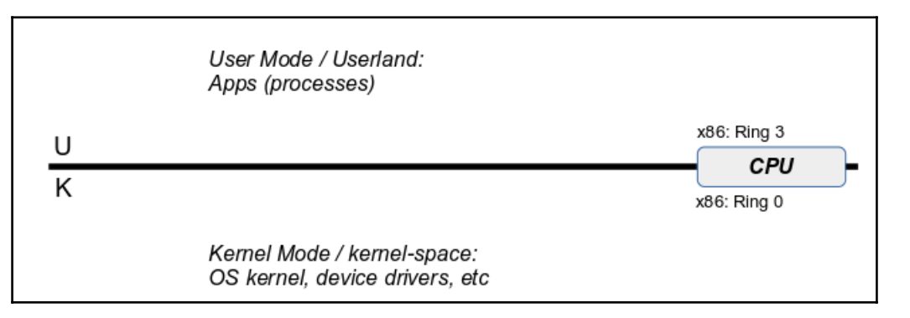
Importantly, the processor ISA assigns every machine instruction with a privilege
level or levels at which they are allowed to be executed. A machine instruction that is
allowed to execute at the user privilege level automatically implies it can also be
executed at the Supervisor privilege level. This distinguishing between what can and
cannot be done at what mode also applies to register access.

The preceding code example, getreg_rcx.c, worked because it
attempted to access the content of the general-purpose RCX register, which is allowed
in User Mode (Ring 3, as well as at the other levels, of course)!
But the code of getreg_cr0.c failed; it crashed, because it attempted to access the
content of the CR0 control register, which is disallowed in User Mode (Ring 3), and
allowed only at the Ring 0 privilege!

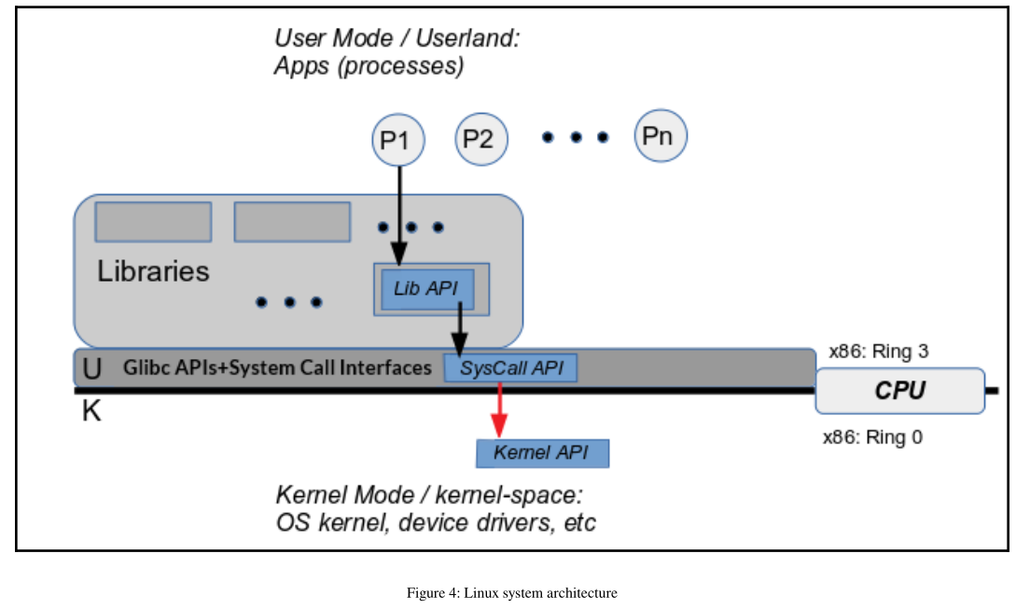

System calls
System calls are actually kernel functionality that can be invoked from userspace via
glibc stub routines. They serve a critical function; they connect userspace to kernel-
space. If a user program wants to request something of the kernel (read from a file,
write to the network, change a file's permissions), it does so by issuing a system call.
Therefore, system calls are the only legal entry point to the kernel. There is no other
way for a user-space process to invoke the kernel.

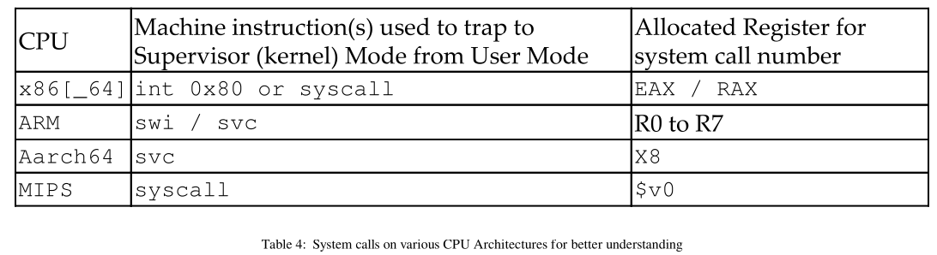

The question is, how exactly does the printf(3) API write to the monitor
device?
The short answer: it does not.
The reality is that printf(3) only has the intelligence to format a string as specified;
that's it. Once done, printf actually invokes the write(2) API – a system call. The
write system call does have the ability to write the buffer content to a special device
file – the monitor device, seen by write as stdout. Go back to our discussion regarding
The Unix philosophy in a nutshell : if it's not a process, it's a file! Of course, it gets really
complex under the hood in the kernel; to cut a long story short, the kernel code of
write ultimately switches to the correct driver code; the device driver is the only
component that can directly work with peripheral hardware. It performs the actual
write to the monitor, and return values propagate all the way back to the application.

Execution contexts within the kernel
Kernel code always executes in one of two contexts:
Process
Interrupt

Process context
Now we understand that one can invoke kernel services by issuing a system call.
When this occurs, the calling process runs the kernel code of the system call in kernel
mode. This is termed process context – kernel code is now running in the context of
the process that invoked the system call.
Process context code has the following attributes:
- Always triggered by a process (or thread) issuing a system call
- Top-down approach
- Synchronous execution of kernel code by a process

Interrupt Context
The interrupt context code has the following attributes:
Always triggered by a hardware interrupt (not a software interrupt, fault or
exception; that's still process context)
Bottom-up approach
Asynchronous execution of kernel code by an interrupt
If, at some point, you do report a kernel bug, it helps if you point
out the execution context.

Virtual memory
Modern operating systems are based on a memory model called VM. This includes
Linux, Unixes, MS Windows, and macOS

First, what is a process?
A process is an instance of a program in execution.
A program is a binary executable file: a dead, disk object. For
example, take the cat program:
$ ls -l /bin/cat
-rwxr-xr-x 1 root root 36784 Nov 10 23:26 /bin/cat
$
When we run cat it becomes a live runtime schedulable entity,
which, in the Unix universe, we call a process

In order to understand deeper concepts clearly, we start with a small, simple, and
fictional machine. Imagine it has a microprocessor with 16 address lines. Thus, it's
easy to see, it will have access to a total potential memory space (or address space) of
216 = 65,536 bytes = 64 KB:

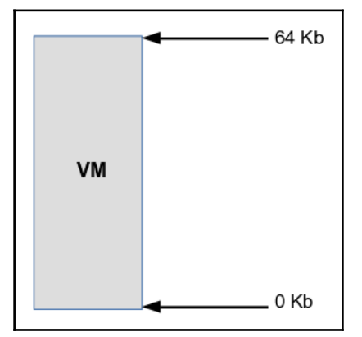
But what if the physical memory (RAM) on the machine is a lot less, say, 32 KB?
Clearly, the preceding diagram depicts virtual memory, not physical.
Meanwhile, physical memory (RAM) looks as follows

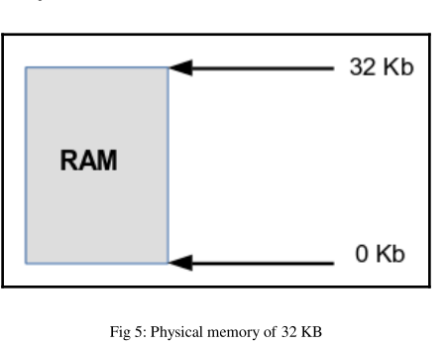

Sounds absurd,
right? Yes, until one realizes that memory is more than just RAM; in fact, memory is
viewed as a hierarchy – what's commonly referred to as the memory pyramid:
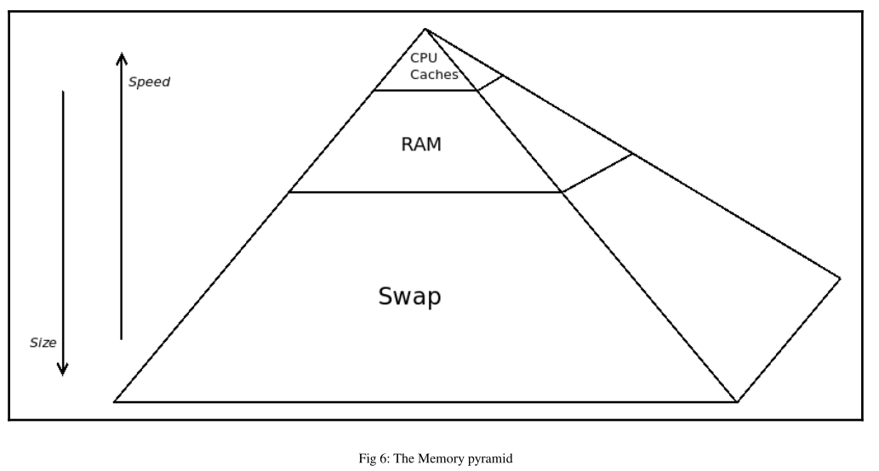

As with life, everything's a trade-off. Toward the apex of the pyramid, we gain in
Speed at the cost of size; toward the bottom of the pyramid, it's inverted: Size at the
cost of speed. One could also consider CPU registers to be at the very apex of the
pyramid; as its size is almost insignificant, it has not been shown.
Swap is a filesystem type – a raw disk partition is formatted as swap
upon system installation. It's treated as second-level RAM by the
OS. When the OS runs out of RAM, it uses swap. As a rough
heuristic, system administrators sometimes configure the size of the
swap partition to be twice that of available RAM.

