**Cashbook (React.js)**

Design and develop a Cash Book application using React.js, follow the below instruction to complete the submission.  
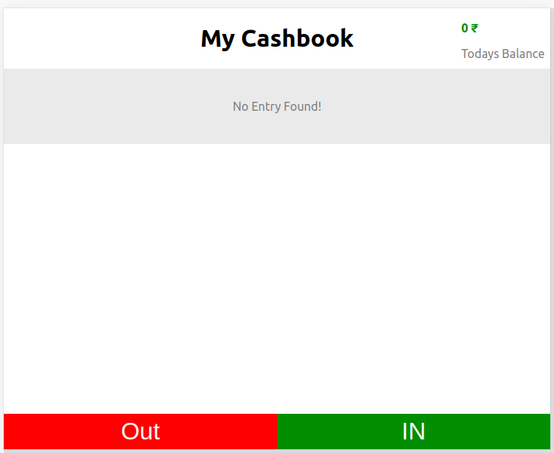

[**Download Source Code here**](https://cdn.skillenza.com/files/4aafcba1-88cb-4c1d-a672-977ae625e347/cashbook.zip)

To begin developing the **Cash Book**, an empty state is required and must consist of the screenshot shown below.

And Today's Balance should be zero with **No Entry Found!** message at the centre of the screen.  
  
Add two action buttons at the bottom (refer the App.css provided).

Let’s now understand about these two buttons

* IN Button (used to make an entry for cash-in)
* OUT Button (used to make an entry for cash-out)  
  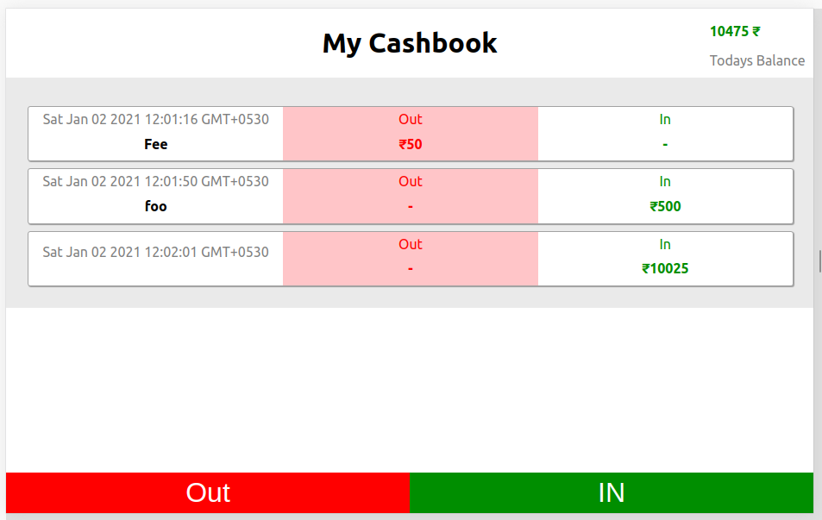

What are Cash-in and Cash-out?

* whenever an amount is received we record an entry for it (amount received) as cash-in.
* whenever we spend any amount on something we record an entry for it (amount spent) as cash-out.

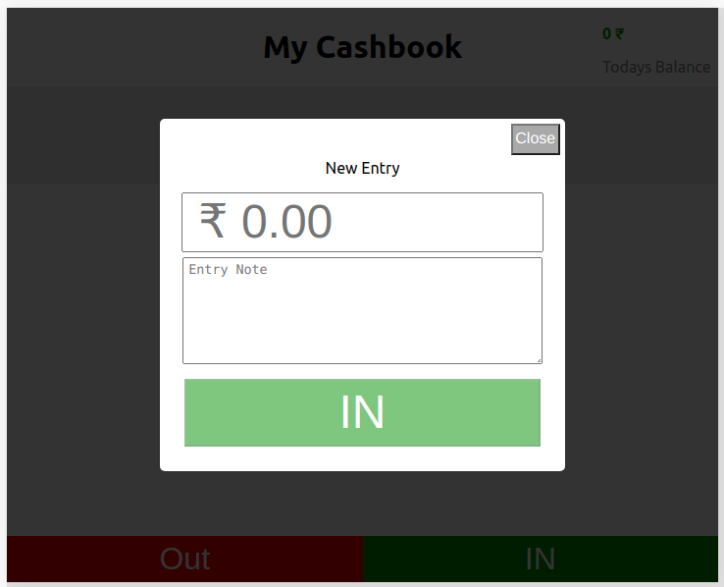  
  
When creating an entry for cash-in we take amount, note, timestamp, type (refer the mock folder for details)

Perform validation:

* amount should be of the Integer or Float
* note should be a String
* create new entry button should be disabled for invalid values  
    
  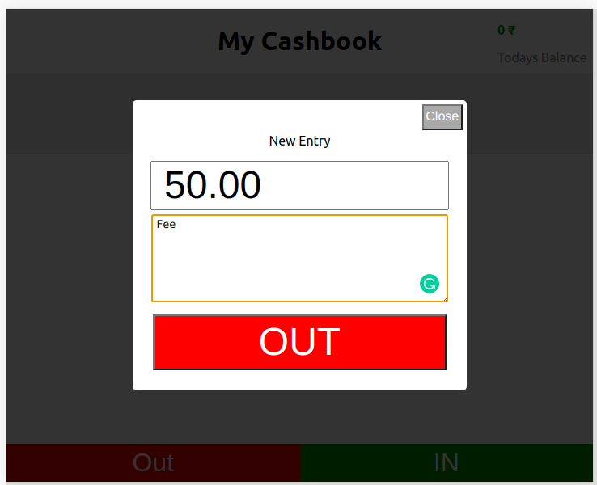  
    
  Similarly, we do for cash-out and perform the required validation as mentioned above.

**Refer App.test.js for testing your submission, please make sure to include testid(exactly same as mentioned in the test) of the elements to get maximum score and run you test locally and submit App.js file in the below submission form once you are done with the development.**

**Command to run your test locally yarn test --reporters=default --reporters=jest-junit**

# Create Entry “/entry”

**[Request]**

{

note: "foobar",

amount: 10.00,

type: 1,

timestamp: "Tue Jan 05 2021 14:36:56 GMT+0530 (India Standard Time)"

}

**[Response]**

{

message: 'entry created'

}

# Get Entries “/entry”

**[Response]**

[

...

{

note: "foobar",

amount: 10.00,

type: 1,

timestamp: "Tue Jan 05 2021 14:36:56 GMT+0530 (India Standard Time)"

},

...

]