Table of Contents
Version History 2
Introduction 2
POS Desktop 2
POS Website 3
Source code Repository 3
Database Restoration Detail 3
Technologies used 3
POS Desktop 3
POS web 3
Application setup and softwares required 4
Softwares required 4
POS Desktop 4
POS web 5
Application login credential 5
POS Desktop 5
POS web 5
Git branching 5

Version History
Authored by | Version | Date | Reviewed by
Sridhar S | 1.0 | 23/02/2022 | Vasudevan S

Introduction

POS Desktop
POS (Point of sale) is used at restaurants attached to casino to keep track of hospitality services availed by patrons. Users can access POS Desktop without requiring login. Users are presented with login screen only when restricted tile option (setup menu) is accessed.
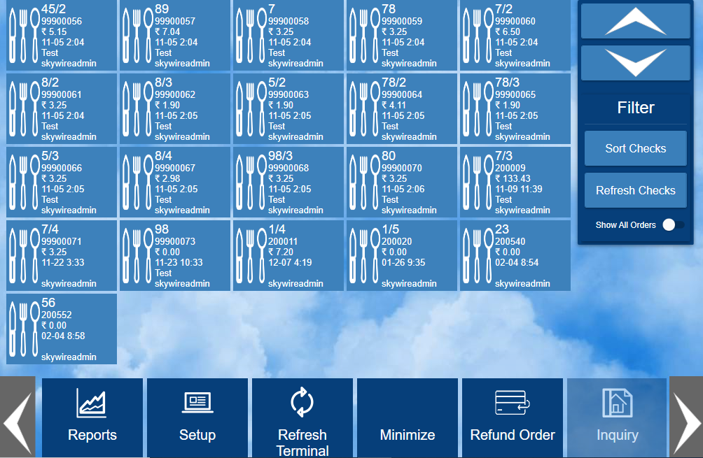
On clicking setup tile, user is prompted to login as shown below
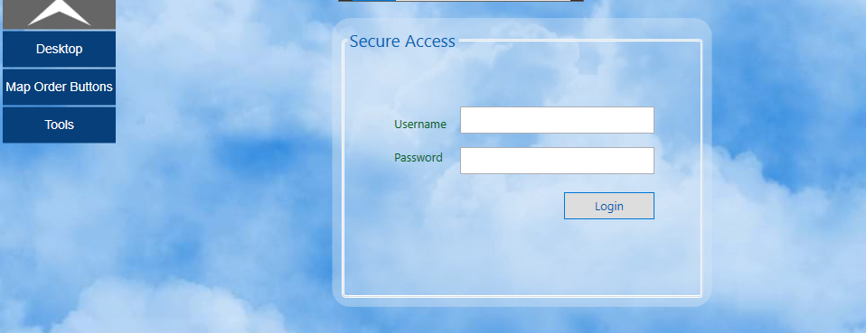
After successful login, next screen is presented as follows
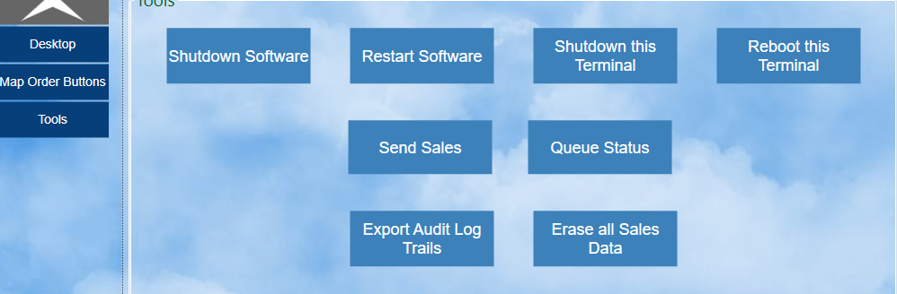

POS Website
POS website is used to view enterprise property information sales information, add/view product details and reporting. Further details to be updated.

Source code Repository
- Source code is hosted in bitbucket URL given below (access to be provided upon request). Project name is Pebble
- https://bitbucket.org/neviotech/workspace/projects/PEB
- once opening the URL, three repo will be shown as in the below image. Developers can clone them separately one by one
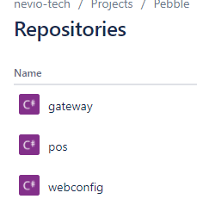

Database Restoration Detail
Developer will be provided with database copy as .bak file. Backup file can be restored using SQL server management studio

Technologies used

POS Desktop
Application is developed in WPF, Entity framework, RabbitMQ and C# with backend SQL Server

POS web
Application is developed in ASP.NET MVC, Jquery, Entity framework and C# with backend SQL Server

Application setup and softwares required

Softwares required
- Visual studio 2019 with WPF installed
- SQL Server 2019

POS Desktop
Add package source in visual studio by following below steps
- Open visual studio in administrator mode
- Navigate Tools -> Options
- Search “nuget” in search box
- Click “+” button, and add the url (refer below image)
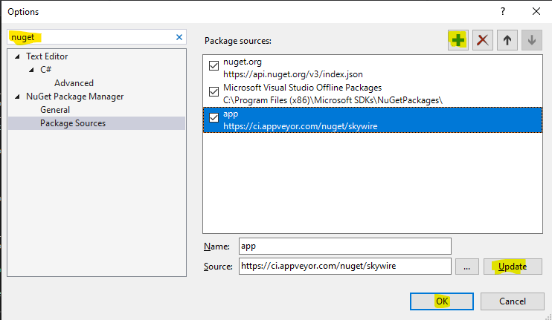
- After completing the above steps, Restore nuget packages in visual studio for the solution. A login prompt will be shown in visual studio as shown in image below,
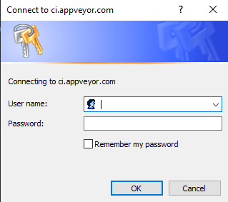
- Use following credentials in the login prompt
username: development@nevio-tech.com
password: @N3V10D3v!
- Locate app.config in “SkyWirePOS” project and ensure database is pointing to local database.

POS web
Steps remain same as above

Application login credential

POS Desktop
PIN : 1111
Username : skywireadmin
Password : P@ssw0rd2

POS web
Username: skywireadmin
Password: P@ssw0rd2
company : DevLab

Git branching
- Tasks shall be assigned in Jira to the respective developer (access will be provided)
- Before commencing work, Developer to Change task status to in-progress
- Create a feature branch before starting work. Branch shall be created from “develop” for User story and for hotfixes, branch to be created directly from “master”.
- Developer can do the work and check - in in feature branch itself, direct check-in in develop (or) master branch should be avoided.

