**Magical Sequence**

You’re given a sequence of digits. Find the count of all contiguous subsequences that make a magical sequence. A magical sequence passes the following test:

1. From the last digit, and moving left, double the value of every alternate digit. If the result of this operation is two digit number, then add the digits (e.g., 18: 1 + 8 = 9).
2. Sum up all the digits.
3. Resultant sum is divisible by 10.

**Input Format**

The first line of input consists of an integer t denoting the number of test cases. The first line of each test case contains the length of the sequence d. This is followed by a sequence containing d digits.

**Output Format**

For each case output the count of all magical sequences.

**Constraints**

1 <= t <= 1000

1 <= d <= 1000

**Sample Input**

8

1

1

1

0

4

0000

10

1234567890

29

41201953788963824033556555672

7

3000158

11

90540677470

36

188648824429847292479287385561746664

**Sample Output**

0

1

10

7

38

10

7

60

Explanation

The sequence 1234567890 has 55 contiguous subsequences out of which only the following 7 are magical

2345

234567

34

345678

5678

67

0

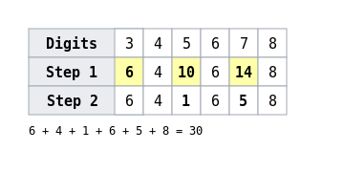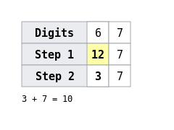

**Environment**

Read from STDIN and write to STDOUT

**Virus Transmission**

You’re given a rectangular petri dish divided into m rows, n columns, each subdivision containing cells or left empty. Cells can be infected (0), weak (1), strong (2) or empty (_). An infected cell can infect adjacent healthy (both weak and strong) cells. Once adjacent to the infected, it takes a day for a weak cell to get infected and be able to transmit the virus, and two days for a strong one. The objective is to find the number of days required to infect all weak and strong cells.

A subdivision can have a maximum of 4 adjacent subdivisions as show below. Infected cell is shown in red and it’s adjacent 4 cells are shown by black dots.

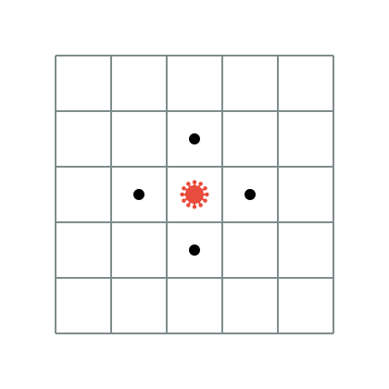

### Input Format

The first line contains and integer t denoting the number of test cases. The second line consists of two space separated integers m and n. The next m rows each contain n characters.

### Output Format

For each test case output the number of days required. If it’s not possible to turn all healthy cells to infected, output -1. If there are no healthy cells output 0.

### Sample Input

4

4 5

02_20

21212

_121_

__2__

3 3

_1_

101

_1_

2 3

1_2

_0_

1 2

0_

### Sample Output

8

1

-1

0

## Explanation

For test case

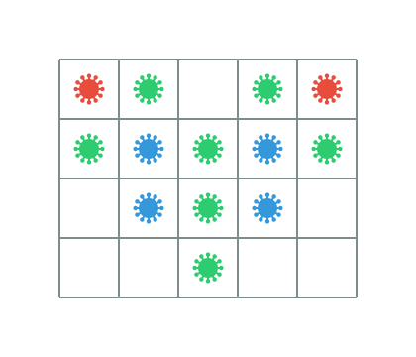

After Day 1

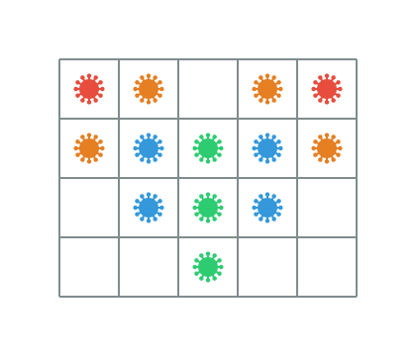

After Day 2

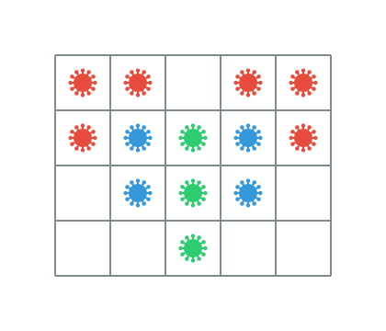

After Day 3

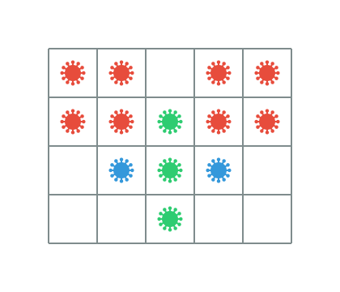

After Day 4

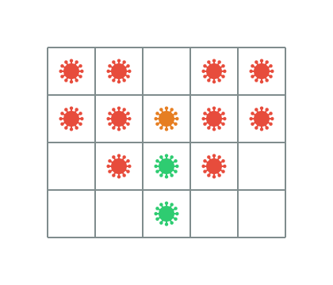

After Day 5

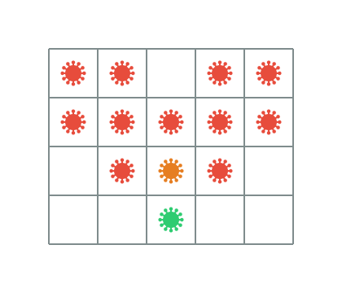

After Day 6

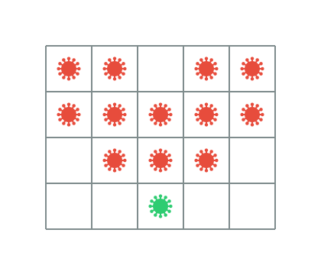

After Day 7

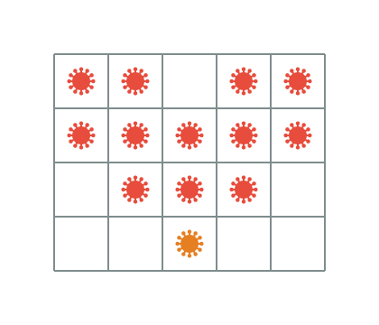

After Day 8

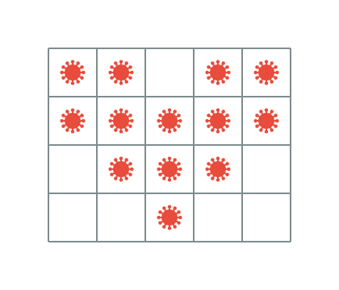

It takes a total of 8 days.

Infected cell is shown in red, weak in blue and strong in green. Intermediate state of a strong cell after first day of infection is shown in orange.

### Constraints

1 <= t <= 1000

1 <= m,n <= 100

### Environment