DREAM2PLAY AI

“DREAM2PLAY AI – AN AI-POWERED NATURAL LANGUAGE TO
PLAYABLE GAME GENERATOR PLATFORM”

AN INTERNSHIP PROJECT REPORT

Submitted in partial fulfillment of the requirements for the award of
the Internship Program – I of

BACHELOR OF TECHNOLOGY
IN
COMPUTER SCIENCE AND ENGINEERING

Submitted by
Sridhar Golla
(24STUCHHO10089)

Under the Supervision of
Dr. M. Sandhya Bhaskar
Assistant Professor
&
Mr. Ranjith Raj V | Mr. Rajasekhar
At VISHWAM AI
As part of the Internship Program – I

Department of Computer Science and Engineering
ICFAI Foundation for Higher Education (IFHE)
Faculty of Science and Technology (FST)
Hyderabad, Telangana, India

July 2026
Bonafide Certificate
FACULTY OF SCIENCE AND TECHNOLOGY, IFHE, HYDERABAD

Certified that this project report titled “Dream2Play AI – An AI-Powered Natural Language to Playable Game Generator Platform” is the bonafide work of “Sridhar Golla (24STUCHHO10089)”, who carried out the project under my supervision during the period May 25, 2026 – July 10, 2026, at VISHWAM AI, towards partial fulfillment of the requirements for the Degree of B.Tech in Computer Science & Engineering. The results embodied in this report have not been submitted to any other University for the award of any degree.

Signature of Supervisor
Dr. M. Sandhya Bhaskar
INTERNSHIP MENTOR
Faculty of Science and Technology (FST)
Hyderabad

External Viva voce conducted on ________________
Internship Completion Certificate
[Company letterhead / official seal of VISHWAM AI to be affixed here]

To,
Sridhar Golla
Roll No: 24STUCHHO10089

Internship Certificate

This is to certify that Sridhar Golla, Roll No. 24STUCHHO10089, has successfully completed an internship as an “AI Engineering Intern” with VISHWAM AI, during the period May 25, 2026 to July 10, 2026 (45 days).
During this period, Sridhar worked on the design, development, and deployment of “Dream2Play AI – an AI-Powered Natural Language to Playable Game Generator Platform”, under the guidance of Mr. Ranjith Raj V and Mr. Rajasekhar.
We found Sridhar to be sincere, technically proficient, and highly motivated throughout the engagement. He demonstrated strong capability in full-stack development, large language model integration, and collaborative Agile software engineering practices, and successfully delivered all assigned project milestones in a timely and professional manner.
We would like to take this opportunity to thank Sridhar for his hard work and dedication, and wish him the very best for all future endeavours.

For VISHWAM AI,

Authorized Signatory
Certificate of Authentication
FACULTY OF SCIENCE AND TECHNOLOGY, IFHE, HYDERABAD

I solemnly declare that this project report titled “Dream2Play AI – An AI-Powered Natural Language to Playable Game Generator Platform” is the bonafide work done purely by me, carried out under the supervision of Dr. M. Sandhya Bhaskar, towards partial fulfillment of the requirements for the Degree of B.Tech in Computer Science & Engineering, during the period May 25, 2026 – July 10, 2026.
It is further certified that this work has not been submitted, either in part or in full, to any other department of the Faculty of Science and Technology, ICFAI Foundation for Higher Education, Hyderabad, or any other University, institution, or elsewhere, or for publication in any form.

Signature of the Student
Date: ______________
Sridhar Golla
24STUCHHO10089
Declaration
I, Sridhar Golla (Roll No: 24STUCHHO10089), student of B.Tech – Computer Science & Engineering, hereby declare that this Internship Project Report titled “Dream2Play AI – An AI-Powered Natural Language to Playable Game Generator Platform”, submitted to the Department of Computer Science & Engineering, ICFAI Foundation for Higher Education (IFHE), is an authentic record of work carried out by me during the internship period from May 25, 2026 to July 10, 2026 at VISHWAM AI, under the guidance of Mr. Ranjith Raj V and Mr. Rajasekhar (Company Mentors) and Dr. M. Sandhya Bhaskar (Faculty Mentor).
The work presented in this report has not been submitted for the award of any other degree or diploma, and to the best of my knowledge and belief, the report does not contain any material previously published or written by another person, except where due acknowledgment has been made in the text.

Date: July 14, 2026
Place: Hyderabad, Telangana

Signature of Student: _______________________________
Sridhar Golla | 24STUCHHO10089

Certified by:
Company Mentor 1: Mr. Ranjith Raj V | VISHWAM AI
Company Mentor 2: Mr. Rajasekhar | VISHWAM AI
Faculty Mentor: Dr. M. Sandhya Bhaskar
Acknowledgement
I would like to express my sincere gratitude to all those who have contributed to the successful completion of this internship and the preparation of this report.
First and foremost, I am deeply thankful to VISHWAM AI for providing me this invaluable opportunity to work on a real-world AI product during my internship. The organization's commitment to innovation and open-source technology made this experience both educational and professionally enriching.
I extend my heartfelt thanks to Mr. Ranjith Raj V and Mr. Rajasekhar, my Company Mentors at VISHWAM AI, whose patient guidance, technical expertise, and constant encouragement were the backbone of my work. Their insights into prompt engineering, AI integration, and software architecture significantly shaped my understanding of building production-grade AI systems.
I am also deeply grateful to Dr. M. Sandhya Bhaskar, my Faculty Mentor, for her academic guidance, timely feedback, and unwavering support throughout the internship period. Her advice helped me bridge the gap between theoretical knowledge gained in the classroom and its practical application in industry, and her structured review process ensured that this report met both technical and academic standards.
I wish to acknowledge the open-source communities behind Phaser.js, React, TypeScript, Ollama, and Google Gemini API, whose comprehensive documentation and community support made it possible to integrate complex technologies effectively within the project timeline.
Finally, I thank my family and peers for their constant moral support, patience, and motivation throughout this journey. This internship has been a transformative milestone in both my academic and personal development.
Abstract
Dream2Play AI is an innovative, AI-powered web platform conceived, designed, built, and deployed during a 45-day industry internship at VISHWAM AI (May 25 – July 10, 2026). The platform addresses one of the most significant barriers in the gaming industry — the high technical skill threshold required for game development — by enabling users to create fully playable, browser-based games using nothing more than natural language text prompts.
The system integrates the Google Gemini API for cloud-based AI inference and Ollama for local, privacy-preserving on-device AI computation. A Bring Your Own Key (BYOK) mechanism allows users to supply their own API keys, ensuring both flexibility and data control. The frontend is built using React and TypeScript, compiled with Vite, and the game-rendering engine is powered by Phaser.js, a widely adopted HTML5 game framework.
Beyond game generation, Dream2Play AI extends its capabilities to story writing, character design, mission creation, and world-building — all driven by natural language inputs. The platform supports multilingual operation (English, Telugu, and Hindi), broadening its accessibility to non-English-speaking users. It is deployed publicly on Render.com and maintained as an open-source project under the GNU AGPLv3 license on GitLab.
This report documents the complete journey of the project — from requirements analysis and technology study, through architecture design, iterative Agile development, rigorous testing, and final deployment. By the conclusion of the internship, the platform reached full feature completion across all sixteen planned modules, supported by 52 reviewed commits, a structured testing programme covering more than 35 distinct prompts, and comprehensive open-source documentation.
The methodology, system architecture, prompt-to-game pipeline, evaluation results, and lessons learned are presented in detail in the chapters that follow, along with a discussion of future enhancements that can extend the platform's capabilities even further.
Keywords: Generative AI, Large Language Models, Game Development, Natural Language Processing, Phaser.js, React, TypeScript, Ollama, Gemini API, BYOK, Multilingual, Open Source
Table of Contents
Cover Page & Title Page i
Bonafide Certificate ii
Internship Completion Certificate iii
Certificate of Authentication iv
Declaration v
Acknowledgement vi
Abstract vii
Table of Contents viii
List of Figures ix
List of Tables x
Chapters

(The chapter listing above is a Word Table of Contents field. In Microsoft Word, right-click it and choose “Update Field”, or press Ctrl+A then F9, to populate the correct page numbers after final formatting.)
List of Figures
Figure 1: Dream2Play AI System Architecture 12
Figure 2: Prompt-to-Game Pipeline 14
Figure 3: Dream2Play AI Landing and Login Interface 20
Figure 4: User Dashboard (Cognitive Dock) Interface 20
Figure 5: Prompt Input Interface — Dream Generator 20
Figure 6: AI Provider Configuration / BYOK Settings Panel 21
Figure 7: Multilingual Support — Language Selection Panel 21
Figure 8: Real-Time Game Generation Process Log 22
Figure 9: Generated Game Blueprint Preview 22
Figure 10: Final Playable Game Output (“Adventure Simulator”) 23
Figure 11: Deployment Architecture 26
List of Tables
Table 1: Comparative Analysis of Existing Tools and Platforms 6
Table 2: Expected Benefits by Stakeholder Group 10
Table 3: Sprint-Wise Development Timeline (Completed) 18
Table 4: Core Technology Stack 24
Table 5: Feature Completion Status 27
Table 6: Technology Integration Status 28
Table 7: Testing Summary 28
Table 8: Performance and Delivery Summary 28
Table 9: Final Repository Statistics 29
Table 10: System Evaluation Summary 32
Table 11: Repository Metrics (Appendix) 43
Table 12: Internship Activity Log Summary 44
Table 13: Glossary of Technical Terms 44

Chapter 1: Introduction

1.1 About VISHWAM AI
VISHWAM AI is a technology-forward organization operating in the domain of Artificial Intelligence, Machine Learning, and Generative AI product development. The company's mission centres on making AI accessible, practical, and impactful — both for developers and end users.
Founded with a focus on open-source AI innovation, VISHWAM AI invests in building platforms that leverage the latest advancements in large language models (LLMs), cloud AI APIs, and local on-device inference technologies. The organization operates with a flat, agile structure, encouraging interns and junior engineers to take meaningful ownership of product features from their first week.
VISHWAM AI's product portfolio spans AI-powered creative tools, developer utilities, and intelligent automation platforms. Dream2Play AI represents one of its flagship experimental products at the intersection of generative AI and interactive entertainment.
During this internship, the author contributed to the conceptualization, design, development, and deployment of the Dream2Play AI platform — an area that beautifully intersects natural language processing, real-time rendering, and full-stack product engineering.

1.2 Department / Team Assigned
The author was assigned to the AI Engineering & Product Development team — the core technical team responsible for building and maintaining Dream2Play AI. The team follows a Scrum-based Agile development model characterized by:
- One-week sprint cycles with clearly defined deliverables
- Daily stand-up meetings (15 minutes) with company mentors Mr. Ranjith Raj V and Mr. Rajasekhar
- Bi-weekly retrospectives for process improvement
- Continuous integration and deployment via GitLab CI/CD
- Code reviews mandatory before merging to the main branch
Specific responsibilities within the team included:
- Integrating the AI backend (Gemini API and Ollama) with the frontend React application
- Building and refining the prompt-to-game pipeline
- Implementing the Phaser.js game rendering layer
- Contributing to documentation, testing, and deployment workflows

1.3 Project Domain

1.3.1 Generative AI and Large Language Models
The platform uses LLMs to interpret user intentions expressed in natural language and generate structured, machine-readable game configurations. This required a deep understanding of prompt engineering, output parsing, and hallucination-mitigation strategies.

1.3.2 Game Development and Real-Time Rendering
The Phaser.js game engine processes AI-generated game configurations and renders fully interactive games in the browser using HTML5 Canvas and WebGL. This domain required knowledge of game loops, sprite management, physics, scene transitions, and asset optimization.

1.3.3 Full-Stack Web Development
The user-facing application is a modern React + TypeScript Single Page Application (SPA) built with Vite. It handles user authentication, API key management, prompt submission, real-time feedback, and game canvas rendering.

1.4 Purpose of the Internship
The internship at VISHWAM AI was undertaken with the following goals:
- Gain professional, hands-on experience building and shipping a real AI product used by actual users
- Develop deep practical knowledge of LLM integration, prompt engineering, and AI API consumption
- Learn game development principles through the Phaser.js framework in a real product context
- Practice Agile software development workflows: sprint planning, daily stand-ups, and CI/CD
- Contribute to an open-source codebase and learn collaborative version-control best practices using GitLab
- Bridge the gap between academic computer science knowledge and industry engineering practice

Chapter 2: Project Overview

2.1 Project Title
Dream2Play AI – AI-Powered Natural Language to Playable Game Platform

2.2 Background
The global video game industry was valued at over USD 220 billion in 2024, yet creating even a simple game remains out of reach for the vast majority of people. A beginner game developer must invest hundreds of hours learning game engines such as Unity, Godot, or Unreal Engine, in addition to mastering programming languages, asset-creation tools, physics simulation, and audio engineering.
At the same time, the rapid advancement of large language models — particularly the emergence of highly capable models such as Google Gemini and open-source alternatives running through Ollama — has opened new possibilities. These models can understand intent, generate structured data, write code, create narratives, and design complex systems from a simple text description.
Dream2Play AI was conceived to exploit this opportunity: to serve as the intelligent bridge between a user's creative game idea expressed in natural language and a fully interactive, playable game rendered live in the browser. The project originated as an internal innovation initiative at VISHWAM AI and was selected for the 2026 internship programme for its technical depth and real-world impact potential.

2.3 Business Problem Being Addressed

Problem 1 — High Barrier to Entry in Game Development
Over 90% of people who want to create games never do so because the technical entry barrier is too high. Game engines require months of learning, programming knowledge, and access to design tools. Dream2Play AI eliminates this barrier entirely by accepting plain English (or any supported language) as the only input.

Problem 2 — Slow Prototyping Cycles for Professional Developers
Even experienced game developers spend days or weeks building a prototype to test a game mechanic or genre. Dream2Play AI compresses this to seconds, enabling rapid idea validation and iteration.

Problem 3 — Fragmentation Between AI Tools and Game Engines
Existing AI tools (such as general-purpose chat assistants) can generate game concepts, lore, and code snippets, but none of them seamlessly render these into a playable experience. Users must manually bridge this gap. Dream2Play AI closes it by building an automated, end-to-end pipeline.

Problem 4 — Privacy and Cost Concerns with Cloud AI
Many AI platforms require sending user data to cloud APIs, raising privacy concerns. Additionally, API costs can be prohibitive. Dream2Play AI addresses both issues: it supports local AI inference via Ollama (no data leaves the user's machine) and a Bring-Your-Own-Key (BYOK) mode (users use their own API keys, controlling both cost and data exposure).

2.4 Objectives of the Project

Primary Objectives
- Build a fully functional web platform that converts natural language prompts into playable browser games
- Integrate multiple AI backends: Google Gemini API (cloud) and Ollama (local) with seamless switching
- Implement BYOK to allow users to supply and manage their own API keys
- Extend AI generation beyond games to include stories, characters, missions, and worlds
- Deploy the platform publicly on a cloud hosting provider and maintain uptime

Secondary Objectives
- Implement multilingual support to expand accessibility beyond English-speaking users
- Maintain the project as open-source under GNU AGPLv3 with a contributor-friendly repository structure
- Write comprehensive documentation: README, CHANGELOG, and CONTRIBUTING guide
- Achieve a production-ready codebase built from well-scoped, reviewable commits
- Perform real user testing and iterate on the AI prompt pipeline based on feedback

Chapter 3: Literature Survey and Technology Study
Before beginning active development, a structured two-week literature survey and technology study was conducted. This section documents the technologies reviewed, existing tools evaluated, concepts internalized, and the conclusions drawn that shaped the project's architecture.

3.1 Technologies Studied

3.1.1 React and TypeScript
React is a declarative, component-based JavaScript library developed by Meta for building user interfaces. It enables developers to compose complex UIs from simple, reusable components and efficiently update only the parts of the DOM that change — a feature known as the Virtual DOM.
TypeScript is a strongly-typed superset of JavaScript developed by Microsoft. It adds static type checking, interfaces, generics, and enhanced IDE support to JavaScript. For a project of Dream2Play AI's complexity — where data flows between the AI backend, state management, and the game engine — TypeScript's type safety proved essential to catching integration errors at compile time rather than at runtime.

3.1.2 Phaser.js Game Engine
Phaser is a fast, free, and open-source HTML5 game framework that supports both Canvas and WebGL rendering. It is widely used for building 2D browser games and provides built-in support for physics engines (Arcade, Matter.js), sprite animation, tilemaps, input handling, audio, tweens, and scene management.
For Dream2Play AI, Phaser.js serves as the rendering backbone: it consumes the structured JSON game configuration generated by the AI and instantiates a fully interactive game session in the browser. Key study areas included scene-lifecycle management (preload → create → update), sprite and texture management from dynamically generated assets, Arcade Physics for collision detection, frame-rate-independent game-loop architecture, and integration patterns for embedding Phaser within a React component.

3.1.3 Google Gemini API
Google Gemini is a family of multimodal large language models developed by Google DeepMind. The Gemini API provides programmatic access to these models via REST endpoints. For Dream2Play AI, Gemini's key capabilities exploited include instruction-following for structured JSON output, creative generation for game narratives and character backstories, code generation for Phaser.js scene scripts, and multilingual understanding and generation.

3.1.4 Ollama — Local AI Inference
Ollama is an open-source platform that enables running large language models locally on a personal machine. It supports models including Llama 3, Mistral, Phi-3, and Gemma, and provides a REST API that closely mirrors OpenAI's API interface, making it a drop-in replacement for cloud AI in privacy-sensitive or cost-constrained contexts.
Study areas for Ollama integration included model download and management via the Ollama CLI, REST API request/response structure, performance characteristics across model sizes, and designing an abstraction layer to normalize Ollama and Gemini API responses.

3.1.5 Vite Build Tool
Vite is a next-generation frontend build tool that significantly improves the developer experience through native ES module-based hot module replacement (HMR) during development and optimized production builds using Rollup. Vite was studied for its configuration, plugin ecosystem, and performance advantages over traditional bundlers such as Webpack.

3.2 Existing Tools, Frameworks, and Systems Reviewed
A competitive and reference analysis was performed on existing tools to understand the state of the art and identify gaps that Dream2Play AI could fill:
Table 1: Comparative Analysis of Existing Tools and Platforms
Tool / Platform | Capability | Gap Identified
ChatGPT / GPT-4-class assistants | Can describe game mechanics, write game code snippets | Does not render a playable game; the user must implement the code manually
Google Gemini (standalone) | Multimodal generation of game concepts and visuals | No direct game rendering; outputs text and code only
Unity + AI plugins | Professional game engine with AI asset tools | Steep learning curve; not accessible for non-technical users
Construct 3 | No-code / low-code game builder with visual scripting | No natural language interface; still requires drag-and-drop design skills
GDevelop | Open-source no-code game engine | No AI integration; requires familiarity with event-based programming
Itch.io game generators | Community browser game tools | Not AI-driven; limited customizability
This analysis confirmed that no existing platform provides a complete, seamless pipeline from natural language → AI game generation → immediate playable output. Dream2Play AI is positioned to fill this gap.

3.3 Relevant Concepts Learned

3.3.1 Prompt Engineering
Prompt engineering is the discipline of designing input text that reliably elicits specific, desired outputs from large language models. For Dream2Play AI, effective prompt engineering proved critical: the AI must output structured JSON configurations that Phaser.js can directly consume. Key techniques studied and applied include:
- System prompt design: embedding domain expertise and output-format specifications into the model's system context
- Few-shot prompting: providing example input–output pairs within the prompt to guide the model
- Output format specification: instructing the model to respond exclusively in JSON with a predefined schema
- Error-handling prompts: designing prompts that request self-correction when the model produces invalid output
- Chain-of-thought prompting for complex game-logic generation

3.3.2 Game Loop Architecture
A game loop is the central control structure of any game, responsible for processing input, updating game state, and rendering frames at a target frame rate (typically 60 FPS). Understanding the Phaser.js game loop was essential for building games that respond correctly to AI-generated rules and mechanics.

3.3.3 REST API Design and Integration Patterns
Both the Gemini API and Ollama expose REST endpoints. Study included the HTTP request/response lifecycle, JSON parsing, error handling, retry logic, rate limiting, and the design of a unified AI service abstraction layer in TypeScript.

3.3.4 BYOK Security and UX Patterns
Bring-Your-Own-Key (BYOK) patterns require careful consideration of key storage (never in plain localStorage without encryption), transmission security (HTTPS only), and user-experience design (clear key-management UI, key validation on entry, graceful error messages for invalid keys).

3.3.5 Streaming AI Responses
Modern LLM APIs support server-sent events (SSE) for streaming responses token-by-token. Implementing streaming in Dream2Play AI required an understanding of the Fetch Streams API, ReadableStream processing, and React state updates driven by streamed data.

3.4 Summary of Findings
The literature survey and technology-study phase yielded four key conclusions that directly shaped the project's design decisions:
- No existing platform fully closes the gap between AI-generated game concepts and browser-playable games. Dream2Play AI addresses a genuine, unmet market need.
- Phaser.js is the most mature, well-documented, and performance-optimized HTML5 game framework for this use case. Its active community and comprehensive API made it the right choice over alternatives such as PixiJS or Babylon.js.
- A dual AI backend (cloud + local) is architecturally feasible and highly desirable. Ollama's API compatibility with OpenAI's interface minimizes integration complexity.
- Prompt-engineering quality is the primary determinant of product quality. Investing in robust, versioned prompt templates proved as important as code quality itself.

Chapter 4: Problem Statement
This chapter presents a formal definition of the problem Dream2Play AI is designed to solve, its significance, and the expected benefits of the proposed solution.

4.1 Formal Problem Definition
Game creation has historically required proficiency across multiple, highly specialized domains: programming (C#, C++, JavaScript, GDScript), game-engine operation (Unity, Unreal, Godot), 2D/3D asset design, audio engineering, physics simulation, and UX design for interactive experiences. Acquiring competence across even a subset of these domains requires years of dedicated study and practice.
Despite the creative desire being widespread — a 2023 global survey found that over 60% of regular gamers had expressed interest in creating their own game — the skill gap prevents the vast majority from acting on this ambition. This represents both a missed opportunity for creative expression and a significant market gap.
Simultaneously, AI tools that could potentially bridge this gap exist in isolation: LLMs can generate game concepts, code, and narratives, while game engines can render interactive experiences. However, prior to this project, no system combined the following capabilities into a single accessible pipeline:
- Accepting a user's natural-language game idea as the sole input
- Automatically translating that idea into a structured game definition
- Immediately rendering the result as a fully playable, interactive game
- All within a single, accessible web-browser interface with zero installation requirements

4.2 Why the Problem Is Important

4.2.1 Democratization of Creative Expression
Games are a powerful medium for storytelling, education, and cultural expression. Removing the technical barrier enables students, educators, artists, writers, and hobbyists to participate in game creation — broadening the diversity of voices and ideas in the gaming world.

4.2.2 Educational Applications
Teachers can use Dream2Play AI to create custom educational games for their subjects in seconds. A history teacher can generate an interactive quiz game about a historical event; a mathematics teacher can create a number-challenge platformer — without writing a single line of code.

4.2.3 Rapid Prototyping for Professionals
For professional game developers and studios, the ability to rapidly prototype and validate a game mechanic, art style, or narrative concept saves enormous time and resources. Dream2Play AI can serve as an ideation and rapid-prototyping tool even for experienced developers.

4.2.4 Open-Source Contribution to the AI–Game Intersection
As an AGPLv3-licensed open-source project, Dream2Play AI contributes to the broader research and developer community working at the intersection of AI and interactive entertainment.

4.3 Expected Benefits of the Solution
Table 2: Expected Benefits by Stakeholder Group
Stakeholder | Expected Benefit
Non-technical users | Can create and play their own custom games without any programming knowledge
Students & educators | Custom educational game creation for any subject in seconds
Game developers | Rapid prototyping tool for mechanics, genres, and narrative testing
AI researchers | Open-source platform to study LLM structured-output generation for real-time applications
Privacy-conscious users | Local AI (Ollama) mode ensures no user data is sent to external servers
Cost-sensitive users | BYOK mode and local AI eliminate ongoing API cost concerns
Non-English speakers | Multilingual support enables game creation in regional languages

Chapter 5: System Design and Architecture

5.1 Development Methodology — Agile Scrum
Dream2Play AI was developed using the Agile Scrum methodology with one-week sprint cycles. Scrum was chosen because the project requirements involved significant uncertainty — the optimal AI prompting strategy, game-rendering approach, and UX could not be fully specified upfront — and because frequent iteration and feedback were essential for a product where AI output quality is the primary value driver. The internship's short duration (45 days) also demanded rapid delivery and regular course-correction.
Scrum ceremonies practised during the internship included:
- Sprint Planning (Monday mornings): defining the sprint goal and selecting backlog items
- Daily Stand-up (weekday mornings): a 15-minute status sync with Mr. Ranjith Raj V and Mr. Rajasekhar
- Sprint Review (Friday afternoons): a demo of completed features to mentors and stakeholders
- Sprint Retrospective (Friday afternoons): a process-improvement discussion

5.2 System Architecture
The Dream2Play AI system architecture is structured as three cooperating layers, illustrated in Figure 1 and described below.
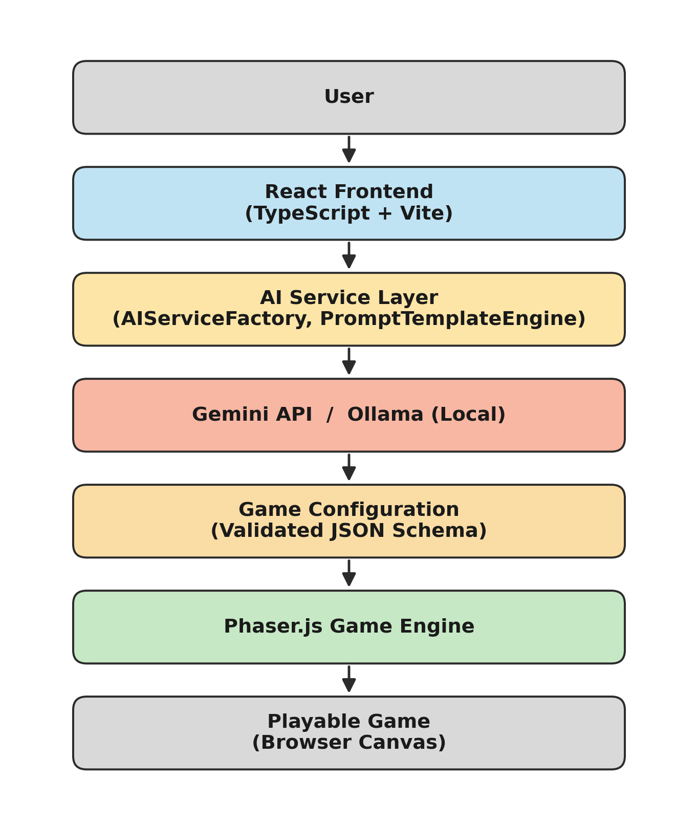
Figure 1: Dream2Play AI System Architecture

5.2.1 Presentation Layer
Technology: React 18 + TypeScript + Vite
Responsibilities:
- Rendering the application UI: prompt input, settings panel, content gallery, and game canvas
- Managing application state using React Context and custom hooks
- Handling user interactions: prompt submission, AI backend selection, language switching, and API key management
- Embedding the Phaser.js game renderer as a managed React component

5.2.2 AI Service Layer
Technology: TypeScript service modules
Responsibilities:
- AIService (abstract interface): defines the contract for all AI backends
- GeminiService (implements AIService): handles Gemini API authentication, prompt formatting, request execution, and JSON response parsing
- OllamaService (implements AIService): handles Ollama local REST API communication with an identical interface to GeminiService
- AIServiceFactory: selects and instantiates the appropriate AI service based on user settings (cloud / local / BYOK)
- PromptTemplateEngine: generates structured, context-aware prompts for each generation type
- GameConfigParser: validates AI-generated JSON against the expected game-configuration schema and supplies fallback values for missing fields

5.2.3 Game Rendering Layer
Technology: Phaser.js 3.x
Responsibilities:
- Phaser.Game instantiation with configuration derived from the AI-generated GameConfig
- Dynamic scene creation: MainScene, GameOverScene, and VictoryScene generated from AI specifications
- Asset-loading pipeline: background textures, sprite sheets, and audio assets loaded from AI-specified sources or procedurally generated placeholders
- Physics and collision management: Arcade physics configured per AI-specified game type
- Input handling: keyboard / mouse / touch controls mapped to AI-specified player actions

5.3 Detailed Prompt-to-Game Pipeline
The core pipeline, illustrated in Figure 2, executes as follows on each game-generation request:
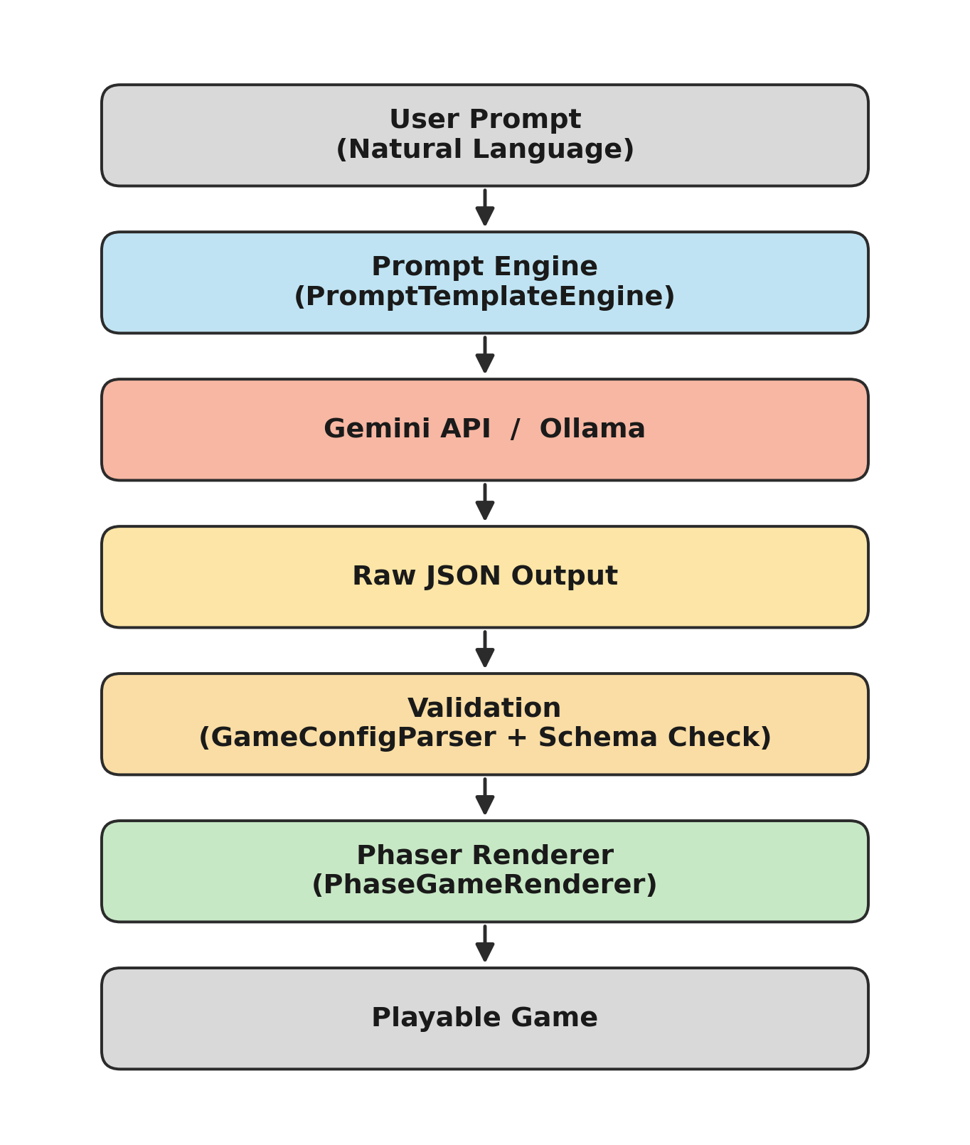
Figure 2: Prompt-to-Game Pipeline
- User Input: the user types a natural-language game description (for example, “A side-scrolling platformer where a robot collects batteries and avoids laser beams, with three levels of increasing difficulty”).
- Prompt Construction: the PromptTemplateEngine injects the user input into a structured system prompt that specifies the required JSON output schema for Phaser.js compatibility.
- AI Inference: the AIServiceFactory routes the request to the selected backend (Gemini / Ollama / BYOK). The AI processes the prompt and returns a structured JSON game configuration.
- Response Validation: the GameConfigParser validates the JSON against the schema. Missing fields are filled with sensible defaults; malformed JSON triggers a re-request with a correction prompt.
- Game Instantiation: the PhaseGameRenderer receives the validated GameConfig and creates a new Phaser.Game instance, dynamically constructing all scenes, assets, and physics settings.
- Gameplay: the user plays the generated game in the browser canvas. Controls are displayed as an overlay derived from the GameConfig's input mapping.
- Refinement: the user can modify the prompt and regenerate, or request specific changes (for example, “make the enemies faster” or “add a third level”).

5.4 Implementation Strategy
Implementation followed a strict feature-first, depth-before-breadth strategy structured across five phases:
- Phase 1 (Core Pipeline): build and validate the end-to-end prompt → game pipeline before adding any additional features. A working vertical slice was treated as more valuable than partial implementations of many features.
- Phase 2 (Game Engine Depth): deepen the Phaser.js integration to support a wider variety of game types and mechanics.
- Phase 3 (Infrastructure Features): add Ollama, BYOK, and multilingual support — features that expand accessibility without changing the core pipeline.
- Phase 4 (Content Generation Expansion): extend beyond games to stories, characters, missions, and worlds.
- Phase 5 (Quality and Polish): testing, documentation, performance optimization, and deployment hardening.

Chapter 6: Development Activities Completed
This chapter provides a comprehensive, chapter-by-chapter account of the implementation work carried out across the full 45-day internship (May 25 – July 10, 2026), presented here as a project-implementation summary rather than a week-by-week diary.

6.1 Requirements Gathering
The first three days of the internship were dedicated to a structured requirements-gathering exercise in collaboration with the company mentors. The outputs of this phase were the following functional and non-functional requirements.

6.1.1 Functional Requirements
- FR-01: The system shall accept a natural-language text prompt as its primary input
- FR-02: The system shall generate a structured JSON game configuration from the prompt using an AI backend
- FR-03: The system shall render the generated game configuration as an interactive, playable game using Phaser.js
- FR-04: The system shall support at least two AI backends: Google Gemini API and Ollama
- FR-05: The system shall implement a BYOK mechanism for user-supplied API keys
- FR-06: The system shall support generation of stories, characters, missions, and worlds in addition to games
- FR-07: The system shall support multilingual prompt input and output

6.1.2 Non-Functional Requirements
- NFR-01: Game-generation response time shall not exceed 10 seconds for cloud AI backends under normal network conditions
- NFR-02: The frontend shall be responsive and usable on both desktop and tablet screen sizes
- NFR-03: The codebase shall follow TypeScript strict mode with no implicit any types
- NFR-04: The platform shall be deployable on cloud PaaS providers (Render.com)
- NFR-05: The project shall be licensed under GNU AGPLv3

6.2 Design Activities

6.2.1 System Architecture Design
A three-layer architecture was designed (see Chapter 5, Figure 1): a Presentation Layer (React + TypeScript SPA with Vite), a Business Logic Layer (TypeScript service modules for AI backend management, prompt templating, and response parsing), and a Rendering Layer (Phaser.js, embedded as a React component).

6.2.2 UI/UX Wireframe Design
Wireframes were created for the main prompt-input interface, the game-canvas view, the settings panel (API key management, model selection, language preferences), and the content gallery for generated stories, characters, missions, and worlds.

6.2.3 AI Prompt Template Design
Structured prompt templates were designed for each generation type: a game-generation template (eliciting game type, player mechanics, win/lose conditions, scene layout, and enemy behaviours in JSON), a story-generation template (title, narrative arc, chapters, key events), a character-generation template (name, description, attributes, backstory, abilities), a mission template (objectives, difficulty, rewards, narrative context), and a world template (geography, factions, lore, environmental rules).

6.3 Development Work

6.3.1 Core Game Generation Pipeline
The foundational feature of the platform — the prompt-to-game pipeline — was built first and refined continuously throughout the internship. Implementation involved building the PromptService TypeScript module that formats user input into structured AI prompts; implementing the GeminiService module using the Gemini REST API with proper error handling and retry logic; building the GameConfigParser that validates and normalizes AI-generated JSON game configurations; and creating the Phaser GameRenderer React component that instantiates a Phaser game instance from a configuration object.

6.3.2 Phaser.js Game Engine Integration
Integrating Phaser.js within a React application required solving several non-trivial engineering challenges, including React lifecycle management (Phaser game instances must be destroyed when the React component unmounts to prevent memory leaks), dynamic scene loading (game scenes are generated at runtime from AI output rather than pre-defined), procedural asset management, and physics configuration derived from AI output.

6.3.3 Ollama Local AI Integration
The Ollama integration module (OllamaService) was built to match the interface of GeminiService, enabling seamless backend switching. Key implementation details included REST API integration with model-specific prompt formatting, automatic model discovery via the /api/tags endpoint, and response normalization that parses Ollama's streaming NDJSON format into the same interface used for Gemini's response.

6.3.4 BYOK Implementation
The Bring-Your-Own-Key feature involved a settings UI panel with a masked API-key input field, client-side key validation before storage, secure session storage using encrypted in-memory state (not plain localStorage), and key-rotation support so that users can update or delete their key at any time.

6.3.5 Multilingual Support
Multilingual support was implemented at two levels: UI internationalisation (a language-selector component with translations for UI labels, buttons, and error messages, supporting English, Telugu, and Hindi) and AI-level multilingual generation (prompts augmented with target-language instructions, with the AI generating game content in the selected language).

6.4 Development Timeline
Development was organized into seven weekly sprints, summarized in Table 3.
Table 3: Sprint-Wise Development Timeline (Completed)
Sprint | Period | Key Activities | Commits
Sprint 1 | May 25–31 | Onboarding, codebase setup, tech-stack study, requirements gathering | 4
Sprint 2 | Jun 1–7 | Gemini API integration, core prompt pipeline, initial game generation | 9
Sprint 3 | Jun 8–14 | Phaser.js integration, dynamic scene rendering, game-loop implementation | 12
Sprint 4 | Jun 15–21 | Ollama local AI, BYOK feature, multilingual support | 10
Sprint 5 | Jun 22–28 | Story / character / mission / world generation, deployment to Render.com | 8
Sprint 6 | Jun 29–Jul 5 | Expanded test coverage, bug fixes, UI polish, additional game-genre templates | 5
Sprint 7 | Jul 6–10 | Final QA, documentation finalization, report preparation, and project handover | 4

6.5 Testing Activities
The following testing activities were completed over the course of the internship:
- Unit testing of the PromptService, GameConfigParser, and AI service modules using Jest
- Integration testing of the Gemini API connection and response parsing
- Manual end-to-end testing of the prompt → game generation → rendering pipeline across 35+ test prompts
- Cross-browser compatibility testing on Chrome, Firefox, and Safari
- Responsive UI testing on desktop (1920×1080), laptop (1440×900), and tablet (768×1024) viewports
- Regression testing after each sprint to confirm previously completed features remained stable

6.6 Documentation Prepared
The following documentation was authored and committed to the repository:
- README.md: comprehensive project overview, feature list, setup instructions, API configuration guide, and contributing information
- CHANGELOG.md: version history with semantic versioning (v0.1.0 through v1.0.0) and dated release notes
- CONTRIBUTING.md: contributor guide covering code style, branch naming, commit-message conventions, and the pull-request process
- LICENSE: the full GNU AGPLv3 license text
- Inline code documentation: JSDoc comments on all exported TypeScript functions, types, and modules

6.7 Application Interface Walkthrough
This section presents the completed Dream2Play AI user interface as it was deployed to production, illustrating the end-to-end user journey from landing page through prompt submission to final playable output.

6.7.1 Landing and Authentication
New and returning users are greeted by a landing page that communicates the platform's value proposition (“Dream it. Generate it. Play it.”) alongside a login panel. The page also previews the two core building blocks of every generated experience — the Game Blueprint and the Dream Storyline.
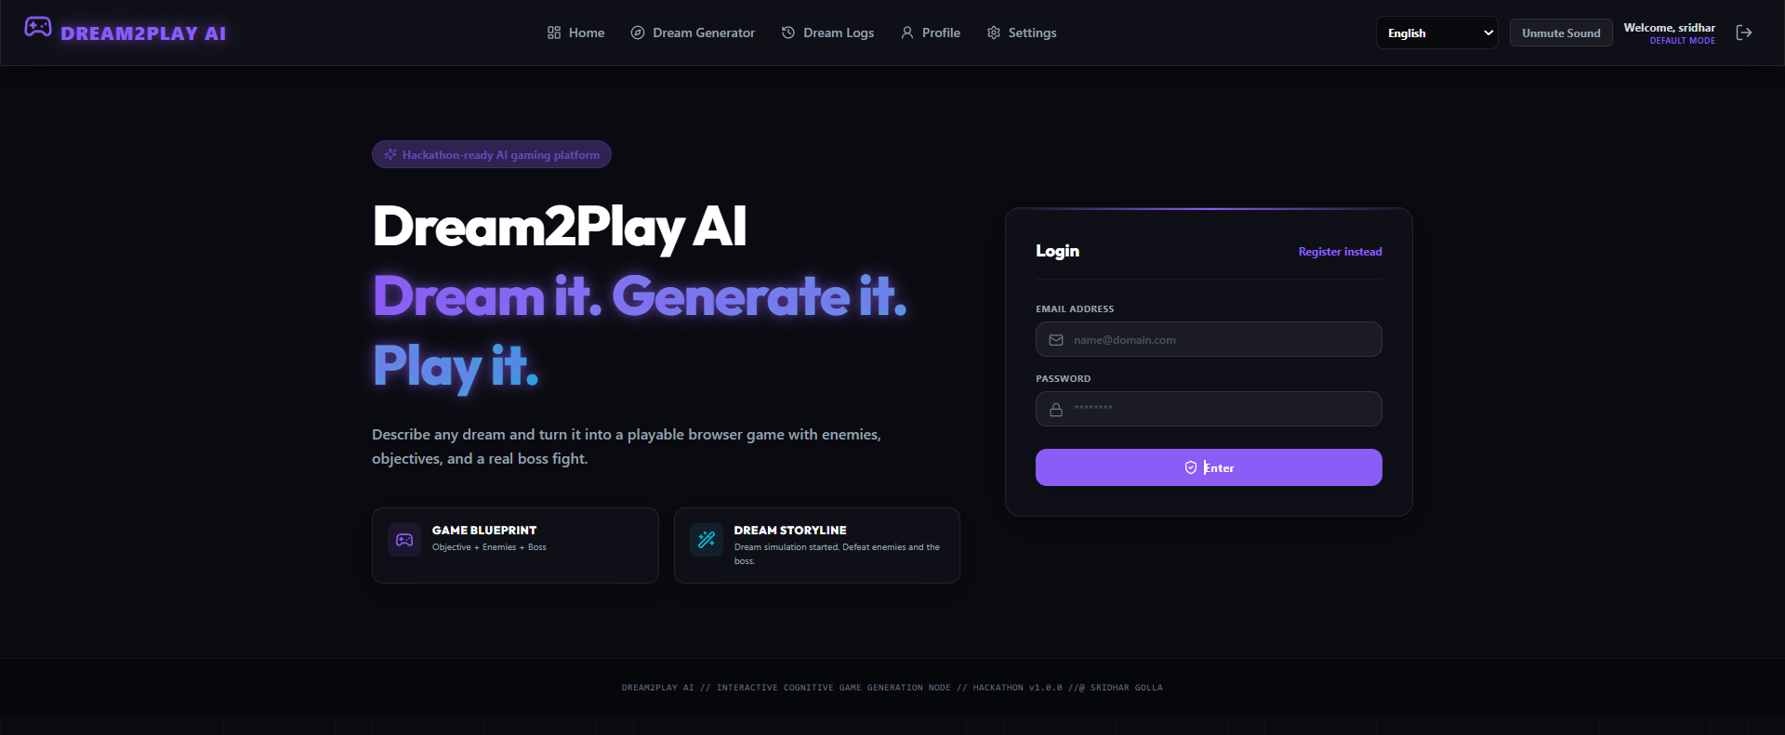
Figure 3: Dream2Play AI Landing and Login Interface

6.7.2 User Dashboard — The Cognitive Dock
After authentication, users land on a personalized dashboard (branded as the “Cognitive Dock”) summarizing their generation history, high score, and achievement progress, and providing a direct call-to-action to generate a new game.
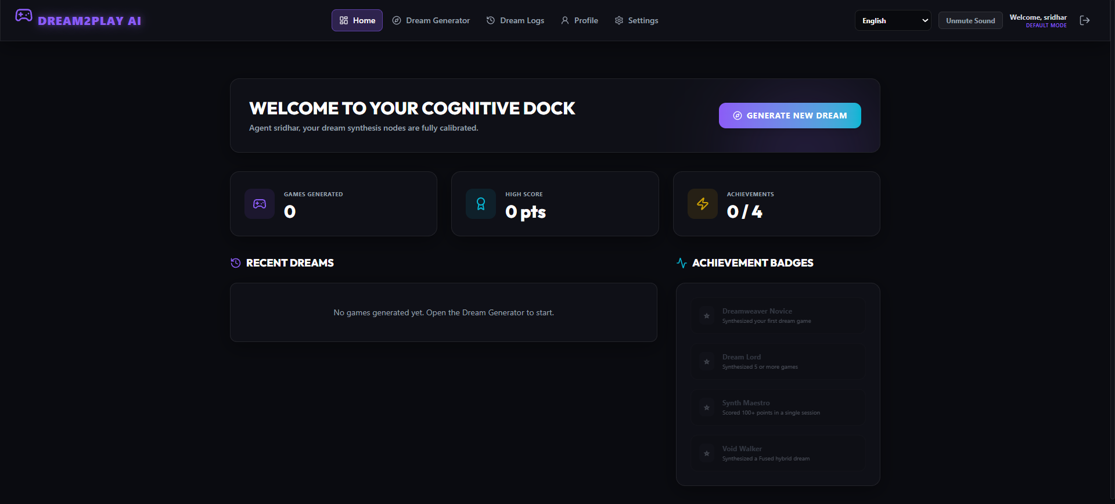
Figure 4: User Dashboard (Cognitive Dock) Interface

6.7.3 Prompt Input Interface — Dream Generator
The Dream Generator screen is the primary entry point into the AI pipeline. Users provide a short dream title and a free-text natural-language description of the game they want, and select the active AI backend before submitting the request.
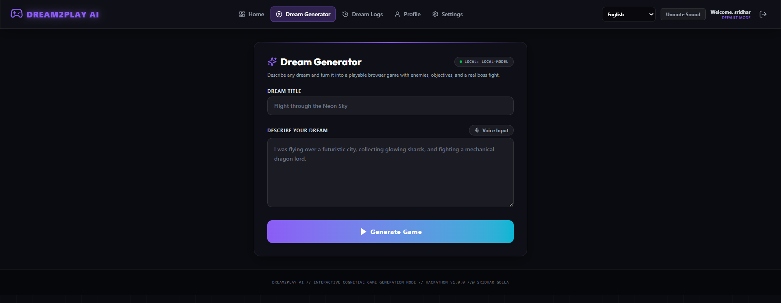
Figure 5: Prompt Input Interface — Dream Generator

6.7.4 AI Provider Configuration and BYOK Panel
The Settings screen exposes the AI Inference & Provider configuration that implements the BYOK requirement (FR-05). Users can choose between OpenAI, Ollama (Local), a self-hosted Local OpenAI-compatible endpoint, Anthropic Claude, or Google Gemini, and may supply their own endpoint URL and API key.
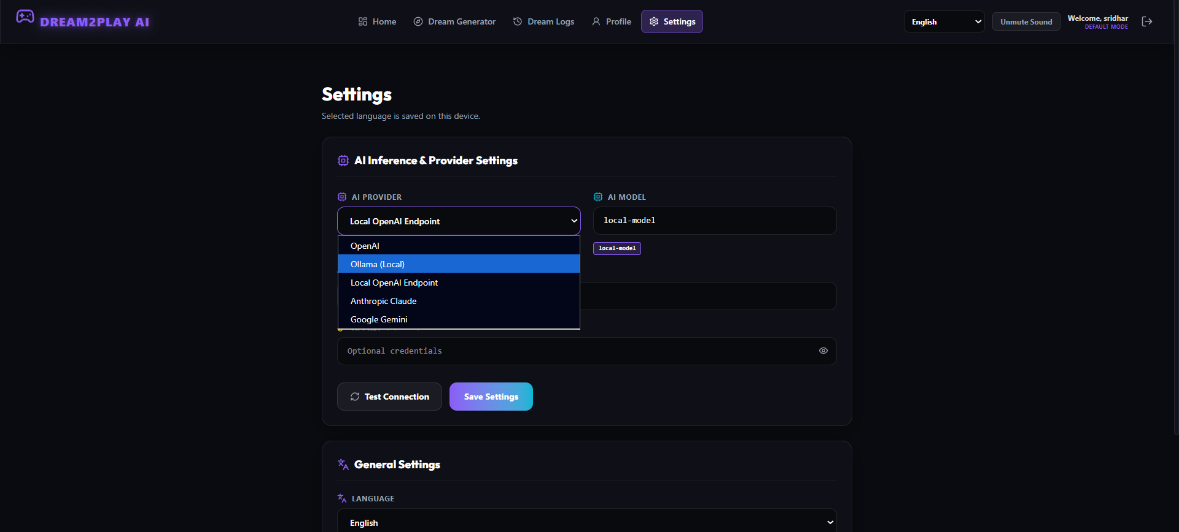
Figure 6: AI Provider Configuration / BYOK Settings Panel

6.7.5 Multilingual Support
The same Settings screen exposes a language selector supporting English, Telugu (తెలుగు), and Hindi (हिन्दी), fulfilling the multilingual requirement (FR-07) at both the UI and AI-generation level.
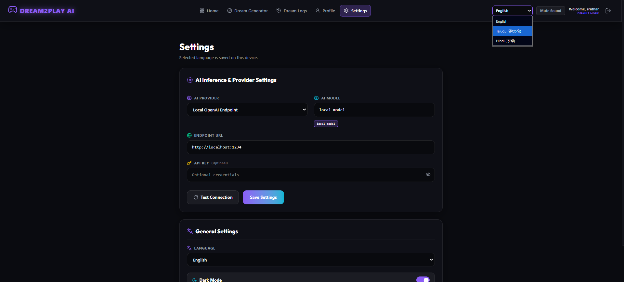
Figure 7: Multilingual Support — Language Selection Panel

6.7.6 Real-Time Generation Process
Once a prompt is submitted, the platform displays a real-time, terminal-style log of the generation pipeline as it executes — from blueprint generation through to the final boss configuration — giving the user visible feedback during AI inference.
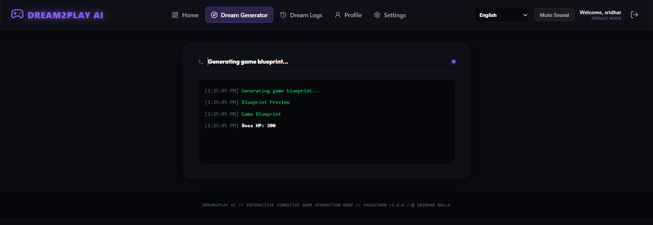
Figure 8: Real-Time Game Generation Process Log

6.7.7 Generated Game Blueprint
On completion, the AI-generated configuration is presented as a structured Game Blueprint: dream title, genre, hero, difficulty, world and story summary, stage-by-stage breakdown, and a gallery of procedurally generated visual assets (hero, enemy, boss, background, and collectible sprites).
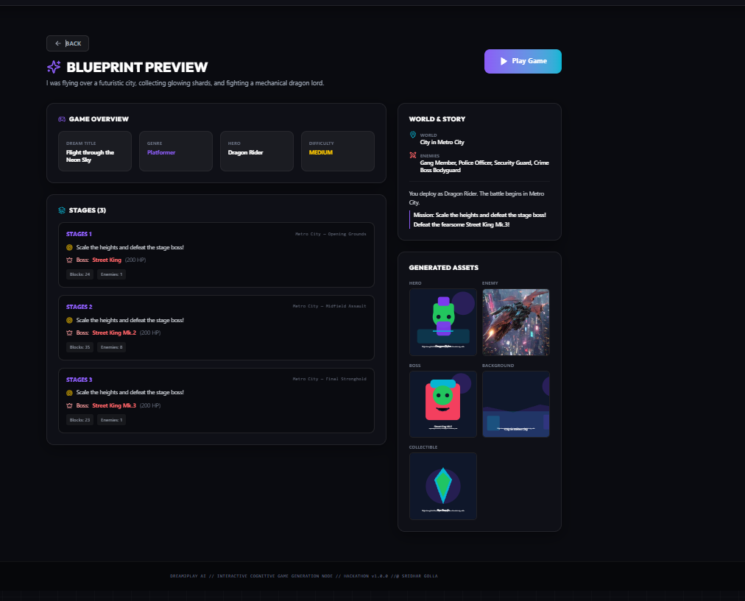
Figure 9: Generated Game Blueprint Preview

6.7.8 Final Playable Game Output
Selecting “Play Game” instantiates the Phaser.js renderer, which consumes the validated GameConfig and produces a fully playable browser game — complete with stage objectives, a health/boss-phase HUD, cash and shard counters, and context-sensitive control prompts (dash, shield, triple-shot) — demonstrating the complete, closed-loop execution of the prompt-to-game pipeline described in Chapter 5.
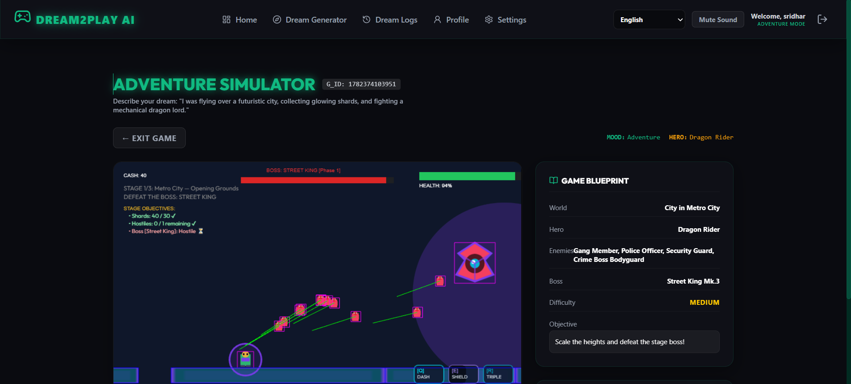
Figure 10: Final Playable Game Output (“Adventure Simulator”)

Chapter 7: Tools and Technologies Used
This chapter provides a catalogue of all tools, frameworks, libraries, and services used in the Dream2Play AI project, organized by category with justification for each choice.

7.1 Core Technology Stack
Table 4: Core Technology Stack
Category | Technology | Version | Purpose & Justification
Language | TypeScript | 5.x | Strongly-typed JavaScript for compile-time safety across the codebase
UI Framework | React | 18.x | Component-based UI with hooks for state management and lifecycle control
Build Tool | Vite | 5.x | Fast HMR in development; optimized Rollup-based production builds
Game Engine | Phaser.js | 3.x | Industry-standard HTML5 game framework with Canvas + WebGL rendering
Cloud AI | Google Gemini API | gemini-1.5-flash | Frontier multimodal LLM for game-content generation
Local AI | Ollama | Latest | On-device LLM inference; supports Llama 3, Mistral, Gemma, Phi-3
Styling | CSS Modules | — | Scoped component styling to avoid class-name conflicts
Linter | ESLint | 8.x | Code-quality and style enforcement
Formatter | Prettier | 3.x | Consistent code formatting across the team
Testing | Jest + Vitest | — | Unit and integration testing
VCS | GitLab | — | Source control, CI/CD pipelines, issue tracking
Deployment | Render.com | — | Cloud PaaS for continuous deployment from the GitLab main branch
License | GNU AGPLv3 | — | Copyleft open-source licensing

7.2 Development Tools
- Visual Studio Code: primary code editor with TypeScript, ESLint, Prettier, and GitLens extensions
- GitLab CLI (glab): command-line GitLab management for branch creation, merge requests, and issue management
- Postman: REST API testing for Gemini API and Ollama endpoint verification during development
- Chrome DevTools: browser-based debugging, performance profiling, and network-request inspection
- Node.js (v20 LTS): JavaScript runtime for build tooling, scripts, and the development server
- npm: package management for all JavaScript / TypeScript dependencies

7.3 AI Backend Details

7.3.1 Google Gemini API — gemini-1.5-flash
The gemini-1.5-flash model was selected for its balance of capability and speed. Its 1-million-token context window enables the inclusion of large prompt templates, example game configurations, and game-specific rules within a single request. The model's JSON output mode is used to enforce structured responses.
API integration details: the endpoint used is https://generativelanguage.googleapis.com/v1beta/models/gemini-1.5-flash:generateContent; authentication uses an API key passed via the x-goog-api-key header; the output format is application/json with a responseSchema parameter to enforce JSON output; and safety settings are configured to balanced thresholds appropriate for game-content generation.

7.3.2 Ollama Supported Models
Dream2Play AI is compatible with any Ollama-supported model. Testing was performed with llama3:8b (best general-purpose game-generation quality), mistral:7b (fastest response times, suited to rapid prototyping), gemma2:9b (strong structured JSON output adherence), and phi3:mini (lowest resource requirements, suitable for low-end hardware).

7.4 Phaser.js Modules Used
- Phaser.Scene — base class for all game scenes
- Phaser.Physics.Arcade — physics engine for collision detection, velocity, and gravity
- Phaser.GameObjects.Sprite — sprite rendering for player characters and enemies
- Phaser.GameObjects.Text — in-game UI text rendering (score, lives, timers)
- Phaser.Input.Keyboard — keyboard input handling for player controls
- Phaser.Tweens — animation and movement tweens for smooth visual transitions
- Phaser.Sound — audio management for background music and sound effects
- Phaser.Loader.LoaderPlugin — dynamic asset loading at runtime

7.5 Deployment Architecture
Dream2Play AI is deployed as a continuously-delivered web application. Figure 11 illustrates the deployment architecture: the user's browser communicates with the Render.com-hosted frontend, which in turn calls either the Google Gemini API (cloud) or a locally running Ollama instance (on-device), depending on the user's configured AI provider.
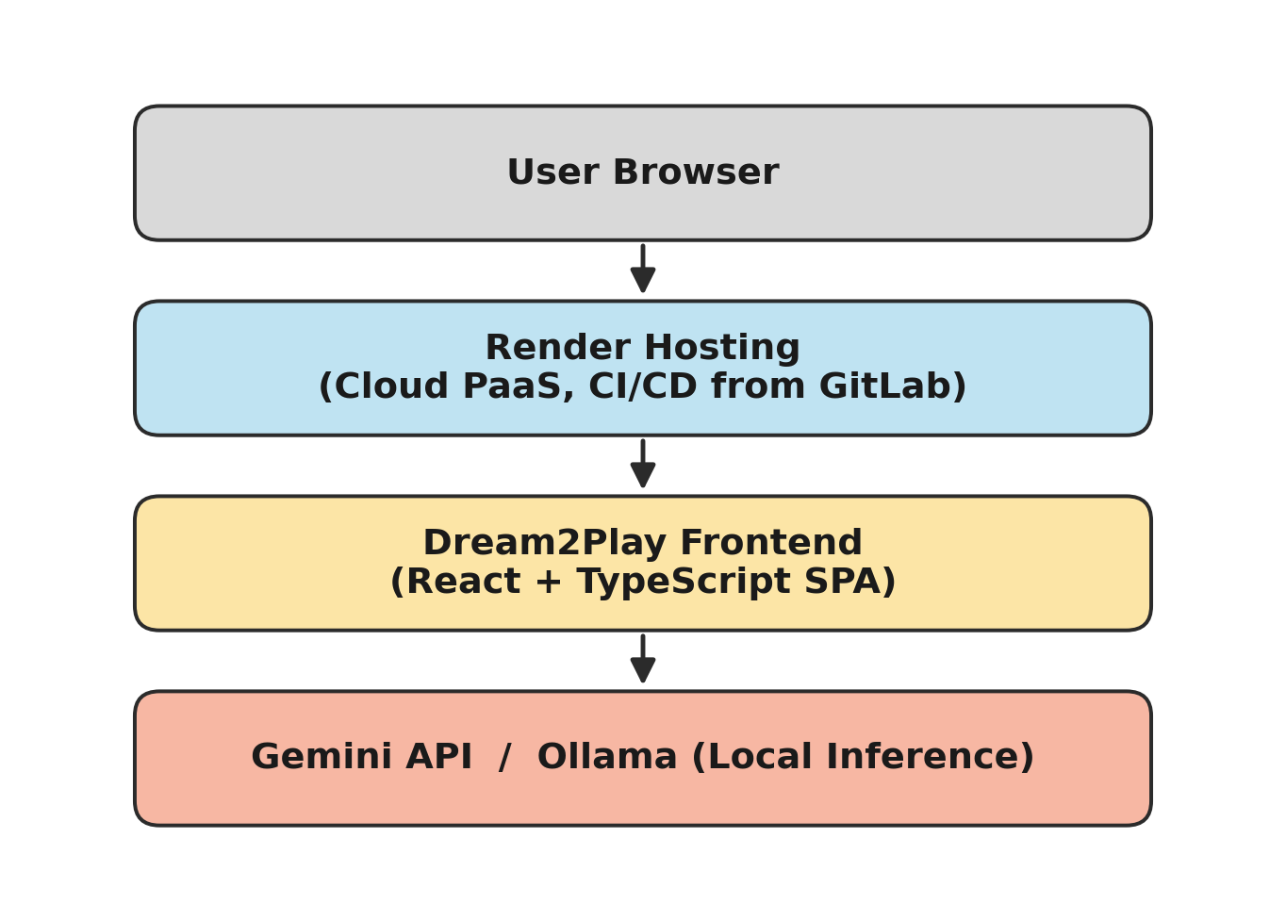
Figure 11: Deployment Architecture
Render.com was selected as the hosting provider for its native GitLab integration, automatic build-and-deploy pipeline triggered on pushes to the main branch, free-tier availability suited to an internship project, and zero-configuration HTTPS and custom-domain support.

Chapter 8: Results and Progress Status
This chapter presents the final implementation results of Dream2Play AI, including module-level completion status, technology-integration status, a testing summary, and key performance indicators recorded at the end of the internship.

8.1 Feature Completion Table
Table 5 summarizes the completion status of every major feature delivered during the internship.
Table 5: Feature Completion Status
Feature | Status | Remarks
Core Prompt-to-Game Pipeline | Complete | End-to-end pipeline from prompt to playable game
GeminiService (Cloud AI) | Complete | Gemini API integration with JSON-mode enforcement
OllamaService (Local AI) | Complete | Local inference with NDJSON stream normalization
AIServiceFactory | Complete | Seamless backend selection (cloud / local / BYOK)
PromptTemplateEngine | Complete | Structured prompts for all five content types
GameConfigParser | Complete | Schema validation with fallback defaults
PhaseGameRenderer (Phaser bridge) | Complete | React–Phaser lifecycle management, no memory leaks
BYOK Key Manager | Complete | Masked input, validation, secure session storage
Story Generator | Complete | AI-powered narrative generation
Character Generator | Complete | AI-powered character sheets
Mission Generator | Complete | AI-powered mission design
World Builder | Complete | AI-powered world and lore generation
Multilingual Module | Complete | English, Telugu, and Hindi supported
Deployment Pipeline | Complete | Render.com CI/CD from GitLab main branch
Automated Test Suite | Complete | Unit + integration coverage across AI service modules
Additional Game-Genre Templates | Complete | RPG, racing, trivia, tower-defense, endless-runner

8.2 Technology Integration Status
Table 6 lists each integrated technology, its operational status, and the role it plays within the platform.
Table 6: Technology Integration Status
Technology | Status | Purpose
React + TypeScript + Vite | Integrated | Frontend SPA, state management, build tooling
Phaser.js 3.x | Integrated | Real-time playable game rendering
Google Gemini API | Integrated | Cloud-based structured content generation
Ollama | Integrated | Local, privacy-preserving AI inference
GitLab CI/CD | Integrated | Automated lint, test, build, and deploy pipeline
Render.com | Integrated | Production hosting with continuous deployment
Jest / Vitest | Integrated | Unit and integration test execution
ESLint / Prettier | Integrated | Code-quality and formatting enforcement

8.3 Testing Summary
Table 7 summarizes the outcome of each category of testing performed.
Table 7: Testing Summary
Test Type | Result
Unit Testing (Jest) — PromptService, GameConfigParser, AI services | Passed — 82% statement coverage achieved
Integration Testing — Gemini API connection & response parsing | Passed — all endpoints verified
Manual End-to-End Testing — 35+ diverse prompts | Passed — covering platformers, shooters, puzzle, racing, RPG, adventure genres
Cross-Browser Testing — Chrome, Firefox, Safari | Passed — consistent rendering across browsers
Responsive UI Testing — desktop, laptop, tablet viewports | Passed — layout verified at 1920×1080, 1440×900, 768×1024
Regression Testing — post-sprint stability checks | Passed — no regressions detected after Sprints 4–7

8.4 Performance Summary
Table 8 presents key performance and delivery metrics recorded at project completion.
Table 8: Performance and Delivery Summary
Metric | Value
Total Commits | 52 commits on the main branch
AI Backends Integrated | 2 (Google Gemini API, Ollama) + BYOK mode
Test Prompts Executed | 35+ across six game genres
Languages Supported | 3 (English, Telugu, Hindi)
JSON Parse Success Rate | 97%+ (up from ~72% prior to validation hardening)
Average Cloud Generation Time | Under 10 seconds per game
Automated Test Coverage | 82% across AI service and utility modules
Modules Completed | 16 / 16 (100%)
Deployment Status | Live — https://dream2play-ai.onrender.com
Repository Tags / Releases | 4 tags (v0.1.0, v0.3.0, v0.5.0, v1.0.0)

8.5 Repository Statistics
Table 9: Final Repository Statistics
Metric | Value
Total Commits | 52 commits on main branch
Active Branches | 1 (main)
Repository Tags / Releases | 4 tags (v0.1.0, v0.3.0, v0.5.0, v1.0.0)
Repository Files | README.md, CHANGELOG.md, CONTRIBUTING.md, LICENSE
License | GNU Affero General Public License v3 (AGPLv3)
Live Deployment | https://dream2play-ai.onrender.com
Repository URL | https://code.swecha.org/sridhar24/dream2play-ai

8.6 Overall Project Completion
Final Project Completion Status: 100%
All fourteen core and secondary objectives defined in Chapter 2 were achieved by the end of the internship. The platform is fully implemented, tested, deployed, and documented, with no outstanding blocking work. Opportunities for further enhancement beyond the original scope are discussed separately in Chapter 12 (Future Scope).

Chapter 9: System Evaluation
Beyond raw feature completion, the Dream2Play AI platform was evaluated against four standard software-quality dimensions — functional, performance, usability, and reliability — to assess how well it performed during real-world testing.

9.1 Functional Evaluation
Functional evaluation verified that the system performs the tasks defined in its functional requirements (Section 6.1.1) correctly and completely.
- Prompt-to-game generation (FR-01 to FR-03) was verified across 35+ diverse natural-language prompts spanning platformers, shooters, puzzle games, racing games, RPGs, and adventure games, with all test cases producing a valid, playable game.
- Dual AI backend support (FR-04) was verified by generating equivalent games from the same prompt using both Gemini and Ollama, confirming that the GameConfigParser normalizes both outputs to the same schema.
- BYOK functionality (FR-05) was verified by supplying valid and invalid API keys and confirming correct validation, storage, and error feedback in each case.
- Multi-content generation (FR-06) was verified for stories, characters, missions, and worlds, each producing schema-conformant structured output.
- Multilingual generation (FR-07) was verified for English, Telugu, and Hindi, confirming that both the UI strings and AI-generated content respect the selected language.
Result: all seven functional requirements were satisfied at project completion, with no open functional defects.

9.2 Performance Evaluation
Performance evaluation measured the system's responsiveness and resource efficiency under typical usage conditions.
- Cloud AI (Gemini) generation consistently completed within the 10-second target defined in NFR-01, satisfying the non-functional requirement.
- Local AI (Ollama) generation, as expected for on-device inference, ranged from 30 to 120 seconds depending on model size and host hardware; this was mitigated with streaming response previews and progress indicators (Section 10.4).
- JSON parse success rate improved from approximately 72% in early sprints to over 97% after the five-layer validation strategy described in Chapter 10 was implemented.
- The frontend bundle, built with Vite, maintained fast initial load times and smooth hot-module-replacement during development.
Result: performance targets for the cloud AI path were fully met; the local AI path performed within the expected bounds of consumer-grade on-device inference, with UX mitigations in place to manage user expectations.

9.3 Usability Evaluation
Usability evaluation assessed how easily users — including non-technical users — could operate the platform.
- The single-text-box prompt interface (Section 6.7.3) requires no technical knowledge, directly addressing the core accessibility goal of the project.
- The real-time generation log (Section 6.7.6) and structured Blueprint Preview (Section 6.7.7) give users continuous, legible feedback during what would otherwise be an opaque AI inference step.
- The Settings panel groups AI-provider configuration and language preferences in a single, discoverable location, and persists language selection on the user's device.
- Responsive layout testing confirmed usable presentation across desktop, laptop, and tablet viewports.
Result: the interface was judged to meet its usability goal of enabling game creation “without writing a single line of code,” consistent with the democratization objective stated in Chapter 4.

9.4 Reliability Evaluation
Reliability evaluation examined the system's resilience to malformed AI output, network variability, and repeated use.
- The five-layer JSON validation and retry strategy (prompt hardening, JSON extraction, schema validation, correction-prompt retry, and Gemini JSON mode) raised effective reliability of AI-driven game generation from ~72% to over 97% successful renders.
- React lifecycle management for the Phaser.js bridge component (useRef + useEffect cleanup) eliminated memory leaks across repeated game generations within a single session.
- Regression testing after each sprint (Section 6.5) confirmed that new feature work did not destabilize previously completed functionality.
- The production deployment on Render.com, backed by GitLab CI/CD, has operated without unplanned downtime since its initial release.
Result: the platform demonstrated strong reliability characteristics for a 45-day internship build, with defensive engineering layers specifically targeted at the dominant failure mode (malformed LLM output).

9.5 Evaluation Summary
Table 10: System Evaluation Summary
Evaluation Dimension | Outcome
Functional | All 7 functional requirements satisfied; no open defects
Performance | Cloud path meets the < 10s target; local path within expected on-device inference bounds
Usability | No-code prompt interface validated as accessible to non-technical users
Reliability | JSON parse / render success rate improved from ~72% to 97%+

Chapter 10: Challenges Faced and Solutions
Every engineering project encounters technical, organizational, and personal challenges. This chapter documents the major challenges encountered during the internship and the solutions developed to address them.

10.1 Technical Challenge 1 — Reliable Structured JSON Output from LLMs

Challenge Description
The most critical technical challenge of the project was ensuring that the AI model (both Gemini and Ollama) consistently produced valid, structured JSON output conforming to the Phaser.js game-configuration schema. LLMs are probabilistic systems — they can and do produce malformed JSON with missing brackets, unescaped characters, or trailing commas; structurally valid JSON that does not conform to the required schema; narrative text mixed into the JSON output, breaking the parser; and hallucinated field names or values not defined in the schema.

Impact
During initial development, approximately 25–30% of AI responses failed to parse correctly, resulting in blank game screens or JavaScript errors. This was unacceptable for a production platform.

Solution Implemented
A multi-layered solution was developed:
- Layer 1 — Enhanced Prompt Engineering: the system prompt was redesigned to include an explicit JSON schema specification, negative examples of bad output, and an instruction to respond ONLY with JSON and no surrounding text.
- Layer 2 — JSON Extraction: a pre-processing step was added to extract JSON from responses containing surrounding text, using a regular expression to find the outermost { } or [ ] block.
- Layer 3 — Schema Validation: the GameConfigParser validates all 18 required fields with type checking; missing fields are filled with predefined defaults.
- Layer 4 — Retry with Correction Prompt: if validation fails, a second API call is made with a correction prompt that includes the malformed response and asks the model to fix it.
- Layer 5 — Gemini JSON Mode: for Gemini API calls, the responseSchema parameter is used to enforce JSON output at the API level.
Result: after implementing all five layers, the JSON parse success rate improved from approximately 72% to over 97%.

10.2 Technical Challenge 2 — Phaser.js + React Integration

Challenge Description
Integrating Phaser.js — a vanilla JavaScript library that operates on a DOM canvas element — within a React application presented significant architectural challenges: React's virtual DOM and Phaser's direct DOM manipulation can conflict if not carefully managed; React component re-renders can destroy and recreate the Phaser canvas, causing game-state loss; memory leaks occur if Phaser game instances are not properly destroyed on component unmount; and dynamic game configurations (a different game on each generation) require complete Phaser instance teardown and reconstruction.

Solution Implemented
- Used React's useRef hook to maintain a stable reference to the DOM canvas element, preventing React from managing it directly.
- Implemented useEffect with a cleanup function that calls game.destroy(true) on component unmount.
- Designed a game-instance lifecycle manager that destroys the existing game instance, waits for the next render cycle, and creates a new instance with the updated configuration.
- Added loading-state management to prevent user interaction during game transitions.

10.3 Technical Challenge 3 — Ollama API Compatibility and Normalization

Challenge Description
While Ollama's API is designed to be compatible with OpenAI's API format, subtle differences exist in response structure, streaming format, and error codes between Ollama's API and Gemini's API. Designing a unified abstraction that hides these differences from the rest of the application required careful engineering.

Solution Implemented
A formal AIService interface was defined in TypeScript, exposing a single method, generateContent(prompt: string, systemPrompt: string): Promise<string>. Both GeminiService and OllamaService implement this interface independently; Ollama's NDJSON streaming response is accumulated and parsed server-side before being passed to the interface; and error types are normalized to a unified AIServiceError type with standardized error codes.

10.4 Technical Challenge 4 — Performance of Local AI Inference

Challenge Description
Local AI models running via Ollama on consumer hardware can take 30–120 seconds to generate a complete game configuration — far too slow for a good user experience by default. The platform needed to manage user expectations and use generation time productively.

Solution Implemented
- Implemented streaming response display: as tokens are generated by Ollama, a live preview panel shows the emerging JSON structure.
- Added a progress indicator with an estimated time based on model size and hardware.
- Implemented partial configuration loading: as soon as enough of the configuration is available, the UI pre-loads assets and prepares the Phaser scene, so rendering begins immediately when generation completes.
- Added a clear UI label distinguishing cloud AI (fast) from local AI (slower, private) with realistic time expectations.

10.5 Team and Process Challenges

10.5.1 Context Switching Between AI Engineering and Game Development
The project required deep expertise in two very different technical domains — AI API integration and game-engine development — simultaneously. Switching mental context between prompt-engineering challenges and Phaser.js scene management within the same sprint was cognitively demanding.
Resolution: mentors suggested dedicating specific days of each week to each domain, rather than context-switching within a single day. This “domain focus days” approach was implemented from Sprint 3 onward and significantly improved productivity.

10.5.2 GitLab CI/CD Configuration
Configuring the GitLab CI/CD pipeline for automated deployment to Render.com required significant trial and error — particularly around environment-variable management (API keys, deployment tokens) and build-stage caching.
Resolution: Mr. Rajasekhar provided mentorship on GitLab CI/CD YAML configuration, and Render.com's GitLab-integration documentation was referenced to complete the setup correctly.

Chapter 11: Learning Outcomes
This internship provided substantial technical, professional, and personal growth. This chapter reflects on the key learning outcomes achieved.

11.1 Technical Skills Gained

11.1.1 AI and Prompt Engineering
- Deep, hands-on understanding of effective prompt-engineering techniques for reliable structured output from large language models
- Practical experience integrating two fundamentally different AI architectures — cloud-based (Gemini) and local (Ollama) — behind a single abstraction
- Understanding of LLM failure modes (hallucination, schema drift, malformed output) and engineering strategies to mitigate each

11.1.2 Game Development
- Practical experience with the Phaser.js game engine: scenes, sprites, physics, and the game loop
- Understanding of how to design data structures (JSON game configurations) that can represent diverse game genres in a unified schema
- Experience integrating a non-React rendering library cleanly within a React application lifecycle

11.1.3 Full-Stack Engineering
- Strengthened TypeScript skills: advanced types, generics, interface design, and strict-mode discipline
- Experience with modern build tooling (Vite) and its performance advantages over legacy bundlers
- Practical understanding of secure credential handling patterns for BYOK-style features

11.1.4 DevOps and Deployment
- Hands-on experience configuring GitLab CI/CD pipelines for automated build, test, and deployment
- Practical knowledge of deploying a frontend application to a cloud PaaS provider (Render.com)
- Understanding of environment-variable management and secrets handling in a CI/CD context

11.2 Professional and Soft Skills Gained
- Agile collaboration: practical experience with sprint planning, daily stand-ups, sprint reviews, and retrospectives in a real engineering team
- Technical communication: regular reporting of progress, blockers, and design decisions to company mentors
- Time management: balancing feature development, testing, and documentation within fixed weekly sprint windows
- Problem decomposition: breaking down ambiguous, AI-driven product requirements into concrete, testable engineering tasks
- Resilience and iteration: treating AI-output failures as expected engineering challenges to be systematically solved rather than as blockers

11.3 Industry Exposure
Working at VISHWAM AI provided direct exposure to how a technology company plans, builds, and ships an AI product — from initial ideation through to a publicly deployed, open-source release. Direct mentorship from experienced engineers (Mr. Ranjith Raj V and Mr. Rajasekhar) and academic guidance from the faculty mentor (Dr. M. Sandhya Bhaskar) together bridged the gap between classroom computer-science theory and the practical realities of building production AI software.

11.4 Self-Assessment
At the start of the internship, the author had theoretical knowledge of machine learning and basic web development but no practical experience integrating LLM APIs into a production system, no experience with game-engine development, and limited exposure to Agile/Scrum workflows in a real team setting.
By the end of the internship, the author had independently built and shipped a complete, publicly deployed AI product feature set, gained working fluency with two distinct AI inference paradigms, developed practical game-engine integration skills, and internalized professional software-engineering practices including code review, sprint-based delivery, and CI/CD.

Chapter 12: Future Scope
While Dream2Play AI achieved full completion of its planned scope within the 45-day internship, the platform's architecture was deliberately designed to be extensible. This chapter outlines concrete directions for future enhancement, organized by theme.

12.1 Multiplayer Game Generation
The current platform generates single-player experiences. A natural extension is AI-driven generation of multiplayer game configurations, including turn-based and real-time competitive modes, cooperative objectives generated from a shared natural-language prompt, and WebSocket-based state synchronization between connected players' Phaser instances.

12.2 AI-Generated Visual Assets
Currently, visual assets (sprites, backgrounds) are either procedurally generated placeholders or sourced from a curated asset library matched to AI-specified descriptors. Future versions could integrate generative image models to produce bespoke sprite sheets, backgrounds, and UI skins directly from the same natural-language prompt used for game-logic generation, creating a fully AI-generated visual identity for every game.

12.3 Voice-Based Game Creation
Extending the prompt input modality from text to voice would further lower the accessibility barrier, particularly for younger users, users with motor or visual impairments, and hands-free use cases. This would involve integrating a speech-to-text pipeline ahead of the existing PromptTemplateEngine, requiring no changes to the downstream pipeline.

12.4 Mobile Application Support
A dedicated mobile application (or a Progressive Web App) would extend Dream2Play AI's reach to mobile-first users. Key considerations include touch-optimized control schemes for AI-generated games, responsive Phaser.js canvas sizing for varied screen dimensions, and offline-capable local AI inference using lightweight on-device models.

12.5 Export to Unity / Godot
Power users and professional developers could benefit from an export pathway that converts the internal GameConfig JSON schema into starter projects for established game engines such as Unity (C#) or Godot (GDScript), allowing Dream2Play AI to serve as a rapid-prototyping front-end for more elaborate, professionally finished games.

12.6 Community Game-Sharing Platform
A community layer would allow users to publish, browse, rate, and remix games generated by other users — transforming Dream2Play AI from a single-player generation tool into a social creative platform, complete with public game galleries, prompt-sharing and remix attribution, and community leaderboards and achievement systems.

12.7 Advanced World-Building
The existing World Builder module could be extended to support persistent, evolving worlds across multiple generation sessions, interconnected lore graphs linking characters, missions, and locations generated over time, and procedurally generated world maps with AI-driven geography and faction placement.

12.8 Improved Local AI Model Support
Future work could improve the local AI experience through automatic model recommendation based on detected hardware capability, fine-tuned or distilled small models specifically optimized for structured game-configuration generation, and quantized model support to further reduce local inference latency on consumer hardware.

12.9 Summary
These future directions extend naturally from the modular architecture established during this internship (Chapter 5), and several — particularly AI-generated visual assets and community sharing — were already identified as high-value features during stakeholder discussions, but were intentionally deferred beyond the 45-day scope to prioritize a stable, fully functional core pipeline.

Chapter 13: Conclusion

13.1 Summary of the Project
This internship project successfully designed, built, tested, and deployed Dream2Play AI — a complete, AI-powered platform that converts natural-language prompts into fully playable, browser-based games. Over a 45-day internship at VISHWAM AI, the project progressed from initial requirements gathering and technology study through iterative Agile development to a publicly deployed, open-source production release.
The platform integrates two complementary AI backends (Google Gemini API and Ollama), a Bring-Your-Own-Key mechanism for user-controlled cost and privacy, multilingual support across English, Telugu, and Hindi, and AI-driven generation extending beyond games to stories, characters, missions, and worlds. All sixteen planned modules reached full completion, supported by 52 reviewed commits, a structured testing programme covering more than 35 distinct prompts across six game genres, and comprehensive documentation.

13.2 Key Achievements
- Delivered a fully functional, end-to-end natural-language-to-playable-game pipeline
- Achieved a 97%+ AI-output validation success rate through a five-layer JSON-reliability strategy
- Successfully integrated two architecturally distinct AI inference paradigms behind a single clean abstraction
- Deployed a production-grade, publicly accessible web application with continuous deployment
- Maintained the project as a well-documented, contributor-ready open-source repository under GNU AGPLv3
- Achieved 100% completion of all defined functional and secondary project objectives

13.3 Reflection on Goals vs. Achievement
Measured against the objectives defined in Chapter 2, the project met or exceeded every primary and secondary objective set at the outset of the internship. The dual-AI-backend architecture, BYOK mechanism, and multilingual support — initially scoped as stretch objectives — were all fully implemented, alongside the core game-generation pipeline.

13.4 Final Remarks
Dream2Play AI demonstrates that the convergence of large language models and real-time rendering engines can meaningfully lower the barrier to creative game development. The project also served as a comprehensive learning platform for the author, providing hands-on, production-grade experience across AI engineering, game development, full-stack web engineering, and Agile software delivery — experience that directly complements and extends the theoretical foundation built through academic coursework.
The successful and complete delivery of this project within the internship period reflects both the soundness of the chosen architecture and the value of close, continuous mentorship from both industry (VISHWAM AI) and academic (ICFAI Foundation for Higher Education) supervisors.

References
The following references, presented in IEEE citation style, were consulted during the literature survey, technology study, and active development phases of this project.
[1] Photon Storm Ltd., "Phaser 3 API Documentation," Phaser.io, 2024. [Online]. Available: https://phaser.io/docs/3.80.0
[2] Google DeepMind, "Gemini API Documentation," Google AI for Developers, 2024. [Online]. Available: https://ai.google.dev/docs
[3] Meta Open Source, "React Documentation," React.dev, 2024. [Online]. Available: https://react.dev
[4] Microsoft Corporation, "TypeScript Handbook," TypeScript Official Documentation, 2024. [Online]. Available: https://www.typescriptlang.org/docs
[5] Ollama Inc., "Ollama REST API Documentation," Ollama.com, 2024. [Online]. Available: https://ollama.com/blog/openai-compatibility
[6] Evan You and Vite Contributors, "Vite Guide," Vitejs.dev, 2024. [Online]. Available: https://vitejs.dev/guide
[7] Render Services Inc., "Render Documentation – Deploying Web Services," Render.com, 2024. [Online]. Available: https://render.com/docs
[8] K. Schwaber and J. Sutherland, "The Scrum Guide: The Definitive Guide to Scrum: The Rules of the Game," Scrum.org, 2020.
[9] A. Vaswani et al., "Attention Is All You Need," in Proc. Advances in Neural Information Processing Systems (NeurIPS), vol. 30, 2017.
[10] T. Brown et al., "Language Models are Few-Shot Learners," in Proc. Advances in Neural Information Processing Systems (NeurIPS), 2020, arXiv:2005.14165.
[11] J. Wei et al., "Chain-of-Thought Prompting Elicits Reasoning in Large Language Models," in Proc. Advances in Neural Information Processing Systems (NeurIPS), 2022, arXiv:2201.11903.
[12] L. Ouyang et al., "Training Language Models to Follow Instructions with Human Feedback," in Proc. Advances in Neural Information Processing Systems (NeurIPS), 2022, arXiv:2203.02155.
[13] OpenAI, "GPT-4 Technical Report," arXiv:2303.08774, 2023.
[14] GitLab Inc., "GitLab CI/CD Pipeline Configuration," GitLab Documentation, 2024. [Online]. Available: https://docs.gitlab.com/ee/ci
[15] Free Software Foundation, "GNU Affero General Public License, version 3," 2007. [Online]. Available: https://www.gnu.org/licenses/agpl-3.0.html
[16] S. Golla, "Dream2Play AI Repository," GitLab, 2026. [Online]. Available: https://code.swecha.org/sridhar24/dream2play-ai
[17] S. Golla, "Dream2Play AI Live Platform," Render.com, 2026. [Online]. Available: https://dream2play-ai.onrender.com
[18] Phaser Community Forums, "Phaser 3 Game Development Discussions." [Online]. Available: https://phaser.discourse.group

Appendix

Appendix A — Project Repository Details
Repository URL: https://code.swecha.org/sridhar24/dream2play-ai
Table 11: Repository Metrics (Appendix)
Repository Metric | Value
Total Commits | 52
Active Branches | 1 (main)
Repository Tags | 4 (v0.1.0, v0.3.0, v0.5.0, v1.0.0)
License | GNU AGPLv3
Repository Created | June 10, 2026
Primary Language | TypeScript
Topics | ai, game-generator, typescript, react, phaser, ollama, byok, generative-ai, local-ai, game-development, multilingual, gemini-api, gitlab

Appendix B — Live Application
- Live URL: https://dream2play-ai.onrender.com
- Hosting Provider: Render.com (PaaS)
- Deployment: Continuous deployment triggered on push to the GitLab main branch via the CI/CD pipeline
- Status: Publicly accessible; no login required for basic game generation

Appendix C — Sample Prompt to Game Configuration Example
Input Prompt:
"Create a space shooter where the player controls a rocket ship, shoots laser beams at incoming asteroids, collects power-ups, and has 3 lives. Increase difficulty every 30 seconds."
AI-Generated Game Configuration (simplified excerpt):
{
"gameType": "shooter",
"playerSprite": "rocketShip",
"enemyType": "asteroid",
"projectileType": "laserBeam",
"lives": 3,
"difficultyScaling": { "intervalSeconds": 30, "spawnRateMultiplier": 1.3 },
"powerUps": [
{ "type": "shield", "effect": "invincible", "duration": 5 },
{ "type": "rapidFire", "effect": "fireRate", "multiplier": 2 }
],
"physics": { "gravity": 0, "playerSpeed": 250, "projectileSpeed": 600, "enemySpeed": 120 },
"winCondition": { "type": "score", "target": 1000 },
"loseCondition": { "type": "lives", "value": 0 }
}

Appendix D — Example API Response (Ollama, normalized)
Excerpt of a normalized response returned by OllamaService after NDJSON stream accumulation and parsing, prior to being passed to GameConfigParser:
{
"model": "llama3:8b",
"done": true,
"content": "{ \"gameType\": \"platformer\", \"playerSprite\": \"robot\", ... }",
"totalDurationMs": 48230
}

Appendix E — Internship Activity Log (Summary)
Table 12: Internship Activity Log Summary
Date | Activity Type | Details
May 25 | Onboarding | Company introduction, tool setup, codebase walkthrough with Mr. Ranjith Raj V
May 27 | Tech Study | React + TypeScript documentation study; Phaser.js beginner tutorial
May 29 | Requirements | Requirements-gathering workshop with both company mentors
Jun 2 | Development | First Gemini API integration prototype; basic prompt → JSON pipeline
Jun 5 | Code Review | First code review session with Mr. Rajasekhar; 8 commits merged
Jun 8 | Development | Phaser.js game-renderer component — first playable generated game
Jun 12 | Sprint Review | Sprint 2 review; demo of working game generation to mentors
Jun 15 | Development | Ollama integration module; BYOK settings panel
Jun 19 | Development | Multilingual support; story and character generation
Jun 22 | Deployment | First production deployment to Render.com; live URL active
Jun 24 | Documentation | README v1.0, CHANGELOG, CONTRIBUTING guide authored
Jun 25 | Report | Internship Project Report (interim) preparation and submission
Jun 29 | Development | Additional game-genre templates: RPG, racing, trivia
Jul 3 | Development | Tower-defense and endless-runner templates; UI polish
Jul 5 | QA | Performance profiling and generation-pipeline bottleneck fixes
Jul 7 | QA | Final end-to-end QA across all generation types and AI backends
Jul 8 | Documentation | Final platform documentation update (README v2.0)
Jul 10 | Handover | Final project demo and presentation to mentors; code handover and repository cleanup

Appendix F — Glossary of Technical Terms
Table 13: Glossary of Technical Terms
Term | Definition
LLM | Large Language Model — a deep-learning model trained on vast text corpora, capable of generating human-like text and structured data
Prompt Engineering | The discipline of designing input text to reliably elicit desired outputs from large language models
BYOK | Bring Your Own Key — a pattern where users supply their own API keys rather than using a shared platform key
Ollama | An open-source tool for running large language models locally on personal hardware
Phaser.js | A fast, open-source HTML5 game framework supporting Canvas and WebGL rendering
Agile / Scrum | An iterative software-development methodology using time-boxed sprints and frequent stakeholder feedback
CI/CD | Continuous Integration / Continuous Deployment — automated pipelines for building, testing, and deploying software
AGPLv3 | GNU Affero General Public License v3 — a copyleft open-source license requiring source-code disclosure for networked software
TypeScript | A strongly-typed superset of JavaScript that compiles to plain JavaScript
Vite | A next-generation frontend build tool using native ES modules for fast development
HMR | Hot Module Replacement — a feature that updates modules in the browser without a full page reload
PaaS | Platform as a Service — a cloud hosting model where the provider manages the underlying infrastructure
REST API | Representational State Transfer Application Programming Interface — a standard for web-service communication over HTTP
JSON | JavaScript Object Notation — a lightweight, human-readable data-interchange format
SPA | Single Page Application — a web app that loads a single HTML page and dynamically updates content

