1.Git Status to check the changes that need to be committed or staged.

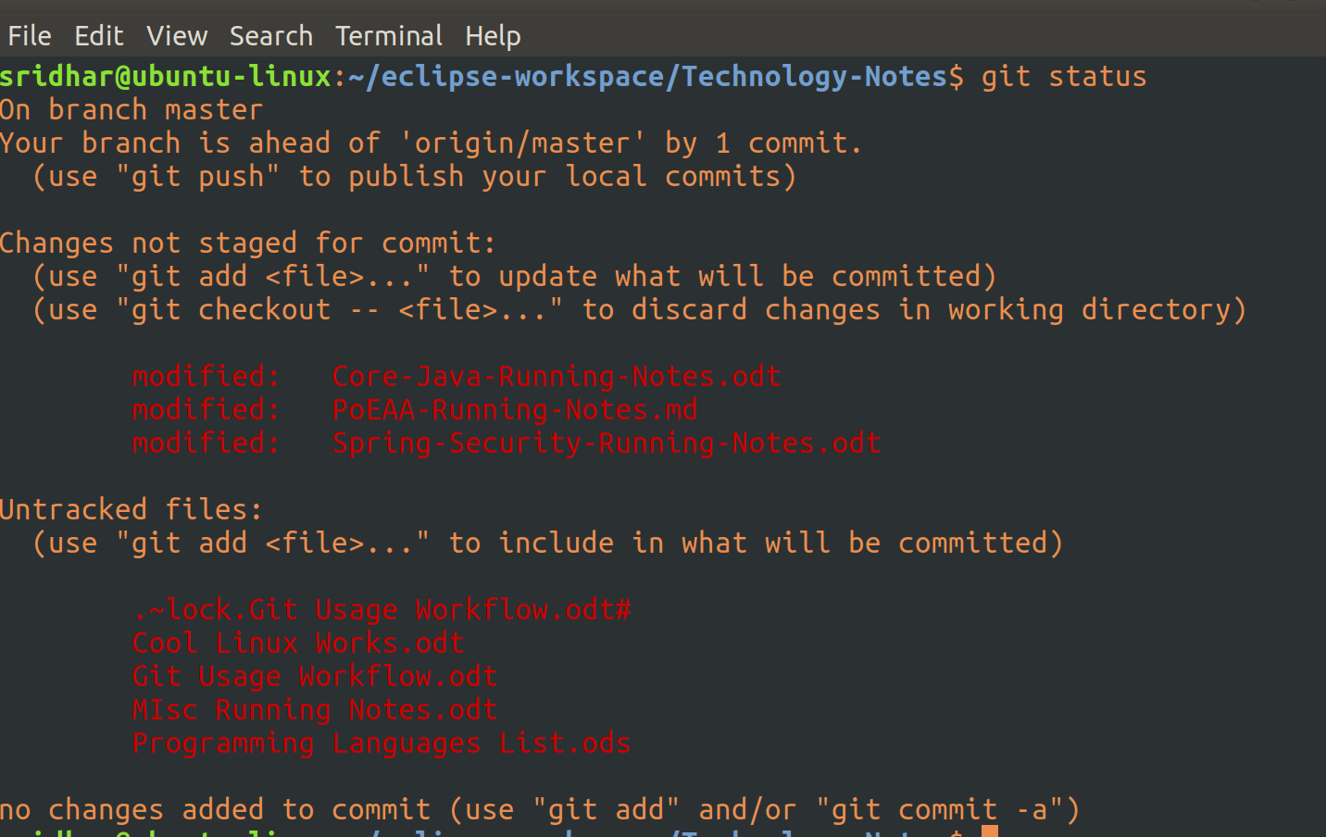
This basically shows you the high-level differences b/w your local repo and the remote repo.

As you can see above, this is the normal linux command terminal. First, navigate to the directory for which you want to see that status in comparision with it’s remote repo, which, in this case is ‘Technology-Notes’.

As you can see, it says, 3 files are modified and there are 4 new files which are not on the remote repo.

2.Staging, Committing and Pushing a file

Now, if you want to push your local modifications into the remote repo, you first have to stage the file(s). And ‘git add <file-name>’ is the command to do that.

When you do a git add command, it basically stages the said file(s), meaning, it will create an index file in which an entry of these file(s) will be made.

Git’s add command is used to stage both modified and new changes.

So, I have just staged a single file (Core-Java-Running-Notes.odt) which basically was modified locally.

Now, if you run a ‘git status’ command:

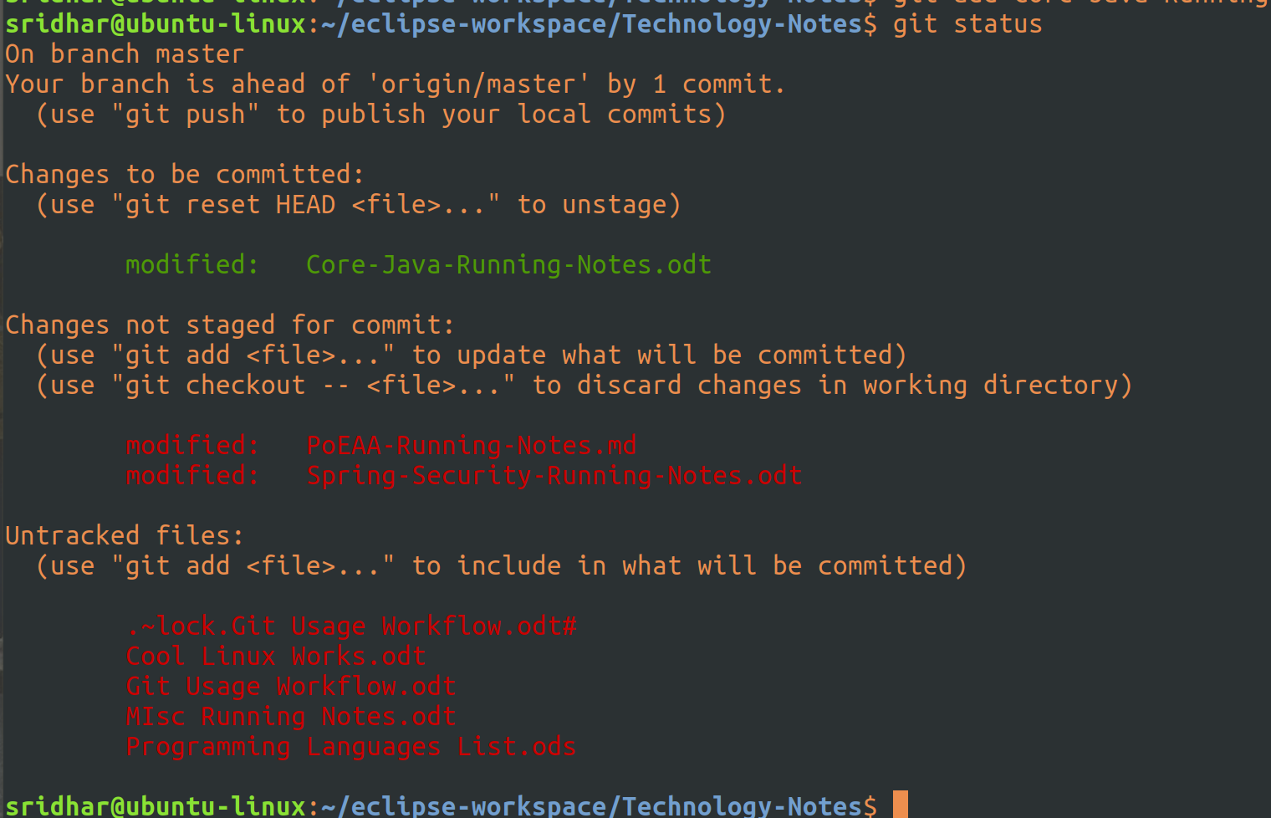
So, this says, one file (Anki Questions.odt) is staged and yet to be committed and 3 files are modified and yet to be staged and there are 3 new files which are not on the remote repo.

It shows us that 1 file is to be committed, 2 files are not yet stages (and are modified locally), and 4 files are untracked (not present in remote repo).

Now, let’s go ahead and commit the staged file. To commit a staged file, you need to run: git commit -m “some message”

When you run the above the staged file is not committed to remote repo but is only saves a new commit object in the local git repo. This is unlike other versioning systems (like svn), where by commit, it pushes the changes to the remote repo.

So, when you do a commit in git, it saves a new commit object in the local git repo which then has to be pushed, fetched or pull to the remote repo.

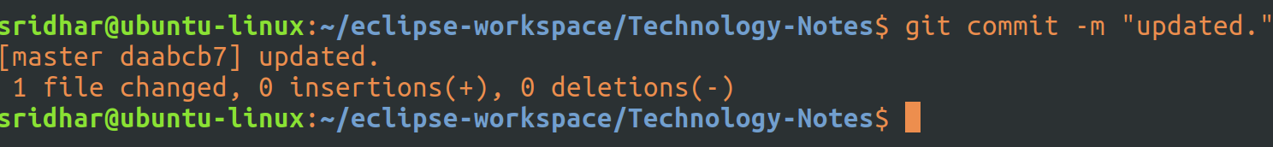
As you can see from above, it says, 1 file changed. Now the file that was staged earlier ( Core-Java-Running-Notes.odt) has been now locally committed as a new object in the local repo, ready to be pushed to the remote repo.
Now, let’s again run git status to see what it says:

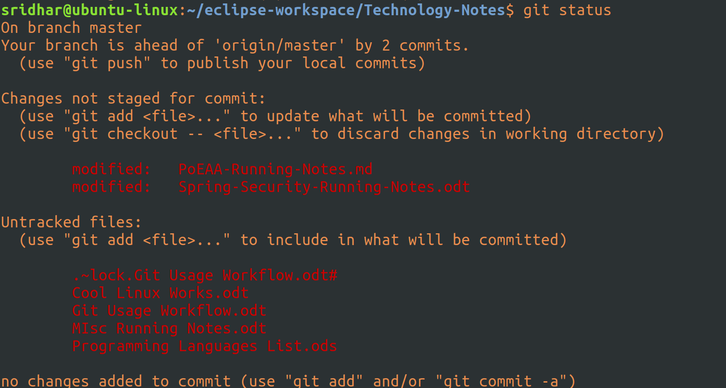
It says, ‘your branch is ahead of master by 2 commits’ - 2 because, one i have already done and the second one is the one which we have done above. So, basically, there are now 2 commites which are to be pushsed into remote repo or also called as master or origin.

Push the files to master:
To push the commits to the remote repo/master, run the command:
git push origin master

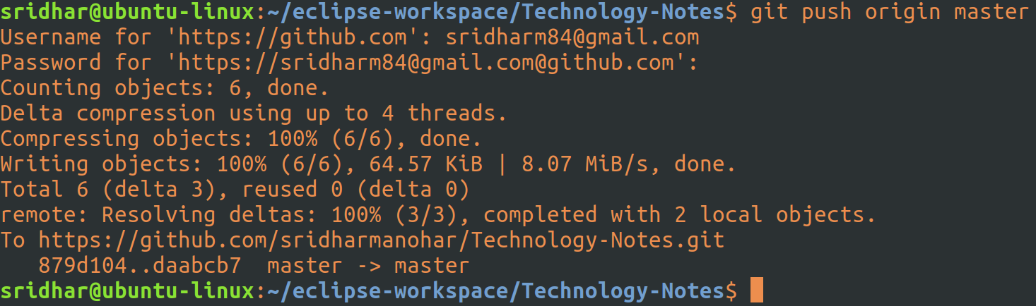

Asks for username and password of the git repo you are trying to push to and then pushes the changes.

Now, run the git status command to check the status:

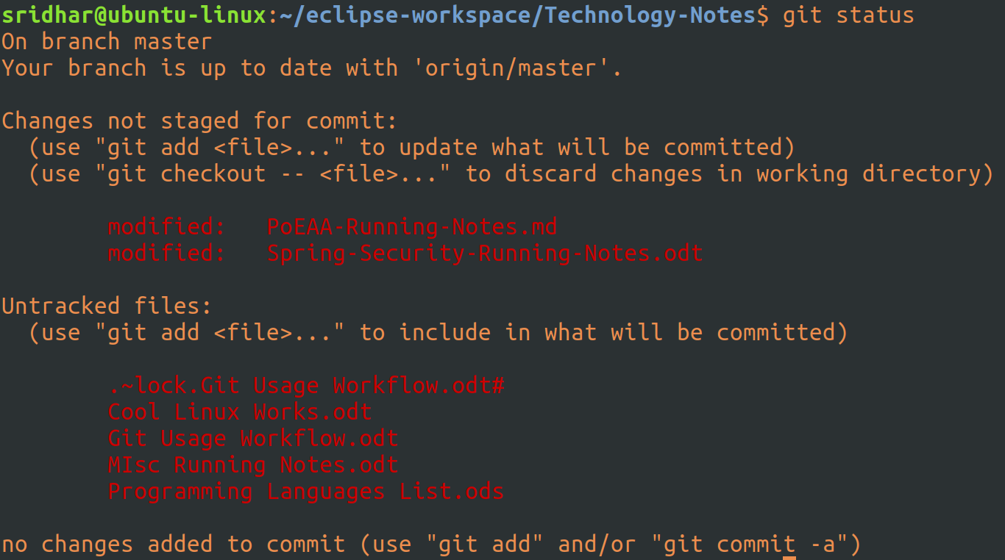
So, as expected, it says, branch is up to date with ‘origin/master’.

3.Mass Staging

We can also do mass staging by running the following command: git add .

This will basically stage all modifications/new files that are to be staged.

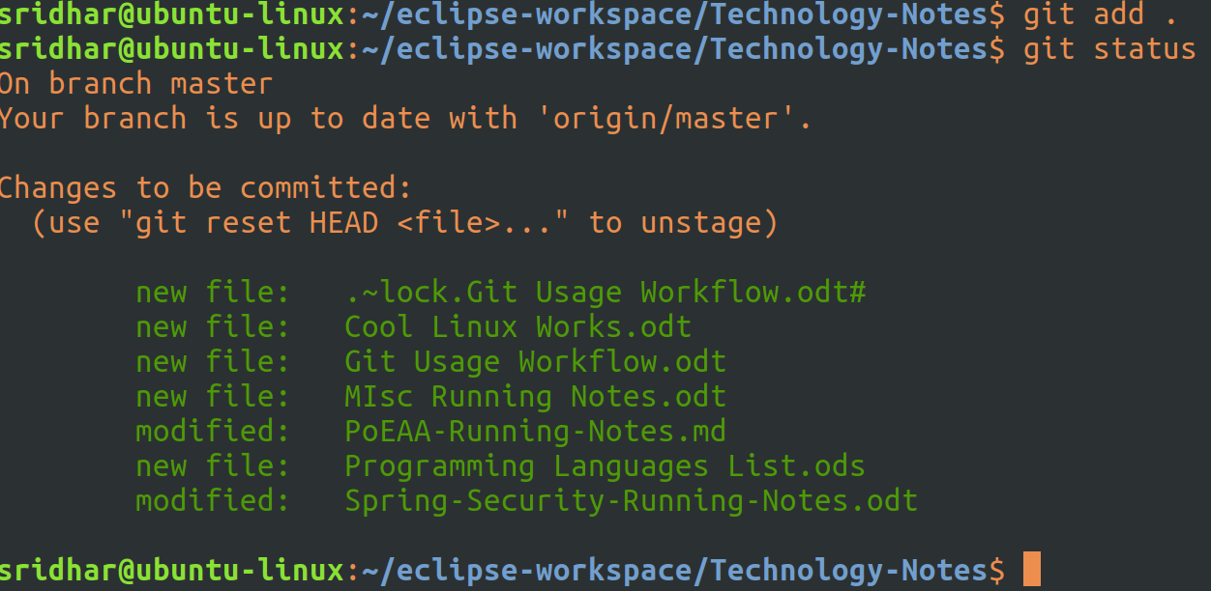
As you can see from above, all files are staged now.

Let’s commit them all with git commit -m “updated and new” :

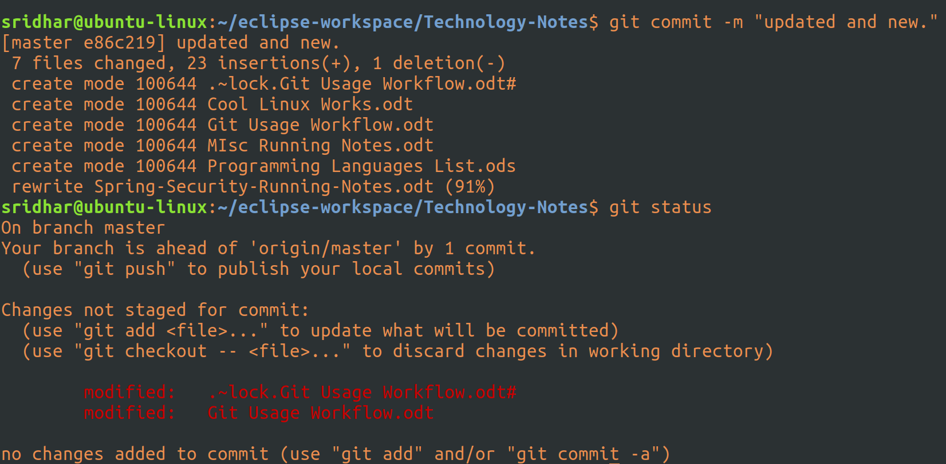
Committed and checked the staus. I can see one file has not been staged because that’s the file I’m working on currently :). It has to be closed first.

Let me know push the files to the master: git push origin master

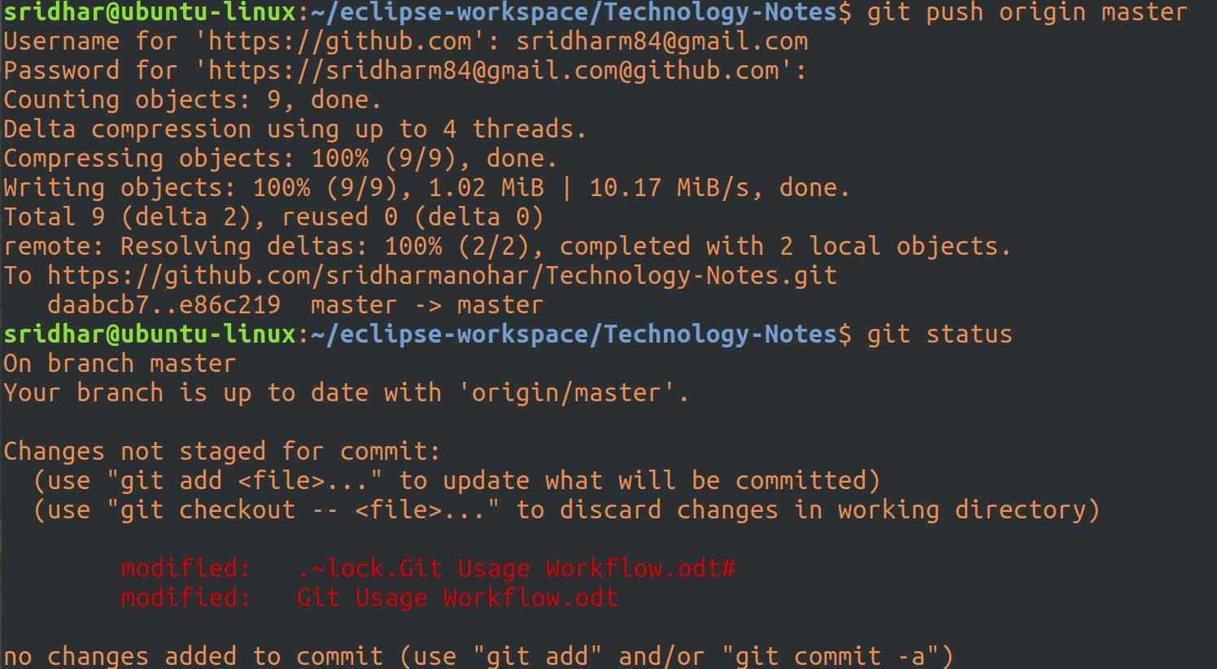
So all files now pushed to master except for one which I need to first stage but for that I need to first close that file.

You can also combine all these commands in one go:

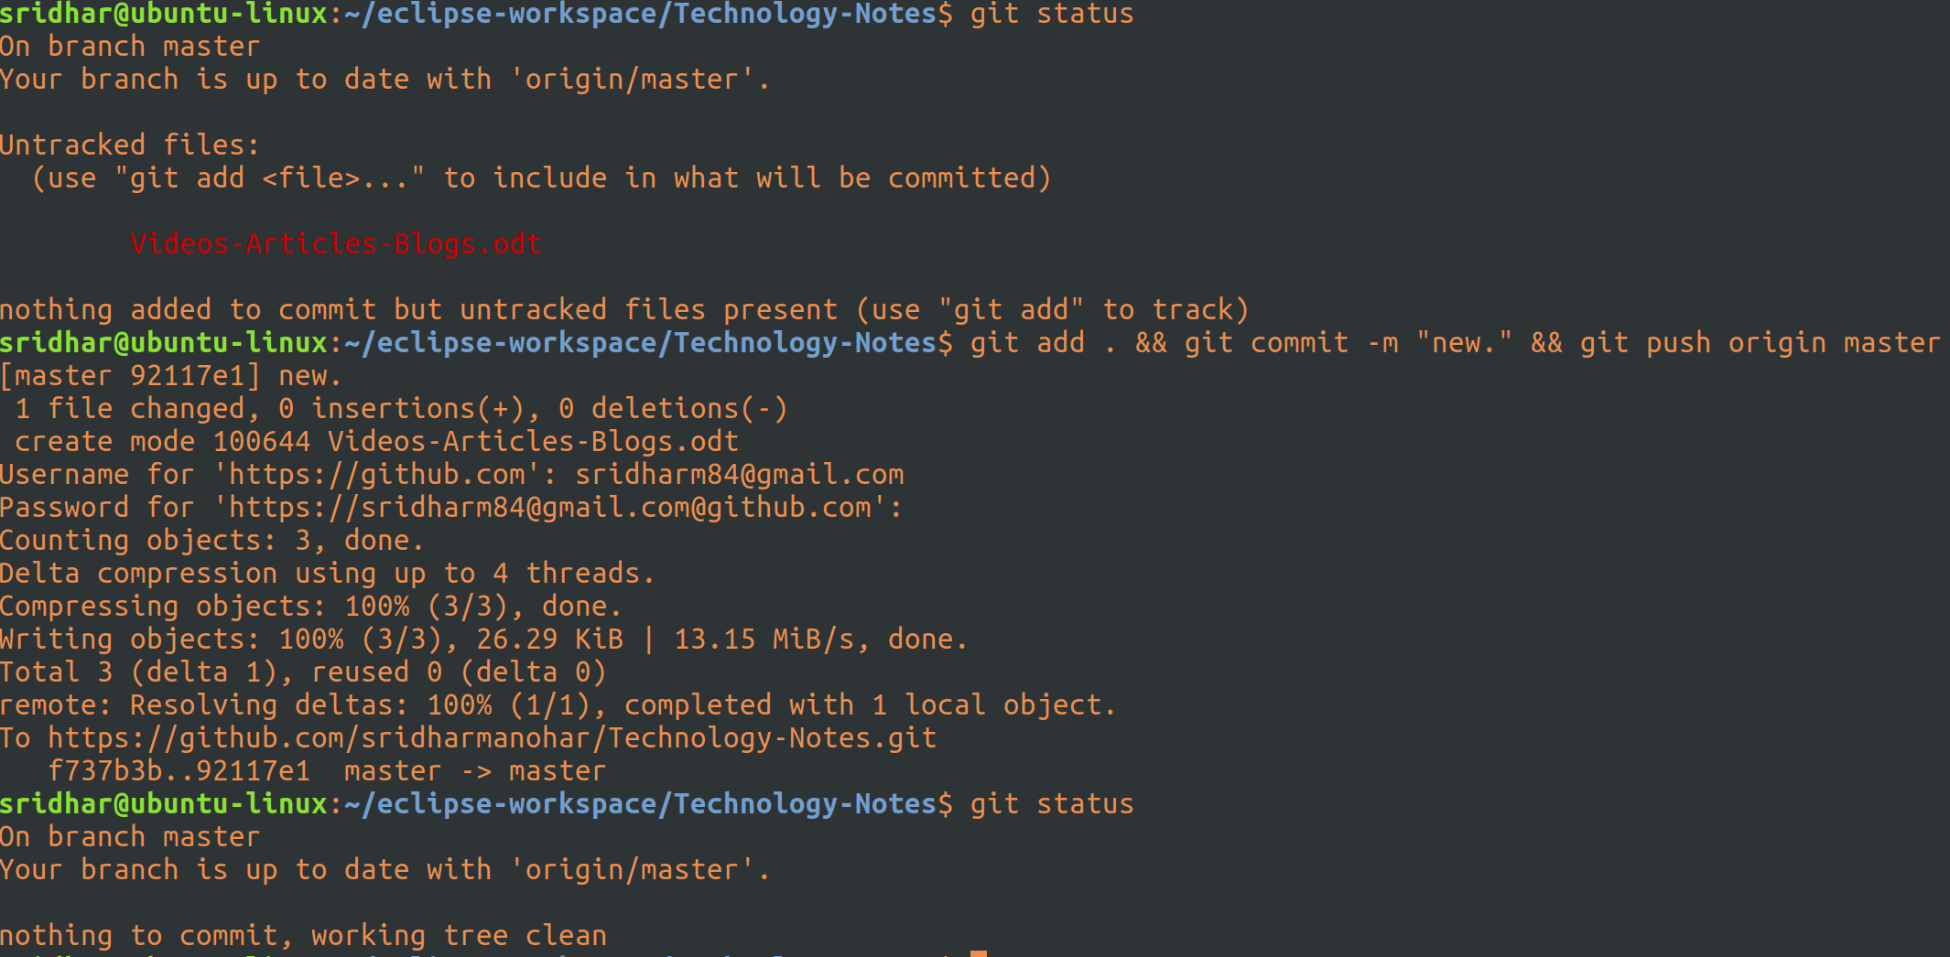

4.To create a new repo on github and map it to the local code base

[] Suppose you have created a couple of projects in your local machine and you want to push them to github

[] Let’s say these are the two local projects:


[] And, these two projects do not have any mapping with a github project:
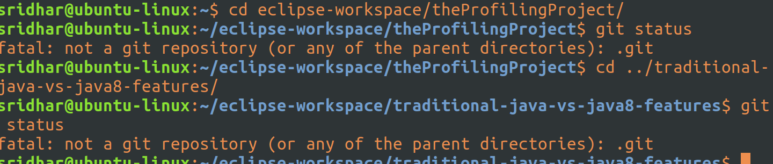
[] So, we want to create two repo on github and map them two these two local projects and push them onto hub.

[] Create Github repositories:

[] Okay, so begin with, we first have to create two repos on github.

[] So, lets login to github and create two repos, preferrable with the same name as that of the loca projects (to avoid confusion).

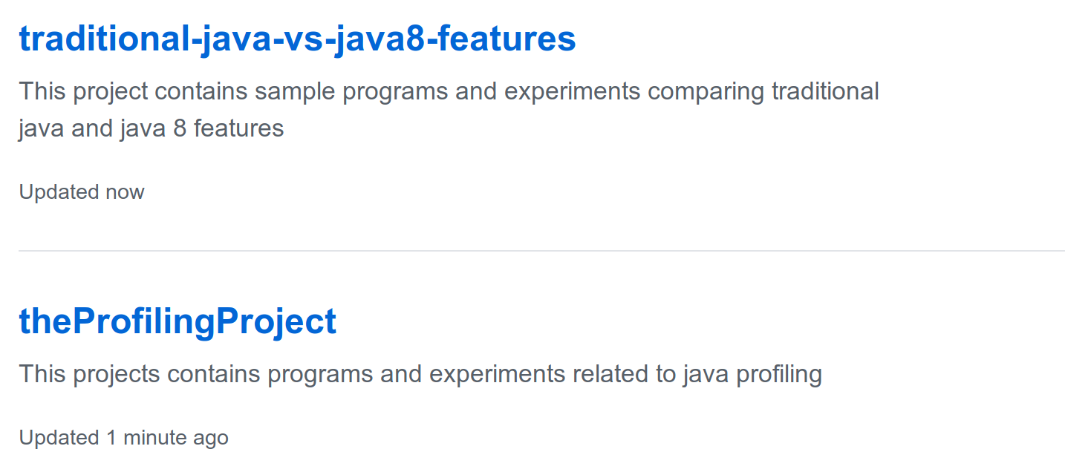

[] Now, go to each individual project in github and copy it’s git url

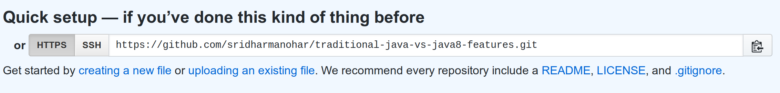
[] Now,in your local machine, go to the project folder (in terminal)
and do a git init

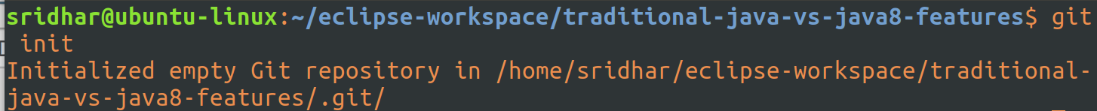
[] This is basically asking git to monitor your folder

[] Next, we have to map this folder/project to the github repo and to do that, we do a git remote add origin <repo_url>
[] Now, check git status
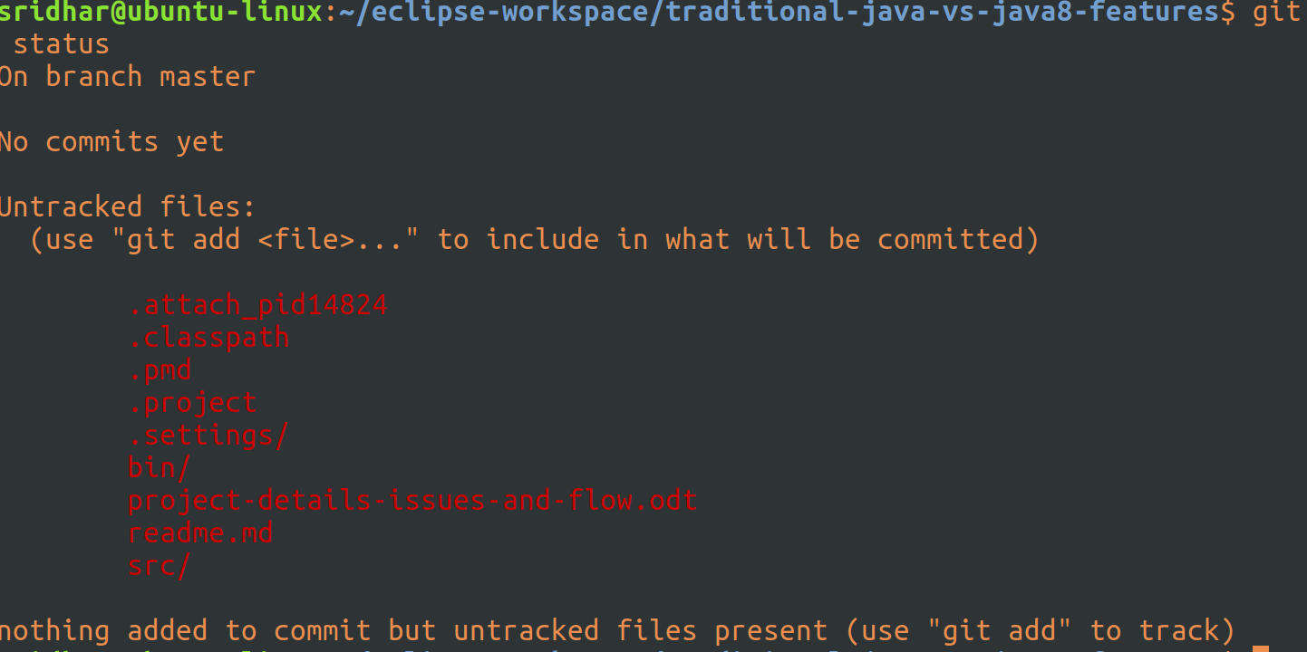
[] There you go, this project is now mapped to the github repo.

[] Now, let’s first add all files, commit them and then push them to the remote repo.
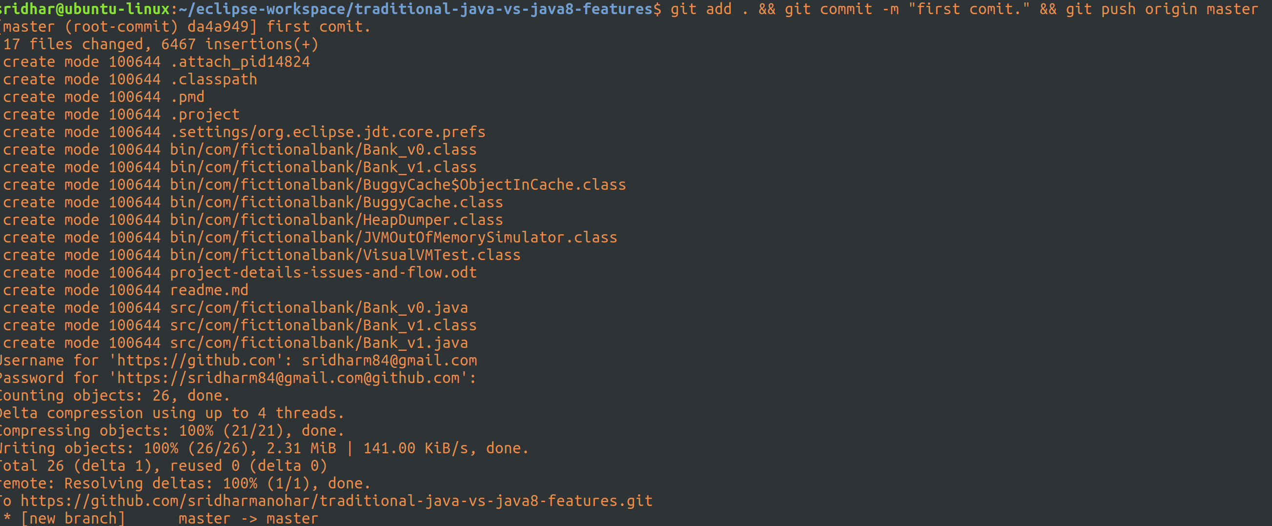

[] That’s it, now if you do a git status, you’ll find everything in sync
[] Let’s also check in the rmeote repo:
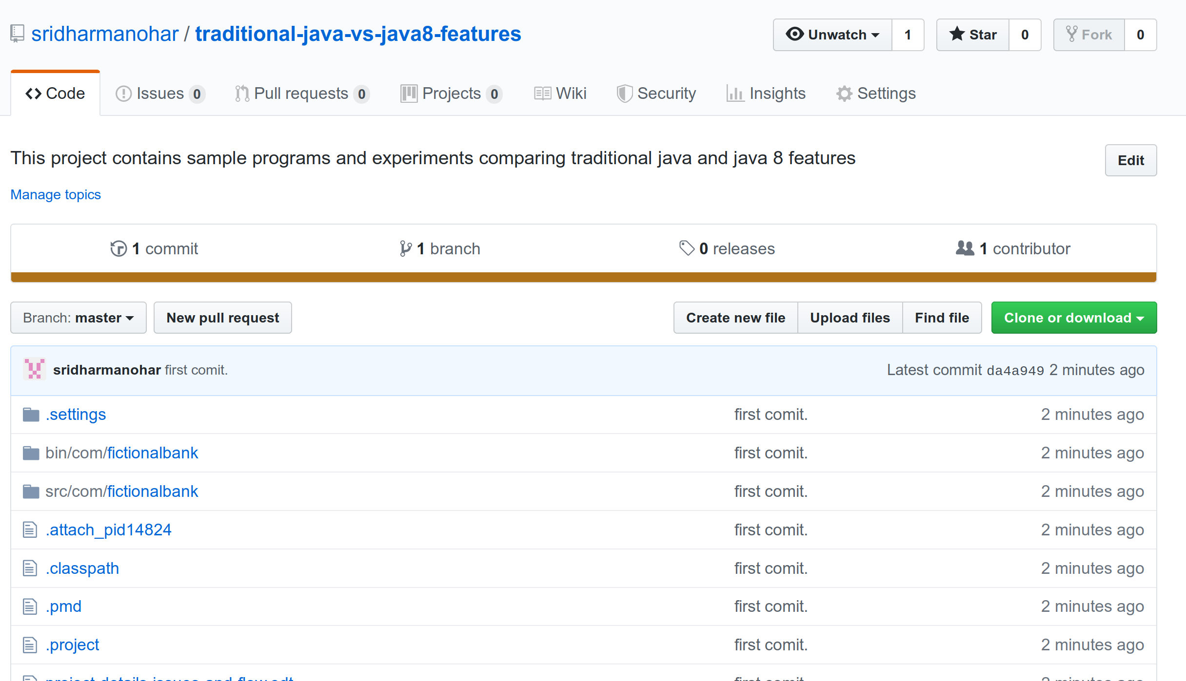
[] That’s it. Now similarly do for the other local project also.

[TO ADD ONLY A FEW FILES TO GIT REPO AND IGNORE OTHERS]

In my local repo I have a few heapdump files that are around 2.5 GB and I don’t want them to be part of the github repo, so to ignore them while adding them to repo, I have tried following ways:

a.This is a raw way of doing it:

I’ve literally given all the names of the files that needs to be added in the git add command thereby purposefully excluding those two files, once the commit is done check the status:
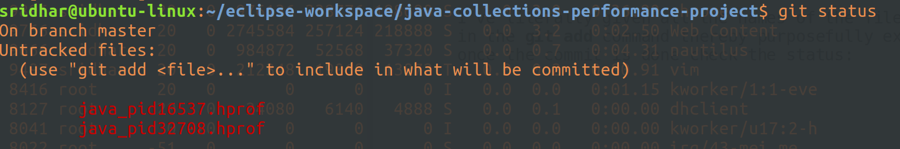
Two files left out, as wanted.

b.The other easier way to do this is to add .gitignore file.

The contents inside the git ignore will be ignore while doing a git add.

Created a .gitignore file at the root project dir:
And, added only one line in the file:
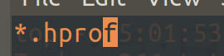

To ignore all files ending with .hprof, which are basically heapdump files.

Committed the .gitignore file to the repo:
And, now when I do a git status I don’t see the two heapdump files:
That’s it, this means, git is no longer tracking these two files.

The thing is, .gitignore only ignores those files that are not already tracked by git i.e. those that have not been git added before. So, If you want to untrack an already staged/committed file, then do a :
git reset name_of_file

Then add the name of this (to be untracked file) in the .gitignore file.

And, If you also want to remove this file from the repo itself, then:
git rm --cached name_of_file

Although, you can create a .gitignore file at any dir level in the project dir, it is preferred to create it at the root of the project dir, so that there is only one .gitgnore file per project.

