https://stackoverflow.com/questions/9537392/git-fetch-remote-branch

https://stackoverflow.com/questions/12486653/git-push-to-existing-remote-branch

https://stackoverflow.com/questions/1800783/how-to-compare-a-local-git-branch-with-its-remote-branch

https://www.freecodecamp.org/forum/t/how-to-delete-a-git-branch-both-locally-and-remotely/13211

https://dzone.com/articles/git-strategies-for-software-development

Current Status of Project:

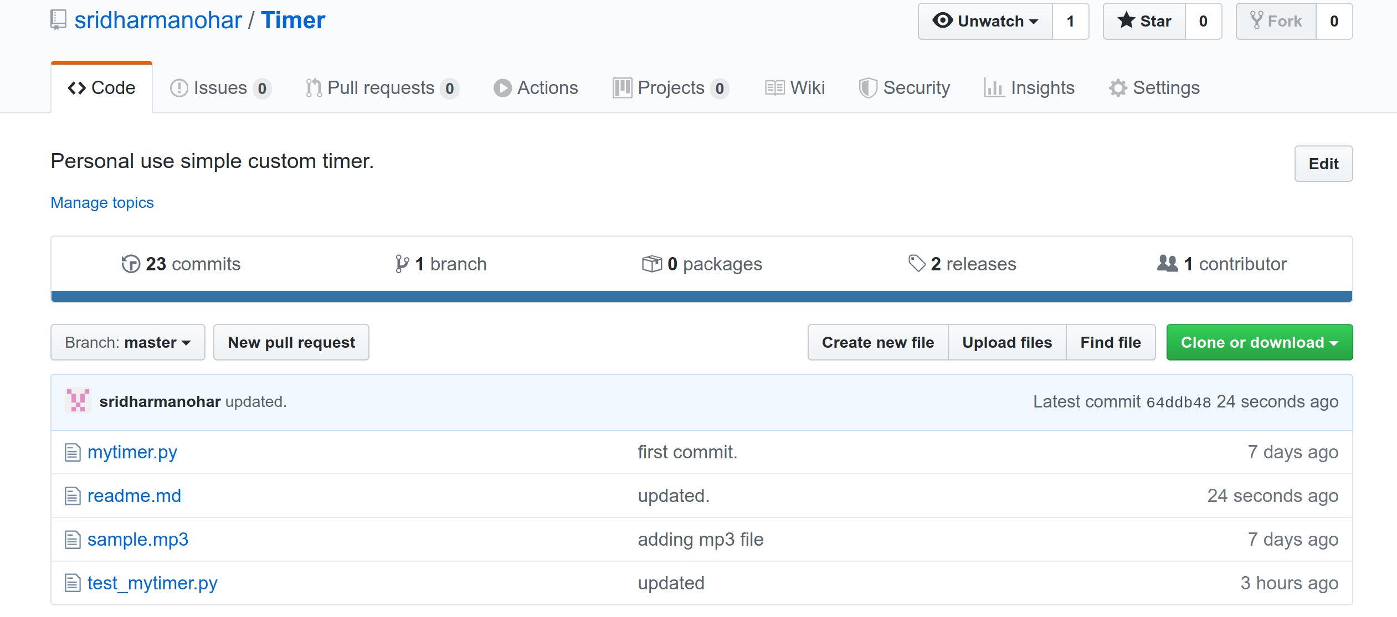
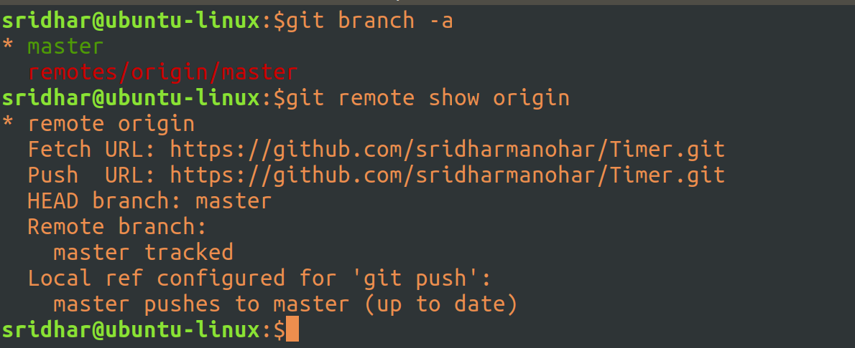

Create a new remote (development) branch:

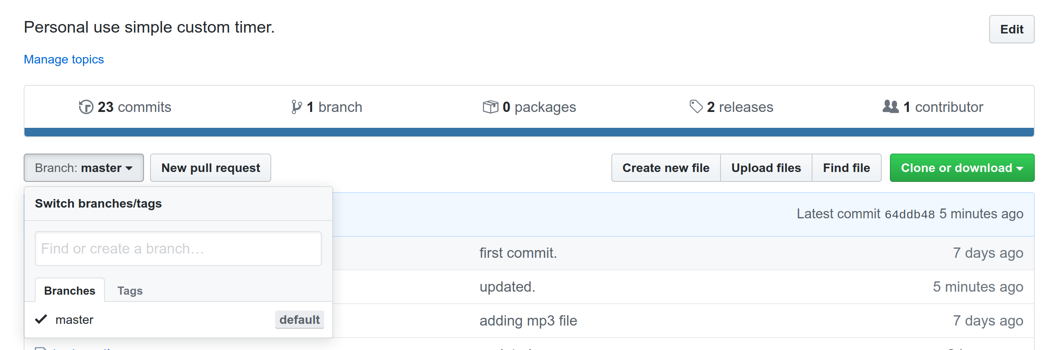
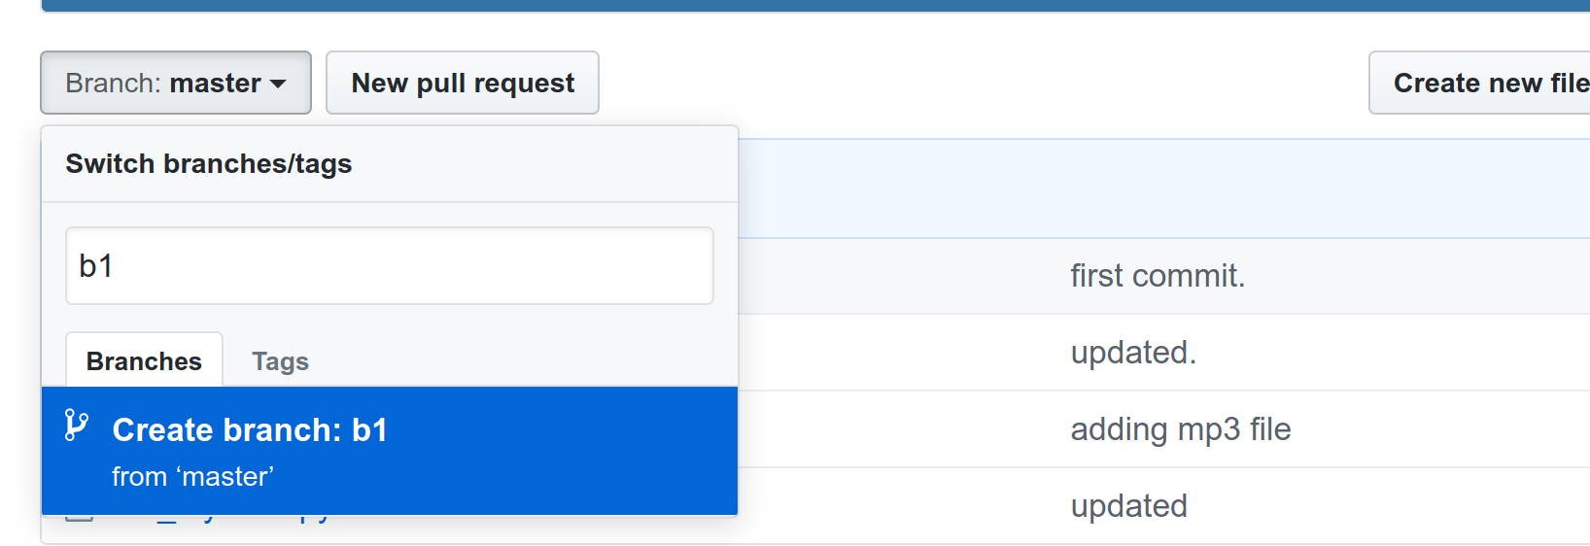
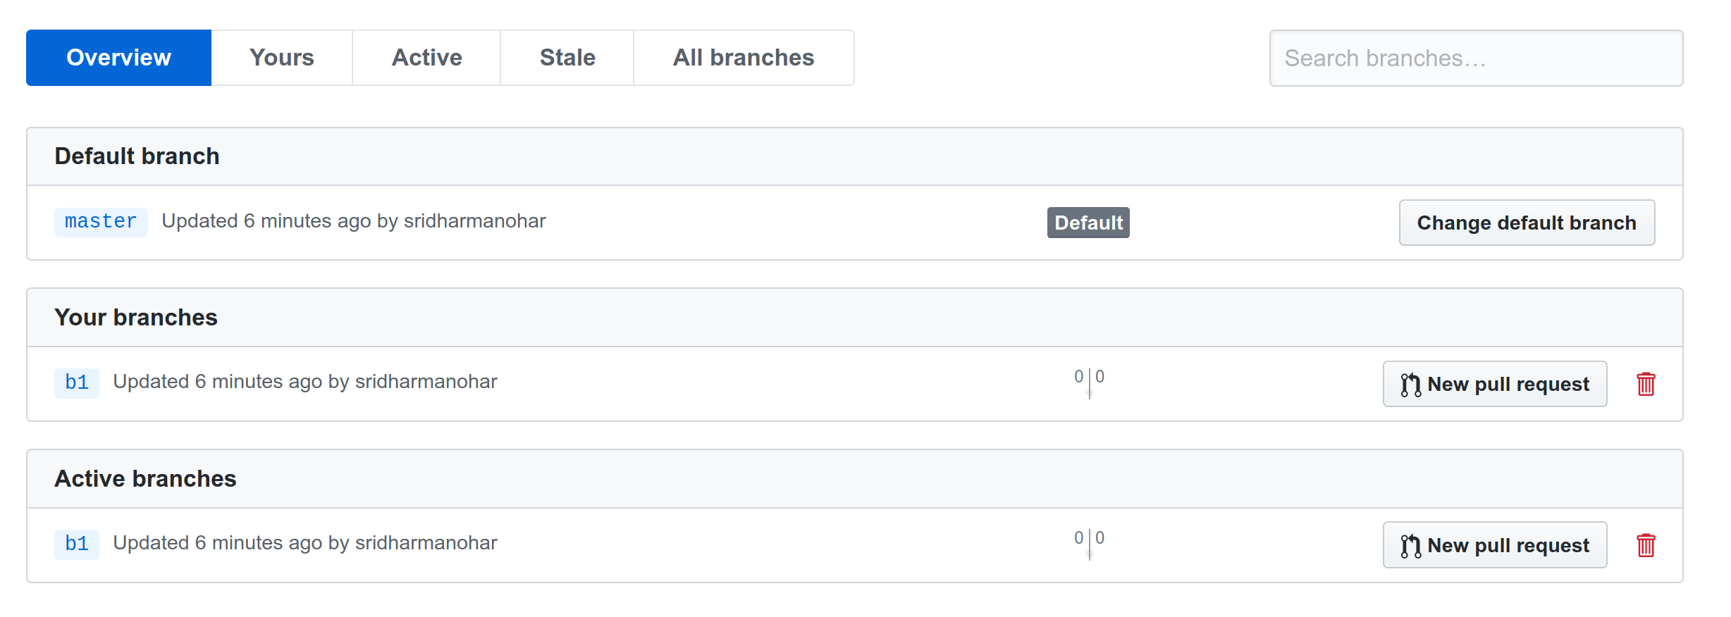
Fetch the remote dev branch (b1) to your local machine (to start working on the branch, rather than on master):

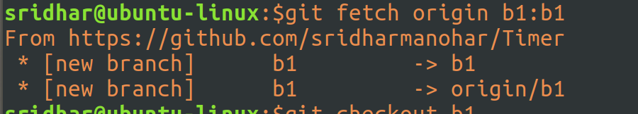
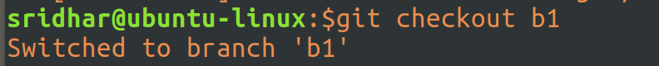
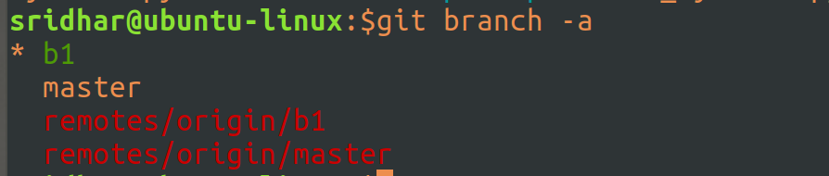
Open Sublime (to make changes to code in your dev branch i.e. b1):

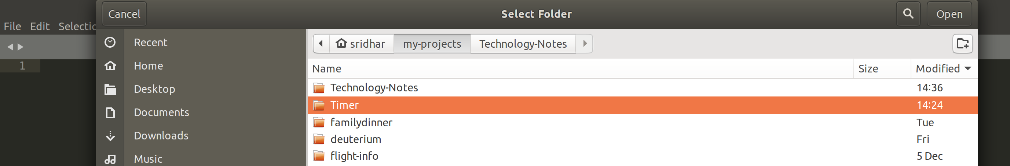
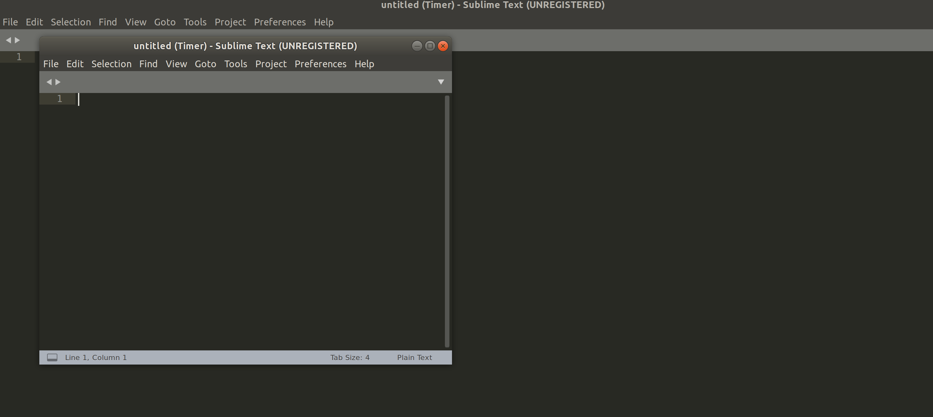
Tools -> Git -> Branches -> choose b1

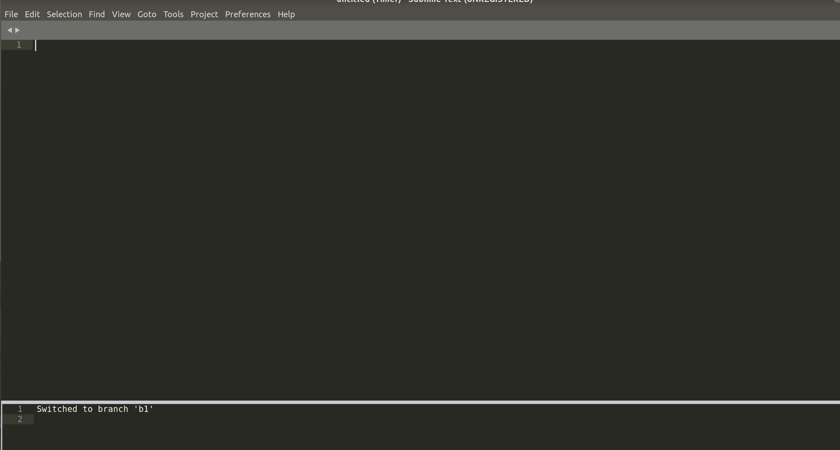

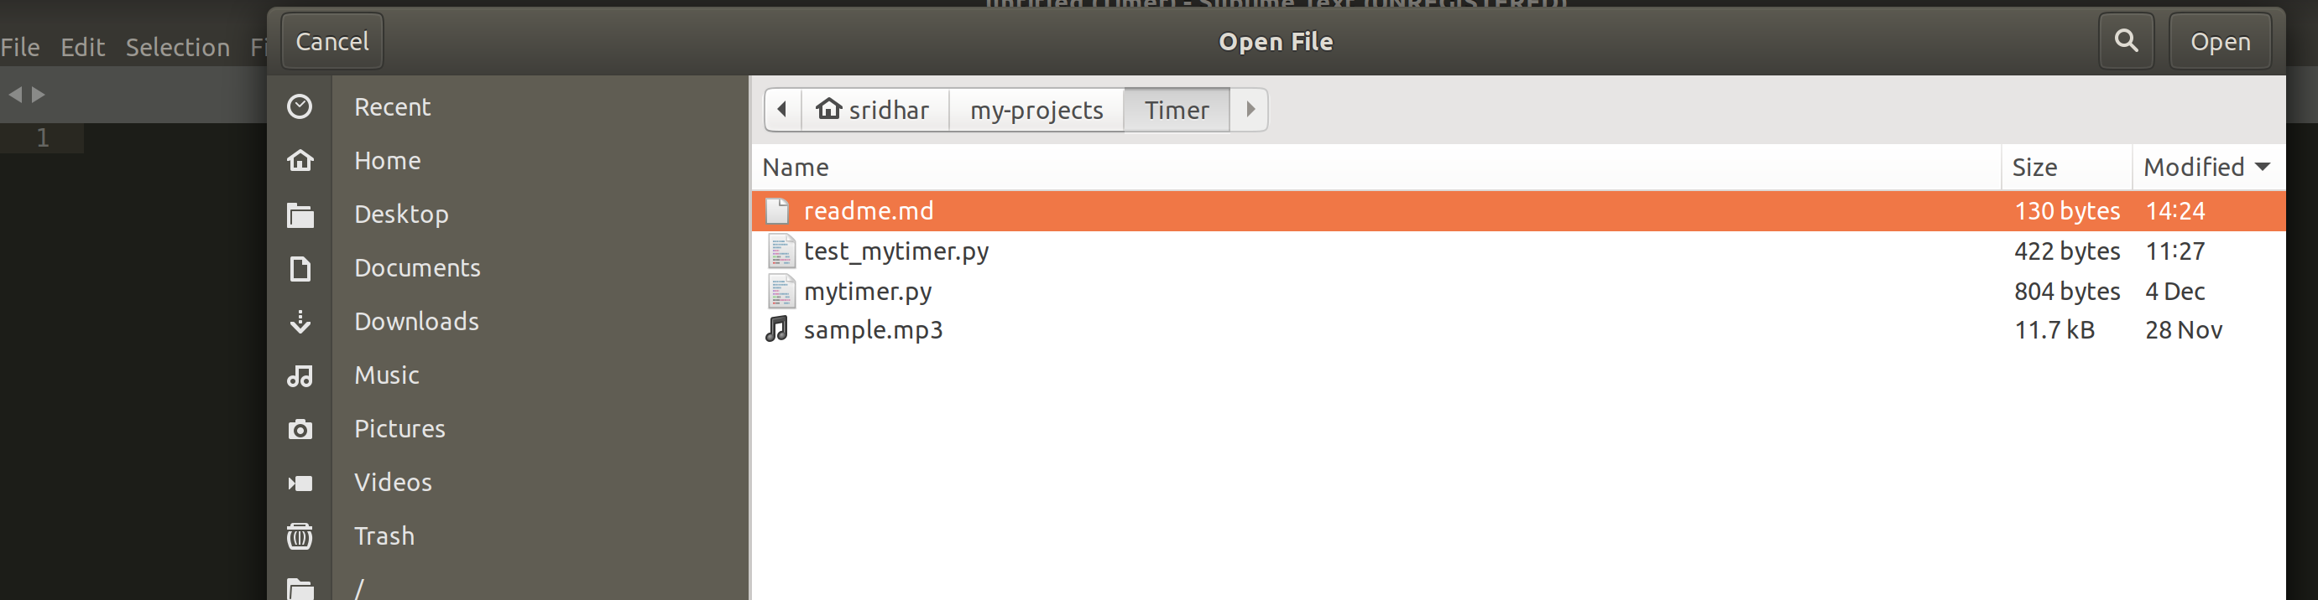

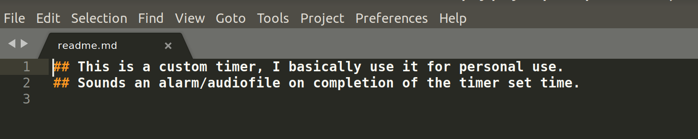
Make Changes:

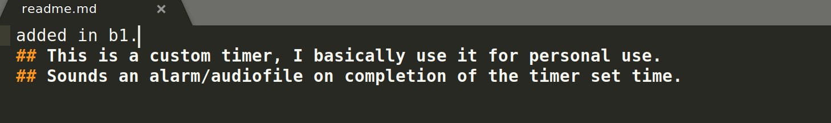

Tools -> Git -> This file -> Add (to index/stage the file) OR
do it from the command line: go to the branch (git checkout b1) and git add readme.md

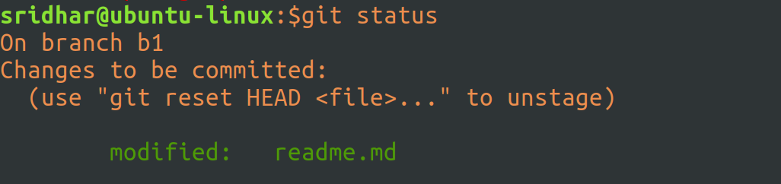

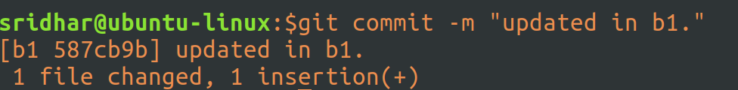
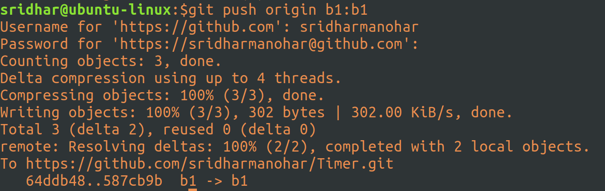

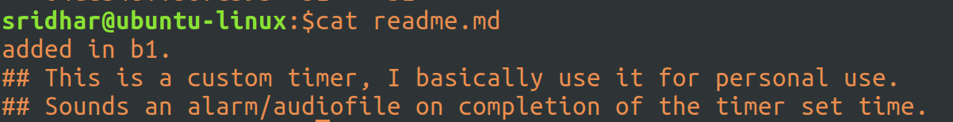
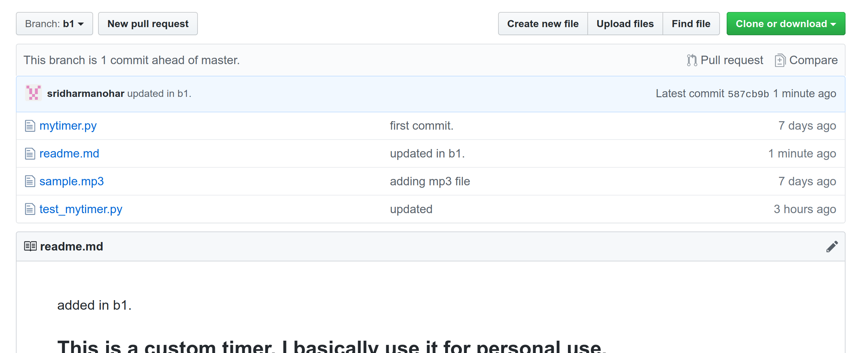

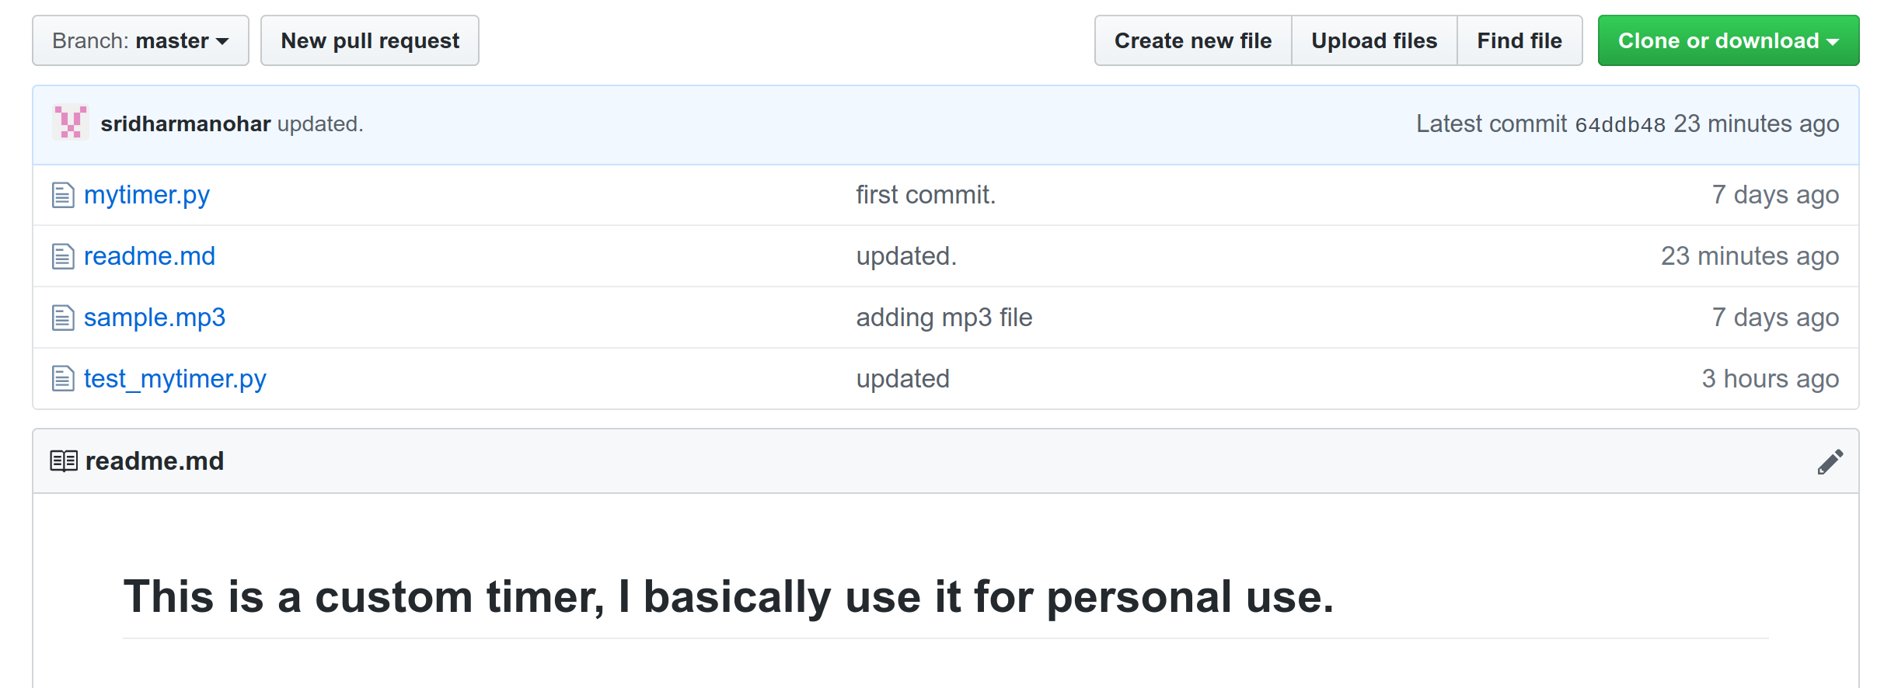

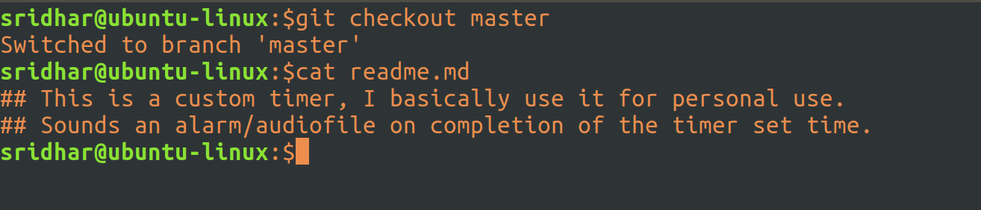
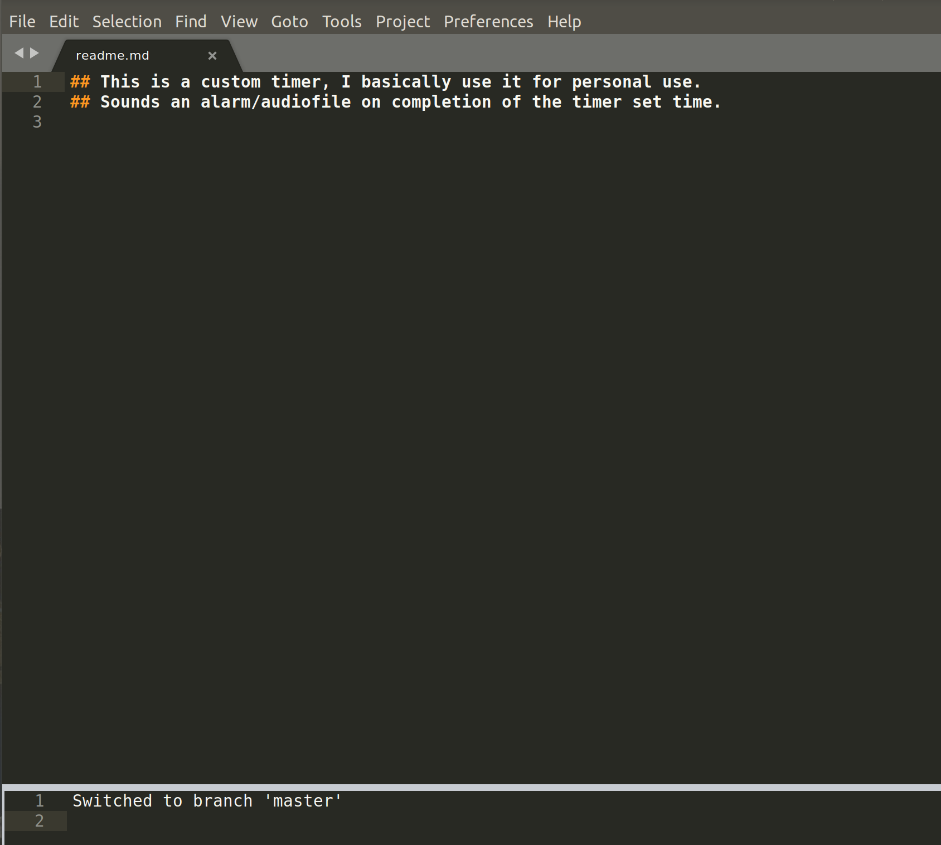
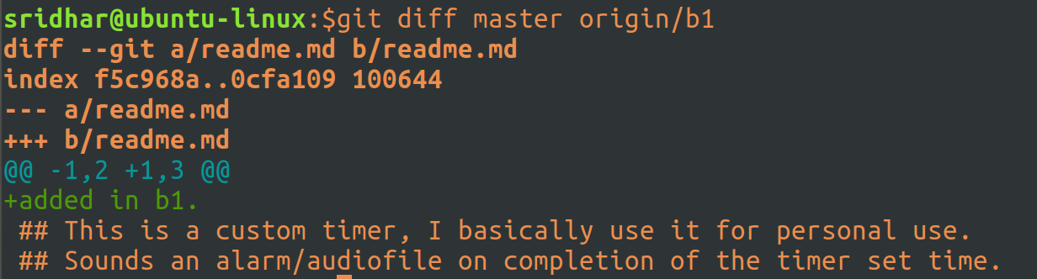

Create a tag from branch:

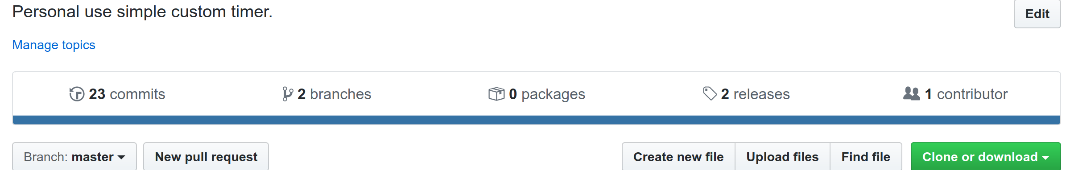


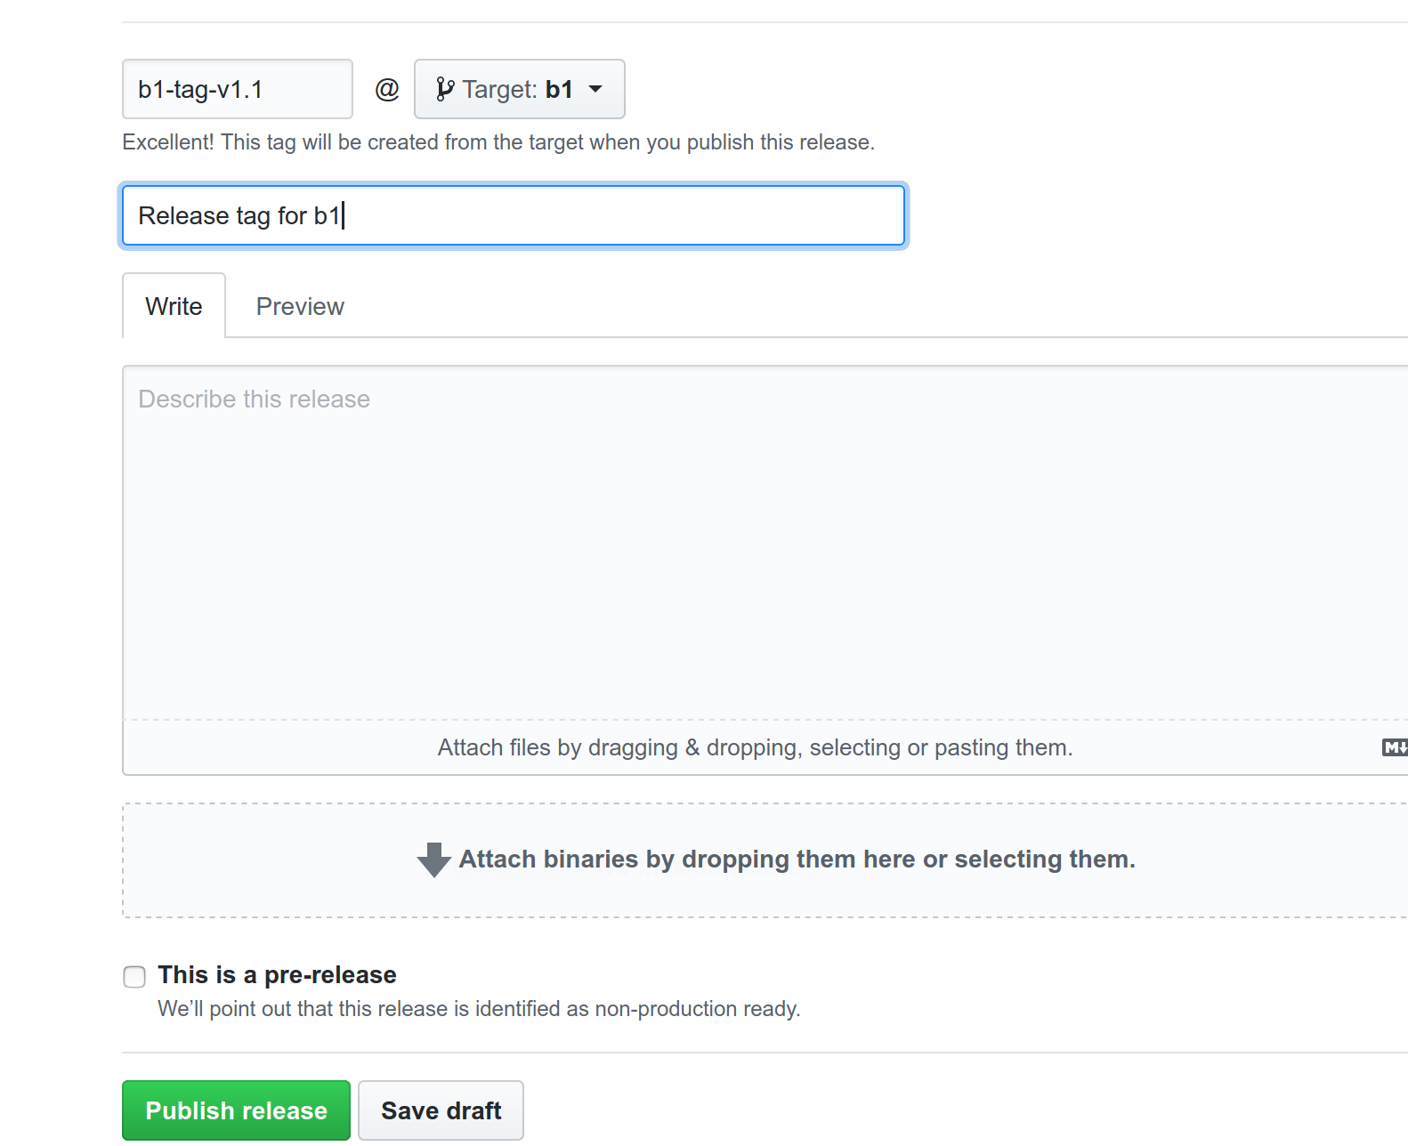
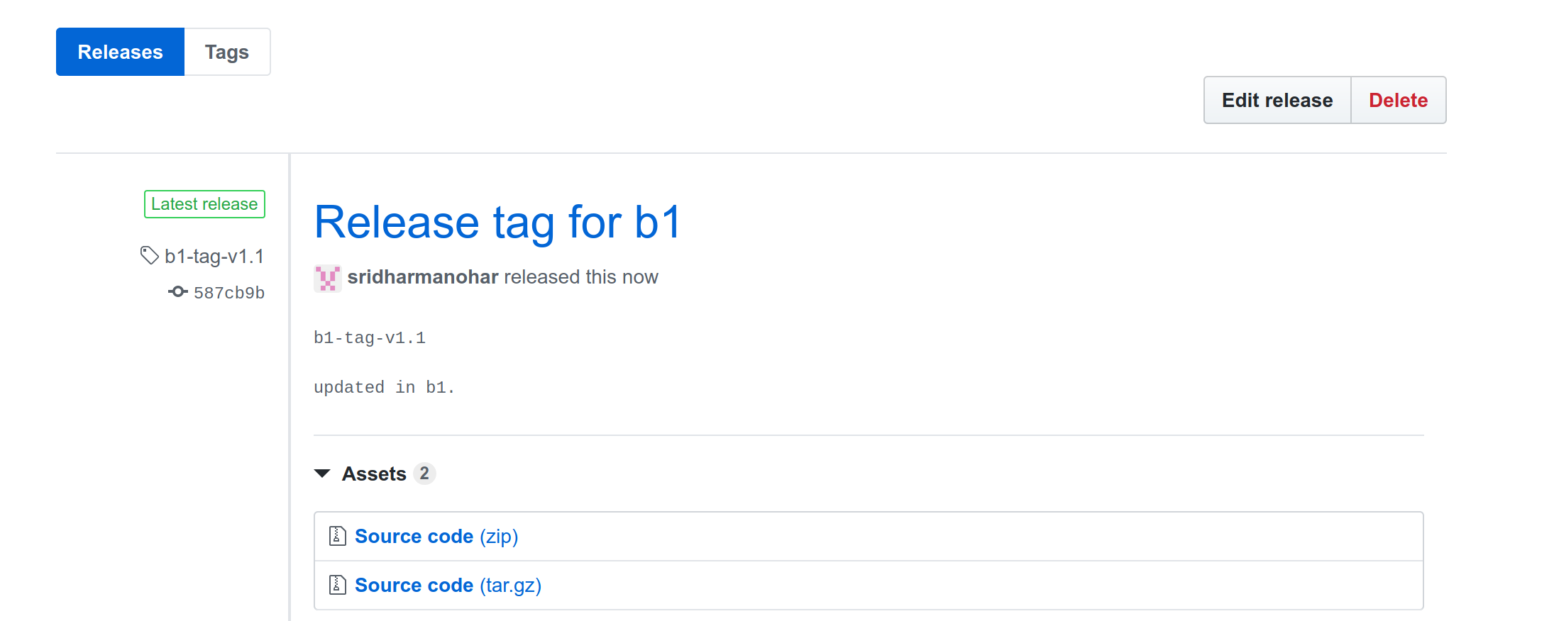

Pull Request:
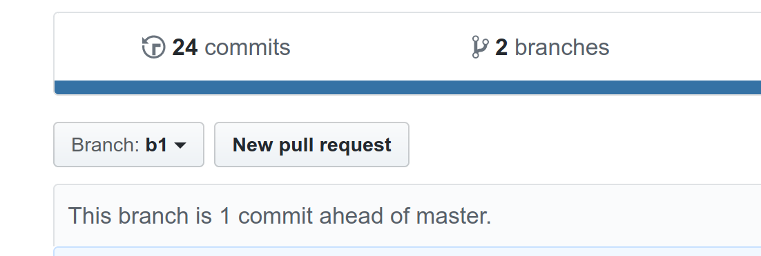
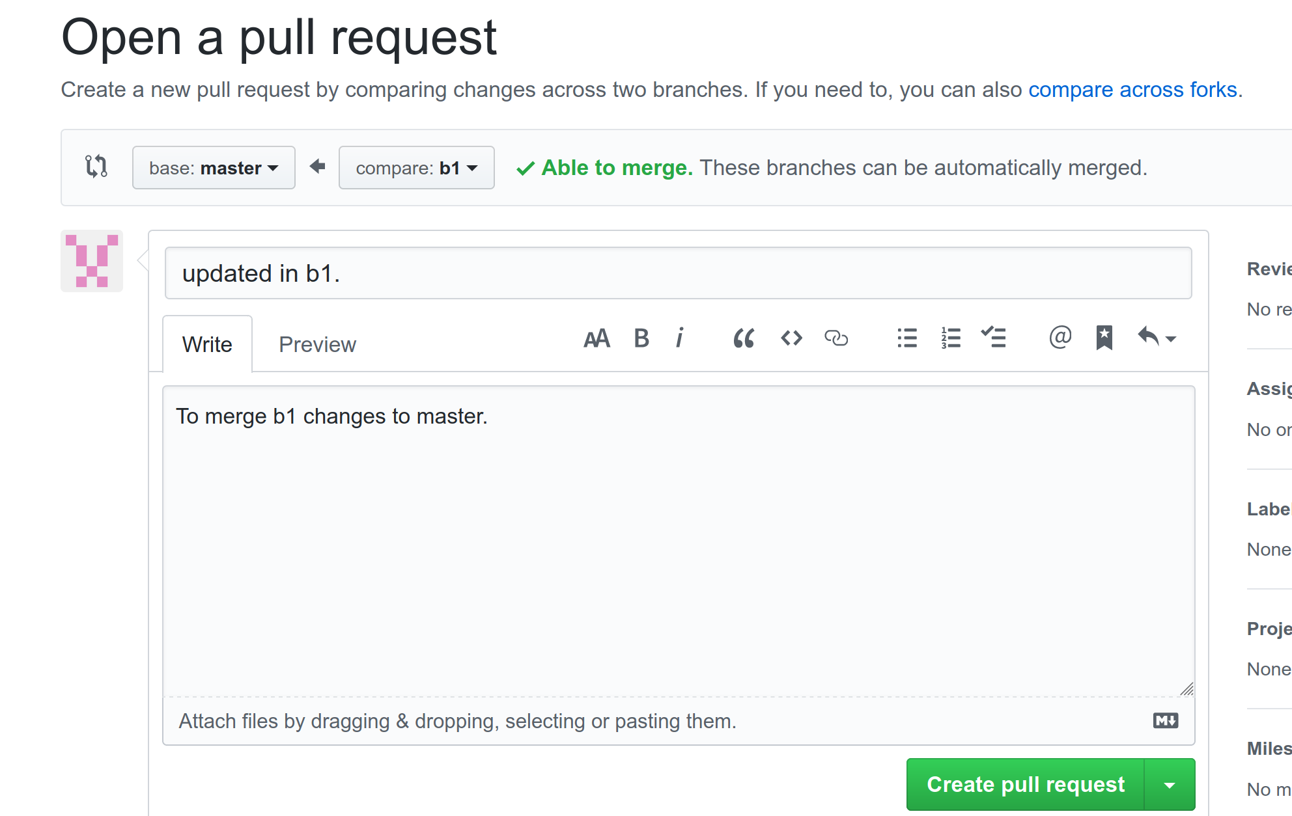
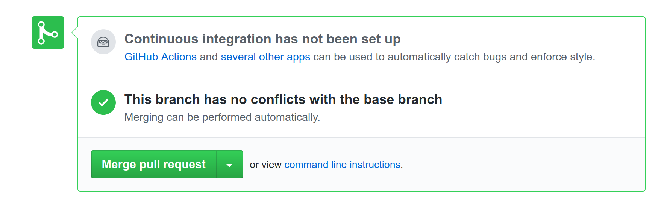
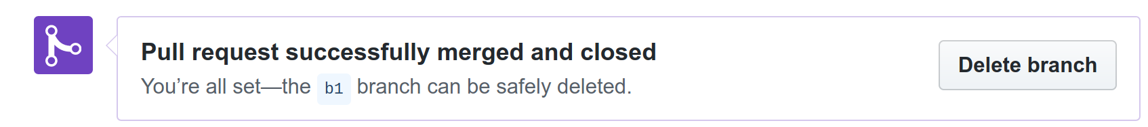
Click on Delete branch:

