This is basically a git workflow project. Here, I would like to try out many real-time issues that one would encounter with git and the solutions around them (including troubleshooting).

[WORKFLOW]

Created this eclipse maven project under eclipse-workspace directory/folder:


And created a folder named ‘project0’.
I will be, similarly, creating multiple projectX folders for different experiments inside the master ‘git-experiments-project’ folder.

Some of the screenshots below will be referring to ‘git-experiments-project’ folder because I created the ‘project0’ folder later (when I realized that I might need more than one project for experiments).

So, moved all stuff from under the ‘git-experiments-project’ folder into the ‘project0’ folder and in future, if required, I may create more such project folders in this master folder.

Currently, this project is not tracked by git:

Before we proceed further, let’s first do an listing of all files (including the hidden ones that are present in this dir):
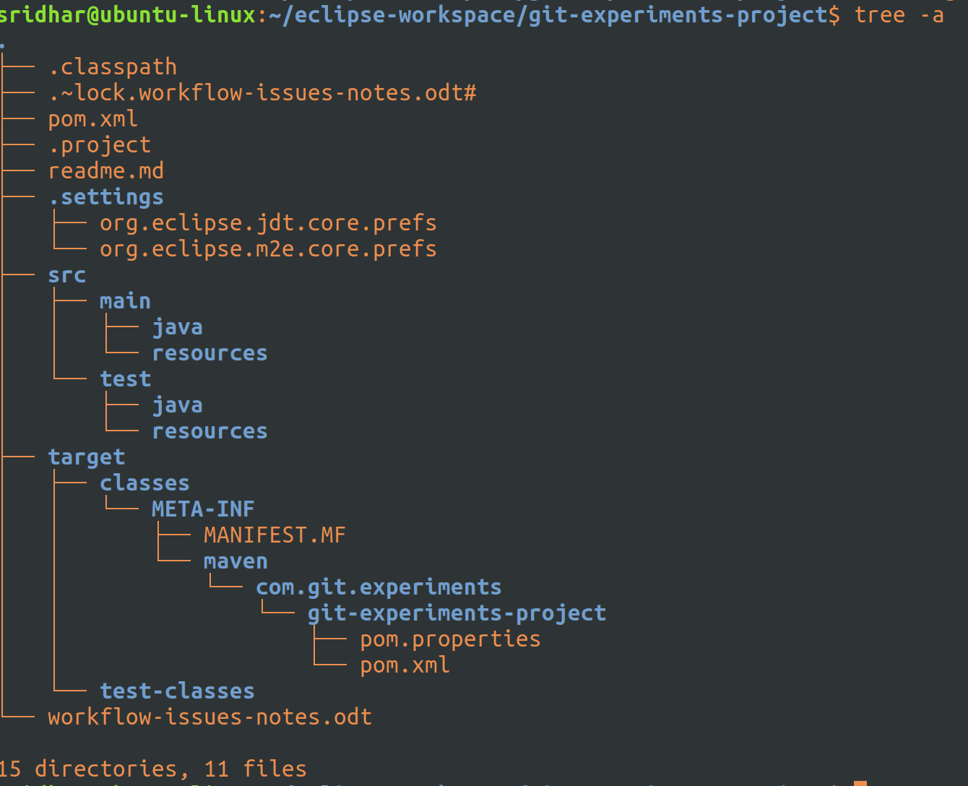
Now, let’s create a new local repo; this also asks git to moitor this repo: git init

Let’s do a listing now:
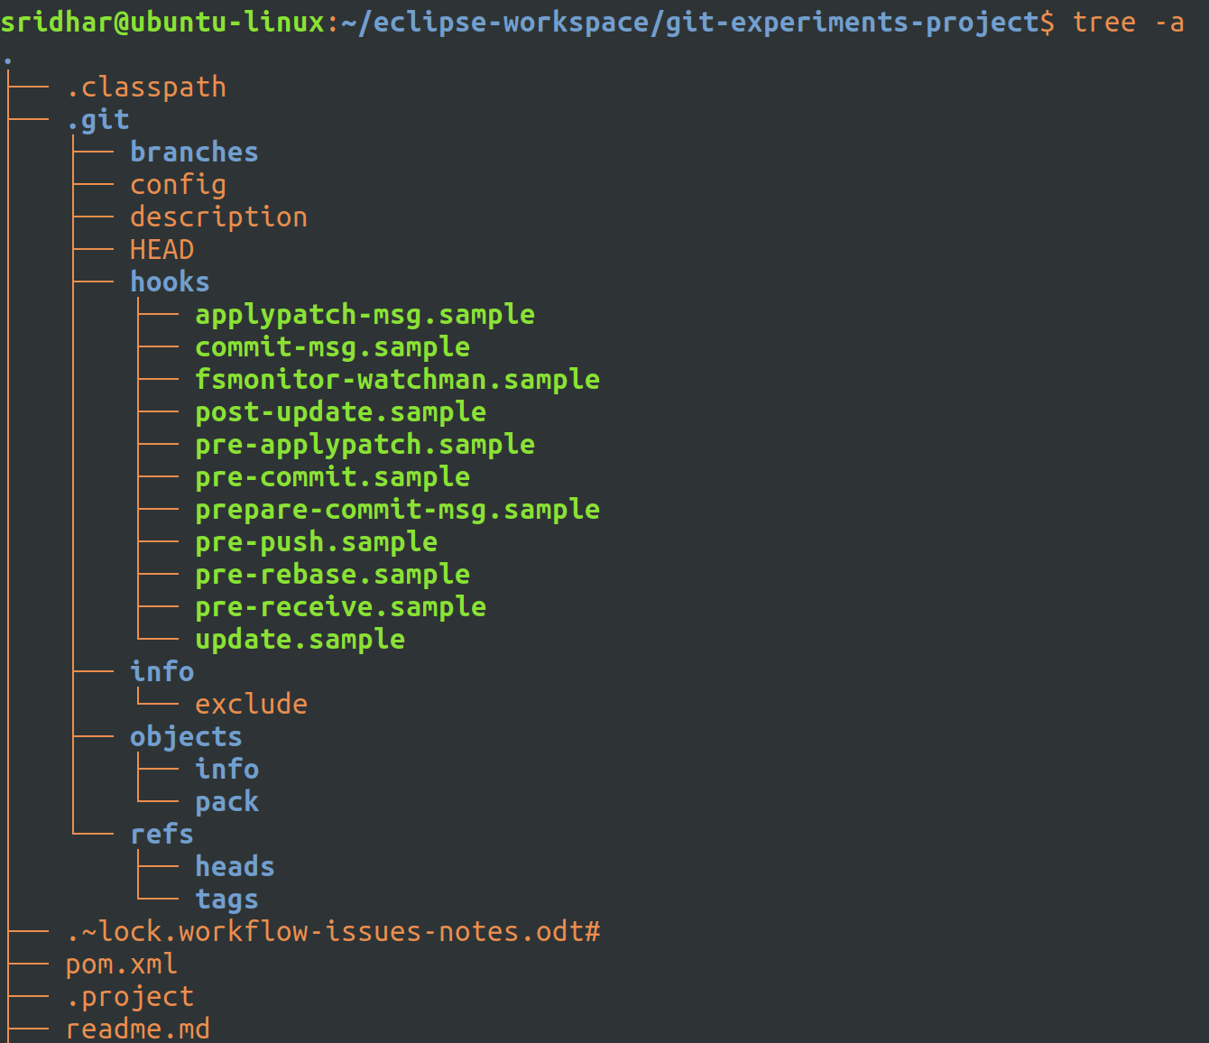
Let’s focus on the .git dir that got created and the stuff in it.

If I do a git status now, this is what it shows:
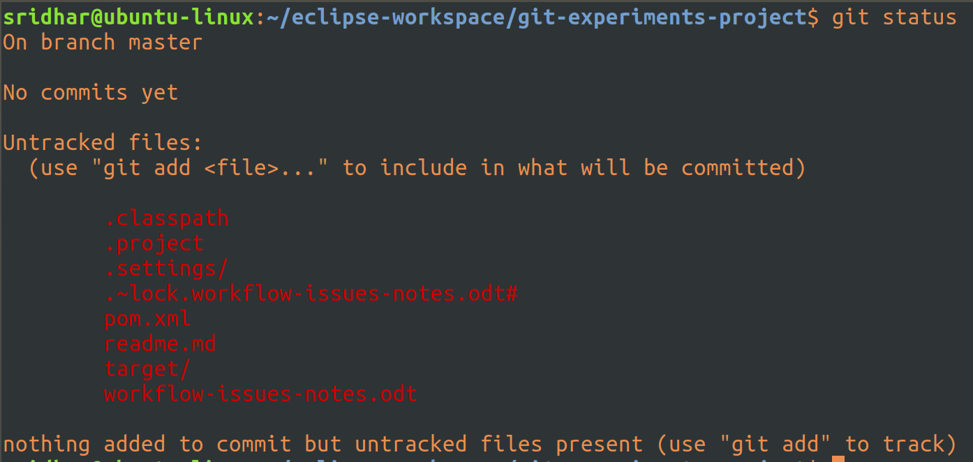
Please remember the local repo that I have created, by calling git init, is in itself a full-scale repo, it need not be mapped to any other remote repo anywhere else.

That is the reason, even though this repo is not mapped to any remote repo it still says the above files are untracked or yet to be committed.

Ok, now let’s do a git add:
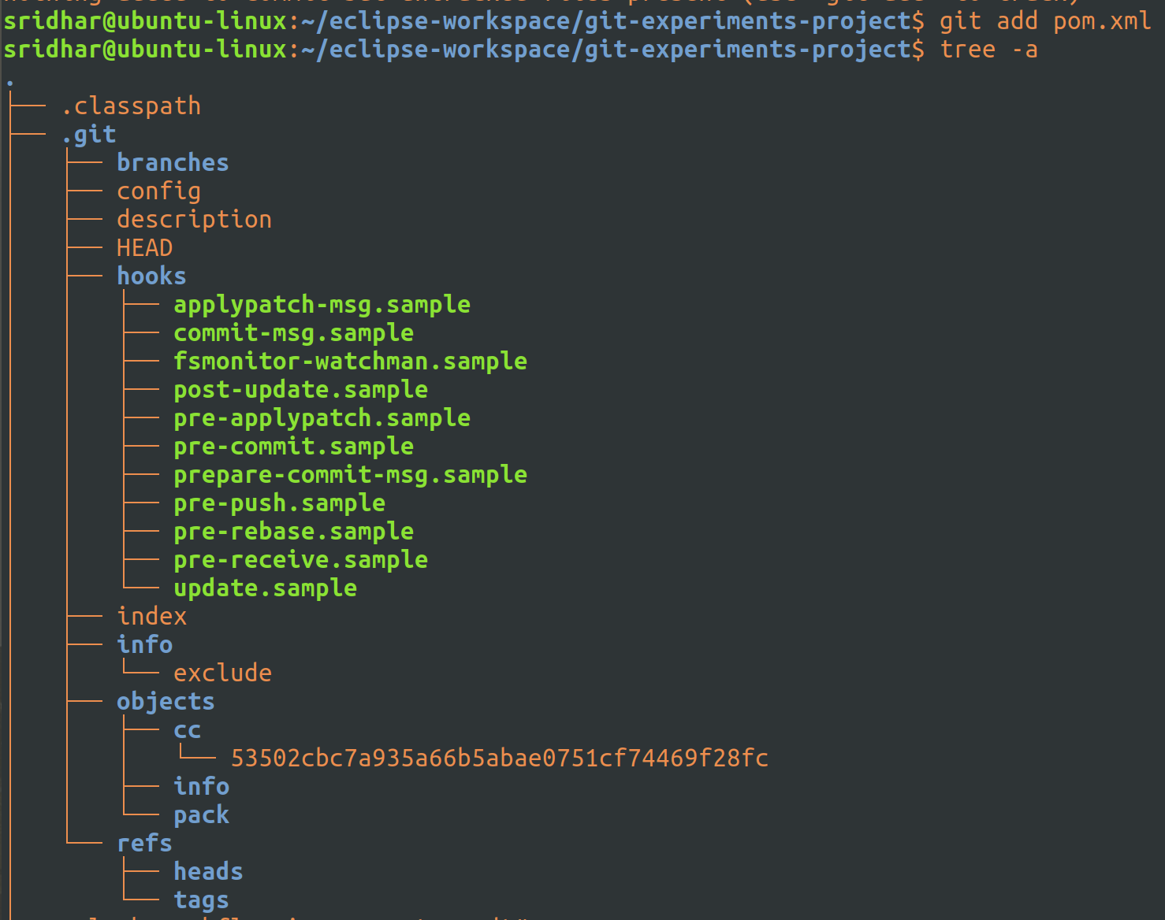
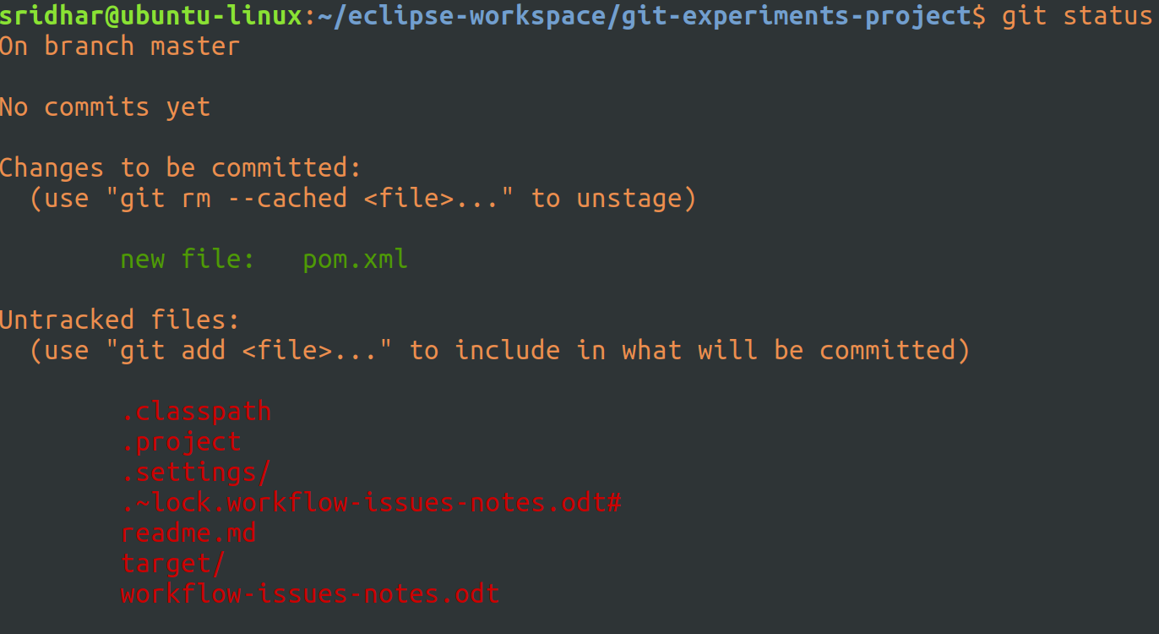
I added one pom file and then did a tree listing and you can see an index
file is created and a dir by the name cc under objects is created and there is a file (hash key) present under it.

Tried opening the index file with vim editor:
As you can see it is not human readable.

The index is a binary file (generally kept in .git/index) containing a sorted list of path names (which are staged), each with permissions and the SHA1 of a blob object;

git ls-files can show you the contents of the index:
Now, this SHA-1 that you find in the git index file is just 38 digits long, whereas the actual SHA-1 is supposed to be 160-bits (i.e. 20 bytes), which is in hexdecimal form as a 40 digit long text.

So, if you observe carefully, the SHA-1 of this blob is:
cc53502cbc7a935a66b5abae0751cf74469f28fc , which is 40-characters long but git uses the first two characters i.e. ‘cc’, in this case, as a dir to store related SHA-1 blobs.

So, If you look at the tree listing above, you’ll notice, that cc is a dir and it has the sha-1 of the blob (which is 38-chars long) and which is what also stored in the index file.

Files with same content in any git repo will have the same SHA-1 :
In git, the SHA-1 name of the blob is the SHA-1 of the contents of the blob, so, if any file that has the contents (irrespective of the name of the file), will have the same SHA-1 in git.

To prove this, let me create 3 files: a.txt, b.txt and c.jpg and all files will have the same content, which is just a ‘hello’.

After I do a git add a.txt b.txt c.jpg this what the tree -a looks like:
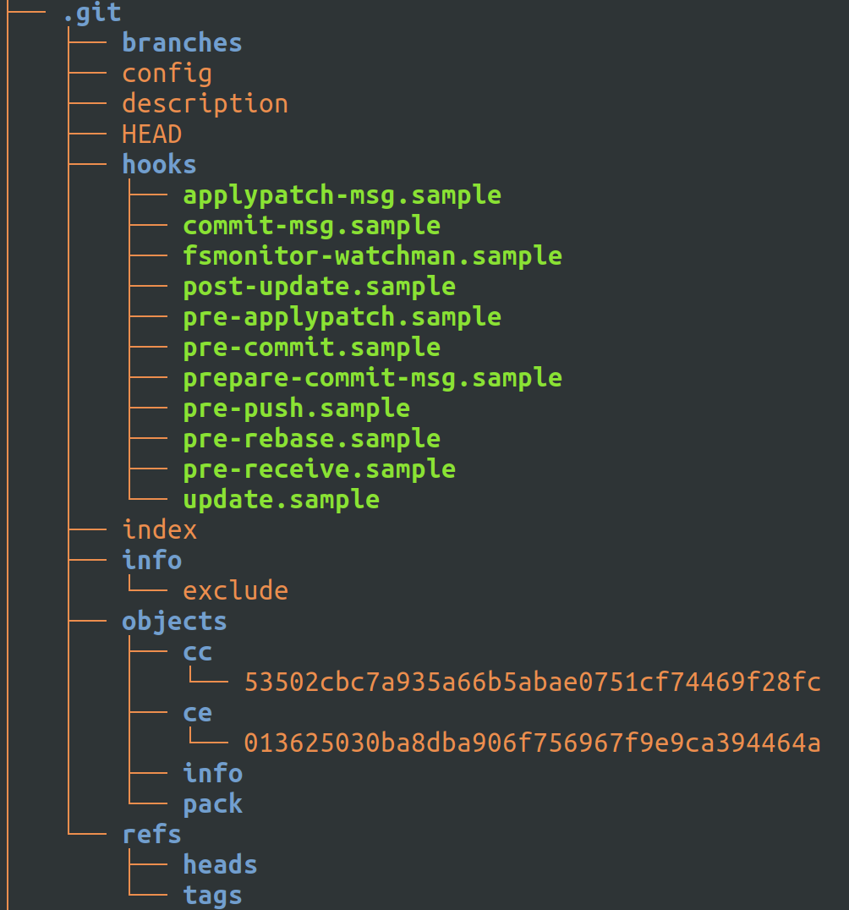
As you can see there are two blob objects one under cc and the other under ce. The one under cc is of the pom.xml which I staged previously and the one under ce is for the three files i.e. a.txt, b.txt and c.jpg that I staged recently.

Meaning, all three files, share the same blob i.e. they have the same SHA-1 because SHA-1 in git is calculated by taking into account the contents of the file but not the name of the file, so even though three files have diff names and one of them was even of a diff type (jpg) but since they all had the same content (hello), they have the same SHA-1’s and git optimizes this by creating only one blob for them all.

Now, If you look at what’s in the staging file i.e in index file:
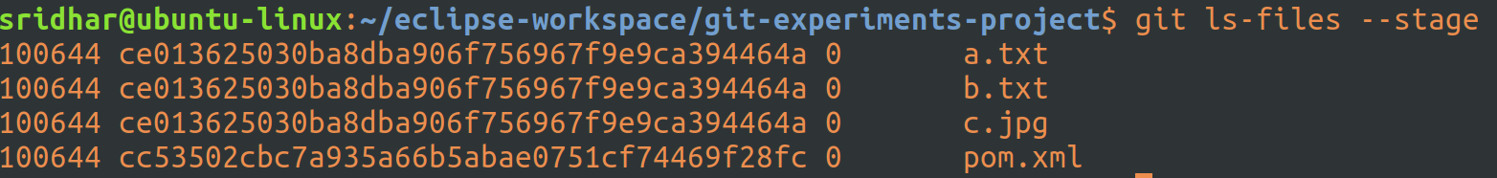
So, index has all entries of all files staged so far. 3 files with the same SHA-1 but the path of these files are different and they are noted in the index (though I’m not displaying the full path, you can look at the file-name).

That’s a cool feature.

If we run a git status now, it’ll show whatever is in the index and those that are not tracked (meaning not in index) and those that are committed:
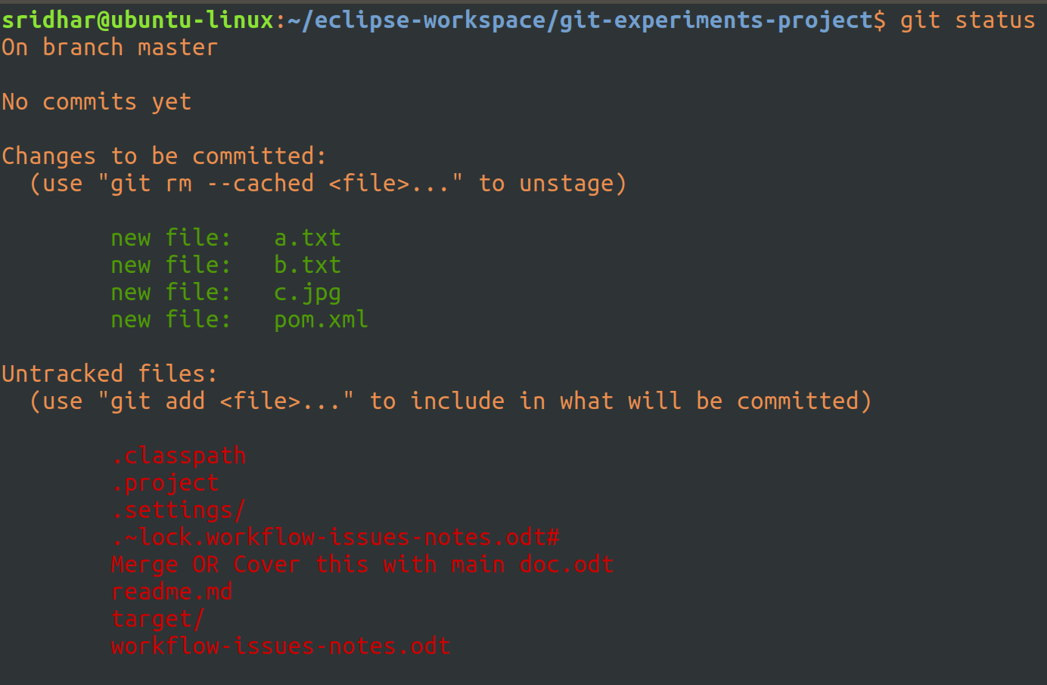
If you want to see the changes you’ve made and staged to index then use git diff -–cached:
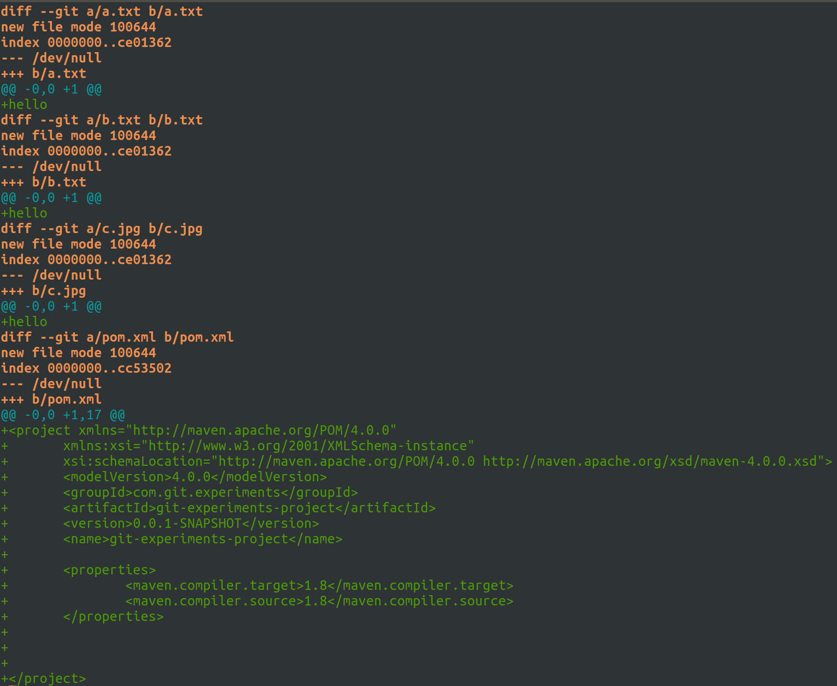

As you can see, it shows all changes made to the 4 files (which have been indexed).

Committing the changes:
I’ve used the -m option with git commit multiple times in order to display the comit message in multiple lines. The other way of doing this is:

git commit -m ‘Some message

message contd and
over’

But the advantage of using separate -m options is to enable emailing systems (connected to git) to automatically pickup the first comment (supplied with first -m) as the header/subject of email and the remaining comment as part of the body.

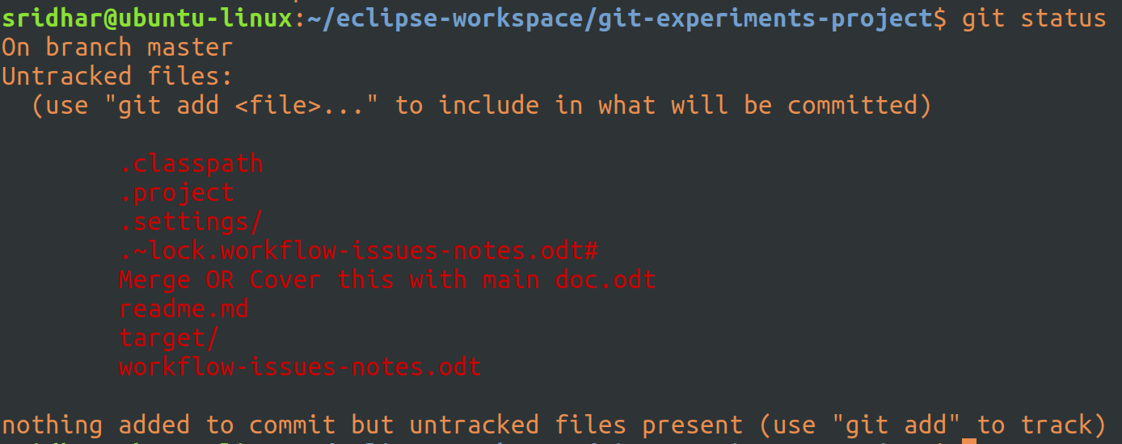
Git status above confirms that there’s nothing pending for commit (from index).

And, git diff with cached, which returns all diffs between what’s in staging and in commit and since all files that are staged have been committed, it now does not have any diffs to show b/w the staged files and the committed ones.

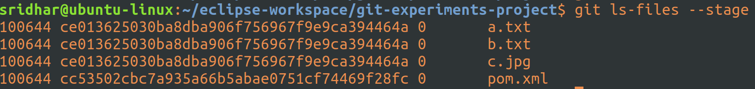
But, when I ran git ls-files –stage, it still shows the files as staged, no difference even in the mode of the file, it still says 0.

IDK, if this is normal behaviour or not!

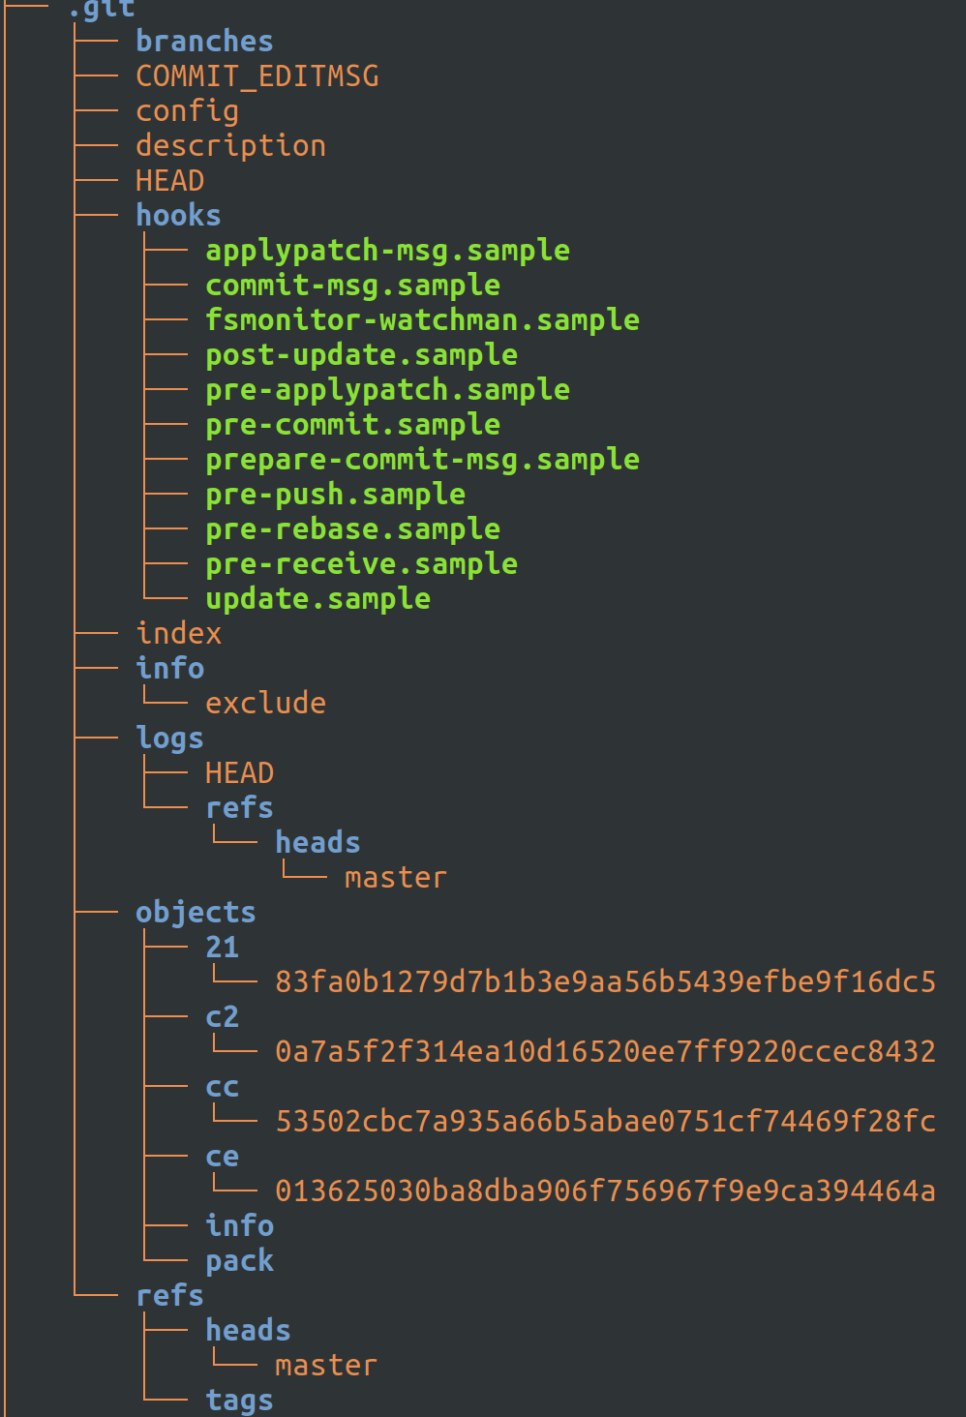
Now, if you compare the above tree -a snapshot with the one that was taken before commit (and after staging), you’ll notice, the new logs dir and new master under refs -> heads and two new objects.

Of the four objects, we already know that cc object represent the a.txt, b.txt, and c.jpg file content and ce object represents the pom.xml file. Now, let’s see what c2 and 21 objects contain.

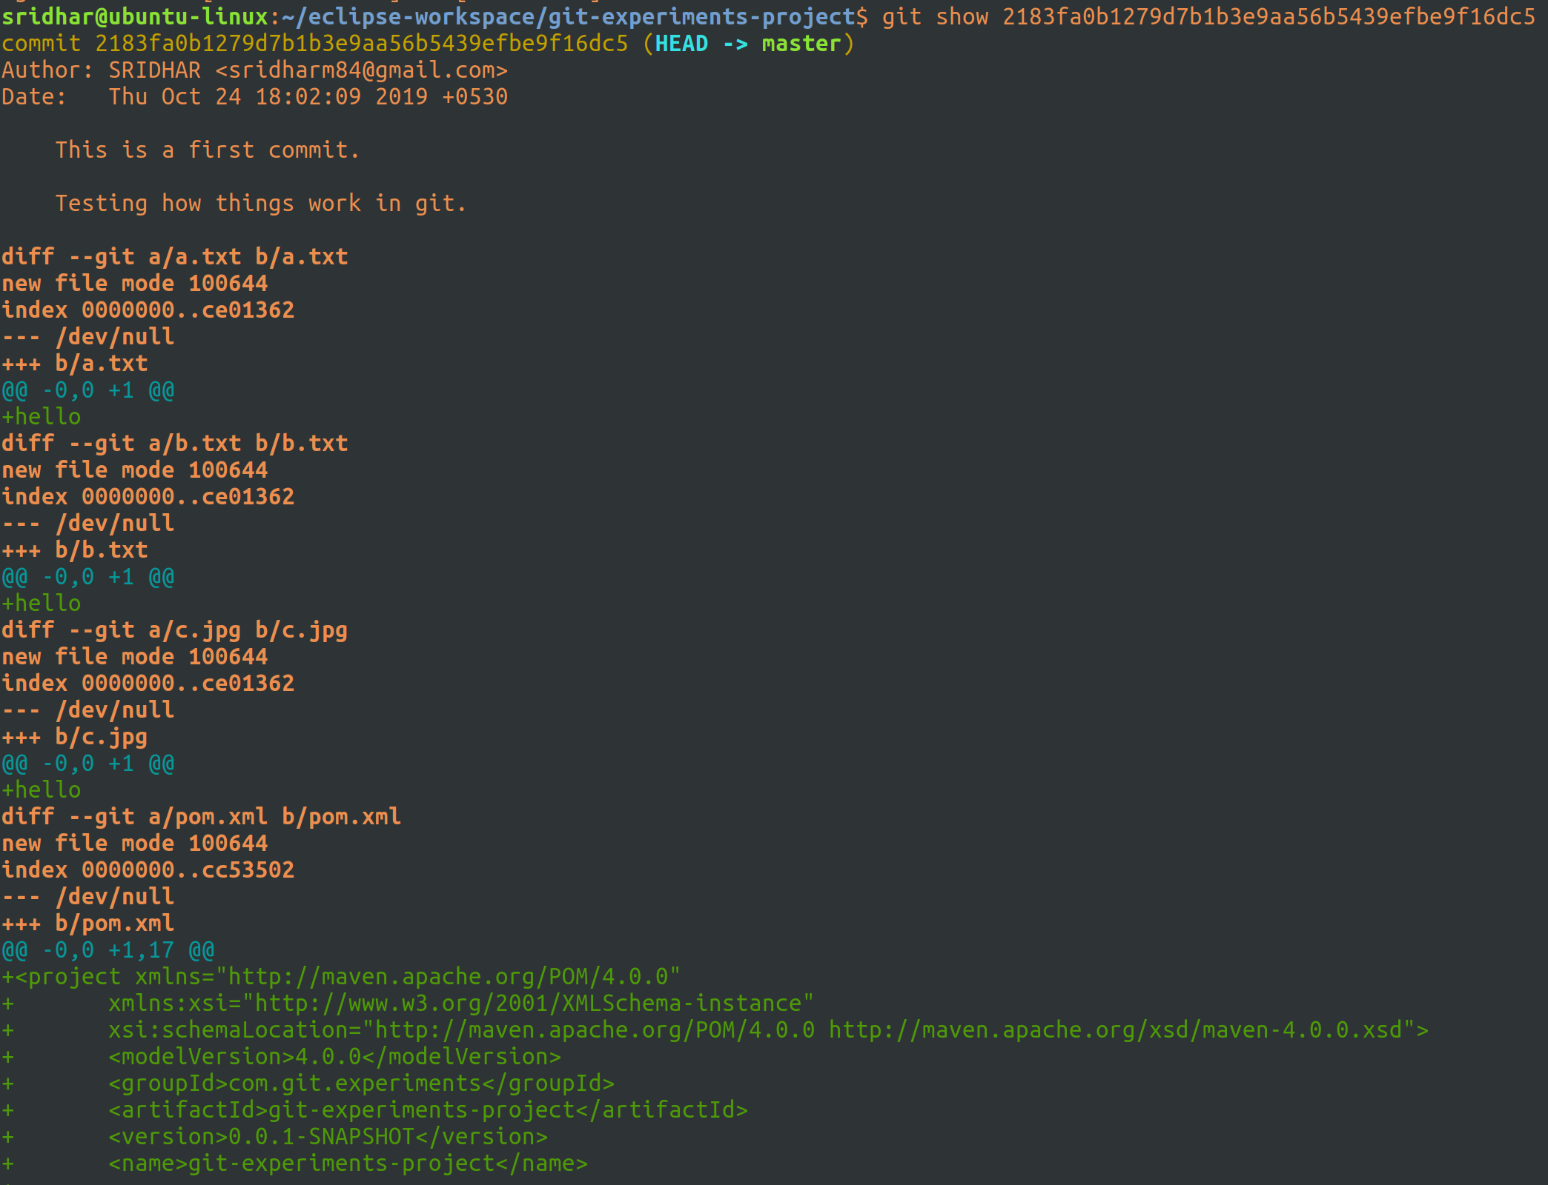
The git show of the 21 object (i.e. the sha-1 of object under dir 21), as you can see from above is the commit object.

This object contains all the files that have been staged (which were later committed in one go).

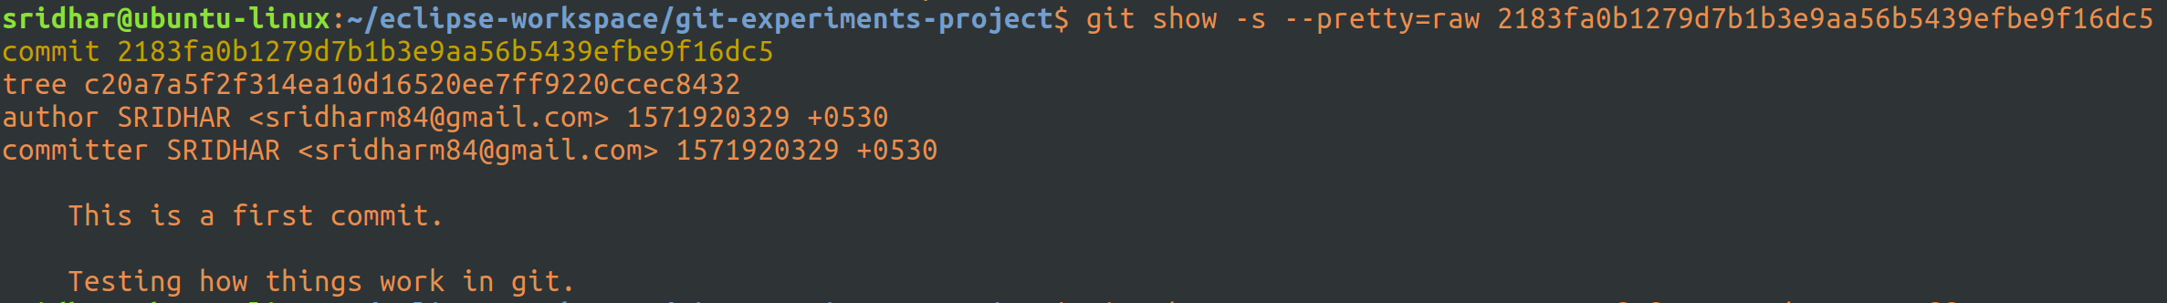
Git show with pretty=raw option shows the commit object details at a higher-level.

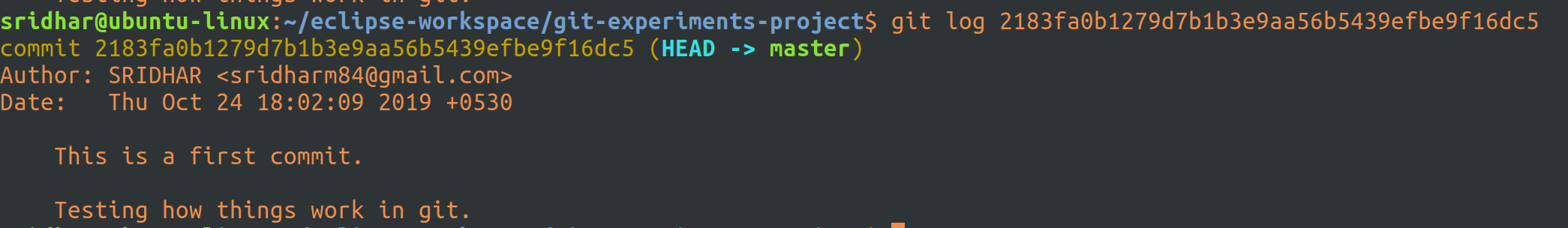
Instead of git show with pretty, you can also use git log to get a higher-level view of the commit object.

A commit does not itself contain any info about what actually changed; all changes are calculated by comparing the contents of the tree referred to by this commit with the trees associated wiht its parents.

To refer what all blobs/trees this commit contains, you can run a git ls-tree.

Now, let’s look at the other new object:
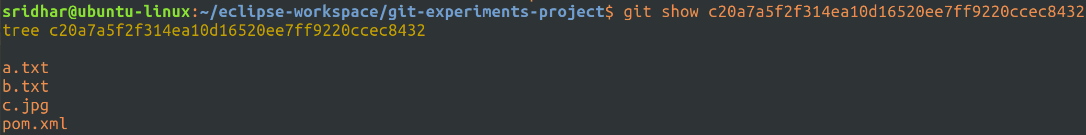
We can see it’s a tree object and it contains references to other blobs that are part of one commit.

Everything in git is a branch, unlike svn, where there is a head and you can then create branches out of that head. In git, even master is a branch.

Run git branch to see the branches:

It says currently there is one branch, which is the master.

Let’s create a new branch:
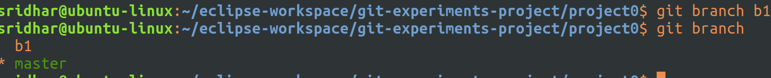
I created a branch b1 (din’t name it b0 because from git perspective master is also a branch, so I thought better name it 1 and consider master as 0).

And, I can also see there are now 2 branches and the current branch is the master (with a * next to it).

Let’s move to the new branch:
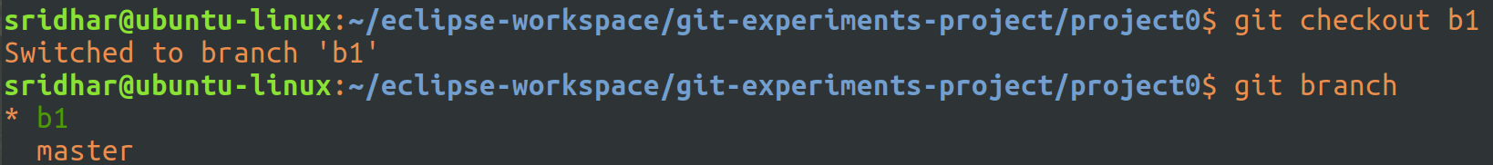
You do that by running a git checkout <branch_name> and to ensure that you are indeed on the checkedout branch, do a git branch and you should see a * next to your checkedout branch name.

Before we do anything let’s just take a note of the current status from the branch b1’s perspective:
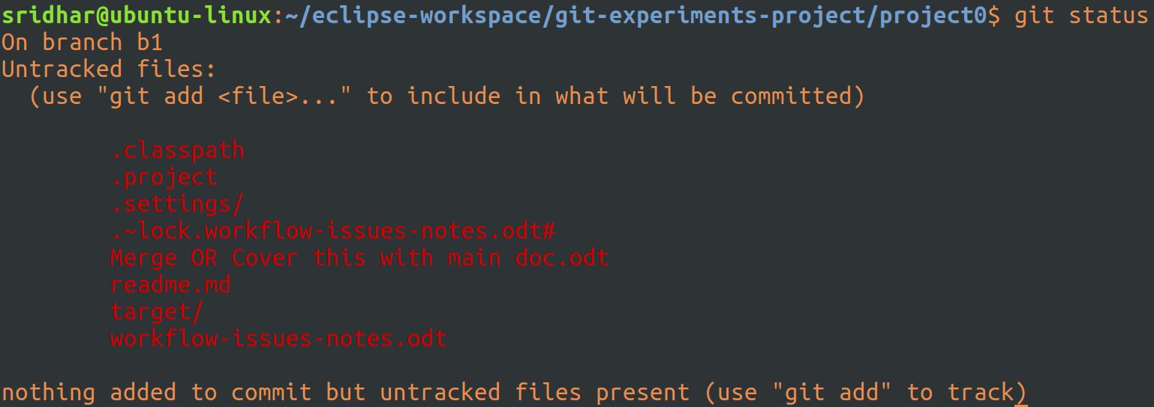
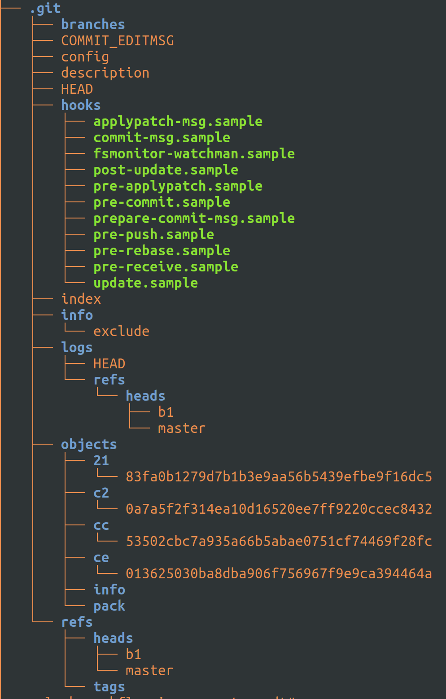
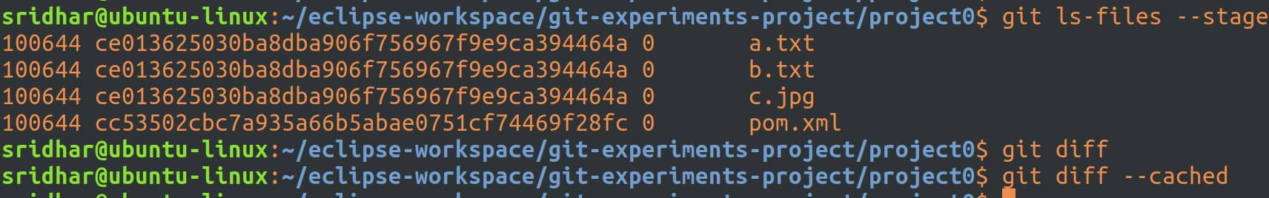

The git status, tree -a, git ls – files, diff and diff with cached all show same results as it would in master branch.

So, from a user and git perspective, everything looks same, as it should be, we should be able to access all files that are accessible from master branch.

Now, let’s edit a file:
Modified the a.txt file with a sentence which I expect it to be vsisible only when I’m in b1 branch.

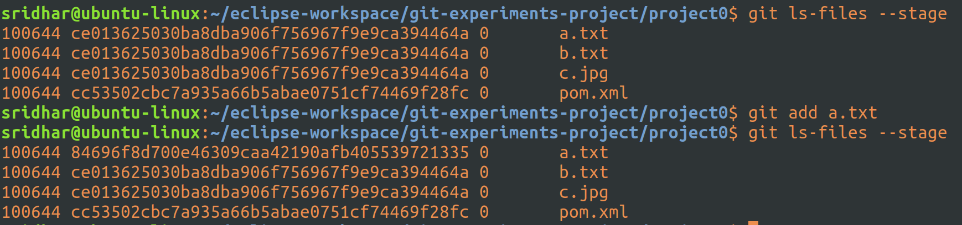
Here, we go, I’ve taken the ls – files snapshot just before adding the changed a.txt file to index/staging and after it.

You can clearly see that the SHA-1 name of a.txt after staging the modified file is different from that of b.yxy and c.jpg because the modified a.txt contains different text.

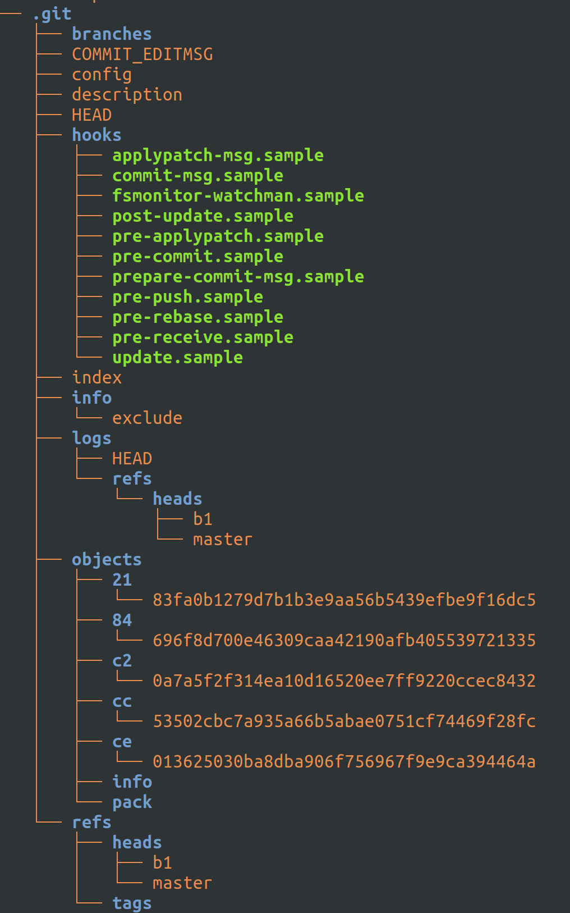
And, we can also see a new object under 84 dir and this sha-1 matches with what we can see in the index file (above with ls – files output).

A git show on the sha-1 will give us:

confirming that this is indeed the contents of the modified file.

Let’s now go back to master branch and see if these changes are visible there:
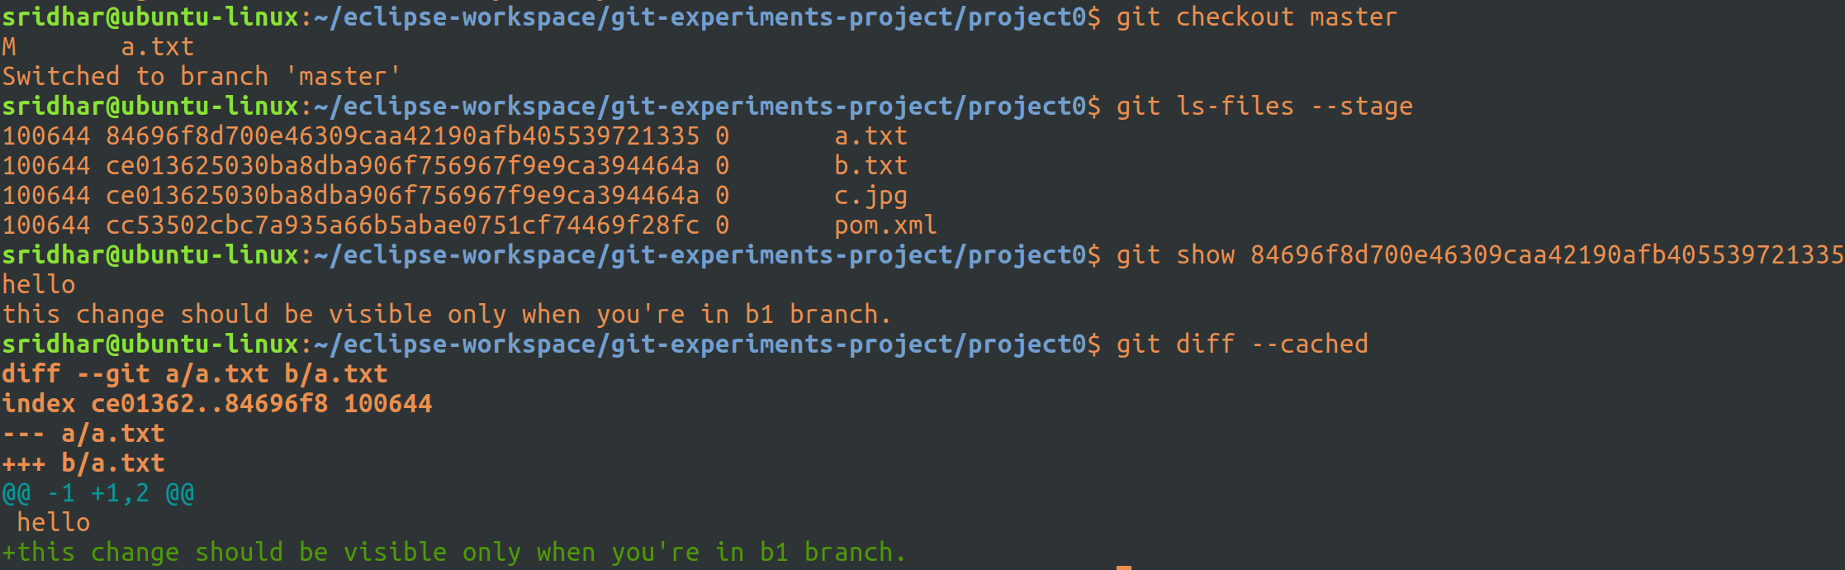
Quite surprising. All the changes done in the branch b1 are visible from master also.

I don;t understand this!

I understood this later – I should be looking at the contents of the file a.txt doing a cat a.txt, which would’ve shown that changes in b1 are not in master, because that’s what matters at the end of the day.

Okay, let’s switch back to branch b1 and commit the file (a.txt):
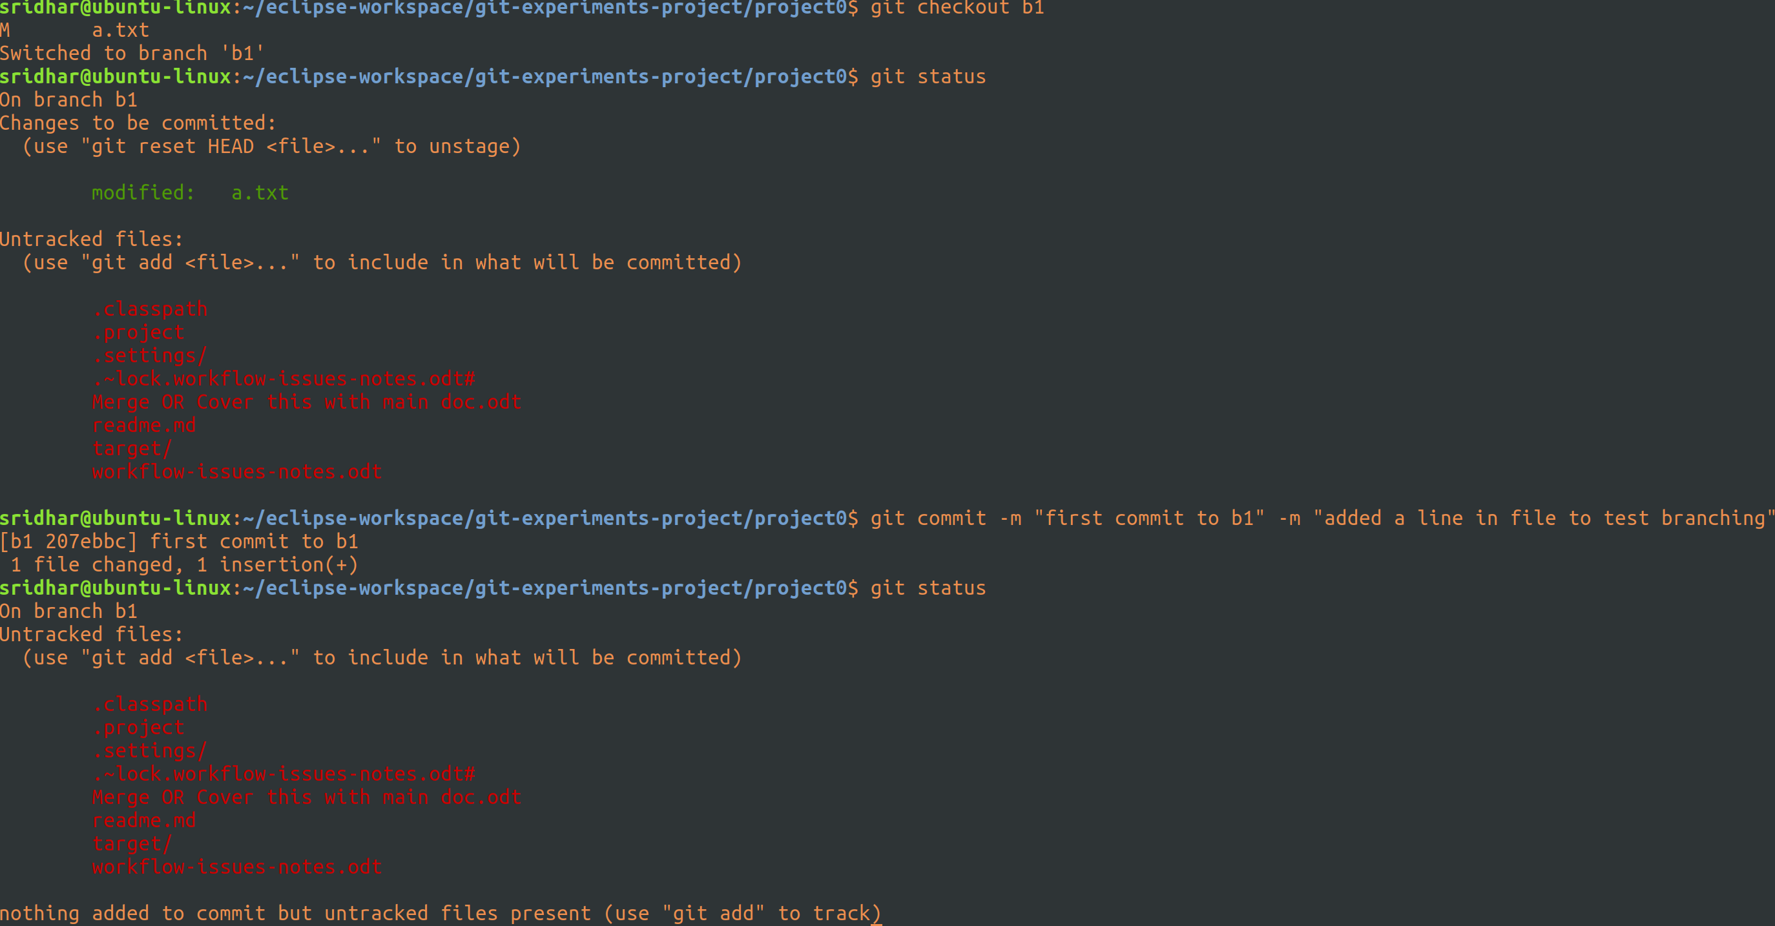
Committed the modified file.

Let’s have a look at the tree now:
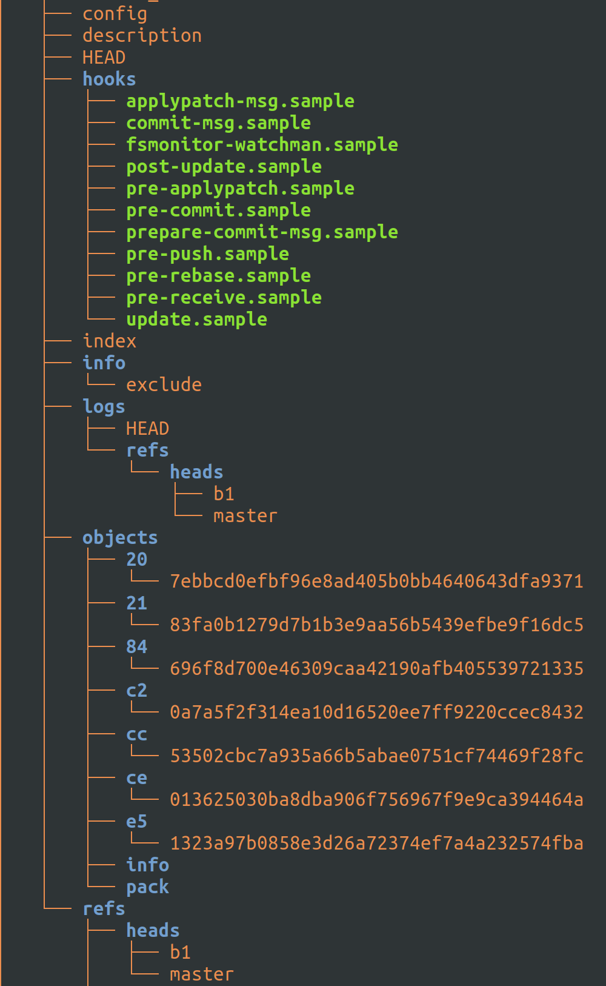
I see 2 more new objects. My guess, one should be the commite object and the other tree object (which contains all other objects that are part of this commit). Let’s check.

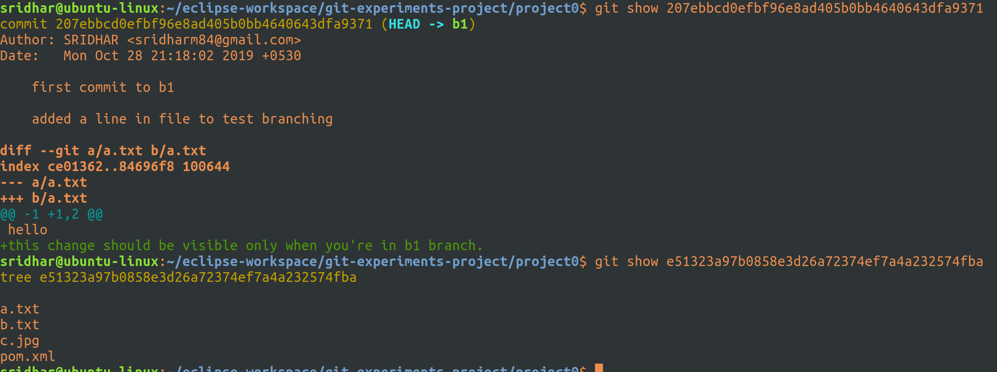

And, as expected, you can see, one is a commit object and the other a tree.

But I don’t understand why does the tree object has references to b.txt, c.jpg and pom.xml files. I did not changes/stage/commit these files in one go this time, in fact, i din;t even touch them!

But, let’s now just check out the contents of the file a.txt in master and b1:
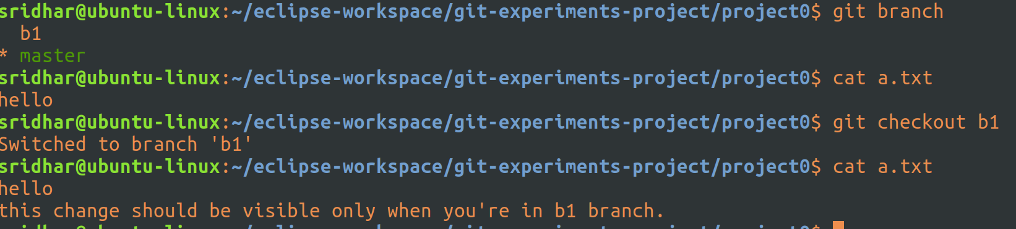
Okay, now that’s amazing and is actually expected behaviour. Changes done to file a.txt in b1 is not visible in the file that’s on master.
But, how does git make it happen, because git index files and objects are all same in both b1 and master, so how does it work?

Let’s now make some change in master in the same file (a.txt):
Have added a sentence in the master’s a.txt file.

Let’s just check the ls – files output before we add:
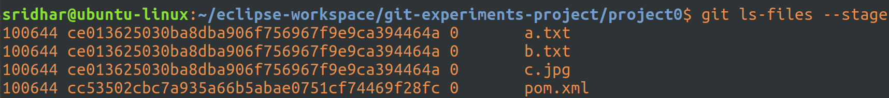
I don’t understand. The sha-1 of a,b and c files are same, which is what was expected, but when I made the changes to a.txt in b1 and staged and switched to master and checked ls – files, I was seeing the a.txt have a different sha-1 (which was the same sha-1 as was on the b1’s a.txt) from the b.txt and c.jpg, but then how now it is showing correctly?

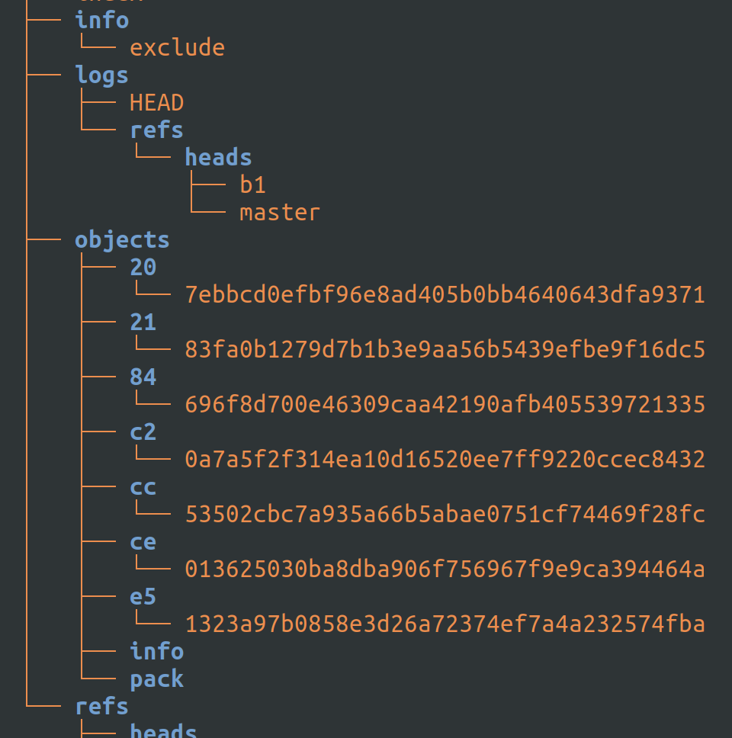
The tree shows all objects though and that is okay, the main thing is what’s in the index file and now it is showing correctly, IDK what happened before.

Btw, I just tried to switch to b1 and I got this:
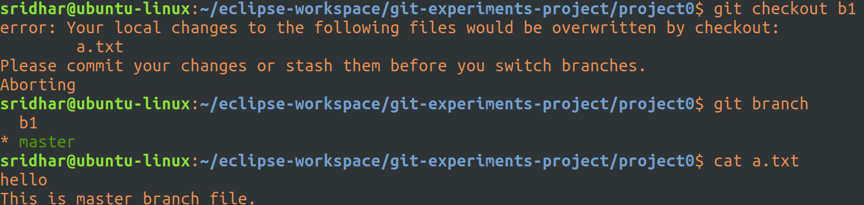
This means, I can’t switch to a different branch w/o first at least staging the changes done in the current branch or at least stash them.

Let’s stage it and then try switching:
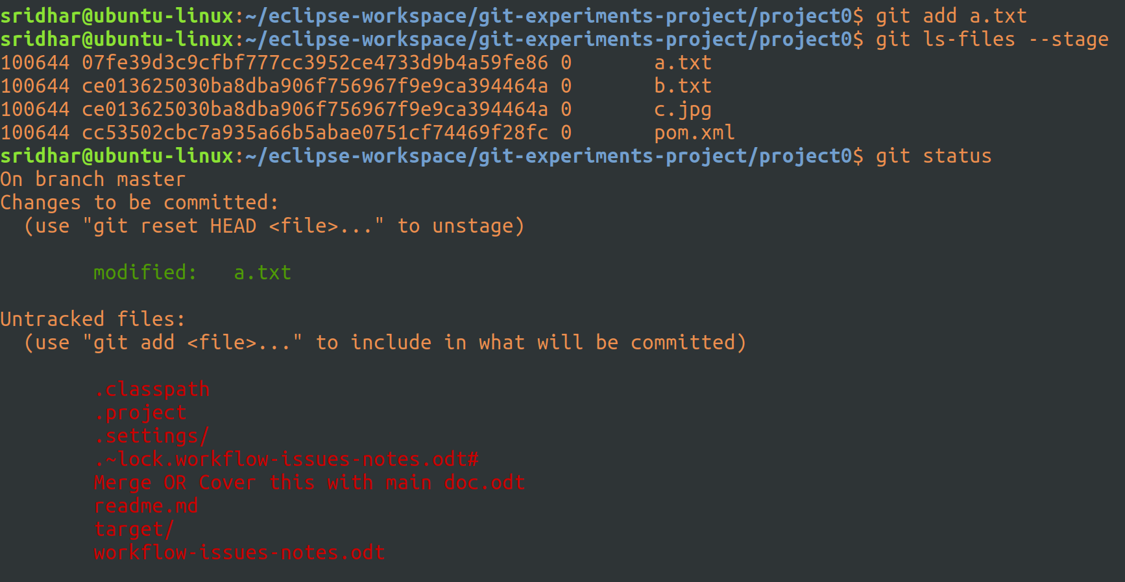
Okay, staged and I see a different sha-1 name for a.txt compared to b and c, as expected.

Now, let’s try and switch to b1 branch, see if it allows us now:
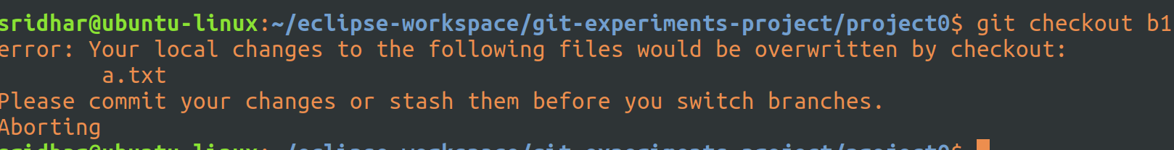
Nope. I think I’ll have to commit, only then!
Now, let’s switch to b1 and see if it allows:
Yeah.

Let’s compare what’s in the index of b1 and master now:
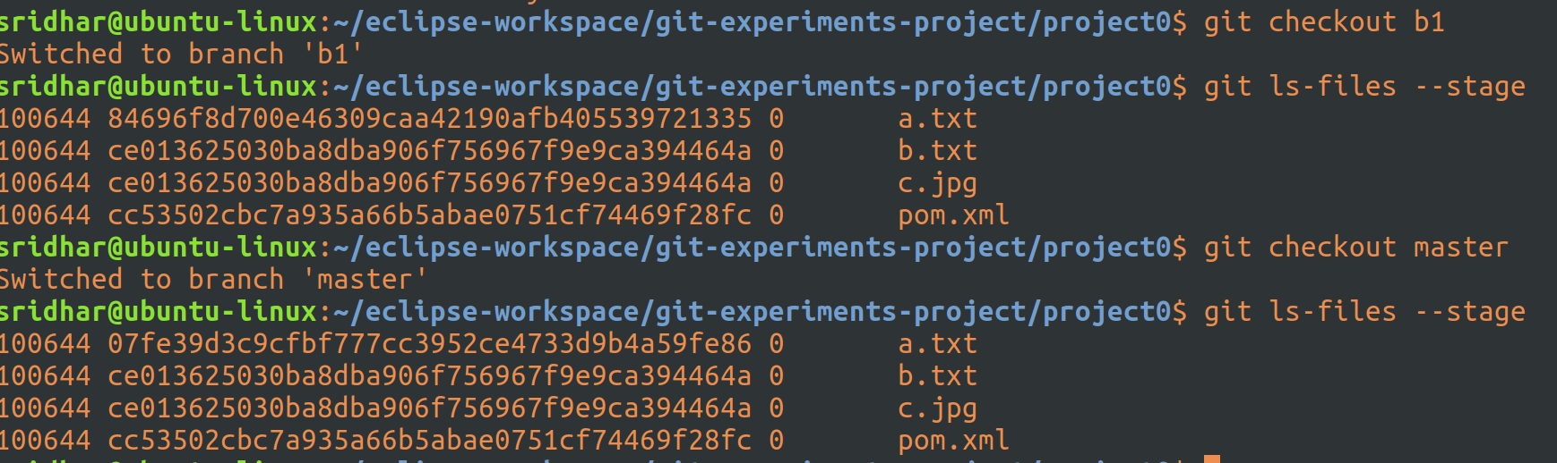
Yeah, perfect, the sha-1’s of a.txt in index of both b1 and master are different.

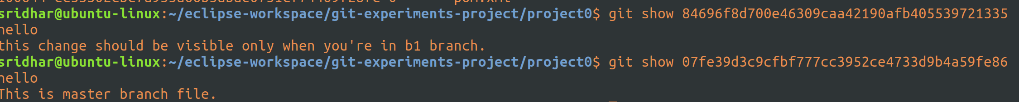
And the above git show confirms the contents of this file on master and b1 also, perfect, as expected.

Let’s just take a look at tree before the next step:
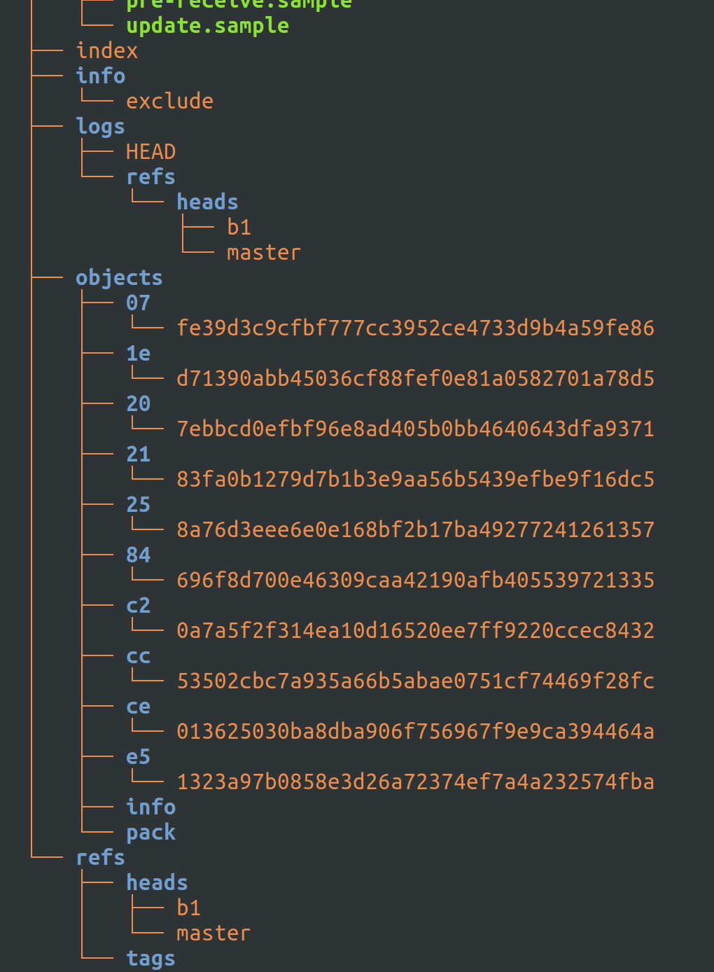
Let’s now merge the contents of a1.txt of b1 into master:
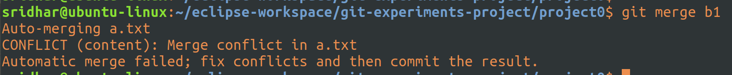
Alright, let’s find out what the conflicts are:
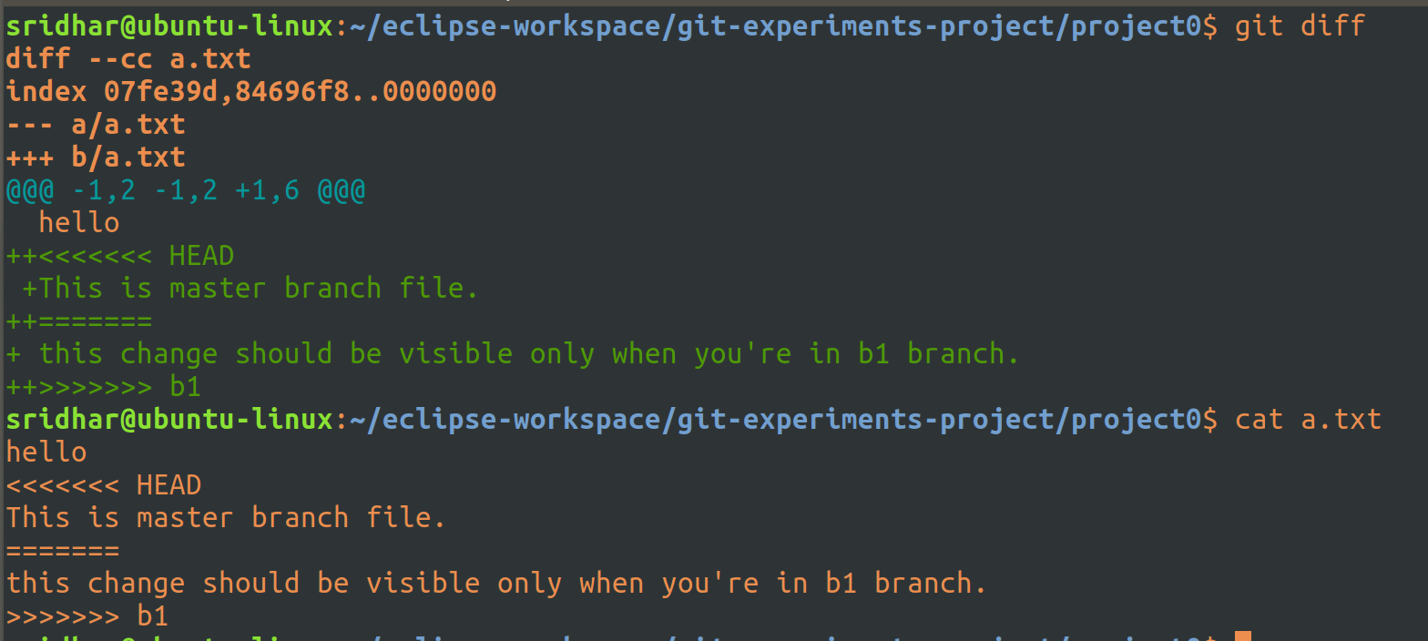
So, git diff shows the conflicts and when I do a cat of the file, I see it in detail, so it seems, content is merged into a.txt file of master but I need to correct the conflict in the file and then stage and commit the changes.

Alright, opened vim, did changes and these are the contents in a.txt now:
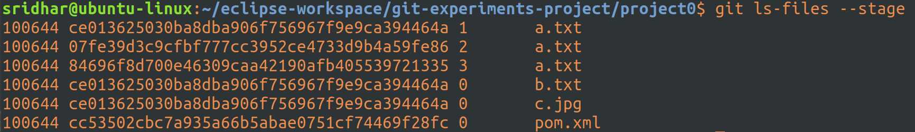
Btw, I am seeing 3 entries for a.txt in stage of master, let’s check what each of them is:
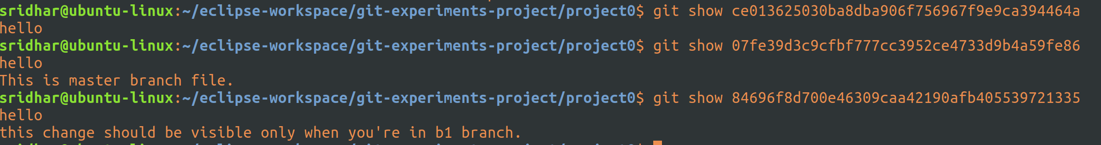
This is amazing. Git keeps a separate sha-1 name for the content that is same in both files (that are being merged). And, the second one contains contents of master and the third one contains the contents of b1.

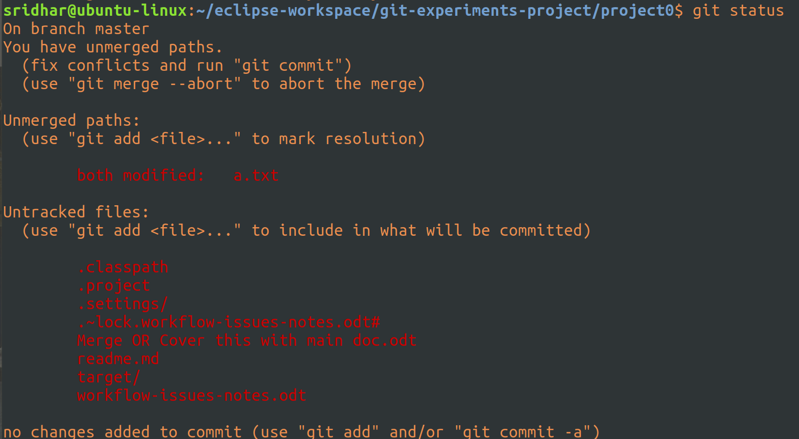
Alright, the above git status tells us the merge is yet to be committed and for that, we first need to stage it and then commit the changes or just do a git commit -a, which will first stage and then do a commit in a single command:
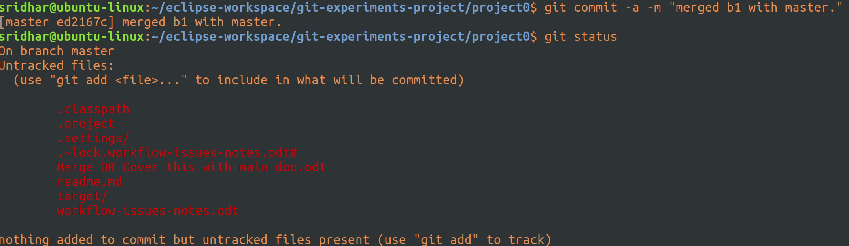
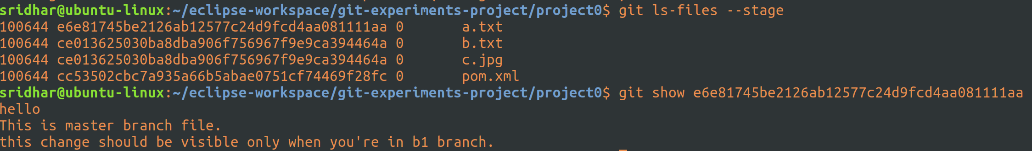
Okay, now, we have a single sha-1 name for a.txt in the index and we can see the contents of the sha-1 as well.

Tree, meanwhile, keeps on piling objects, never let’s it go, unless you do a git gc:
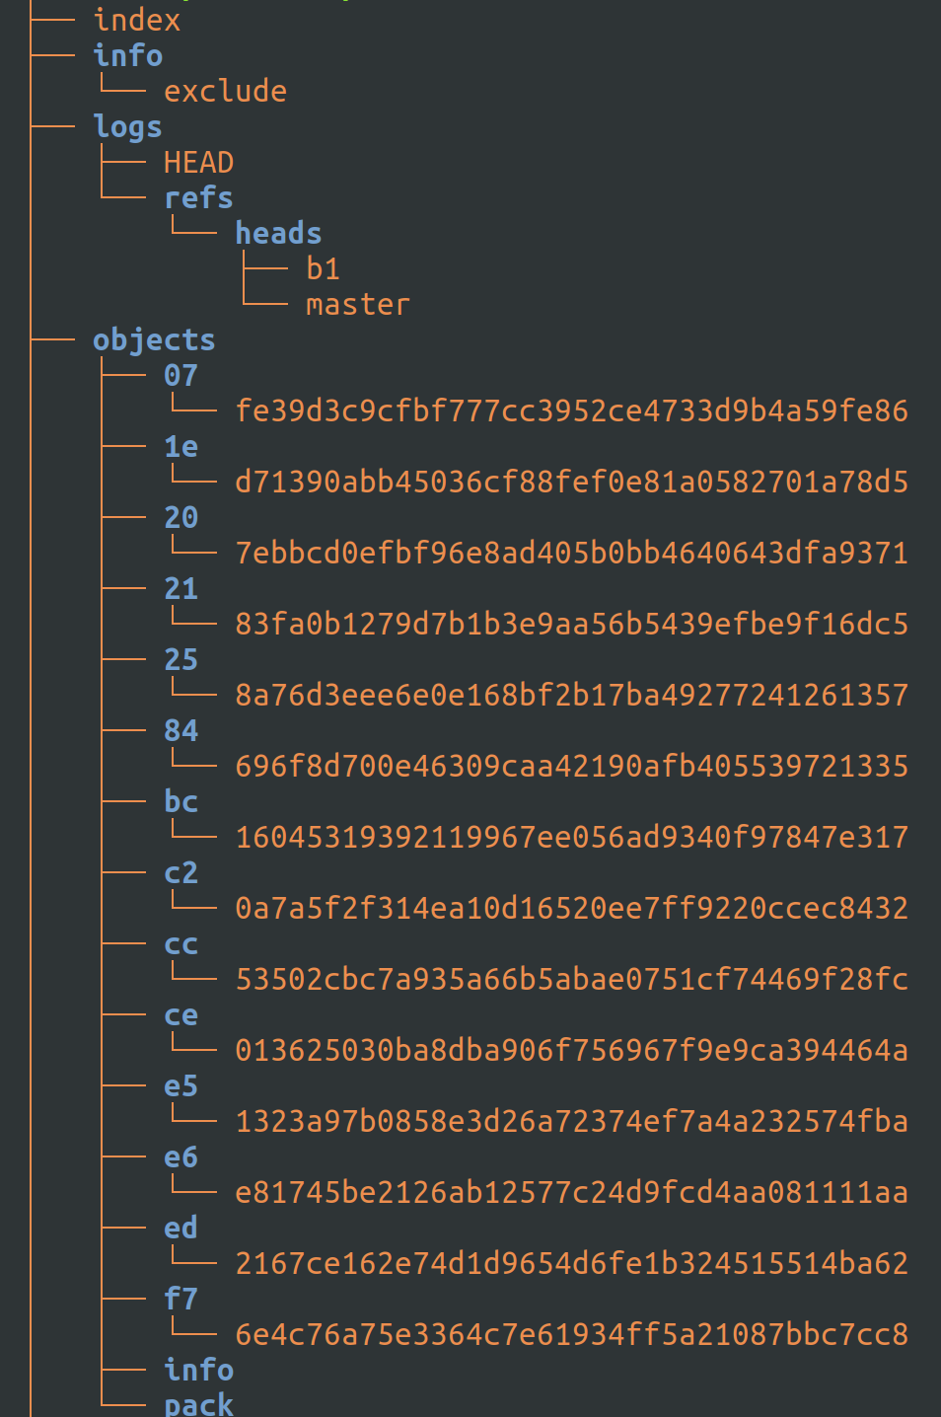
Okay, let’s just go back to b1 and check to see that the contents of a.txt on b1 are as is:
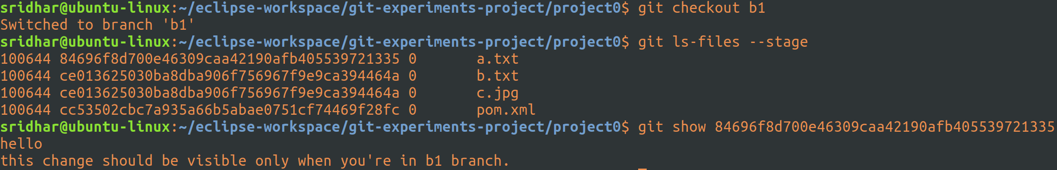
Perfect.

Okay, let’s tag a commit object. You can tag any object, but let’s just tag a commit object which is a general practice:
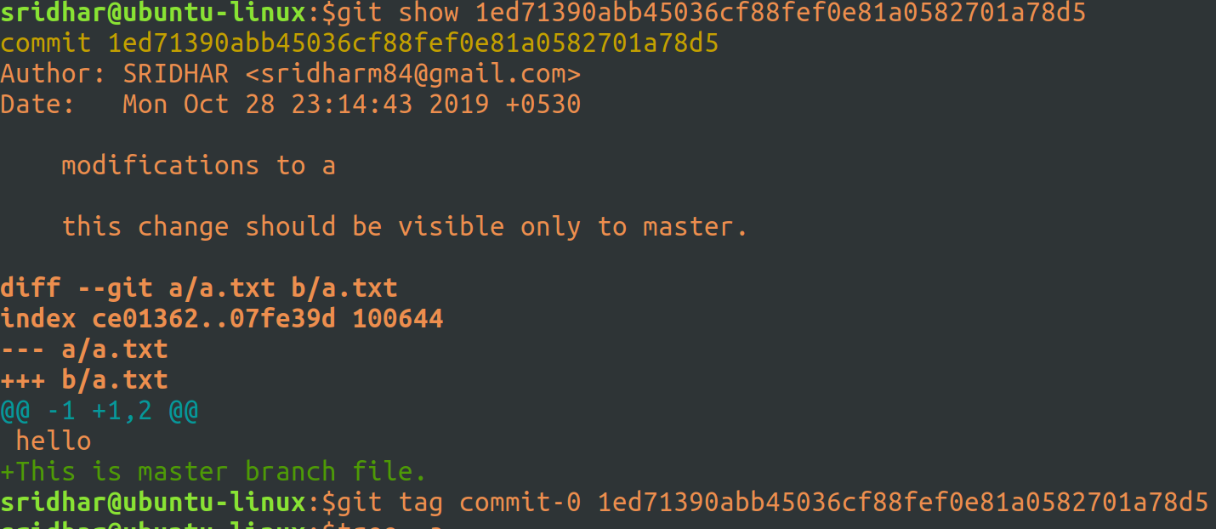
Tagged 1ed71390abb45036cf88fef0e81a0582701a78d5 commit object with commit-0 tag name.

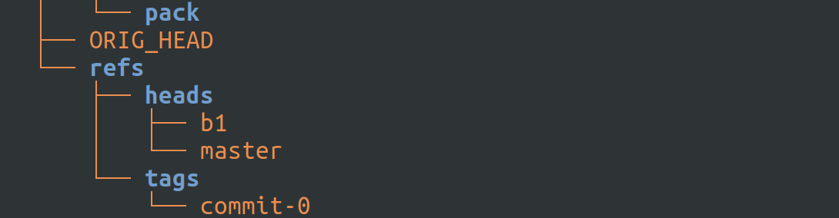
You can see above an entry under tags.

Now, from here onwards, we can refer to that particular object using this tag:
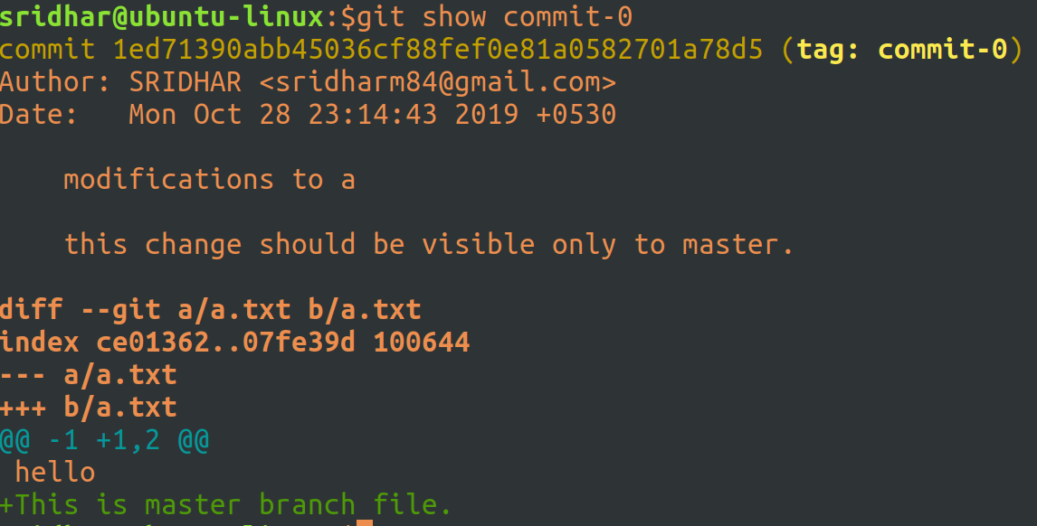
What I used above is a light-weight tag. If you want to add a comment and/or sign the tag with your key (a gpg key something), then you’ll have to use create a tag object.

Let’s now try and create a tag object for the same commit object:
Just tried creating with the same tag name, wanted to see if it works, but cleverly, it doesn’t.

The below statement creates a tag object (commit-1) for the said object:
The moment you run the above command, an editor opens-up for you to enter a message. A tag message is compulsory while using tag objects.

You can see the commit-1 tag under tags:

And, since I created a tag object, it creates a new object under objects:
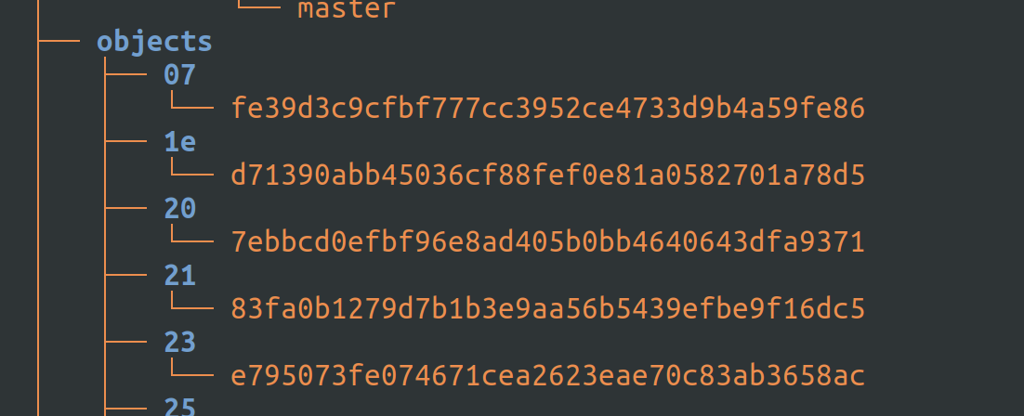
The one starting with 23 is the new object that corresponds to the above tag object. And this tag object now becomes a whole object in itself, meaning, you can actually delete the branch and refer to this tag object or create a branch out of this tag object.

And, when I do a git show of the object:
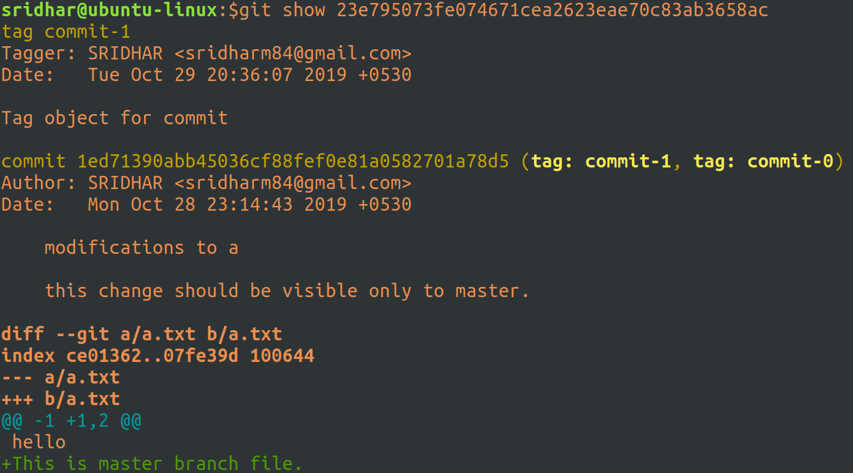
As you can see above, this new object is the tag object.

So, if you are not really willing to put a message to a tag and/or a signature key, then better just use a lightweight tag, which won’t create any new objects.

Now, let’s clone the current project (project0) to project1:
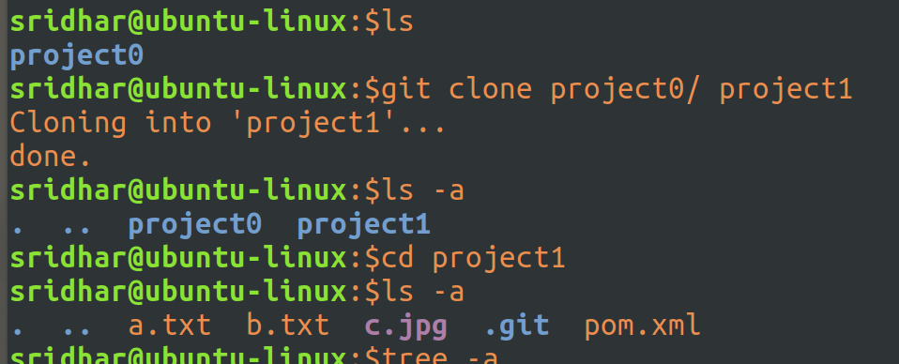
Project is cloned.

Let’s look at the tree at project1:
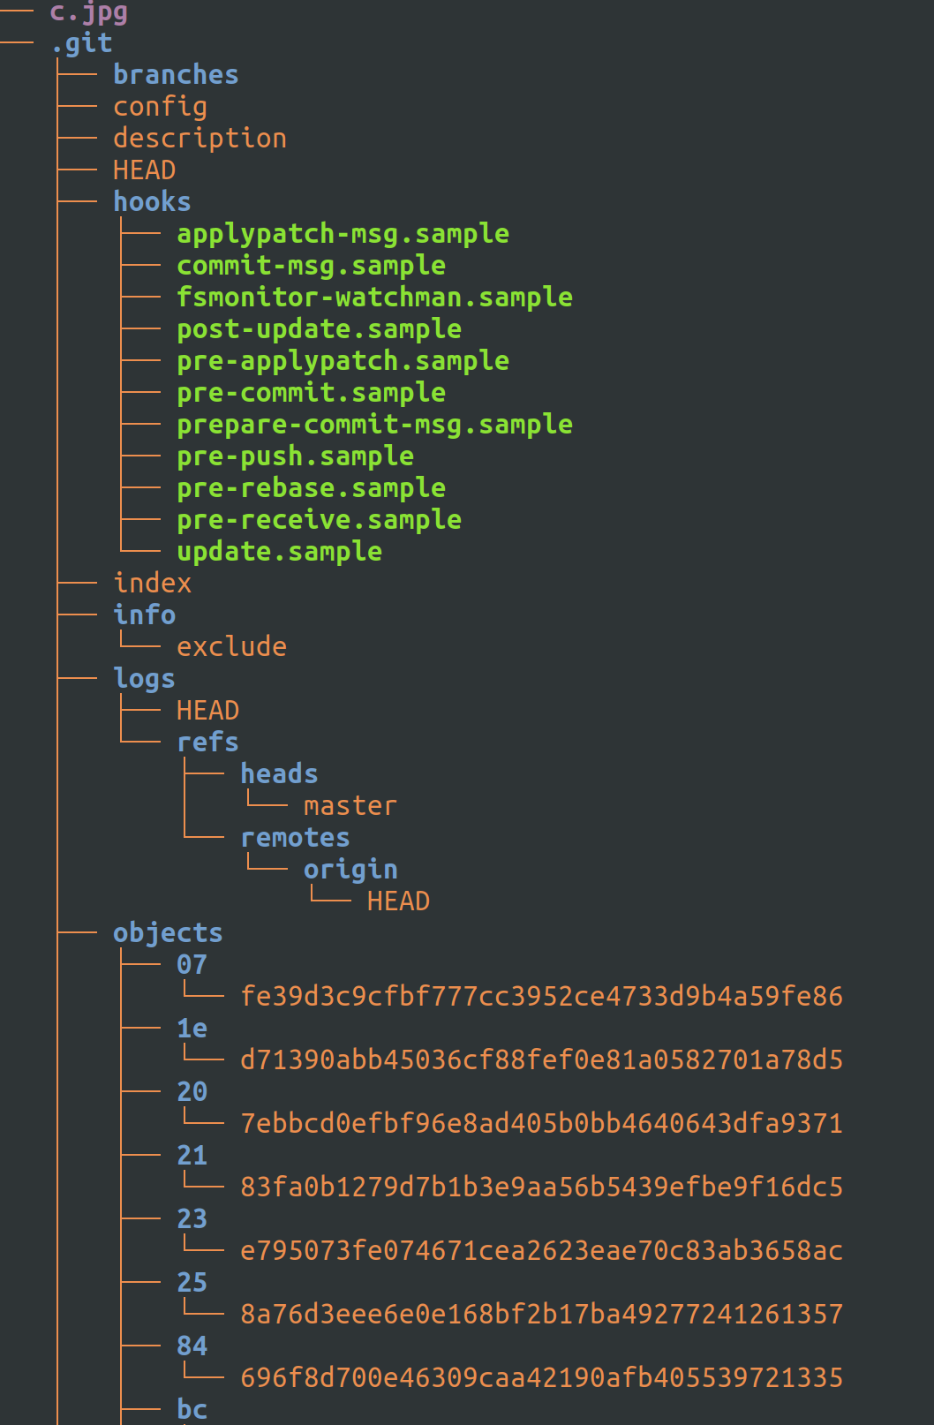
Has all that project0 has.

Let’s now make some changes in the c.jpg file of project1:
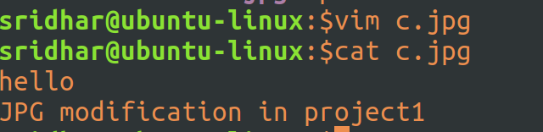
Stage the file:
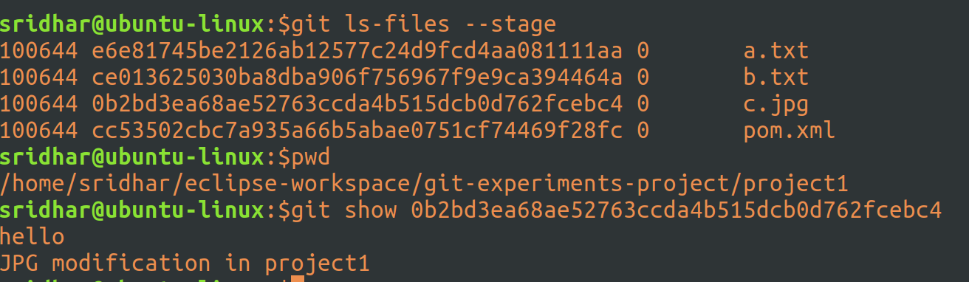
Staged and I can see the entry in ls – files.

Committed as well.

Now, let’s ask the project0 maintainers to take in my changes at project1 – this is same as submitting a pull-request, of course there is no such functionality at git, so we directly go into project0 and do the needful:

In project0.

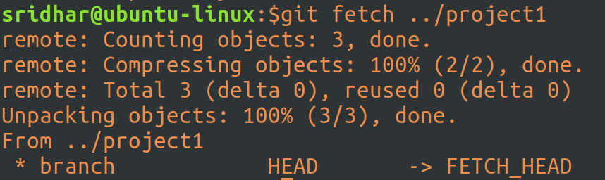
I’ve done a fetch here, could also done a pull but that would actually merge all changes from project1 into the current branch of project0, but I first to check what all changes have been done and then decide to accept or not, so I do a fetch, which will fetch the project1 stuff into a remote tracking branch.

After this step, I neither was able to find the remote tracking branch nor was able to merge changes from the remote tracking branch.

So, decided to go with a git pull rather:
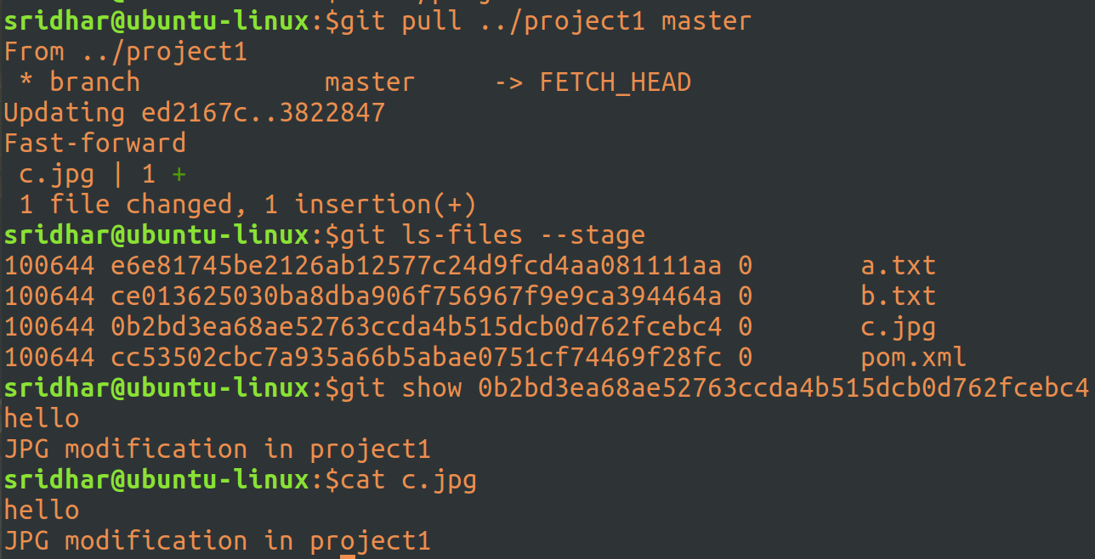
That’s it, did a pull. I can see the entry in ls – files and the cat output confirms, merge complete.

Now, let’s go to project1 and make some more changes to c.jpg file:
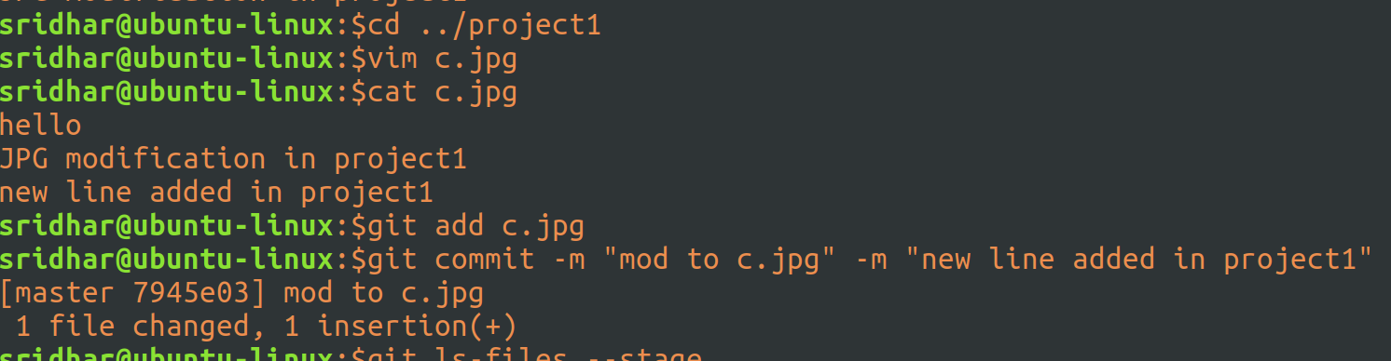
Modified the file, staged and committed.

Now, let’s go to project0 and do some changes in a diff file here and then merge project1’s file changes:
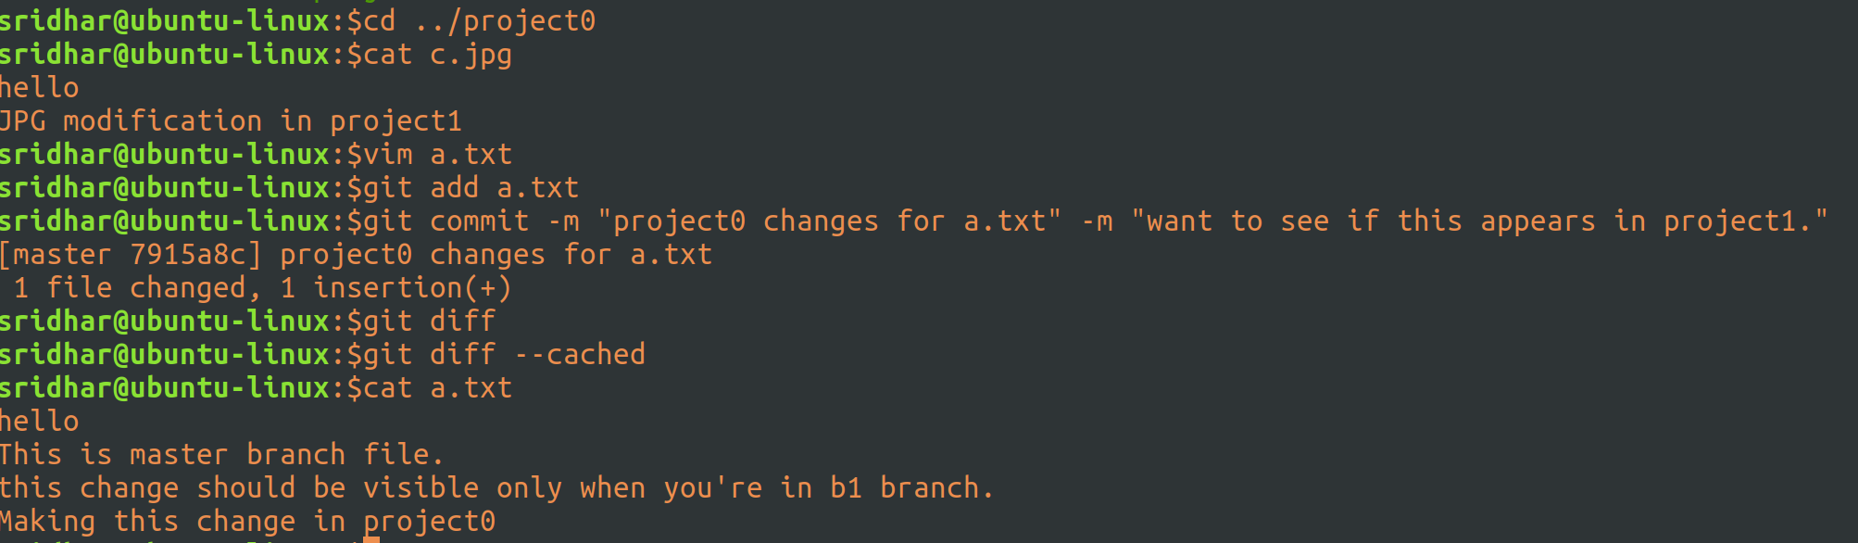
Alright. Went into project0, checked the contents of c.jpg – they are wat they should be in project0 and then modified a.txt, staged and committed.

Now, let’s pull in the changes from project1:
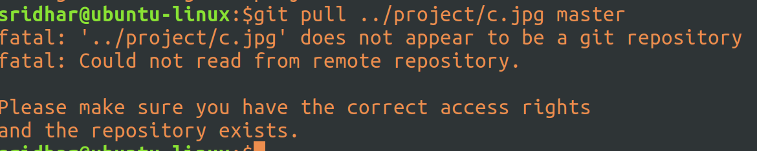
Tried this, you can;t do it a file level. All that’s at master comes in.

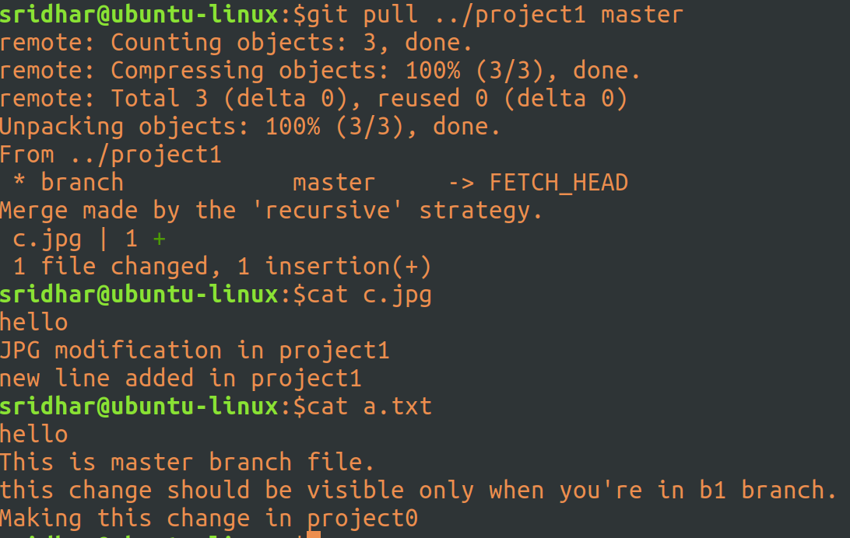
Now it’s done and please note the changes to a.txt in project0 did not get wiped out as only one file was taken from project1.

Now, let’s go to project1 and pull the latest changes from project0:
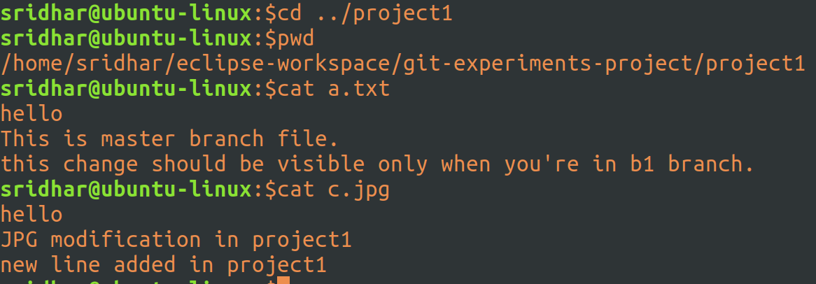
This is what it looks like now in project1.

And, doing a pull:
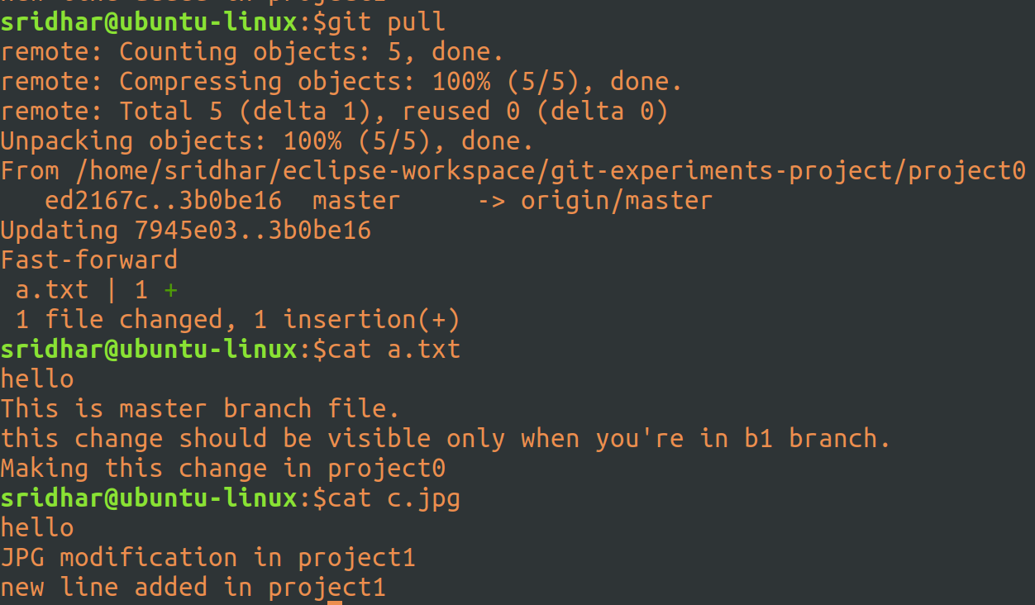
Done. I don’t have to mention that I have to pull from project0 since this project is anyways cloned from project0, git remembers where to pull from.

And, contents of a.txt gets updated in project1 and in sync with project0.

