https://stackoverflow.com/questions/5817579/how-can-i-preview-a-merge-in-git : Should try this, I find this a safer way than abort on master!

Created a maven project under:
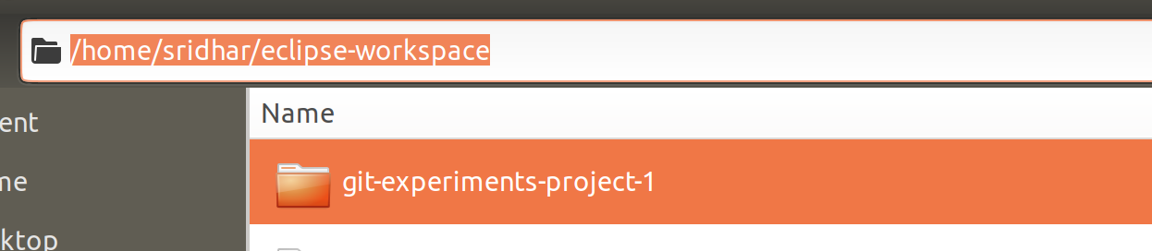
Created a Movie class with following attributes and their getters and setters and a constructor:
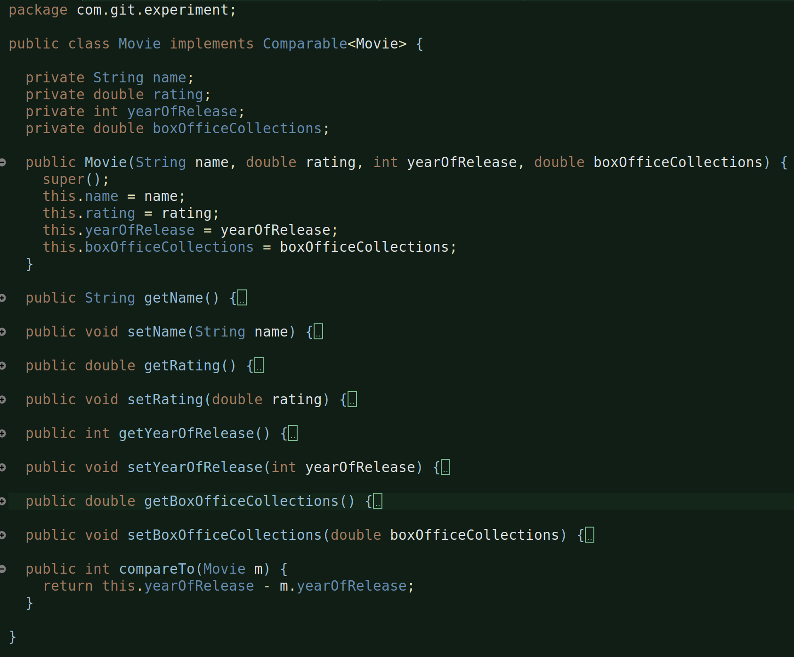
Movie class also implements Comparable interface which is actually required if you want to sort the elements of the class by using Collections class sort(List<>) method which requires natural ordering of the object that needs to be sorted or else we need to provide a comparator.

Next, created a MovieAddr class:
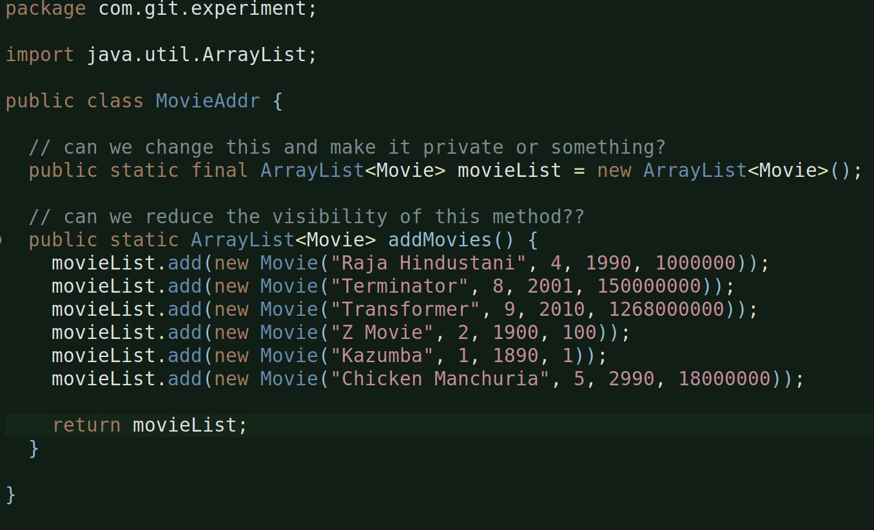
which basically adds movies to the static list.

Then, created a MovieSorter class:
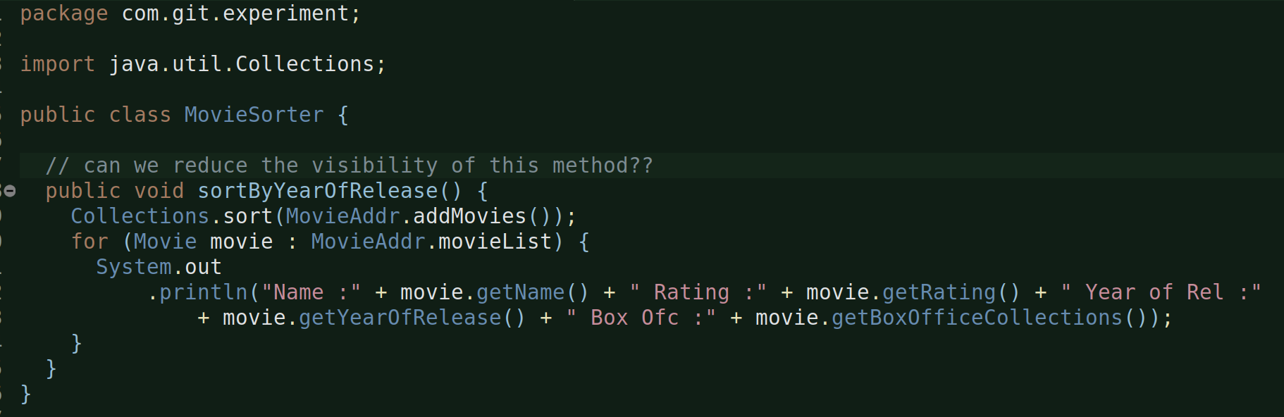
this basically calls the MovieAddr’s add method which then returns the collection full of movies and then passes that collection to Collections.sort(List) method which sorts the object on the basis of it’s natural ordering and since the natural ordering we mentioned is based on the yearOfRelease, this will sort accordingly and then iterate over it and displays the result.

Next is the main class:
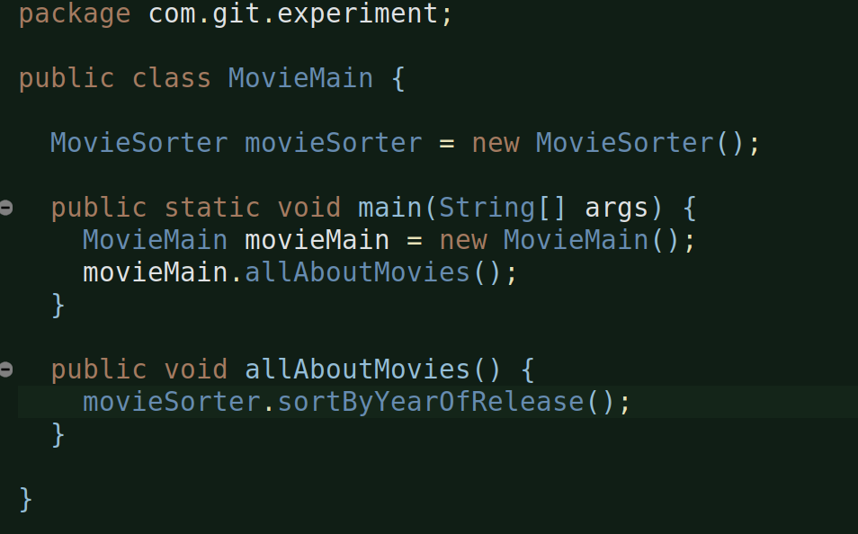
calls MovieSorter’s sortByYearOfRelease method, which calls other necessary stuff and produces the output.

Let’s now initialize a git (local) repo, stage and commit files:

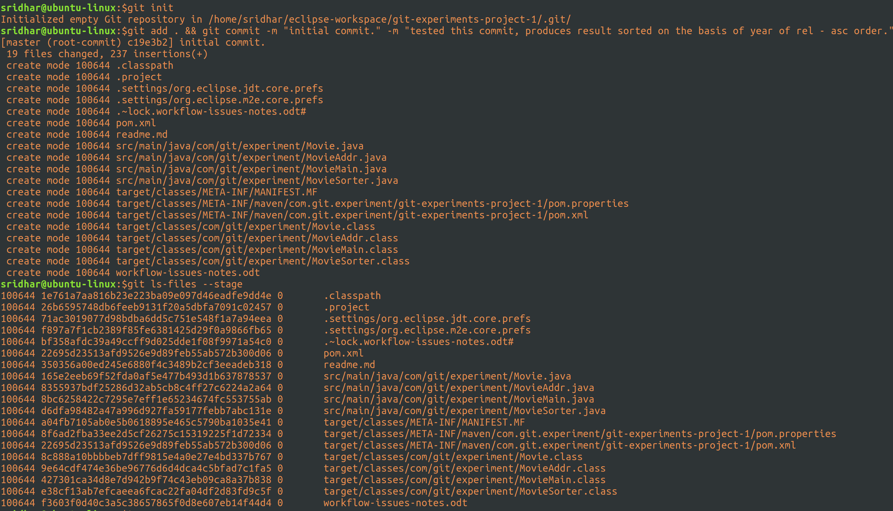
successfully initialized the repo, staged and committed fields with comment.
You can also see the ls – files output.

Git status output:
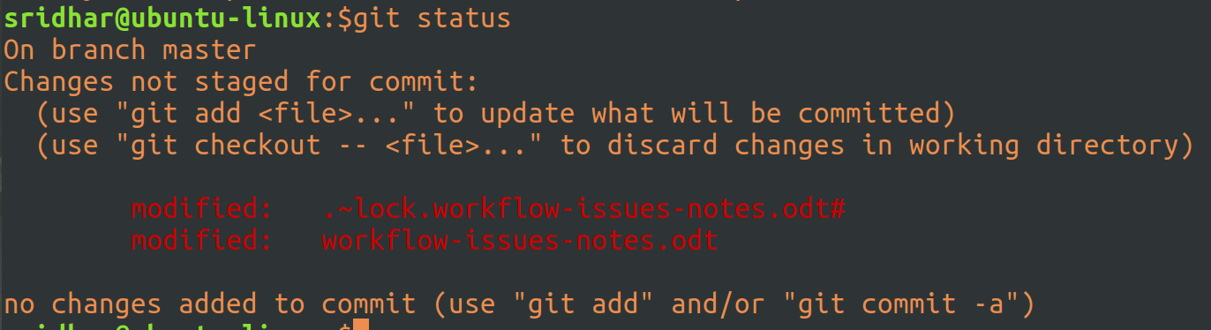
that’s because I’m currently using these two files and hecne they din’t get committed (not even staged), fair enough.
And, it says there are no untracked files that means everything else has been committed. Perfect.

Now, let’s clone this project:
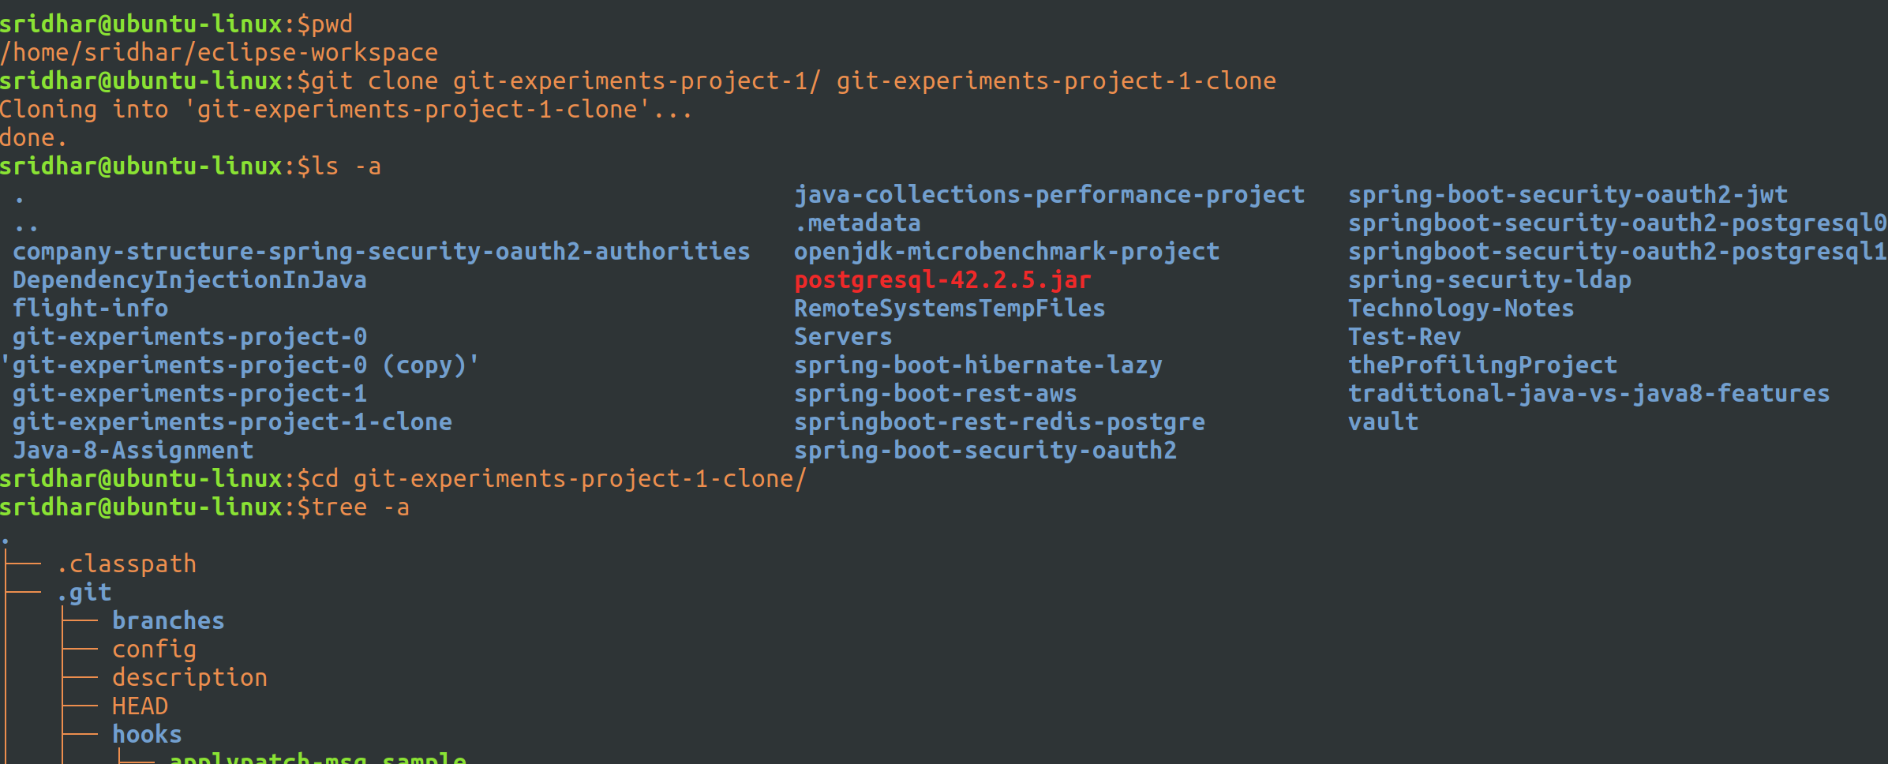
cloning is complete. You can check the new dir that’s created and the o/p of tree command of that dir as well.

Let’s import this cloned project into our eclipse:

Modified the pom.xml on the cloned project to a different name otherwise eclipse was not allowing me to import this project saying there is a already a project with the same pom name and stuff:
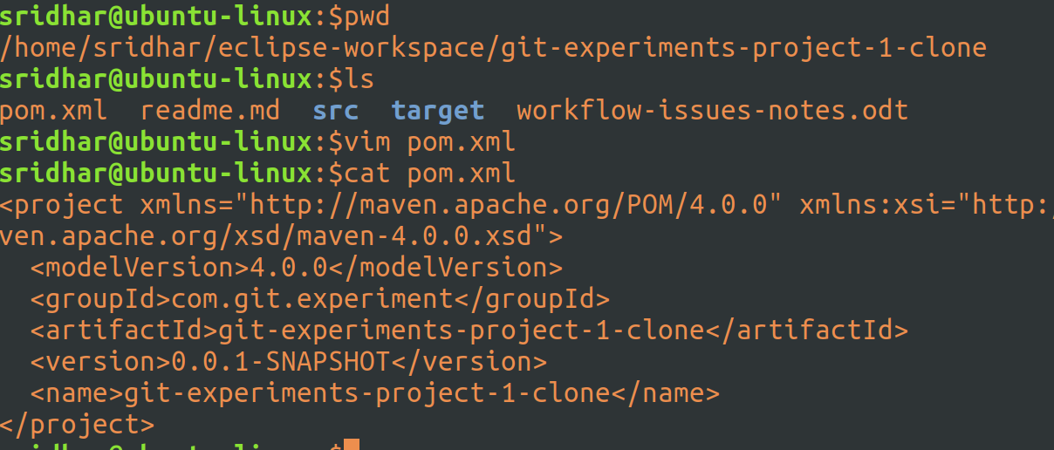
And,
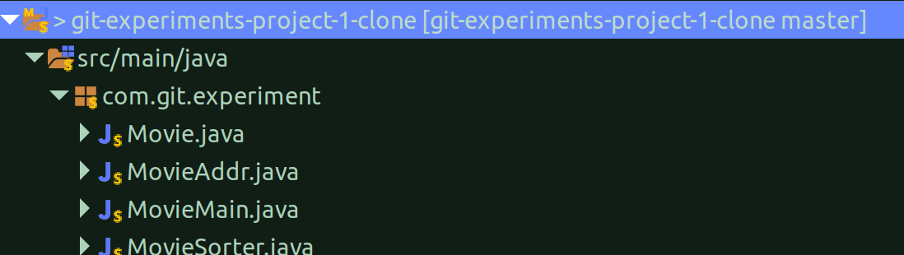
Import Successful.

Created the class which will provide sorting functionality on the basis of movie rating:
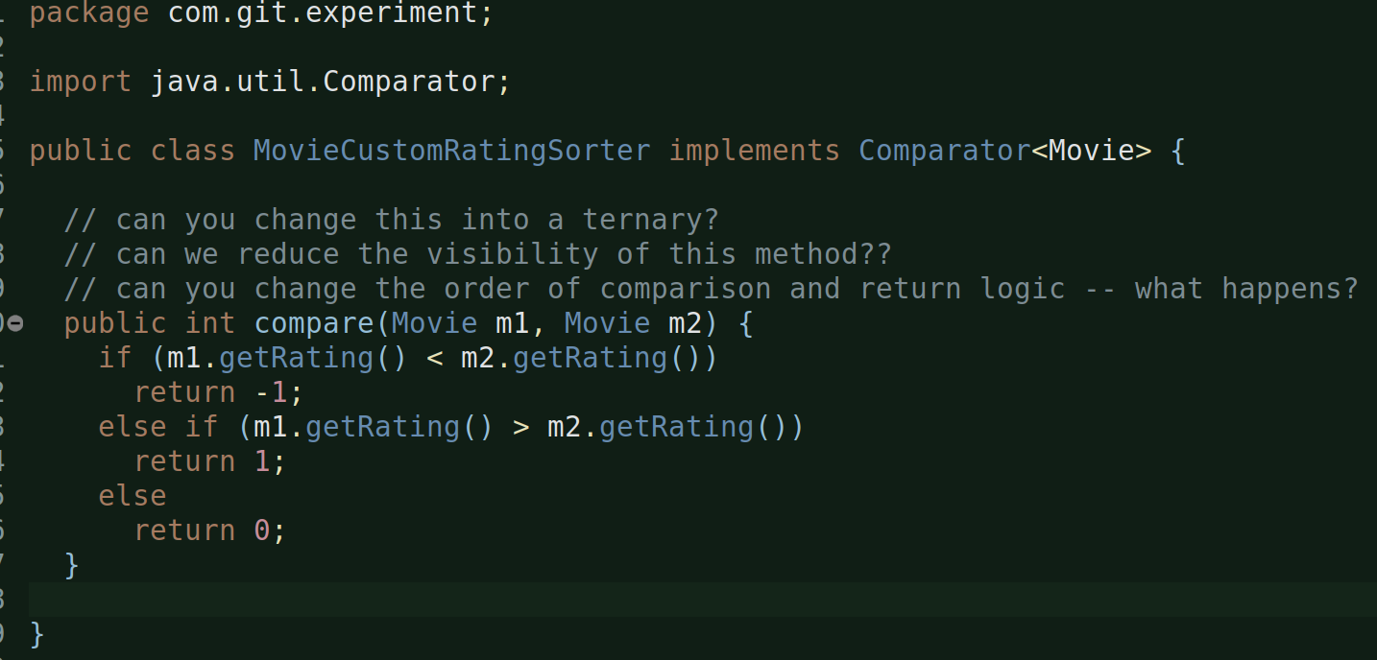
this class implements the Comparator and provides the impl for it’s compare method.

I have not yet added this class in the MovieSorter and MovieMain classes, meaning, this class currently does not get called anywhere. And, before I do that, I want to submit this as a pull-request to the origin project and look for their approval.

Let’s just check the current status in our cloned project:
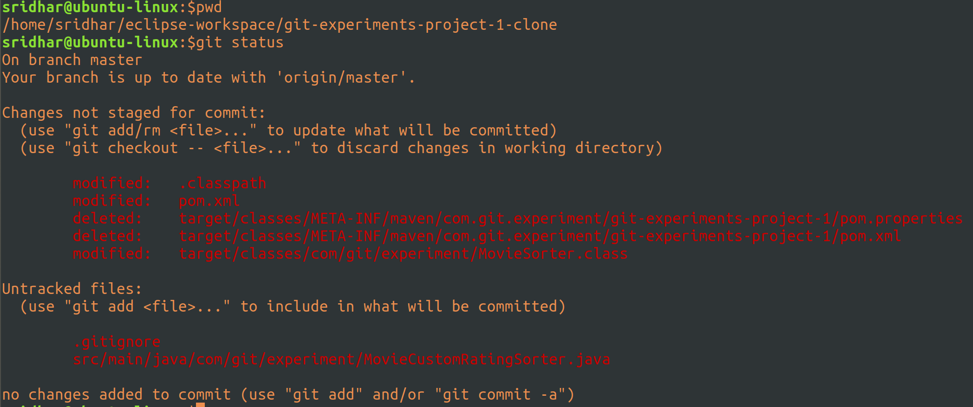
So, it says, MovieCustomRatingSorter, which we just created above is yet to be tracked and rightly so. And, also a .gitignore which needs to be tracked.

And, it says, pom file has been modified, rightly so, because we have modified the artifact id of this cloned project and hence it differs from the origin pom, let’s just try editing the pom in clone project to make it same as the origin one.
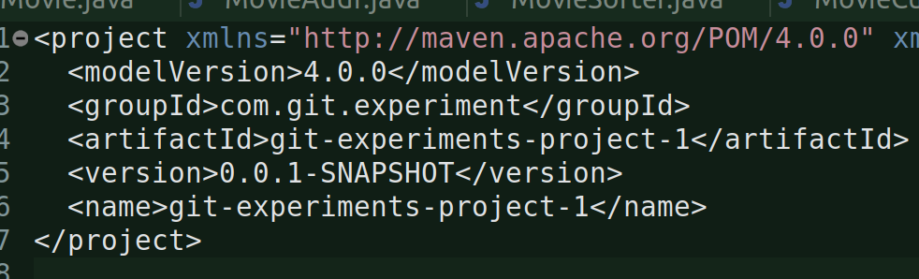
Ok, done. No errors.

We’ll now just stage and commit everything that is there in this clone:
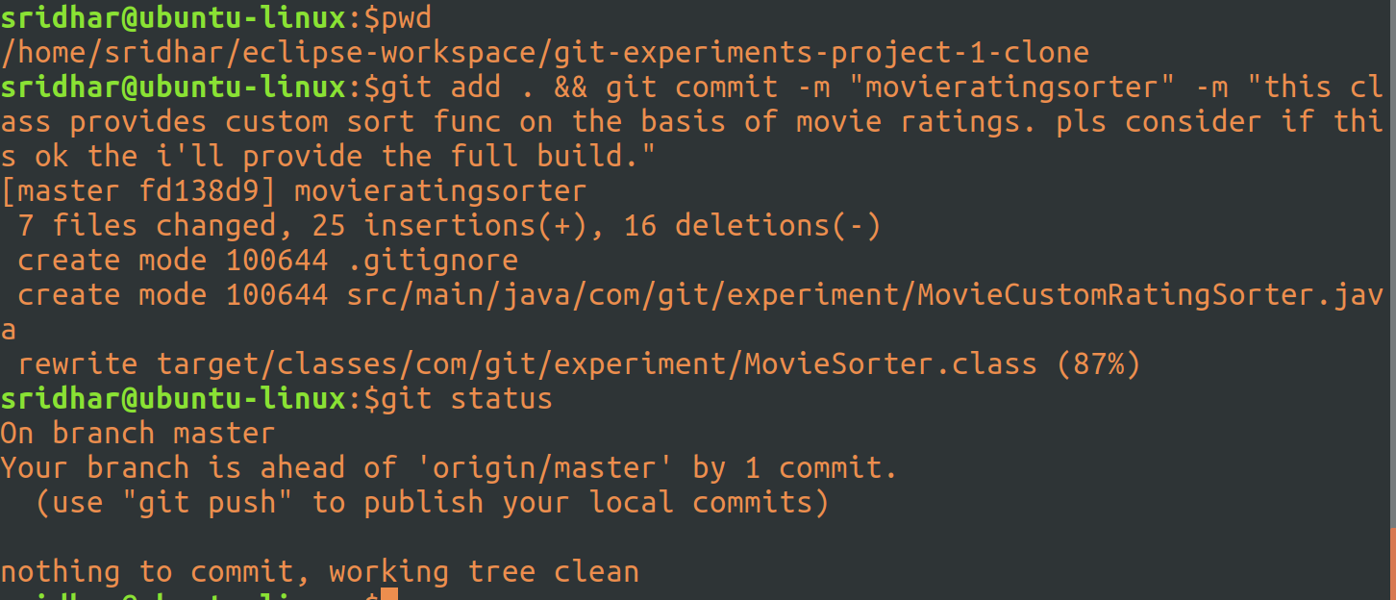
committed all and provided a good comment. Git status shows i’m ahead of the origin, rightly so, and wants me to push.

SO, I basically wanted to submit a pull request from clone to the origin but it seems to do that I first need to do a git push to the remote repo, in this case, the origin
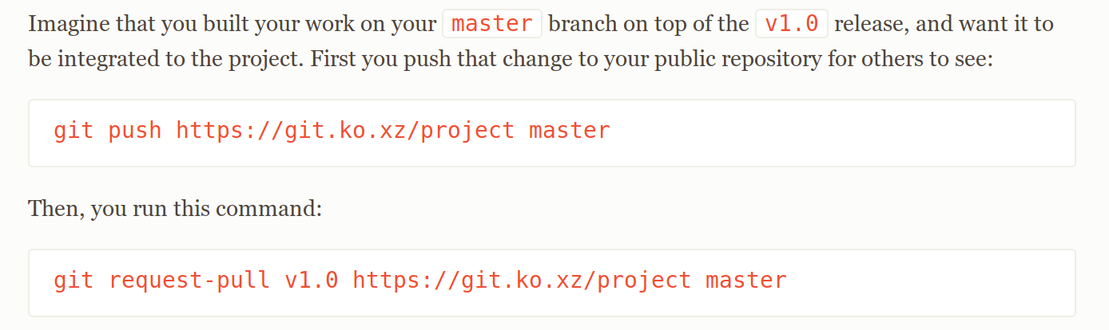
so I did that and I get this error:
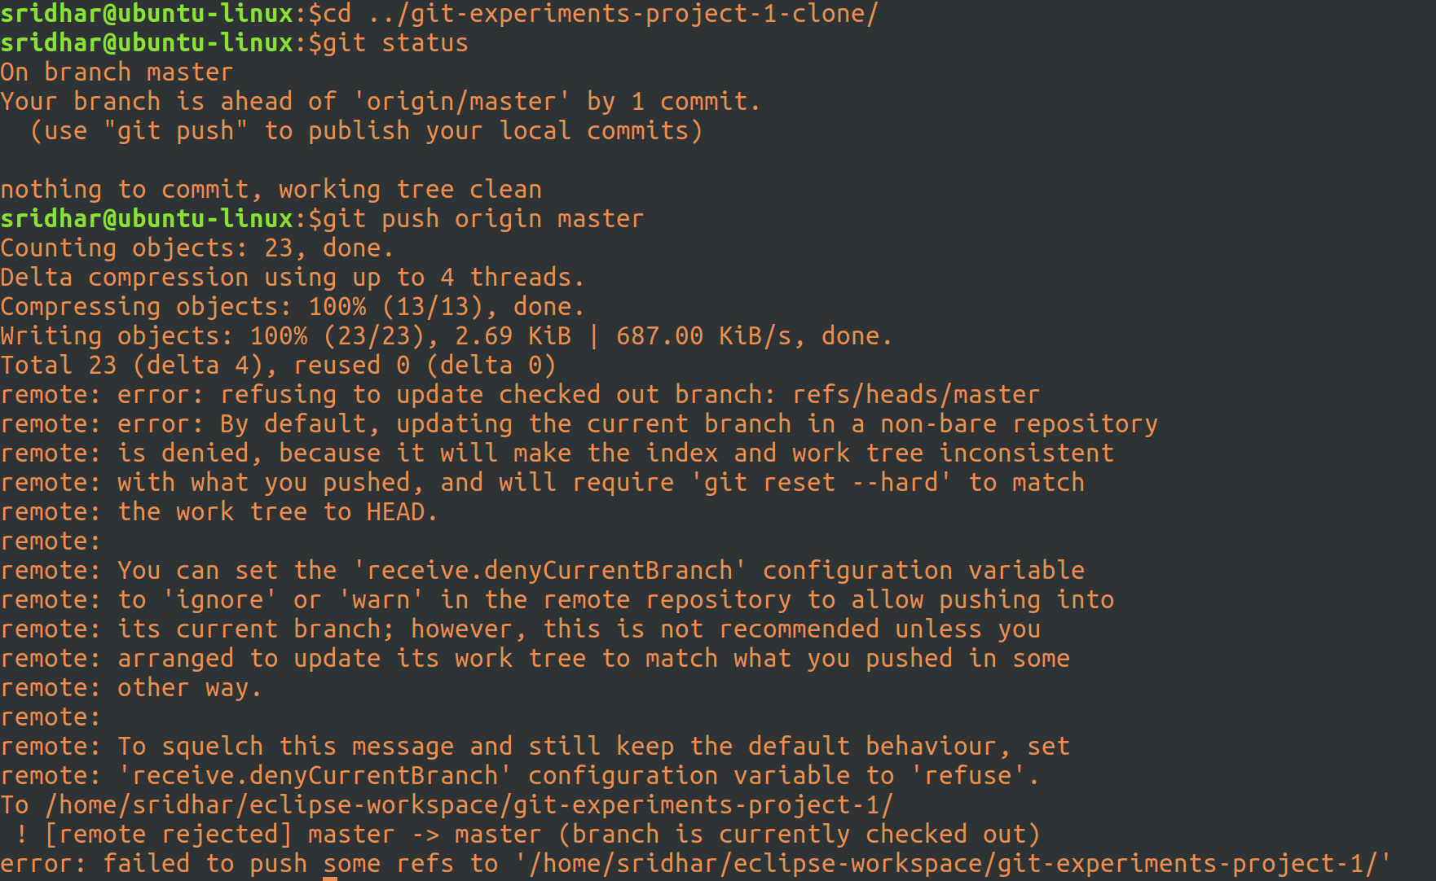
and it seems that it is not possible to do that unless that remote repo is a bare repo. This is a limitation amongst local repos, this is possible if your remote repo were on a github or something but not in the local system.

I mean it’s possible but then I need to do this at the origin:
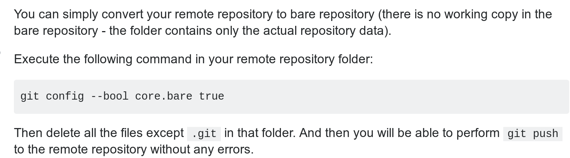
which I don’t want to.

so, I decided to call-off the pull-request submition part in local.

So, let’s just go ahead with a merge option:
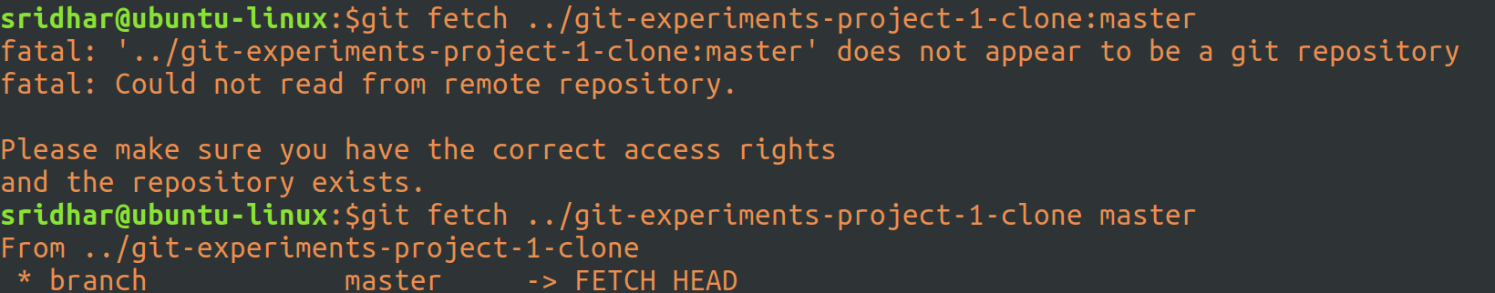
The first command above failed because syntaxt was wrong.
The second command did a fetch but I could not find where it did that.

Thing is, git fetch <from> <remoteBranch>:<localBranch> is the syntax, so in the above case, I just case the <from> and the <remoteBranch> but din’t mention the local branch name where the contents needs to fetched into so that it can reviewed by the origin owner.

Although, the above op. din’t fail, it din’t server my purpose of revieweing code either but anyways decided to merge the fetched stuff:
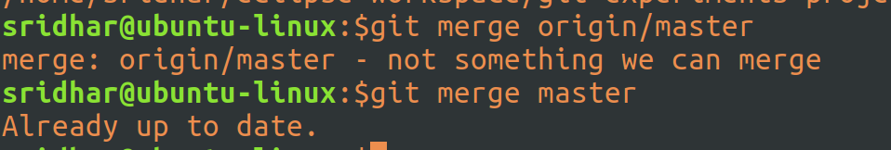
And that din;t work either, so I decided to do a fetch again, this time with the local branch mentioned as well:
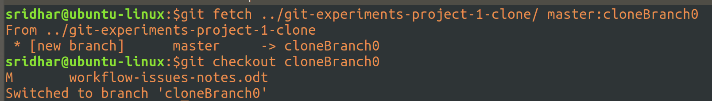
the above command fetches the code from the given url/location from it’s master to the local branch namedd cloneBranch0. This local branch will automatically be created.

And then I switched to cloneBranch0.

And, I can see the new class that was added as part of this fetch:
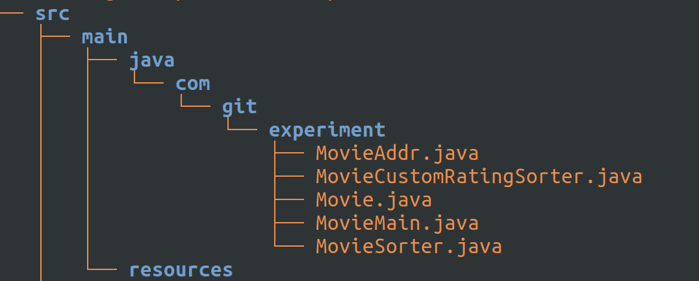
and did my code review of the submitted changes.

And, switched to master and merged the fetch from cloneBranch0:
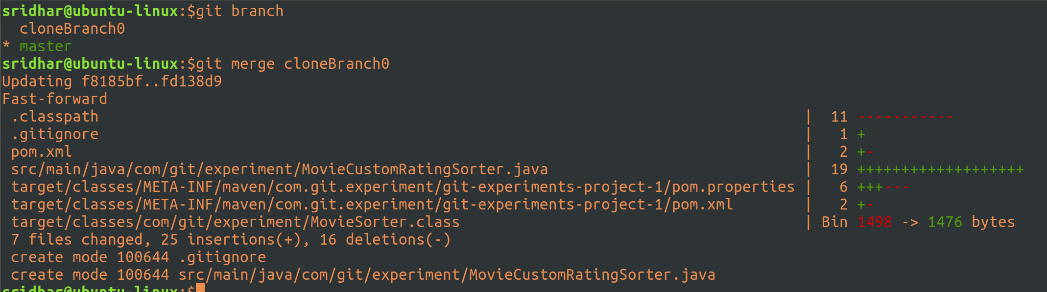
And, now I can see the newly added class in the master branch as well.
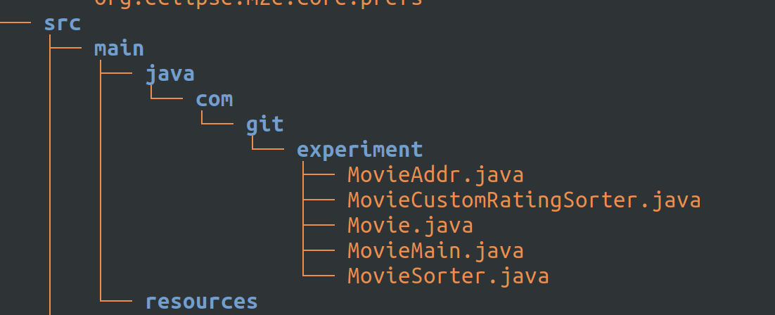

Okay, let’s now switch to the clone project and do a git pull, just to ensure that we have all the latest from master:
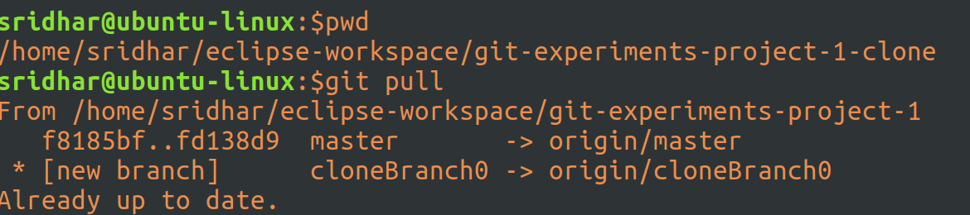
it says ‘Already up to date’ because there are no changes that were made at origin since we merged, so nothing to update here as well.

Okay, now let’s create a class to provide custom sort implementation on the basis of Box Office Collections:
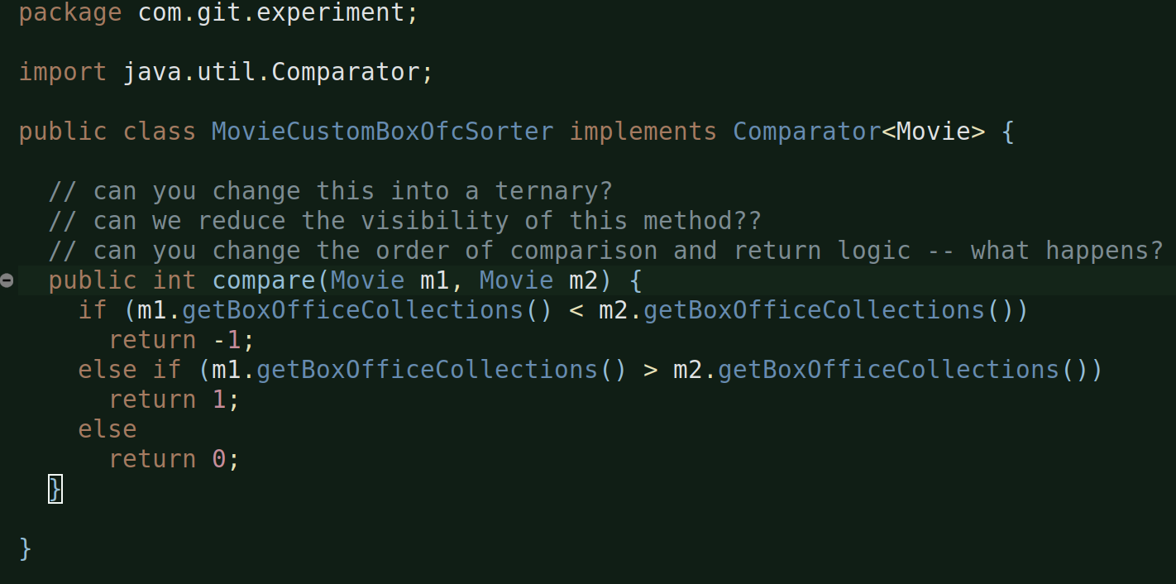
this class implements Comparator and provides the impl for its compare method.

Now, let’s call and use both the newly created MovieCustomBoxOfcSorter and MovieCustomRatingSorter in the MovieSorter class:
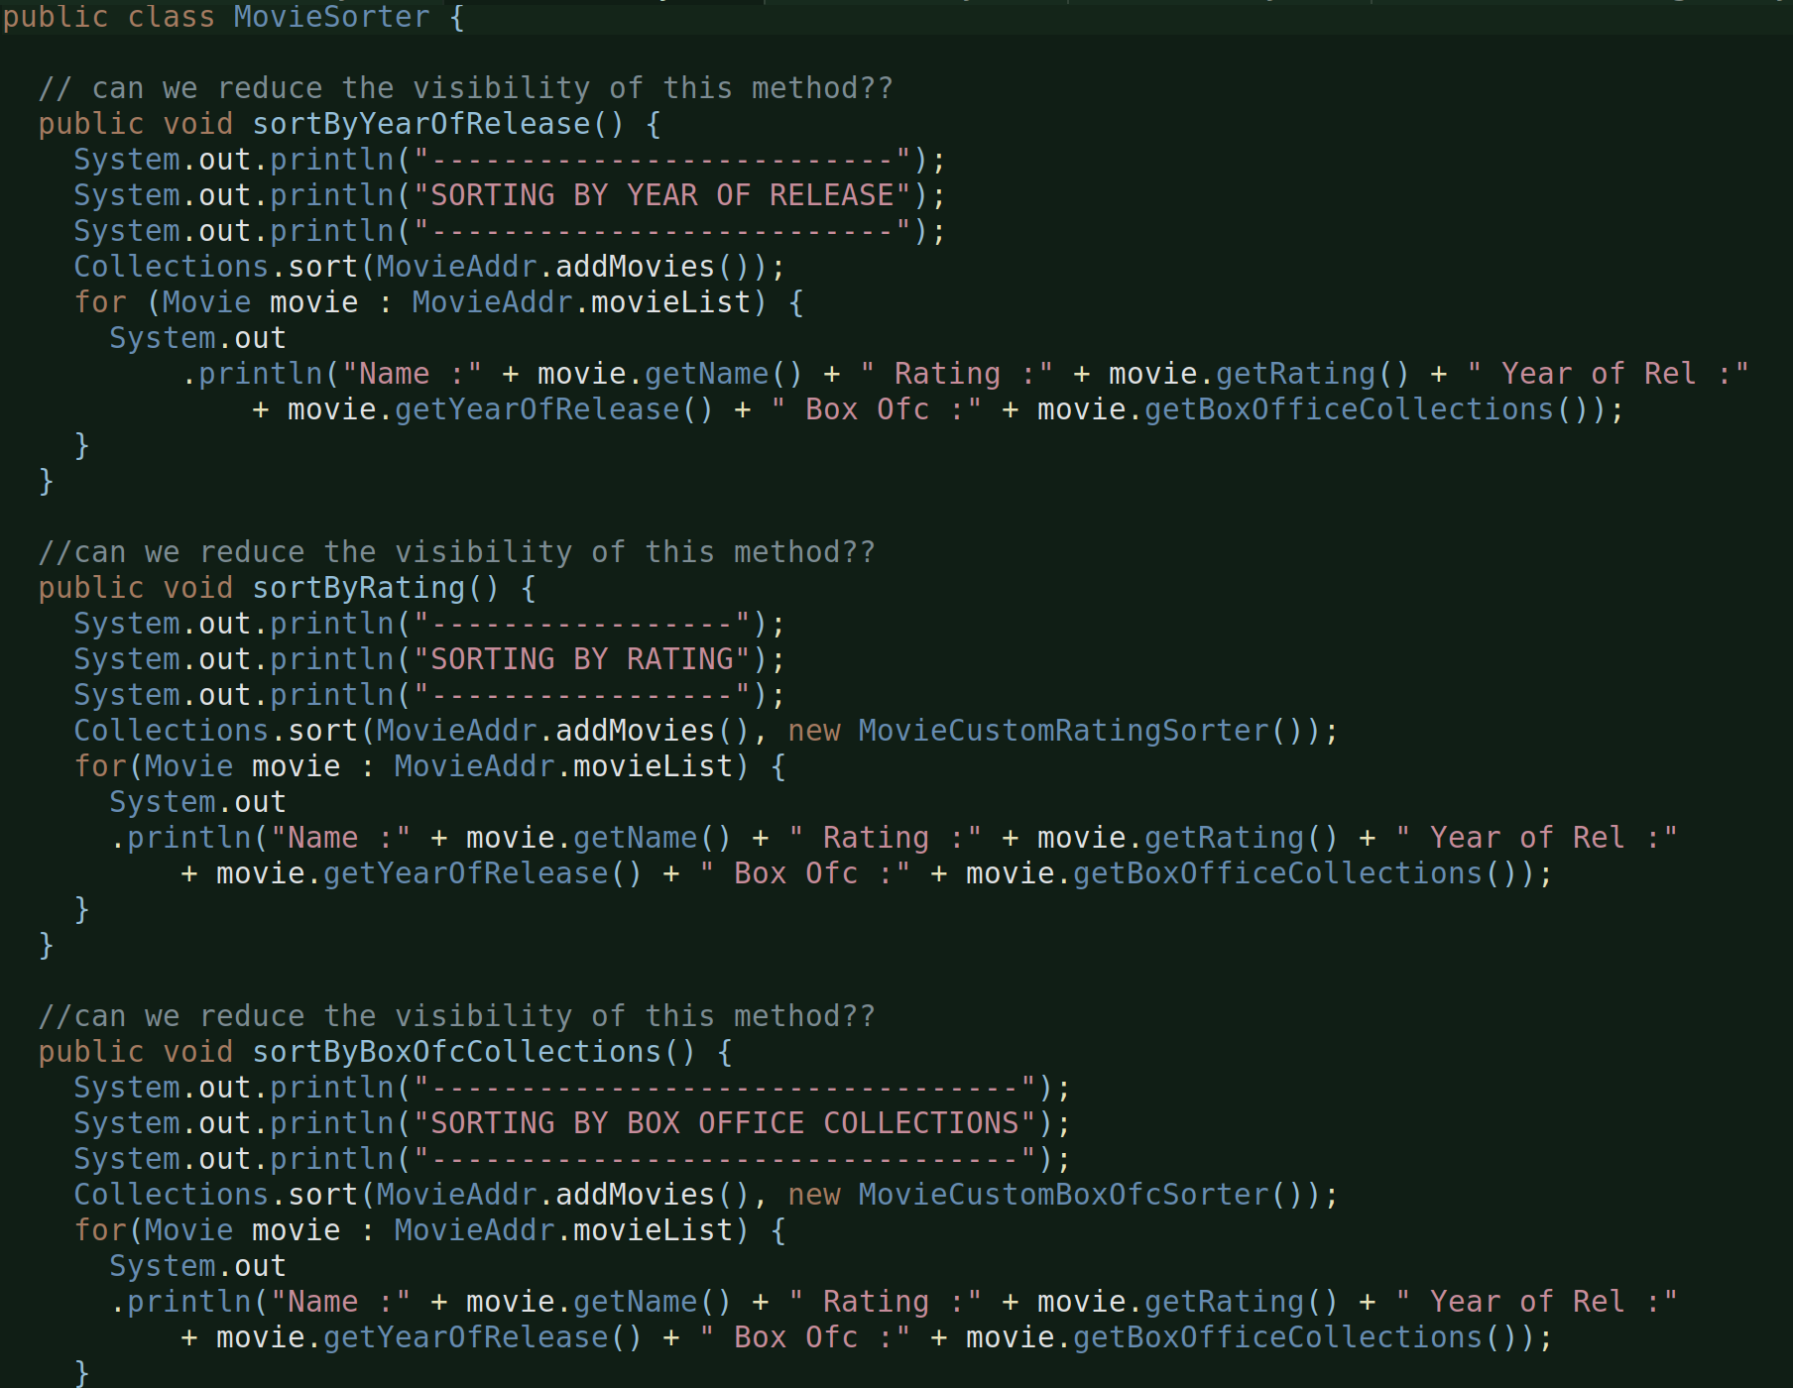
just like we previously impl sortByYearOfRelease(), we impl sortBYRating and sortByBoxOfcCollections as well. Only difference is, these two methods while sorting pass a Comparator since we are not sorting on the basis of natural ordering and using our custom sorters to gives the desired sort order.

And, then of course, we need to call these two methods from the main class:
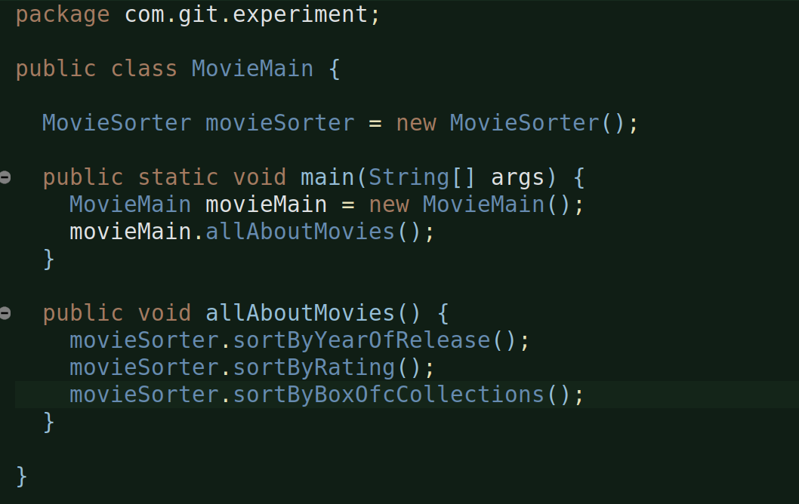
that’s it. Perfect. Tested and output as expected.

Let’s stage and commit the changes:
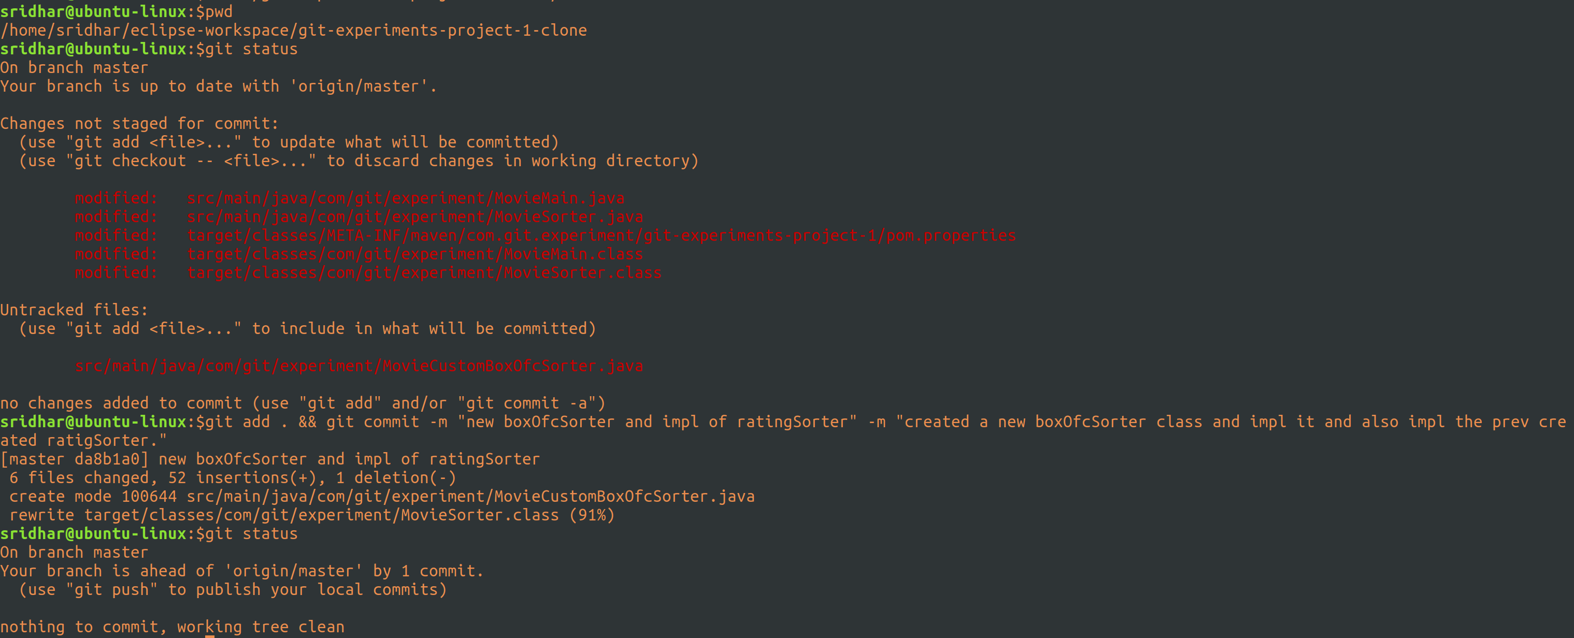
done.

Okay, so now, let’s create a branch in the origin project:
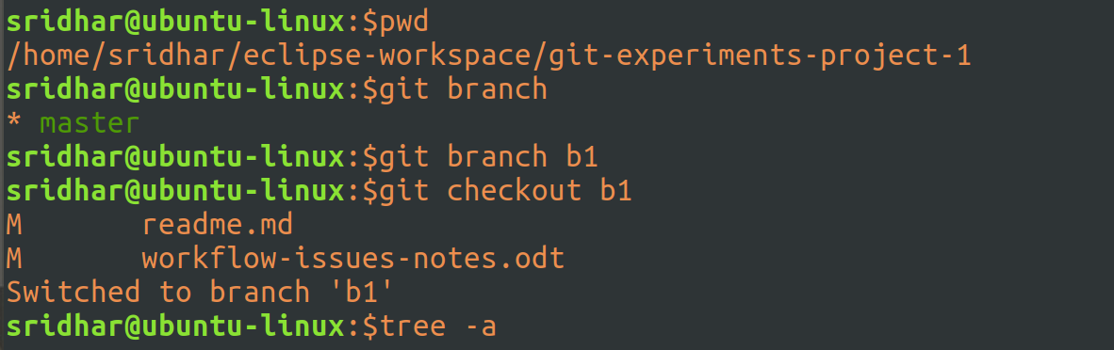
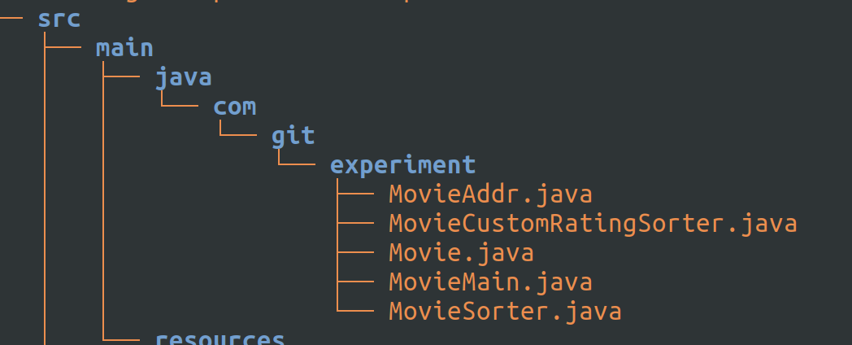
branch b1 created and switched to it and ran tree on it to ensure we have all master data (which we anyways will of course).

I did this because I did not want to merge stuff from the clone project directly into the master of origin for the fear of corrupting something which may be difficult to correct.

So, rather, I create a branch at origin, which will of course have everything that master has, now I will fetch the stuff from clone project into a remote branch and then I will merge the remote branch into branch b1. If everything goes well, will then test and if it’s found okay then I will merge this into master. This way master is almost kept clean.

Fetching stuff from master branch of clone project into remote branch on origin:
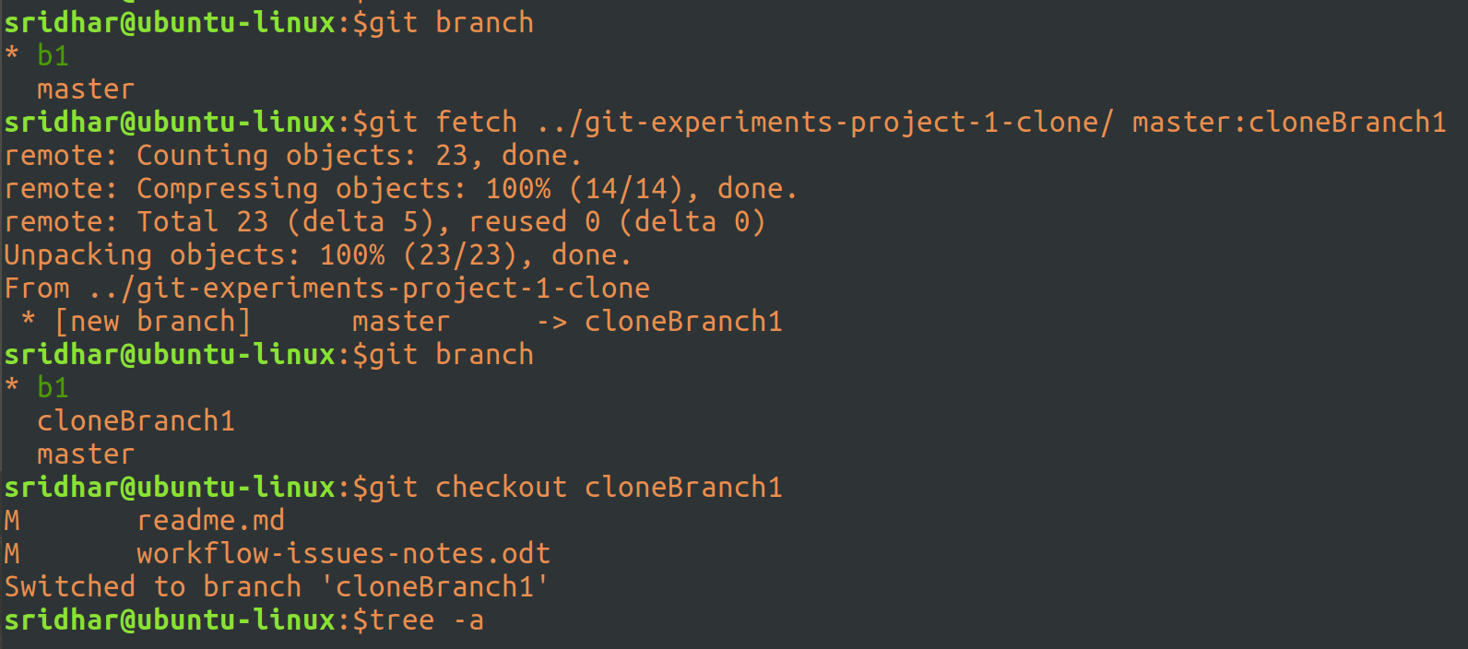
fetched the stuff from master branch of clone project into a remote branch ‘cloneBranch1’ of origin.

The branch ‘cloneBranch1’ will automatically be created and all committe stuff from clone project will be dumped into this branch.

Ran a tree on the branch ‘cloneBranch1’:
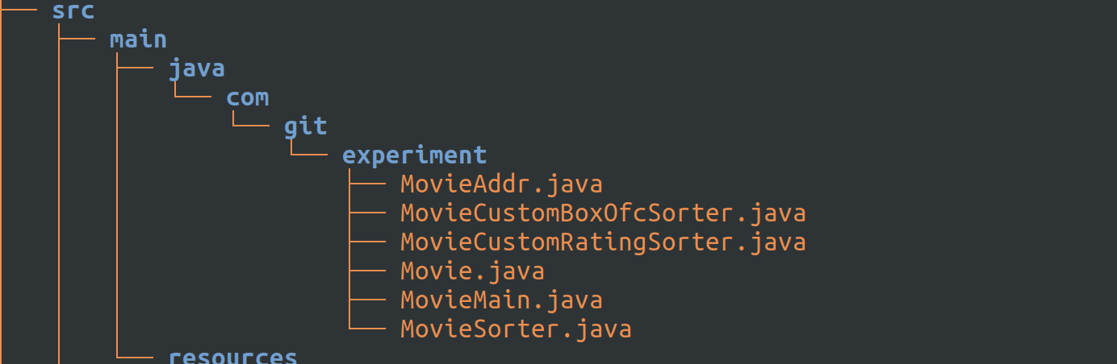
and I see all classes from the clone project. Perfect.

Let’s quickly switch to b1 and master branches and check the tree o/p there to ensure they don;t this data (yet), coz we have’t yet merged:
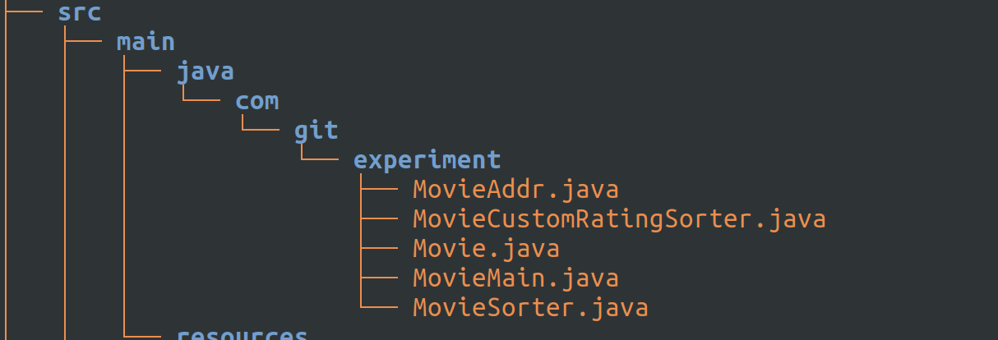
so both b1 and master have the same data and that is good.

Let’s now do a code review of what’s in the cloneBranch1 and to do that I will run gitk, which is an external utility which I installed and I am going to use it now:
as soon as I run the command I get a popup like this:
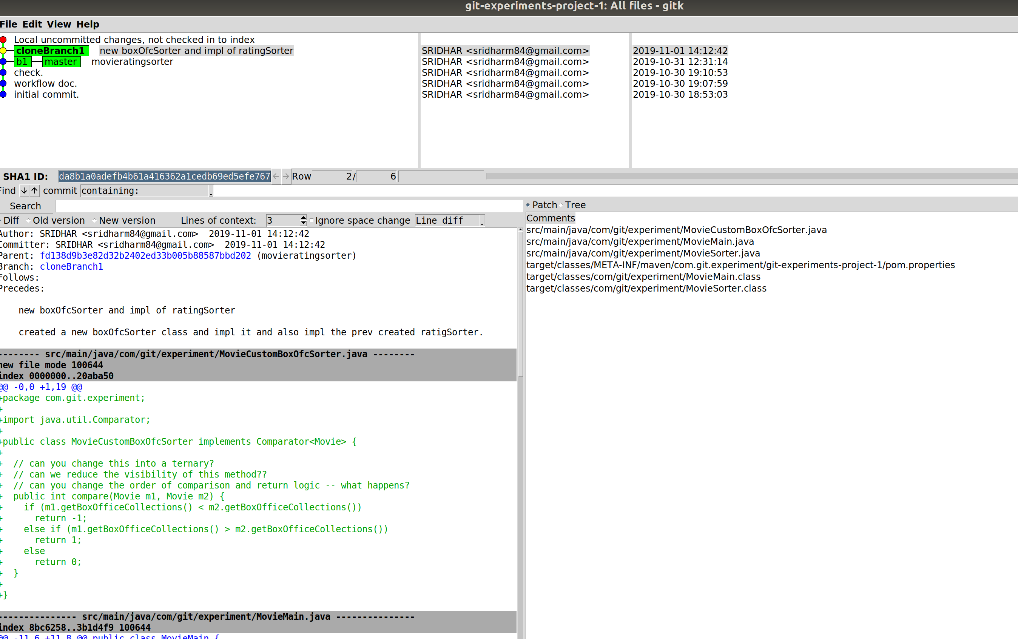
which basically shows me the diffs, old version and new version.

See the diffs, review code, deploy and run code and test it (of course, this part is not taken care by gitk, you have to do it yourself).

Now, let me merge the stuff from branch cloneBranch1 into branch b1:
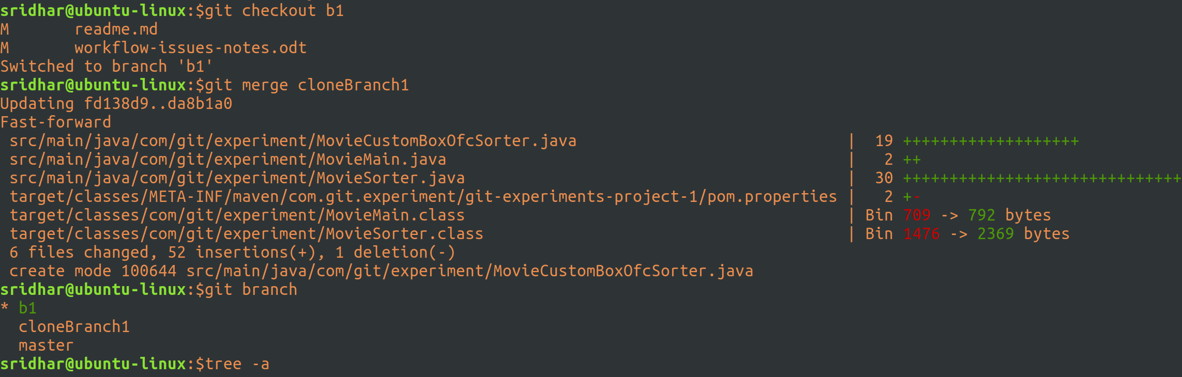
switched to branch b1 and then did a merge with cloneBranch1 branch, it was succesful.
And did a tree to ensure I have the new stuff in b1 branch:
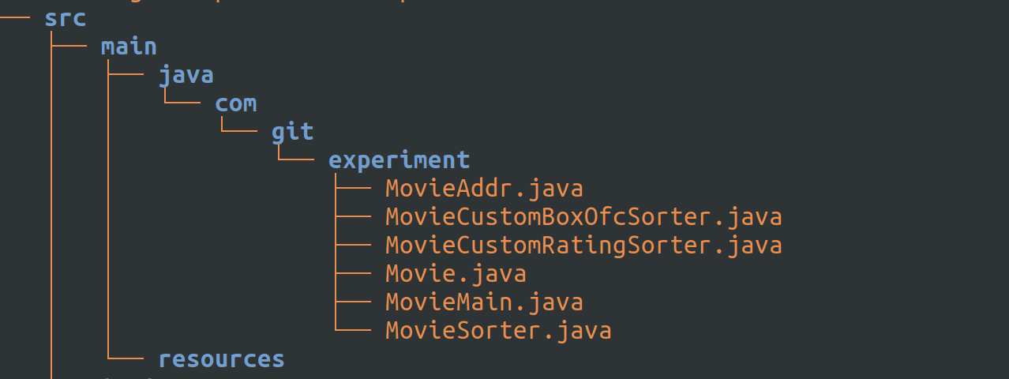
yup. All Fine.

Now I can get the code from b1 and test it and when satisfied I’d then merge this into master branch.

So, now the question is how can you download code from a branch?
Basically you have two options –
a.the first option is through an IDE like Eclipse.

And ensure you have this git eclipse plugin:
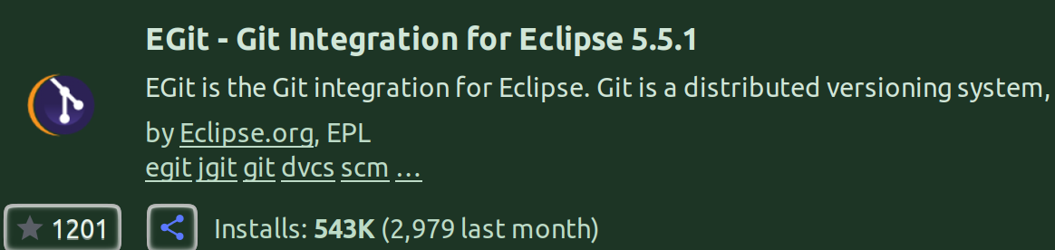
or maybe something similar, I am sure most will be able to do the job.

Now, the other thing to esnure here is to do a git checkout (from terminal) on the branch whose code you want to download, this is because when you import Git Projects from eclipse, it’ll only show those code branches which are currently checkedout.

And, since you checked out the branch, when you do a git import of project into eclipse, you’ll be getting the checkedout branches code.

b.the second option is to just clone the branch:
Yes, we can clone a branch:
the - - single-branch option is to clone just one branch and pass the name of the branch (which you want to clone) and from where and to where and with what name.

git clone –single-branch –branch=<remote_branch_name> <url> <dest_folder_name>

