[CODE REVIEW PLUGINS]

Since there are not many free full-fledged code review tools, I am using a combination of SpotBugs, CheckStyle and PMD to perform code review.

In reality, you generally integrate your code review tools in your CI/CD pipeliness and there are tols that do a code reveiew on your github pull-request/code but I couldn’t find any free to use self-hosted/plugins for code review.

Yet to look at SonarQube.

But most of these tools and plugins are commercial versions only.

[SPOTBUGS PLUGIN]

[] Before going with SpotBugs, I looked at many other plugins, like – PMD, CheckStyle and other free tools.

[] PMD is more for code equality and it cannot do any security vulnerability analysis.

[] CheckStyle is more for code styling.

[] SpotBugs is the only eclipse pluging, among the three, which ont only gives code quality inputs but also let’s us analyze code for security vulnerabilities.

[] There are other open source tools for security vulnerability analysis but they are mainly for web application. OWASP itself has a free open-source tool for the same.

[] Installed it from Eclipse Marketplace.

[] After installation and eclipse restart, you can navigate to Window -> Preferences -> Java -> SpotBugs to look at it’s default configuration and can configure it according to your needs:
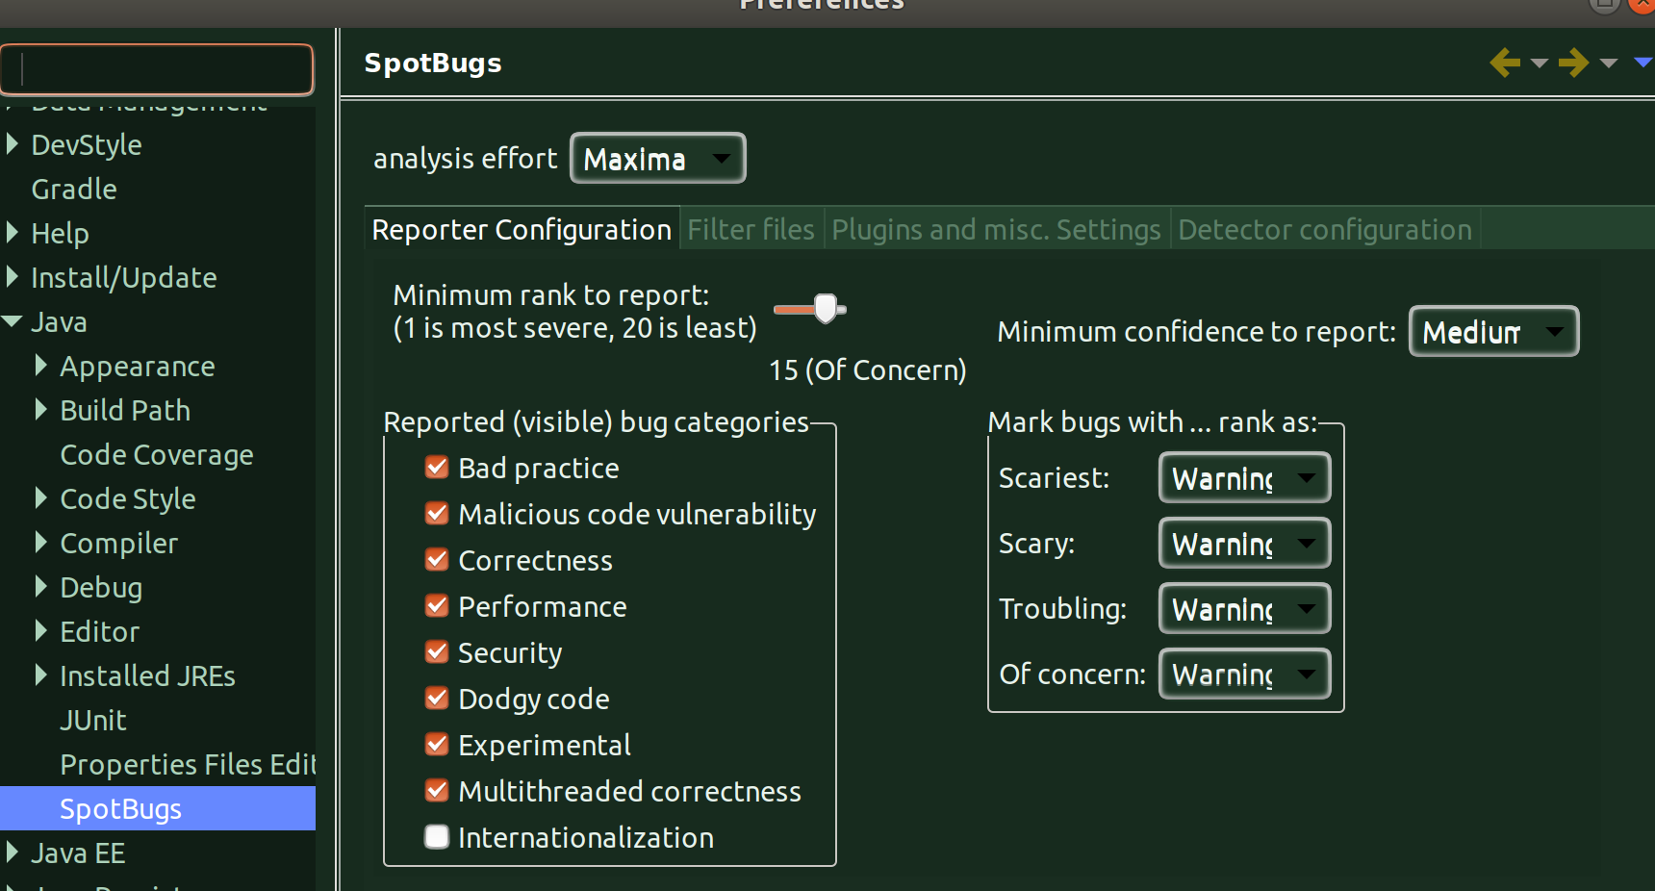

[ISSUE: You are going to run SpotBugs on a not compiled or partially compiled project]

[] When you try and run the SpotBugs check for a particular project or a class file you may encounter the below issue/error:

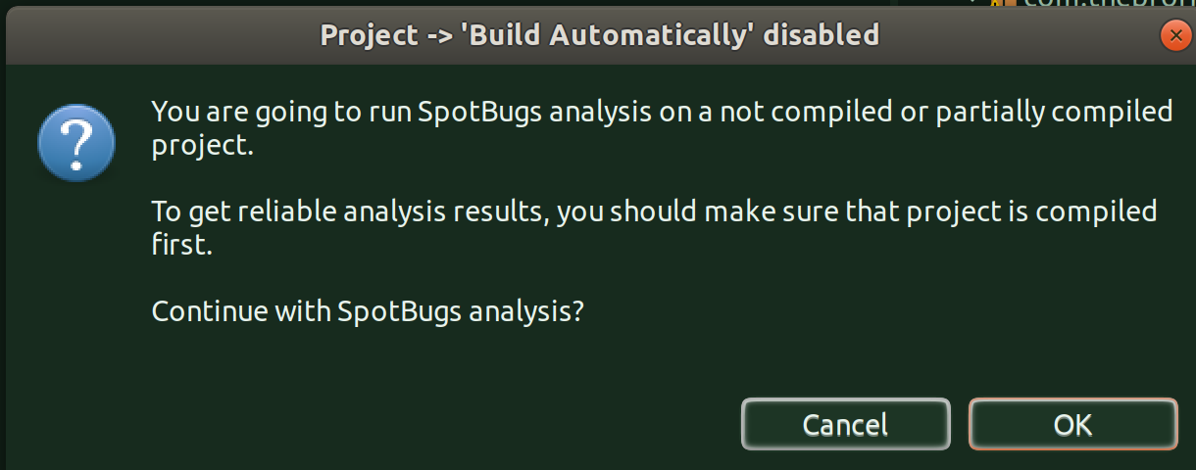
[] Solution:
[] You simply have to enable ‘Build Automatically’ option in the Project menu.
[] SpotBugs apparently needs source code compiled to run, so this option needs to be enabled.
[ISSUE: SpotsBugs not identifying any issues]:

[] At times, when you run SpotBugs, it may finish scanning but not display any issues this could be becuase of the configuration.

[] Then, go to Window -> Preferences -> Java -> SpotBugs and Minimum Rank to Report to 20 and Minimum Confidence to Report to Low
[] And, now rebuild your project and run it again, now if there are any issues at all, it’ll throw.

[Using SpotBogs to identify only Security vulnerabilities]:

[] You can configure SpotBugs to identify only security vulnerbailites also by configuring the Security option from Window -> Preferences -> Java -> SpotBugs, just check ‘Security’ and uncheck everything else.

[] Now, it’ll report only security vulnerabilies, if any.

[CHECKSTYLE SLOWNESS ISSUE]

CheckStyle performs code checkstyle, by default, against google code checkstyle template. And, it reviews one code file at a time and can’t link between files, so it always better to run it on a per file basis rather than running it in one go for the entire project.

And, if the LOC of a file is around 2k then Checkstyles considerably slows, as you can see from below and it takes around 8 minutes to generates the vioaltions.
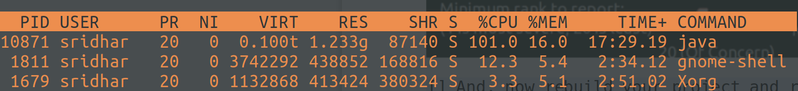
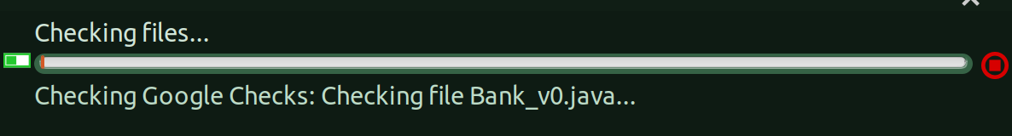
So, keep the LOC per file as less as posisble, when running checkstyle.

