[HOW JAVA PROFILERS WORK]

[] Profilers inspect the state of a JVM either by passively listening for events from the JVM or by actively querying the JVM for its state.

[] Profilers can also modify the bytecode of classes to add instrumentation code, like inserting a methodEntered and methodExit event at the beginning and end of a method or inserting an objectCreated event into a constructor.

[] There are lots of events that are generated by the JVM, and these can be categorized into two types: instant events and duration events. Instant events are one-time events that have a timestamp and the event data. Examples include exception events, class load events, and object allocation events.

[] Instant events let us know that something has occurred and can be reacted to or simply watched and analyzed.

[] Duration events have a start time and an end time and are therefore used to provide timing for some activity. Examples include garbage collection, which tells you the start and end time of garbage collection, monitor wait which tells you how long a thread waited on an object, and monitor contended, which tells you how long a thread was waiting on a lock to be released.

[] In addition to the generated events, the JVM also has profiling functions that return data about its internal state. Some commonly used ones are the thread functions like GetThreadState and GetAllThreads, and the stack trace functions like GetStackTrace and GetAllStackTraces. This internal state data is queried periodically by the profiler in a process known as sampling and the sampling period is how often the functions get called to fetch the data. For example, every 20 milliseconds.

[PERFORMANCE ANALYSIS USING JAVA PROFILERS]

[] When analyzing application performance, there are a number of profiling activities that are commonly performed by programmers and analysts. These include CPU profiling, memory profiling, and thread profiling. In some cases, depending on the type of application, I/O Profiling becomes important as well, but the majority of applications are most concerned with the aforementioned 3.

[CPU Profiling]:
[] CPU profiling is primarily concerned with the frequency and length of time of method execution. With CPU profiling, you can find out what methods run the most frequently, therefore, eat up the most CPU time. These are commonly referred to as "hot methods." This gives you an indication of what methods or areas of the code you should focus on optimizing.

[] There are two ways in which CPU profilers get method execution information; by sampling or by instrumentation.

[] Sampling Profilers:
[] Sampling profilers work by periodically querying the JVM for all the running threads and getting the stack trace for each thread. It then determines what method each thread was executing when the sample was taken and compares the samples to determine how much time was spent in that method.

[] Profiling by sampling has the least amount of overhead and is, therefore, suitable for production use. However, because it's an indirect way of measuring method execution, it can be error-prone or inaccurate depending on the execution flow of the application and how often the profiler samples.

[] To minimize sampling errors, your options are to profile over a longer period of time, reduce the interval between samples, or both. However, reducing the interval between samples results in increasing the overhead on the JVM, therefore, there's a trade-off that has to be made between accuracy and overhead.

[] Instrumenting Profilers:
[] Instrumenting profilers work by modifying the application's bytecode and inserting code for counting invocations or timing methods. This makes them more accurate in determining method invocation counts and potentially more accurate in determining method timing.

[] However, instrumenting application bytecode has a higher potential for introducing performance differences for two reasons. One is that the instrumentation code will likely have some overhead attached to it and the other is that; depending on how the instrumentation is done there may be some optimizations that could have been applied to the non-instrumented code that can't be applied to the instrumented code.

[Memory Profiling]:
[] The next common profiling activity is memory profiling. Memory profiling is primarily concerned with understanding what objects are using up memory and how memory is being freed by garbage collection.

[] With memory profiling, you can monitor the memory usage of your class objects over a period of time, find out what objects are growing and shrinking in size, and where in your code these allocations are taking place. You can also analyze garbage collections. You can see the number and types of garbage collections that have occurred, the length of the pause times for each garbage collection, and how much memory they were able to free.

[Thread Profiling]:
[] The third common profiling activity is thread profiling. Thread profiling is primarily concerned with understanding what states threads are in and why.

[] With thread profiling, you can see if your threads are able to run in parallel or not, find out what how much time your threads spend sleeping, waiting, blocked, or executing, and find and analyze cases of high lock contention.

[] Thread profiling is useful when your application is not as performant as it should be yet its CPU usage is low. In this case, your application performance could be hindered by locking, and thread profiling helps you find that out.

[TYPES OF JAVA PROFILERS]

[JVM Profilers]:
[] Great for debugging tasks and tracking down memory leaks
[] Show a large amount of details — but relevance may depend on debugging task

[] Features:
[] Tracking all the JVM details (CPU, threads, memory, garbage collection)
[] Track all method calls with memory usage and and allow dive into the call structure
[] Track details of all memory usage with responsible classes/objects
[] CPU sampling feature to track and aggregate CPU time by class and method to help zero in on hot spots
[] Allow to manually run garbage collection and review memory consumption (great way to find classes and processes that are holding on to memory in error)

[] Implementation Details:
[] A direct connection to the JVM is used (not favorable in production use)
[] May slow down the application or require downtime (not favorable in production use)

[] Examples:
[] VisualVM, JProfiler, YourKit, Java Mission Control

[Transaction Profilers]:
There are 2 types of implementations for Transaction Profilers.

[] Aspect Profilers:
[] Use aspect-oriented programming (AOP) to inject code into the start and end of specified methods (the injected code can start a timer and then report the elapsed time when the method finishes); Simple to set up; Need to prior knowledge/guessing on what to profile

[] Agent Profilers:
[] Use Java Instrumentation API to inject code into the application; Have in-depth access to application since the code is being rewritten at the bytecode level — allowing for any code running in application (written by us or came from 3rd party libraries) to be instrumented; More complicated to write

[] Examples:
[] XRebel, Stackify Prefix

[APM Tools]:
[] Great for monitoring applications live in production environments
[] Show a less amount of details (with aggregations and sampling) — but mostly the right information which are smartly selected to have high relevance to common performance concerns

[] Implementation Details:
[] Use the Java Agent profiler method but with different instrumentation rules to allow them to run without affecting performance in productions.

[] Examples:
[] AppDynamics, Stackify Retrace, New Relic, Dynatrace

[LIST OF POPULAR COMMAND-LINE JVM PROFILERS]

[jstat]:
[] Command line tool shipped with standard JDK (no installation/setup process)
[] Useful for monitoring JVM memory, heap sizing, and garbage collection activity using command line
[] Uses the built-in instrumentation in JVM, which is enabled by default (no need to start JVM with special commands)
[] Identify the target Java process using virtual machine identifier (VMID)
[] If you want only the current status of memory usage (instead of monitoring), use jmap

[] Using jstat:
[] Run your Java program with some predefined performance constraints

java -Xmx120m -Xms30m -Xmn10m -XX:PermSize=20m -XX:MaxPermSize=20m -XX:+UseSerialGC AwesomeJavaProgram

[] Obtain the process id

ps aux | grep java

[] Run jstat with -gc option on terminal to start monitoring JVM Heap Memory usage

jstat gc <pid> <timeinterval-between-each-output>

[jmap]:
[] Command line tool shipped with standard JDK (no installation/setup process)
[] Useful for printing out current memory-related statistics (heap summary, histogram of java object heap, class loader statistics, information on objects awaiting finalization, dump java heap in hprof binary format) for a running VM or core file
[] Specially helpful to inspect underlying configurations and algorithms
[] Recommended to use the latest utility, jcmd (since JDK 8) instead of jmap utility, for enhanced diagnostics and reduced performance overhead
[] If you want to monitor memory usage (instead of current usage), use jstat

[] Using jmap to JVM heap details: jmap –heap <JAVA_PID>[]

[] Using jmap to create a heap dump: jmap –dump:file=<FILE> <JAVA_PID>

[jcmd]:
[] Command line tool shipped with standard JDK (no installation/setup process)
[] Useful for send diagnostic command requests to the JVM

[] Using jcmd to create a heap dump:

jcmd <JAVA_PID> GC.heap_dump filename=<FILE>

[jhat]:
[] Command line tool shipped with standard JDK (no installation/setup process)
[] Useful for browsing the object topology in a heap snaphot (a.k.a. heap dump)
[] Replaces the Heap Analysis Tool (HAT)
[] Parses a heap dump in binary format (e.g. a heap dump produced by jcmd)
[] Can help debug unintentional object relation (Java language equivalent of a memory leak — an object that is no longer needed but is kept alive due to references through some path from the rootset)
[] e.g. 1) an unintentional static reference to an object remains after the object is no longer needed
[] e.g. 2) an observer or listener fails to unregister itself from its subject when it is no longer needed
[] e.g. 3) a thread that refers to an object does not terminate when it should

[] Using jhat to analyze a heap dump: jhat <HPROF_FILE>

[hprof]:
[] Command line tool shipped with standard JDK (no installation/setup process)
[] Useful for heap and CPU profiling when analyzing performance, lock contention, memory leaks and other issues
[] Works as a dynamic-link library (DLL) that interfaces with the JVM using the Java Virtual Machine Tool Interface (JVMTI)
[] Writes profiling information either to a file or to a socket in ASCII or binary format
[] Can report CPU usage, heap allocation statistics, complete heap dumps and states of all the monitors and threads in the JVM, and monitor contention profiles

[] Implementation Details:
[] HPROF instructs the JVM to send it the relevant events depending on the type of profiling requested
[] The tool then processes the event data into profiling information
[] By default, heap profiling information is written out to java.hprof.txt (in ASCII) in the current working directory

[] Using hprof to profile a class:
java –agentlib:hprof ToBeProfiledClass

[] Using hprof to obtain heap allocation profile:
javac –J-agentlib:hprof=heap=sites Hello.java
[] This shows the amount of allocation that occurs in various parts of the program.

[] Using hprof to create a heap dump:
[] javac –J-agentlib:hprof=heap=dump Hello.java
[] This consists of the root set as determined by the garbage collector, and an entry for each Java object in the heap that can be reached from the root set.

[] Using hprof to collect CPU Usage:
[] javac –J-agentlib:hprof=cpu=samples Hello.java
[] Here the HPROF agent periodically samples the stack of all running threads to record the most frequent active stacktraces.

[LIST OF POPULAR JVM PROFILERS WITH GUI]

[Java VisualVM with Visual GC Plugin]:
[] GUI tool shipped with standard JDK (no installation/setup process)
[] Useful for monitoring CPU sampling, memory sampling, run garbage collections, analyze heap errors, take snapshots and more using GUI
[] Can develop new functionalities as plugins
[] Supports local and remote profiling (does not provide support for ssh tunneling, need to configure JMX ports for remote profiling)
[] Can take snapshots of profiling sessions for later analysis
[] Relies on other standalone tools provided in the JDK, such as JConsole, jstat, jstack, jinfo, and jmap

[Java Flight Recorder JFR and Java Mission Control JMC]:
[] Complete tool chain to continuously collect low level and detailed runtime information enabling after-the-fact incident analysis
[] JFR — profiling and event collection framework built into the Oracle JDK, gather detailed low level information about JVM and application
[] JMC — advanced set of tools that enables efficient and detailed analysis of the extensive of data collected by JFR

[Jprofiler]:
[] Top (paid) choice for many developers
[] Includes almost all the features in VisualVM (viewing system performance, memory usage, potential memory leaks, and thread profiling), but the UI is more intuitive and friendlier to use
[] Profiling remote applications
[] Advanced profiling for both SQL and NoSQL databases
[] Call tree of interactions with our database and connections that may be leaked
[] Live memory usage for object declarations and instances or for the full call tree
[] Navigate from snapshot to source code

[YourKit]:
[] Top (paid) powerful choice for many developers
[] Include core features like in VisualVM and JProfiler (visualizing threads, garbage collections, memory usage, and memory leaks, with support for local and remote profiling via ssh tunneling)
[] Profile thrown exceptions
[] Powerful CPU profiling feature that allows focused profiling on certain areas of our code such as methods or subtrees in threads
[] Allows for conditional profiling through its what-if feature
[] Profile SQL, and NoSQL database calls

[LIST OF POPULAR TRANSACTION PROFILERS]

[Stackiy Prefix]:
[] Developer-oriented Java Profiler
[] Use Java Agent profiling method
[] Have prior knowledge on the most desired classes and 3rd party libraries developers want to be instrumented
[] e.g. 1) When running an application using Hibernate, Prefix will not only detail out the elapsed time for queries but also displays parameter values for the generated SQL
[] e.g. 2) When your app calls to a SOAP/REST API, Prefix provides the request and response content
[] Cost: FREE
[] There is no linux and macOS version available, as of now only windows.

[Xrebel]:
[] Provides real-time feedback on application performance in local development (made for the developer, not for the operations-analyst)
[] Supports many developer-level profiling needs, great tools for debugging tasks

[LIST OF POPULAR APM TOOLS]

[New Relic]:
[] Top (paid) choice for many developers
[] Great set of features for enterprise-grade production use
[] Cost: $75–600 per month per server, cheaper annually

[AppDynamics]:
[] Considered as an application intelligence platform
[] Covers from data collection to processing, monitoring, and deriving insights and knowledge
[] Great set of features for enterprise-grade production ease
[] Cost: $230 per month per server

[Stackify Retrace]:
[] Provides method-level visibility to application code that is running in production
[] e.g. A slow web request will translate into a trace and from there the problematic methods can be searched
[] Underlying tech is similar to Stackify Prefix (Transaction Profiler version from the same vendor), but adjusted to run smoothly in staging and production environments
[] Cost: $25–50 per month per server, $10 for non-production

[Dynatrace]:
[] First self-learning Application Performance Monitoring Software (take some time to learn)
[] Not only a performance tool, provides auto-discovered topology visualizations of applications and their components
[] Performance issues in web-scale applications discovered with artificial intelligence
[] Cost: $216 per month per server for SaaS version

[SUMMARY]
[] Standard JVM Profilers and Transaction Profilers are great choices for debugging tasks in development, while APM Tools are the choice for monitoring tasks in production
[] For not-so-large firms, APM Tools can be an overpriced solution to digest (e.g. purchasing a $200-per-month-per-server APM subscription for a $100-per-month AWS server. Wow, seriously?). I would recommend you to start with free tools and go for advanced tools only when you have a real use case.
[] People who performance test their application using multiple profilers tend to find more performance issues than just using one

[INSTALLING JAVA VISUALVM and USAGE]

[] To profile further I needed an professional profiling tool and java visual vm which comes naturally along with the java jdk was the obvious choice for me.

[] But what comes by default with the java jdk does not have GUI to it and it does not really help, so I had to download the eclipse plugin for it.

[] The installation of the plugin is easy, I just followed all the steps from this url: https://blog.idrsolutions.com/2013/05/setting-up-visualvm-in-under-5-minutes/

[] And below is the snapshot of my visvual vm final configuration in eclipse:

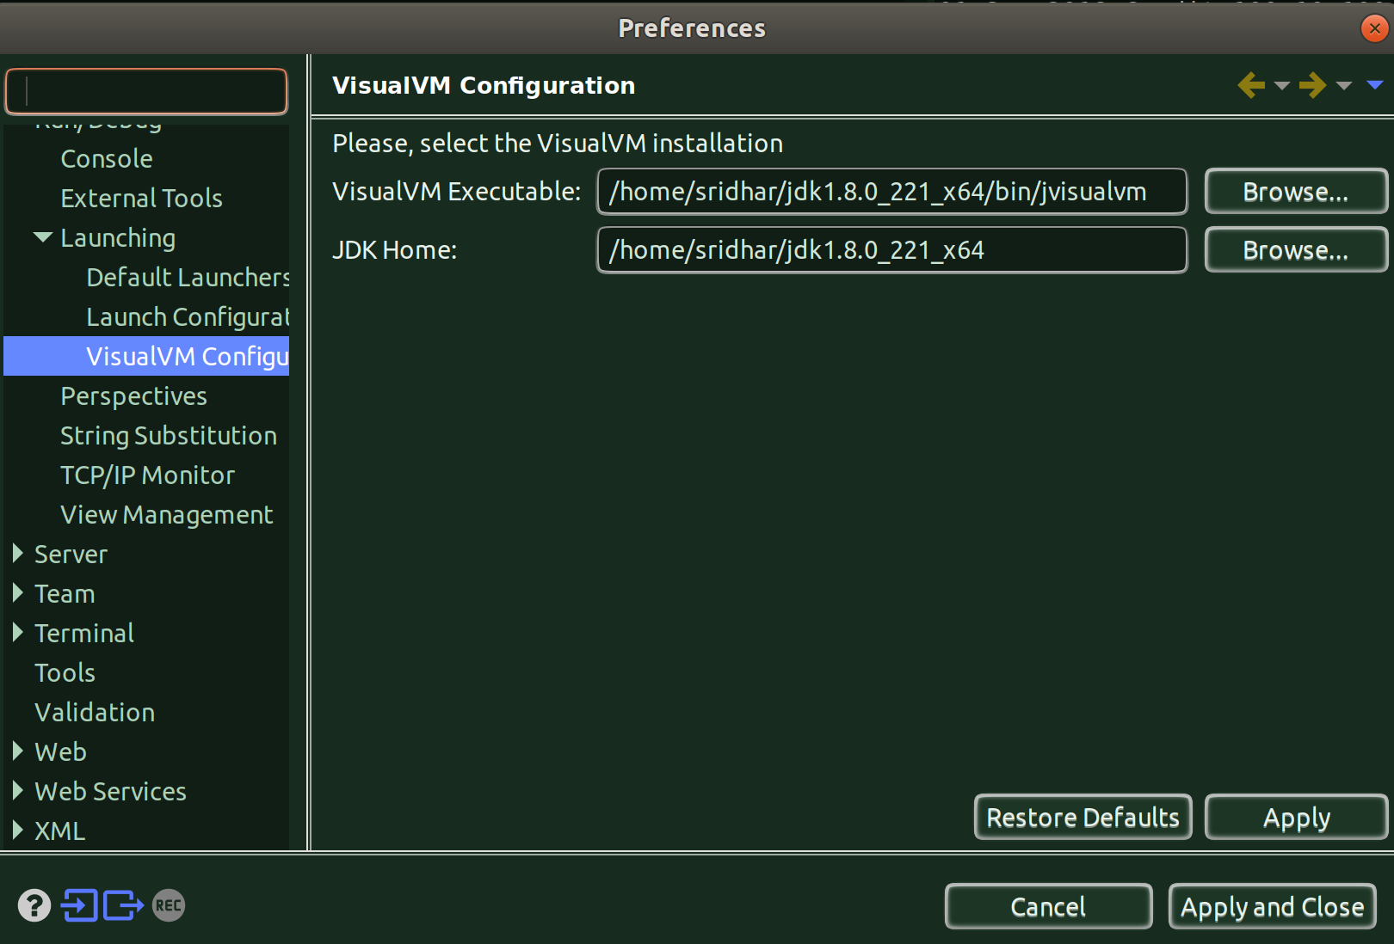

[Running]:
[] You can run it in two ways, you can either run by setting a breakpoint or setup a sleep i.e. a Thread.sleep for say 100 secs, because otherwise if the program is too small, the java visualvm won’t pick up.

[] And, the visual vm gets triggered only when you are running the application in debug mode. Because that is how we have set it up as per the instructions in the url above. We can configure it to get it run even in the normal run mode but that will become a headache everytime you want to just run the program w/o wanting to profile anything.
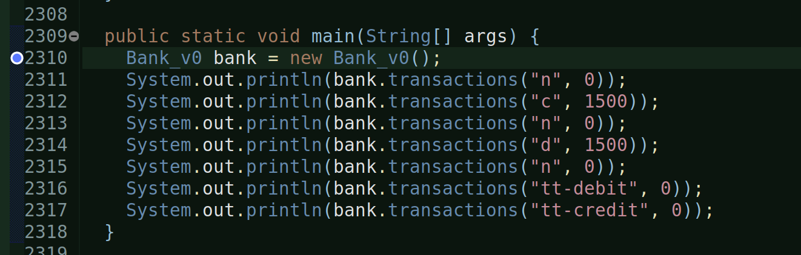
[] As you can see from the above image, I have used a breakpoint, that is where the execution halts and it gives the time for the visual vm to start.

[] Now, lets run the program in debug mode.

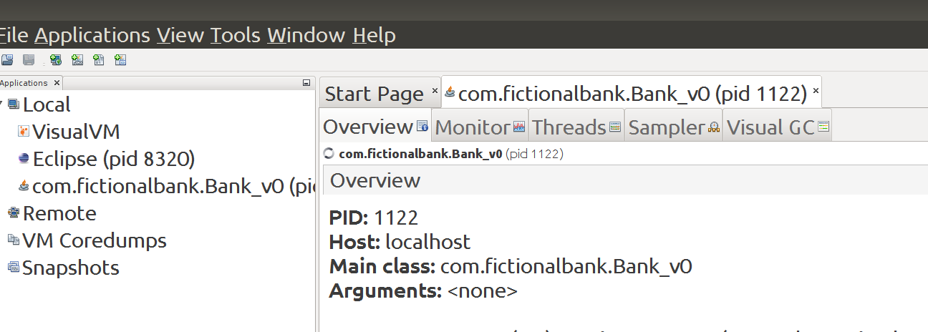

[] And as you can see from the above image, the profiler gets triggered and it captures the program.

[] You go to Profiler and hit on ‘Memory’ and it starts capturing:

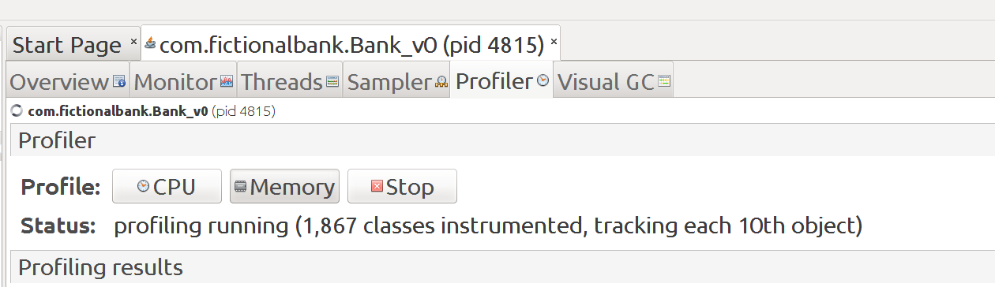
[] Now, you go back to eclipse and resume the program execution (because it is waiting at the breakpoint).

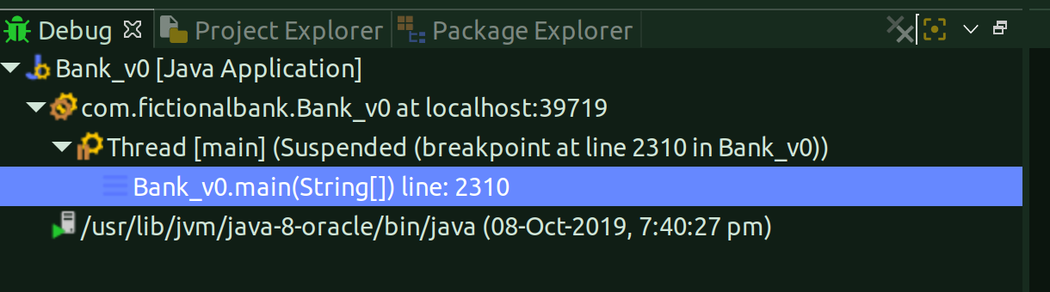
[] As soon as you do that, the program finishes and hence the profiler also finishes capturing the memory footprint and you’ll see this message in the visualvm:

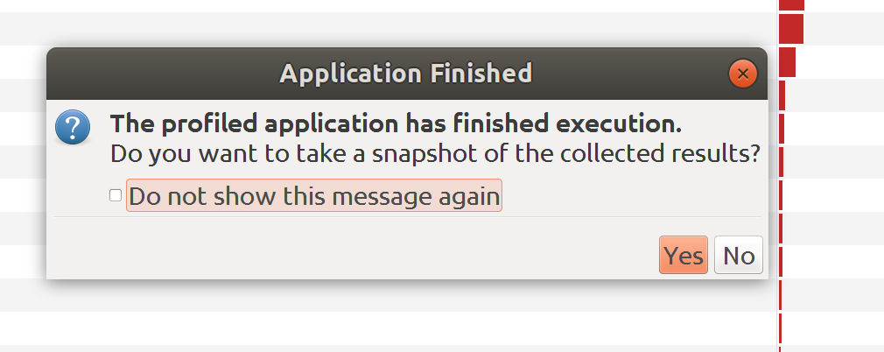
[] You hit ‘Yes’ and you’ll see the snapshot of the profile:

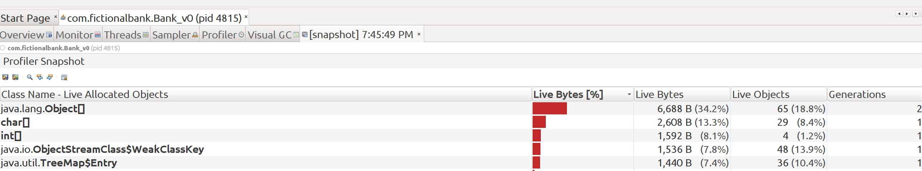
[] You can compare snapshots as well.

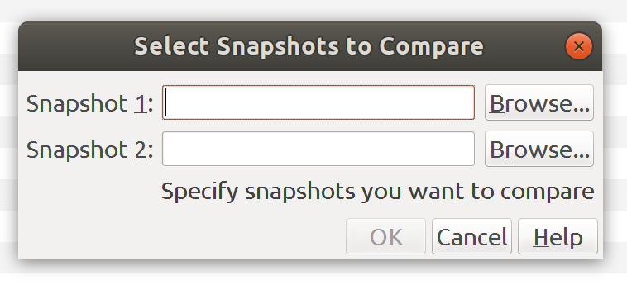
[] You get the option from the File menu of java visual vm.

[] And when you compare, you see something like this:

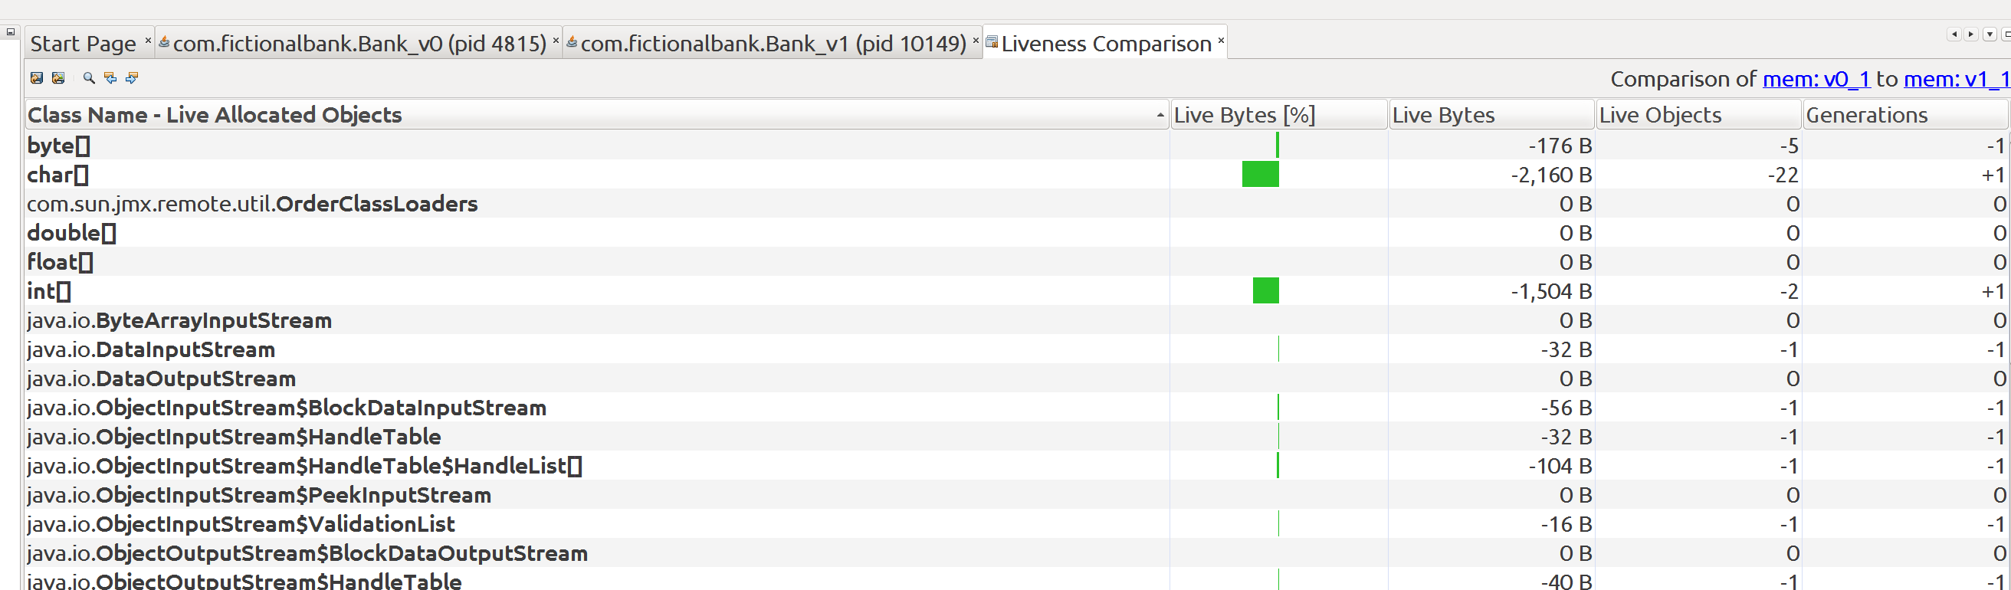

[ISSUE : Redefinition failed with error 62]
[] You can encounter this issue when you are trying to access the ‘CPU’ profiling option from the ‘Profiler’ tab in the java visualvm.

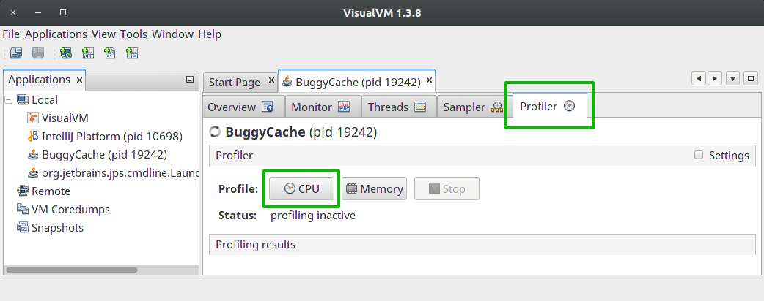
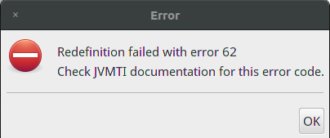

[] To fix it, close app running session and close VisualVM. Open Run configuration in Eclipse and add -Xverify:none to VM options

[] Below is the snapshot from eclipse:
allows you to

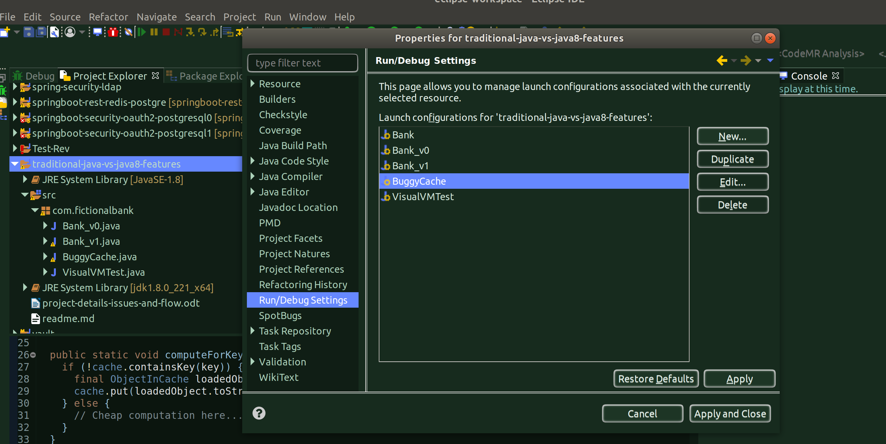

[] So, go to eclipse, go to the project in which you have the program/class which you are trying to profile from profiler, right-click on the project and go to Properties.

[] Now, go to Run/Debug Settings, and select the individual class which you are basically trying to profile, and click on Edit.

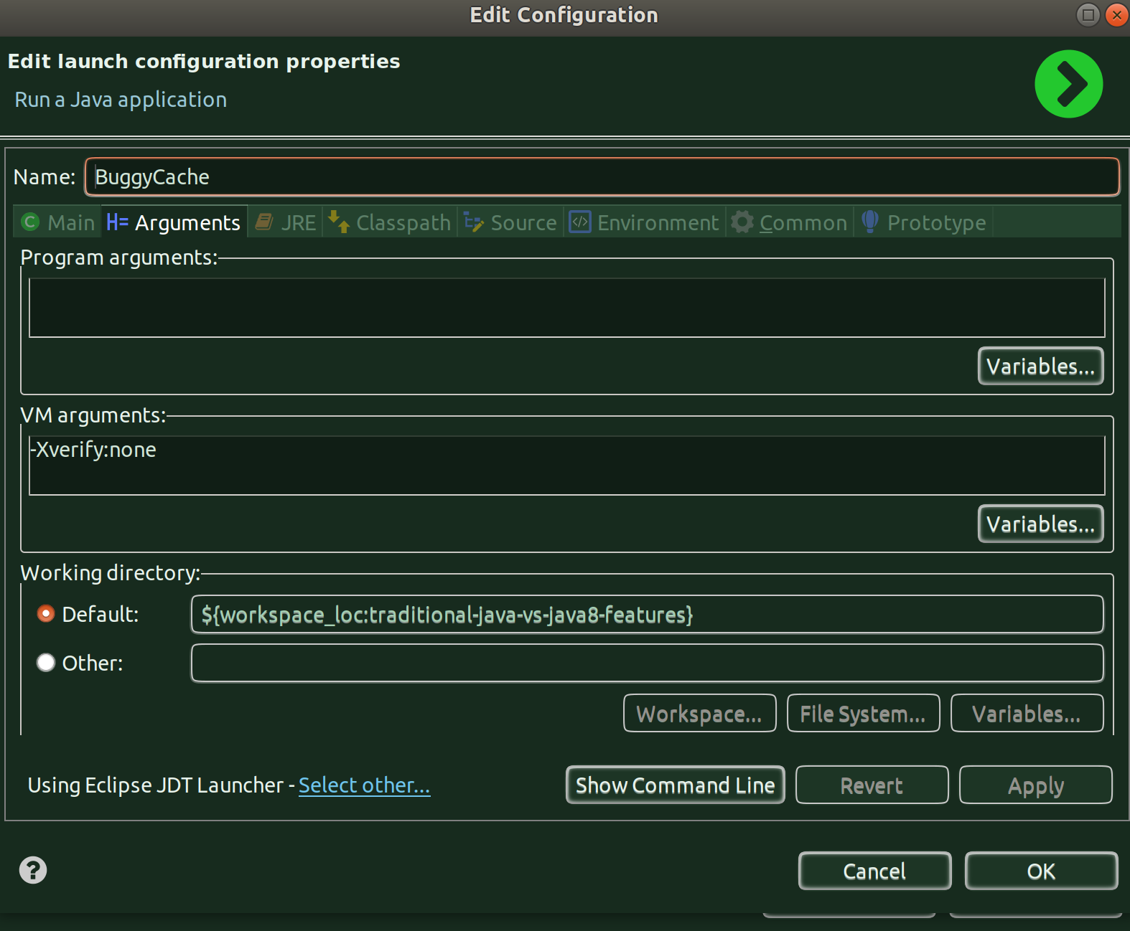

[] In the ‘Edit Configuration’ window, click on Arguments and enter
-Xverify:none in the VM Arguments section, click Apply and Apply and Close.

[] NOTE: Apparently, it seems, -Xverify:none is an VM Option which should not be used and has also been deprecated from Java 13 onwards, it seems, it makes the code less secure. But, for now, I don’t have any other option, so going with it, but this for sure should not be part of your vm arguments except for this one time.

[Notes on -Xverify:none VM argument]:
[] This arugment basically disables java bytecode verification.

[] When Java source code is compiled, it is converted into bytecode, saved in one or more class files, and executed by the Java Virtual Machine (JVM). Java class files may be compiled on one machine and executed on another machine. A properly generated class file is said to be conforming. When the JVM loads a class file, it has no way of knowing whether the class file is conforming. The class file could have been created by some other process, or an attacker may have tampered with a conforming class file.

[] The Java bytecode verifier is an internal component of the JVM that is responsible for detecting nonconforming Java bytecode. It ensures that the class file is in the proper Java class format, that illegal type casts are avoided, that operand stack underflows are impossible, and that each method eventually removes from the operand stack everything pushed by that method.

[] Users often assume that Java class files obtained from a trustworthy source will be conforming and, consequently, safe for execution. This belief can erroneously lead them to see bytecode verification as a superfluous activity for such classes. Consequently, they might disable bytecode verification, undermining Java's safety and security guarantees. The bytecode verifier must not be suppressed.

[] The bytecode verification process runs by default. The -Xverify:none flag on the JVM command line suppresses the verification process.

[] Most JVM implementations perform bytecode verification by default; it is also performed during dynamic class loading.

[] Specifying the -Xverify:all flag on the command line requires the JVM to enable bytecode verification (even when it would otherwise have been suppressed). And the reason is - Although the bytecode verifier is automatically applied to recompiled code, it is not applied automatically to unmodified code that may depend on the modified code. In the example, if class Ssn is modified to make the ssn field private, but class SsnVerify is not modified, then SsnVerify will still be able to access the (now) private ssn field.

[] The Java options `-Xverify:none` and `-noverify` have been deprecated in this release. The options will continue to work as intended but will generate the following warning when used

[ISSUE: Not seeing Profiler tab on first run]
[] Have noticed an issue in which the ‘Profiler’ tab is not visible when you first run a program from eclipse to be profiled by the visual vm.

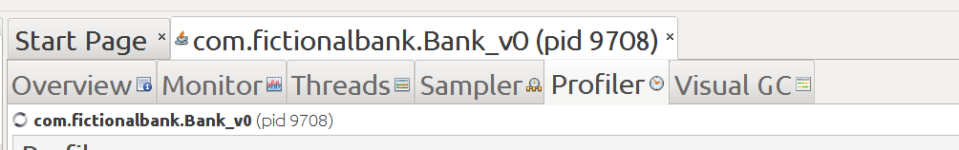
[] You won’t see the above tab in first run.

[] Solution is to simply re-run the program from eclipse (in debug mode) and you’ll see it in the next run.

[] Please remember, we have configured visualvm to be run only during debug mode operation in eclipse and hence we always need to run debug mode whenever we expect the code to be profiled by the visualvm profiler.

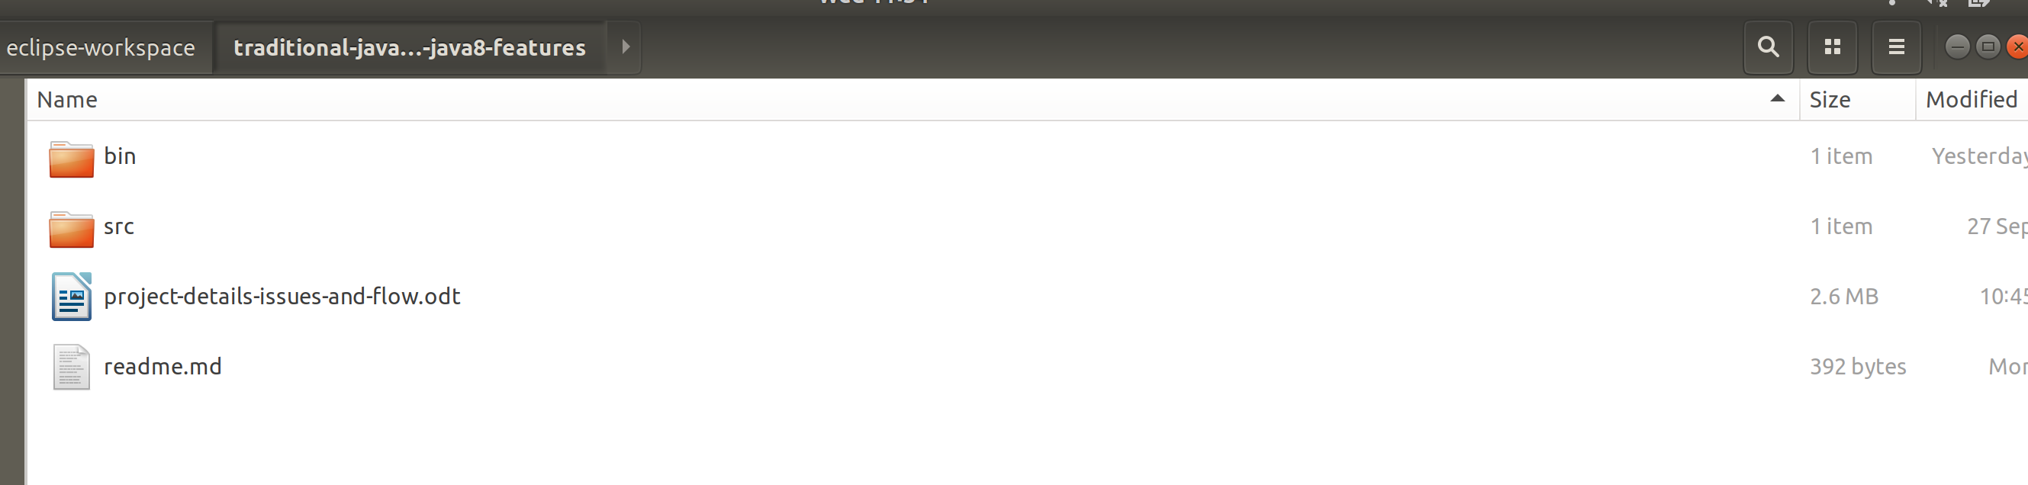

[GENERATING HEAP DUMP WHEN AN OUTOFMEMORY ERROR OCCURS]

[] You don’t really know when an outofmemory error might occur in your java application so it is always better to run your java applications with a vm argument which will automatically create an heapdump file as soon as the error occurs.

[] Below is the snapshot of the vm argument configuration for enabling heapdump creation as soon as outpfmemory error occurs.

[] The -Xverify:none operation, in the snapshot below, is to disable bytecode verification, it’s got nothing to do with the heap dump capture.

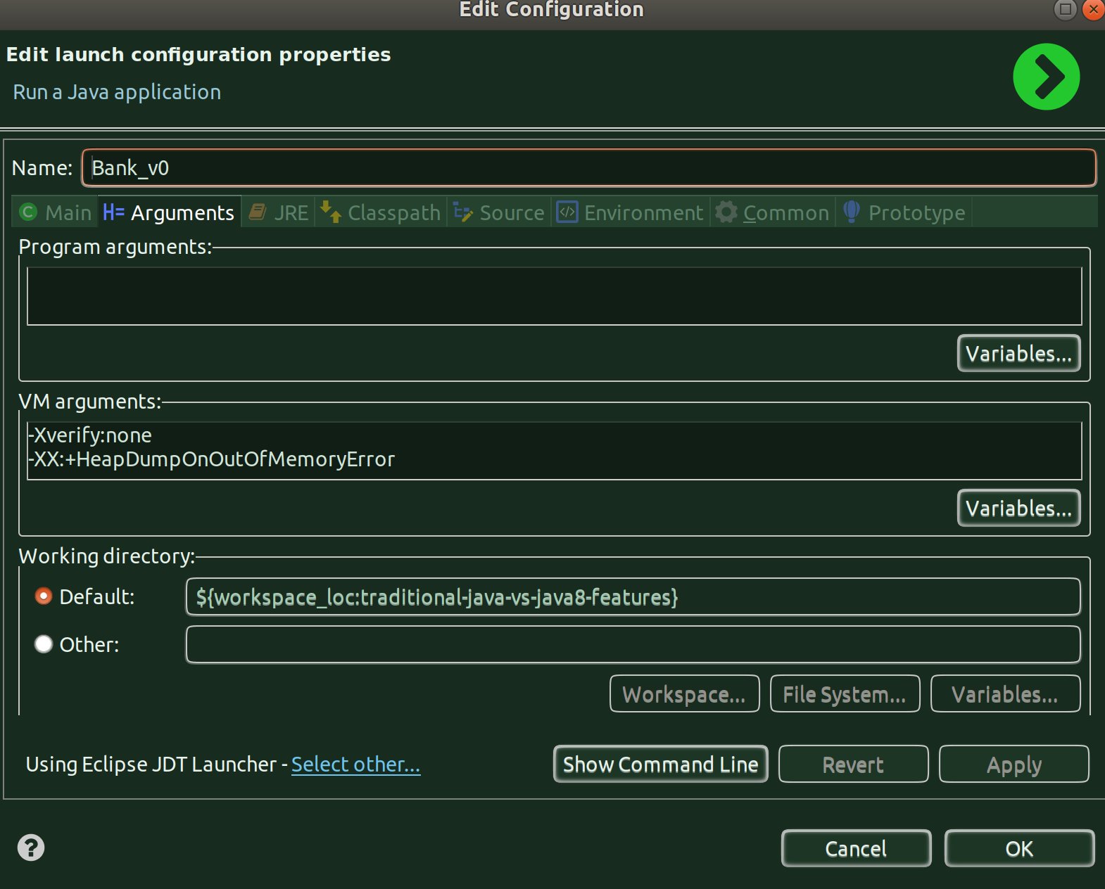

[] To set this, you need to right-click on the project and click on Properties and go to Run/Debug Settings and there you need to click on the individual class which you want to enable it with this argument.

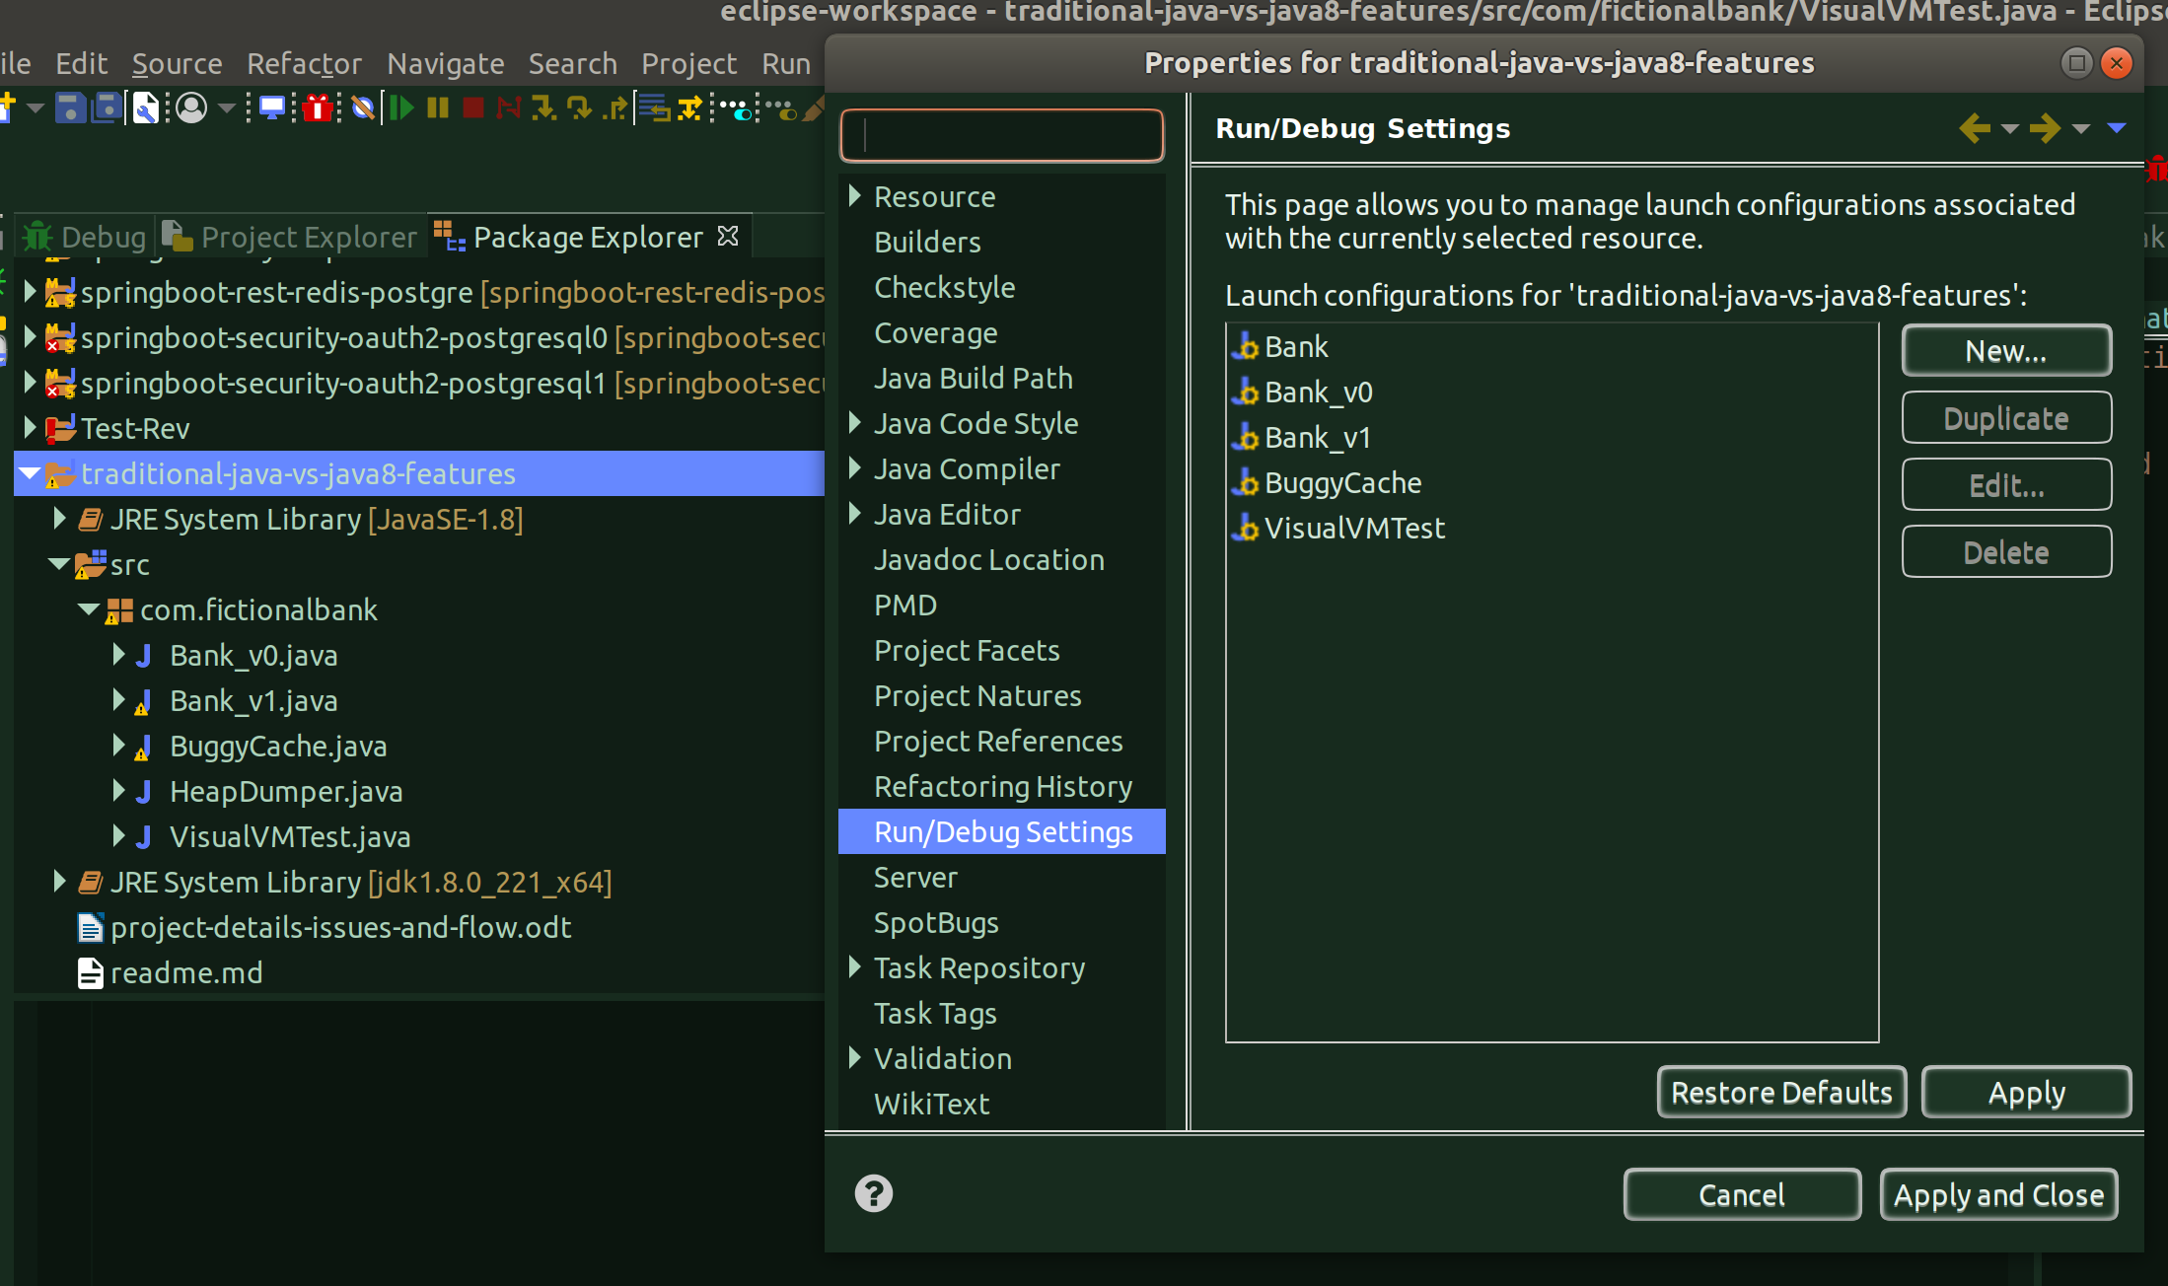

[INSTALLING AND USING ECLIPSE MEMORY ANALYZER TOOL]

[] You first to install the software/pluging from Eclipse Marketplace

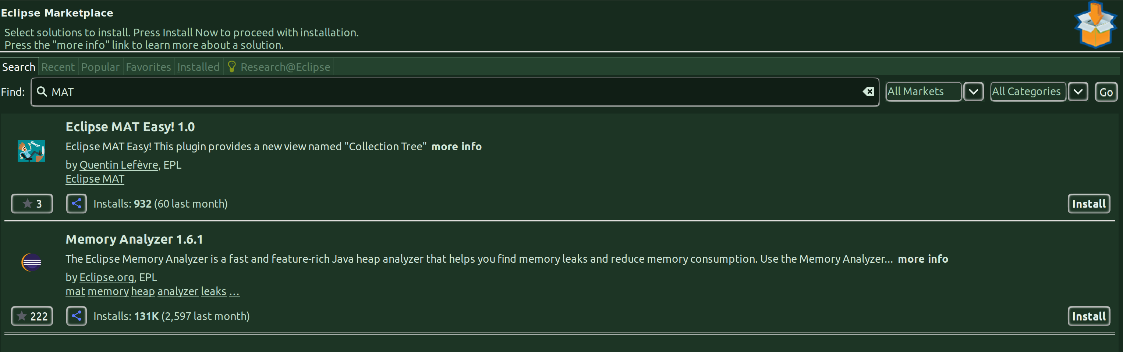

[] Click on Install and accept the eclipse software license agreement and the installation will begin:

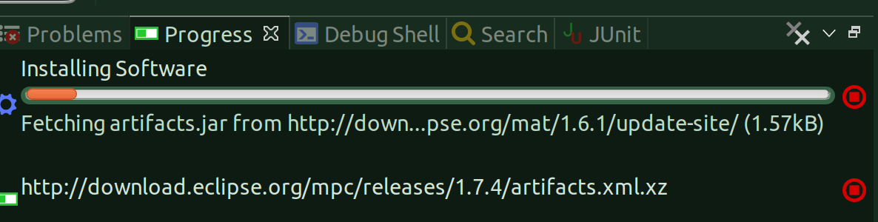
[] Once the installation is complete just restart the eclipse.

[Analyzing an heap dump using Eclipse MAT]
[] Let’s say that you already have a heapdump file available and you want to analyze that.

[] Of course, you can open that file using the visualvm as well and do manual analysis but here we will be using the eclipse memory analyze tool.

[] Put that heapdump file a place which you can access it using the eclipse MAT, for instance, I have put it under a project:
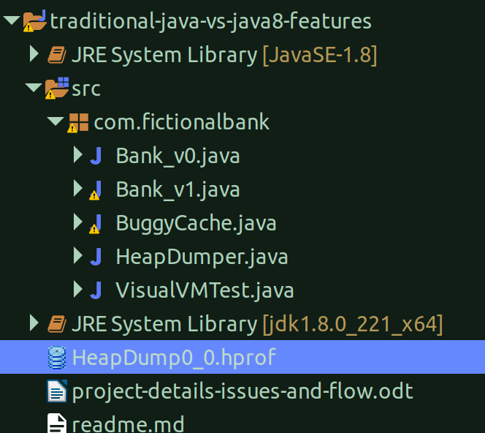

[] Now, I can just right-click on the file and open-it-with the eclipse MAT.

[] The moment you open it, you will see a pop-up, asking you to choose an option to do the analysis:
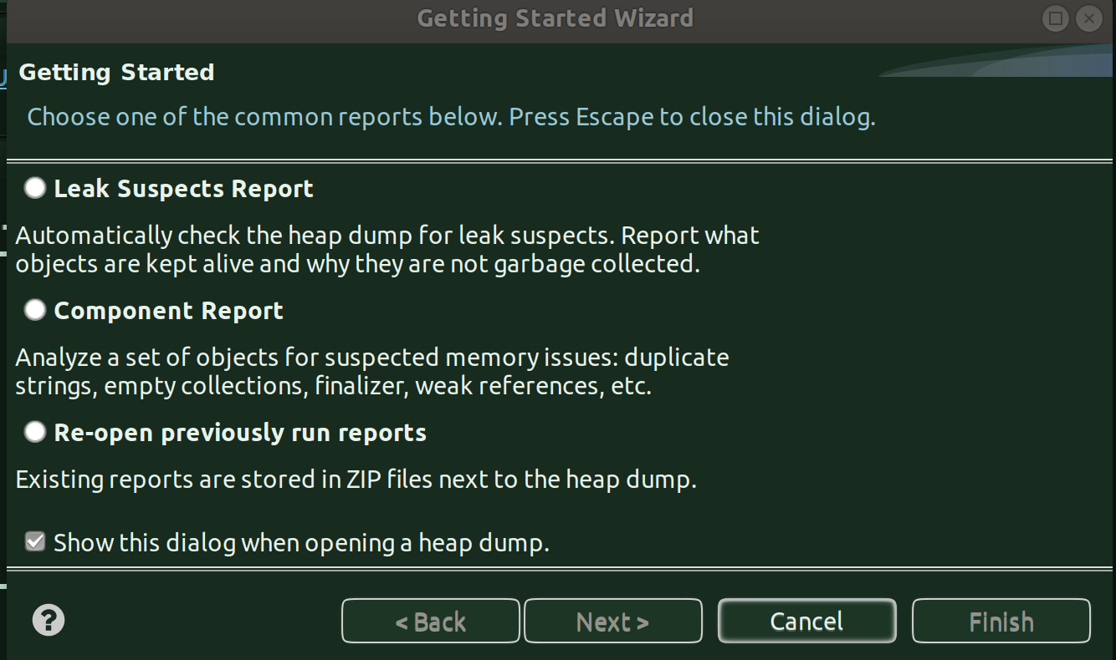

[] If you click cancel, you will see the graph by object size and click on each item to dig deep.

[] But the best way is to do in a steap-by-step manner. To know that, just click on the ‘Component Report’ option that’ll see at the bottom:

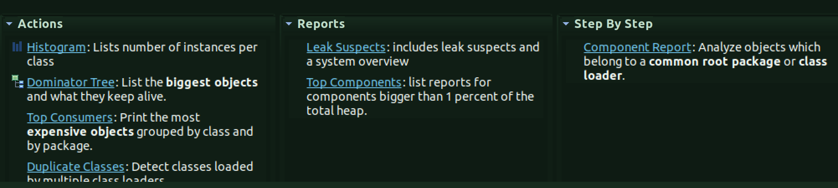
[] When you click on it you’ll see a cheat sheet open and just navigate through each step in it and dig deeper in an ordered manner:
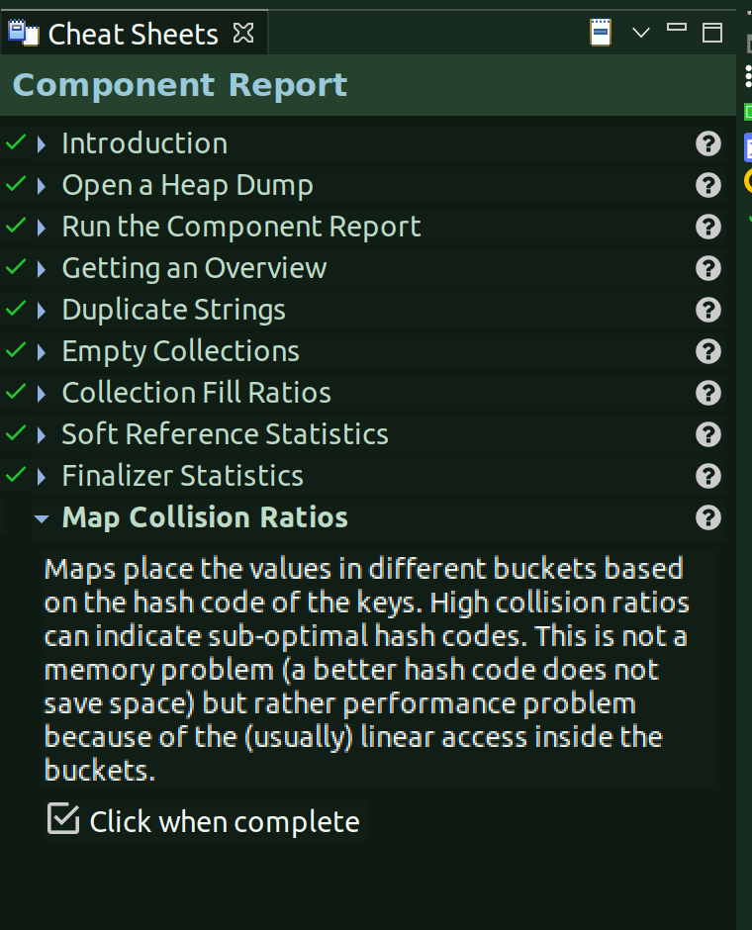

[] Shallow Heap vs Retained Heap:
[] Shallow heap is the memory consumed by one object. An object needs 32 or 64 bits (depending on the OS architecture) per reference, 4 bytes per Integer, 8 bytes per Long, etc.
[] Retained set of X is the set of objects which would be removed by GC when X is garbage collected.
[] Retained heap of X is the sum of shallow sizes of all objects in the retained set of X, i.e. memory kept alive by X.

[NOTES ON HEAP DUMPS AND THREAD DUMPS]

[] A JVM heap dump is basically a “snapshot” of the Java heap memory at a given time. It is quite different than a JVM thread dump which is a snapshot of the threads.

[] Please note that it is usually recommended to generate a heap dump following a full GC in order to eliminate unnecessary “noise” from non-referenced objects.

[] Questions you as a developer should ask yourself:
[] How much concurrent threads are needed to run my application concurrently as per load forecast? How much memory each active thread is consuming before they complete their tasks?
[] What is the static memory footprint of my application? (libraries, classloader footprint, in-memory cache data structures etc.)
[] What is the dynamic memory footprint of my application under load? (sessions footprint etc.)
[] Did you profile your application for any memory leak?

[] Load testing, profiling your application and analyzing Java heap dumps (ex: captured during a load test or production problem) will allow you to answer the above questions.

[] When to use:
[] Analyzing JVM heap dumps should not be done every time you are facing a Java heap problem such as OutOfMemoryError.
[] Since it is a time consuming analysis should only be done when there is a need as such.
[] Do it when you have the need to understand & tune your application and / or surrounding API or Java EE container itself memory footprint
[] Do it when you have to do Java heap memory leak troubleshooting
[] Do it when Java classloader memory leaks
[] DO it when there is Sudden Java heap increase problems or trigger events (has to be combined with thread dump analysis as a starting point)

[] Heap dump limitations:
[] JVM heap dump generation is an intensive computing task which will hang your JVM until completed. Proper due diligence is required in order to reduce impact to your production environment
[] Analyzing the heap dump will not give you the full Java process memory footprint e.g. native heap. For this purpose, you will need to rely on other tools and OS commands for that purpose
[] You may face problems opening & parsing heap dumps generated as well.

[] Heap dump analysis tools:
[] You can use visualvm also but eclipse memory analyser tool is better.

