First install ruby and ruby’s package manager:
https://phoenixnap.com/kb/how-to-install-ruby-on-ubuntu-18-04

Add liquid gem to ruby:
https://github.com/Shopify/liquid

Gems in ruby are nothing but libraries and to share it with others you need ruby package manager.

Also, look at this website, I’m not sure what’s the download here for – Source code?
https://shopify.github.io/liquid/

Shopify developer account:
https://www.shopify.in/partners/blog/95401862-3-simple-steps-for-setting-up-a-local-shopify-theme-development-environment

https://shopstoretestsetup.myshopify.com

This how you can customize your Manage Subscriptions Page:
https://support.boldcommerce.com/hc/en-us/articles/360033336552-Customize-Your-Manage-Subscriptions-Page-2-0

And, for that, you need at least an ‘Advanced’ billing plan:
https://support.boldcommerce.com/hc/en-us/articles/360021957571

And, this is the api documentation that they refer to custom create a manage subscriptions page:
https://github.com/bold-commerce/bold-subscriptions-manage-subscriptions-app

Another example of making some subtle customizations:
https://support.boldcommerce.com/hc/en-us/articles/360024629271-Set-the-Subscriptions-Widget-s-Default-Option-to-Subscribe-and-Save

Using webhooks from bold subscriptions:
https://support.boldcommerce.com/hc/en-us/articles/360028881292-Using-Webhooks-with-Bold-Subscriptions

An Overview of Liquid:
https://www.shopify.in/partners/blog/115244038-an-overview-of-liquid-shopifys-templating-language

[RUBY INSTALLATION]

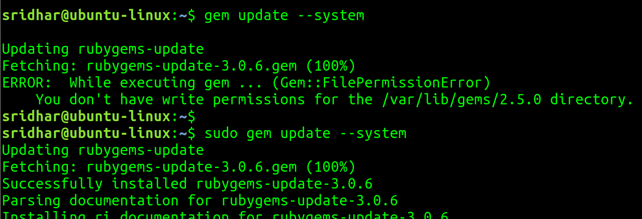
run it with sudo:

ruby gems installed:

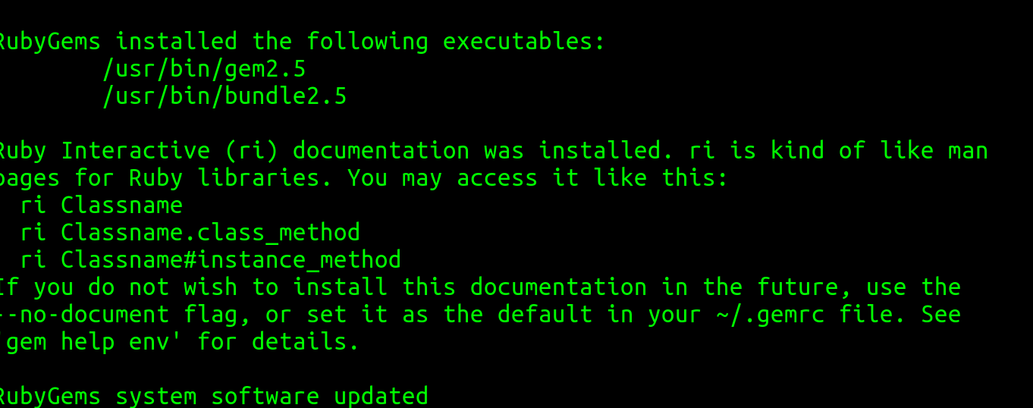
‘ri’ is like man pages:

First ruby proogram: vim hello_world.rb
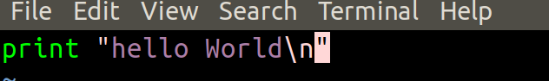
Press ESC -> :x (to save and quit) -> Enter

Execute the ruby program:
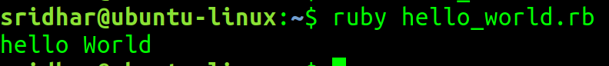

Themekit:
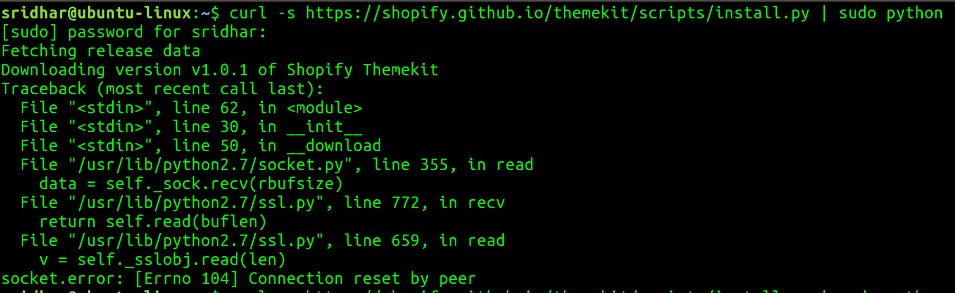
Running it again, we’ll see:
failed again with same error.

Now, trying to Download it from website:
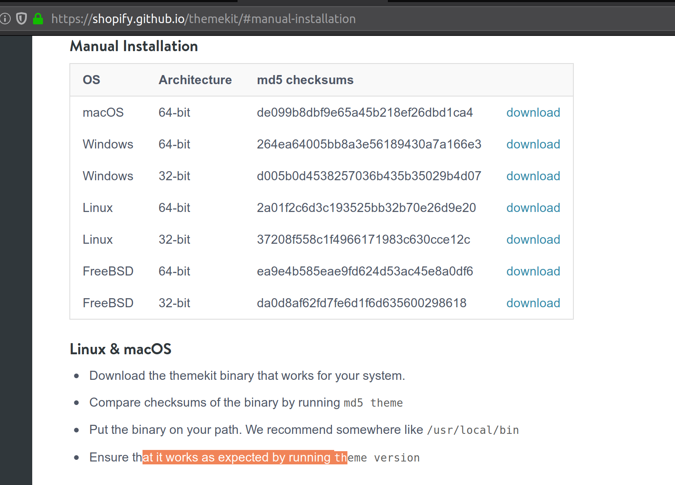

But the download from this site is also failing for Linux 64-bit.

Okay, tried a few more times and finally the 64-bit got downloaded.

Before I would go and use the downloaded version, I just wanted to try the python script based theme kit installation again and:
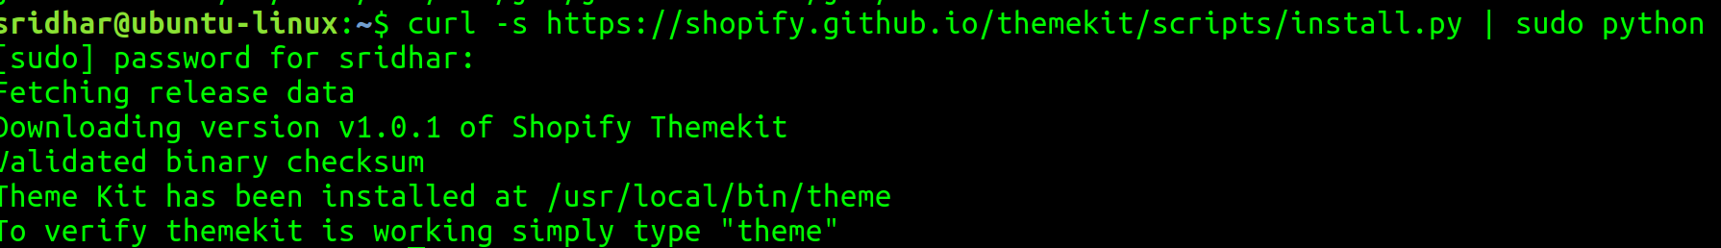
Successful.

And, perfect:
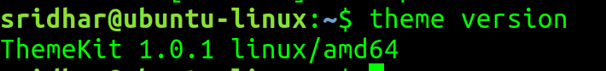
Create a directory for your shopify theme:
Now, we will have to get the API Password and theme id from the shopify store.

Login to your shopify store and click on Themes -> Edit code -> capture the theme id from url:

And, now the Api Password. Since in this example a ‘Private App’ is already created in the shopify store, I’ll just go into it and fetch the API Password. Otherwise, you’ll have to create a private app of your store in order to have a copy of your production code base.

Click Apps -> Bottom of the page:

Click on it.

Click on it.
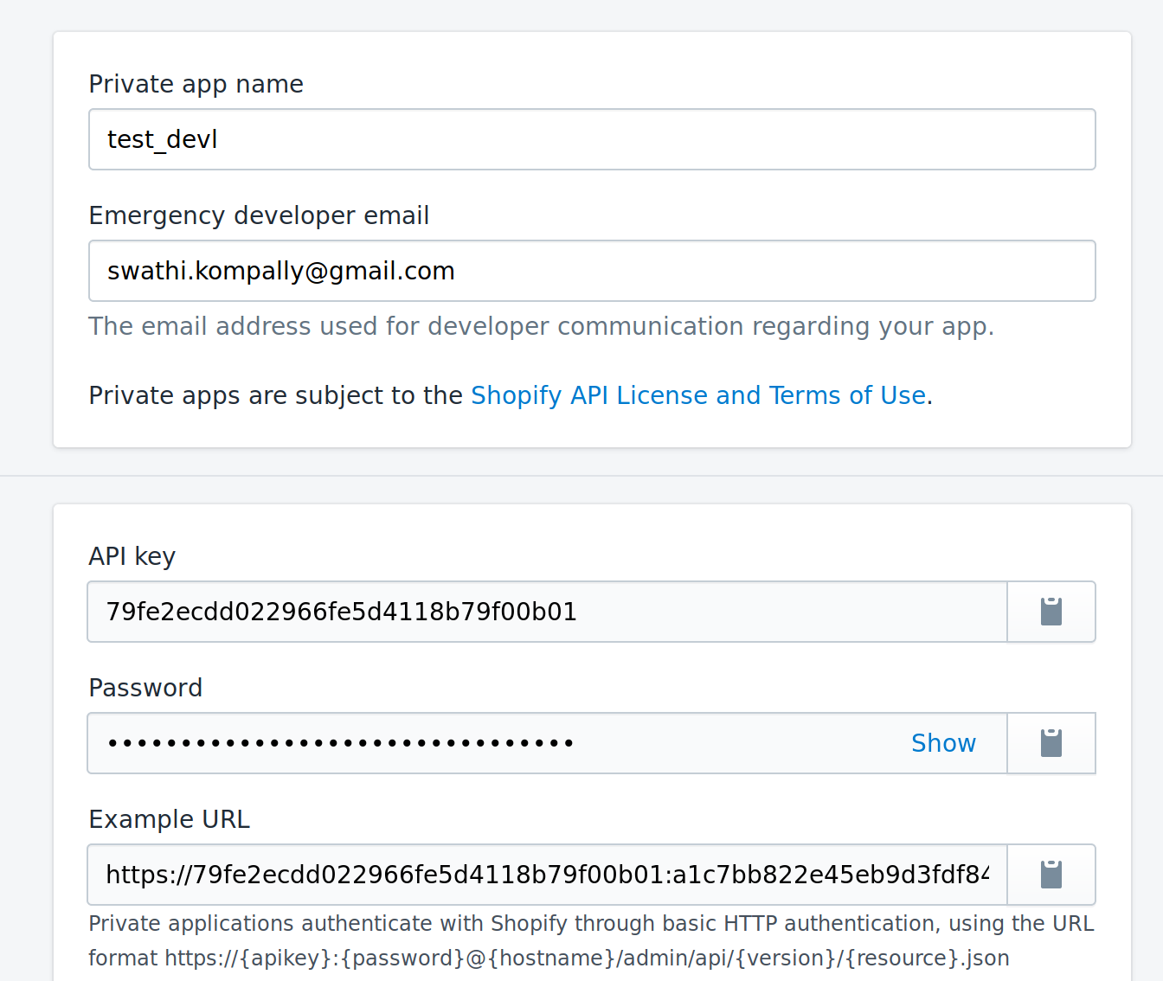
And fetch the API Password.

To download a specific theme, and create the config.yml file that connects this theme with a local version in the directory you just created, run the following command from inside your theme directory:

Check what got downloaded:
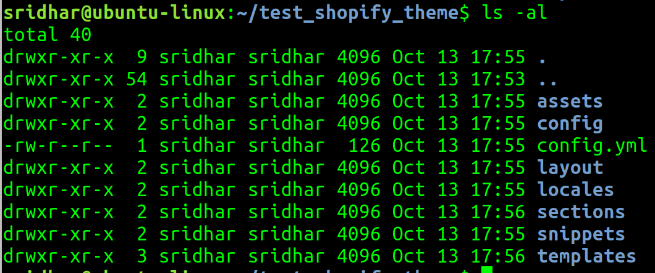

[INSTALLAING SUBLIME TEXT EDITOR IN UBUNTU]

I’m doing this basically for .liquid template coding and styling, for which sublime provides support for (since eclipse does not).

Use the sublime official Apt repository for the installation of Sublime on Ubuntu systems. First of all, you need to import gpg key on your system

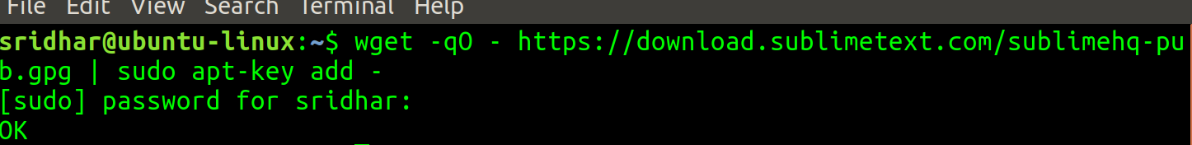
Now, add the Sublime text apt PPA in your system using the following command.
Sublime text PPA is now confiured on your system. Let’s install sublime text latest version on your system by running following commands
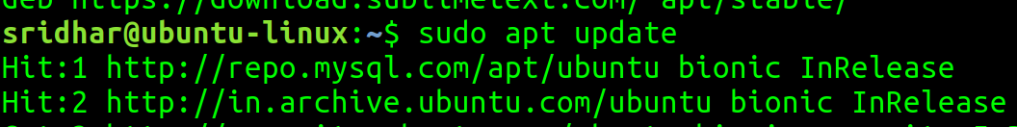

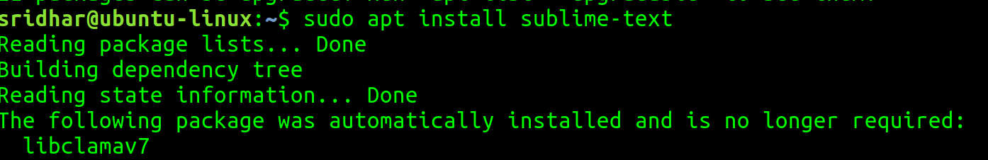
Once this is done, that’s it, you can open sublime.

In Sublime in order to install Liquid template syntax highlighting:
Go to Tools -> Install Package Control -> Once it is done -> Go to Command Palette -> Search Install Package Control and click on it -> It will get installed -> again go to Tools -> Command Palette -> search for Liquid -> and click on the shopify liquid, that’s it.

[OVERVIEW OF LIQUID TEMPLATING LANGUAGE]

Liquid was developed by Shopify co-founder and CEO Tobias Lütke and is now available as an open source project on GitHub. Today, it's used in many different software projects, from content management systems to flat file site generators — and of course, Shopify.

Some refer to Liquid as a template language, while others may call it a template engine. It doesn't really matter which label you apply — in many ways both are right. Personally, I like to call it a template language. It has a syntax (like traditional programming languages), has concepts such as output, logic, and loops, and it interacts with variables (data), just as you would with a web-centric language such as PHP.

However, that's really where the similarities end. There's a lot you can't do with Liquid — by design. For example, it has no concept of "state", it doesn't let you get deep under the covers of the platform, and can occasionally seem counter intuitive for seasoned coders. However, it has been very well thought out and what might at first seem like a limitation, is usually intended and for good reason.

Liquid, like any template language, creates a bridge between an HTML file and a data store — in our context, the data is of course a Shopify store. It does this by allowing us to access variables from within a template with a simple to use, and readable, syntax.

In Shopify, each template allows us to access certain variables without having to do any heavy lifting.

Once we know the names of the variables we have access to, or create, we can use Liquid constructs such as "output" and "loops" to display the data in our templates.

Liquid files have the extension of .liquid. A .liquid file is a mix of standard HTML code and Liquid constructs.

The double curly brace delimiters {{ }} denote output, and the curly brace percentage delimiters {% %} denote logic.

Output:
<h2>{{ product.title }}</h2>

When rendered this would output the name of the currently viewed product in place of the {{ }}

Objects and properties:
The first element preceding the . is the object. The items following the . represent properties of the shop object. A property could be as simple as the name of the store (as per our example above) or it could be a list of items, such as the kinds of payment types enabled in the store.
For e.g. product.title

Collection properties
Let’s consider the shop object of shopify and it’s enabled payment types property to access which, you will write:
shop.enabled_payment_types
You notice that the property here is plural, meaning, Instead of returning a string of data such as the name of the shop they will return an array of data — in other words a list of items we can access via a Liquid loop.
These properties represent Liquid collections.
When first using Shopify and Liquid, it's easy to get confused by collections — I certainly did. I will therefore refer to "product collections" and "Liquid collections". The former being a logical grouping of products defined in the Shopify admin, and the latter being a list of items we can access in Liquid code.

Liquid Loops:
As far as I can tell, there is only one kind of loop in Liquid, which is the for loop.
For e.g.
{% for image in product.images %}
<img src="{{ image | img_url: 'medium' }}">
{% endfor %}
It's worth noting that unless we specifically ask how big our loop will be, we don't know how many loops will occur
In order to access the properties of each list item, we designate a variable to represent the current item in the loop. In our example above it is image.
The second line of our code example consists of part HTML and part Liquid. You'll also notice that the src attribute is populated with a Liquid output tag.
This introduces us to the concept of filters which are denoted by the | (pipe) character. In our example, the filter is taking the image variable (the current item in our loop) and is creating a fully qualified URL to the "medium" size version of the image, which was created when the product image was added in the Shopify admin.
The final line of our example is our closing endfor statement.

Liquid Filters:
Filters are always used in conjunction with a Liquid output.

Operators:
== equal to
!= not equal to
> greater than
< less than
>= bigger or equal
<= less or equal
or this or that
and must be this and that
contains includes the substring if used on a string, or element if used on an array

Summary:
. Liquid is a template language that allows us to display data in a template.
- Liquid has constructs such as output, logic, loops and deals with variables.
- Liquid files are a mixture of HTML and Liquid code, and have the .liquid file extension.
- Liquid files used in a Shopify theme are agnostic and have no concept of the store they are currently being used in.
- The two types of delimiters used in Liquid.
- How to output data from a store in a template.
- How to manipulate data with filters.
- How to loop over a Liquid collection to output multiple items.
- The use of logic in a template.
- The different types of operators used for comparison.

Cheat Sheet for Liquid:
https://www.shopify.co.uk/partners/shopify-cheat-sheet

[SHAREFAMILYDINNER]
When you go to the cart page on the site:
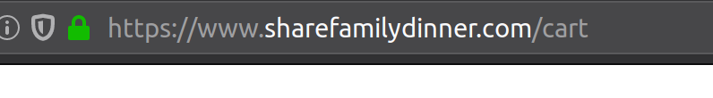
This actually directly maps to the template under /templates / cart.liquid. And, if you open up this template:
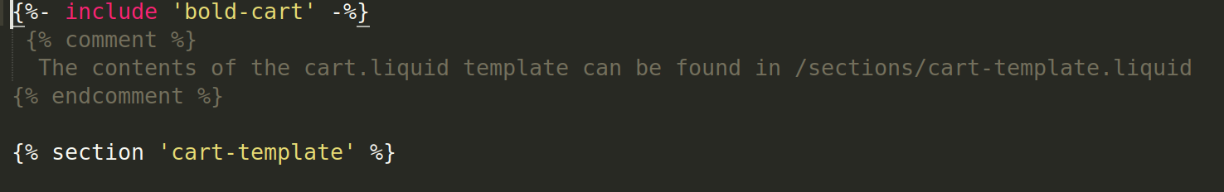
You can see that majoority is from bold-cart and from cart-template (which is in the section). And such includes like bold-cart, will be in the snippets.
So, it looks like, whenever you visit a page on shopify store, that page directly maps to a template under /templates which then uses something in /sections and OR or in /snippets, which they themselves then might be using stuff which is under /assets and /config.

For the rest of section, will look at cart-template.

The delivery time attribute on the cart page:
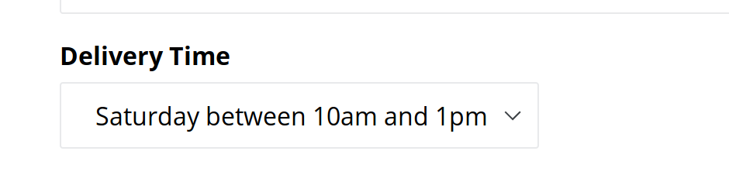
can be found in the code in only two places – /sections/cart-template.liquid and in /assets/storepickup.js

On the cart page, most of the contents of the second-half of the page – both static and dynamic – are coming from /sections /cart-template.liquid:
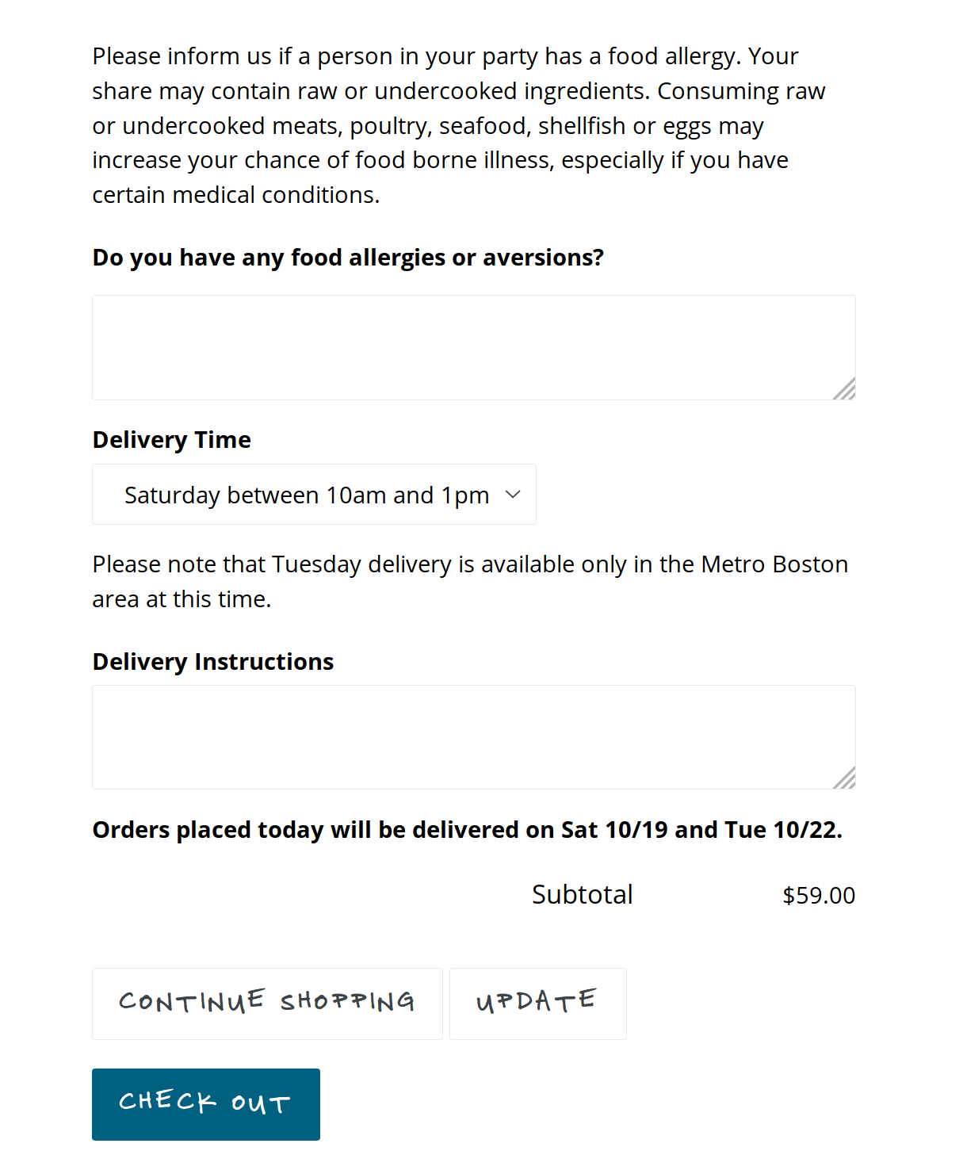
This footer part of this liquid template contains most of this code:
This below piece of text is displayed if a certain condition is true:
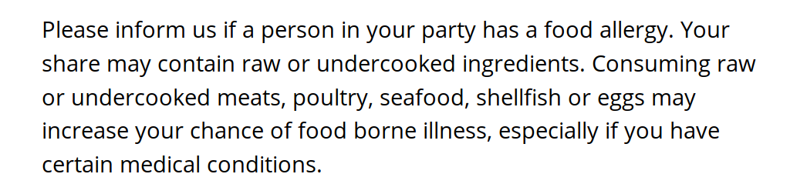
which is written as:
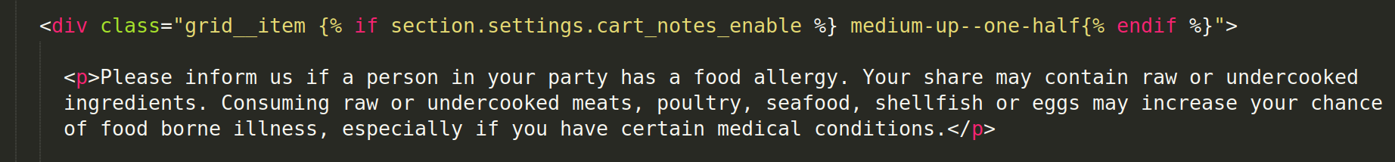
The section.settings.cart_notes_enable:
section is an object and settings is its attribute and cart_notes_enable is mapped in a json file - /config / settings_data.json:
It is mapped to this template with value true.

And, this particular section:

is in the code, here:
but, IDK, where the ‘cart.general.note’ is coming from, which is the text of the label for this textareaa and though I know that the pipe symbol there is the filter but IDK what the ‘t’ is and where is it coming from.
And, the text entered in this textarea will be captured by cart.note.

And, the Delivery Time, it’s options and the static text:
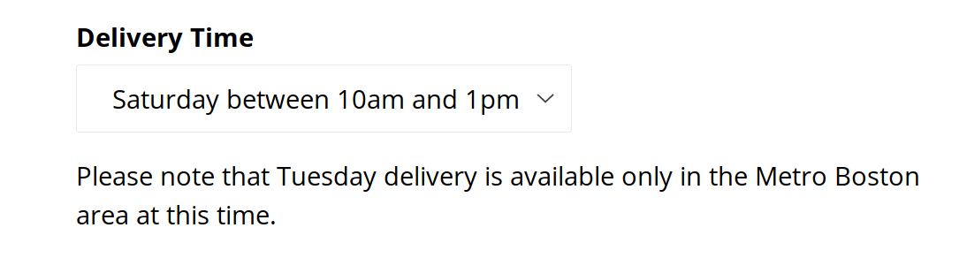
is here:
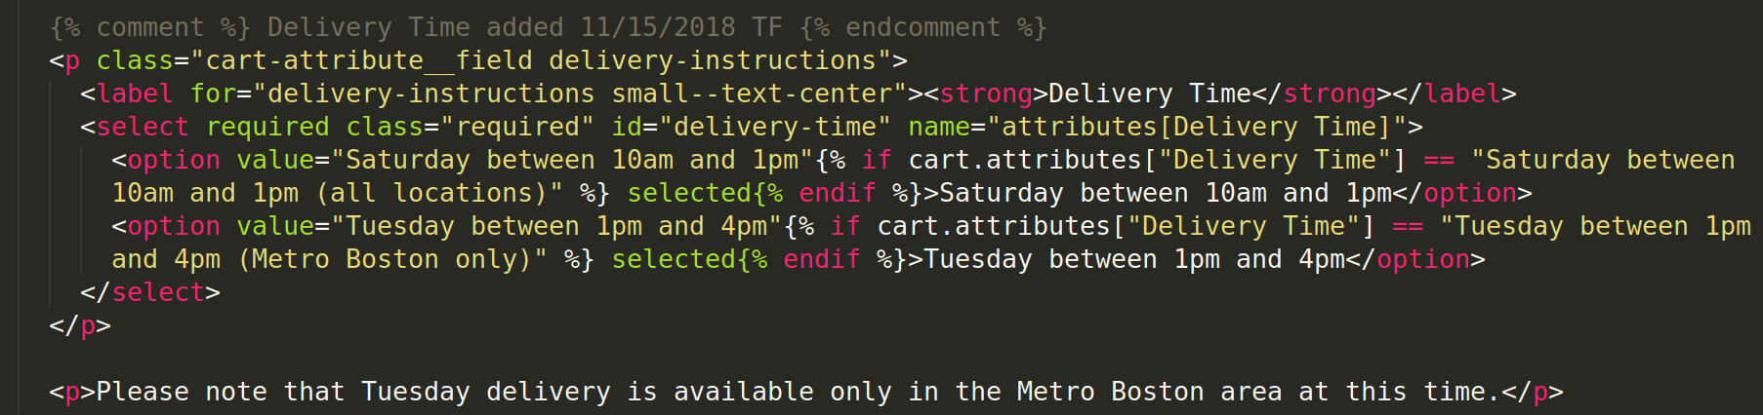
And, this little piece of text on this page:
is not static at all, there is logic for this:
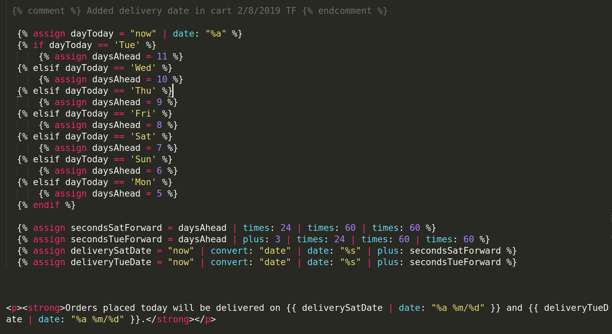

‘assign’ keyword above is a variable tag and it is used to create new variable:
You can find about these things in liquid cheat sheet.

So, basically dayToday is a variable and it is being assigned the value of “now”, and as far as I can tell, that is an jQuery function call, which returns time in timestamp format.
Refer: https://api.jquery.com/jQuery.now/
But from how and where this jQuery call happens, IDK.

After that, there is a filter (the pipe symbol), which is used to convert one thing to other;
Refer: https://help.shopify.com/en/themes/liquid/filters/additional-filters#date

Here, we are using the date filter, and the date in liquid is same as the Ruby’s strftime format, and the %a will basically give us the abbreviated name of the day, as in, ‘Mon’ for Monday.
Refer: https://ruby-doc.org/core-2.6.5/Time.html#method-i-strftime
So, here, we are converting the current timestamp returned by the now method of jquery to a day format by using the date filter.

After which, the value of dayToday is compared to each day (hard-coded) to see which day does it match to and then a number is assigned accordingly to the new variable daysAhead.

And, next, the new var secondsSatForward val will be cal as follows: value of daysAhead (assigned above) multiplied by 24, multiplied by 60, mulitplied by 60. That’s the val of this var.

And, for new var secondsTueForward val is cal as: val of daysAhead (assigned above), plus 3, mulitplied by 24*60*60.

And, new var, deliverySatDate will be calc as: current timestamp (returned by now), will be converted to date, which is then filtered to return time in seconds since epoch (Refer: https://www.epochconverter.com/) and then added to val of secondsSatForward calc above.

Similarly for deliveryTueDate as well.

But, I dont understand, why use current timestamp val and then convert that to date format and then filter it with epoch, when all you are going to get at the end of op. Is an epoch, so why not just use epoch result and sum it up with secondsSatForward val.

And, then finally, the actual text is displayed as follows: the val of deliverySatDate (cal above) is converted using date filter into the format of Day i.e. Sat 09/19 , represented by %a %m/%d strftime formart of Ruby.

Let me just run the above flow with an example:

assume, dayToday = Mon (Oct 14th 2019)
=> daysAhead = 5
=> secondsSatForward = 5 * 24 * 60 * 60 = 432000
=> secondsTueForward = 5 + 3 * 24 * 60 * 60 = 691200
=> deliverySatDate
= ("now" | convert: "date" | date: "%s") + secondsSatForward
= 1571035885 (current unix epoch time) + 432000
= 1571467885 => which when you convert this epoch to human-readable date, we get => Sat, Oct 19, 2019
=> deliveryTueDate
= ("now" | convert: "date" | date: "%s") + secondsTueForward
= 1571035885 (current unix epoch time) + 691200
= 1571727085 => which when you convert this epoch to human-readable date, we get => Tue, Oct 22, 2019

You can fetch current unix epoch time and also convert epoch into human-readable date from: https://www.epochconverter.com/

So, this is the logic of this thing.

