Ngrok let’s you expose your local installation on a secure public url.

If you have an application running locally on apache server on 8080, then you can expose that application with a public url on the internet using ngrok.

After creating an ngrok account:
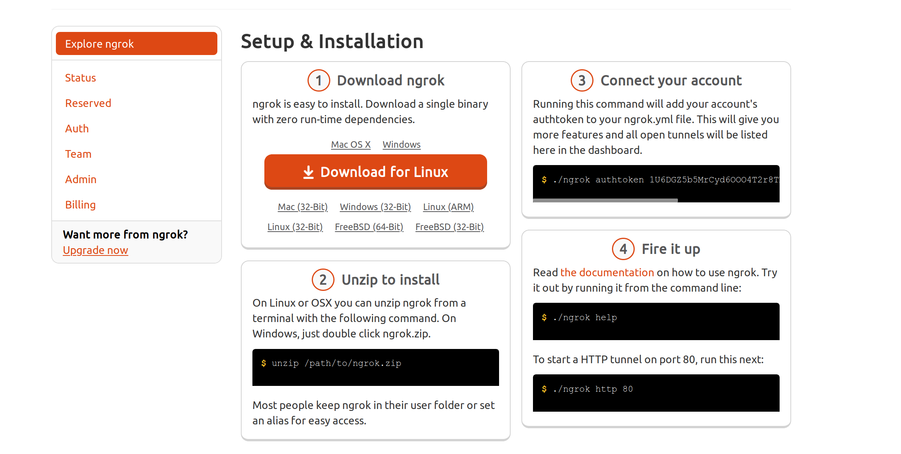
You just have to download the zip file, unzip it and assign your auth code (which you can find under Auth section on the website) to the ngrok installation by runing the command given in step 3 and then fire up ngrok.

As soon as you run the setp 4, a command terminal opens-up, showing your ngrok url, copy that url and share it with other people on the internet and they’ll be access it.

To stop access, just shutdown ngrok by ctrl+c (pretty raw)!.

