https://www.git-tower.com/blog/git-cheat-sheet/
https://shafiul.github.io//gitbook/index.html

Table of Contents
A BIT OF HISTORY 3
DELTA ENCODING OR DELTA COMPRESSION: 5
GIT DATA STRUCTURES: 5
GIT OBJECT MODEL 5
HOW DOES GIT UTILIZES SHA1: 6
NOTES ON SHA1: 6
OBJECTS IN GIT: 7
TYPES OF OBJECTS: 7
NOTES ON BLOBS: 7
DIFFERENT FROM SVN: 8
THE BLOB OBJECT IN GIT (USING GIT SHOW): 8
THE TREE OBJECT IN GIT (USING GIT LS-TREE): 8
THE COMMIT OBJECT IN GIT: 9
THE TAG OBJECT IN GIT (USING GIT CAT-FILE): 9
THE GIT DIRECTORY 9
THE GIT INDEX 10
GIT CONFIG 10
CONFIGURE USER NAME AND EMAIL 10
KNOW CURRENTLY CONFIGURED USER NAME AND EMAIL 10
KNOW REMOTE ORIGIN URL 11
FIND OUT DETAILS ABOUT REMOTE ORIGIN 11
CLONING A REPOSITORY – GIT CLONE 11
CLONING A SINGLE BRANCH 11
INITIALIZING A REPO - GIT INIT 11
NORMAL WORKFLOW – GIT ADD, DIFF, STATUS, COMMIT 12
GIT TRACKS CONTENT NOT FILES: 12
BASIC BRANCHING AND MERGING – GIT BRANCH, CHECKOUT, MERGE, GITK 13
HOW BRANCHES BEHAVE! 13
HOW TO MERGE: 14
RESOLVING A MERGE: 15
UNDOING A MERGE – GIT RESET: 15
FAST-FORWARD MERGES: 15
REVIEWING HISTORY - GIT LOG 16
LOG STATS: 16
FORMATTING THE LOG: 16
ORDERING THE LOG: 17
GIT DIFFs: 17
USING GIT DIFF FOR FILE COMPARE: 18
DISTRIBUTED WORKFLOWS - GIT CLONE, PULL, REMOTE, FETCH 19
PUBLIC REPOSITORY – GIT PUSH 21
GIT TAGS – LIGHWEIGHT & TAG OBJECTs 22
IGNORING FILES - .GITIGNORE 23
REBASING – GIT CHECKOUT, REBASE 23
ADDITIONAL NOTES ON REBASE: 26
THE GOLDEN RULE OF REBASING – GIT REVERT: 28
STASHING – GIT STASH 28
PARTIAL SHA 29
BRANCH, REMOTE OR TAG NAME INSTEAD OF SHA 29
TRACKING BRANCHES 30
FINDING WITH GIT GREP 30
FIXING UN-COMMITTED MISTAKES – GIT RESET, CHECKOUT 31
FIXING COMMITTED MISTAKES – GIT REVERT 31
ENSURING GOOD PERFORMANCE – GIT GC 32
ENSURING REALIABILITY – GIT FSCK 32
FINDING OUT WHO CHANGED FILE - GIT BLAME 32
HOW GIT STORES OBJECTS 33
LOOSE OBJECTS: 33
PACKED OBJECTS: 33
SVN VS GIT 34
IGNORING SECRET/PRIVATE FILES WHILE STAGE & COMMIT 35
REMOVING A FILE (WHICH HAS BEEN DELETED FROM WORKING REPO) FROM REMOTE MASTER 36
GIT PRODUCTION STRATEGIES FOR SOFTWARE DEVELOPMENT 37

A BIT OF HISTORY

Git is a distributed version-control system for tracking changes in source code during software development.

It is designed for coordinating work among programmers, but it can be used to track changes in any set of files.

Its goals include speed, data integrity, and support for distributed, non-linear workflows.

Git was created by Linus Torvalds in 2005 for development of the Linux kernel, with other kernel developers contributing to its initial development.

As with most other distributed version-control systems, and unlike most client–server systems, every Git directory on every computer is a full-fledged repository with complete history and full version-tracking abilities, independent of network access or a central server.

Git is free and open-source software distributed under the terms of the GNU General Public License version 2.

Git development began in April 2005, after many developers of the Linux kernel gave up access to BitKeeper, a proprietary source-control management (SCM) system that they had formerly used to maintain the project. The copyright holder of BitKeeper, Larry McVoy, had withdrawn free use of the product after claiming that Andrew Tridgell had created SourcePuller by reverse engineering the BitKeeper protocols. The same incident also spurred the creation of another version-control system, Mercurial.

Linus Torvalds wanted a distributed system that he could use like BitKeeper, but none of the available free systems met his needs. Torvalds cited an example of a source-control management system needing 30 seconds to apply a patch and update all associated metadata, and noted that this would not scale to the needs of Linux kernel development, where synchronizing with fellow maintainers could require 250 such actions at once. For his design criteria, he specified that patching should take no more than three seconds, and added three more points:
a.Take Concurrent Versions System (CVS) as an example of what not to do; if in doubt, make the exact opposite decision.
b.Support a distributed, BitKeeper-like workflow.
c.Include very strong safeguards against corruption, either accidental or malicious.

These criteria eliminated every then-extant version-control system, so immediately after the 2.6.12-rc2 Linux kernel development release, Torvalds set out to write his own.

The development of Git began on 3 April 2005. Torvalds announced the project on 6 April;it became self-hosting as of 7 April. The first merge of multiple branches took place on 18 April. Torvalds achieved his performance goals; on 29 April, the nascent Git was benchmarked recording patches to the Linux kernel tree at the rate of 6.7 patches per second. On 16 June Git managed the kernel 2.6.12 release.

Torvalds turned over maintenance on 26 July 2005 to Junio Hamano, a major contributor to the project. Hamano was responsible for the 1.0 release on 21 December 2005 and remains the project's maintainer.

Git supports rapid branching and merging, and includes specific tools for visualizing and navigating a non-linear development history. In Git, a core assumption is that a change will be merged more often than it is written, as it is passed around to various reviewers. In Git, branches are very lightweight: a branch is only a reference to one commit.

Like Darcs, BitKeeper, Mercurial, Bazaar, and Monotone, Git gives each developer a local copy of the full development history, and changes are copied from one such repository to another. These changes are imported as added development branches and can be merged in the same way as a locally developed branch.

Repositories can be published via Hypertext Transfer Protocol (HTTP), File Transfer Protocol (FTP), rsync (removed in Git 2.8.0[33]), or a Git protocol over either a plain socket, or Secure Shell (ssh). Git also has a CVS server emulation, which enables the use of existent CVS clients and IDE plugins to access Git repositories. Subversion repositories can be used directly with git-svn.

The Git history is stored in such a way that the ID of a particular version (a commit in Git terms) depends upon the complete development history leading up to that commit. Once it is published, it is not possible to change the old versions without it being noticed. The structure is similar to a Merkle tree, but with added data at the nodes and leaves (Mercurial and Monotone also have this property).

Git was designed as a set of programs written in C and several shell scripts that provide wrappers around those programs. Although most of those scripts have since been rewritten in C for speed and portability, the design remains, and it is easy to chain the components together.

Aborting operations or backing out changes will leave useless dangling objects in the database. These are generally a small fraction of the continuously growing history of wanted objects. Git will automatically perform garbage collection when enough loose objects have been created in the repository. Garbage collection can be called explicitly using git gc --prune

Git stores each newly created object as a separate file. Although individually compressed, this takes a great deal of space and is inefficient. This is solved by the use of packs that store a large number of objects delta-compressed among themselves in one file (or network byte stream) called a packfile. Packs are compressed using the heuristic that files with the same name are probably similar, but do not depend on it for correctness. A corresponding index file is created for each packfile, telling the offset of each object in the packfile. Newly created objects (with newly added history) are still stored as single objects, and periodic repacking is needed to maintain space efficiency. The process of packing the repository can be very computationally costly. By allowing objects to exist in the repository in a loose but quickly generated format, Git allows the costly pack operation to be deferred until later, when time matters less, e.g., the end of a work day. Git does periodic repacking automatically, but manual repacking is also possible with the git gc command. For data integrity, both the packfile and its index have an SHA-1 checksum inside, and the file name of the packfile also contains an SHA-1 checksum. To check the integrity of a repository, run the git
fsck command.

DELTA ENCODING OR DELTA COMPRESSION:
Delta encoding is a way of storing or transmitting data in the form of differences (deltas) between sequential data rather than complete files; more generally this is known as data differencing. Delta encoding is sometimes called delta compression, particularly where archival histories of changes are required (e.g., in revision control software).

The differences are recorded in discrete files called "deltas" or "diffs". In situations where differences are small – for example, the change of a few words in a large document or the change of a few records in a large table – delta encoding greatly reduces data redundancy.

Many of the online backup services adopt this methodology, often known simply as deltas, in order to give their users previous versions of the same file from previous backups. This reduces associated costs, not only in the amount of data that has to be stored as differing versions (as the whole of each changed version of a file has to be offered for users to access), but also those costs in the uploading (and sometimes the downloading) of each file that has been updated (by just the smaller delta having to be used, rather than the whole file).

GIT DATA STRUCTURES:
Git has two data structures: a mutable index (also called stage or cache) that caches information about the working directory and the next revision to be committed; and an immutable, append-only object database.

The index serves as connection point between the object database and the working tree.

GIT OBJECT MODEL

All the information needed to represent the history of a project is stored in files referenced by a 40-digit "object name" that looks something like this:

6ff87c4664981e4397625791c8ea3bbb5f2279a3

You will see these 40-character strings all over the place in Git. In each case the name is calculated by taking the SHA1 hash of the contents of the object.

HOW DOES GIT UTILIZES SHA1:
a.Git can quickly determine whether two objects are identical or not, just by comparing names.
b.Since object names are computed the same way in every repository, the same content stored in two repositories will always be stored under the same name.
c.Git can detect errors when it reads an object, by checking that the object's name is still the SHA1 hash of its contents.

NOTES ON SHA1:
SHA-1 (Secure Hash Algorithm 1) is a cryptographic hash function which takes an input and produces a 160-bit (20-byte) hash value known as a message digest – typically rendered as a hexadecimal number, 40 digits long. It was designed by the United States National Security Agency, and is a U.S. Federal Information Processing Standard.

Since 2005 SHA-1 has not been considered secure against well-funded opponents, and since 2010 many organizations have recommended its replacement by SHA-2 or SHA-3.

All major web browser vendors ceased acceptance of SHA-1 SSL certificates in 2017. In February 2017, CWI Amsterdam and Google announced they had performed a collision attack against SHA-1, publishing two dissimilar PDF files which produced the same SHA-1 hash.

SHA-1 produces a message digest based on principles similar to those used by Ronald L. Rivest of MIT in the design of the MD2, MD4 and MD5 message digest algorithms, but generates a larger hash value (160 bits vs. 128 bits).

SHA-1 is being retired from most government uses; the U.S. National Institute of Standards and Technology said, "Federal agencies should stop using SHA-1 for...applications that require collision resistance as soon as practical, and must use the SHA-2 family of hash functions for these applications after 2010" (emphasis in original), though that was later relaxed to allow SHA-1 to be used for verifying old digital signatures and time stamps.

Revision control systems such as Git, Mercurial, and Monotone use SHA-1 not for security but to identify revisions and to ensure that the data has not changed due to accidental corruption.

Linus Torvalds said about Git: If you have disk corruption, if you have DRAM corruption, if you have any kind of problems at all, Git will notice them. It's not a question of if, it's a guarantee. You can have people who try to be malicious. They won't succeed. ... Nobody has been able to break SHA-1, but the point is the SHA-1, as far as Git is concerned, isn't even a security feature. It's purely a consistency check. The security parts are elsewhere, so a lot of people assume that since Git uses SHA-1 and SHA-1 is used for cryptographically secure stuff, they think that, Okay, it's a huge security feature. It has nothing at all to
do with security, it's just the best hash you can get.

OBJECTS IN GIT:
Every object consists of three things - a type, a size and content.

The size is simply the size of the contents, the contents depend on what type of object it is, and there are four different types of objects: "blob", "tree", "commit", and "tag".

TYPES OF OBJECTS:
a.A "blob" is used to store file data - it is generally a file.
b.A "tree" is basically like a directory - it references a bunch of other trees and/or blobs (i.e. files and sub-directories)
c.A "commit" points to a single tree, marking it as what the project looked like at a certain point in time. It contains meta-information about that point in time, such as a timestamp, the author of the changes since the last commit, a pointer to the previous commit(s), etc.
d.A "tag" is a way to mark a specific commit as special in some way. It is normally used to tag certain commits as specific releases or something along those lines.

NOTES ON BLOBS:
A Binary Large OBject (BLOB) is a collection of binary data stored as a single entity in a database management system. Blobs are typically images, audio or other multimedia objects, though sometimes binary executable code is stored as a blob. Database support for blobs is not universal.

The term is used in NoSQL databases, especially in Key-value store databases such as Redis

The name "blob" is further borrowed by the deep learning software Caffe to represent multi-dimensional arrays.

In the world of free and open-source software, the term is also borrowed to refer to proprietary device drivers, which are distributed without their source code, exclusively through binary code; in such use, the term binary blob is common, even though the first letter in the blob abbreviation already stands for binary.

If you add an image hello.jpg to your repository, and then commit it, you will have two copies of the same data:
a.You will have a file on disk, named hello.jpg, which contains the JPEG data
b.You will have a blob in your Git object database, named with the hash of its contents, which contains the exact same JPEG data in the same format.

BLOBs in Git helps store data of all types of formats, it could be images, textfiles or anything else. It’s easy to have just one file format, i.e. BLOB, instead of having many.

DIFFERENT FROM SVN:
Subversion, CVS, Perforce, Mercurial and the like all use Delta Storage systems - they store the differences between one commit and the next. Git does not do this - it stores a snapshot of what all the files in your project look like in this tree structure each time you commit. This is a very important concept to understand when using Git.

THE BLOB OBJECT IN GIT (USING GIT SHOW):
A blob generally stores the contents of a file.

You can use git show to examine the contents of any blob. Assuming we have the SHA for a blob, we can examine its contents like this:

$ git show 6ff87c4664

A "blob" object is nothing but a chunk of binary data. It doesn't refer to anything else or have attributes of any kind, not even a file name.

Since the blob is entirely defined by its data, if two files in a directory tree (or in multiple different versions of the repository) have the same contents, they will share the same blob object. The object is totally independent of its location in the directory tree, and renaming a file does not change the object that file is associated with.

THE TREE OBJECT IN GIT (USING GIT LS-TREE):
A tree is a simple object that has a bunch of pointers to blobs and other trees - it generally represents the contents of a directory or subdirectory.

The ever-versatile git show command can also be used to examine tree objects, but git ls-tree will give you more details. Assuming we have the SHA for a tree, we can examine it like this:

$ git ls-tree fb3a8bdd0ce

A tree object contains a list of entries, each with a mode, object type, SHA1 name, and name, sorted by name. It represents the contents of a single directory tree.

An object referenced by a tree may be blob, representing the contents of a file, or another tree, representing the contents of a subdirectory. Since trees and blobs, like all other objects, are named by the SHA1 hash of their contents, two trees have the same SHA1 name if and only if their contents (including, recursively, the contents of all subdirectories) are identical. This allows git to quickly determine the differences between two related tree objects, since it can ignore any entries with identical object names.

Note that the files all have mode 644 or 755: git actually only pays attention to the executable bit.

THE COMMIT OBJECT IN GIT:
The "commit" object links a physical state of a tree with a description of how we got there and why.

You can use the --pretty=raw option to git show or git log to examine your favorite commit:

$ git show -s --pretty=raw 2be7fcb476

A commit is defined by:
a.a tree: The SHA1 name of a tree object, representing the contents of a directory at a certain point in time.
b.parent(s): The SHA1 name of some number of commits which represent the immediately previous step(s) in the history of the project. A commit with no parents is called a "root" commit, and represents the initial revision of a project. Each project must have at least one root. A project can also have multiple roots, though that isn't common (or necessarily a good idea).
c.an author: The name of the person responsible for this change, together with its date.
d.a committer: The name of the person who actually created the commit, with the date it was done. This may be different from the author; for example, if the author wrote a patch and emailed it to another person who used the patch to create the commit.
e.a comment describing this commit.

Note that a commit does not itself contain any information about what actually changed; all changes are calculated by comparing the contents of the tree referred to by this commit with the trees associated with its parents.

THE TAG OBJECT IN GIT (USING GIT CAT-FILE):
A tag object contains an object name (called simply 'object'), object type, tag name, the name of the person ("tagger") who created the tag, and a message, which may contain a signature, as can be seen using git cat-file:

$ git cat-file tag v1.5.0

Check the git tag command to learn how to create and verify tag objects. (Note that git tag can also be used to create "lightweight tags", which are not tag objects at all, but just simple references whose names begin with "refs/tags/").

THE GIT DIRECTORY
There is only one Git Directory per project (as opposed to one per subdirectory like with SVN or CVS), and that directory is (by default, though not necessarily) '.git' in the root of your project.

THE GIT INDEX
The Git index is used as a staging area between your working directory and your repository.

You can use the index to build up a set of changes that you want to commit together.

When you create a commit, what is committed is what is currently in the index, not what is in your working directory.

The easiest way to see what is in the index is with the git status command. When you run git status, you can see which files are staged (currently in your index), which are modified but not yet staged, and which are completely untracked.

$>git status

GIT CONFIG

CONFIGURE USER NAME AND EMAIL
The first thing you're going to want to do is set up your name and email address for Git to use to sign your commits.

$ git config --global user.name "Scott Chacon"
$ git config --global user.email "schacon@gmail.com"

That will set up a file in your home directory which may be used by any of your projects. By default that file is ~/.gitconfig and the contents will look like this:

[user]
name = Scott Chacon
email = schacon@gmail.com

If you want to override those values for a specific project (to use a work email address, for example), you can run the git config command without the --global option while in that project. This will add a [user] section like the one shown above to the .git/config file in your project's root directory.

KNOW CURRENTLY CONFIGURED USER NAME AND EMAIL
To know the current configured user.name or user.email for the git repo:
$ git config –-get user.name
$ git config –-get user.email

KNOW REMOTE ORIGIN URL
If you all of a sudden open up a git workspace and wonder with which remote repo is this workspace associated with, then you can find it out using git config:
$git config --get remote.origin.url
This will give you the remote origin url.

FIND OUT DETAILS ABOUT REMOTE ORIGIN
If you want to know more about your remote (origin) that your workspace project is associated with, then you can use:
$git remote show origin

CLONING A REPOSITORY – GIT CLONE
In order to get a copy of a project, you will need to know the project's Git URL - the location of the repository.

Git can operate over many different protocols, so it may begin with ssh://, http(s)://, git://, or just a username (in which case git will assume ssh).

git clone http://www.kernel.org/pub/scm/git/git.git

The git:// protocol is faster and more efficient, but sometimes it is necessary to use http when behind corporate firewalls or what have you.

What you get is basically a complete copy of what was on the server.

CLONING A SINGLE BRANCH
Yes, we can clone a branch:
the - - single-branch option is to clone just one branch and pass the name of the branch (which you want to clone) and from where and to where and with what name.

git clone –single-branch –branch=<remote_branch_name> <url> <dest_folder_name>

INITIALIZING A REPO - GIT INIT
Assume you have a tarball named project.tar.gz with your initial work. You can place it under git revision control as follows.

$ tar xzf project.tar.gz
$ cd project
$ git init
Git will reply

Initialized empty Git repository in .git/

You've now initialized the working directory--you may notice a new directory created, named ".git".

NORMAL WORKFLOW – GIT ADD, DIFF, STATUS, COMMIT
Modify some files, then add their updated contents to the index:

$ git add file1 file2 file3

You are now ready to commit. You can see what is about to be committed using git diff with the --cached option:

$ git diff --cached
(Without --cached, git diff will show you any changes that you've made but not yet added to the index.) You can also get a brief summary of the situation with git status:

$ git status

If you need to make any further adjustments, do so now, and then add any newly modified content to the index. Finally, commit your changes with:

$ git commit

This will again prompt you for a message describing the change, and then record a new version of the project.

Alternatively, instead of running git add beforehand, you can use

$ git commit -a

which will automatically notice any modified (but not new) files, add them to the index, and commit, all in one step.

A note on commit messages: Though not required, it's a good idea to begin the commit message with a single short (less than 50 character) line summarizing the change, followed by a blank line and then a more thorough description. Tools that turn commits into email, for example, use the first line on the Subject: line and the rest of the commit message in the body.

GIT TRACKS CONTENT NOT FILES:
Many revision control systems provide an "add" command that tells the system to start tracking changes to a new file. Git's "add" command does something simpler and more powerful: git add is used both for new and newly modified files, and in both cases it takes a snapshot of the given files and stages that content in the index, ready for inclusion in the next commit.

BASIC BRANCHING AND MERGING – GIT BRANCH, CHECKOUT, MERGE, GITK

HOW BRANCHES BEHAVE!
P.S. Not the way you think!

https://stackoverflow.com/questions/8111991/git-is-automatically-merging-changes-from-a-different-branch-to-master

A single git repository can maintain multiple branches of development. To create a new branch named "experimental", use

$ git branch experimental

If you now run

$ git branch

you'll get a list of all existing branches:

experimental
* master

The "experimental" branch is the one you just created, and the "master" branch is a default branch that was created for you automatically. The asterisk marks the branch you are currently on; type

$ git branch -a
This will show you the list of local and remote branches.

$ git checkout experimental

to switch to the experimental branch. Now edit a file, commit the change, and switch back to the master branch:

(edit file)
$ git commit -a
$ git checkout master

Check that the change you made is no longer visible, since it was made on the experimental branch and you're back on the master branch.

You can make a different change on the master branch:

(edit file)
$ git commit -a

at this point the two branches have diverged, with different changes made in each. To merge the changes made in experimental into master, run

$ git merge experimental

If the changes don't conflict, you're done. If there are conflicts, markers will be left in the problematic files showing the conflict;

$ git diff

will show this. Once you've edited the files to resolve the conflicts,

$ git commit -a

will commit the result of the merge. Finally,

$ gitk

will show a nice graphical representation of the resulting history.

At this point you could delete the experimental branch with

$ git branch -d experimental

This command ensures that the changes in the experimental branch are already in the current branch.

If you develop on a branch crazy-idea, then regret it, you can always delete the branch with

$ git branch -D crazy-idea

Branches are cheap and easy, so this is a good way to try something out.

HOW TO MERGE:
You can rejoin two diverging branches of development using git merge:
$ git merge branchname
$ git merge branchname

merges the changes made in the branch "branchname" into the current branch. If there are conflicts--for example, if the same file is modified in two different ways in the remote branch and the local branch--then you are warned;

Conflict markers are left in the problematic files, and after you resolve the conflicts manually, you can update the index with the contents and run git commit, as you normally would when modifying a file.

If you examine the resulting commit using gitk, you will see that it has two parents: one pointing to the top of the current branch, and one to the top of the other branch.

RESOLVING A MERGE:
When a merge isn't resolved automatically, git leaves the index and the working tree in a special state that gives you all the information you need to help resolve the merge.

Files with conflicts are marked specially in the index, so until you resolve the problem and update the index, git commit will fail.

Also, git status will list those files as "unmerged", and the files with conflicts will have conflict markers added.

All you need to do is edit the files to resolve the conflicts, and then

(edit file)
$ git add file.txt
$ git commit

Note that the commit message will already be filled in for you with some information about the merge. Normally you can just use this default message unchanged, but you may add additional commentary of your own if desired.

UNDOING A MERGE – GIT RESET:
If you get stuck and decide to just give up and throw the whole mess away, you can always return to the pre-merge state with

$ git reset --hard HEAD

Or, if you've already committed the merge that you want to throw away,

$ git reset --hard ORIG_HEAD

However, this last command can be dangerous in some cases--never throw away a commit if that commit may itself have been merged into another branch, as doing so may confuse further merges.

FAST-FORWARD MERGES:
There is one special case not mentioned above, which is treated differently. Normally, a merge results in a merge commit with two parents, one for each of the two lines of development that were merged.

However, if the current branch has not diverged from the other--so every commit present in the current branch is already contained in the other--then git just performs a "fast forward"; the head of the current branch is moved forward to point at the head of the merged-in branch, without any new commits being created.

REVIEWING HISTORY - GIT LOG
The git log command can show lists of commits. On its own, it shows all commits reachable from the parent commit; but you can also make more specific requests:

$ git log v2.5.. # commits since (not reachable from) v2.5
$ git log test..master # commits reachable from master but not test
$ git log master..test # commits reachable from test but not master
$ git log master...test # commits reachable from either test or
# master, but not both
$ git log --since="2 weeks ago" # commits from the last 2 weeks
$ git log Makefile # commits that modify Makefile
$ git log fs/ # commits that modify any file under fs/
$ git log -S'foo()' # commits that add or remove any file data
# matching the string 'foo()'
$ git log --no-merges # dont show merge commits

And of course you can combine all of these; the following finds commits since v2.5 which touch the Makefile or any file under fs:

$ git log v2.5.. Makefile fs/

You can also ask git log to show patches:

$ git log -p

LOG STATS:
If you pass the --stat option to 'git log', it will show you which files have changed in that commit and how many lines were added and removed from each.

$ git log –-stat

FORMATTING THE LOG:
You can also format the log output almost however you want. The '--pretty' option can take a number of preset formats, such as 'oneline':

$ git log --pretty=oneline

or you can do 'short' format:

$ git log –pretty=short

You can also use 'medium', 'full', 'fuller', 'email' or 'raw'.

Another interesting thing you can do is visualize the commit graph with the '--graph' option, like so:

$ git log --pretty=format:'%h : %s' –-graph

It will give a pretty nice ASCII representation of the commit history lines.

ORDERING THE LOG:
You can also view the log entries in a few different orders. Note that git log starts with the most recent commit and works backwards through the parents; however, since git history can contain multiple independent lines of development, the particular order that commits are listed in may be somewhat arbitrary.

By default, the commits are shown in reverse chronological order.

However, you can also specify '--topo-order', which makes the commits appear in topological order (i.e. descendant commits are shown before their parents).

$ git log --pretty=format:'%h : %s' --topo-order --graph

You can also use '--date-order', which orders the commits primarily by commit date.

$ git log --pretty=format:'%h : %s' --date-order --graph

Lastly, you can reverse the order of the log with the '--reverse' option.

GIT DIFFs:
git diff is an incredibly useful tool for figuring out what has changed between any two points in your project's history, or to see what people are trying to introduce in new branches, etc.

You will commonly use git diff for figuring out differences between your last commit, your index, and your current working directory. A common use is to simply run

$ git diff

which will show you changes in the working directory that are not yet staged for the next commit. If you want to see what is staged for the next commit, you can run

$ git diff –cached

which will show you the difference between the index and your last commit; what you would be committing if you run "git commit" without the "-a" option. Lastly, you can run

$ git diff HEAD

which shows changes in the working directory since your last commit; what you would be committing if you run "git commit -a".

If you want to see how your current working directory differs from the state of the project in another branch, you can run something like

$ git diff test

If you don't want to see the whole patch, you can add the '--stat' option, which will limit the output to the files that have changed along with a little text graph depicting how many lines changed in each file.

$>git diff --stat

Sometimes that makes it easier to see overall what has changed, to jog your memory.

You can generate diffs between any two versions of your project using:

$ git diff master..test

That will produce the diff between the tips of the two branches. If you'd prefer to find the diff from their common ancestor to test, you can use three dots instead of two:

$ git diff master...test

USING GIT DIFF FOR FILE COMPARE:
git diff offers a good and git like solution for performing file compare and you can use it for the following purposes:

a.Using git diffcommand without any arguments: will compare each modified files in your file system against the files in the current checked-out branch (or) tag.
b.Using git diff <tag(or)branch name>: will compare each modified files in your file system against the files in the specified branch (or) tag.

c.Using git diff <path/to/file_name (or) path/to/folder>: will compare the specified file or files in the folder in your file system against the current checked-out branch (or) tag.

d.Using git diff <tag1(or)branch1 name> <tag2(or)branch2 name>: will compare all modified files between two branches / tags.

There are many options, you can pass to 'git diff' command to format your output. Here I've listed a few:

a.git diff --name-only : Show only names of changed files, not the contents.

b.git diff --name-status : Show only names and status of changed files.

c.git diff --cached (or --staged) : compares only the files which are staged/indexed.

FYI: git diff will generate output in command line. If you want to see the output in some visual tools, use git difftool.

DISTRIBUTED WORKFLOWS - GIT CLONE, PULL, REMOTE, FETCH
Suppose that Alice has started a new project with a git repository in /home/alice/project, and that Bob, who has a home directory on the same machine, wants to contribute.

Bob begins with:

$ git clone /home/alice/project myrepo

This creates a new directory "myrepo" containing a clone of Alice's repository. The clone is on an equal footing with the original project, possessing its own copy of the original project's history.

Bob then makes some changes and commits them:

(edit files)
$ git commit -a
(repeat as necessary)

When he's ready, he tells Alice to pull changes from the repository at /home/bob/myrepo. She does this with:

$ cd /home/alice/project
$ git pull /home/bob/myrepo master

This merges the changes from Bob's "master" branch into Alice's current branch. If Alice has made her own changes in the meantime, then she may need to manually fix any conflicts. (Note that the "master" argument in the above command is actually unnecessary, as it is the default.)

The "pull" command thus performs two operations: it fetches changes from a remote branch, then merges them into the current branch.

When you are working in a small closely knit group, it is not unusual to interact with the same repository over and over again. By defining 'remote' repository shorthand, you can make it easier:

$ git remote add bob /home/bob/myrepo

With this, Alice can perform the first operation alone using the "git fetch" command without merging them with her own branch, using:

$ git fetch bob

Unlike the longhand form, when Alice fetches from Bob using a remote repository shorthand set up with git remote, what was fetched is stored in a remote tracking branch, in this case bob/master. So after this:

$ git log -p master..bob/master

shows a list of all the changes that Bob made since he branched from Alice's master branch.

After examining those changes, Alice could merge the changes into her master branch:

$ git merge bob/master

This merge can also be done by 'pulling from her own remote tracking branch', like this:

$ git pull . remotes/bob/master

Note that git pull always merges into the current branch, regardless of what else is given on the command line.

Later, Bob can update his repo with Alice's latest changes using

$ git pull

Note that he doesn't need to give the path to Alice's repository; when Bob cloned Alice's repository, git stored the location of her repository in the repository configuration, and that location is used for pulls:

$ git config --get remote.origin.url
/home/alice/project

(The complete configuration created by git-clone is visible using "git config -l", and the git config man page explains the meaning of each option.)

Git also keeps a pristine copy of Alice's master branch under the name "origin/master":

$ git branch -r
origin/master

If Bob later decides to work from a different host, he can still perform clones and pulls using the ssh protocol:

$ git clone alice.org:/home/alice/project myrepo

Alternatively, git has a native protocol, or can use rsync or http.

Git can also be used in a CVS-like mode, with a central repository that various users push changes to; see git push and gitcvs-migration.

PUBLIC REPOSITORY – GIT PUSH
The more common way to do this is to maintain a separate public repository (usually on a different host) for others to pull changes from. This is usually more convenient, and allows you to cleanly separate private work in progress from publicly visible work.

You will continue to do your day-to-day work in your personal repository, but periodically "push" changes from your personal repository into your public repository, allowing other developers to pull from that repository.

You can publish your changes to the public repo by using git push

$ git push ssh://yourserver.com/~you/proj.git master

As with git-fetch, git-push will complain if this does not result in a fast forward.

Note that the target of a "push" is normally a bare repository. You can also push to a repository that has a checked-out working tree, but the working tree will not be updated by the push. This may lead to unexpected results if the branch you push to is the currently checked-out branch!

As with git-fetch, you may also set up configuration options to save typing; so, for example, after

$ cat >>.git/config <<EOF
[remote "public-repo"]
url = ssh://yourserver.com/~you/proj.git
EOF

you should be able to perform the above push with just

$ git push public-repo master

If a push would not result in a fast forward of the remote branch, then it will fail with an error like:

error: remote 'refs/heads/master' is not an ancestor of
local 'refs/heads/master'.
Maybe you are not up-to-date and need to pull first?
error: failed to push to 'ssh://yourserver.com/~you/proj.git'

In this case, you can either pull first or force git-push to perform the update anyway by preceding the branch name with a plus sign:

$ git push ssh://yourserver.com/~you/proj.git +master

Normally whenever a branch head in a public repository is modified, it is modified to point to a descendant of the commit that it pointed to before. By forcing a push in this situation, you break that convention.

Nevertheless, this is a common practice for people that need a simple way to publish a work-in-progress patch series, and it is an acceptable compromise as long as you warn other developers that this is how you intend to manage the branch.

It's also possible for a push to fail in this way when other people have the right to push to the same repository. In that case, the correct solution is to retry the push after first updating your work: either by a pull, or by a fetch followed by a rebase;

GIT TAGS – LIGHWEIGHT & TAG OBJECTs
We can create a tag to refer to a particular commit by running git tag with no arguments.

$ git tag stable-1 1b2e1d63ff

After that, we can use stable-1 to refer to the commit 1b2e1d63ff.

This creates a "lightweight" tag, basically a branch that never moves. If you would also like to include a comment with the tag, and possibly sign it cryptographically, then we can create a tag object instead.

If one of -a, -s, or -u is passed, the command creates a tag object, and requires the tag message. Unless -m

When this happens, a new object is added to the Git object database and the tag ref points to that tag object, rather than the commit itself. The strength of this is that you can sign the tag, so you can verify that it is the correct commit later. You can create a tag object like this:

$ git tag -a stable-1 1b2e1d63ff

It is actually possible to tag any object, but tagging commit objects is the most common.

If you have a GPG key setup, you can create signed tags fairly easily. First, you will probably want to setup your key id

$ git config (--global) user.signingkey <gpg-key-id>

Now you can create a signed tag simply by replacing the -a with a -s.

$ git tag -s stable-1 1b2e1d63ff

If you don't have your GPG key in your config file, you can accomplish the same thing this way:

$ git tag -u <gpg-key-id> stable-1 1b2e1d63ff

IGNORING FILES - .GITIGNORE
A project will often generate files that you do 'not' want to track with git. This typically includes files generated by a build process or temporary backup files made by your editor. Of course, 'not' tracking files with git is just a matter of 'not' calling "git-add" on them. But it quickly becomes annoying to have these untracked files lying around; e.g. they make "git add ." and "git commit -a" practically useless, and they keep showing up in the output of "git status".

You can tell git to ignore certain files by creating a file called .gitignore in the top level of your working directory, with contents such as:

# Lines starting with '#' are considered comments.
# Ignore any file named foo.txt.
foo.txt
# Ignore (generated) html files,
*.html
# except foo.html which is maintained by hand.
!foo.html
# Ignore objects and archives.
*.[oa]

REBASING – GIT CHECKOUT, REBASE
Suppose that you create a branch "mywork" on a remote-tracking branch "origin".

$ git checkout -b mywork origin
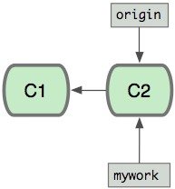

Now you do some work, creating two new commits.

$ vi file.txt
$ git commit
$ vi otherfile.txt
$ git commit
...

Meanwhile, someone else does some work creating two new commits on the origin branch too. This means both 'origin' and 'mywork' has advanced, which means the work has diverged.
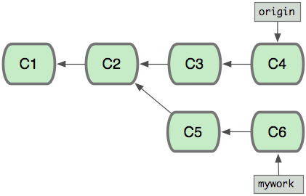

At this point, you could use "pull" to merge your changes back in; the result would create a new merge commit, like this:
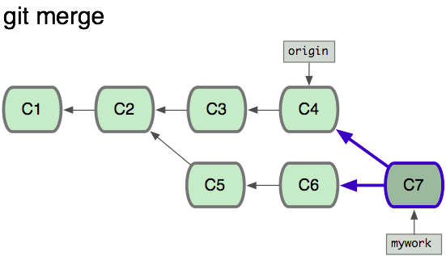

However, if you prefer to keep the history in mywork a simple series of commits without any merges, you may instead choose to use git rebase:

$ git checkout mywork
$ git rebase origin

This will remove each of your commits from mywork, temporarily saving them as patches (in a directory named ".git/rebase"), update mywork to point at the latest version of origin, then apply each of the saved patches to the new mywork.

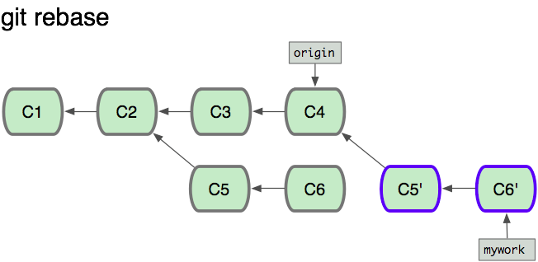
Once the ref ('mywork') is updated to point to the newly created commit objects, your older commits will be abandoned. They will likely be removed if you run a pruning garbage collection.

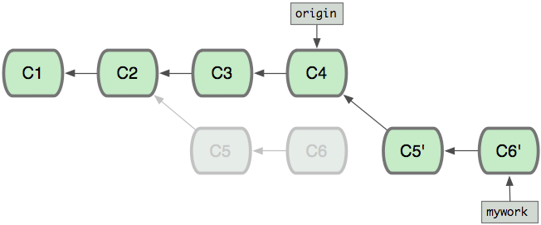
So now we can look at the difference in our history between running a merge and running a rebase:

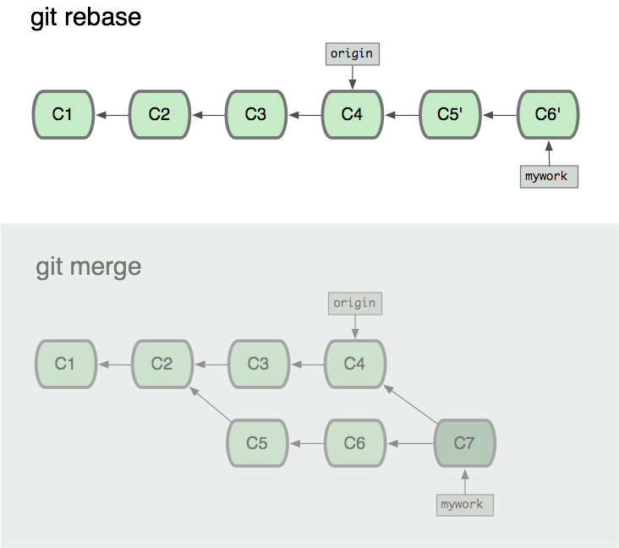

In the process of the rebase, it may discover conflicts. In that case it will stop and allow you to fix the conflicts; after fixing conflicts, use "git-add" to update the index with those contents, and then, instead of running git-commit, just run

$ git rebase –-continue

and git will continue applying the rest of the patches.

At any point you may use the --abort option to abort this process and return mywork to the state it had before you started the rebase:

$ git rebase --abort

ADDITIONAL NOTES ON REBASE:
The first thing to understand about git rebase is that it solves the same problem as git merge. Both of these commands are designed to integrate changes from one branch into another branch—they just do it in very different ways.

Consider what happens when you start working on a new feature in a dedicated branch, then another team member updates the master branch with new commits. This results in a forked history, which should be familiar to anyone who has used Git as a collaboration tool.

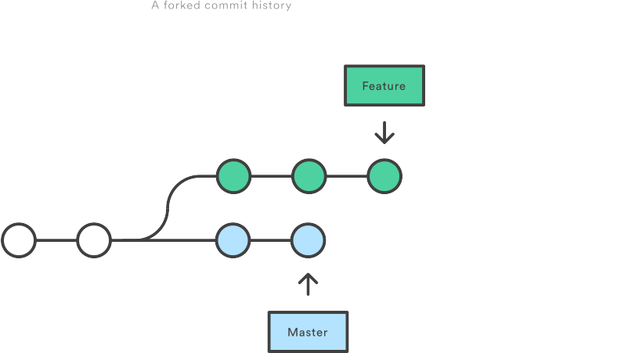

Now, let’s say that the new commits in master are relevant to the feature that you’re working on. To incorporate the new commits into your feature branch, you have two options: merging or rebasing.

The easiest option is to merge the master branch into the feature branch using something like the following:

git checkout feature
git merge master

This creates a new “merge commit” in the feature branch that ties together the histories of both branches, giving you a branch structure that looks like this:

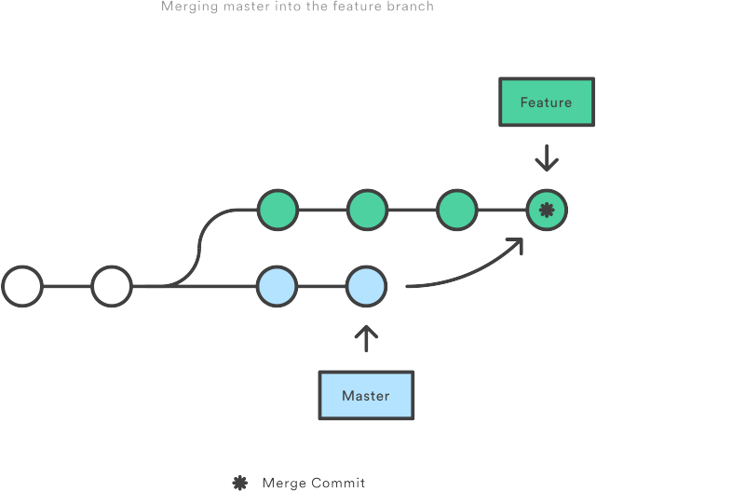

Merging is nice because it’s a non-destructive operation. The existing branches are not changed in any way.

On the other hand, this also means that the feature branch will have an extraneous merge commit every time you need to incorporate upstream changes. If master is very active, this can pollute your feature branch’s history quite a bit. While it’s possible to mitigate this issue with advanced git log options, it can make it hard for other developers to understand the history of the project.

As an alternative to merging, you can rebase the feature branch onto master branch using the following commands:

git checkout feature
git rebase master

This moves the entire feature branch to begin on the tip of the master branch, effectively incorporating all of the new commits in master. But, instead of using a merge commit, rebasing re-writes the project history by creating brand new commits for each commit in the original branch.
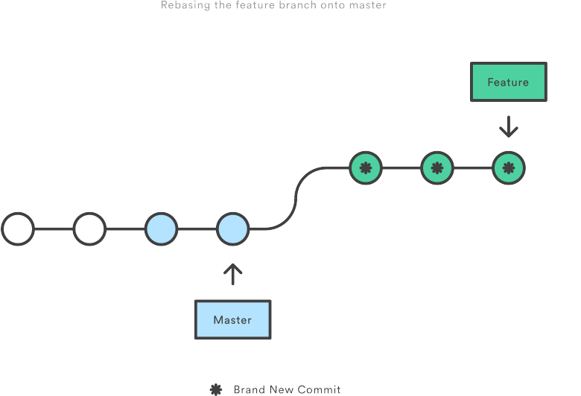

The major benefit of rebasing is that you get a much cleaner project history. First, it eliminates the unnecessary merge commits required by git merge. Second, as you can see in the above diagram, rebasing also results in a perfectly linear project history—you can follow the tip of feature all the way to the beginning of the project without any forks. This makes it easier to navigate your project with commands like git log, git bisect, and gitk.

But, there are two trade-offs for this pristine commit history: safety and traceability.

THE GOLDEN RULE OF REBASING – GIT REVERT:
Once you understand what rebasing is, the most important thing to learn is when not to do it. The golden rule of git rebase is to never use it on public branches.

For example, think about what would happen if you rebased master onto your feature branch:
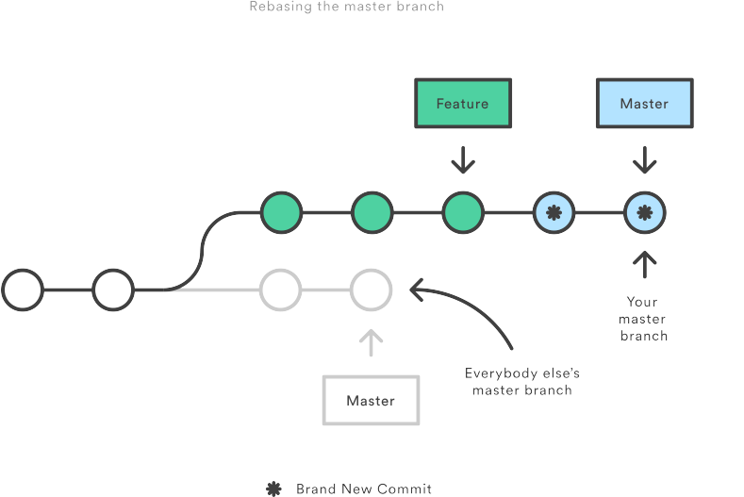

The rebase moves all of the commits in master onto the tip of feature. The problem is that this only happened in your repository. All of the other developers are still working with the original master. Since rebasing results in brand new commits, Git will think that your master branch’s history has diverged from everybody else’s.

The only way to synchronize the two master branches is to merge them back together, resulting in an extra merge commit and two sets of commits that contain the same changes (the original ones, and the ones from your rebased branch). Needless to say, this is a very confusing situation.

So, before you run git rebase, always ask yourself, “Is anyone else looking at this branch?” If the answer is yes, take your hands off the keyboard and start thinking about a non-destructive way to make your changes (e.g., the git revert command). Otherwise, you’re safe to re-write history as much as you like.

STASHING – GIT STASH
While you are in the middle of working on something complicated, you find an unrelated but obvious and trivial bug. You would like to fix it before continuing. You can use git stash to save the current state of your work, and after fixing the bug (or, optionally after doing so on a different branch and then coming back), unstash the work-in-progress changes.

$ git stash save "work in progress for foo feature"

This command will save your changes away to the stash, and reset your working tree and the index to match the tip of your current branch. Then you can make your fix as usual.

... edit and test ...
$ git commit -a -m "blorpl: typofix"

After that, you can go back to what you were working on with git stash apply:

$ git stash apply

You can also use stashing to queue up stashed changes.
If you run 'git stash list' you can see which stashes you have saved:

$>git stash list
stash@{0}: WIP on book: 51bea1d... fixed images
stash@{1}: WIP on master: 9705ae6... changed the browse code to the official repo

Then you can apply them individually with 'git stash apply stash@{1}'. You can clear out the list with 'git stash clear'.

PARTIAL SHA
If your commit sha is '980e3ccdaac54a0d4de358f3fe5d718027d96aae', git will recognize any of the following identically:

980e3ccdaac54a0d4de358f3fe5d718027d96aae
980e3ccdaac54a0d4
980e3cc

As long as the partial sha is unique - it can't be confused with another (which is incredibly unlikely if you use at least 5 characters), git will expand a partial sha for you.

BRANCH, REMOTE OR TAG NAME INSTEAD OF SHA
You can always use a branch, remote or tag name instead of a sha, since they are simply pointers anyhow. If your master branch is on the 980e3 commit and you've pushed it to origin and have tagged it 'v1.0', then all of the following are equivalent:

980e3ccdaac54a0d4de358f3fe5d718027d96aae
origin/master
refs/remotes/origin/master
master
refs/heads/master
v1.0
refs/tags/v1.0

Which means the following will give you identical output:

$ git log master

$ git log refs/tags/v1.0

TRACKING BRANCHES
A 'tracking branch' in Git is a local branch that is connected to a remote branch. When you push and pull on that branch, it automatically pushes and pulls to the remote branch that it is connected with.

Use this if you always pull from the same upstream branch into the new branch, and if you don't want to use "git pull” explicitly.

The 'git clone' command automatically sets up a 'master' branch that is a tracking branch for 'origin/master' - the master branch on the cloned repository.

You can create a tracking branch manually by adding the '--track' option to the 'branch' command in Git.

git branch --track experimental origin/experimental

Then when you run:

$ git pull experimental

It will automatically fetch from 'origin' and merge 'origin/experimental' into your local 'experimental' branch.

Likewise, when you push to origin, it will push what your 'experimental' points to to origins 'experimental', without having to specify it.

FINDING WITH GIT GREP
Finding files with words or phrases in Git is really easy with the git grep command. It is possible to do this with the normal unix 'grep' command, but with 'git grep' you can also search through previous versions of the project without having to check them out.

For example, if I wanted to see every place that used the 'xmmap' call in my git.git repository, I could run this:

$ git grep xmmap

Git Grep has many other options, check them out, if you want to use it deeper.

FIXING UN-COMMITTED MISTAKES – GIT RESET, CHECKOUT
If you've messed up the working tree, but haven't yet committed your mistake, you can return the entire working tree to the last committed state with

$ git reset --hard HEAD

This will throw away any changes you may have added to the git index and as well as any outstanding changes you have in your working tree. In other words, it causes the results of "git diff" and "git diff --cached" to both be empty.

If you just want to restore just one file, say your hello.rb, use git checkout instead

$ git checkout -- hello.rb
$ git checkout HEAD hello.rb

The first command restores hello.rb to the version in the index, so that "git diff hello.rb" returns no differences. The second command will restore hello.rb to the version in the HEAD revision, so that both "git diff hello.rb" and "git diff --cached hello.rb" return no differences.

FIXING COMMITTED MISTAKES – GIT REVERT
If you make a commit that you later wish you hadn't, there are two fundamentally different ways to fix the problem:

a.You can create a new commit that undoes whatever was done by the old commit. This is the correct thing if your mistake has already been made public.

Creating a new commit that reverts an earlier change is very easy; just pass the git revert command a reference to the bad commit; for example, to revert the most recent commit:

$ git revert HEAD

This will create a new commit which undoes the change in HEAD. You will be given a chance to edit the commit message for the new commit.

You can also revert an earlier change, for example, the next-to-last:

$ git revert HEAD^

In this case git will attempt to undo the old change while leaving intact any changes made since then. If more recent changes overlap with the changes to be reverted, then you will be asked to fix conflicts manually, just as in the case of resolving a merge.

b.You can go back and modify the old commit. You should never do this if you have already made the history public; git does not normally expect the "history" of a project to change, and cannot correctly perform repeated merges from a branch that has had its history changed.

If you have just committed something but realize you need to fix up that commit, recent versions of git commit support an --amend flag which instructs git to replace the HEAD commit with a new one, based on the current contents of the index. This gives you an opportunity to add files that you forgot to add or correct typos in a commit message, prior to pushing the change out for the world to see.

If you find a mistake in an older commit, but still one that you have not yet published to the world, you use git rebase in interactive mode, with "git rebase -i" marking the change that requires correction with edit. This will allow you to amend the commit during the rebasing process.

ENSURING GOOD PERFORMANCE – GIT GC
On large repositories, git depends on compression to keep the history information from taking up too much space on disk or in memory.

This compression is not performed automatically. Therefore you should occasionally run git gc:

$ git gc

to recompress the archive. This can be very time-consuming, so you may prefer to run git-gc when you are not doing other work.

ENSURING REALIABILITY – GIT FSCK
The git fsck command runs a number of self-consistency checks on the repository, and reports on any problems. This may take some time. The most common warning by far is about "dangling" objects:

$ git fsck
dangling commit 7281251ddd2a61e38657c827739c57015671a6b3
dangling commit 2706a059f258c6b245f298dc4ff2ccd30ec21a63

Dangling objects are not a problem. At worst they may take up a little extra disk space. They can sometimes provide a last-resort method for recovering lost work.

FINDING OUT WHO CHANGED FILE - GIT BLAME
The git blame command is really helpful for figuring out who changed which sections of a file. If you simple run 'git blame [filename]' you'll get an output of the entire file with the last commit sha, date and author for every line in the file.

$ git blame sha1_file.c

This is often helpful if a file had a line reverted or a mistake that broke the build to help you see who changed that line last.

You can also specify a start and end line for the blame:

$>git blame -L 160,+10 sha1_file.c

HOW GIT STORES OBJECTS
All objects are stored as compressed contents by their sha values. They contain the object type, size and contents in a gzipped format.

There are two formats that Git keeps objects in - loose objects and packed objects.

LOOSE OBJECTS:
Loose objects are the simpler format. It is simply the compressed data stored in a single file on disk. Every object written to a seperate file.

If the sha of your object is ab04d884140f7b0cf8bbf86d6883869f16a46f65, then the file will be stored in the following path:

GIT_DIR/objects/ab/04d884140f7b0cf8bbf86d6883869f16a46f65

It pulls the first two characters off and uses that as the subdirectory, so that there are never too many objects in one directory. The actual file name is the remaining 38 characters.

PACKED OBJECTS:
The other format for object storage is the packfile. Since Git stores each version of each file as a seperate object, it can get pretty inefficient. Imagine having a file several thousand lines long and changing a single line. Git will store the second file in it's entirety, which is a great big waste of space.

In order to save that space, Git utilizes the packfile. This is a format where Git will only save the part that has changed in the second file, with a pointer to the file it is similar to.

When objects are written to disk, it is often in the loose format, since that format is less expensive to access. However, eventually you'll want to save the space by packing up the objects - this is done with the git gc command. It will use a rather complicated heuristic to determine which files are likely most similar and base the deltas off that analysis. There can be multiple packfiles, they can be repacked if neccesary (git repack) or unpacked back into loose files (git unpack-objects) relatively easily.

Git will also write out an index file for each packfile that is much smaller and contains offsets into the packfile to more quickly find specific objects by sha.

SVN VS GIT
1. git is a distributed version control system (dvcs) which is basically based on the concept that complete code base of a project along w/ it's full version history (not just latest snapshot) would be copied onto every developer's machine.

2. This mainly gives the advantage of working offline and also allows us to not rely on a single backup.

3. But because of the concept of full checkout (including the history), the initial checkout is slower and problematic for projects w/ huge history.

4. And this a problem particularly in enterprise codebases where the code base spans across multiple repos., checking-out all and storing everything on local machine is an head-ache.

5. DVCS like git also lacks pessimistic locking mechanisms where only one user is allowed to checkout a file and every other user who tries to checkout the same file will only get a read-only copy.

6. In DVCS, since each developer has a full copy of the repo., s/he can share their changes with other people to get some feedback before sharing these changes w/ everybody.

7. DVCS can also have a central project repo. for e.g. github.

8. Github is a hosting service and software code management too implementing git. But, github, in general, is a centralized repo. following git model, meaning, users of github can get a full-copy of the entire project (along w/ its history) thereby allowing users to work offline and also allowing users to have a full-copy of the entire project w/o having to depend on the github copy.

9. Projects on a dvcs, with a long history, as long as 50000 changesets or more will take a huge amount of time and diskspace to download.

10. svn (Apache Subversion), on the other hand, is a centralized version control system (cvcs), which basically means, there is always a single central copy on a server and all commits are made to this copy.

11. svn provides locking mechanism - both optimistic and pessimistic locking.

12. Since, in case of a cvcs like svn, there is only one true repo (which is the server), it is almost impractical to work offline - can't perform tasks like commit, viewing history etc.
13. a cvcs like svn is probably a better choice when it comes for managing enterprise level projects whereas a dvcs like a git is a better choice for managing foss (free-and-open-source) projects.

14. coz in an enterprise project, downloading full source code spanning across multiple repos to a local machine may not be a practical and secure option whereas in a foss project, especially w/ contributors all across the world, a distributed model with an ability for each developer to download the full copy of the project (along w/ its history) and work offline is a more powerful and practical approach.

IGNORING SECRET/PRIVATE FILES WHILE STAGE & COMMIT

In my local repo I have a few heapdump files that are around 2.5 GB and I don’t want them to be part of the github repo, so to ignore them while adding them to repo, I have tried following ways:

a.This is a raw way of doing it:

I’ve literally given all the names of the files that needs to be added in the git add command thereby purposefully excluding those two files, once the commit is done check the status:
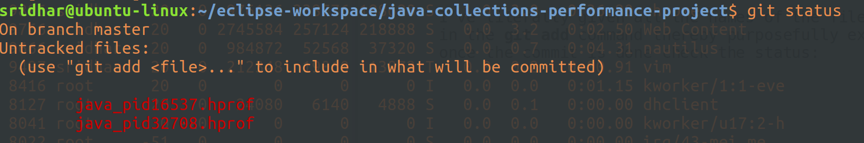
Two files left out, as wanted.

b.The other easier way to do this is to add .gitignore file.

The contents inside the git ignore will be ignore while doing a git add.

Created a .gitignore file at the root project dir:
And, added only one line in the file:
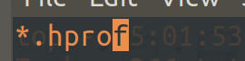

To ignore all files ending with .hprof, which are basically heapdump files.

Committed the .gitignore file to the repo:
And, now when I do a git status I don’t see the two heapdump files:
That’s it, this means, git is no longer tracking these two files.

The thing is, .gitignore only ignores those files that are not already tracked by git i.e. those that have not been git added before. So, If you want to untrack an already staged/committed file, then do a :
git reset name_of_file

Then add the name of this (to be untracked file) in the .gitignore file.

And, If you also want to remove this file from the repo itself, then:
git rm --cached name_of_file

Although, you can create a .gitignore file at any dir level in the project dir, it is preferred to create it at the root of the project dir, so that there is only one .gitgnore file per project.

REMOVING A FILE (WHICH HAS BEEN DELETED FROM WORKING REPO) FROM REMOTE MASTER
Let’s say when you do a git status you come to know that there are files which you have deleted from your working repo but they are present in master (remote) and if you want to delete them from there as well:
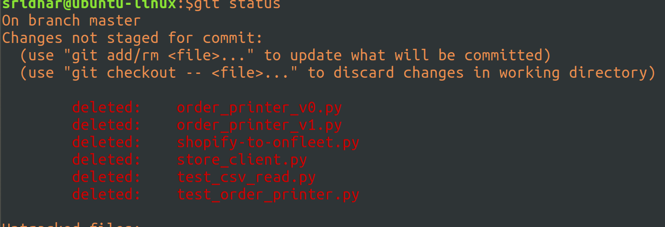
Then, do a git rm and then just commit and push it, that;s it:
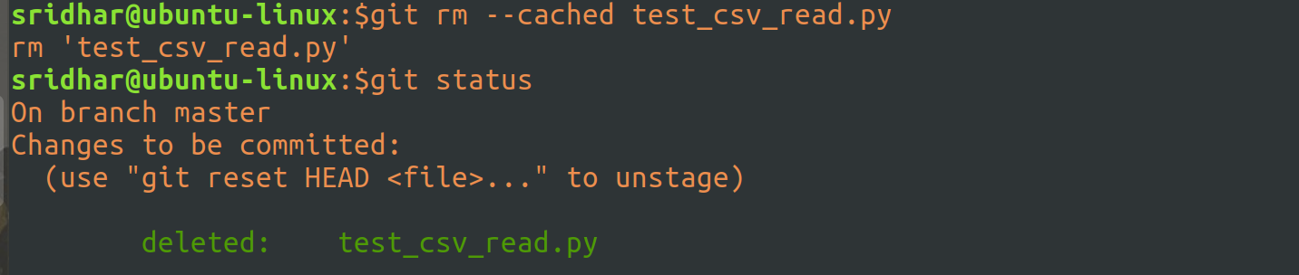
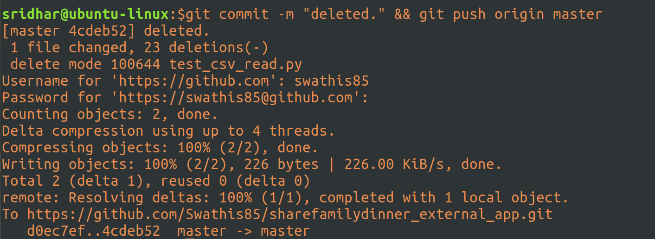

GIT PRODUCTION STRATEGIES FOR SOFTWARE DEVELOPMENT

These two articles here have all the details and are really good workflow for enterprise or production or how we should use git in software companies, the workflow:

https://dzone.com/articles/git-strategies-for-software-development
https://dzone.com/articles/git-strategies-for-software-development-part-2

