[INDEX]

1.TO CHANGE THE HOSTNAME OF THE MACHINE (PERMANENTLY)

2.TO TIME THE SHUTDOWN OF THE MACHINE

3.TO MONITOR NETWORK TRAFFIC
a.Installing and using iftop
b.Using iftop with port display

4.TO DISPLAY AND MONITOR LINUX PROCESSES
a.Using the command 'top' (using htop instead)
a.Sorting with other parameters

5.TO KNOW PRIVATE IP ADDRESS OF YOUR SYSTEM

6.TO KNOW PUBLIC IP ADDRESS OF YOUR SYSTEM

7.HOW TO TRACE THE ROUTE TAKEN WHEN YOU TRY TO CONNECT TO A WEBSITE
a.Installing and Using traceroute
b.Notes on traceroute
c.Using tcptraceroute

8.HOW TO DETERMINE IP ADDRESS FROM HOSTNAME
a.Using nslookup

9.TO DETERMINE GEOLOCATION OF AN IP
a.Calling ipinfo

10.HOW TO DETERMINE THE ASN OF AN IP ADDRESS
a.Installing and Using whois

11.NOTES ON BOGONS

12.INITIATING A COUNTDOWN TIMER IN LINUX TERMINAL
a.Using 'at' command
b.Using 'atq' command

13.PLAYING MUSIC OR SOUND FROM THE TERMINAL

14.TO FIND OUT MORE ABOUT A PROCESS WITH ITS PID

15.TO SEE A LIST OF PIDs ASSOCIATED WITH AN OWNER

16.CHECKING FOR LINUX UPDATES AND UPDATING

17.CHECKING LINUX KERNEL VERSION

18.NOTES ON LINUX PERMISSIONS

19.TO KNOW WHEN A FILE WAS CREATED

20.TO CHECK IF A PARTICULAR SOFTWARE IS ALREADY INSTALLED

21. TO SEE A LIST OF ALL SERVICES THAT START ON STARTUP AND HOW TO SHUT THEM DOWN

22. HOW TO SOLVE DNS ISSUES

23. HOW TO DEAL WITH SWAP MEMORY ISSUES

24. HOW TO MAKE CHANGES TO BASH PROMPT

[TO CHANGE THE HOSTNAME OF THE MACHINE (PERMANENTLY)]

The exact details are in this article:
https://www.cyberciti.biz/faq/ubuntu-18-04-lts-change-hostname-permanently/

I basically did:
sudo hostnamectl set-hostname <newname>

and then:
sudo nano /etc/hosts and replaced any occurrences of the old hostname with the new name and saved the file (ctrl+x) and press Y and exit.

And then finally a reboot:
sudo reboot.

Done.

I din’t follow the nixcraft approach mentioned in the article.

The hostnamectl command basically outputs the hostname of the machine, machine id, os, kernerl and the cpu architecture.

I also tried doing some research regarding changing the username as well, but it is a long and tedious process and good changes of things going wrong, so din;t mess with it.

[TO TIME THE SHUTDOWN OF THE MACHINE]

You can use the shutdown command. It basically allows you to halt/shutdown/reboot a linux machine.

Just shutdown will power-off the machine in 1 minute.
And, shutdown now will do an immeidate shutdown.
And, shutdown +5 will do it in 5mins from now.
You can also do a reboot with a -r option: shutdown -r +5 will reboot in 5 mins from now.

In fact, there is a plain reboot comman also, with which also you can do all 3 things, and if you do not give any args, it will by default reboot.

[TO MONITOR NETWORK TRAFFIC]

iftop can be used to monitor network traffic.

To install: sudo apt install iftop
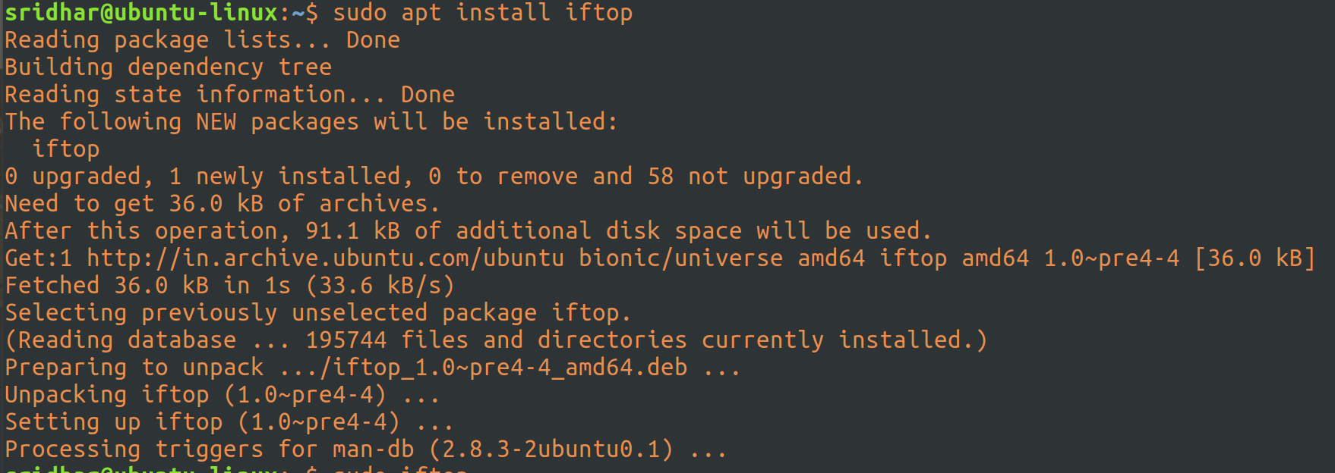
iftop needs to be run with root priveleages, if you run it otherwise, it will fail to capture traffic:

Now, let’s run iftop with sudo: sudo iftop

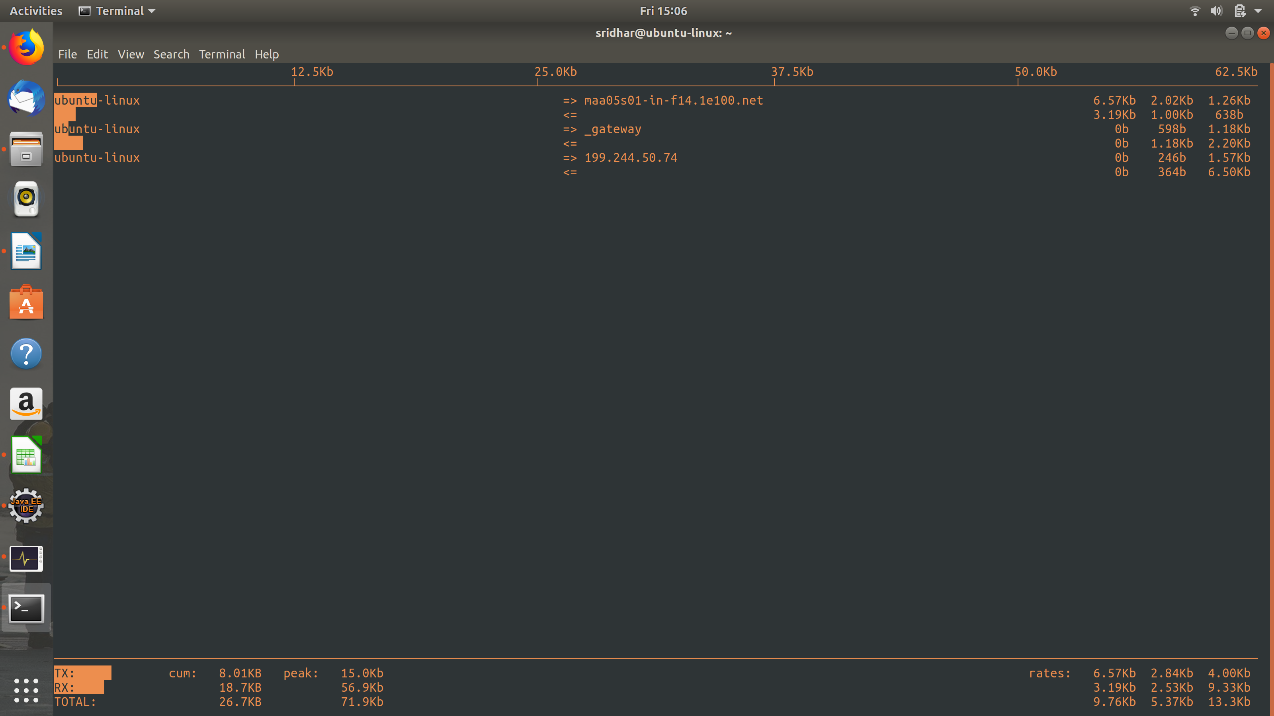
As you can see, it starts capturing traffic.

To also look at port display, meaning, to switch on port display, just press ‘p’ on the keyboard while the iftop is running:

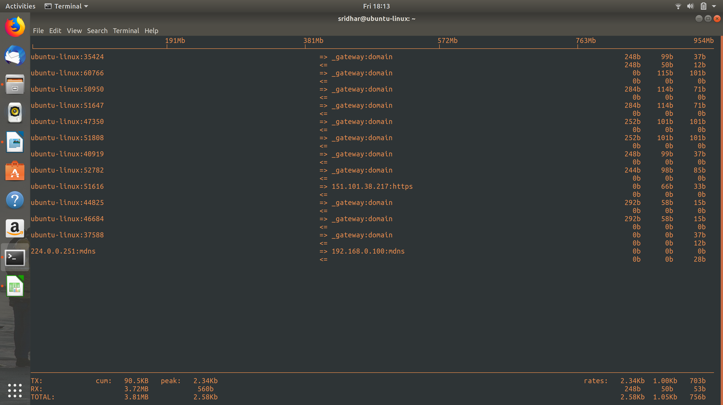

[TO DISPLAY AND MONITOR LINUX PROCESSES]

In order to see which processes in your machine are taking a lot of cpu/memory, you can use the ‘top’ command.

To run, just issue the command: top

Correction/Update: I’v estrated using htop (instead of top). Top is an utility that comes pre-installed in linux distros whereas htop is not but htop is built on top of top :) and it has a better interface and options to scroll through the list as well.

and you’ll the list of processes running currently in your machine, by default, sorted by cpu consumption:

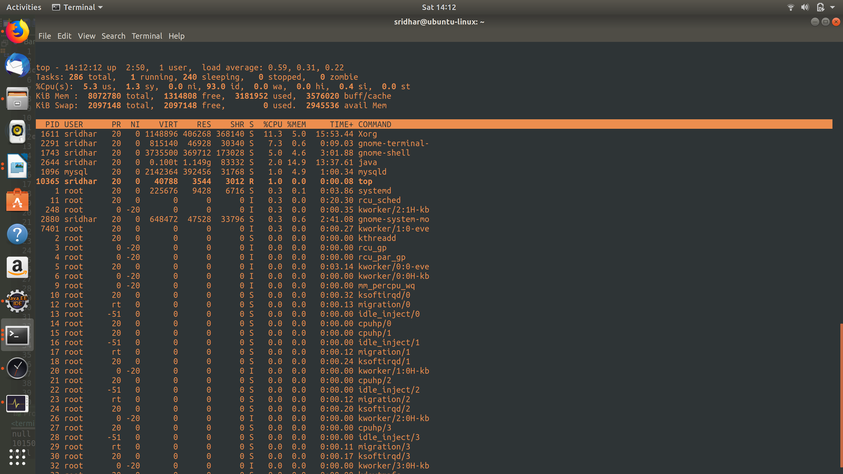

If you want to sort it by any other paramter, then simply press
‘shit + f’ while the top is running:

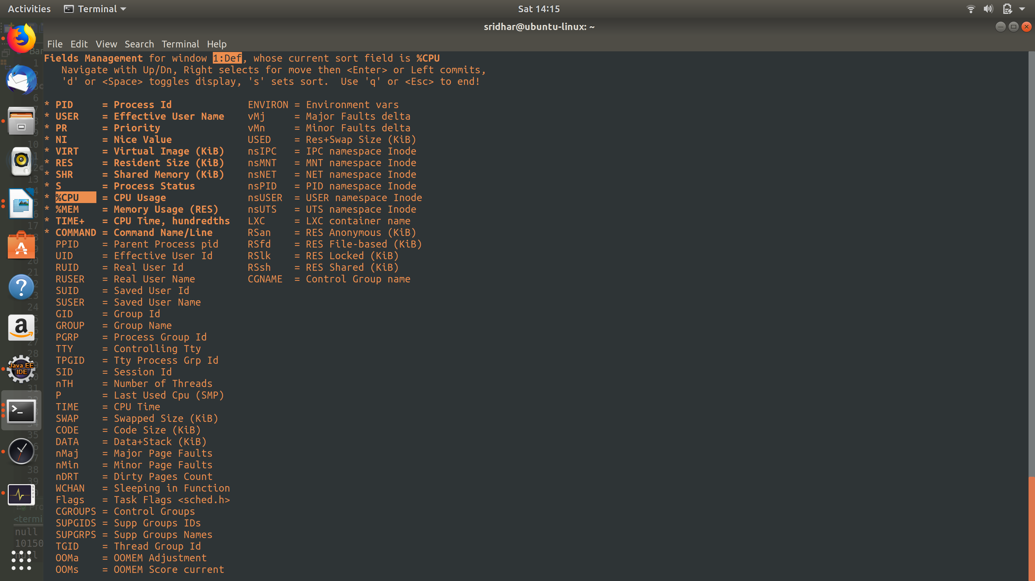
And, you’ll get to see a list of options on the basis of which you can sort.

Use arrow keys to select the sort and then press ‘s’ and press ‘q’:
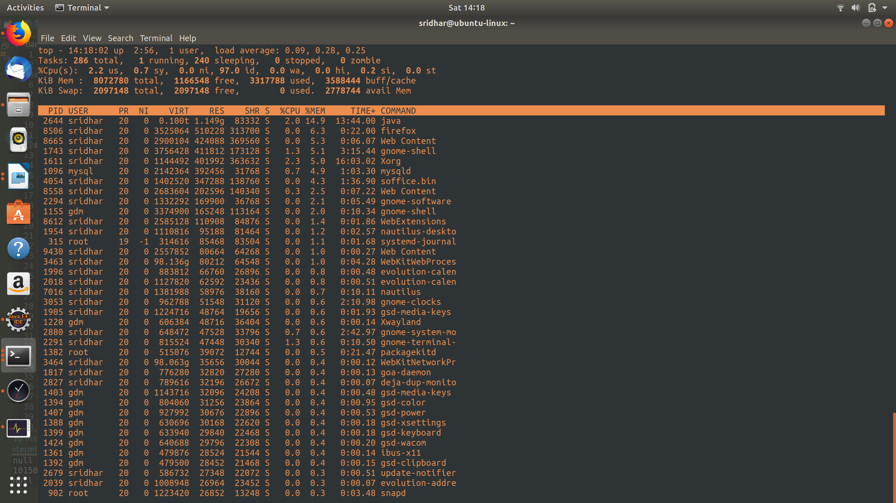

And, as you can see from above, it is now sorted on the basis of memory consumption.

[TO KNOW PRIVATE IP ADDRESS OF YOUR SYSTEM]

You can use ifconfig command, which will display your ipv4 and ipv6 addresses.

You ipv4 private address will be under the ethernet section (for e.g. wlp1s0), and next to ‘inet’ and ipv6 will be next to ‘inet6’.

You can also use hostname -I, please note – if you ‘i’ as an option it’ll display the local host address and not the private ipv4 address.

[TO KNOW PUBLIC IP ADDRESS OF YOUR SYSTEM]

For this, the general way is to ‘curl’ one of those systems on the internet which will return you your public ip address, such as, ifconfig.me, icanhazip.me etc:

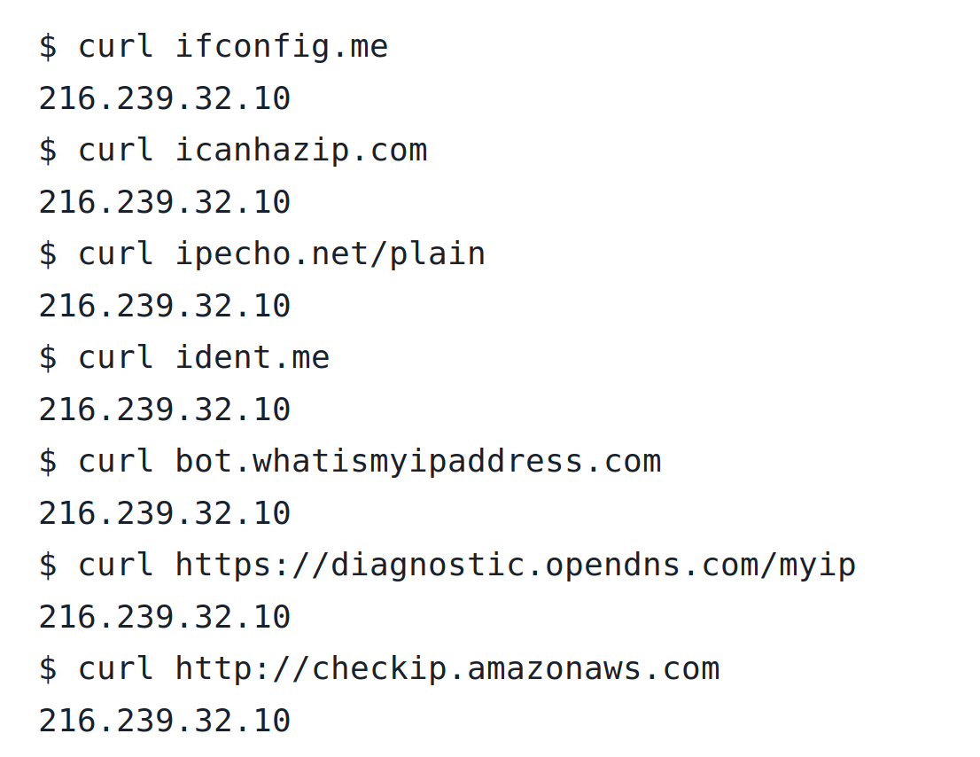
There are a few other ways also, but this is preferrable.

[HOW TO TRACE THE ROUTE TAKEN WHEN YOU TRY TO CONNECT TO A WEBSITE]

For this you need to install the ‘traceroute’ package in ubuntu.

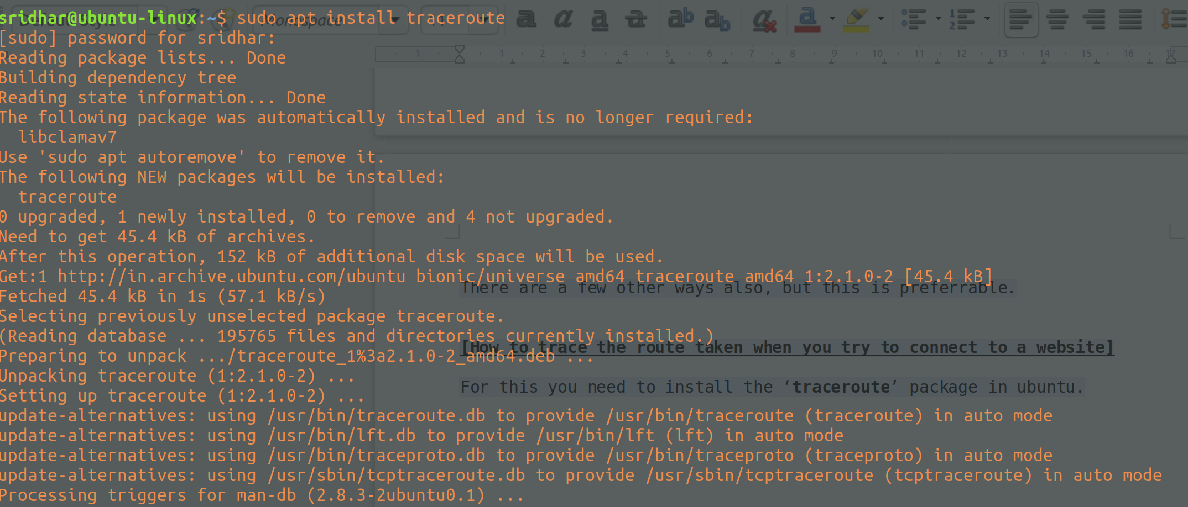
Once this is dnoe, now you’re ready to use it and trace the route of any website you’re trying to connect to.

Let’s try and connect to askubuntu.com and see what route does it take:

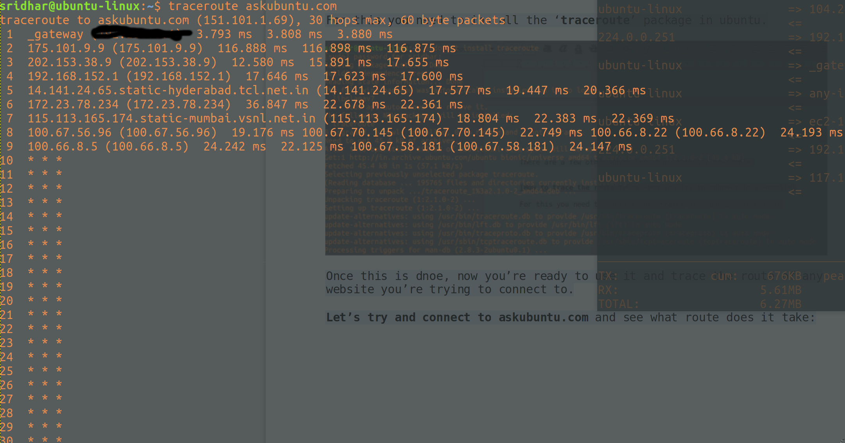
That’s it.

[More about traceroute]
[] The traceroute command is used in Linux to map the journey that a packet of information undertakes from its source to its destination.

[] One use for traceroute is to locate when data loss occurs throughout a network, which could signify a node that's down.

[] Because each hop in the record reflects a new server or router between the originating PC and the intended target, reviewing the results of a traceroute scan also lets you identify slow points that may adversely affect your network traffic.

[] A hop is a computer networking term that refers to the number of routers that a packet (a portion of data) passes through from its source to its destination. Sometimes a hop is counted when a packet passes through other hardware on a network, like switches, access points, and repeaters. This isn't always the case and it depends on what role those devices are playing on the network and how they're configured.

[] Traceroute uses the IP protocol time to live field to solicit an ICMP TIME_EXCEEDED response from each gateway along the path to a destination host.

[] All the tracerouting tools rely on the following principle: they send packets with a short life, and wait for ICMP packets reporting the death of these packets. An IP packet has a field called "TTL" (as "Time To Live") which is decremented at each hop; when it reaches 0, the packet dies, and the router on which this happens is supposed to send back a "Time Exceeded" ICMP message. That ICMP message contains the IP address of the said router, thus revealing it.

[] The only parameter you must include when you execute the traceroute command is the host name or IP address of the destination.

[] Traceroute outlines the path an IP packet follows to an internet host by launching UDP probe packets with a small TTL then listening for an ICMP "time exceeded" reply from a gateway. Start probes with a TTL of one and increase by one until you get an ICMP "port unreachable" (which means the packet arrived at its destination) or hit a max value of attempts, which defaults to 30 hops and can be changed with the -m flag.

[] Three probes are sent at each ttl setting and a line is printed showing the ttl, address of the gateway and rounf trip time of each probe.

[] If there is no response or if there is a firewall which blocks sending out information or if the host is a ‘silent gateway’, we will print ‘*’.

[Using TCP Traceroute]
[] This option uses modern tcp syn method to probe.

[] This is intended to bypass firewalls.

[] This method well known ‘half-open technique’, which prevents applications on the destination host from seeing our probes at all.
[] A tcp syn is sent.

[] You can use this command by either issuing:
tcp -T google.com or tcptraceroute google.com ,
both will work and are the same available as part of traceroute package.

[] Plain traceroute uses either UDP packets, or ICMP "Echo" packets, both kinds being routinely blocked by (over)zealous sysadmins. tcptraceroute instead uses a TCP "SYN" packet, i.e. the kind of packet that would occur as first step in the TCP "three-way handshake". That kind of packet is not usually blocked by firewall, at least as long as the destination port is "allowed". tcptraceroute will not complete any TCP handshake; it just relies on the ideas that SYN packets are not shot on sight by firewalls.

[] There is no risk in using this and there is nothing to mitigate.

Here’s the output using tcp traceroute, you can compare it with the UDP one:

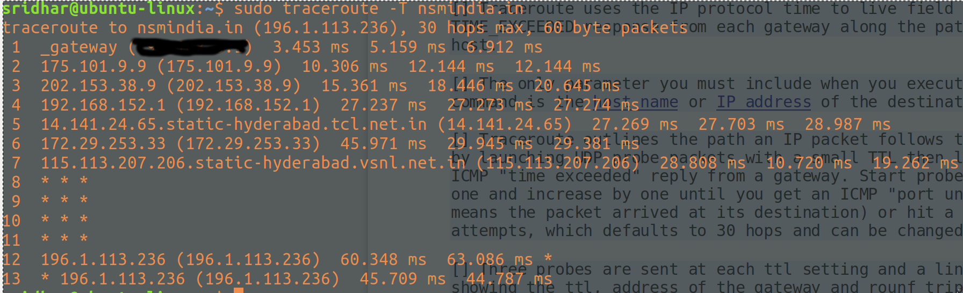

[HOW TO DETERMINE IP ADDRESS FROM HOSTNAME]

[] There will be situations where you will see some randome hostnames connecting to your system when you run sudo iftop

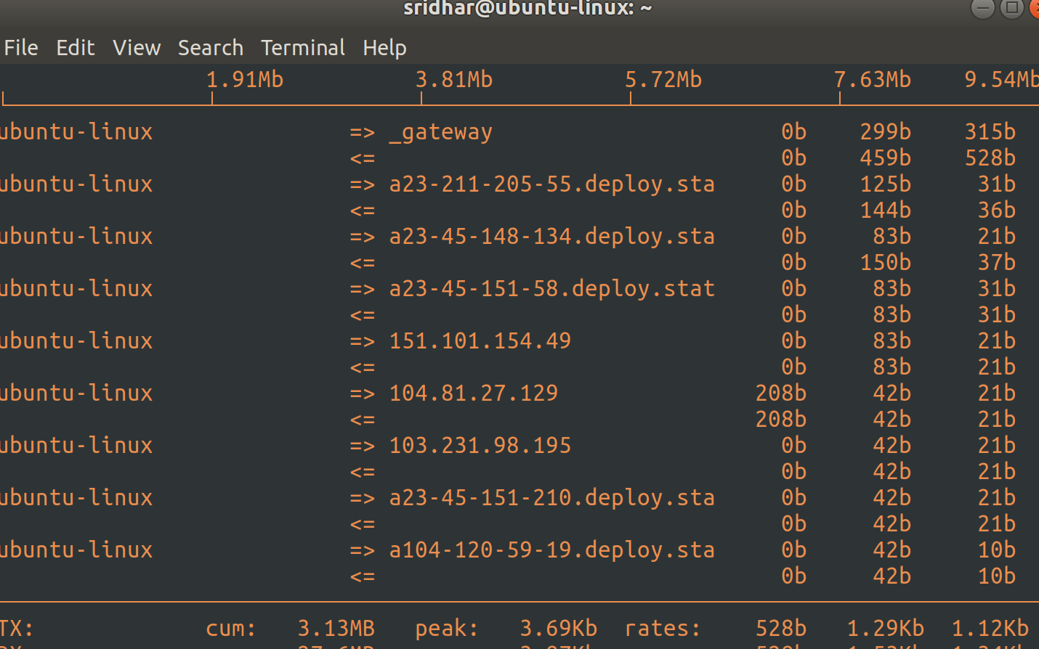
[] As you can see in the above screencast, not everything is an ip address, some of them are hostnames, so in order to determine the ip address of this hostname, we will use, nslookup command:

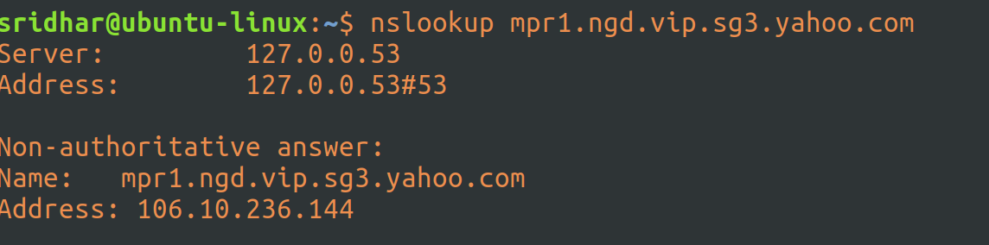

[TO DETERMINE GEOLOCATION OF AN IP]

[] There are websites which you can visit and check but this is about finding out the geolocation through linux terminal.
[] Use curl and call the relevant website which accepts the input and gives you a response, mostly in json.
[] I’ve used both ipvigilante and ipinfo sites.
[] Check the screenshots below:

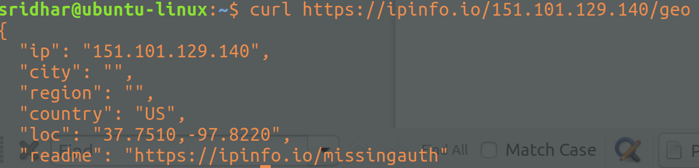

I found ipinfo to be better, but I am not sure if there is any rate limit as such, let’s see.

[HOW TO DETERMINE THE ASN OF AN IP ADDRESS]

[] For this you need to install whois package.

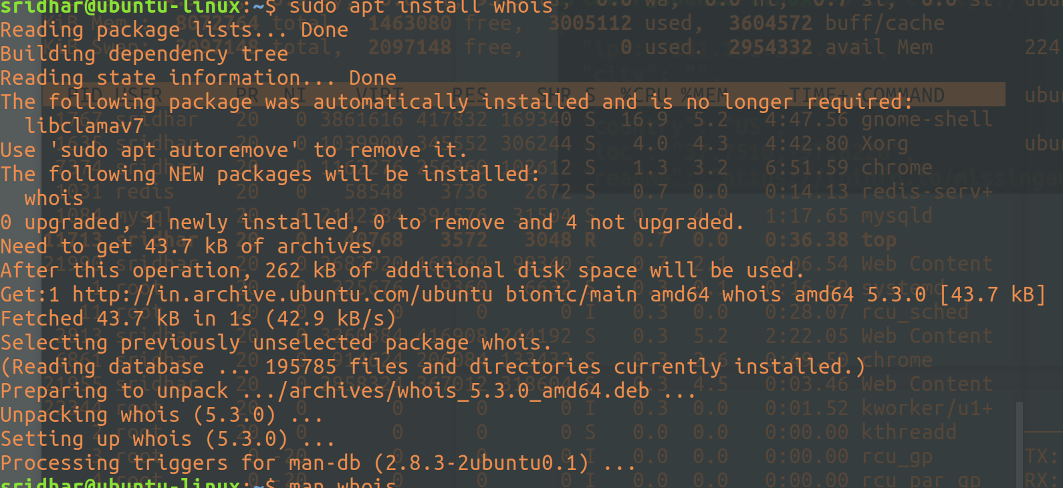
[] Once done, you can issue the following command to lookup ASN of an ip: whois -h whois.cymru.com " -v [IP_ADDR]"

[BOGONS]

[] A bogon is an bogus IP address from the bogon space, which is a set of IP addresses not yet officially assigned to any entity by the Internet Assigned Number Authority (IANA) or a regional Internet registration institute.

[] Bogon IP addresses are legitimate addresses. You may see a bogon IP address as a result of a misconfiguration (whether intentional or unintentional) that fools a recipient about a sender's legitimate IP address.

[] Bogon IP addresses are popular in hacking or malicious activities and are used by spammers and those who initiate distributed denial-of-service attacks. As such, many Internet service providers and firewalls block bogons.

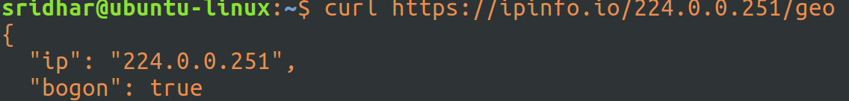

[Bogons Ate my Website – 2005 article]
[] We were recently contacted by one of our customers wanting to know why their site was dropping in their search engine rankings. The site's presence in Yahoo! was slowing eroding - every day a few more indexed pages would disappear. The site had not undergone any content changes, but it had recently changed ISPs. What could be causing the problem? It was only through the teamwork of networking staff at both Yahoo! and RackSpace that the issue was identified, isolated, and corrected. Curiously, neither was to blame, but both were instrumental in solving the problem.

[] There were a number of unusual aspects to the case, including the fact that only rankings on Yahoo seemed to be affected. More interestingly, Yahoo's spiders were reaching the site according to the logs, but when we checked with Yahoo they were apparently reporting an error.

[] So we began a detailed analysis of what was going on. The analysis was made more difficult by the fact that running a traceroute from Yahoo to the website showed that the ping made it into RackSpace's network before disappearing. RackSpace, doing the same trace in reverse, noted that the ping disappeared once Yahoo's network was reached, thus prompting a scenario where each initially blamed the other based on the evidence presented.

[] We had no reason to believe that either party was misleading us, so we began a careful troubleshooting checklist. The site itself was clean and fast, used no risky tactics and was very spiderable. The robots.txt and other robot behavior control codes freely allowed spiders into the site, and there were no errors in the DNS or other related server technologies. Additionally, the site had been spidered by various search engines in the past, and was ranking well in several categories. We knew it wasn't the site, and began to check the network.

[] First, we checked the IP address of the website. There was no indication of it being blacklisted for spam purposes.

[] Next, we checked for the website being blocked by Yahoo or the Yahoo spiders being blocked by RackSpace. Both parties assured us that this was not the case. Yahoo was able to confirm that the spiders were unable to access the site, however.

[] The only odd factor in the new hosting location was that the IP block was only recently allocated - previously it was part of a reserved block not in use anywhere. It was this oddity that allowed us to identify the culprit: a monster lurking in the internet known as a bogon.

[] After a few phone calls and some additional tests, we verified that a bogon had indeed eaten our website and Yahoo's spiders, and could very well be lurking out there on the internet waiting for others, as well. Once we confirmed this to Yahoo they were able to deal with the matter and the client is now enjoying his previous rankings and traffic.

[] Let's back up a step and outline an issue that networks deal with all the time - spammers and hackers. Naturally these people do not wish to be traced or identified, so they often send fake return IP addresses to make it difficult to track them. It's like sending a nasty letter to someone and using a fake return address.

[] There are billions of potential IP addresses in the world, including a lot of IP addresses that are not being used. They are either being held in reserve for future needs, or are allocated for testing or other purposes. It's a fair assumption that anything coming to you with an address you know is fake is probably up to no good.

[] Network administrators have discovered that if they block all of these known unused addresses from moving through their networks, they can block upwards of 60% of spam and hackers. This makes blocking known unused addresses a very easy way to make your network run better and make your users happy.

[] These unused IP addresses are collectively known as a bogon, a contraction of "bogus logon", or a logon from a place you know no one can actually logon from.

[] Smart network administrators block bogons at the router or firewall level, never letting them get into the system in the first place. But what happens when a previously unallocated IP address is released into public use?

[] In a perfect world, all network administrators everywhere would either manually or automatically update their bogon filters to allow the new IP's to flow through their network. But it's not a perfect world, and RackSpace reports that a large number of administrators either do not update their bogon filters automatically or are running systems that need to be manually updated and have not done so yet.

[] This means that if you are given an IP address that was a bogon until recently, you may find your website blocked from various ISP's and networks.

[] The issue with our client was not that Yahoo was blocking the IP, but Yahoo's ISP was. Since the main router for RackSpace was a known safe IP address, what would happen was that the trace from Yahoo would leave Yahoo, go through their ISP, enter RackSpace's network and then get directed to the new IP, all the while reporting back at each step that it had successfully arrived.

[] Of course, the report back from the new IP was being blocked by Yahoo's ISP, which made it look like the trace ping entered RackSpace but never arrived at the new IP, since the return packet was being blocked. This explains why Yahoo's spiders were showing up in the logs, but were not reporting their visit back to Yahoo - they were visiting and reporting, but the reports were being intercepted by the bogon filter and discarded.

[] Yahoo's ISP has since fixed this problem, but there are a great many ISP's and networks out there that have not. There may be websites that are not accessible to some search engines and visitors, with the website owner not having any clue as to the reason why.

[INITIATING A COUNTDOWN TIMER IN LINUX TERMINAL]

[] You can basically use the linux ‘at’ command to initiate a timer, in fact, it is used to schedule a job at a certain date/time.

[] ‘now + 1 minute’ is when you are scheduling something and that something is described by the ‘notify-send ALARM’

[] when you execute the command, this is what you will see as the response:
[] you can check all available scheduled jobs with ‘atq’ command:
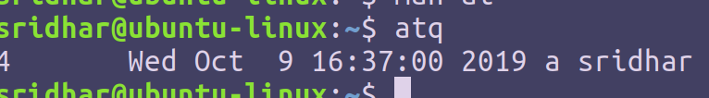
[] so, when the timer finishes, you’ll see a popup on your desktop w/o any sound.
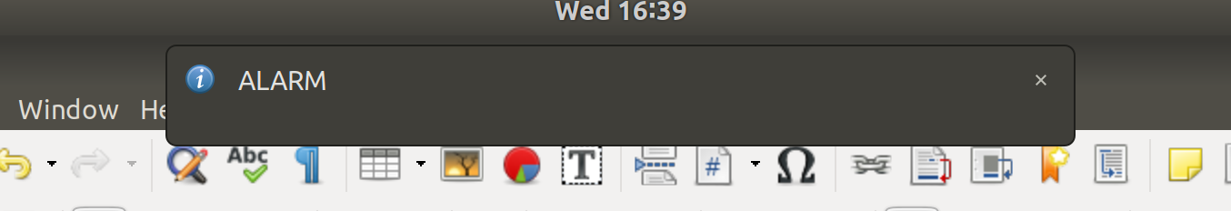

[PLAYING MUSIC OR SOUND FROM TERMINAL]

[] The ‘aplay’ command of linux utility allows you to play any sound or music from the terminal, at a desired frequency for a certain amount of time.

[] More details here:
https://www.geeksforgeeks.org/aplay-command-in-linux-with-examples/

[TO FIND OUT MORE ABOUT A PROCESS WITH ITS PID]

Let’s assume that I know the pid of a process and I want to know more about it.

So, we know 2 PID’s of two processes (from above screenshot of top command), I can now use ps command to just focus on them:

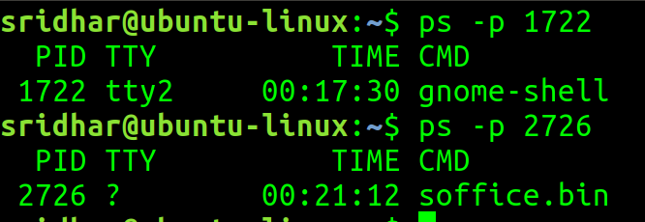
This information is available only for live processes. I mean, ps command, in general is for live processes only.

[TO SEE A LIST OF PIDs ASSOCIATED WITH AN OWNER]

This is a snapshot of top:
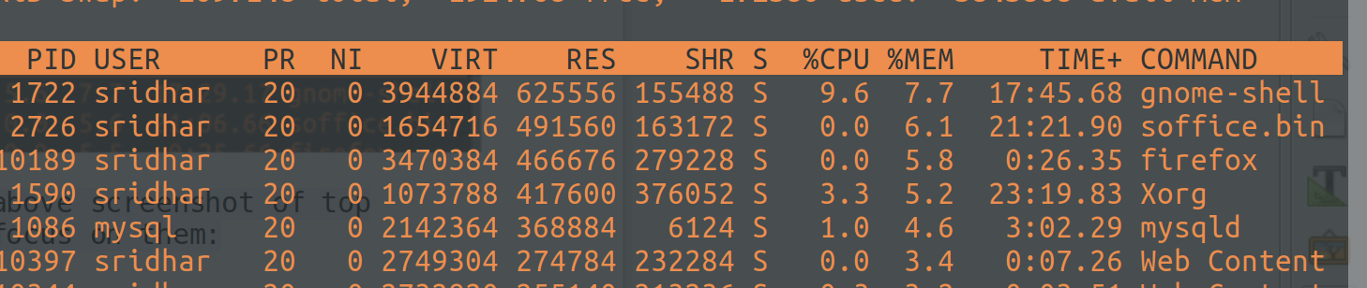
Now, let’s say, I wanna know all processes owned and currently running by owner ‘firefox’:
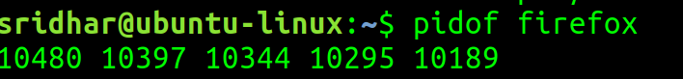

pidof allows us to see all pid’s associated with an owner.

And, if we want to see the same info in detail:
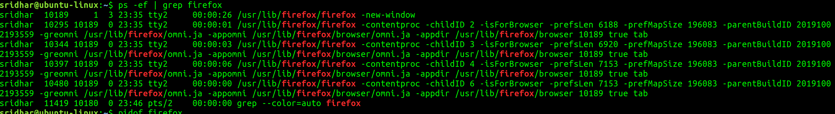
ps -ef | grep firefox : This is same as pidof, except that, this brings in many more details associated with the owner.

[CHECKING FOR LINUX UPDATES AND UPDATING]

You can do a an Alt+F2 and you will get a screen for all updates or you can go into the terminal and run
sudo apt update
sudo apt dist-upgrade
Refer: https://wiki.ubuntu.com/Security/Upgrades

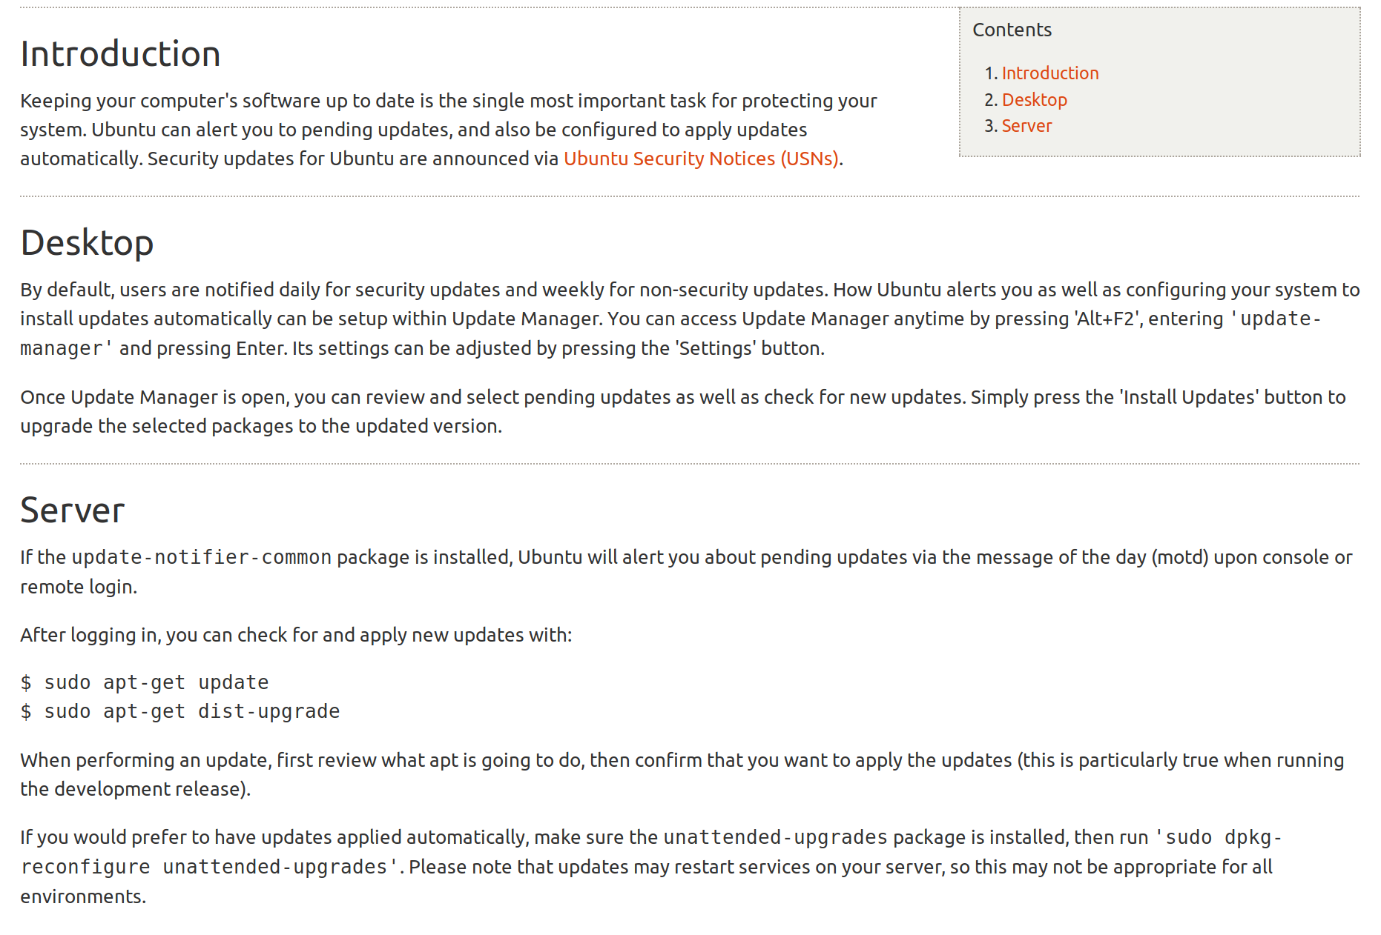
[CHECKING LINUX KERNEL VERSION]

You can check your linux kernel version by typing uname -r in the linux terminal.

[DEBUGGING MOUSE AND KEYBOARD EVENTS]

If you are having any issues with keyboard, mouse and touchpad in linux then you can debug using the ‘xev’ command;

This will basically open up a window on which you can enter keyborad events or perform mouse ops and see what events/keys/buttons are getting called for each, helps debugging.

I am having mouse scroll issue. Whenever I’m scrolling up, the scroll down gets called intermittently and vice-versa. I can see this even with the xev to confirm the issue.
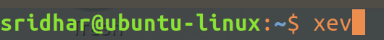

A window like this opens up:
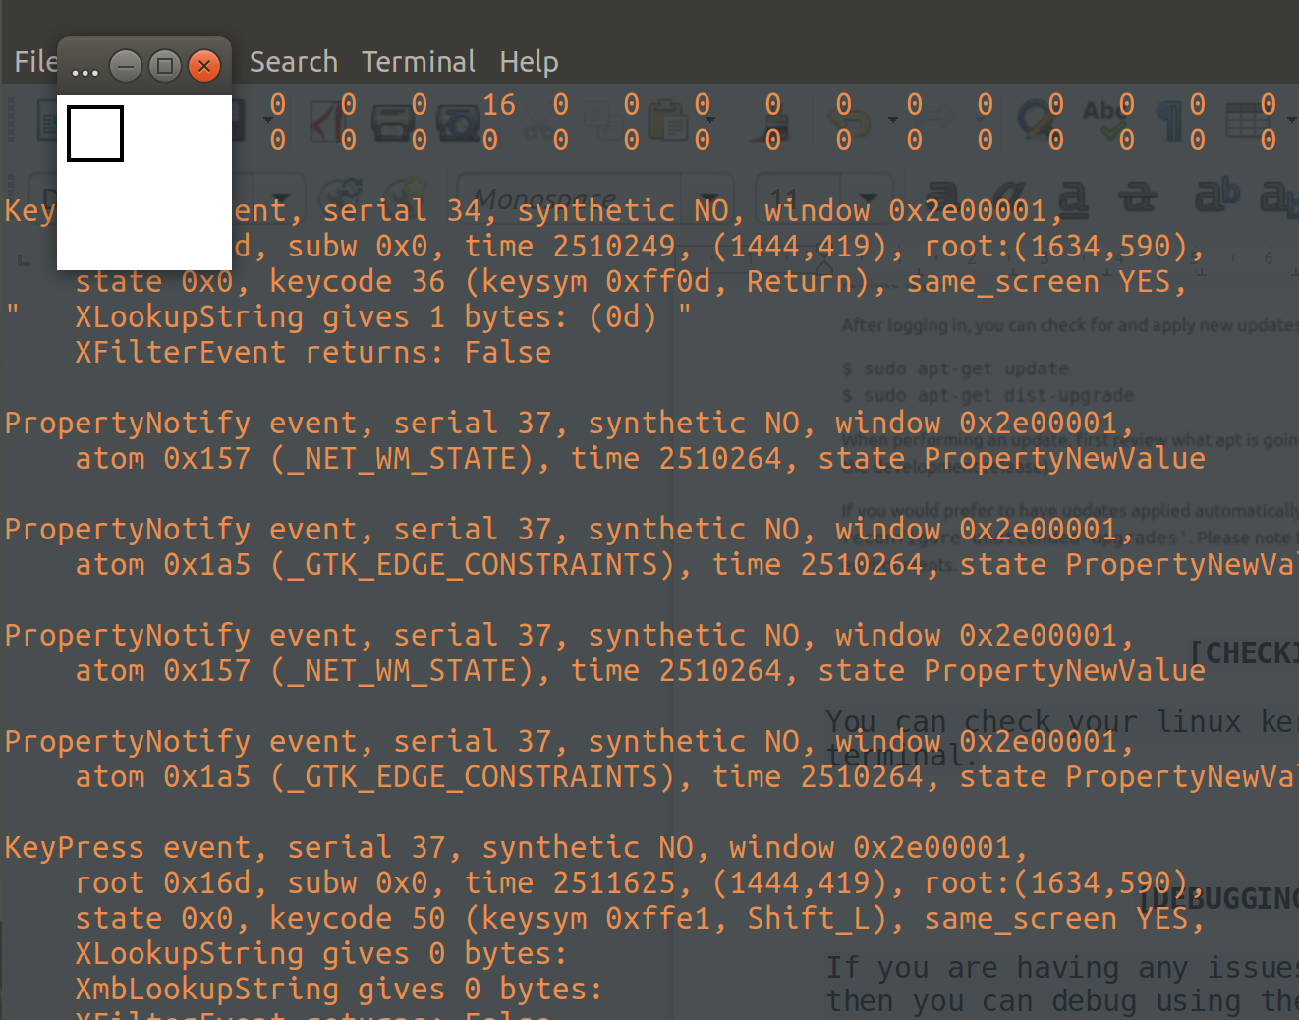
Now perform evens in that white window and track events/buttons in your terminal.

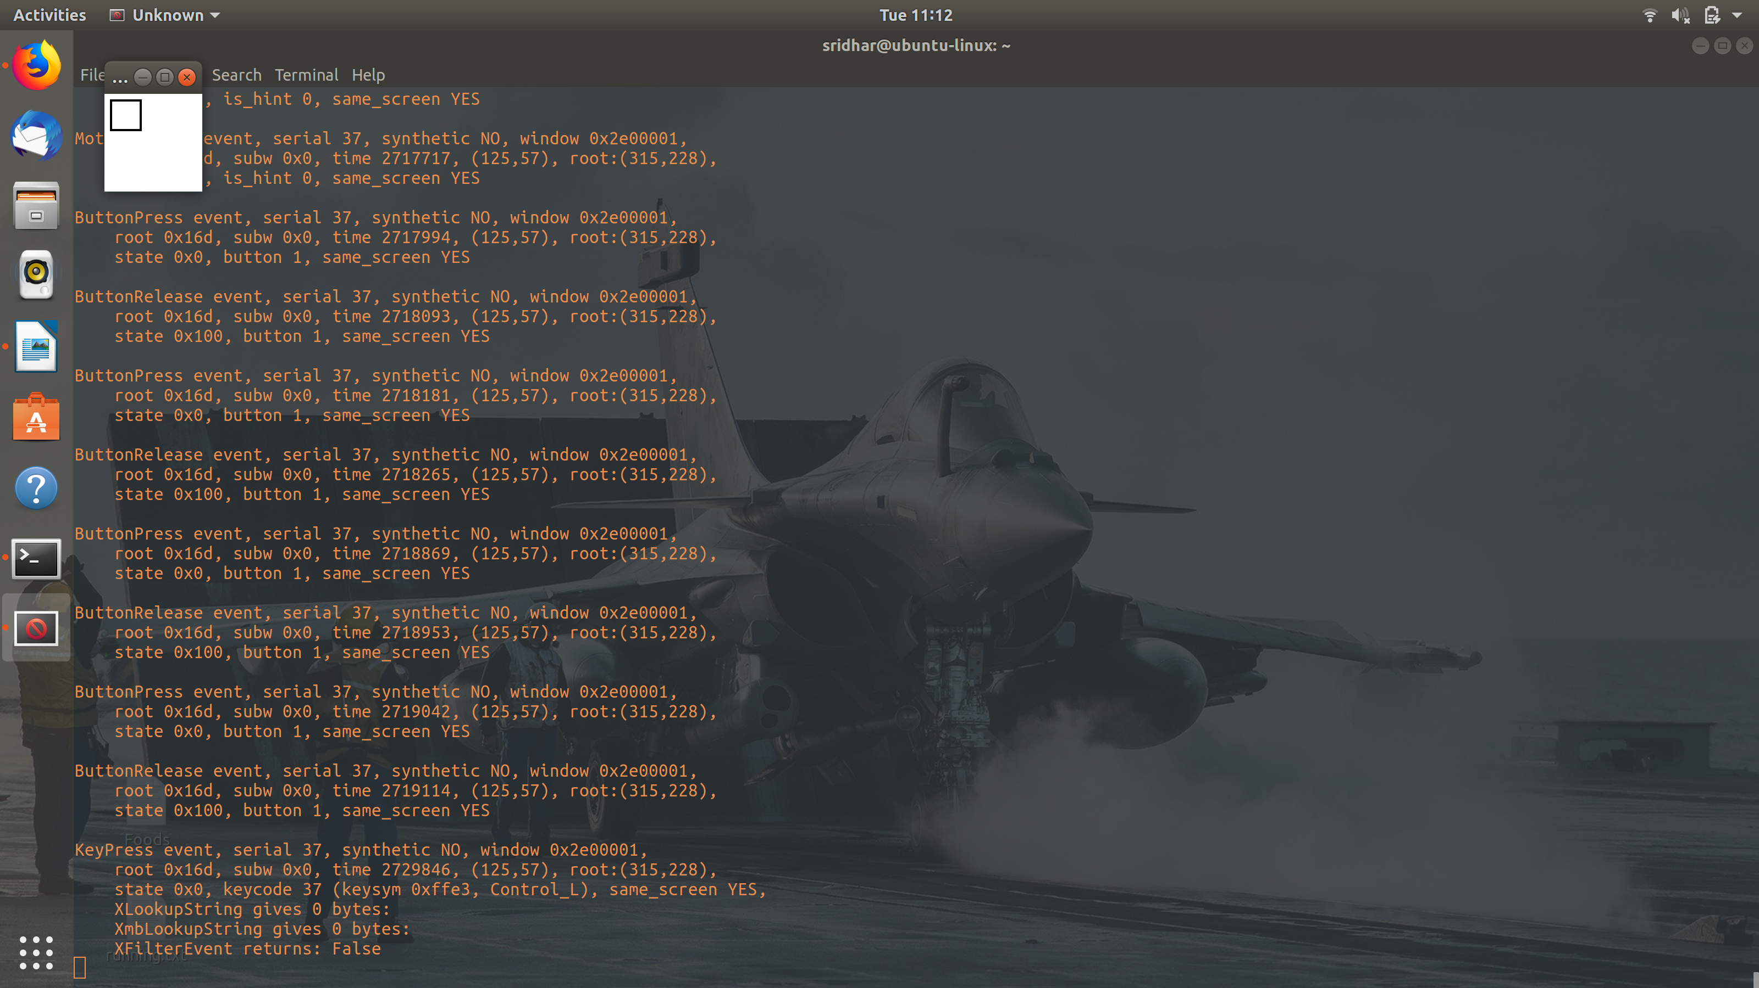
You can ‘button 1’, this was when I pressed my left mouse button, similarly I came to know that button 3 is for my right mouse button and 4 for mouse scroll up and 5 for down.

And, this way, I noticed that when I am scrollin up (which is button 4), button 5 is also getting called intermittently and vice-versa, which proves the issue I am having with my mouse currently.

Although, at this moment, IDK the solution, I also don’t know why this is happening – drive issue OR mouse issue OR mouse wireless receiver issue OR kernel issue.

[UISNG HISTORY IN LINUX TO NOT REPEAT WRITE ALREADY EXECUTED COMMANDS]

Many a times you’ll end up writing the same commands in linux terminal which you must’ve already written some time ago.
One shortcut is, you use the up-arrow to scroll through a list of previously entered commands from histroy but what if it was an very old command, it then becomes to do the up-arrow forever.

The best way is to use history output and then work from there.

Type history in the terminal:
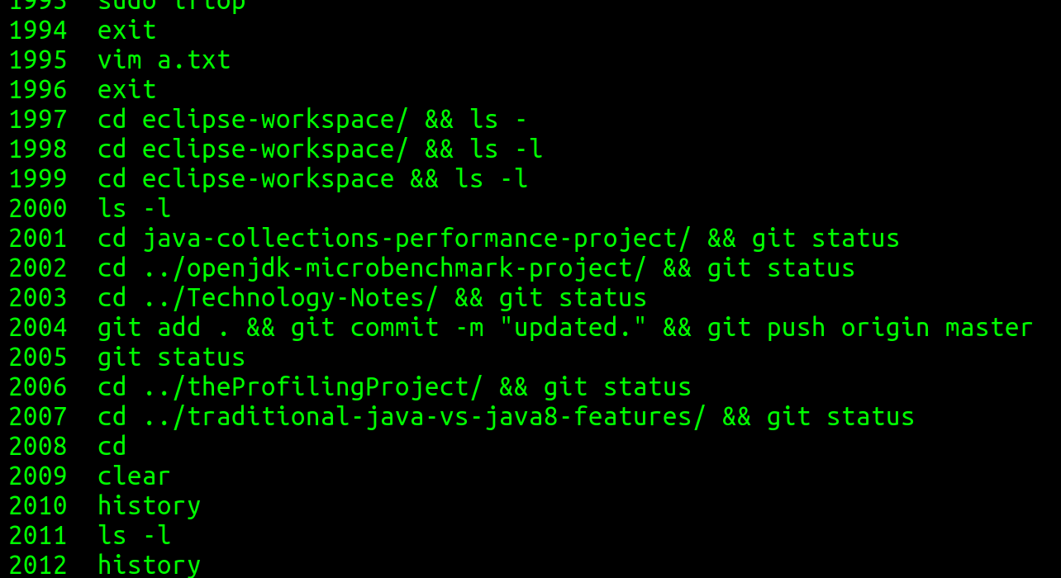
And, you get to see output like this.

[Based on Line-number]:
Now, you can select and execute an already written command (from history) by using it’s line-number:
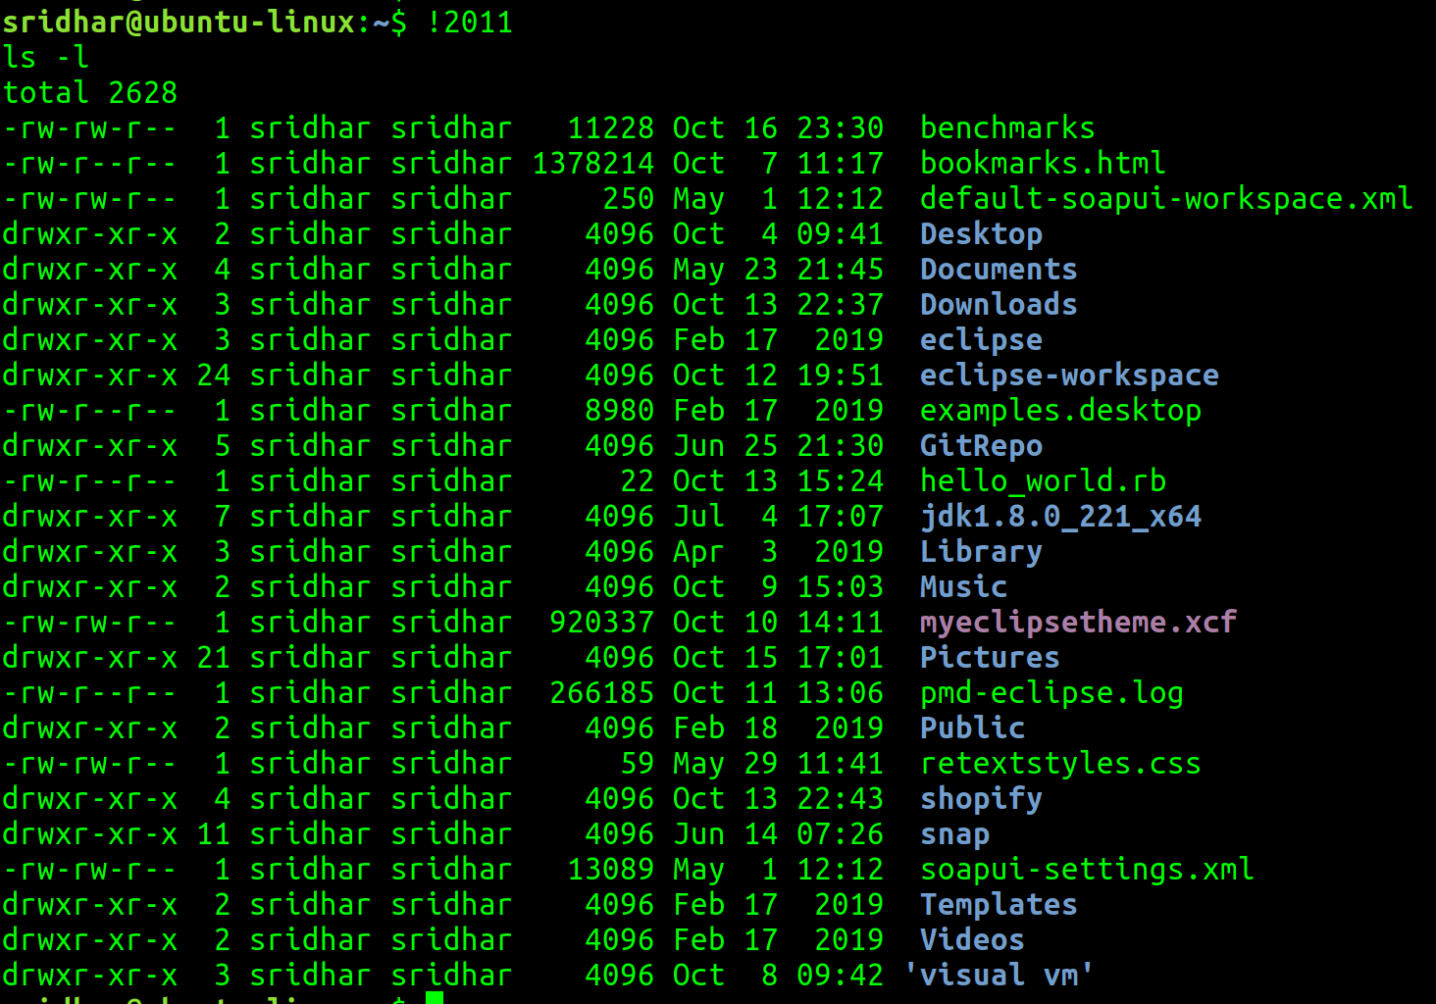

[Based on Search]:
You can also search through the history by typing ctrl+R (which will invoke a reverse-i-search):
So, I did, ctrl+R and entered vim and it shows me that i have ‘vim b.txt’ already in history, to execute as is, just hit enter:
and the b.txt file opens.

If you want to edit the command before executing it, then just use your left/right arrow keys to edit it before you open it up, that’s it.

a.Reverse-i-search is nothing but browsing through the history (on the basis of your search argument) in reverse order (i.e. from last to first).

b.Doing a reverse-i-search multiple times:
Say, you want to look for a previously entered vim command, so you do a reverse-i-search by invoking ctrl+R and then type vim:
But what it is showing me here is not the file/command that I want to exeucte (and I do not want to edit the command either) and I am sure I have executed the command before and it is there somewhere in the history, so I decide to search through the history by hitting ctrl+R multi-times (until I land up with the command I wish to execute):
Here, I did a ctrl+R until I found what I was looking for.

[TO HIDE OR NOT DISPLAY THE PWD IN LINUX TERMINAL]

Normally, in the terminal, when you navigate to a directory, the pwd automatically shows up in the terminal:
If you don’t want this to happen, if you want to hide the path, then:
you need to edit the above environment variable, remove the ‘\w’:
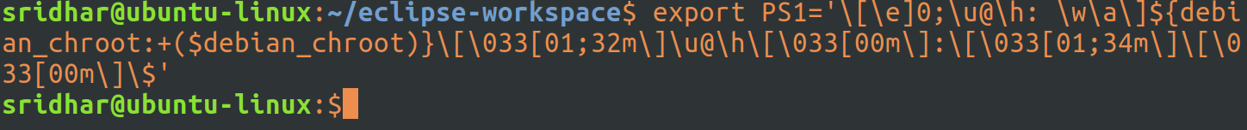

That’s it. The above command does not have a ‘\w’ in it. And you can see immediately that the next comman does not have a pwd in it.

Of course, this change will remain only for this session, if you want to make it permanent, make the change in the .bashrc file.

[NOTES ON LINUX PERMISSIONS]

This is a very good link on understanding linux permissions and stuff related to that:

https://www.geeksforgeeks.org/permissions-in-linux/

[TO KNOW WHEN A FILE WAS CREATED]

What we generally get to see is the file last modified date but if we want to know when was the file created follow this, pretty good an works:

https://www.tecmint.com/debugfs-command-show-file-creation-time-in-linux/

[TO CHECK IF A PARTICULAR SOFTWARE IS ALREADY INSTALLED]
You can use the apt-cache policy command and find out:

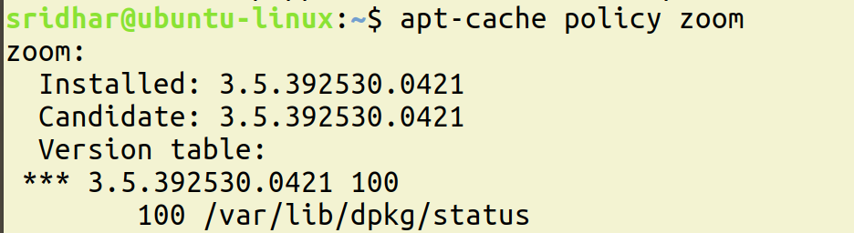
The above snapshot says, installed version of zoom.

After I remove the software, If i run the above command again:
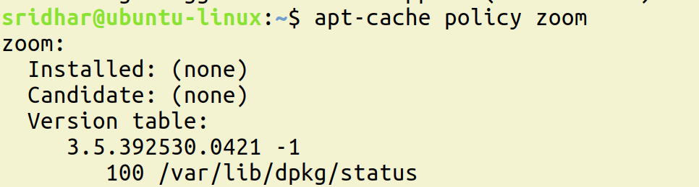

[TO SEE A LIST OF ALL SERVICES THAT START ON STARTUP AND HOW TO SHUT THEM DOWN]

service –status-all

and

sudo service docker stop (to stop a particular service)

[HOW TO SOLVE DNS ISSUES]

If you are frequently (intermittently) not able to access a site (or a set of sites), this could be a dns issue:

resolve it by making an entry into the etchosts file as shown here:
https://www.tecmint.com/setup-local-dns-using-etc-hosts-file-in-linux/

[HOW TO DEAL WITH SWAP MEMORY ISSUES]

Do as mentioned in this article:
https://www.redhat.com/sysadmin/clear-swap-linux

[HOW TO MAKE CHANGES TO BASH PROMPT]

https://bash.cyberciti.biz/guide/Changing_bash_prompt

