WHAT IS THIS DOCUMENT ABOUT?
+ Creating a (development) branch in github
+ Fetching that branch and it’s code in local workspace.
+ Making changes to the branch code in local.
+ Committing the changes from local branch to remote branch on githhub.
+ Creating a release tag on the branch on github.
+ Merging the branch code into master on github.
+ Deleting the branch on github.
+ Deleting the branch in local workspace.
+ Working with the tagged version in local workspace (in case of any issues on the branch code.)

LINKS AND REFERENCES
The following are all the links that I’ve reffered to while I was creating this document. They are pretty good.

https://stackoverflow.com/questions/9537392/git-fetch-remote-branch

https://stackoverflow.com/questions/12486653/git-push-to-existing-remote-branch

https://stackoverflow.com/questions/1800783/how-to-compare-a-local-git-branch-with-its-remote-branch

https://www.freecodecamp.org/forum/t/how-to-delete-a-git-branch-both-locally-and-remotely/13211

https://dzone.com/articles/git-strategies-for-software-development

PROJECT FLOW

We are taking an already existing (personal) python project which is on github and my local code is cloned from the remote repo.

Screenshot to show project exists on github:
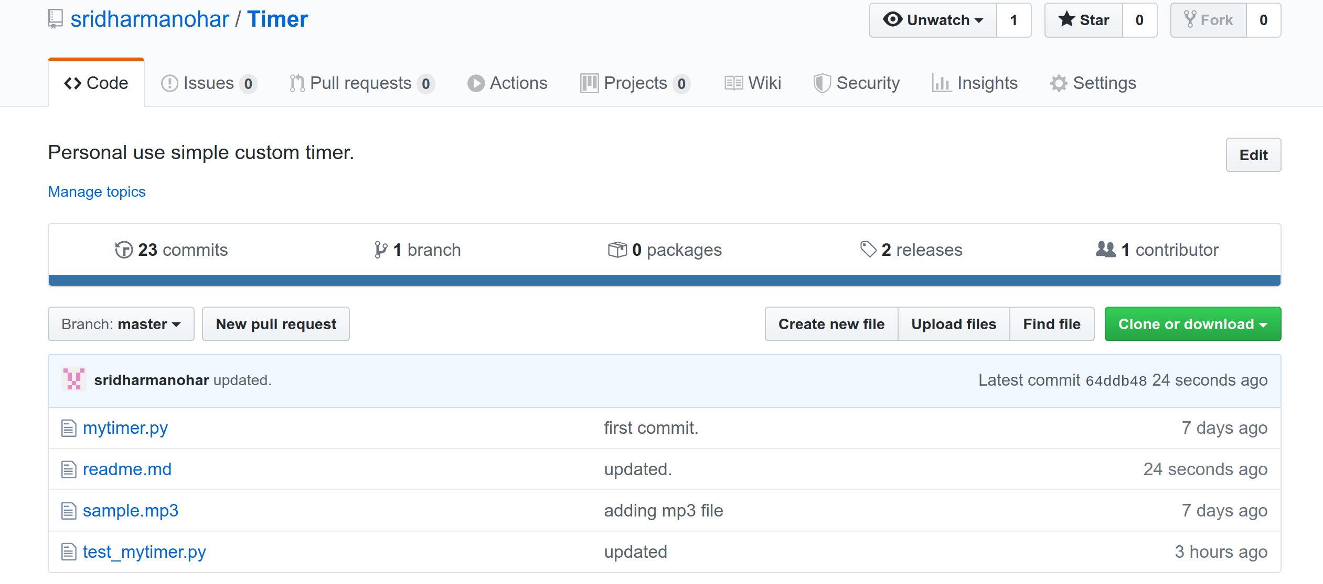

Project exists on my local workspace:
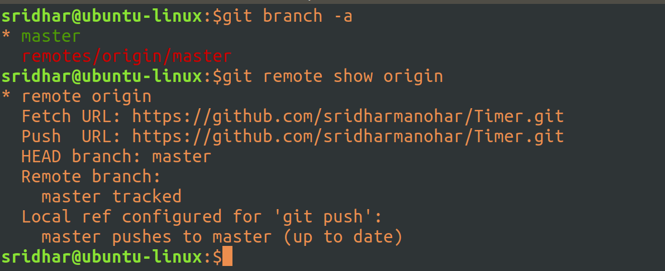

Create a new remote (development) branch:
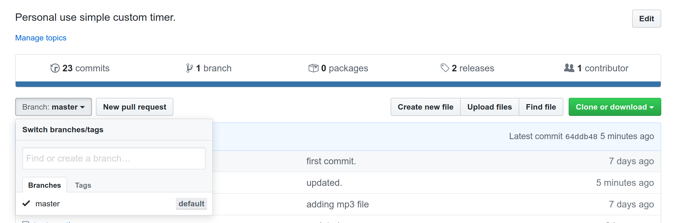
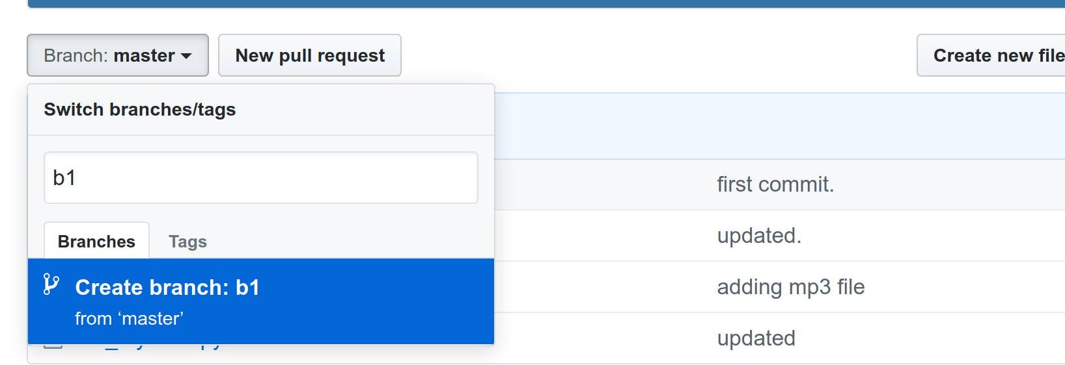
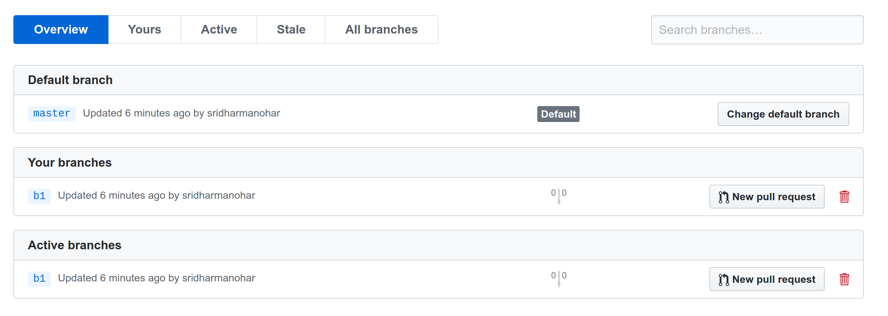
Fetch the remote dev branch (b1) to your local machine (to start working on the branch, rather than on master):

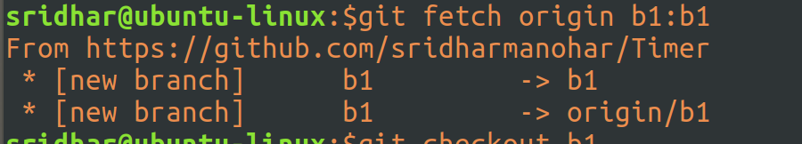
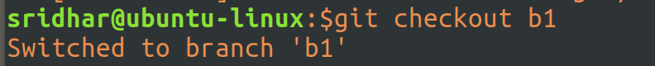
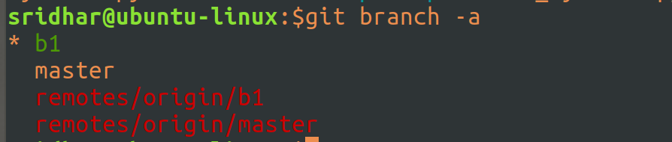
Open Sublime (to make changes to code in your dev branch i.e. b1):

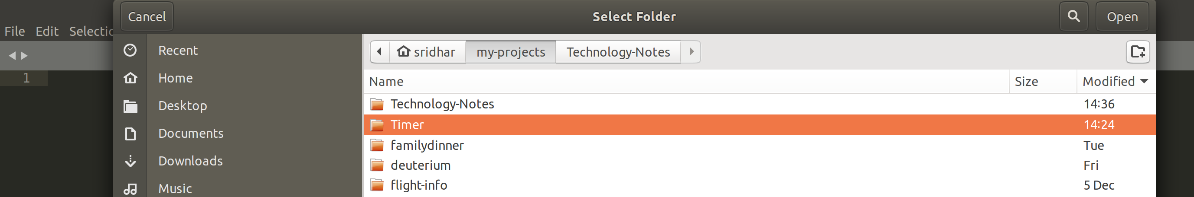
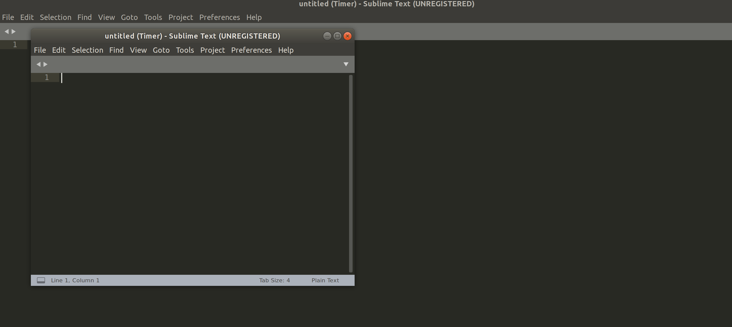
Tools -> Git -> Branches -> choose b1

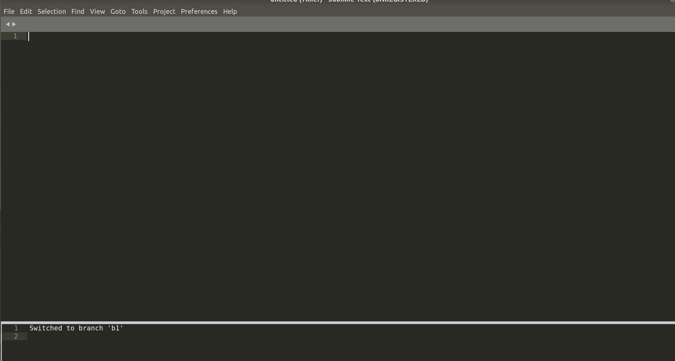
File -> Open file -> Navigate to the project folder and load the desired file (that you want to work on), the file loaded will be from the b1 branch:
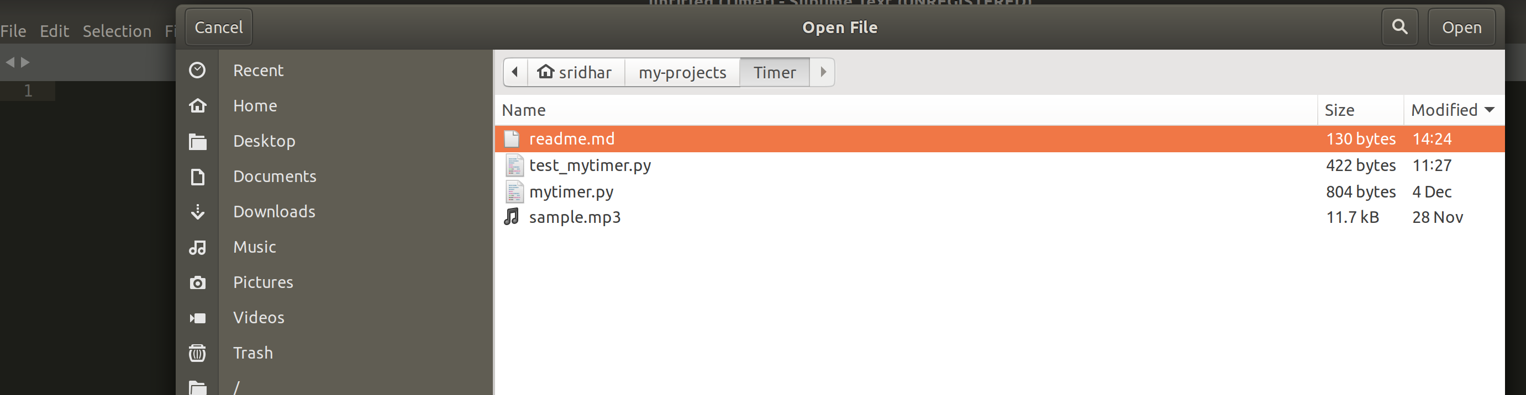

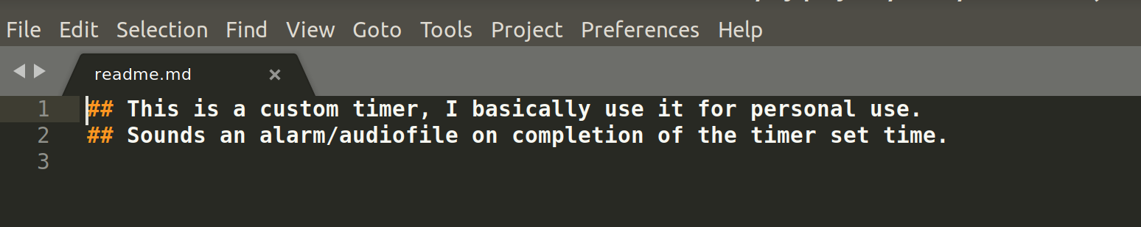

Make Changes:

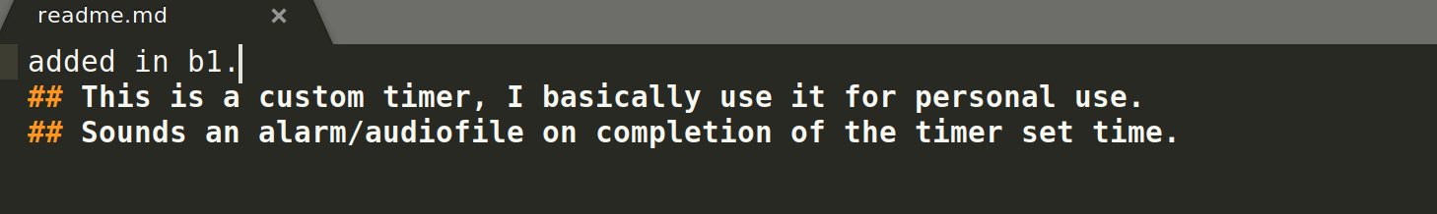

Tools -> Git -> This file -> Add (to index/stage the file) OR
do it from the command line: go to the branch (git checkout b1) and git add readme.md

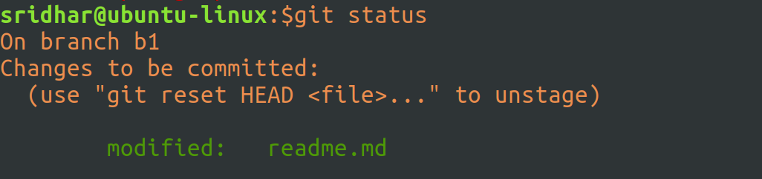

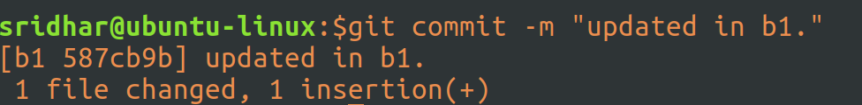

Push the commit file to remote branch b1 from local branch b1:
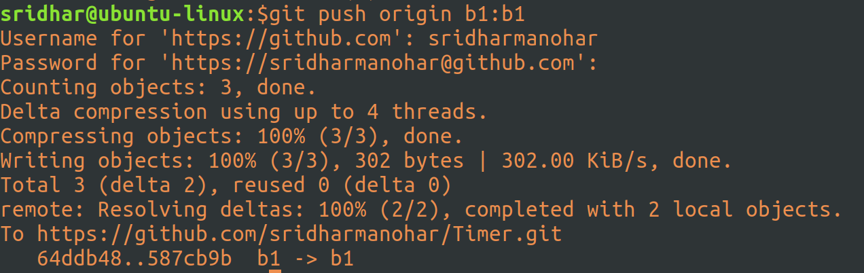

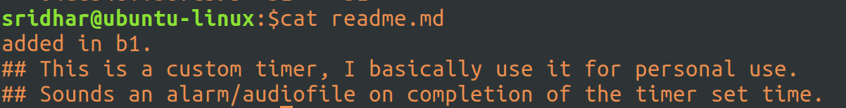

Changes reflect on branch b1 on github;
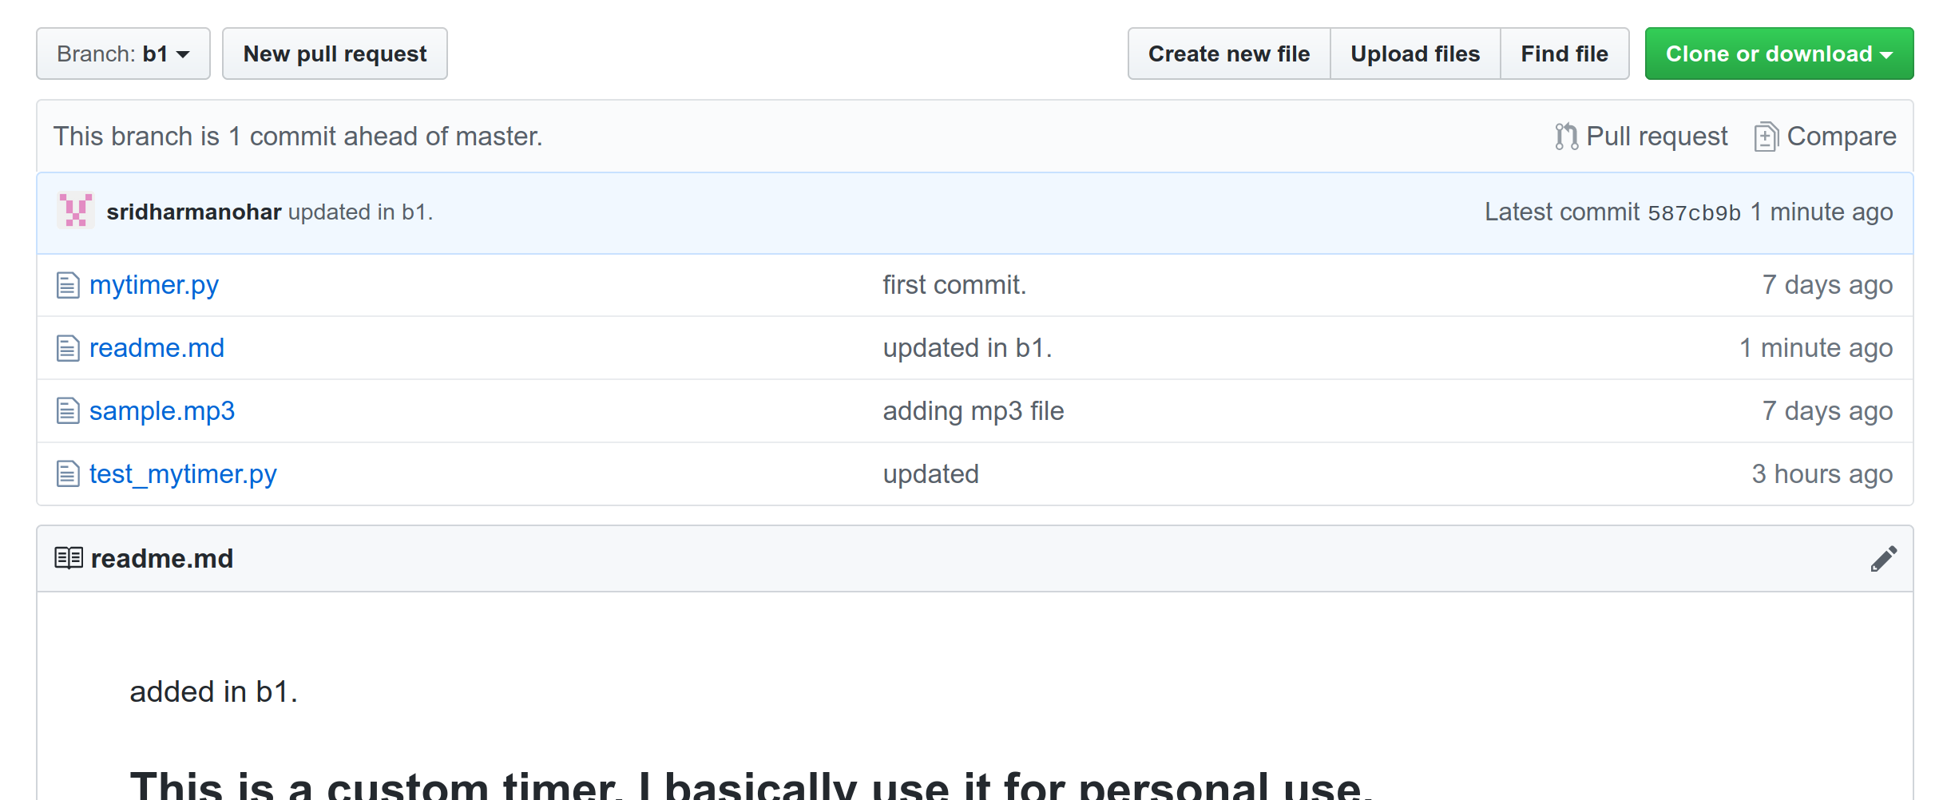

You don’t see those changes in master (rightly so):
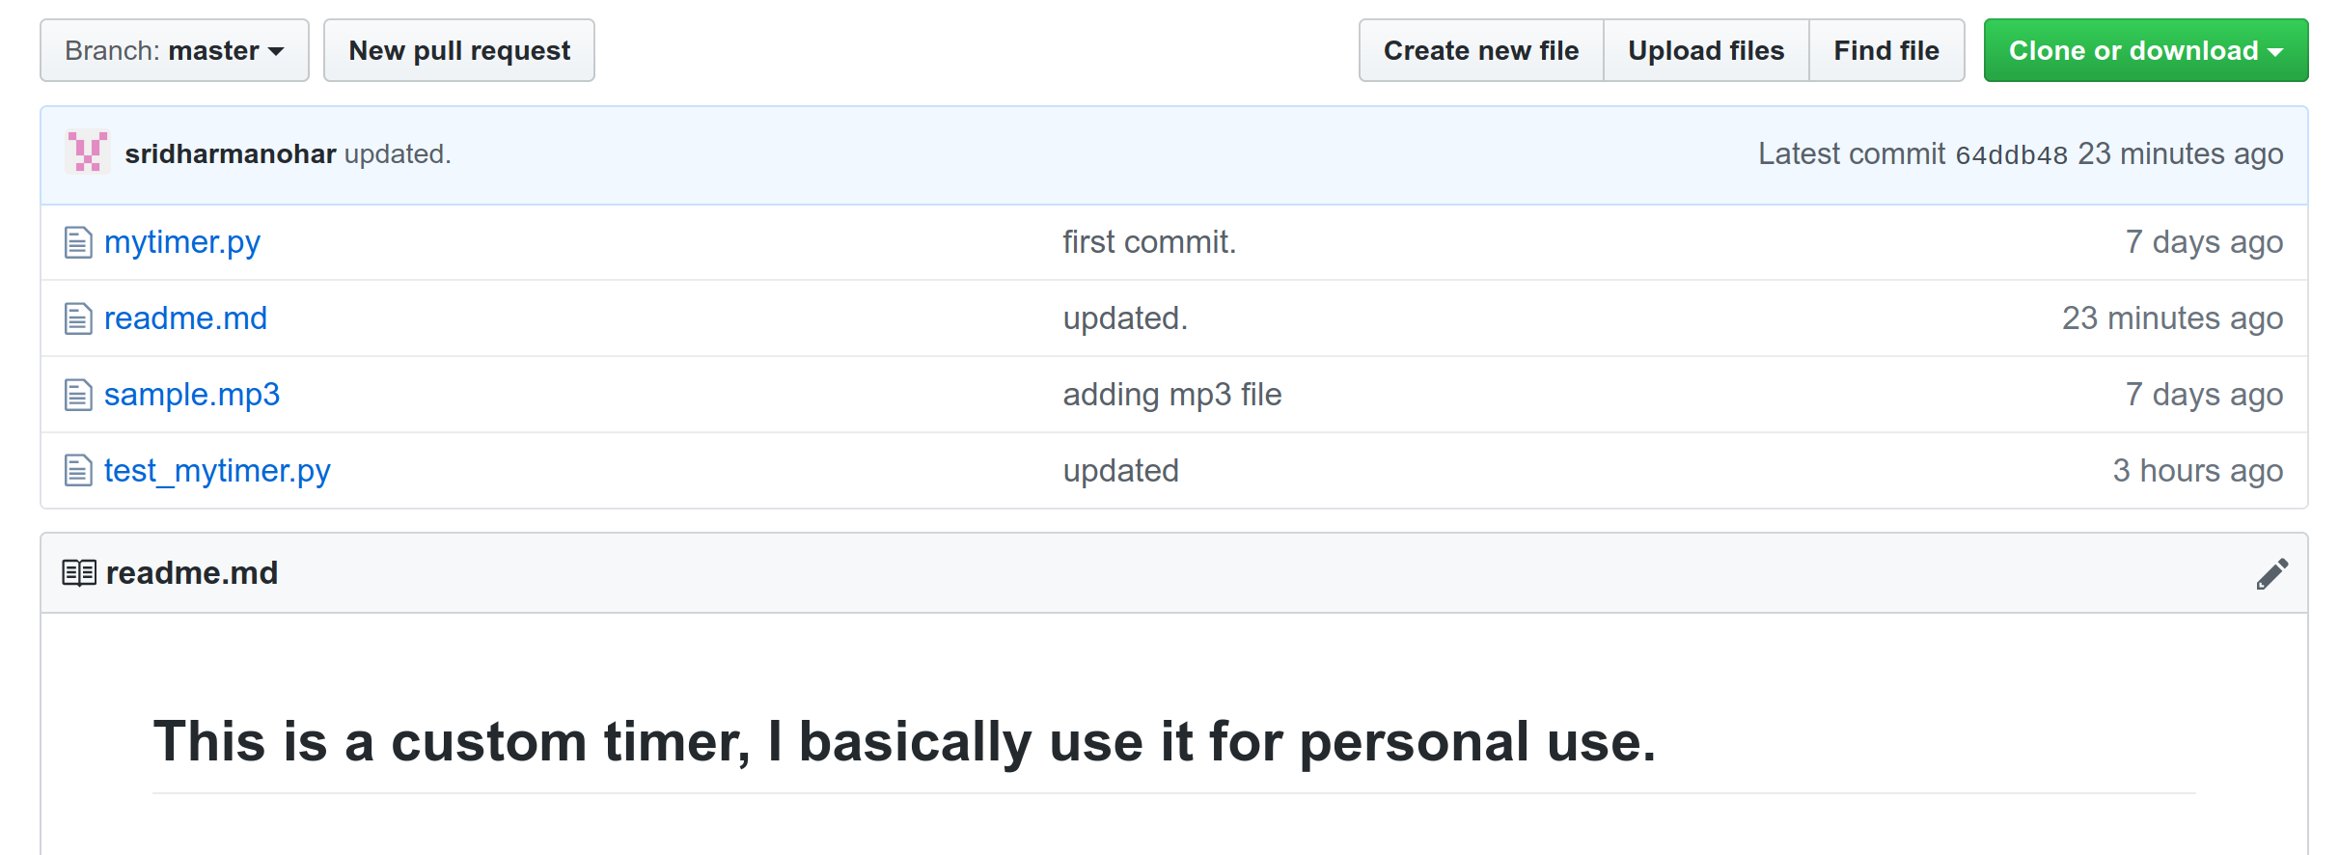

Changes don’t reflect in your local master also (rightly so):

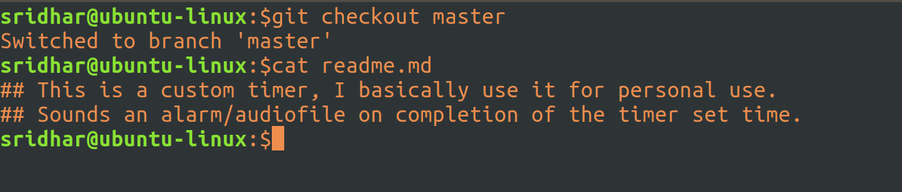

Switch to master from sublime and open the file – you don’t see the changes (perfect):
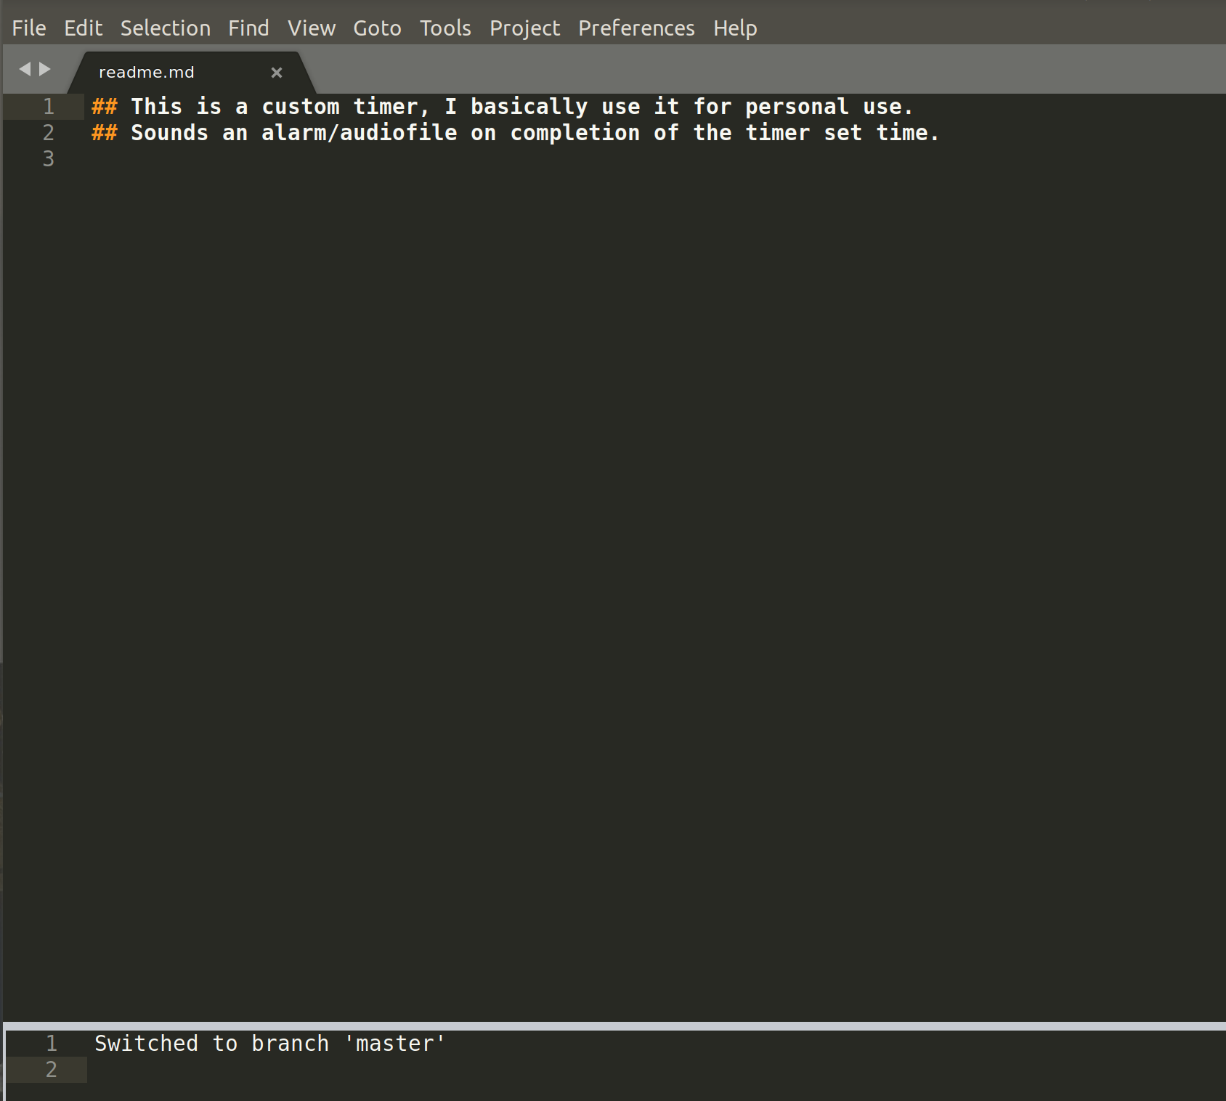
Check the difference between your local master code and the remote branch b1 code:
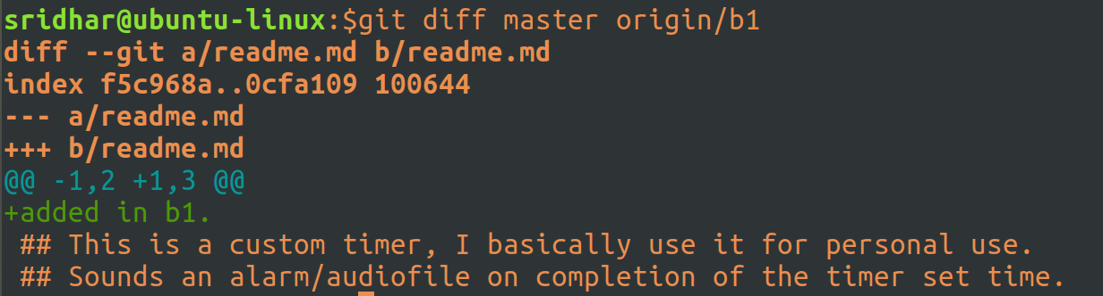

Create a tag from branch b1:

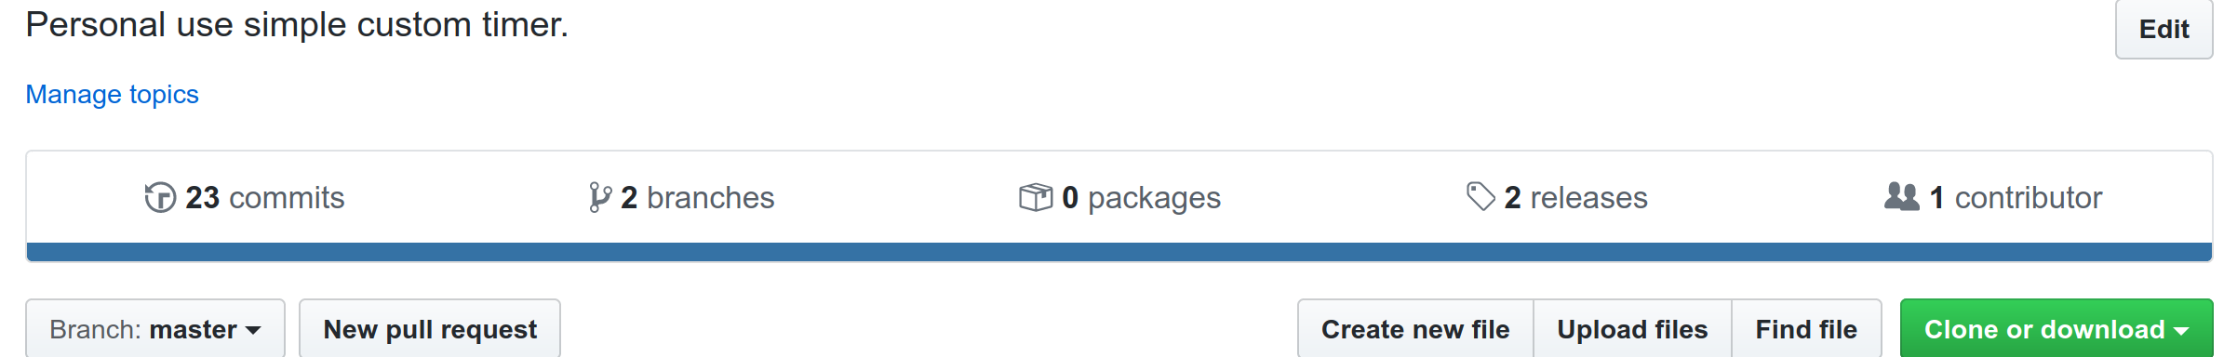


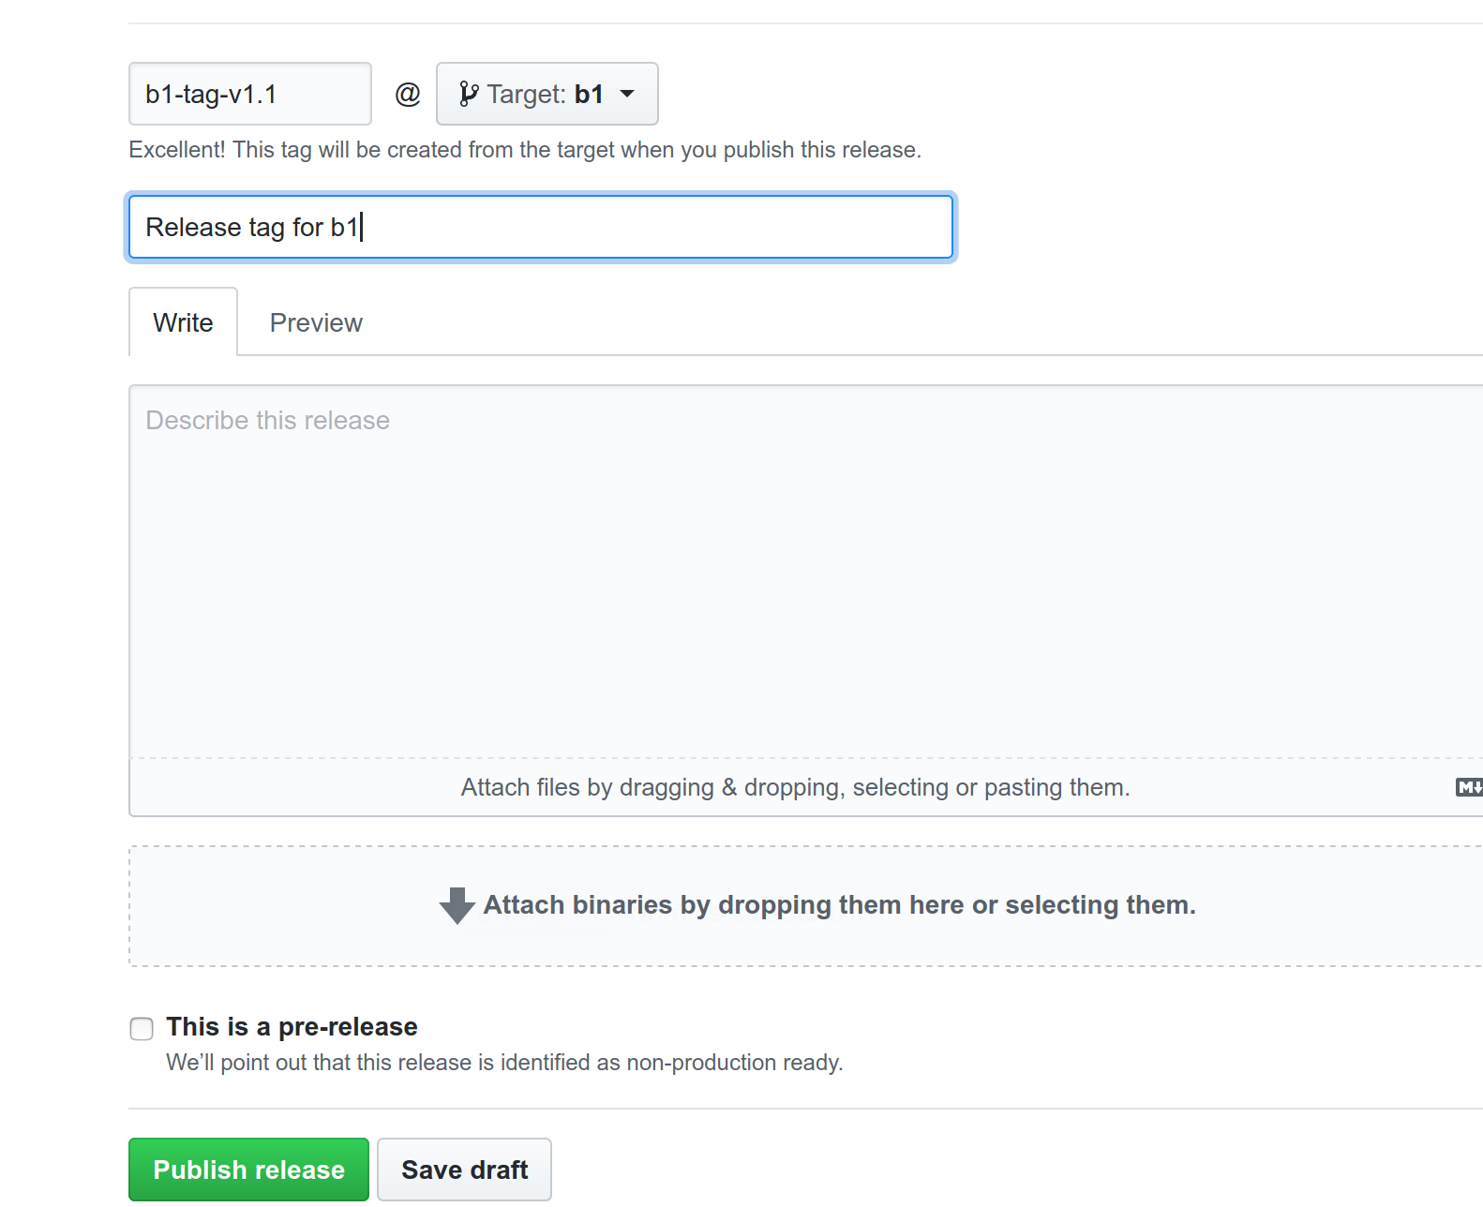
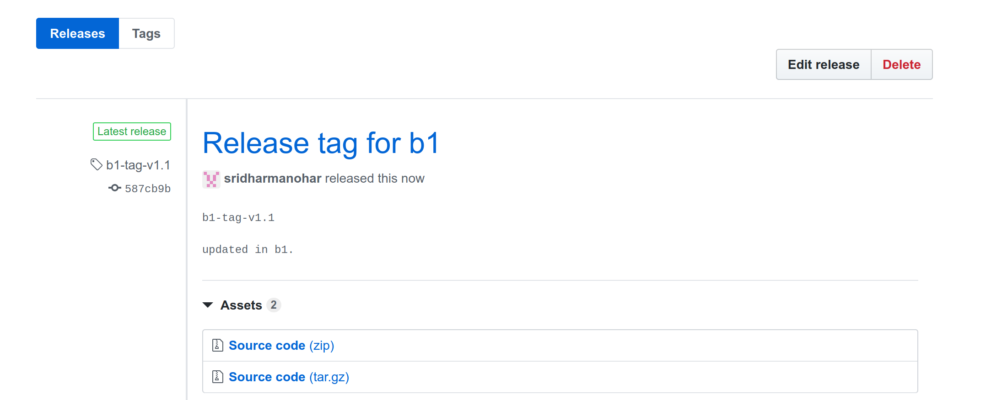

Create a Pull Request from branch b1 to merge b1 changes to master on github:
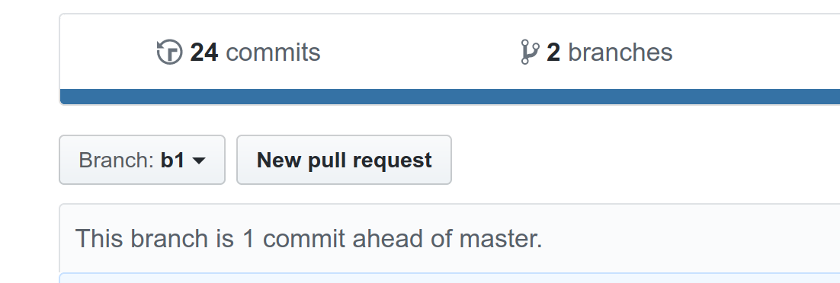
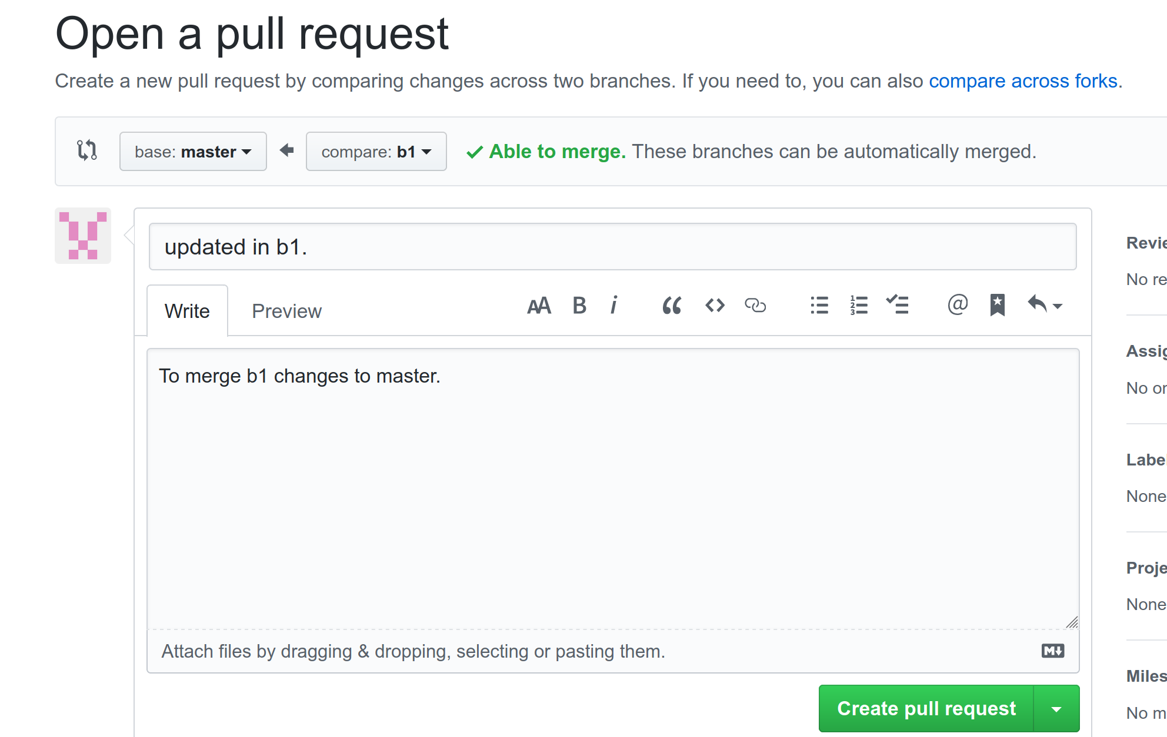
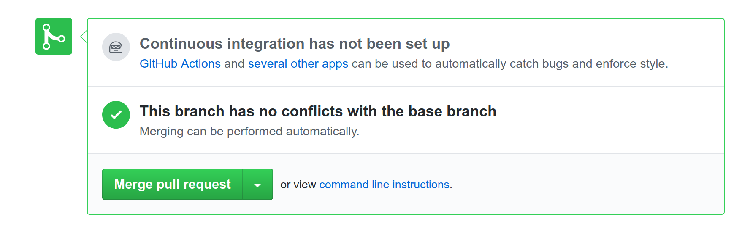
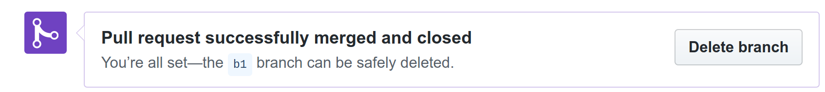
Click on Delete branch to delete the branch b1 (since changes are now committed to master):

Go to master and you should see the changes:

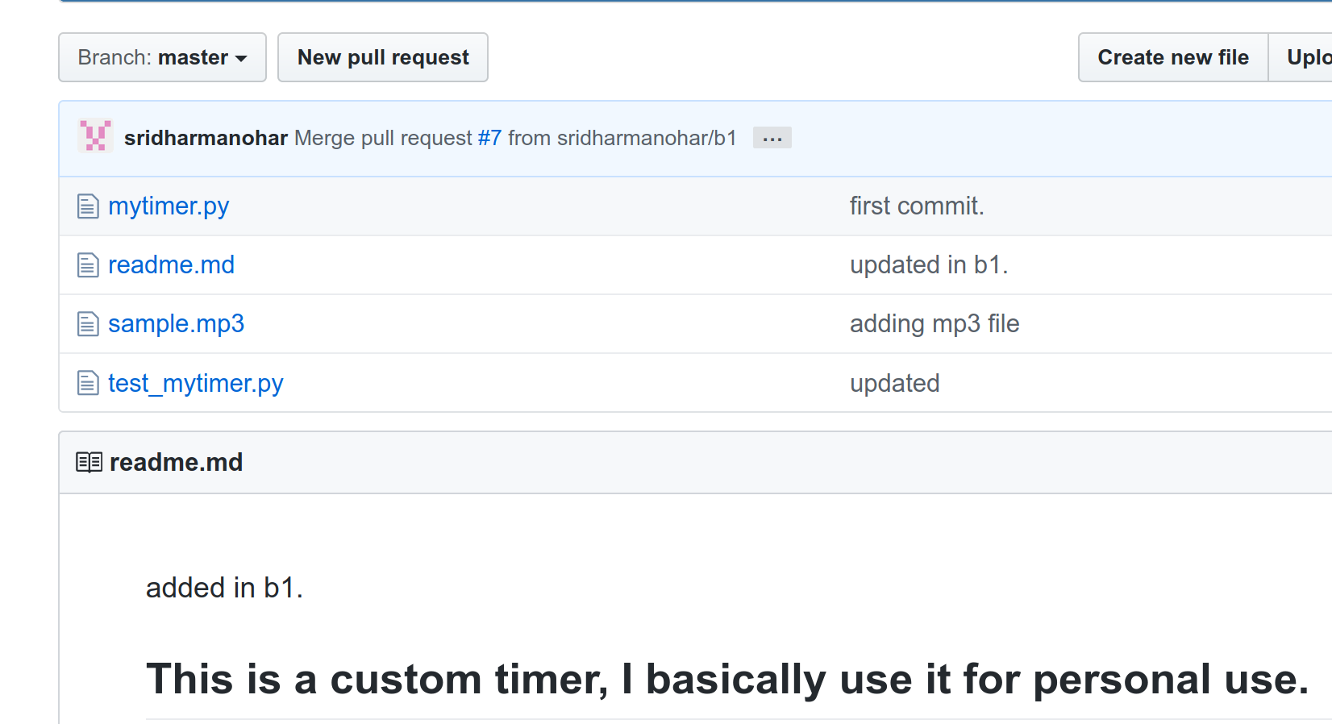
Switch to master in your local (if not already on it) and compare local master with remote master:

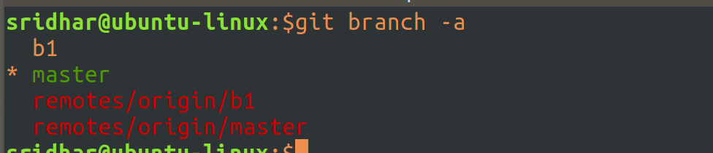

You don’t see any differences because your remote master has been updated but your local is not aware of it (yet). It’s not like everytime you do a git diff a direct https call happens to the remote repo to check for changes, no, you need to fetch the changes from remote into local and then do a compare.

Do a git fetch to fetch meta-data about changes from remote into local:

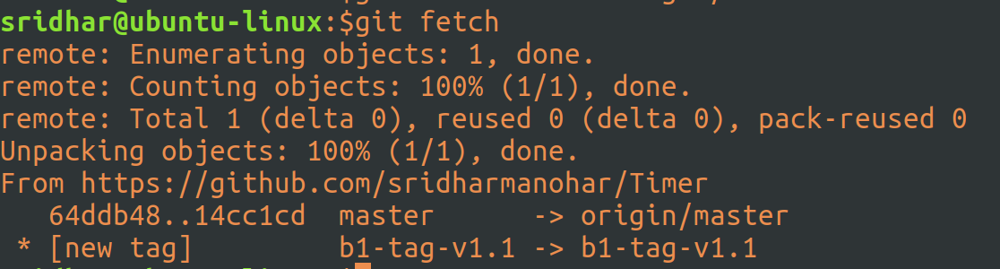
Now run the diff (you’ll see the differences):

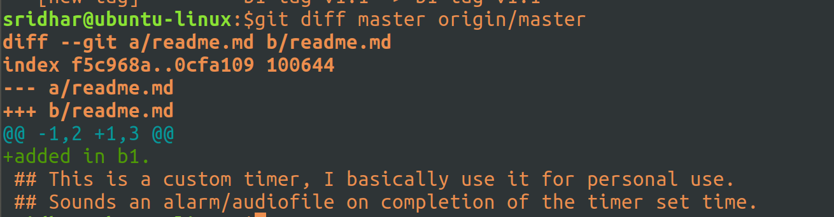
Fetch will never modify your local copy, you can see that here. It’ll only bring in the mate-data and store it somewhere inside .git so that it can use it for comparision purpose later:

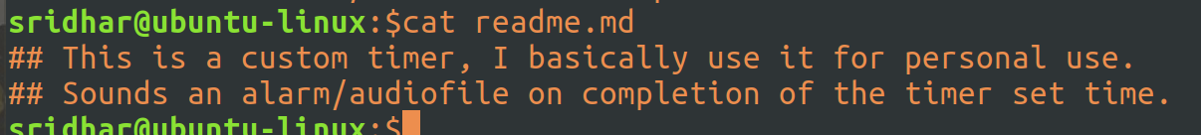

Pull all the changes from remote master into local master:

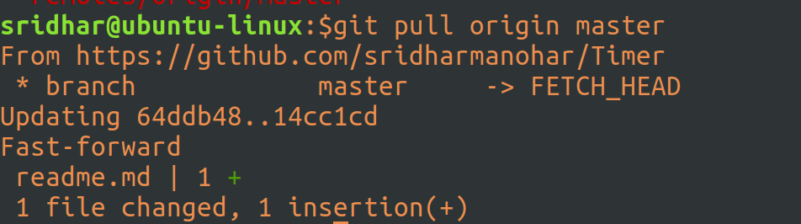

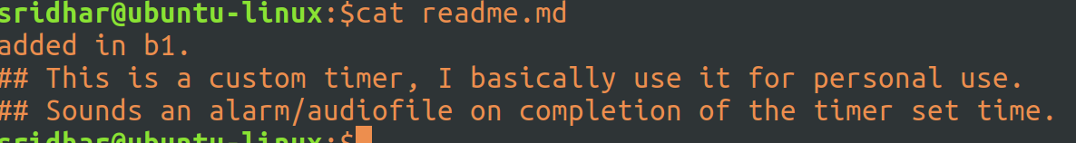

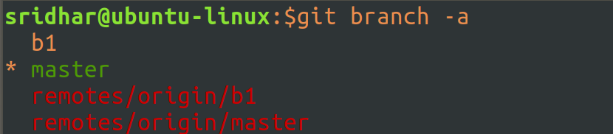
Do a fetch -p : this will fetch all repo from remote, at the same time will delete those that have been delete on remote:

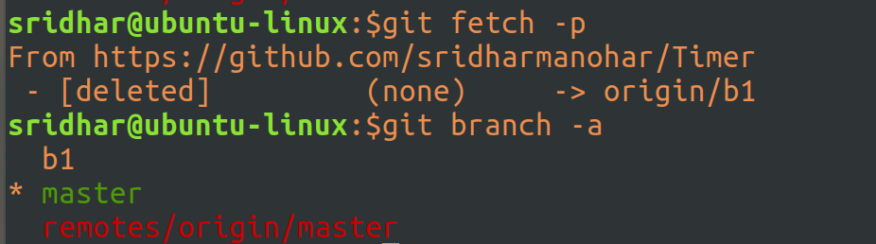
Do a checkout of the tag that we created on remote:

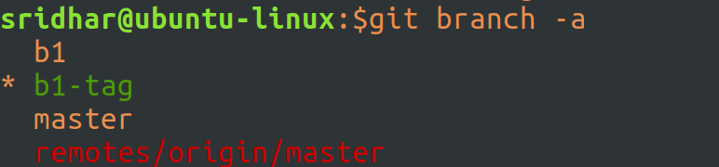
You can work on the tag, if, in future, there are any bugs related to this particular release. Tags are never deleted (you can’t) from github.

