Using Git plugin from Eclipse:
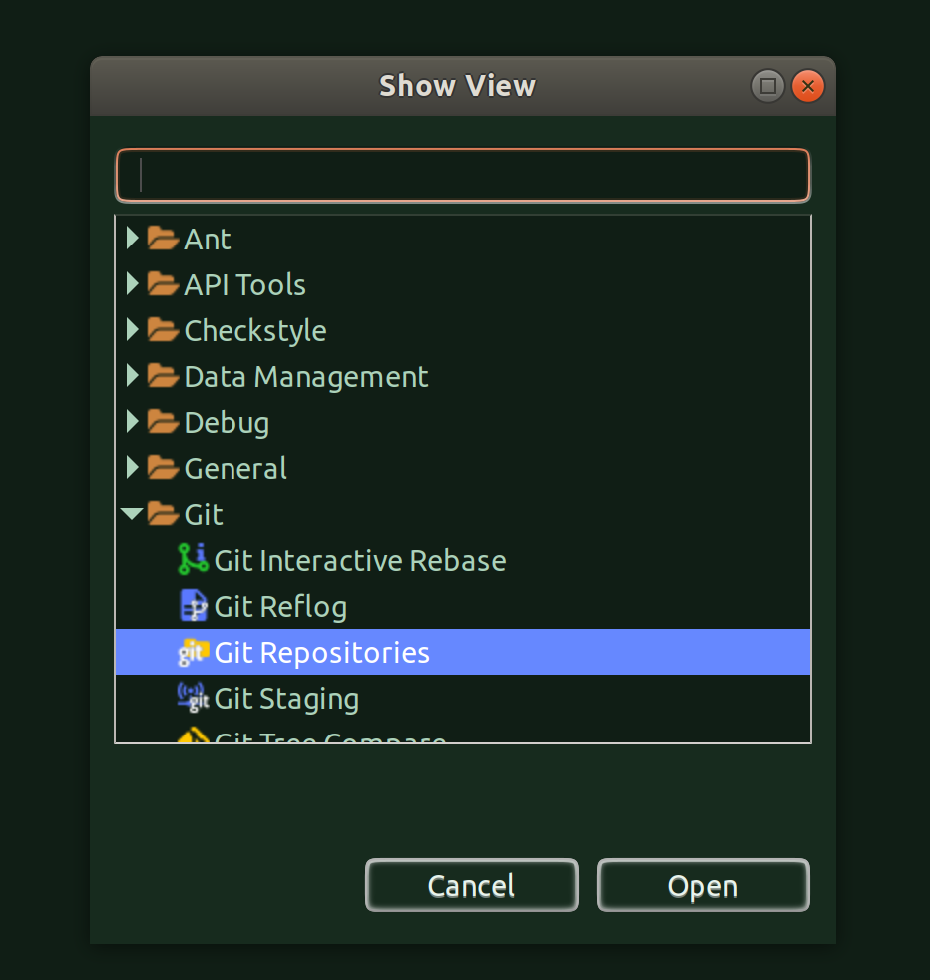
You get to see all the git repos:
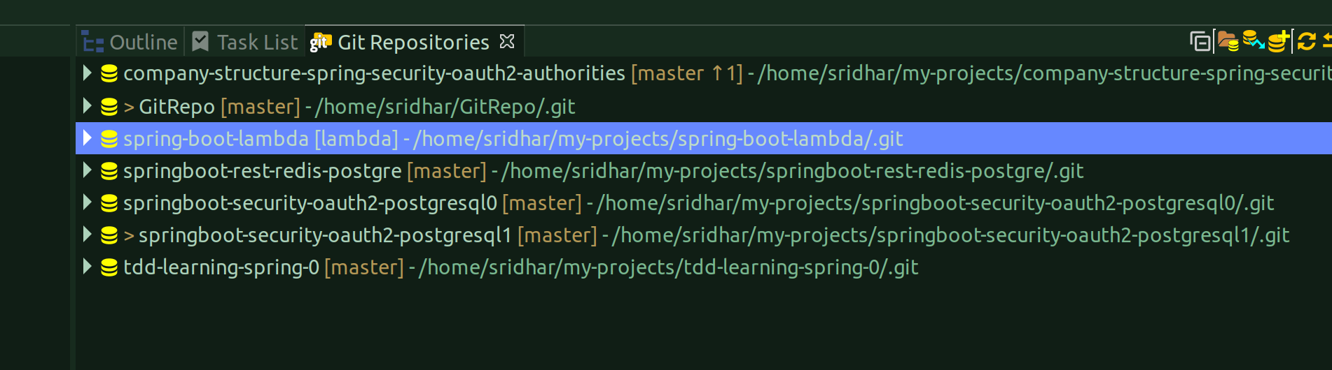

Do a right-click on the desired branch and choose ‘Show In’ -> ‘Project Explorer’ from the below screenshot:
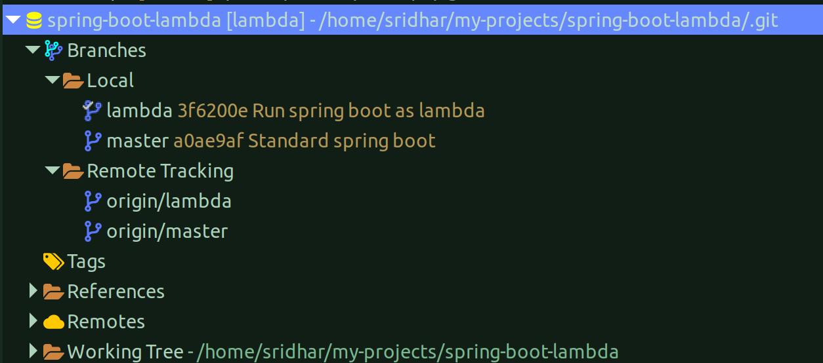
And, you will get the ‘Project Explorer’ view of the selectecd branch:
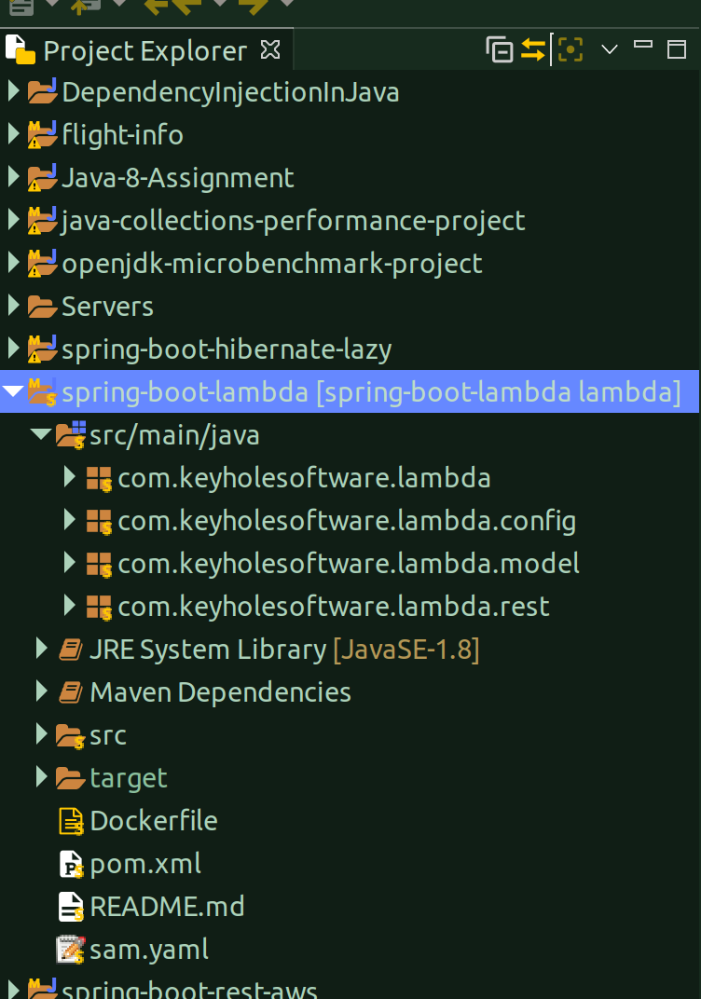
If you want to switch to a different branch, just do a right-click on the ‘Branch’ or ‘Local’ and click on ‘switch to’ option and choose the branch:

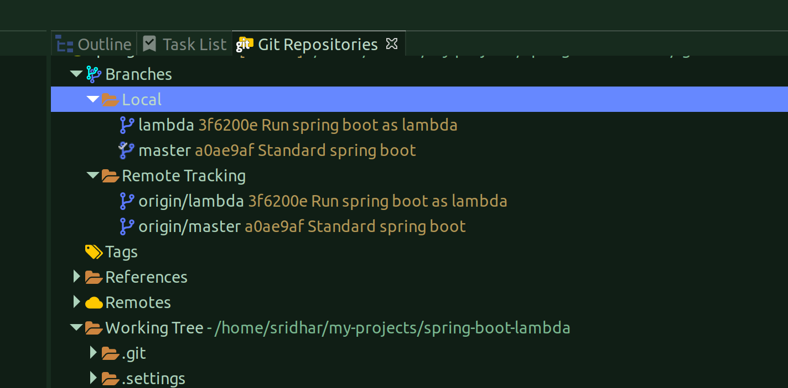

Issue with Lambda when triggered from the Api Endpoint:
Solution was to configure the API Gateway as a proxy integration:
