[JAVA MICROBENCHMARK HARNESS – OPENJDK]

This is mostly theoretical. Implementation is in a separate project in eclipse-workspace.

[HISTORY]
I’m not going to talk about installing the tool and using it here, that is covered by a practical project, and that also has been documented in a detailed manner.

This, here, I’ll primarily be focussing on it’s theoretical aspects on the tool.

Benchmarking appears to be a simple task. After all, it should consist of compiling your code, running it in a loop, and measuring how long that takes. The faster the better, right? That can be the case for statically compiled languages, such as C or C++, but for Java developers, there is an additional layer of complexity: the JVM.

Stressing that specific piece of code and extracting meaningful metrics can be difficult in the JVM world, because the JVM is an adaptive virtual machine and can perform optimizations that can produce misleading—or even completely useless—results. Unlike with statically compiled languages, the actual machine code that is executed is determined by the JVM while it is running, and it can change the code depending on what happens during the execution. This allows for the above-mentioned optimizations, but it also means Java developers need to be extra careful when writing benchmarks!

The need for specific precautions when writing benchmarks for Java culminated in the development of the JMH.

JMH is a Java harness library for writing benchmarks on the JVM, and it was developed as part of the OpenJDK project.
JMH itself does not prevent the pitfalls that were briefly mentioned earlier, but it greatly helps in mitigating them.

JMH is popular for writing microbenchmarks, that is, benchmarks that stress a very specific piece of code. JMH also excels at concurrent benchmarks. That being said, JMH is a general-purpose benchmarking harness, so it is useful for larger benchmarks, too.

[ANNOTATIONS]

@Benchmark:
Every method annotated with @Benchmark is considered by JMH to be a benchmark to be executed. You can have any number of benchmark methods inside the benchmark class. Just be aware that the more benchmarks you add, the more time it'll take.

Benchmark Modes:
There are 5 modes in which JMH can run a benchmark:

a.Throughput: measures the number of times your benchmark method could be executed (an operation, in the JMH idiom) per time unit.

b.Average time: measures the average time it takes for your benchmark method to be executed.

c.Sample time: measures the time it takes for the benchmark method to run, including the minimum, maximum, etc. Times.

d.Single shot time: measures how long a single benchmark method execution takes to run; this is helpful for testing how it performs under a cold start (no JVM warm up).

e.All: all the above; "all" is mostly used to test JMH itself while developing it.

@BenchmarkMode:
You can specify in which mode each benchmark is to be executed using the @BenchmarkMode annotation. The default mode is throughput.

@Warmup:
JMH performs a few runs of a given benchmark and then discards the results. That constitutes the warmup phase, and its role is to allow the JVM to perform any class loading, compilation to native code, and caching steps it would normally do in a long-running application before starting to collect actual results.

The difference between running the code with and without a warmup can be quite noticeable, so it's recommended that the benchmark is allowed to warm up at least a few times.
The number of iterations per warmup phase can be configured using the @Warmup annotation. The default value is 20.

@Fork:
There are many things that can affect the performance of an application in the Java world, such as OS-related things like memory alignment when a process is created, the moments the GC pauses occur, differences in how the JIT behaves (both as a whole and in each execution), etc.
For instance, if two benchmarks deal with classes that implement the same interface, the benchmark that gets executed first might tend to be faster than the other one since the JIT compiler may replace direct method calls to the first implementation with interface method calls when it discovers the second implementation. That could produce inaccurate results since the order of execution of the benchmarks can affect the performance.
JMH avoids them by forking the JVM process for each set of benchmark trials. The number of times this is done can be controlled with the @Fork annotation. It's highly recommended that at least 1 fork is used. Here again, the default is 10.

@State:
Sometimes you'll want to initialize some variables that your benchmark code needs, but which you do not want to be part of the code your benchmark measures. Such variables are called state variables. State variables are declared in special state classes, and an instance of that state class can then be provided as parameter to the benchmark method.

The state class needs to be annotated with the @State annotation, and it needs to adhere to some standards:
a.The class must be declared public
b.If the class is a nested class, it must be declared static (e.g. public static class)
c.The class must have a public no-arg constructor (no parameters to the constructor).

Scope parameter of @State:
A state object can be reused across multiple calls to your benchmark method. JMH provides different scopes that the state object can be reused in:
a.Thread: each thread running the benchmark will create its own instance of the state object.
b.Group: each thread group running the benchmark will create its own instance of the state object.
c.Benchmark: all threads running the benchmark share the same state object.

@Setup, @Teardown and the Level parameter:
These annotations can receive an argument that controls when to run the corresponding methods. Those arguments, called Levels, can be:
a.Trial: the method is called once for each full run of the benchmark, that is, a full fork including all warmup and benchmark iterations.
b.Iteration: the method is called once for each iteration of the benchmark.
c.Invocation: the method is called once for each call to the benchmark method.

@Param:
It might be interesting, for a number of reasons, to run the same benchmark for a given set of parameters. One common reason to do this is scaling. Even slow solutions can appear to be fast if the number of items on which they operate is small enough. Another common use-case is testing different parameters for a configurable algorithm or data structure, like the max depth of a queue or the number of reader and writer threads.
There's no need to run the benchmark separately for each one of those cases. A state object can contain a field on which JMH will inject a set of parameterized values, one for each set of benchmark runs. This field needs to be annotated with the @Param annotation, which receives as argument an array of strings.
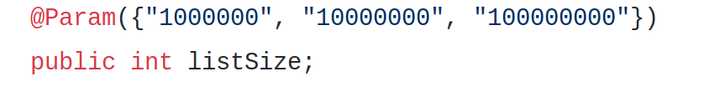
In the above screenshot, the @Param was used to set a different list size for each set of executions (1 million, 10 million and 100 million).

JVM Optimizations that you must know which can impact benchmarking:
One common pitfall is the set of optimizations the JVM can end up applying to our benchmarks that it would not apply in our original application, making our code appear to be faster than it really is.

Some of these are as follows:

I.Loop Optimizations
You might be tempted to put your code inside a loop so that it will be executed more times per benchmark iteration and hence reduce the overhead of the benchmark method call. Don't. Only ever put loops in if they're part of the code you want to benchmark, that is, the loop is in the code and not around it.
The JVM is quite good at optimizing loops, so it may produce a different result if you wrap your code in a loop, and you may end up with a test result that does not correspond to the code running outside of a loop.

II.Dead Code Elimination
Another optimization the JVM commonly uses is getting rid of dead code. Dead code is - as the name implies - code that does nothing or is never used. The JVM can detect such pieces of code, and it'll happily remove them for you.
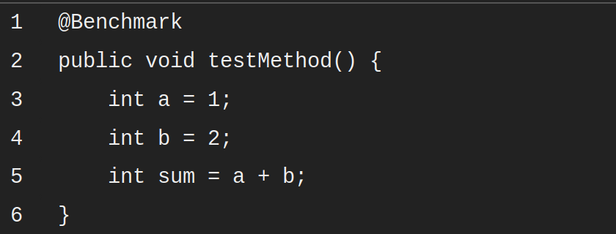
In the example above, the JVM will detect that the calculation a + b, which is assigned to sum, is never used, and it will remove the a + b operation from the method. Since a and b are also never used, they too can be removed. Because of this, you'll end up with a benchmark that is measuring how fast Java can do - literally - nothing.

To avoid dead code elimination, a couple of things can be done:
1.Return the result of the operation from the benchmark method.
2.Pass the value to a blackhole provided by JMH as a method argument.

1.Return Value from Benchmark Method
The point here is to trick the JVM into thinking the code is being used by returning the result of the calculation from the benchmark method. This way, the JVM cannot just eliminate the addition, because the return value might be used by the caller. JMH will take care of tricking the JVM into thinking the value is going to be used.
The change itself is trivial, as shown below:
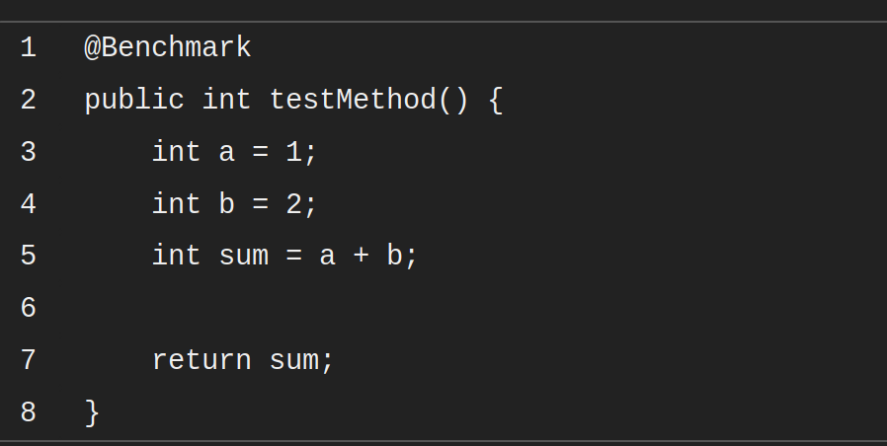
However, it does not solve the problem of having dead code inside the method, say intermediate values or other calculations, that won't be returned. That code would still be eliminated. For such cases, JMH provides what it calls the Blackhole.

2.Passing Value to a Blackhole
In order to avoid returned combined values, JMH includes a Blackhole class that contains a consume method. This method can be used to trick the JVM into thinking code is not dead by passing the intermediate and non-returned values to it.

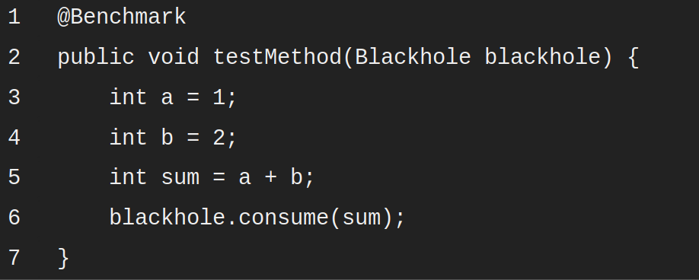
Notice two things here: the method now takes a Blackhole as an argument, and the blackhole object is used to consume the result of the addition operation. This will trick the JVM into thinking the sum variable is being used, and it'll avoid eliminating it as dead code.

If your benchmark method produces multiple results, you can pass each of these results to a black hole, meaning calling consume on the Blackhole instance for each value.

III.Constant Folding
The JVM is quite smart. So smart that even with the Blackhole or returning a value, our benchmark would still produce inaccurate results because both a and b are constants. A calculation that is based on constants will always produce the exact same result, regardless of how many times the calculation is performed. The JVM may detect that and replace the calculation with the result of the calculation. This process is an optimization known as constant folding.
Our benchmark could become:
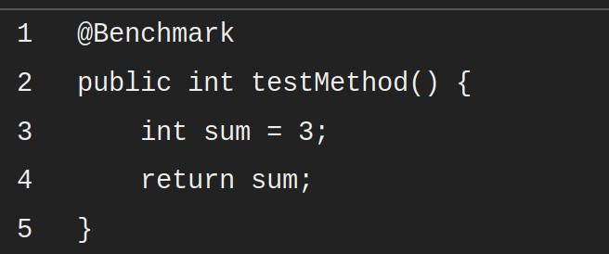
It might go even further and replace the variable sum with return 3 since it's able to detect the method always returns 3. It can even replace every external call to the method with a literal, since it already knows the method always returns 3.

Avoiding Constant Folding:
To avoid constant folding, you must not hardcode constants into your benchmark methods. Instead, the input to your calculations should come from a state object. This makes it harder for the JVM to see that the calculations are based on constant values.
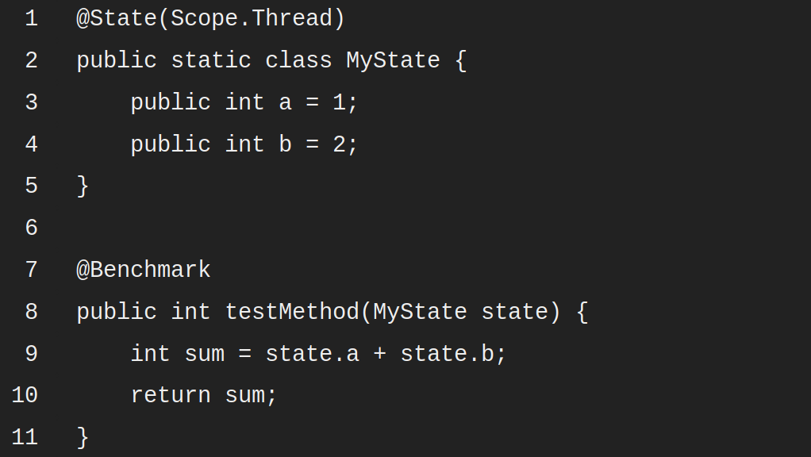
Remember, if your benchmark method calculates multiple values, you can pass them through a black hole instead of returning them, avoiding the dead code elimination optimization.

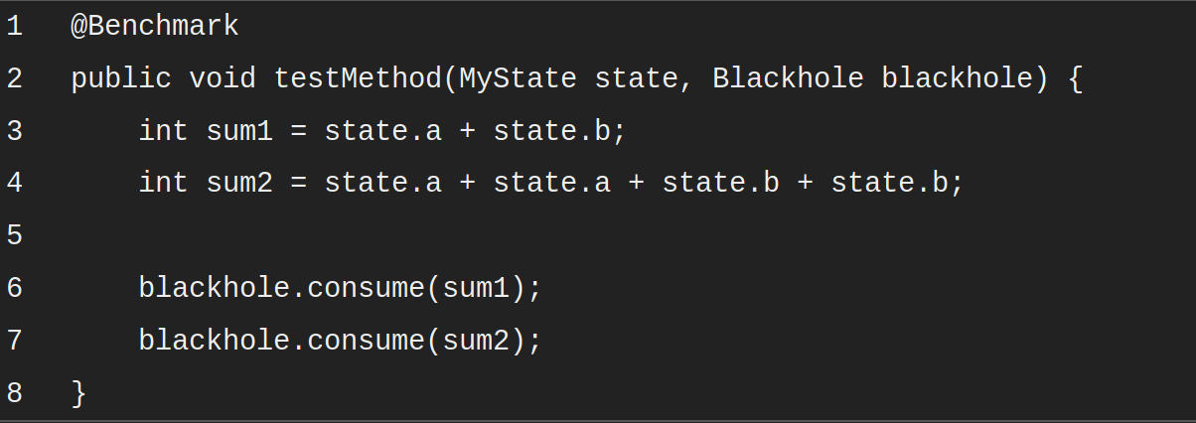
Source: The above mentioned notes have been taken from a series of articles from: https://blog.avenuecode.com/java-microbenchmarks-with-jmh-part-1

