Table of Contents
FOREWORD 2
WHAT IS REFACTORING? 3
THE FIRST STEP IN REFACTORING 3
WHEN SHOULD YOU REFACTOR? 3
WHAT IS IT THAT MAKES PROGRAMS HARD TO WORK WITH? 3
WHAT DO I TELL MY MANAGER? 3
PROBLEMS WITH REFACTORING 4
DATABASES 4
CHANGING INTERFACES 4
WHEN SHOULDN'T YOU REFACTOR? 4
REFACTORING AND PERFORMANCE 5
BAD SMELLS IN CODE THAT SHOULD BE REFACTORED 5
DUPLICATED CODE 5
LONG METHOD 5
LARGE CLASS 5
LONG PARAMETER LIST 5
DIVERGENT CHANGE 6
SHOTGUN SURGERY 6
FEATURE ENVY 6
DATA CLUMPS 6
SWITCH STATEMENTS 7
PARALLEL INHERITANCE HIERARCHIES 7
LAZY CLASS 7
SPECULATIVE GENERALITY 7
A CATALOG OF REFACTORINGS 7
COMPOSING METHODS 8
EXTRACT METHOD 8
INLINE METHOD 8
INLINE TEMP 8
REPLACE TEMP WITH QUERY 9
INTRODUCE EXPLAINING VARIABLE 9
SPLIT TEMPORARY VARIABLE 10
REMOVE ASSIGNMENTS TO PARAMETERS 11
PASS BY VALUE IN JAVA 12
REPLACE METHOD WITH METHOD OBJECT 12
SUBSTITUTE ALGORITHM 13
MOVING FEATURES BETWEEN OBJECTS 14
MOVE METHOD 14
MOVE FIELD 15
EXTRACT CLASS 16
INLINE CLASS 17
HIDE DELEGATE 18
REMOVE MIDDLE MAN 19
INTRODUCE FOREIGN METHOD 19
INTRODUCE LOCAL EXTENSION 20
ORGANIZING DATA 21
SELF ENCAPSULATE FIELD 21
REPLACE DATA VALUE WITH OBJECT 22
REPLACE ARRAY WITH OBJECT 23
REPLACE MAGIC NUMBER WITH SYMBOLIC CONSTANT 24
ENCAPSULATE FIELD 24
MOVING BEHAVIOR INTO THE CLASS 25

RUNNING NOTES OF REFACTORING - IMPROVING THE DESIGN OF EXISTING CODE

BY MARTIN FOWLER

FOREWORD
"Refactoring" was conceived in Smalltalk circles, but it wasn't long before it found its way into other programming language camps. Because refactoring is integral to framework development,
the term comes up quickly when "frameworkers" talk about their craft. It comes up when they refine their class hierarchies and when they rave about how many lines of code they were able to
delete. Frameworkers know that a framework won't be right the first time around—it must evolve as they gain experience. They also know that the code will be read and modified more frequently
than it will be written. The key to keeping code readable and modifiable is refactoring—for frameworks, in particular, but also for software in general.

So, what's the problem? Simply this: Refactoring is risky. It requires changes to working code that can introduce subtle bugs. Refactoring, if not done properly, can set you back days, even weeks.
And refactoring becomes riskier when practiced informally or ad hoc. You start digging in the code. Soon you discover new opportunities for change, and you dig deeper. The more you dig,
the more stuff you turn up…and the more changes you make. Eventually you dig yourself into a hole you can't get out of. To avoid digging your own grave, refactoring must be done systematically.

This book explains the principles and best practices of refactoring, and points out when and where you should start digging in your code to improve it.

WHAT IS REFACTORING?
Refactoring is the process of changing a software system in such a way that it does not alter the external behavior of the code yet improves its internal structure. It is a disciplined way to clean up code that minimizes the chances of introducing bugs. In essence when you refactor you are improving the design of the code after it has been written.

My aim is to show you how to do refactoring in a controlled and efficient manner. You will learn to refactor in such a way that you don't introduce bugs into the code but instead methodically improve the structure.

THE FIRST STEP IN REFACTORING
Whenever I do refactoring, the first step is always the same. I need to build a solid set of tests for that section of code. The tests are essential because even though I follow refactorings structured to avoid most of the opportunities for introducing bugs, I'm still human and still make mistakes. Thus I need solid tests.

Before you start refactoring, check that you have a solid suite of tests. These tests must be self-checking.

Refactoring changes the programs in small steps. If you make a mistake, it is easy to find the bug.

WHEN SHOULD YOU REFACTOR?
Refactor When You Add Function
Refactor When You Need to Fix a Bug
Refactor As You Do a Code Review

WHAT IS IT THAT MAKES PROGRAMS HARD TO WORK WITH?
· Programs that are hard to read are hard to modify.
· Programs that have duplicated logic are hard to modify.
· Programs that require additional behavior that requires you to
change running code are hard to modify.
· Programs with complex conditional logic are hard to modify.

WHAT DO I TELL MY MANAGER?
How to tell a manager about refactoring is one of the most common questions I've been asked. If the manager is technically savvy, introducing the subject may not be that hard. If the manager is
genuinely quality oriented, then the thing to stress is the quality aspects. Here using refactoring in the review process is a good way to work things. Tons of studies show that technical reviews are an important way to reduce bugs and thus speed up development. Take a look at any book on reviews, inspections, or the software development process for the latest citations. These should convince most managers of the value of reviews. It is then a short step to introduce refactoring as a way of getting review comments into the code.
Of course, many people say they are driven by quality but are more driven by schedule. In these cases I give my more controversial advice: Don't tell!

PROBLEMS WITH REFACTORING

DATABASES
One problem area for refactoring is databases. Most business applications are tightly coupled to the database schema that supports them. That's one reason that the database is difficult to
change. Another reason is data migration. Even if you have carefully layered your system to minimize the dependencies between the database schema and the object model, changing the database schema forces you to migrate the data, which can be a long and fraught task.

CHANGING INTERFACES
In short, if a refactoring changes a published interface, you have to retain both the old interface and the new one, at least until your users have had a chance to react to the change. Fortunately,
this is not too awkward. You can usually arrange things so that the old interface still works. Try to do this so that the old interface calls the new interface. In this way when you change the name of method, keep the old one, and just let it call the new one. Don't copy the method body—that leads you down the path to damnation by way of duplicated code. You should also use the deprecation facility in Java to mark the code as deprecated. That way your callers will know that something is up.

WHEN SHOULDN'T YOU REFACTOR?
There are times when you should not refactor at all. The principle example is when you should rewrite from scratch instead. There are times when the existing code is such a mess that although you could refactor it, it would be easier to start from the beginning. This decision is not an easy one to make, and I admit that I don't really have good guidelines for it.
A clear sign of the need to rewrite is when the current code just does not work. You may discover this only by trying to test it and discovering that the code is so full of bugs that you cannot
stablilize it. Remember, code has to work mostly correctly before you refactor.

REFACTORING AND PERFORMANCE
A common concern with refactoring is the effect it has on the performance of a program. To make the software easier to understand, you often make changes that will cause the program to run more slowly. This is an important issue. I'm not one of the school of thought that ignores performance in favor of design purity or in hopes of faster hardware.
The lesson is: Even if you know exactly what is going on in your system, measure performance, don't speculate. You'll learn something, and nine times out of ten, it won't be that you were right!

BAD SMELLS IN CODE THAT SHOULD BE REFACTORED
You should use this chapter as a way to give you inspiration when you're not sure what refactorings to do. Read the chapter
try to identify what it is you're smelling, then go to the refactorings we suggest to see whether they will help you. You may not find the exact smell you can detect, but hopefully it should point you in the right direction.

DUPLICATED CODE
Number one in the stink parade is duplicated code. If you see the same code structure in more than one place, you can be sure that your program will be better if you find a way to unify them.

LONG METHOD
The object programs that live best and longest are those with short methods. Programmers new to objects often feel that no computation ever takes place, that object programs are endless
sequences of delegation. When you have lived with such a program for a few years, however, you learn just how valuable all those little methods are.

LARGE CLASS
When a class is trying to do too much, it often shows up as too many instance variables. When a class has too many instance variables, duplicated code cannot be far behind.

LONG PARAMETER LIST
In our early programming days we were taught to pass in as parameters everything needed by a routine. This was understandable because the alternative was global data, and global data is evil
and usually painful. Objects change this situation because if you don't have something you need, you can always ask another object to get it for you. Thus with objects you don't pass in everything
the method needs; instead you pass enough so that the method can get to everything it needs.
Long parameter lists are hard to understand, because they become
inconsistent and difficult to use, and because you are forever changing them as you need more data. Most changes are removed by passing objects because you are much more likely to need to make only a couple of requests to get at a new piece of data.

DIVERGENT CHANGE
Divergent change occurs when one class is commonly changed in different ways for different reasons. If you look at a class and say, "Well, I will have to change these three methods every
time I get a new database; I have to change these four methods every time there is a new financial instrument," you likely have a situation in which two objects are better than one. That
way each object is changed only as a result of one kind of change. Of course, you often discover this only after you've added a few databases or financial instruments. Any change to handle a
variation should change a single class, and all the typing in the new class should express the variation.

SHOTGUN SURGERY
Shotgun surgery is similar to divergent change but is the opposite. You whiff this when every time you make a kind of change, you have to make a lot of little changes to a lot of different classes.
When the changes are all over the place, they are hard to find, and it's easy to miss an important change.

FEATURE ENVY
A classic smell is a method that seems more interested in a class other than the one it actually is in. The most common focus of the envy is the data. We've lost count of the times we've seen a method that invokes half-a-dozen getting methods on another object to calculate some value. Fortunately the cure is obvious, the method clearly wants to be elsewhere.

DATA CLUMPS
Data items tend to be like children; they enjoy hanging around in groups together. Often you'll see the same three or four data items together in lots of places: fields in a couple of classes,
parameters in many method signatures. Bunches of data that hang around together really ought to be made into their own object.

SWITCH STATEMENTS
One of the most obvious symptoms of object-oriented code is its comparative lack of switch (or case) statements. The problem with switch statements is essentially that of duplication. Often you
find the same switch statement scattered about a program in different places. If you add a new clause to the switch, you have to find all these switch, statements and change them. The objectoriented notion of polymorphism gives you an elegant way to deal with this problem.
Most times you see a switch statement you should consider polymorphism.

PARALLEL INHERITANCE HIERARCHIES
Parallel inheritance hierarchies is really a special case of shotgun surgery. In this case, every time you make a subclass of one class, you also have to make a subclass of another. You can
recognize this smell because the prefixes of the class names in one hierarchy are the same as the prefixes in another hierarchy.

LAZY CLASS
Each class you create costs money to maintain and understand. A class that isn't doing enough to pay for itself should be eliminated. Often this might be a class that used to pay its way but has been downsized with refactoring. Or it might be a class that was added because of changes that were planned but not made. Either way, you let the class die with dignity. If you have subclasses that aren't doing enough, try to use Collapse Hierarchy . Nearly useless components should be subjected to Inline Class .

SPECULATIVE GENERALITY
Brian Foote suggested this name for a smell to which we are very sensitive. You get it when people say, "Oh, I think we need the ability to this kind of thing someday" and thus want all sorts
of hooks and special cases to handle things that aren't required. The result often is harder to understand and maintain. If all this machinery were being used, it would be worth it. But if it isn't,
it isn't. The machinery just gets in the way, so get rid of it.

A CATALOG OF REFACTORINGS
Initial catalog of refactorings. They've grown from the notes I've made in refactoring over the last few years. This catalog is by no means comprehensive or watertight, but it should provide a solid starting point for your own refactoring work.

COMPOSING METHODS

EXTRACT METHOD
Extract Method is one of the most common refactorings I do. I look at a method that is too long or look at code that needs a comment to understand its purpose. I then turn that fragment of code into its own method.
I prefer short, well-named methods for several reasons. First, it increases the chances that other methods can use a method when the method is finely grained. Second, it allows the higher-level methods to read more like a series of comments. Overriding also is easier when the methods are finely grained.

A good reference for how long a method can be is probably around 10 lines, if it’s more than that then maybe it can be extracted.

INLINE METHOD
A theme of this book is to use short methods named to show their intention, because these methods lead to clearer and easier to read code. But sometimes you do come across a method in which the body is as clear as the name. Or you refactor the body of the code into something that is just as clear as the name. When this happens, you should then get rid of the method.
Indirection can be helpful, but needless indirection is irritating.
Another time to use Inline Method is when you have a group of methods that seem badly factored. You can inline them all into one big method and then reextract the methods.

Mechanics:
+ Check that the method is not polymorphic :Don't inline if subclasses override the method; they cannot override a method that isn't there.
+ Find all calls to the method.
+ Replace each call with the method body.

INLINE TEMP
You have a temp that is assigned to once with a simple expression, and the temp is getting in the way of other refactorings.

Replace all references to that temp with the expression.

double basePrice = anOrder.basePrice();
return (basePrice > 1000)

the above two statements can be don with this:

return (anOrder.basePrice() > 1000)

Mechanics:
+ Declare the temp as final if it isn't already, and compile.This checks that the temp is really only assigned to once.
+ Find all references to the temp and replace them with the right-hand side of the assignment.

REPLACE TEMP WITH QUERY
You are using a temporary variable to hold the result of an expression.
Extract the expression into a method. Replace all references to the temp with the expression. The new method can then be used in other methods.

double basePrice = _quantity * _itemPrice;
if (basePrice > 1000)
return basePrice * 0.95;
else
return basePrice * 0.98;

replace the above with:

if (basePrice() > 1000)
return basePrice() * 0.95;
else
return basePrice() * 0.98;
...
double basePrice() {
return _quantity * _itemPrice;
}

Mechanics:
Here is the simple case:
+ Look for a temporary variable that is assigned to once. If a temp is set more than once consider Split Temporary Variable.
+ Declare the temp as final.
+ Extract the right-hand side of the assignment into a method. Initially mark the method as private. You may find more use for it later, but you can easily relax the protection later.
+ Ensure the extracted method is free of side effects, that is, it does not modify any object. If it is not free of side effects, use Separate Query from Modifier .
+ Use Replace Temp with Query on the temp.

INTRODUCE EXPLAINING VARIABLE
You have a complicated expression. Put the result of the expression, or parts of the expression, in a temporary variable with a name that explains the purpose.

if ( (platform.toUpperCase().indexOf("MAC") > -1) &&
(browser.toUpperCase().indexOf("IE") > -1) &&
wasInitialized() && resize > 0 )
{
// do something
}

the above with this:

final boolean isMacOs = platform.toUpperCase().indexOf("MAC") >
-1;
final boolean isIEBrowser = browser.toUpperCase().indexOf("IE") >
-1;
final boolean wasResized = resize > 0;
if (isMacOs && isIEBrowser && wasInitialized() && wasResized) {
// do something
}

Mechanics:
+ Declare a final temporary variable, and set it to the result of part of the complex expression.
+ Replace the result part of the expression with the value of the temp. If the result part of the expression is repeated, you can replace the repeats one at a time.

SPLIT TEMPORARY VARIABLE
You have a temporary variable assigned to more than once, but is not a loop variable nor a collecting temporary variable.

Make a separate temporary variable for each assignment.

double temp = 2 * (_height + _width);
System.out.println (temp);
temp = _height * _width;
System.out.println (temp);

the above with his:

final double perimeter = 2 * (_height + _width);
System.out.println (perimeter);
final double area = _height * _width;
System.out.println (area);

These kinds of variables should be set only once. That they are set more than once is a sign that they have more than one responsibility within the method. Any variable with more than one responsibility should be replaced with a temp for each responsibility. Using a temp for two different things is very confusing for the reader.

Mechanics:
+ Change the name of a temp at its declaration and its first assignment. If the later assignments are of the form i = i + some expression, that indicates that it is a collecting temporary variable, so don't split it. The operator for a collecting temporary variable usually is addition, string concatenation, writing to a stream, or adding to a collection.
+ Declare the new temp as final.
+ Change all references of the temp up to its second assignment.
+ Declare the temp at its second assignment.

REMOVE ASSIGNMENTS TO PARAMETERS
The code assigns to a parameter. Use a temporary variable instead.

int discount (int inputVal, int quantity, int yearToDate) {
if (inputVal > 50) inputVal -= 2;

the above with this:

int discount (int inputVal, int quantity, int yearToDate) {
int result = inputVal;
if (inputVal > 50) result -= 2;

The reason I don't like this comes down to lack of clarity and to confusion between pass by value and pass by reference. Java uses pass by value exclusively (see later), and this discussion is based on that usage.
With pass by value, any change to the parameter is not reflected in the calling routine. Those who have used pass by reference will probably find this confusing.

The other area of confusion is within the body of the code itself. It is much clearer if you use only the parameter to represent what has been passed in, because that is a consistent usage.
In Java, don't assign to parameters, and if you see code that does, apply Remove Assignments to Parameters.
Of course this rule does not necessarily apply to other languages that use output parameters, although even with these languages I prefer to use output parameters as little as possible.

Mechanics:
+ Create a temporary variable for the parameter.
+ Replace all references to the parameter, made after the assignment, to the temporary variable.
+ Change the assignment to assign to the temporary variable.

PASS BY VALUE IN JAVA
Use of pass by value often is a source of confusion in Java. Java strictly uses pass by value in all places, thus the following program:

class Param {
public static void main(String[] args) {
int x = 5;
triple(x);
System.out.println ("x after triple: " + x);
}
private static void triple(int arg) {
arg = arg * 3;
System.out.println ("arg in triple: " + arg);
}
}

produces the following output:

arg in triple: 15
x after triple: 5

REPLACE METHOD WITH METHOD OBJECT
You have a long method that uses local variables in such a way that you cannot apply Extract Method.

Turn the method into its own object so that all the local variables become fields on that object.

You can then decompose the method into other methods on the same object.

class Order...
double price() {
double primaryBasePrice;
double secondaryBasePrice;
double tertiaryBasePrice;
// long computation;
...
}

the above can done as:

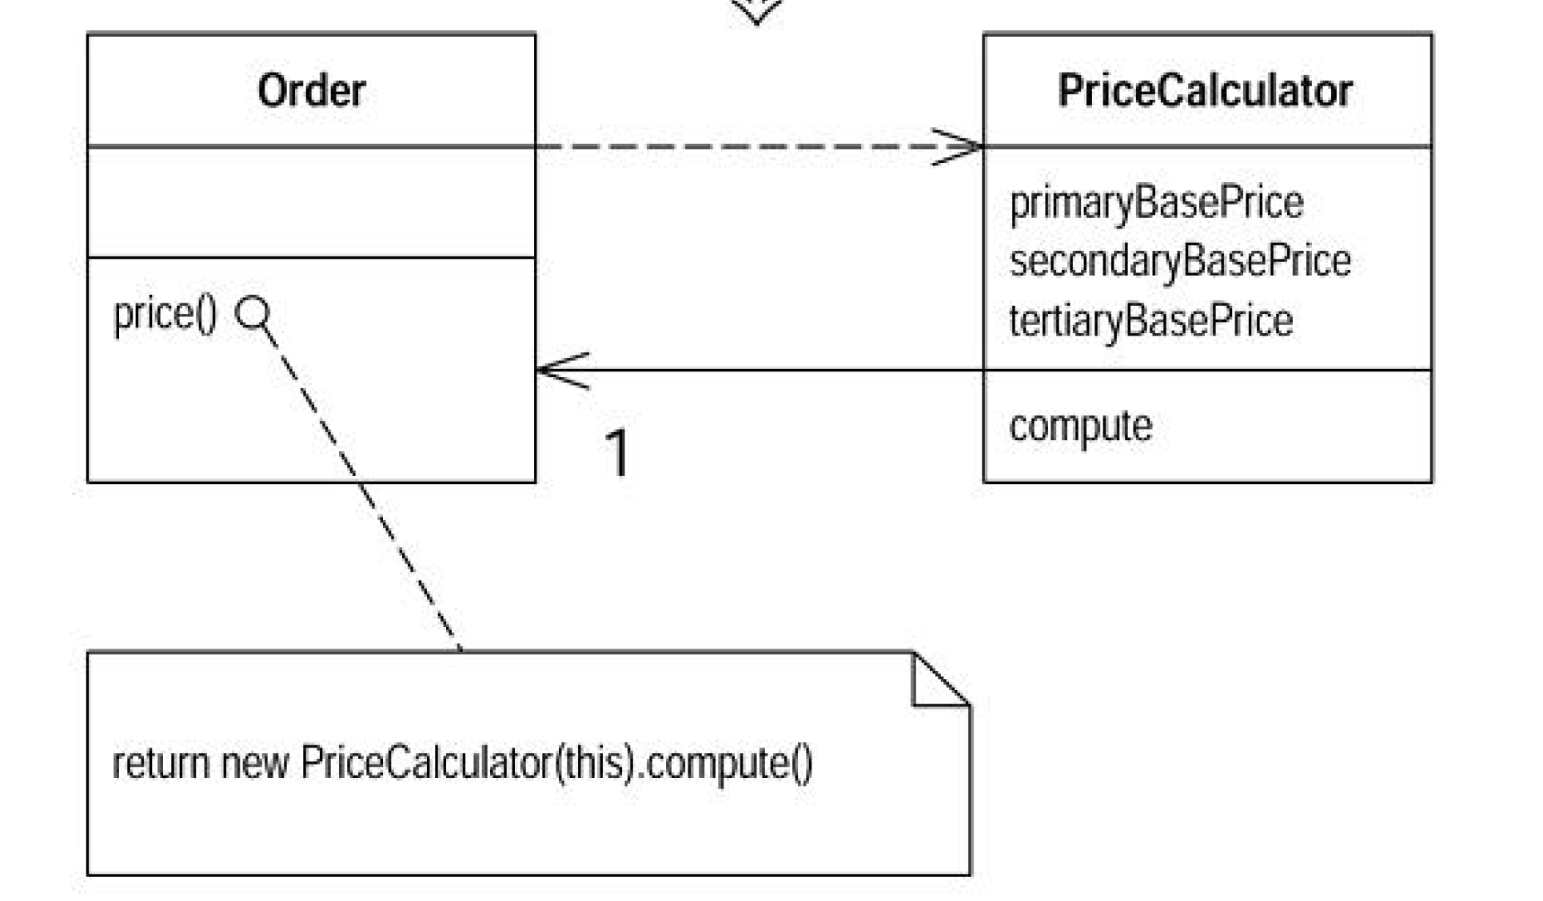
In this book I emphasize the beauty of small methods. By extracting pieces out of a large method, you make things much more comprehensible.
The difficulty in decomposing a method lies in local variables. If they are rampant, decomposition can be difficult. Using Replace Temp with Query helps to reduce this burden, but occasionally
you may find you cannot break down a method that needs breaking. In this case you reach deep into the tool bag and get out your method object.

Mechanics:
+ Create a new class, name it after the method.
+ Give the new class a final field for the object that hosted the original method (the source object) and a field for each temporary variable and each parameter in the method.
+ Give the new class a constructor that takes the source object and each parameter.
+ Give the new class a method named "compute."
+ Copy the body of the original method into compute. Use the source object field for any invocations of methods on the original object.
+ Replace the old method with one that creates the new object and calls compute.

SUBSTITUTE ALGORITHM
You want to replace an algorithm with one that is clearer.

Replace the body of the method with the new algorithm.

String foundPerson(String[] people){
for (int i = 0; i < people.length; i++) {
if (people[i].equals ("Don")){
return "Don";
}
if (people[i].equals ("John")){
return "John";
}
if (people[i].equals ("Kent")){
return "Kent";
}
}
return "";
}

this can be replaced with:

String foundPerson(String[] people){
List candidates = Arrays.asList(new String[] {"Don", "John",
"Kent"});
for (int i=0; i<people.length; i++)
if (candidates.contains(people[i]))
return people[i];
return "";
}

Mechanics:
+ Prepare your alternative algorithm. Get it so that it compiles.
+ Run the new algorithm against your tests. If the results are the same, you're finished.
+ If the results aren't the same, use the old algorithm for comparison in testing and debugging. Run each test case with old and new algorithms and watch both results. That will help you see which test cases are causing trouble, and how.

MOVING FEATURES BETWEEN OBJECTS
One of the most fundamental, if not the fundamental, decision in object design is deciding where to put responsibilities. I've been working with objects for more than a decade, but I still never get
it right the first time. That used to bother me, but now I realize that I can use refactoring to change my mind in these cases.

MOVE METHOD
A method is, or will be, using or used by more features of another class than the class on which it is defined.
Create a new method with a similar body in the class it uses most. Either turn the old method into a simple delegation, or remove it altogether.

Moving methods is the bread and butter of refactoring. I move methods when classes have too much behavior or when classes are collaborating too much and are too highly coupled. By moving methods around, I can make the classes simpler and they end up being a more crisp implementation of a set of responsibilities.
I usually look through the methods on a class to find a method that seems to reference another object more than the object it lives on. A good time to do this is after I have moved some fields.

Mechanics:
+ Examine all features used by the source method that are defined on the source class. Consider whether they also should be moved.
If a feature is used only by the method you are about to move, you
might as well move it, too. If the feature is used by other methods, consider moving them as well. Sometimes it is easier to move a clutch of methods than to move them one at a time.

+ Check the sub- and superclasses of the source class for other declarations of the method. If there are any other declarations, you may not be able to make the move, unless the polymorphism can also be expressed on the target.
+ Declare the method in the target class. You may choose to use a different name, one that makes more sense in the target class.

+ Copy the code from the source method to the target. Adjust the method to make it work in its new home. If the method uses its source, you need to determine how to reference the source object from the target method. If there is no mechanism in the target class, pass the source object reference to the new method as a parameter. If the method includes exception handlers, decide which class should logically handle the exception. If the source class should be responsible, leave the handlers behind.

+ Decide whether to remove the source method or retain it as a delegating method. Leaving the source as a delegating method is easier if you have many references.

+ If you remove the source method, replace all the references with references to the target method. You can compile and test after changing each reference, although it is usually easier to change all references with one search and replace.

MOVE FIELD
A field is, or will be, used by another class more than the class on which it is defined.

Create a new field in the target class, and change all its users.

I consider moving a field if I see more methods on another class using the field than the class itself. This usage may be indirect, through getting and setting methods. I may choose to move the
methods; this decision based on interface. But if the methods seem sensible where they are, I move the field.

Mechanics:
+ If the field is public, use Encapsulate Field. If you are likely to be moving the methods that access it frequently or if a lot of methods access the field, you may find it useful to use Self Encapsulate Field
+ Create a field in the target class with getting and setting methods.
+ Determine how to reference the target object from the source.
An existing field or method may give you the target. If not, see
whether you can easily create a method that will do so. Failing that, you need to create a new field in the source that can store the target. This may be a permanent change, but you can also do it temporarily until you have refactored enough to remove it.
+ Remove the field on the source class.
+ Replace all references to the source field with references to the appropriate method on the target. For accesses to the variable, replace the reference with a call to the target object's getting method; for assignments, replace the reference
with a call to the setting method. If the field is not private, look in all the subclasses of the source for references.

EXTRACT CLASS
You have one class doing work that should be done by two.

Create a new class and move the relevant fields and methods from the old class into the new class.

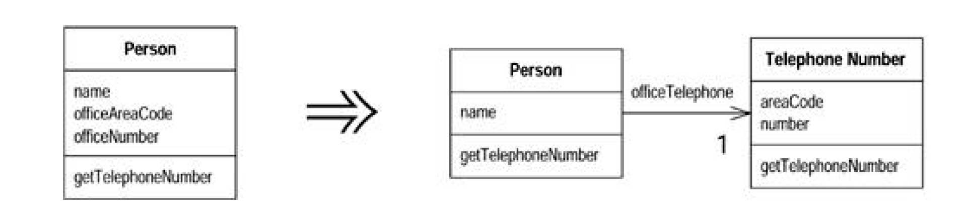
A class that is too big to understand easily. You need to consider where it can be split, and you split it.

Mechanics:
+ Decide how to split the responsibilities of the class.
+ Create a new class to express the split-off responsibilities.
If the responsibilities of the old class no longer match its name,
rename the old class.
+ Make a link from the old to the new class. You may need a two-way link. But don't make the back link until you find you need it.
Use Move Field on each field you wish to move.
+ Compile and test after each move.
+ Use Move Method to move methods over from old to new. Start with lower-level methods (called rather than calling) and build to the higher level.
+ Review and reduce the interfaces of each class. If you did have a two-way link, examine to see whether it can be made one way.
+ Decide whether to expose the new class. If you do expose the class, decide whether to expose it as a reference object or as an immutable value object.

INLINE CLASS
A class isn't doing very much.

Move all its features into another class and delete it.

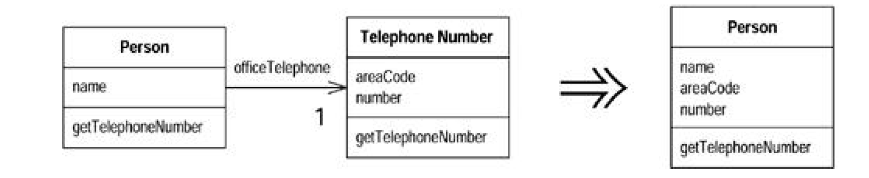
Inline Class is the reverse of Extract Class. I use Inline Class if a class is no longer pulling its weight and shouldn't be around any more. Often this is the result of refactoring that moves other
responsibilities out of the class so there is little left. Then I want to fold this class into another class, picking one that seems to use the runt class the most.

Mechanics:
+ Declare the public protocol of the source class onto the absorbing class. Delegate all these methods to the source class.
If a separate interface makes sense for the source class methods,
use Extract Interface before inlining.
+ Change all references from the source class to the absorbing class. Declare the source class private to remove out-of-package
references. Also change the name of the source class so the compiler catches any dangling references to the source class.
+ Use Move Method and Move Field to move features from the source class to the absorbing class until there is nothing left.

HIDE DELEGATE
A client is calling a delegate class of an object.

Create methods on the server to hide the delegate.

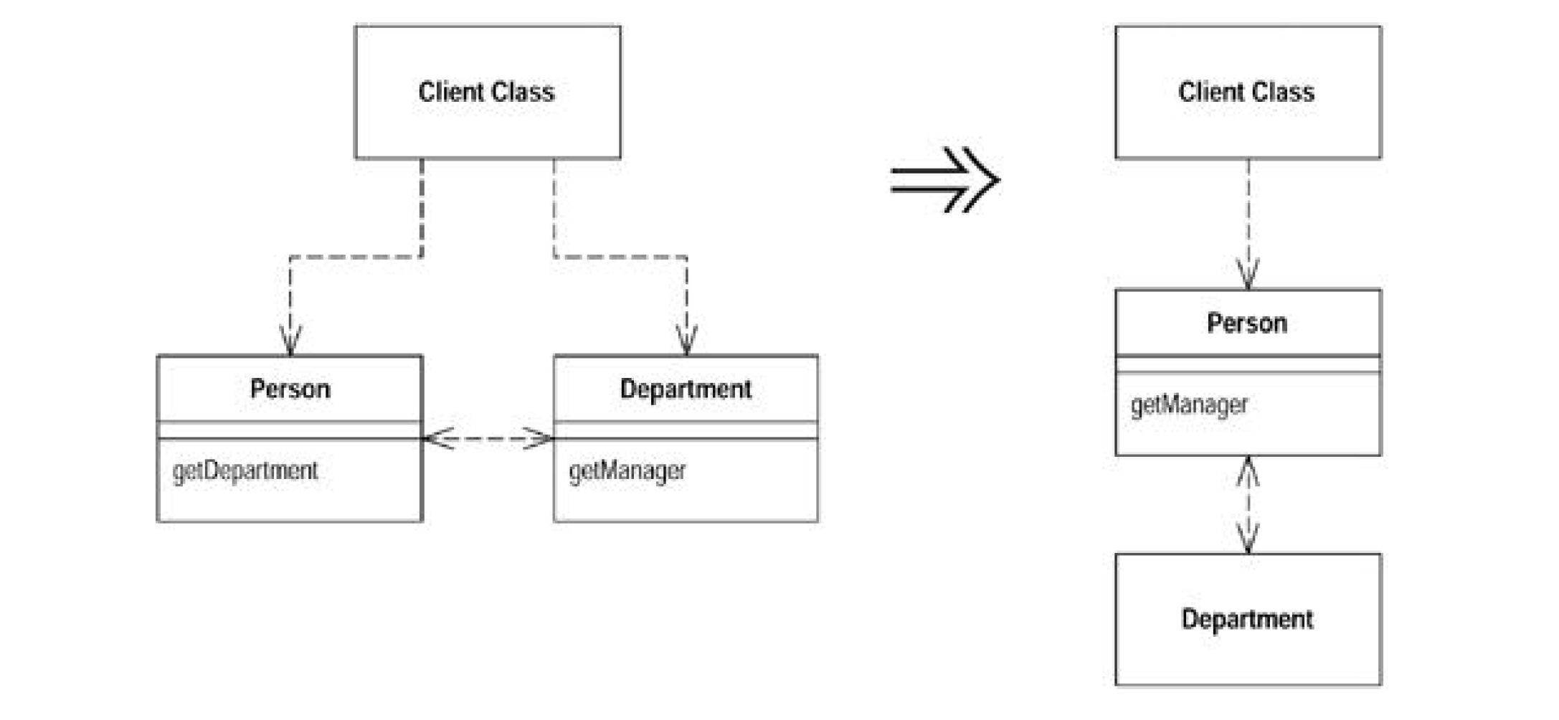
One of the keys, if not the key, to objects is encapsulation. Encapsulation means that objects need to know less about other parts of the system. Then when things change, fewer objects need
to be told about the change—which makes the change easier to make.

Anyone involved in objects knows that you should hide your fields, despite the fact that Java allows fields to be public. As you become more sophisticated, you realize there is more you can
encapsulate.
If a client calls a method defined on one of the fields of the server object, the client needs to know about this delegate object. If the delegate changes, the client also may have to change. You can remove this dependency by placing a simple delegating method on the server, which hides the
delegate (Figure 7.1 ). Changes become limited to the server and don't propagate to the client.

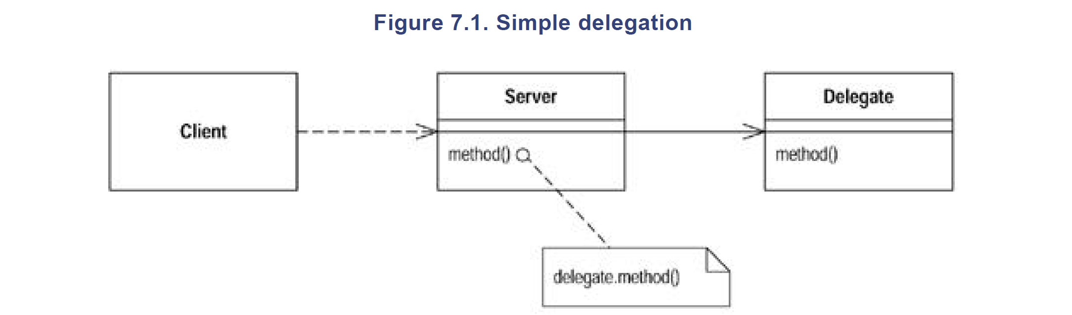
Mechanics:
+ For each method on the delegate, create a simple delegating method on the server.
+ Adjust the client to call the server. If the client is not in the same package as the server, consider changing the delegate method's access to package visibility.
+ If no client needs to access the delegate anymore, remove the server's accessor for the delegate.

REMOVE MIDDLE MAN
A class is doing too much simple delegation.

Get the client to call the delegate directly.

In the motivation for Hide Delegate, I talked about the advantages of encapsulating the use of a delegated object. There is a price for this. The price is that every time the client wants to use a new feature of the delegate, you have to add a simple delegating method to the server. After adding features for a while, it becomes painful. The server class is just a middle man, and perhaps it's time for the client to call the delegate directly.
It's hard to figure out what the right amount of hiding is. Fortunately, with Hide Delegate and Remove Middle Man it does not matter so much. You can adjust your system as time goes on.
As the system changes, the basis for how much you hide also changes. A good encapsulation six months ago may be awkward now. Refactoring means you never have to say you're sorry—you
just fix it.

Mechanics:
+ Create an accessor for the delegate.
+ For each client use of a delegate method, remove the method from the server and replace the call in the client to call method on the delegate.

INTRODUCE FOREIGN METHOD
A server class you are using needs an additional method, but you can't modify the class.

Create a method in the client class with an instance of the server class as its first argument.

It happens often enough. You are using this really nice class that gives you all these great services. Then there is one service it doesn't give you but should. You curse the class, saying,
"Why don't you do that?" If you can change the source, you can add in the method. If you can't change the source, you have to code around the lack of the method in the client.

If you use the method only once in the client class then the extra coding is no big deal and probably wasn't needed on the original class anyway. If you use the method several times, however, you have to repeat this coding around. Because repetition is the root of all software evil, this repetitive code should be factored into a single method. When you do this refactoring, you can clearly signal that this method is really a method that should be on the original by making it a foreign method.

If you find yourself creating many foreign methods on a server class, or you find many of your classes need the same foreign method, you should use Introduce Local Extension instead.
Don't forget that foreign methods are a work-around. If you can, try to get the methods moved to their proper homes. If code ownership is the issue, send the foreign method to the owner of the server class and ask the owner to implement the method for you.

Mechanics:
+ Create a method in the client class that does what you need.
The method should not access any of the features of the client
class. If it needs a value, send it in as a parameter.
+ Make an instance of the server class the first parameter.
+ Comment the method as "foreign method; should be in server. This way you can use a text search to find foreign methods later if
you get the chance to move the method.

INTRODUCE LOCAL EXTENSION
A server class you are using needs several additional methods, but you can't modify the class.

Create a new class that contains these extra methods. Make this extension class a subclass or a wrapper of the original.
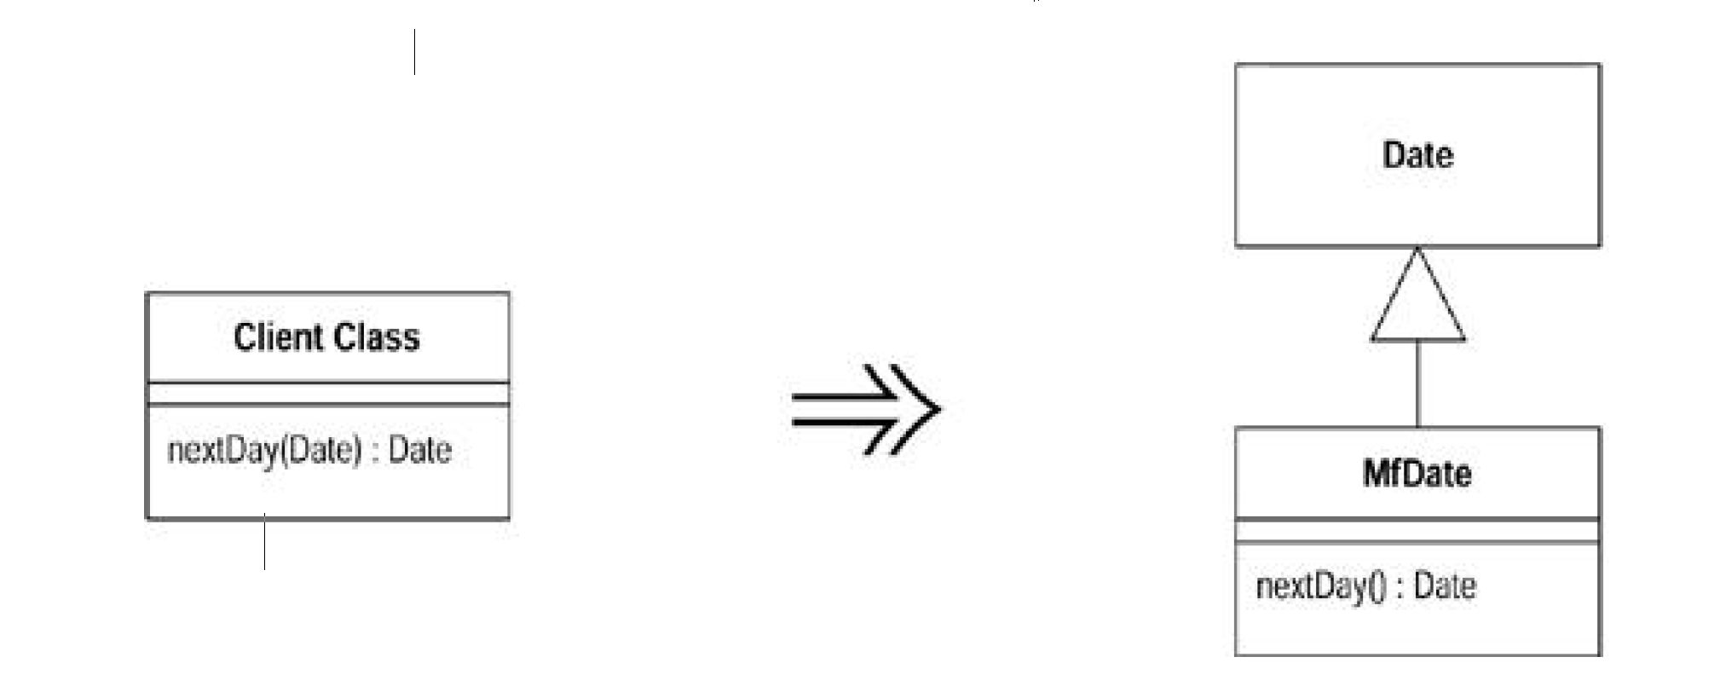
Authors of classes sadly are not omniscient, and they fail to provide useful methods for you. If you can modify the source, often the best thing is to add that method. However, you often cannot modify the source. If you need one or two methods, you can use Introduce Foreign Method.
Once you get beyond a couple of these methods, however, they get out of hand. So you need to group the methods together in a sensible place for them. The standard object-oriented techniques
of subclassing and wrapping are an obvious way to do this. In these circumstances I call the subclass or wrapper a local extension.

Mechanics:
+ Create an extension class either as a subclass or a wrapper of the original. Add converting constructors to the extension.
A constructor takes the original as an argument. The subclass
version calls an appropriate superclass constructor; the wrapper version sets the delegate field to the argument.
+ Add new features to the extension.
+ Replace the original with the extension where needed.
+ Move any foreign methods defined for this class onto the extension.

ORGANIZING DATA
In this chapter I discuss several refactorings that make working with data easier.

SELF ENCAPSULATE FIELD
You are accessing a field directly, but the coupling to the field is becoming awkward.

Create getting and setting methods for the field and use only those to access the field.

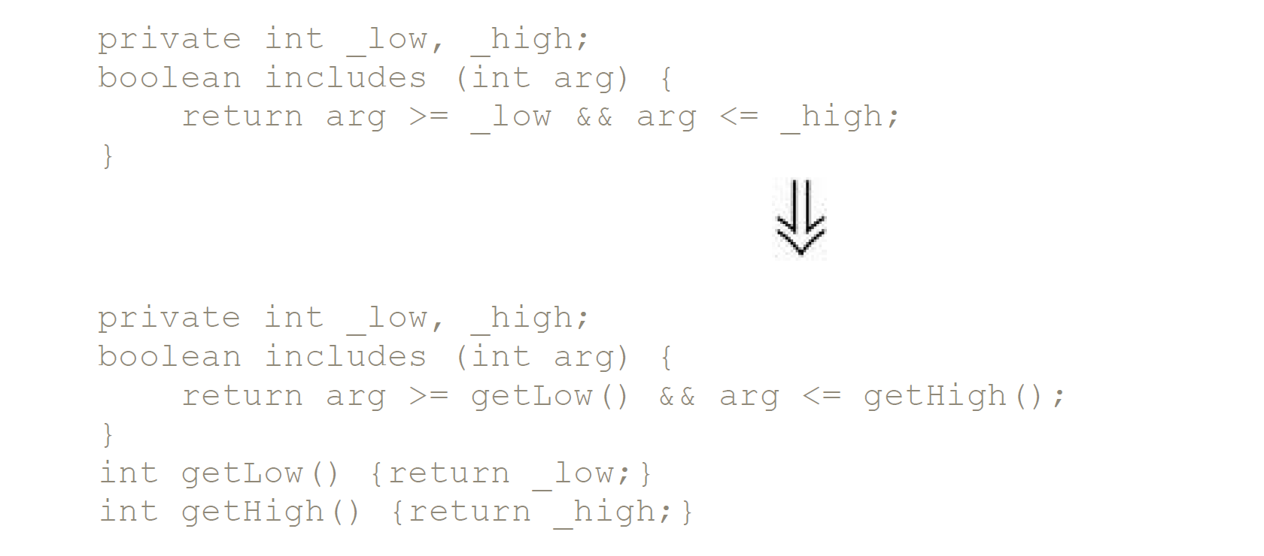
When it comes to accessing fields, there are two schools of thought. One is that within the class where the variable is defined, you should access the variable freely (direct variable access). The other school is that even within the class, you should always use accessors (indirect variable access). Debates between the two can be heated. (See also the discussion in Auer [Auer] on page 413 and Beck [Beck].)

Essentially the advantages of indirect variable access are that it allows a subclass to override how to get that information with a method and that it supports more flexibility in managing the
data, such as lazy initialization, which initializes the value only when you need to use it.

The advantage of direct variable access is that the code is easier to read. You don't need to stop and say, "This is just a getting method."

I'm always of two minds with this choice. I'm usually happy to do what the rest of the team wants to do. Left to myself, though, I like to use direct variable access as a first resort, until it gets in the way. Once things start becoming awkward, I switch to indirect variable access. Refactoring gives you the freedom to change your mind.

Mechanics:
+ Create a getting and setting method for the field.
+ Find all references to the field and replace them with a getting or setting method. Replace accesses to the field with a call to the getting method; replace assignments with a call to the setting method. You can get the compiler to help you check by temporarily
renaming the field.
+ Make the field private.
+ Double check that you have caught all references.

REPLACE DATA VALUE WITH OBJECT
You have a data item that needs additional data or behavior.

Turn the data item into an object.

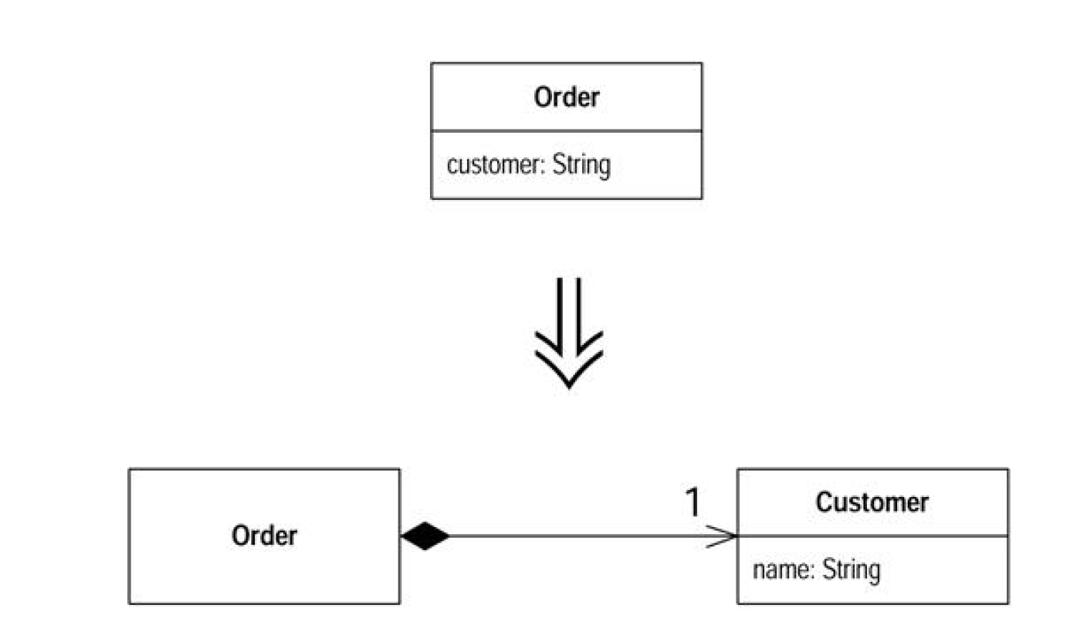
Often in early stages of development you make decisions about representing simple facts as simple data items. As development proceeds you realize that those simple items aren't so simple
anymore. A telephone number may be represented as a string for a while, but later you realize that the telephone needs special behavior for formatting, extracting the area code, and the like.
For one or two items you may put the methods in the owning object, but quickly the code smells of duplication and feature envy. When the smell begins, turn the data value into an object.

Mechanics:
+ Create the class for the value. Give it a final field of the same type as the value in the source class. Add a getter and a constructor that takes the field as an argument.
+ Change the type of the field in the source class to the new class.
+ Change the getter in the source class to call the getter in the new class.
+ If the field is mentioned in the source class constructor, assign the field using the constructor of the new class.
+ Change the getting method to create a new instance of the new class.
+ You may now need to use Change Value to Reference on the new object.

REPLACE ARRAY WITH OBJECT
You have an array in which certain elements mean different things.

Replace the array with an object that has a field for each element.

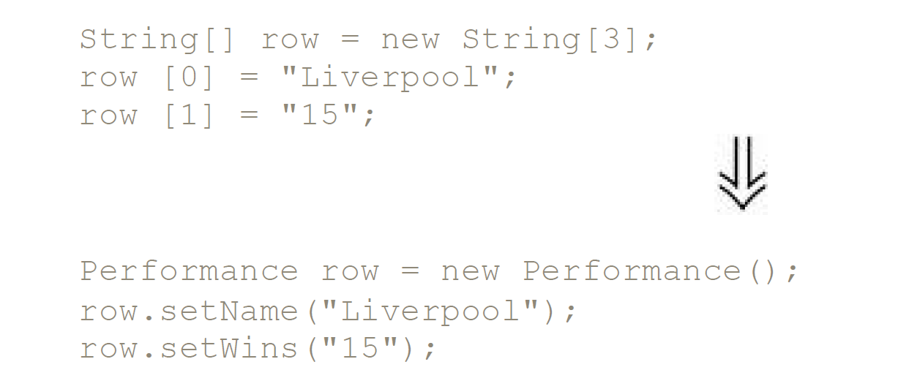
Arrays are a common structure for organizing data. However, they should be used only to contain a collection of similar objects in some order. Sometimes, however, you see them used to contain
a number of different things. Conventions such as "the first element on the array is the person's name" are hard to remember. With an object you can use names of fields and methods to convey
this information so you don't have to remember it or hope the comments are up to date.

Mechanics:
+ Create a new class to represent the information in the array. Give it a public field for the array.
+ Change all users of the array to use the new class.
+ One by one, add getters and setters for each element of the array. Name the accessors after the purpose of the array element. Change the clients to use the accessors. Compile and test after each change.
+ When all array accesses are replaced by methods, make the array private.
+ For each element of the array, create a field in the class and change the accessors to use the field.
+ When all elements have been replaced with fields, delete the array.

REPLACE MAGIC NUMBER WITH SYMBOLIC CONSTANT
You have a literal number with a particular meaning.

Create a constant, name it after the meaning, and replace the number with it.

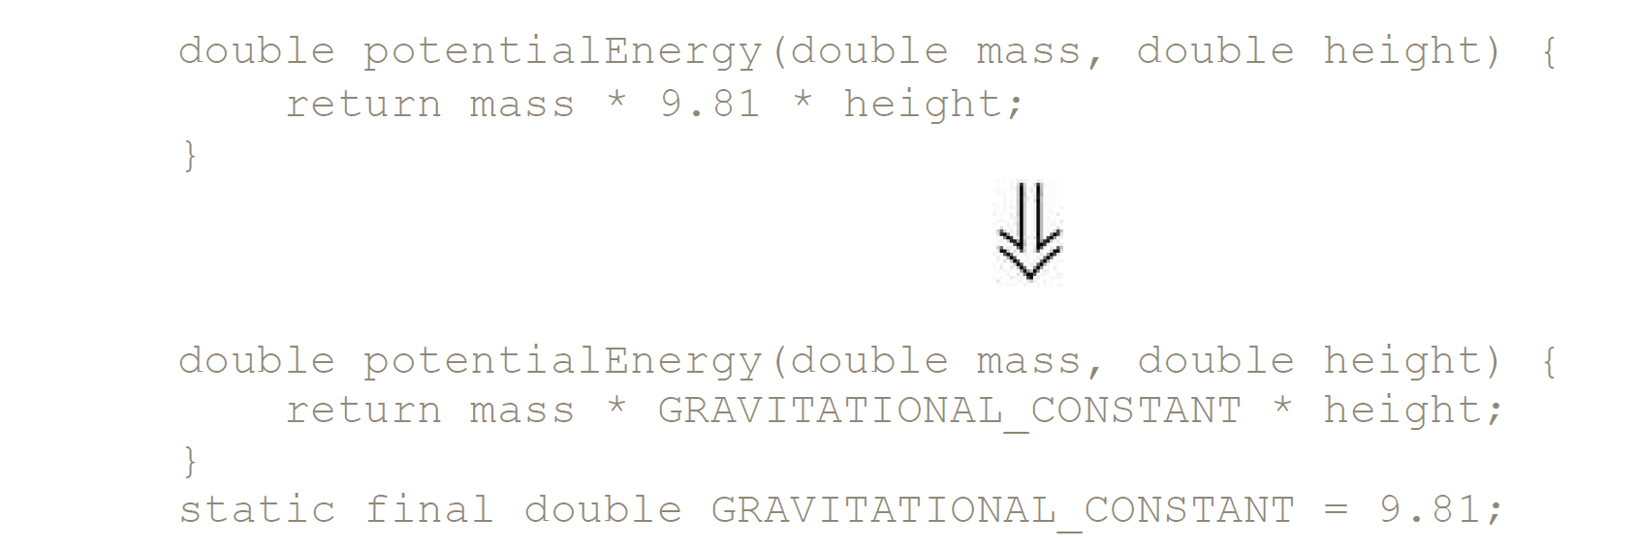

ENCAPSULATE FIELD
There is a public field.

Make it private and provide accessors.

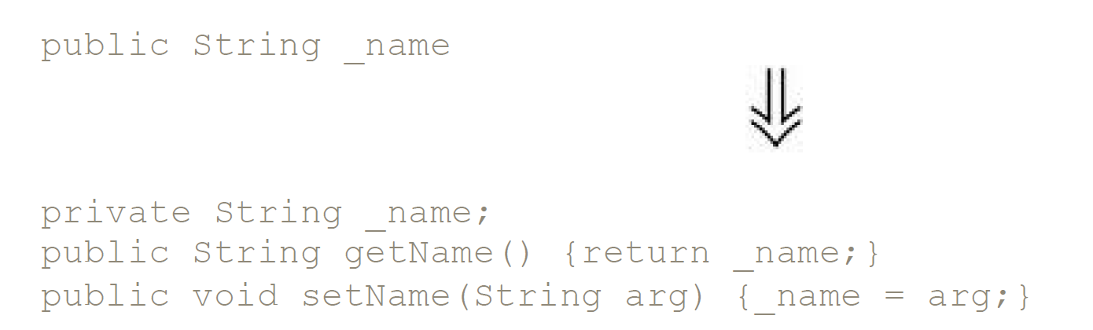
One of the principal tenets of object orientation is encapsulation, or data hiding. This says that you should never make your data public. When you make data public, other objects can change and access data values without the owning object's knowing about it. This separates data from behavior.

But this is only the first step. A class with only accessors is a dumb class that doesn't really take advantage of the opportunities of objects, and an object is terrible thing to waste. Once I've done Encapsulate Field I look for methods that use the new methods to see whether they fancy packing their bags and moving to the new object with a quick Move Method.

MOVING BEHAVIOR INTO THE CLASS
I have the right interface. Now I like to look at the users of the getter to find code that ought to be on person. Code such as

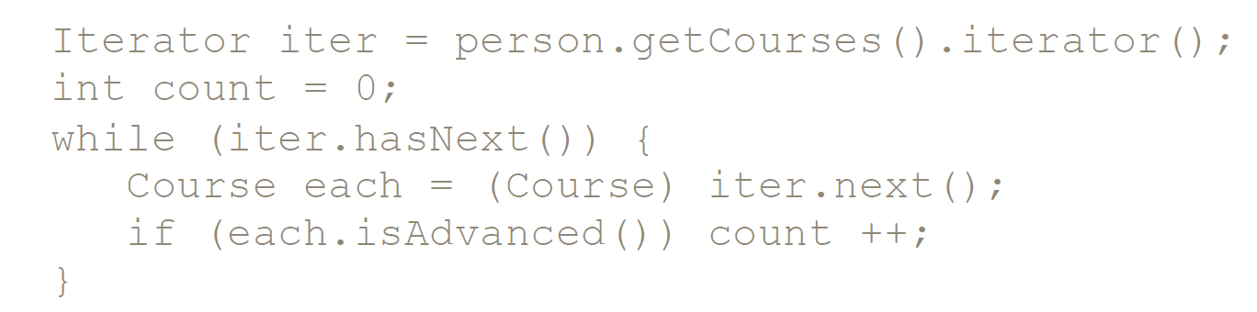
is better moved to person because it uses only person's data. First I use Extract Method on the code:

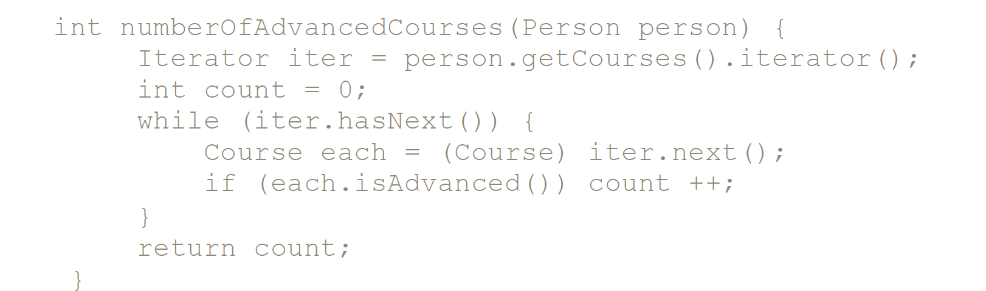
And then I use Move Method to move it to person:

