Docksal Installation

1. Follow the instruction given here for ubuntu:
https://docs.docksal.io/getting-started/setup/#install-linux-debian-fedora

2. Once docksal installation is done (by running the above command), then create a directory as follow:

mkdir -p ~/DocksalProjects

The above dir will host all your docksal projects.

3. Move into the above created dir and do a git clone of the project:

git clone https://sandeepbw@bitbucket.org/busywizzy/agretail.git

Once the clone is complete, you will see the project folder created. Navigate into the folder and do an ls -a -l to a see a listing of all files.

4. Now move into ‘agretail’ project folder and do a ‘fin init’ or ‘fin up’ to initialize your docksal settings for this particular project.

If you happen to see an error message saying ‘This user does not belong to the docker project....’ then just issue the newdocker ... command as shown in the instructions, this will create a temporary session.

Once the init. Is successful, you’ll see the docksal project url, copy it.

5. Once the fin up or fin init is complete, run a fin status. It’s okay, if it says status as ‘unhealthy’

6. Now edit the .env file and replace the docksal url in the .env file with the one copied above.

7. Now we need to import the db dump for this particular project. The dump is already present in database.sql file, connect to the mysql db using any mysql client.

I’ve used mysql-client and connected to it from the command line:

mysql -h 192.168.64.100 -u user -P 32768 -D default -p < full_path_to_database.sql

-h is for the host connection. That is default for all docksal mysql dbs.
-u is for the username. This you can find in the .env file.
-P is for the port. If you do a fin status, you’ll see the port of mysql db for docksal.
-D is the database name.
-p is for the password. It’ll prompt for it. User is the pwd as well.
And an < symbol followed by the full path to the database.sql file

Meaning, we are trying to import the contents of database.sql into the default database of mysql running on the given host @ the given port no. with the given username and password.

Once the instruction is executed. You can connect to the db using:

mysql -h 192.168.64.100 -u user -P 32768 -D default -p

It’ll prompt for pwd and that’s it, you are now connected to the db.

To Start an existing project
1. Taking the example of agretail project:

Navigate to the project folder:
2. Run ‘fin start’:
3. Run ‘newgrp docker’:
This is like virtualbox.

4. Now ‘fin start’ and then ‘fin status’:
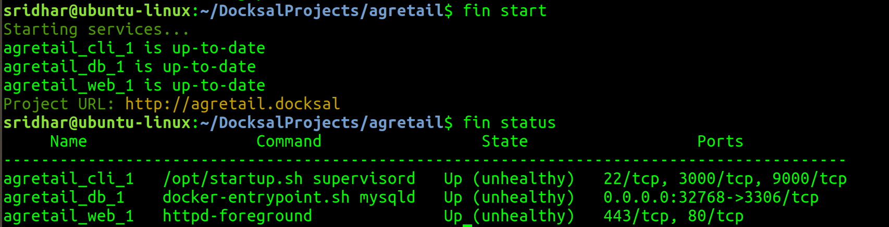
5. Connecting to the db:

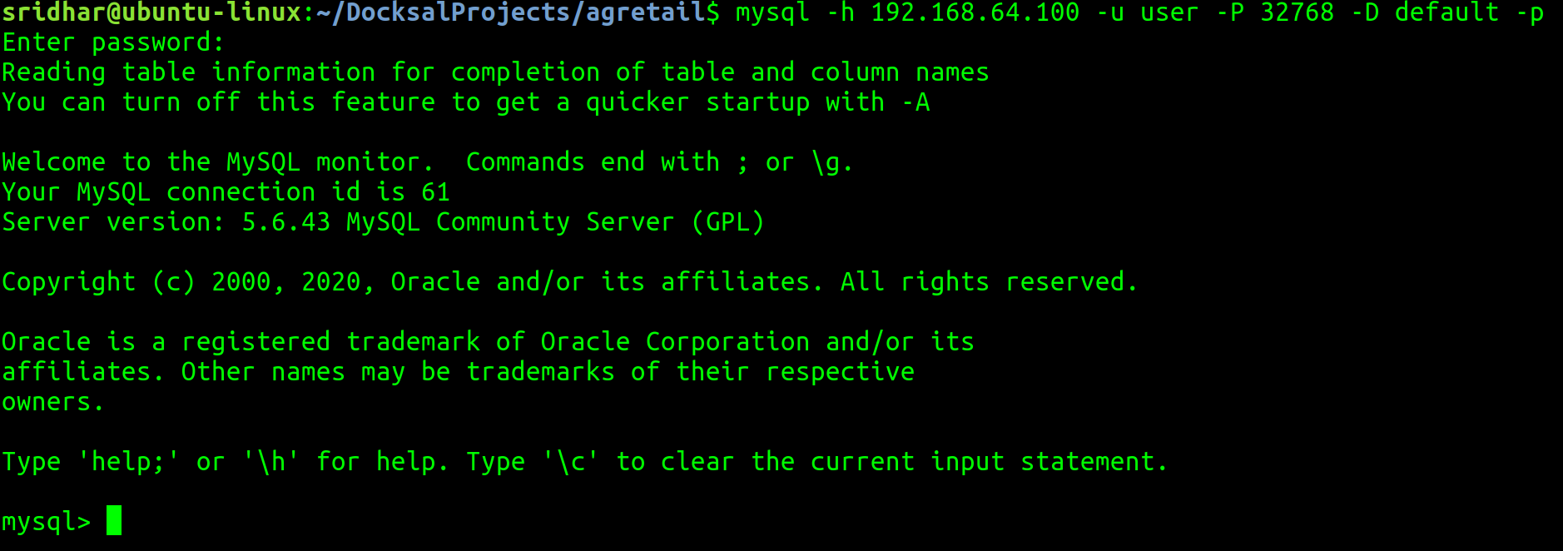

Laravel and PHP

1. Laravel has an url helper function:

The helper converts the passed-in string into an url for the application to be used.

2. gettype(var) function in php will help you identify the type of the passed in var.

3. Notes on usage of checkboxes in html and how to handle them (using isset function) when they are checked/unchecked in php:

This also describes the usage of ternary op. In php.

https://www.sitepoint.com/html-checkbox-radio-button-defaults/

4. Different types of Integer datatypes in mysql and their bit sizes:
https://dev.mysql.com/doc/refman/8.0/en/integer-types.html

5. To clear mysql command-line screen press ctrl+l

6. In Laravel, the database query builder provides some helper function like get() and first():
get() returns a collection and you then need to access the elements in an array format; whereas;

first() return only the first row which can be accessed in a normal object based access like $user_security_info->email.

7. Difference between isset() and empty() functions of php and which to use when:

https://www.php.net/manual/en/function.empty.php

Good examples, creates the doubt immediately.

8. Laravel’s Http Request object is widely used:
all() method on the object will return all of the data as an array.
Except() method will return all params except for the ones specified.

https://laravel.com/docs/7.x/requests

9. Laravel’s Eloquent ORM has fillable and guarded attributes that are to be applied on models, especially when creating the model:

Good explanation here:
https://stackoverflow.com/questions/22279435/what-does-mass-assignment-mean-in-laravel

10. When using mysql commnd line utility, often, when the tables/query results are large, they get wrapped up and the output is not clearly visible.
A solution for this is either use mysql’s ego utility by postfixing the query with \G and then you can see the results vertically:
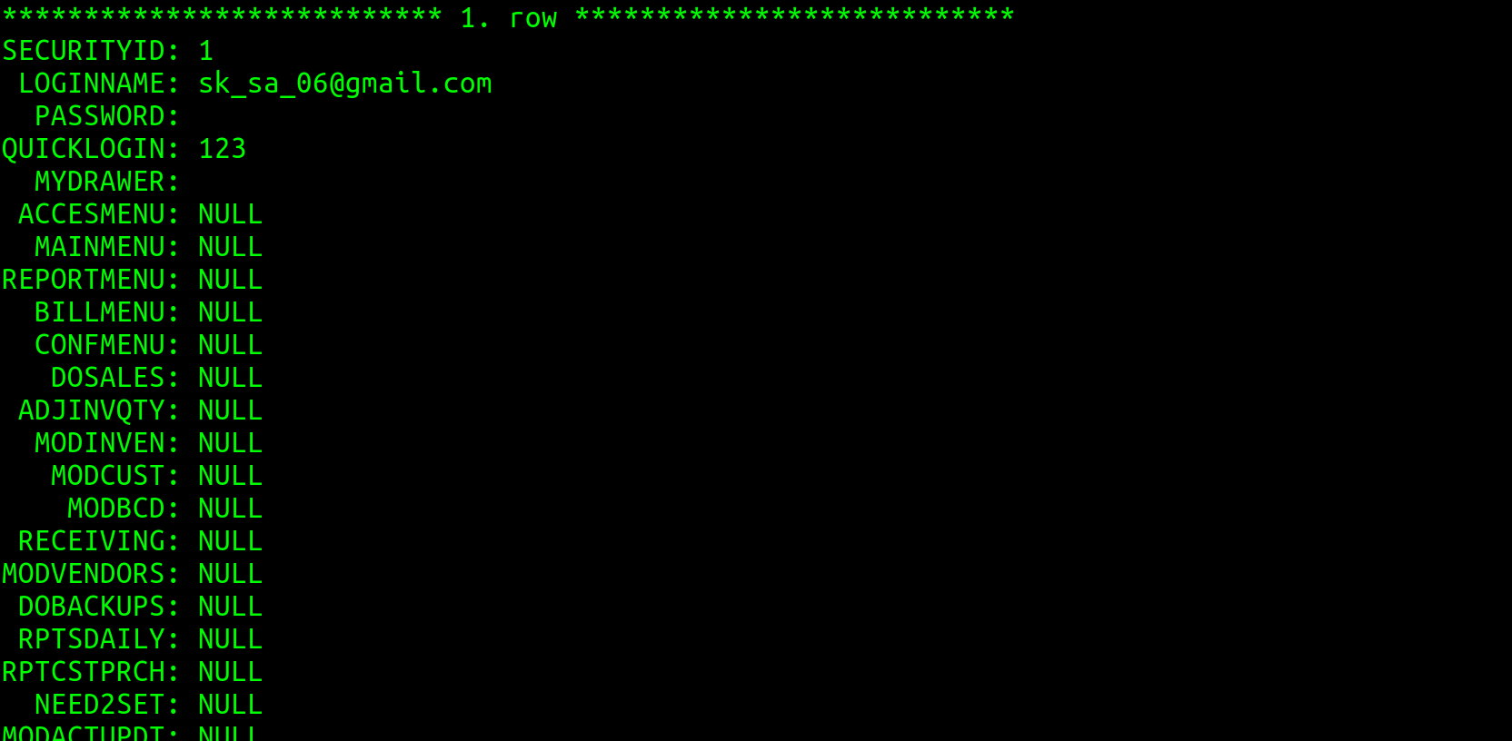
OR

You can use the pager utility of mysql and set it to less -S and then you’ll be able to scroll horizontally/vertically using keys and quit with q:
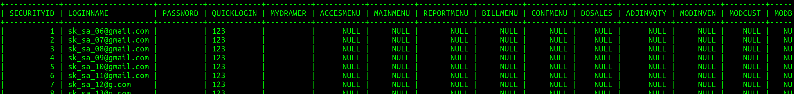

Details are here:
https://stackoverflow.com/questions/924729/how-to-best-display-in-terminal-a-mysql-select-returning-too-many-fields

11. If you want to execute laravel artisan commands, you’ll have to enter fin bash, then you will enter into the artisan cli.

12. To make a migration file, you can use the following command to create the file:
This will create the file under database/migrations, the file will be pre-fixed with timestamp.

To execute a specific migration file:
mention the file path (file name should consist of the timestamp as well)

To execute all (yet-to-be-executed) migration files:
If a migration file has an entry in the migrations table, then it won’t be executed:
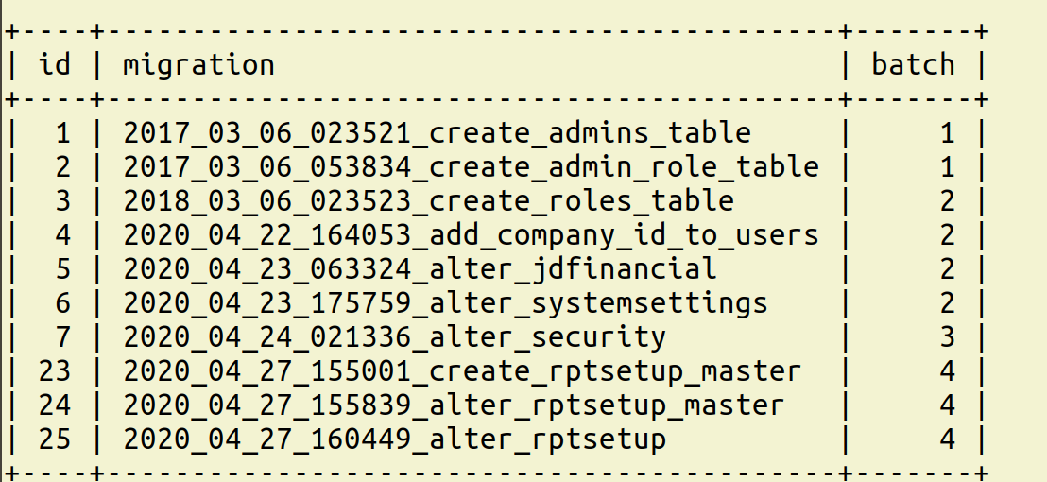
To execute the file again, delete the entry in this table and then run from fin bash, it’ll execute.

13. Laravel provides in-built logging support. It basically uses Monolog library.
To use it, you need to include the following in your class:
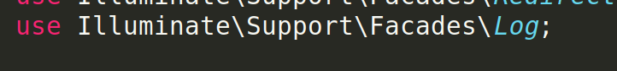
And, then you can just continue use the Log methods:
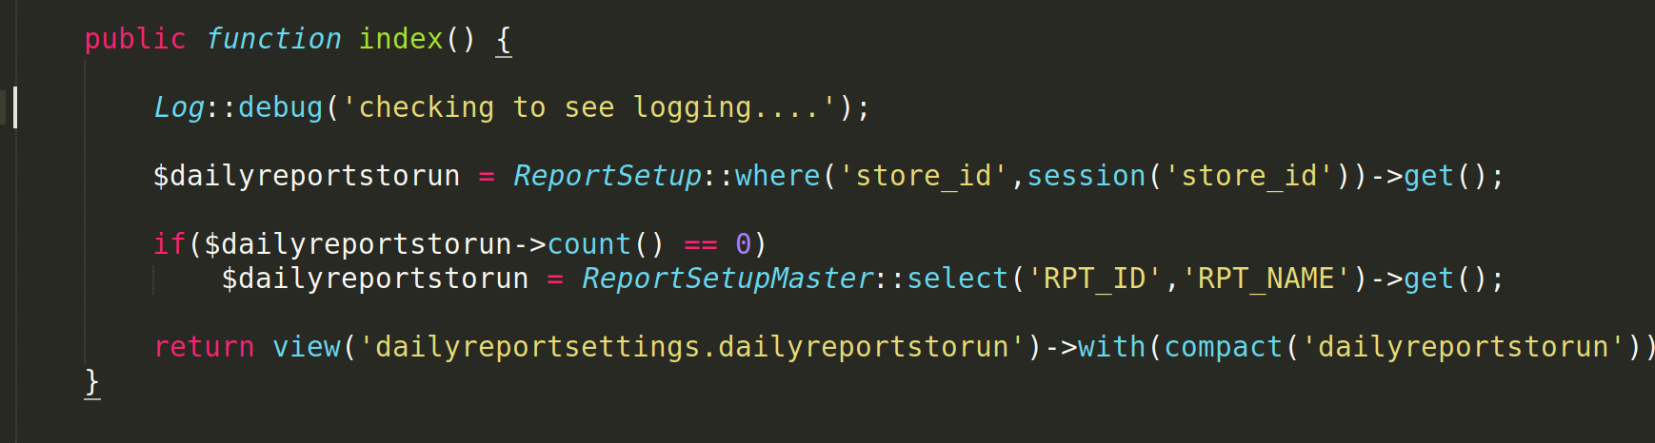
You’ll get the log files under storage/logs/(timestamped).

More details here:
https://laravel.com/docs/5.2/errors

14. In Laravel, in route i.e. in web.php, if you are using a get or post then you need to mention the controller method name with @ symbol otherwise you’ll get an invalid route error:
But, instead, if you are using a resource method then you need not mention the method name, then the index method in the controller gets called:
And hence, if you use the resource method in the route file and don’t mention the method name for the controller, then, it is mandatory to have an index method in the controller, otherwise:
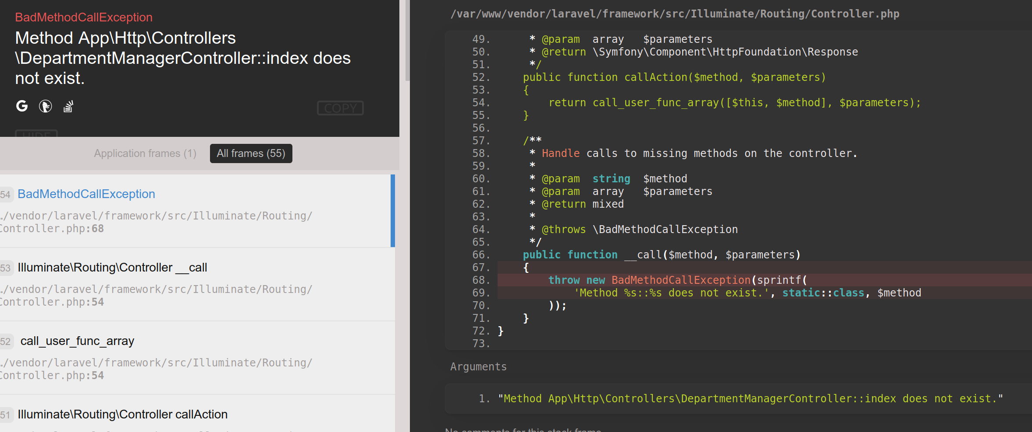
15. Eloquent OMR models.

In Larvael, wehn you create an Elqouent ORM model, you don’t haev to mention the table nae masosciated with that model when your table name isjstu th pelural of the model name:

Meaning, if your model name is Flight, laravle orm expects your table name to be flgihts.

Otherwise, mention your table name uisng the $table property:
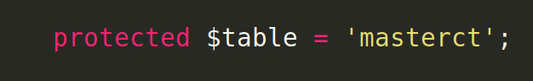
Also, by default, Elouqent ORM models assume that there is one primary key in the table assoictaed with the model and the name of the PK is ‘id’. If your PK’s name is any different that the assumption, then mention the pk of the table using the $primaryKey property.

16. When to use double colon (::) in php, also known as scope resolution operator:
https://www.php.net/manual/en/language.oop5.paamayim-nekudotayim.php

17. Good though on bigint vs int – whether we really need to make pks, fks a bigint?

http://ronaldbradford.com/blog/bigint-v-int-is-there-a-big-deal-2008-07-18/

18. Query to check size occupied by tables, data and indexes per table in mysql:
select table_name,engine,row_format, table_rows, avg_row_length,
(data_length+index_length)/1024/1024 as total_mb,
(data_length)/1024/1024 as data_mb,
(index_length)/1024/1024 as index_mb
from information_schema.tables
where table_schema='default'
order by 6 desc;

And, also a good discussion on widths of int/bigint type columns and their significance:
https://blogs.oracle.com/jsmyth/what-does-the-11-mean-in-int11

And, this too:
https://www.virendrachandak.com/techtalk/mysql-int11-what-does-it-means/

19. Checking project config:
fin config show

This will give you the db version, apache version and dockser version being used.

To check the Laravel version, do a fin bash and then run the php artisan command:
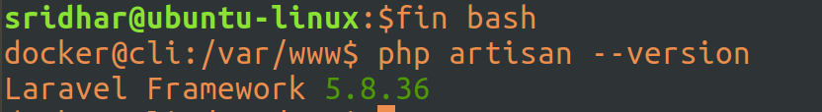
20. Show full columns in tabname gives privelages and collation also
show full columns in customer;
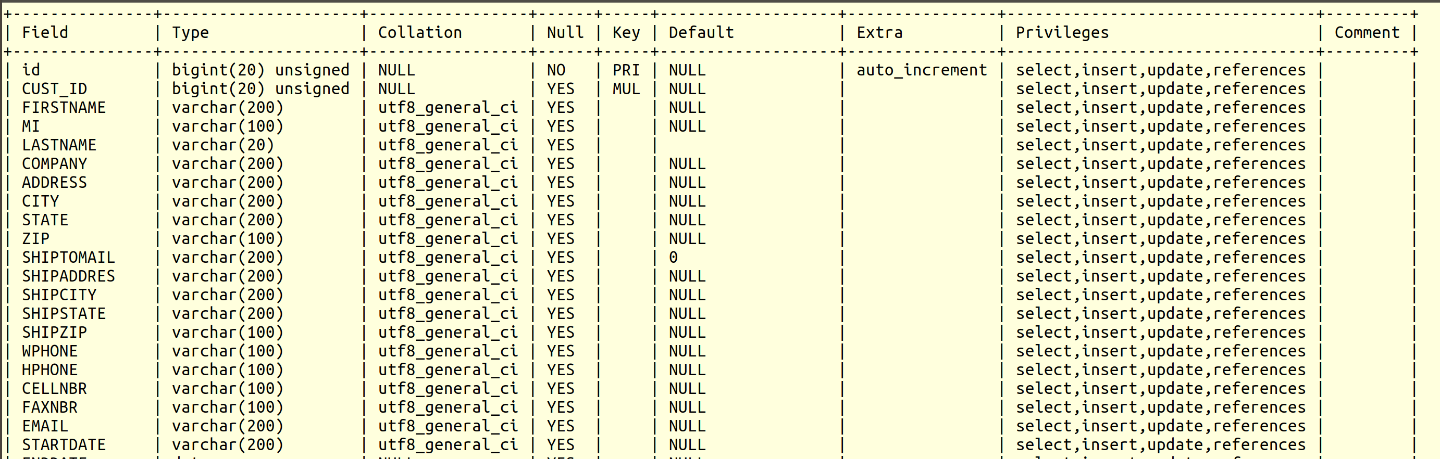
21. PHP Date time extension – Carbon
Laravel, by default, comse wit shupprot for Carbon
https://carbon.nesbot.com/

22. Jquery: Difference between attributes and properties in jquery and .attr() and .prop() methods

https://api.jquery.com/prop/

23. Differences between const, let and var in javascript

https://levelup.gitconnected.com/const-vs-let-vs-var-in-javascript-which-one-should-you-use-c56cf9b9e2a3

