Googlesheets

+ This doc is about googlesheets hacks and workings.

VLOOKUP
Effectively used to search for a key in sheet across a row or column:
https://support.google.com/docs/answer/3093318?hl=en
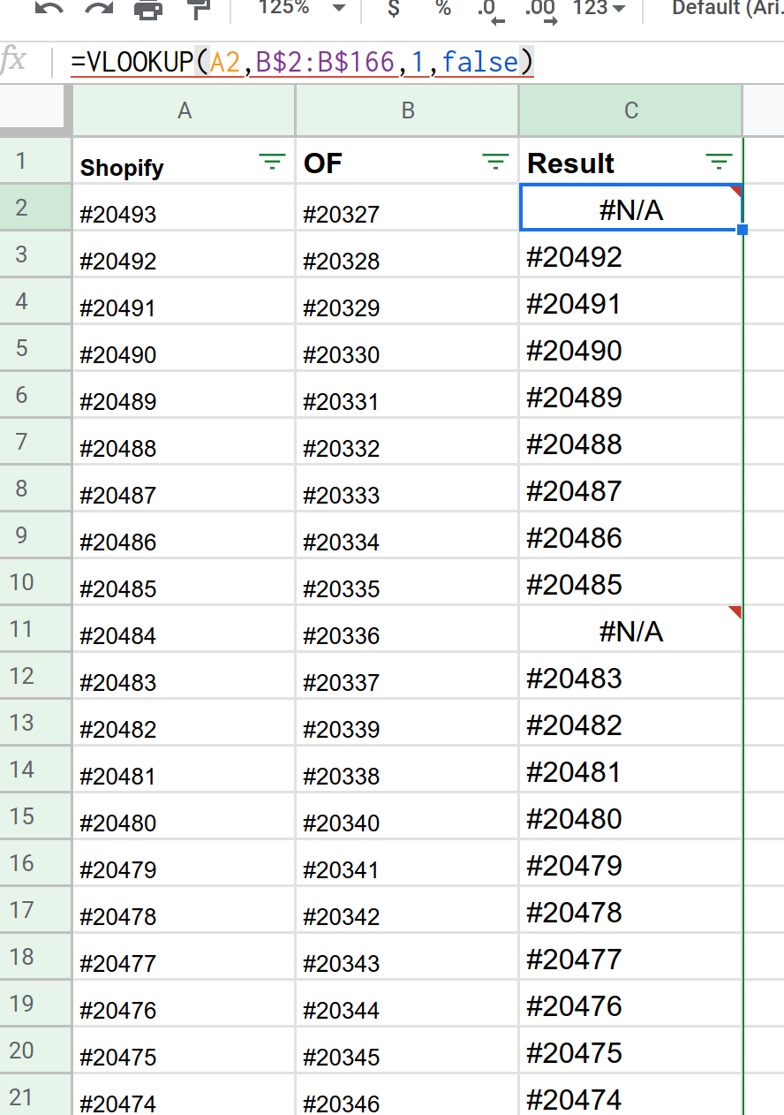

In the screenshot above, I am looking for each row element in A column thorugh the B column and output the A column value when a match found anywhere in the B column.
I was basically looking whether each shopify order has been created in OF or not.

COUNTING DUPLICATES
https://www.extendoffice.com/documents/excel/4707-google-sheets-count-number-of-occurrence.html
The below is to count the total occurrence of each email id in the entire column:
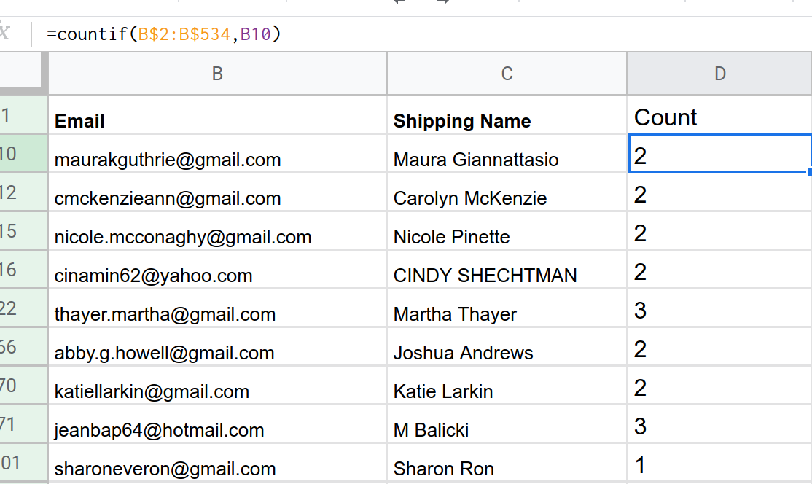

And, this is to first fetch the unique email ids from the first columns and then use this unique list and search from the first B column for number of occurrence of each unique email:
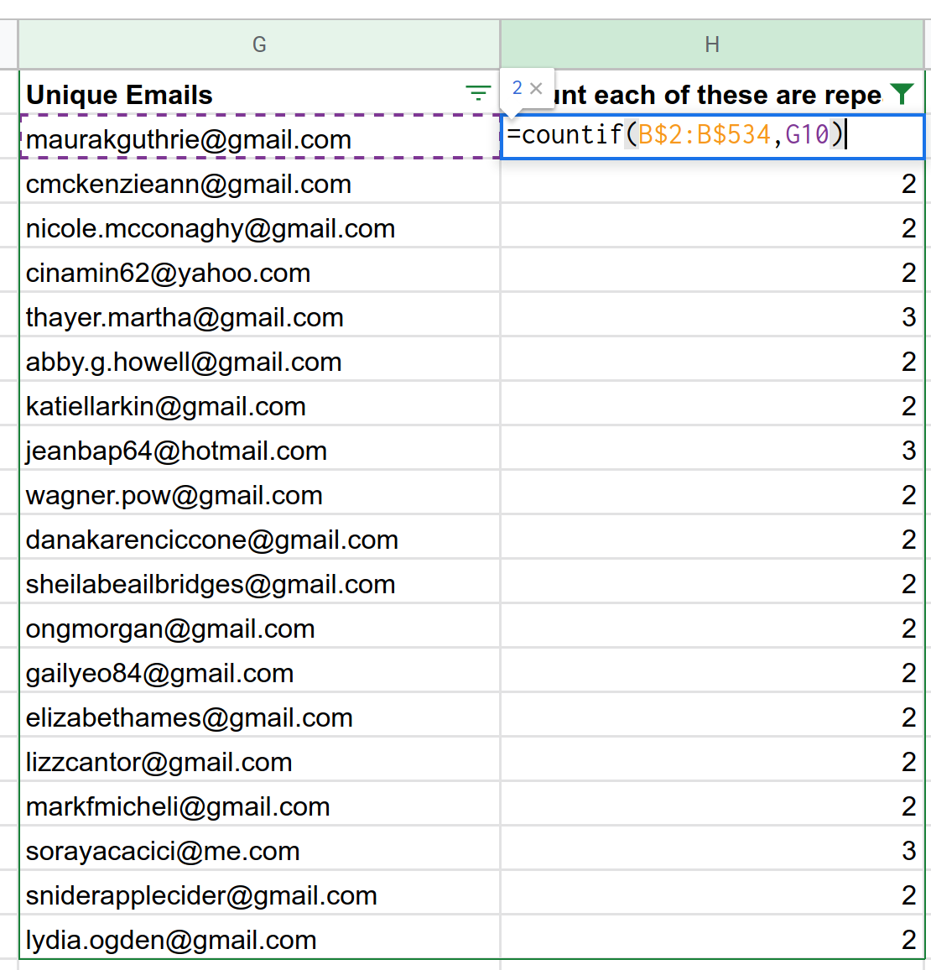
How to find uniques is given in the url above.

To Import Data from other sheets
Here, we are querying the the sheet ‘Shopify Open Orders since 28th Apr’ across all its rows/columns i.e. from A to Z and fetching the info in columns A, B, D, G etc where col A in the sheet matches with the column B data in this sheet:

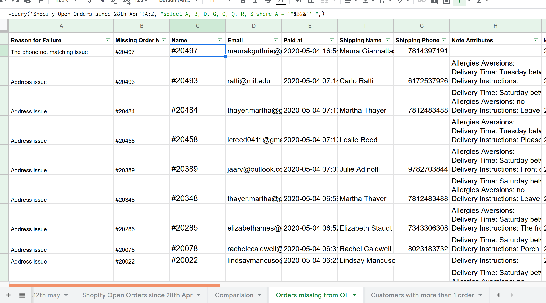
Example here:
https://stackoverflow.com/questions/34618268/extract-rows-from-one-google-sheet-to-another-based-on-criteria-in-column

