Creating a new Maven project.
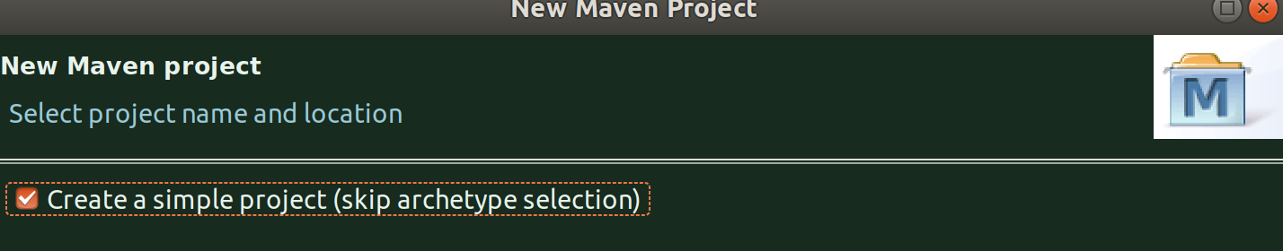
This needs to be a maven project because the openjdk jmh libraries that we need have to be fetched from open source repo, so either make it a maven or a gradle project.

Although, in the screencast below, the Artificat-id and Project Name is java-microbenchmark-project, I’ve later changed it to openjdk-microbenchmark-project. Eveything else remains same.
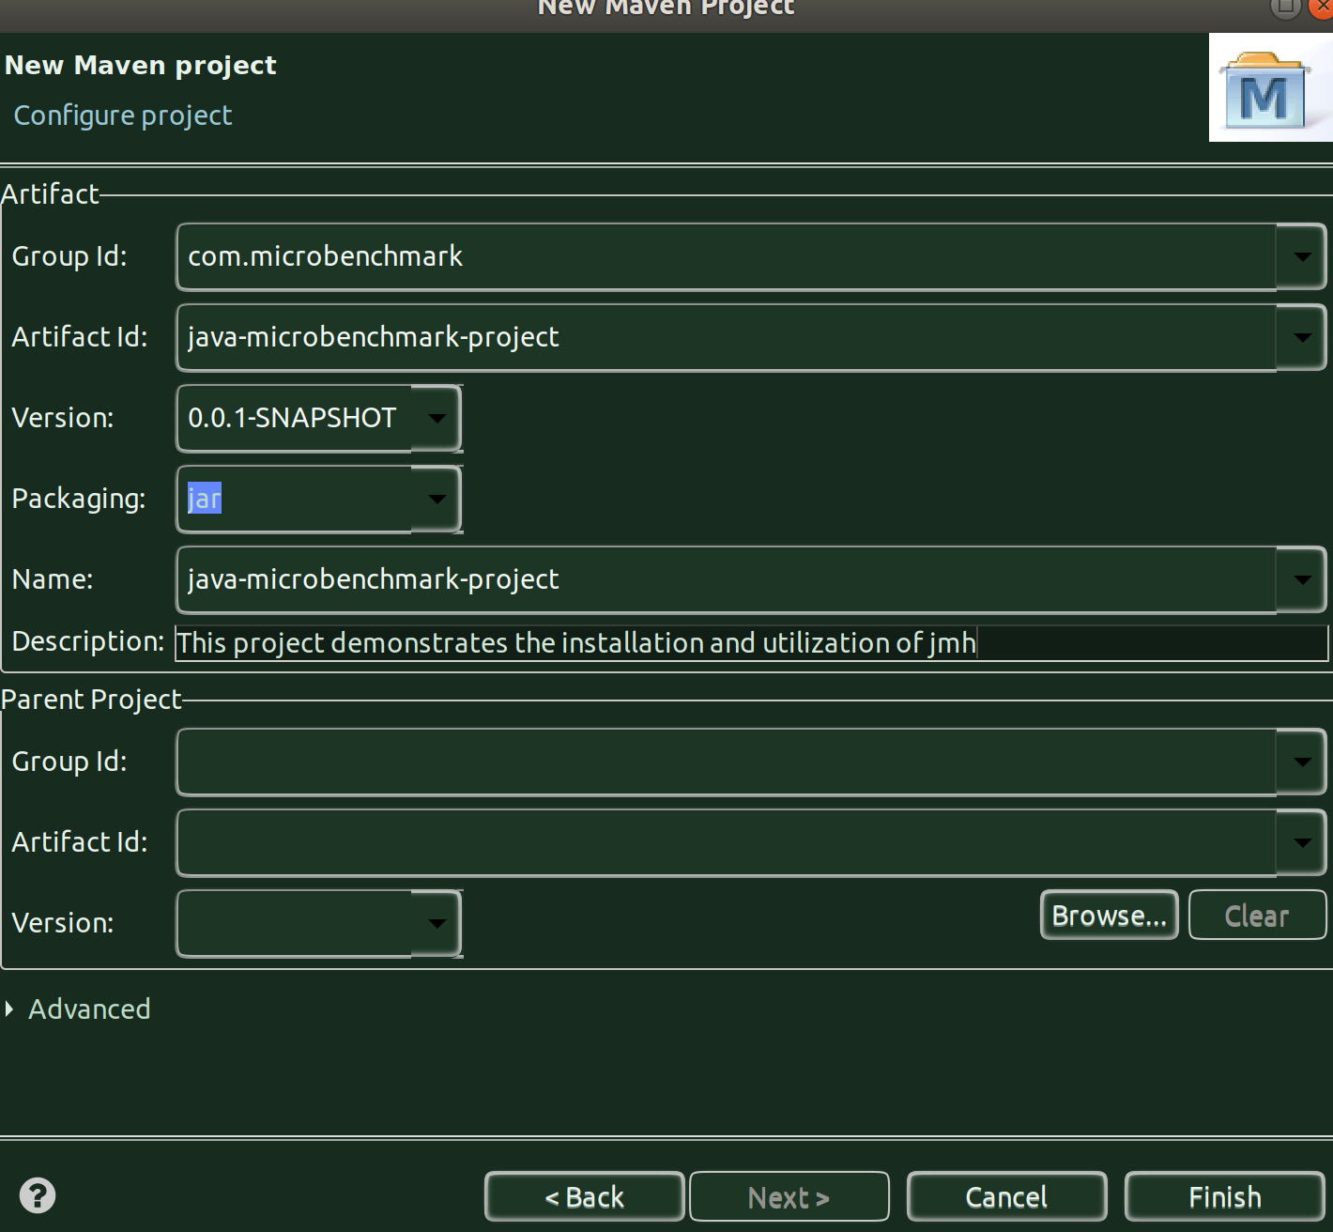
Click Finish

POM file modifications:

We need add jmh-core and jmh-generator-annprocess dependencies in the pom file.
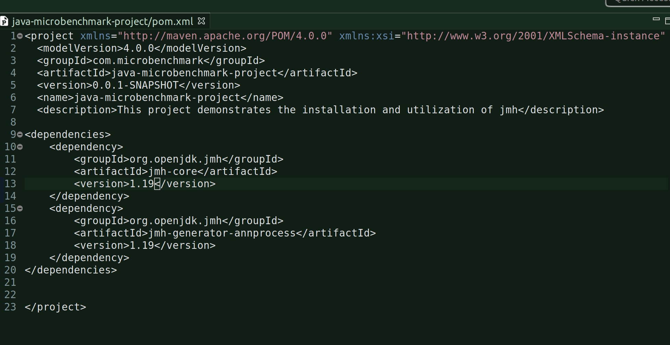
Clean -> Build the project.

Once you clean build, you can see the following Maven dependencies in the project:

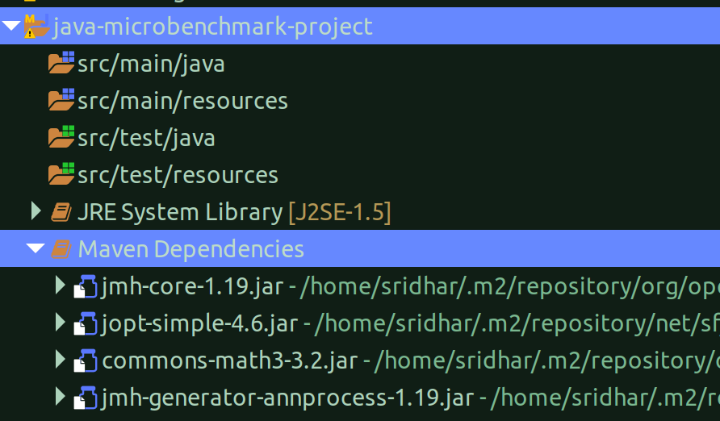

Create a class:
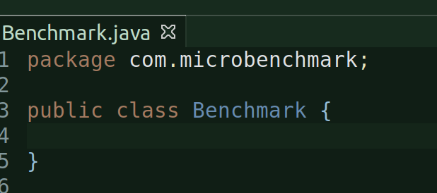
This class mainly will contain benchmark annotations that we will use to benchmark actions in this class.

Create a dummy method and annotate with @Benchmark:
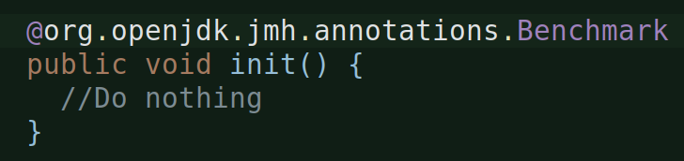

Create a Main class to run the Benchmark:
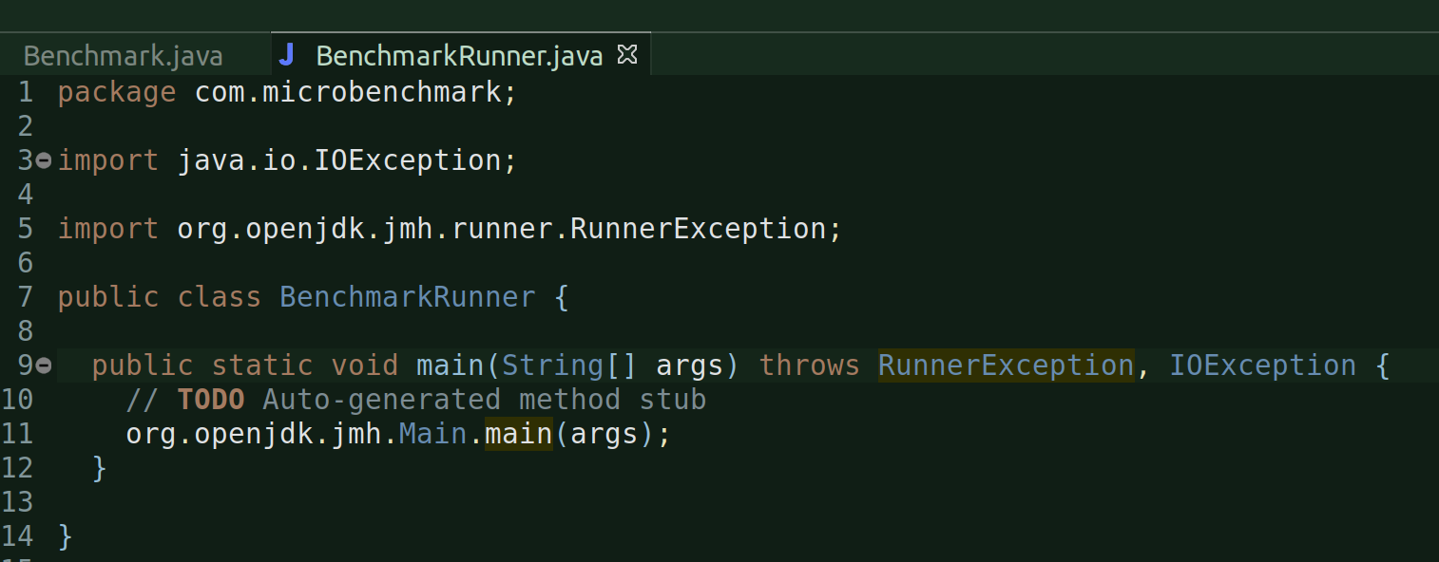
This class is basically the main class, which we need to call to run the benchmark program.

[ISSUE] Now, as soon as I run the BenchmarkRunner class from eclipse:
I get the following error: Unable to find the resource....
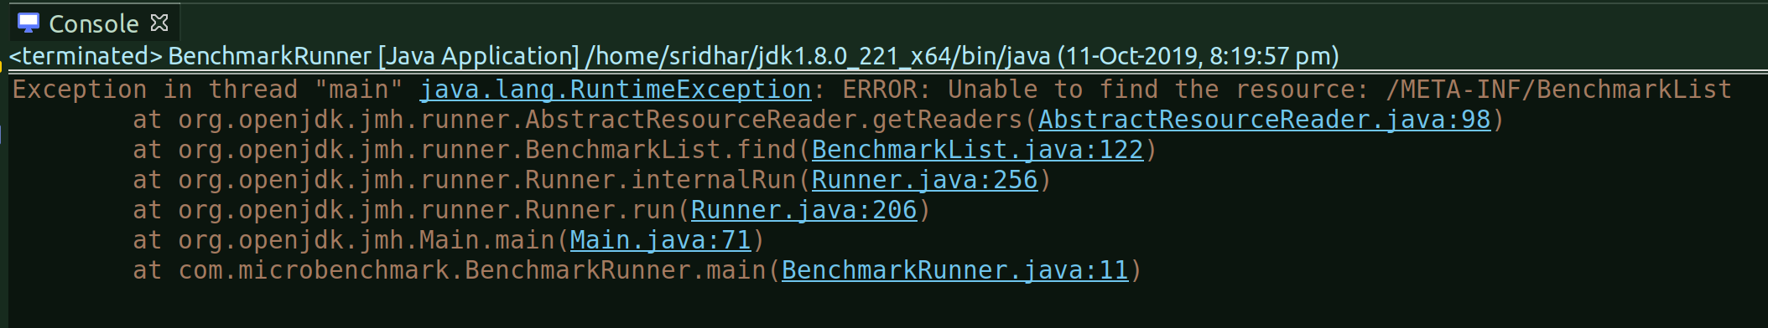

Solution:
It seems there is some problem with the openjdk jmh when you build your project within eclipse.

So, in order to resolve this, I did a maven clean install from the linux terminal (not maven client, I don’t have a specific maven client as such):
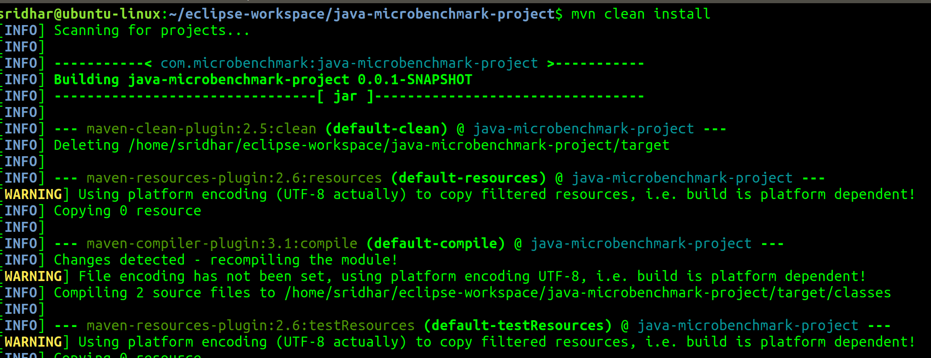
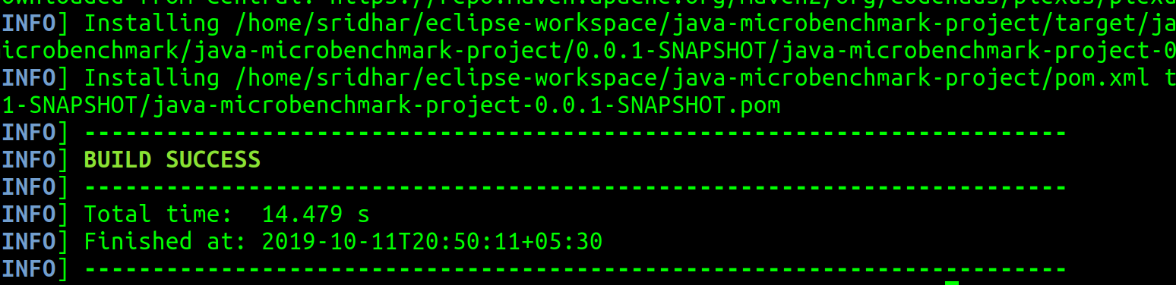
As soon as the mvn clean install is completed successfully i.e. build success, I went to eclips and refreshed the project:
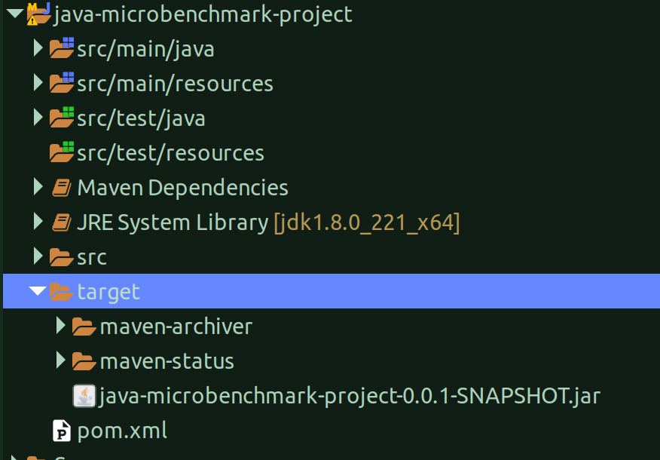

And, I could very well see the target folder with some other folders and a jar file.

This jar file basically contains all the stuff and hence you don’t see any other .class files outside. So, when you basically run the BenchmarkRunner class, this is the jar that gets invoked.

Run the program i.e. BenchmarkRunner.java from eclipse:
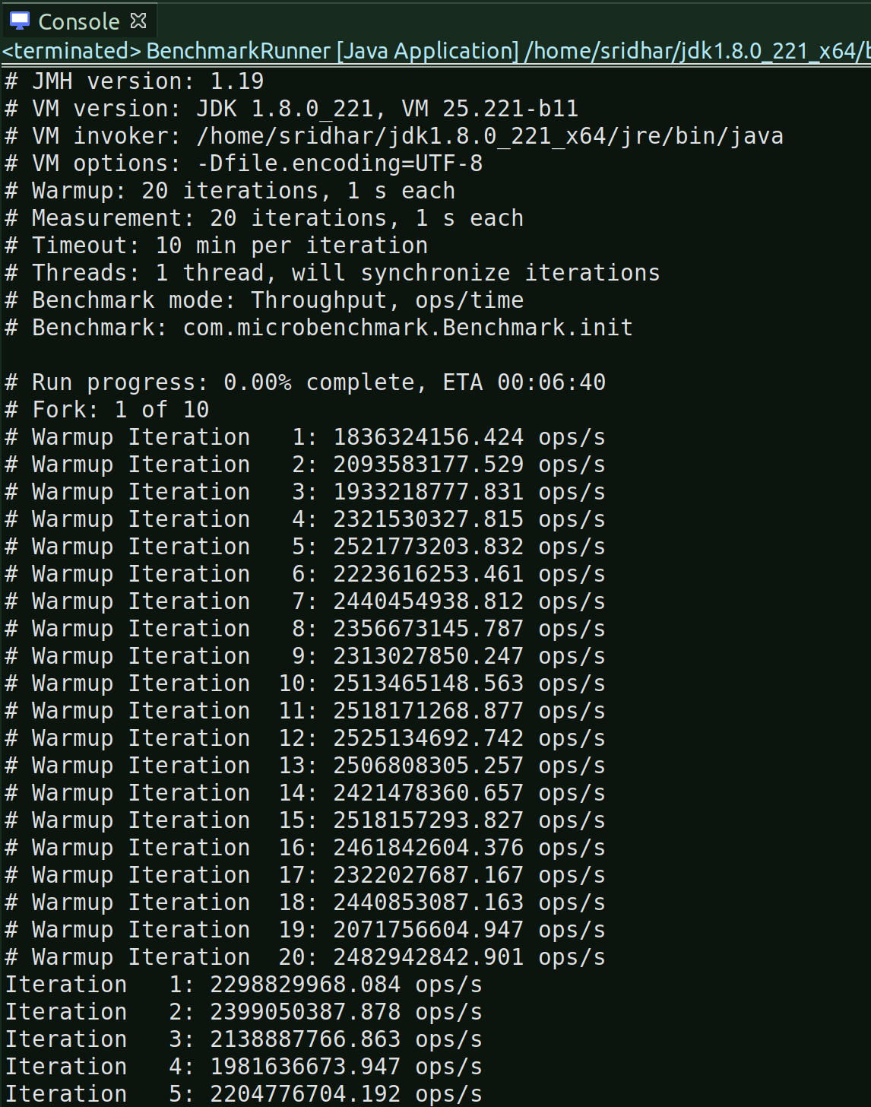
As you can see the ‘Unable to find the resource...’ is now gone.

But I had to force stop when it was at Fork 2/10. And each Fork was having 20 warmup iterations and normal iterations. So, had to stop it.

This is because, by default, jmh runs with 10 forks i.e. warmup benchmarks, each with 20 warmup iterations and 20 normal iterations.

Using @Fork annotation:
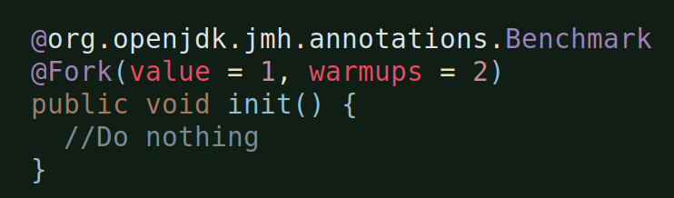
By using the @Fork annotation, we can set up how benchmark execution happens: the value parameter controls how many times the benchmark will be executed, and the warmup parameter controls how many times a benchmark will dry run before results are collected.

This instructs JMH to run two warm-up becnhmarks and discard results before moving onto real timed benchmarking.

Also, the @Warmup annotation can be used to control the number of warmup iterations. For example, @Warmup(iterations = 5) tells JMH that five warm-up iterations will suffice, as opposed to the default 20.

After the above, let’s now Run the Benchmark Runner class:
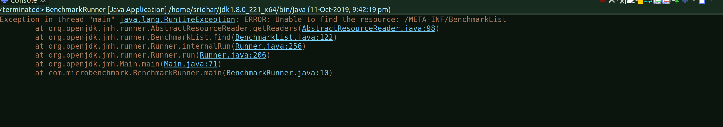
We again get the same error, so everytime we change the code and when we to do a clean -> build, we’ll have to do it outside of eclipse i.e. in the linux terminal.

Terminal:
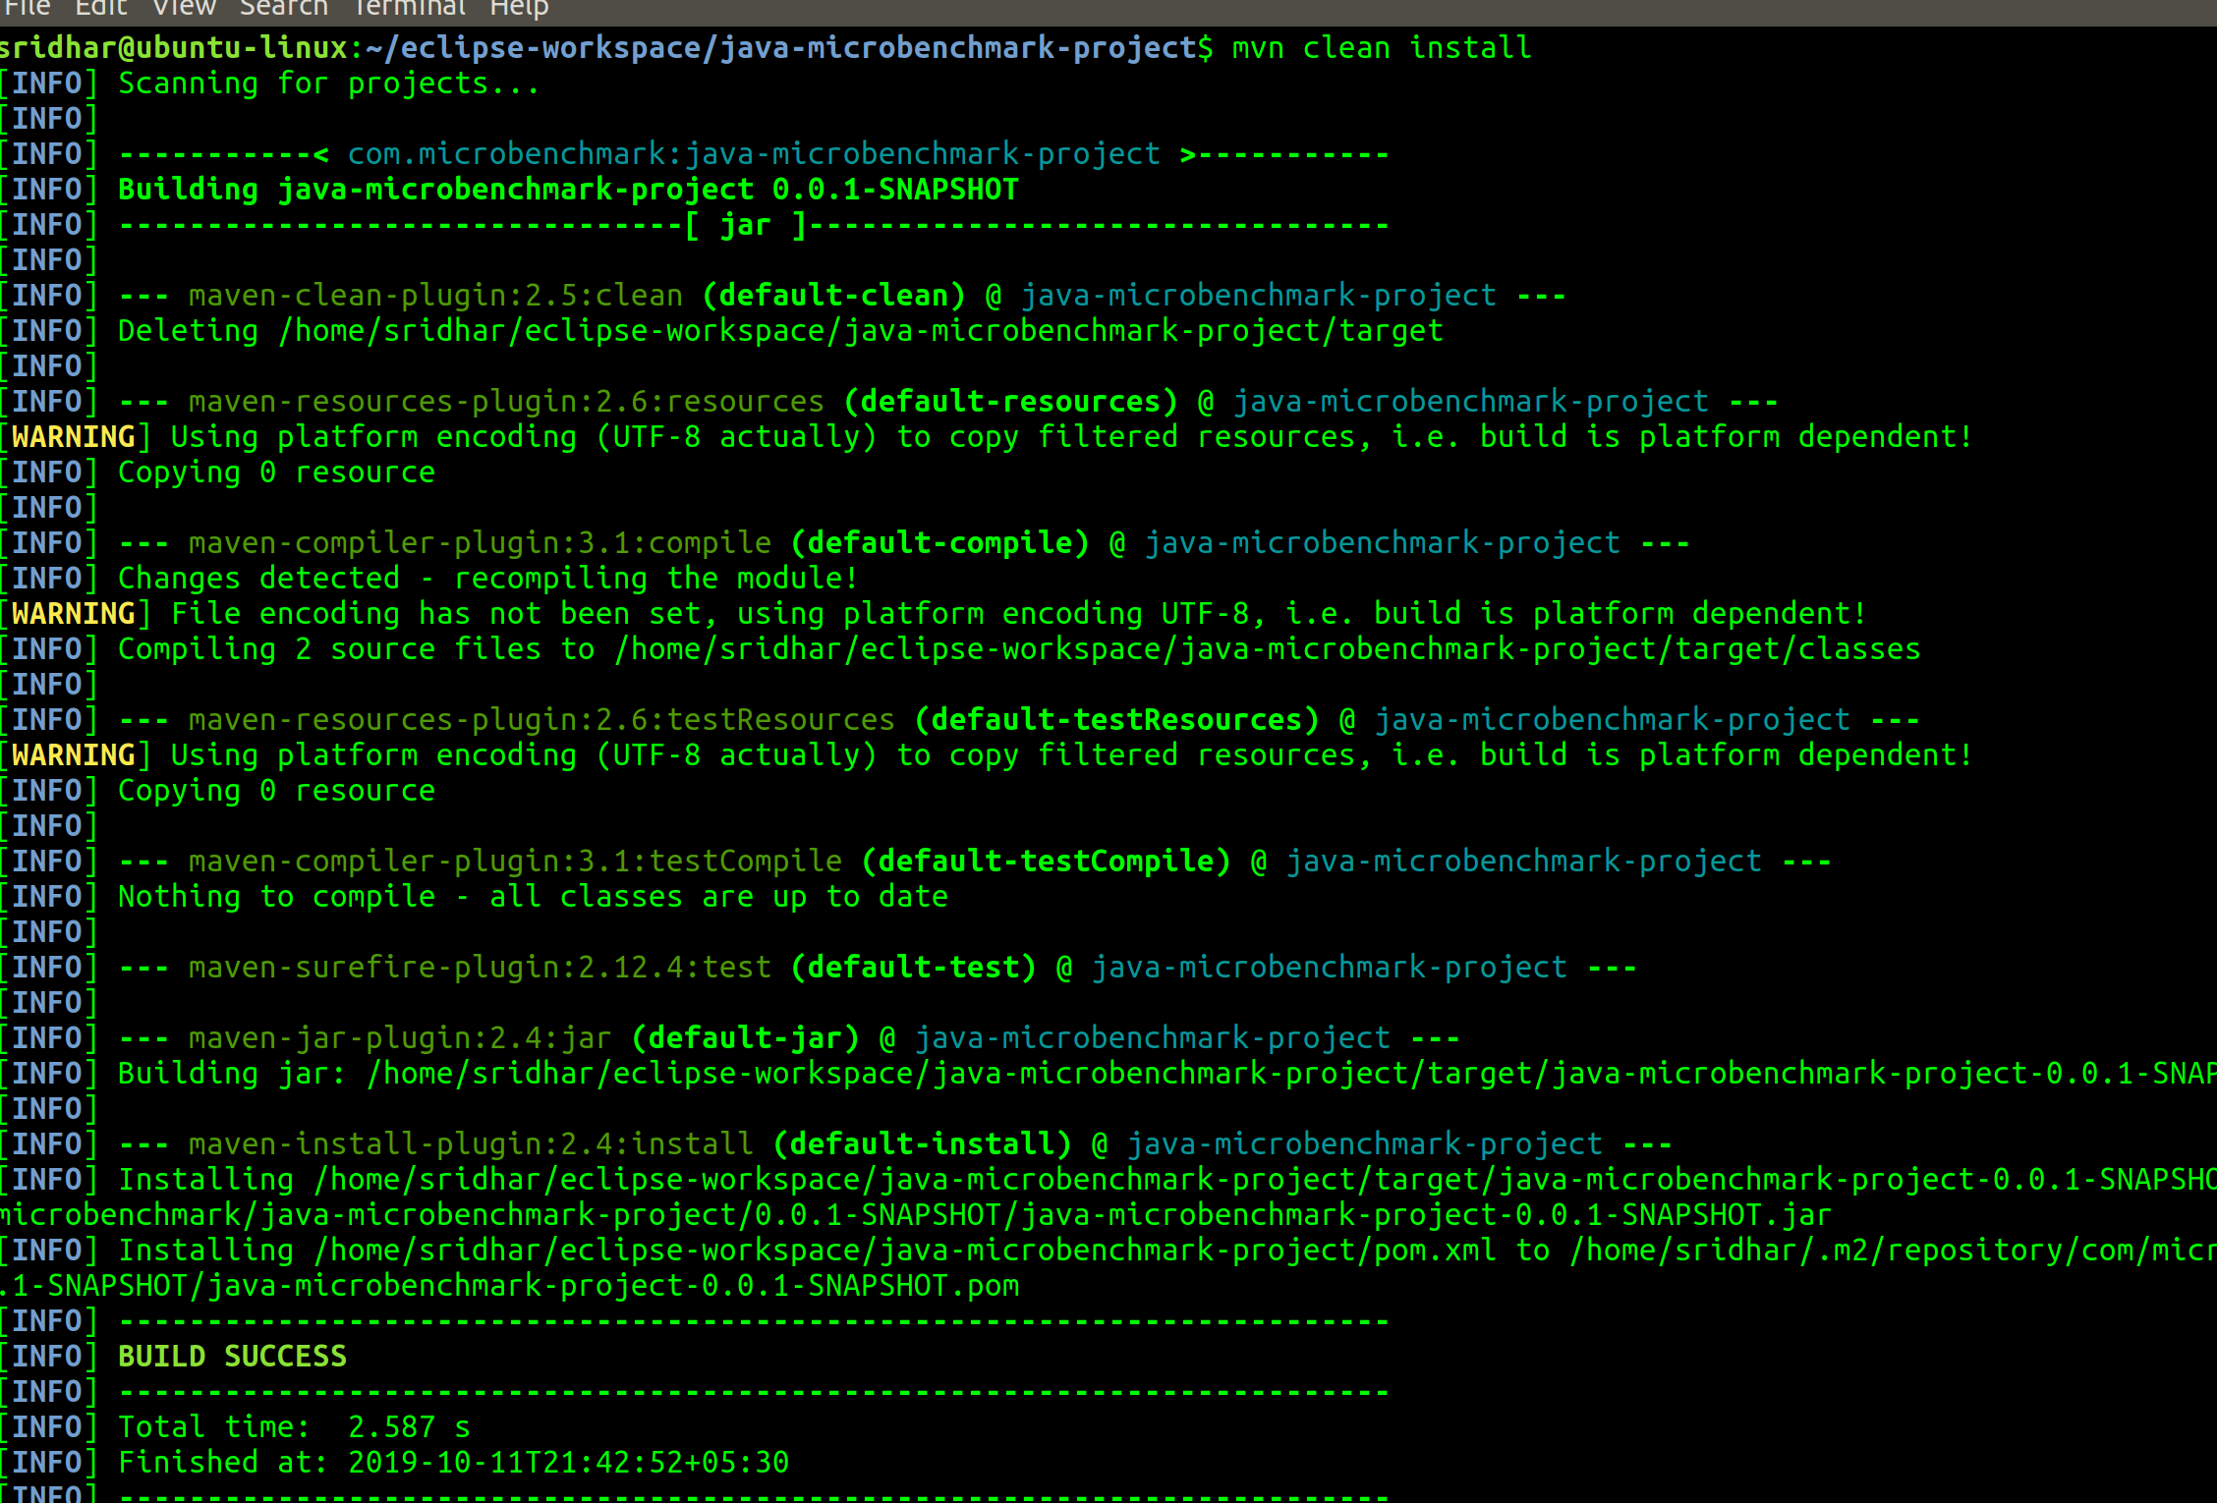

Build Success, let’s Run the program – BenchmarkRunner.java from eclipse:
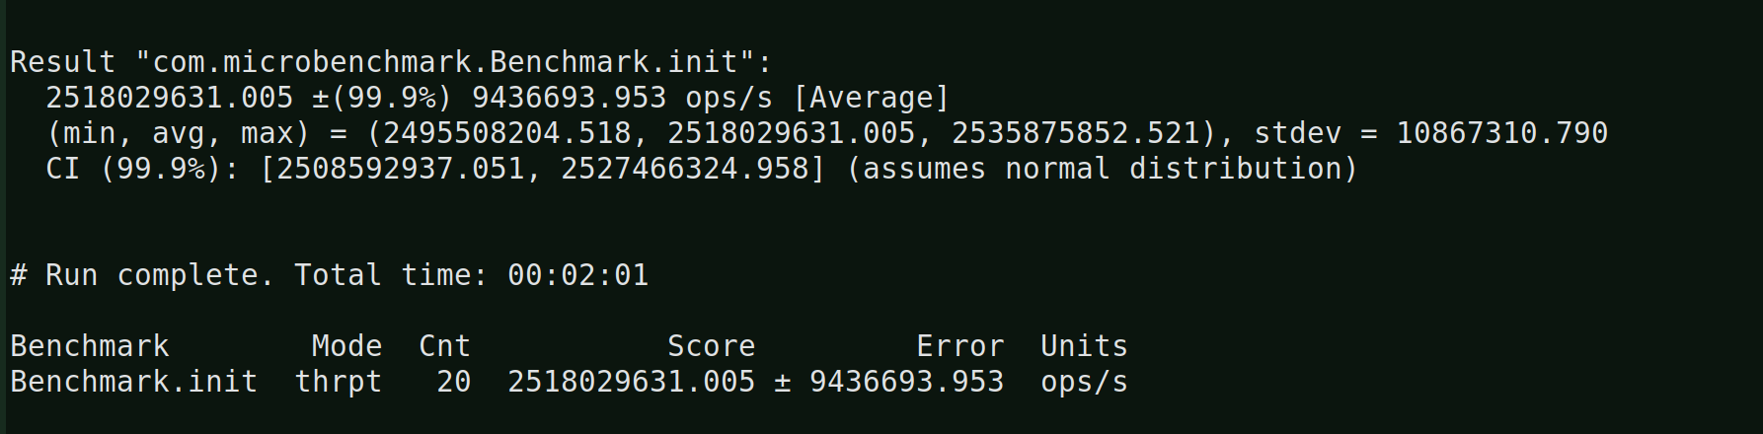

In this run, 2 warmup forks ran (instead of the default 10) w/ 20 warmup iterations and 10 normal iterations, after which, 1 normal fork ran w/ 20 warmup iterations and 20 normal iterations.

This is because of the values I had set above, which is the benchmark execution to 1and dry-run for benchmarks to 2 and hence I had 2 warmup executions and 1 benchmark execution.

Warump iterations are by default 20.

Let’s change the warmup iterations:
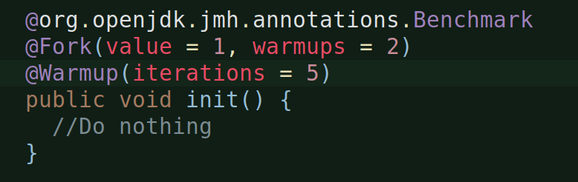
Now Run the BenchmarkRunner.java after eclipse clean build:
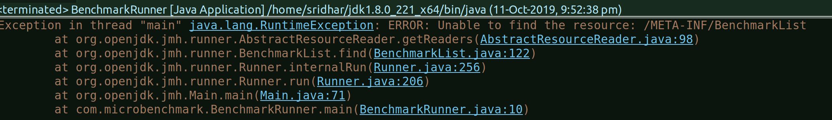

Now do a maven clean install from terminal and run the program again:
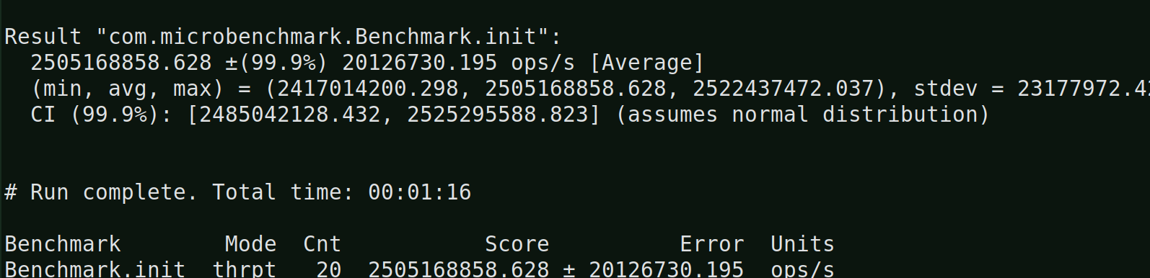
2 benchmark warmup (or dry-run) executions, each with 5 warmup iterations and 20 normal iterations and 1 benchmark execution with 5 warmup iterations and 20 normal iterations.

[ISSUE WITH EXECUTING JAR FILE FROM TERMINAL]

When I try to execute a jar file from command prompt, I get an:
“no main manifest attribute ....” error:

It is because the jar generated does not have the main-class info in the META-INF/Manifest.mf file.

This particular jar was build using ‘mvn clean install’ from the terminal, so it picked up the build information from the projects pom.xml.

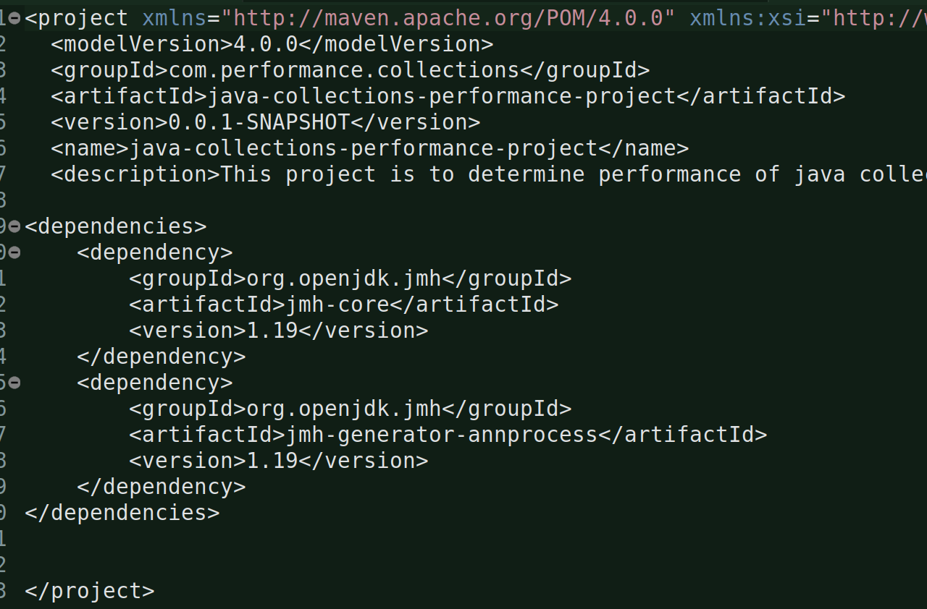
And the pom currently does not contain any information as such.

[SOLUTION]
We need to add a maven-shade-plugin and the main class name in this pom.xml for the mvn to pick it up.
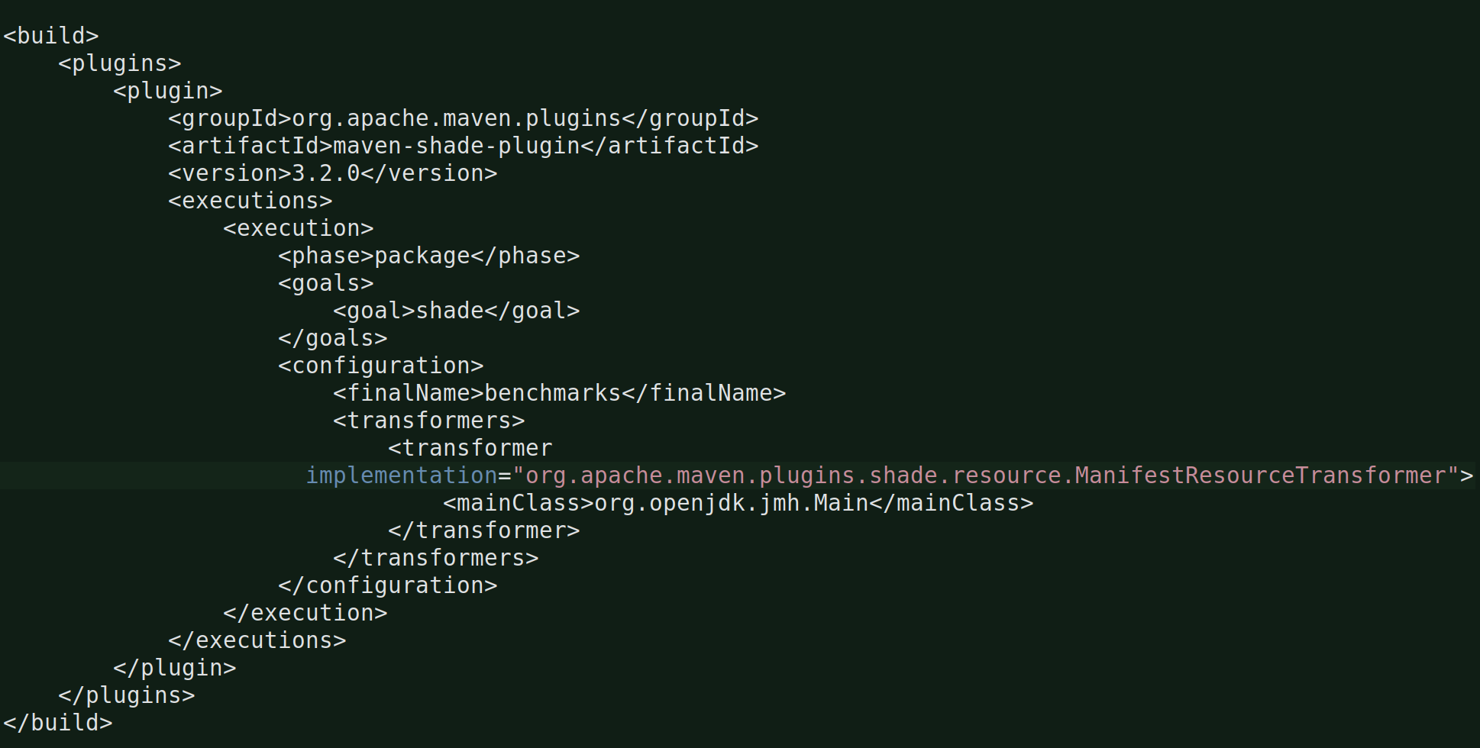

You can find the latest maven-shade-plugin version from https://mvnrepository.com

Go to your terminal and go to the project folder and run
mvn clean install or mvn package
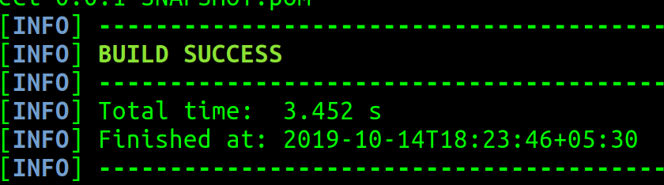
Now, go to the project folder and under target folder you’ll see the jar, extract it and check the Manifest.mf file and if it has a main class in it or not:
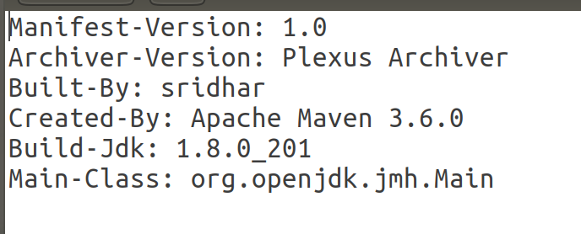
Now, to run or execute the jar from the terminal, go to the projcet folder and:
benchmarks.jar is th ename of the jar that is created and the ListPerformance is the name class that is expected by org.opendjdk.jmh.Main class.

