# https://medium.com/@sheikarbaz5/spring-boot-with-tdd-test-driven-development-part-i-be1b90da51e
# https://spring.io/guides/gs/testing-web/
# https://reflectoring.io/unit-testing-spring-boot/
# https://docs.spring.io/spring-boot/docs/current/reference/html/spring-boot-features.html#boot-features-testing
# https://dzone.com/articles/spring-di-patterns-the-good-the-bad-and-the-ugly

pom.xml

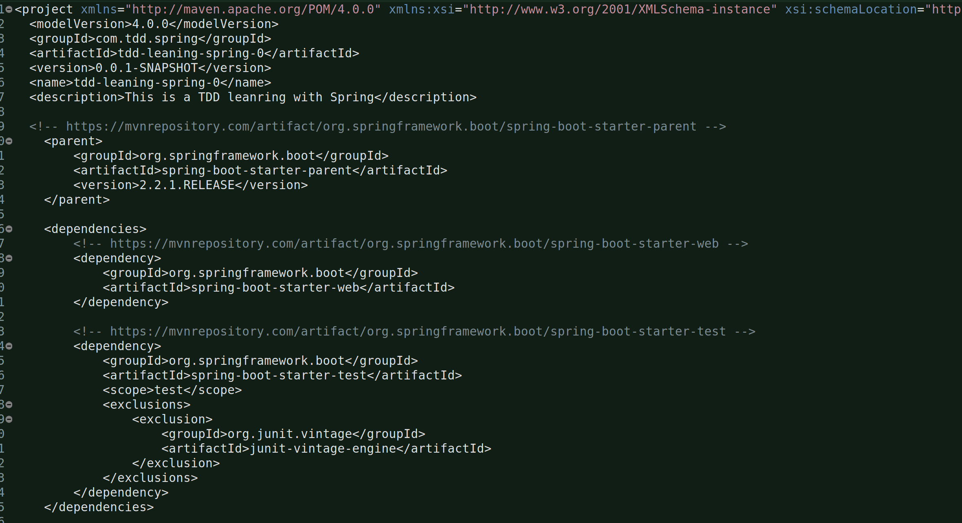
That exclusion is because with Spring-boot-starter-test we get junit vintage engine and hence you get junit4, but if you are going to write unit tests in junit 5 then you need to exclude this engine and as a result you’ll get junit 5 jupiter api.

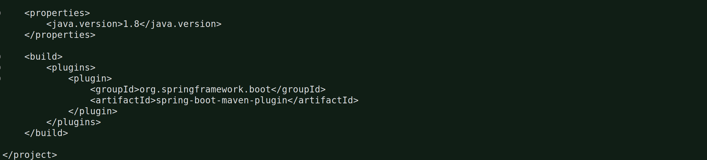
TDD:

Write the test first. Testing the controller.

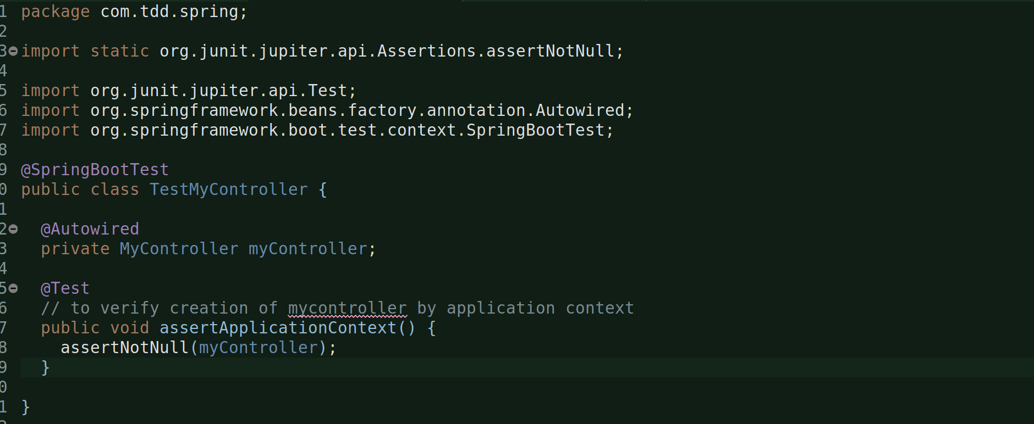
Now, create the MyController class (only then your test will atleast compile).

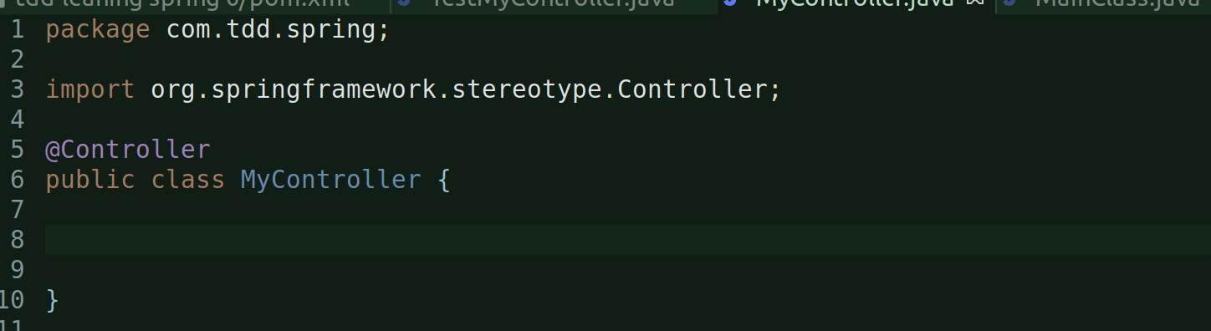
Run the test:
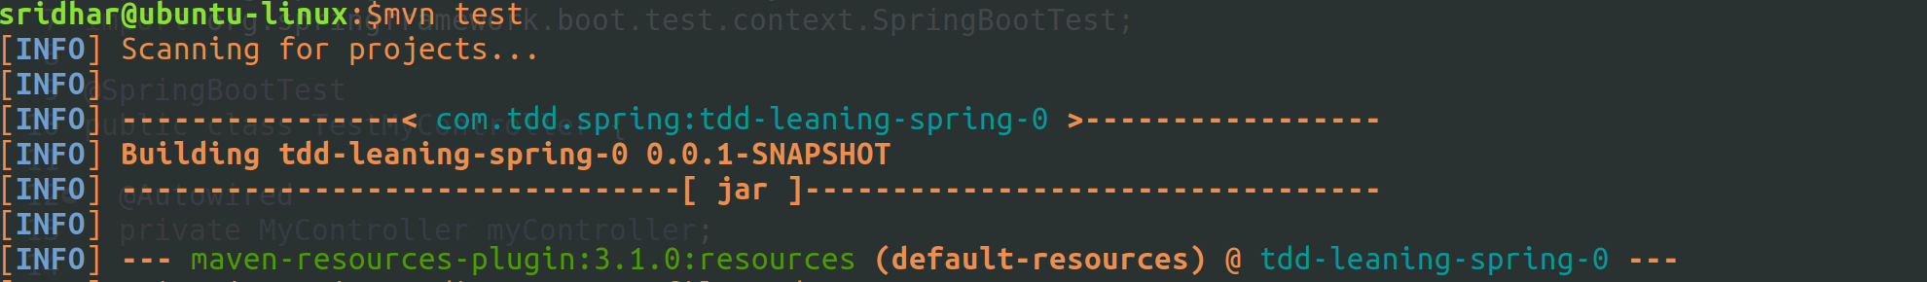
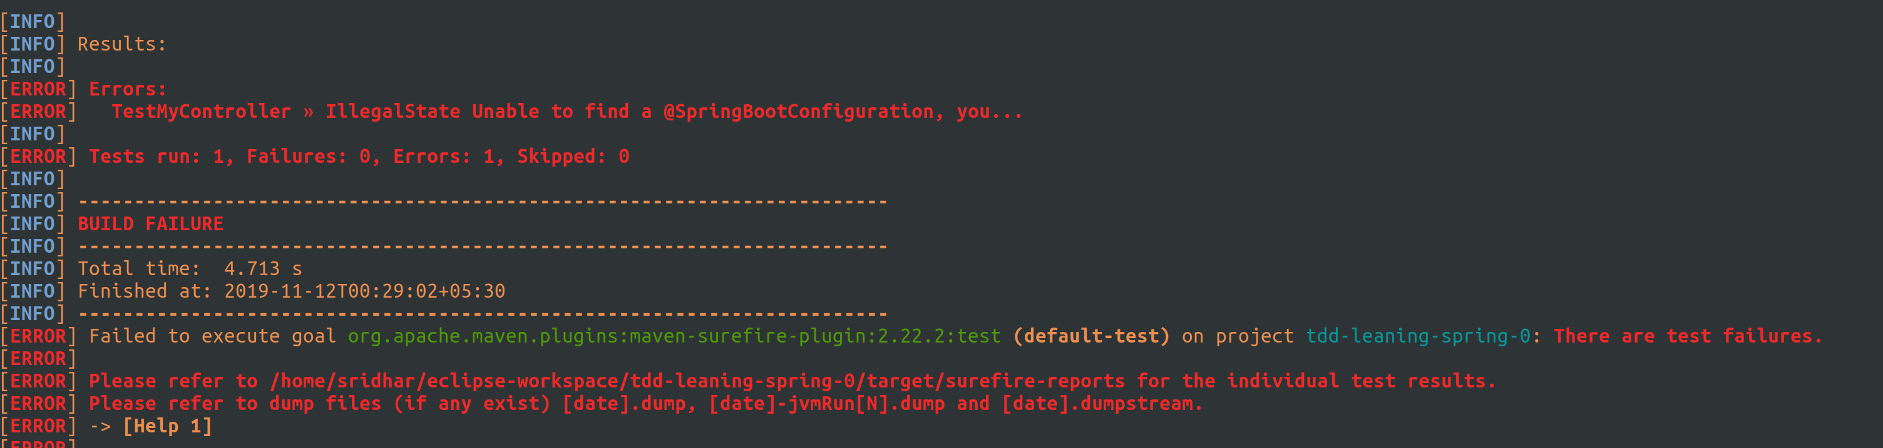
Failed because it was expecting a main class with @SpringBootApplication annotation.

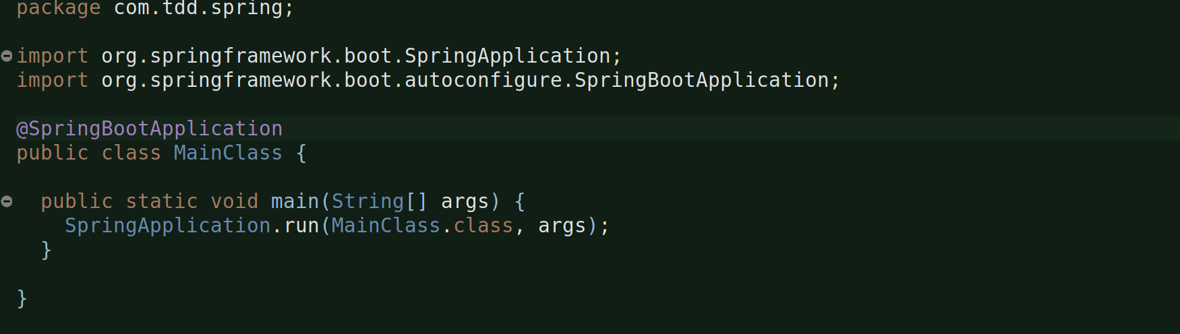
Now, run the test again:
mvn test
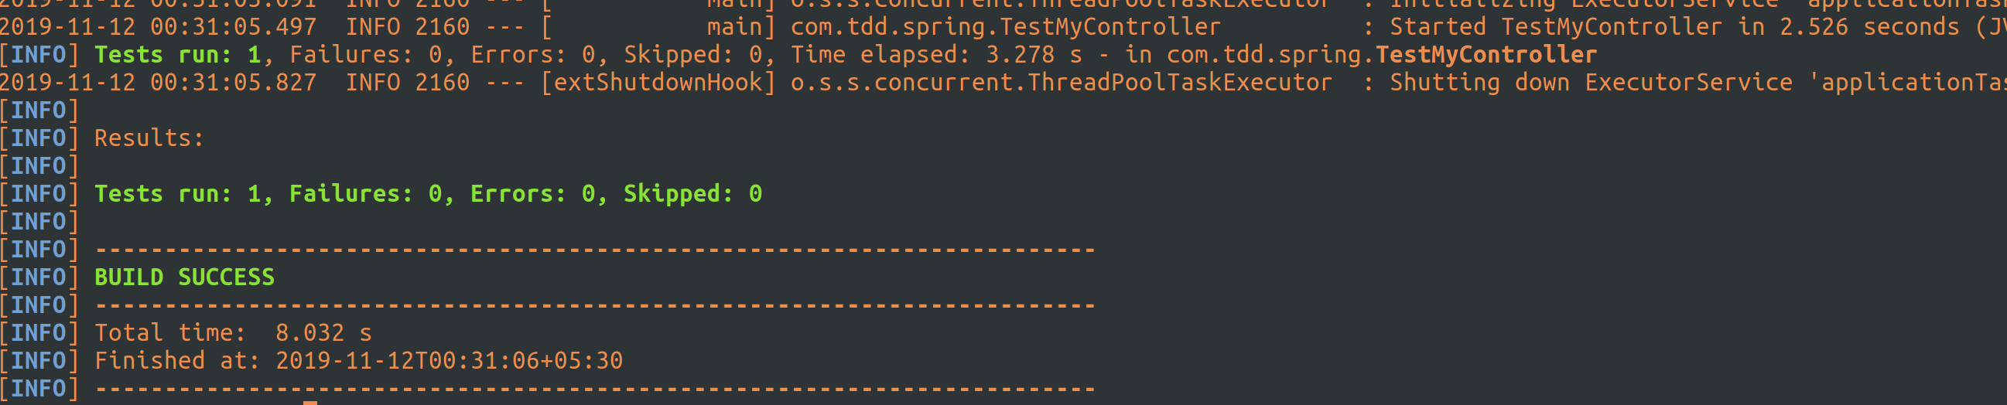
Testing for a mock mvc operation:
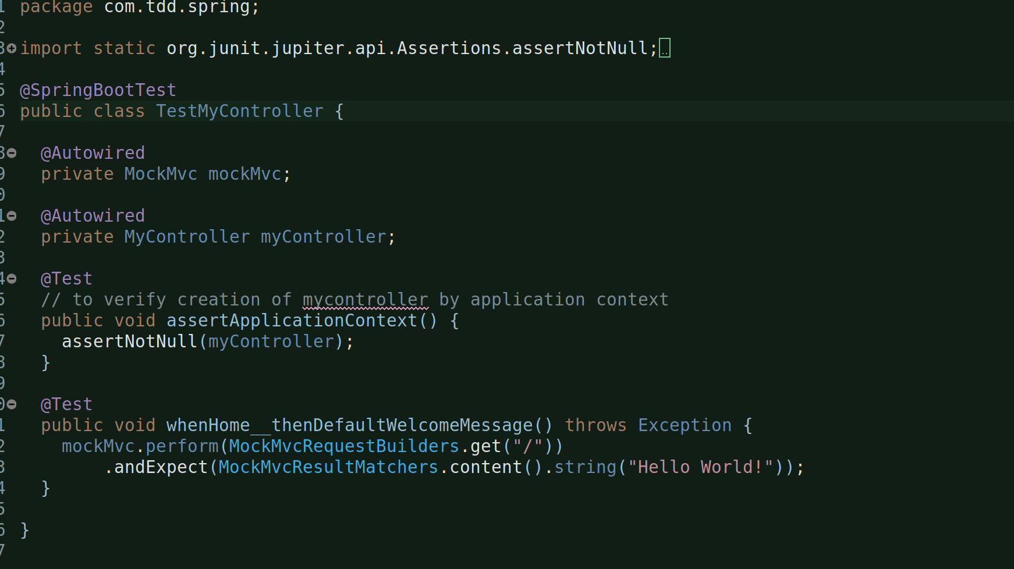
Now, mvn run:
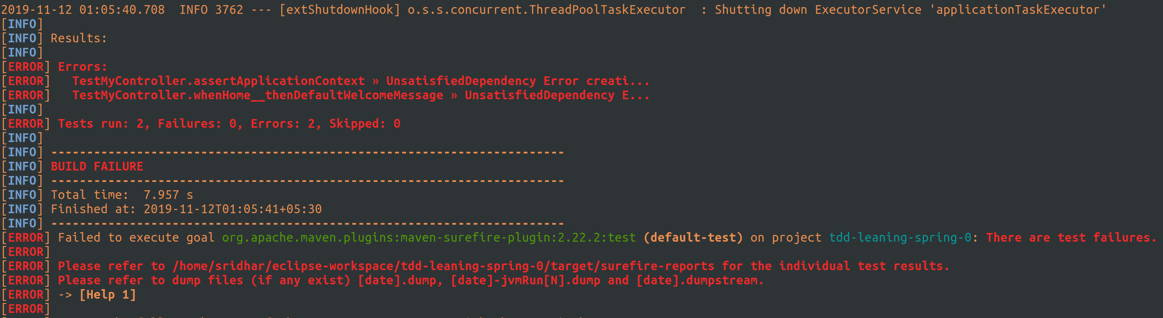
This is failing with NoSuchBeanDefinitionError. And, that;s because we haven’t configured the mock mvc and we need to do that with an annotation: @AutoConfigureMockMvc

Let’s make the change in my TestMyCOntroller test class now:
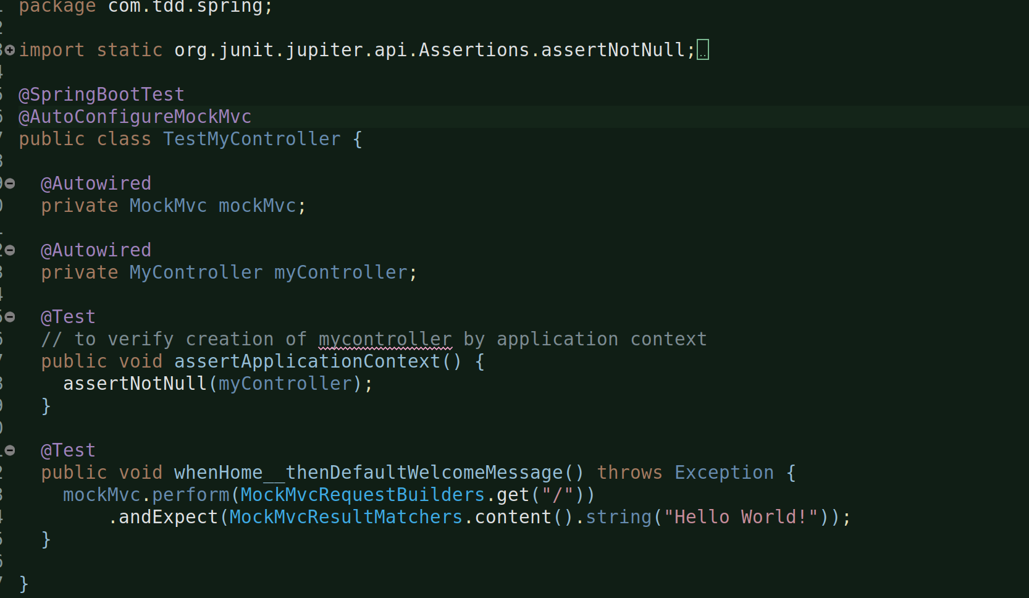
now run: mvn test:
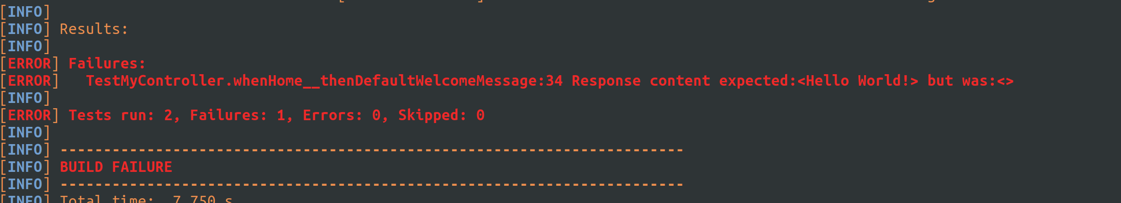
1 failed and 1 pass. And, this is for a different reason. This is because the test output of one of the test methods is not as expected.

Now, let’s write the code:
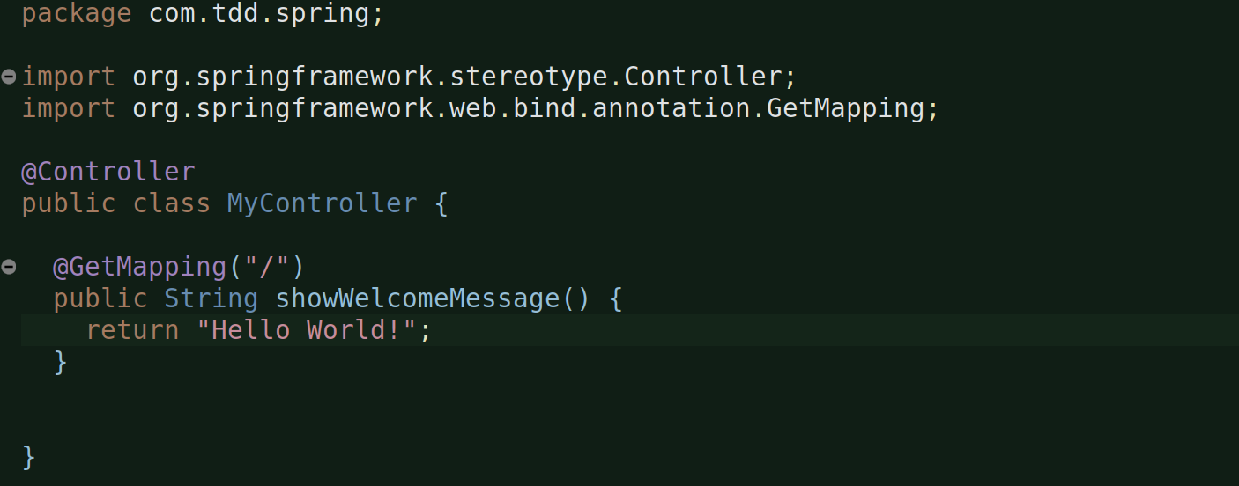

And also make some changes to our test class:
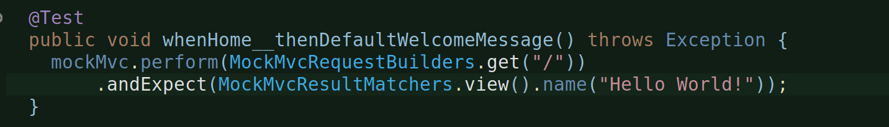
We should be expecting a view with that particular name here because in spring the controller returns a view name.

Now, mvn test:
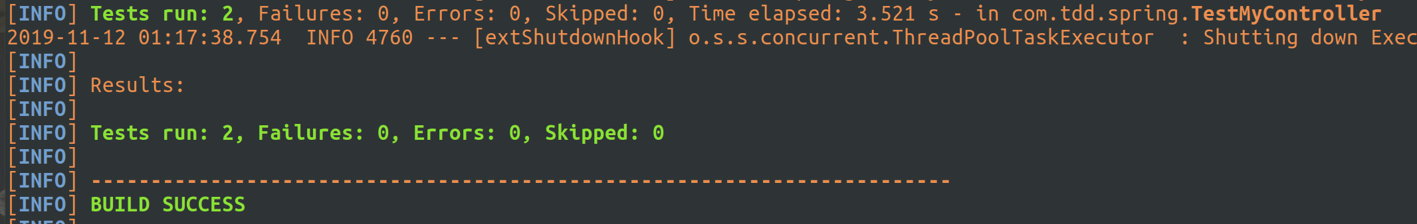
Let’s modify one test and add a new one:
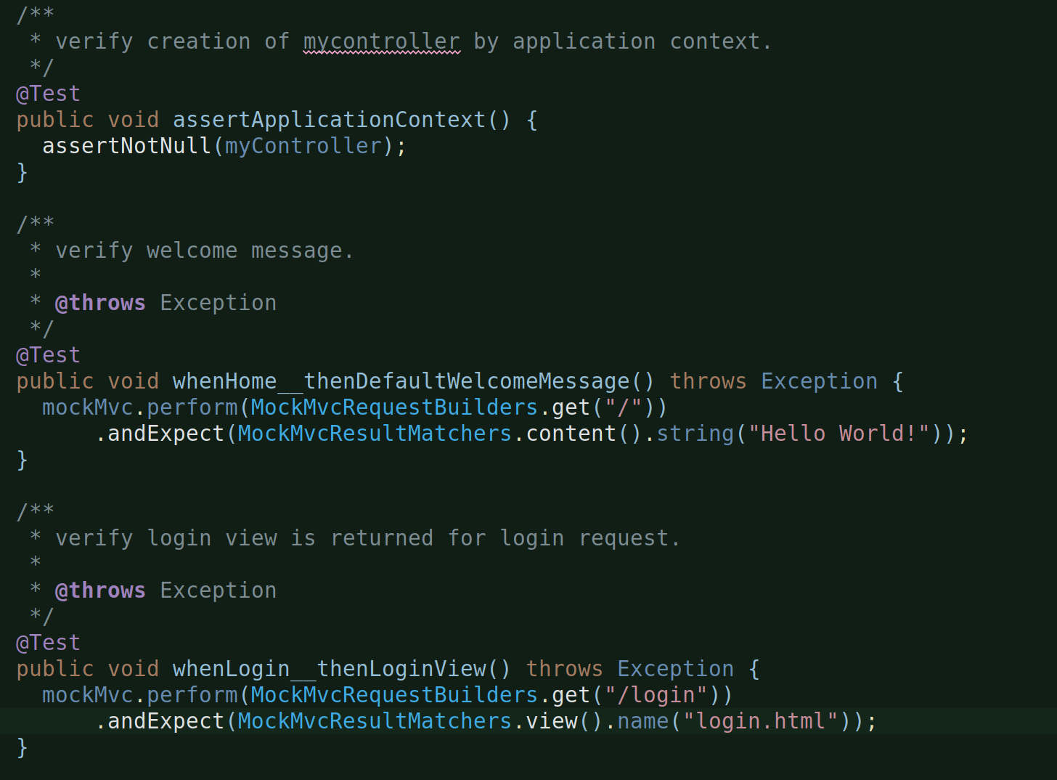
Modified one to verify the welcome message which is now expected to be part of response body, hence .content() and added a new method to verify the correct view name being returned for a particular GET request.

And, let’s now code:
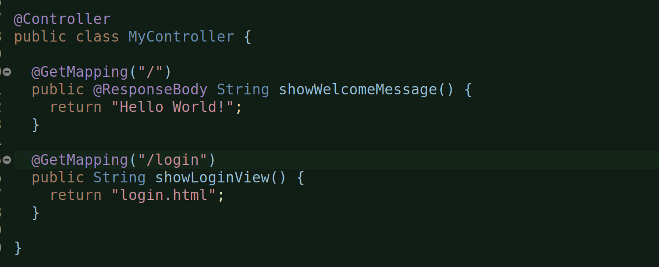
run, mvn test:
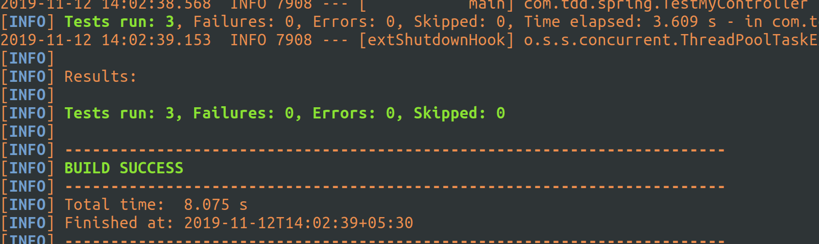
Let’s now refactor our controller to add a service. In Spring, controllers only return view names and other content as part of response body but they themselves do not carry out any business ops as such, they depend service to get the job done:
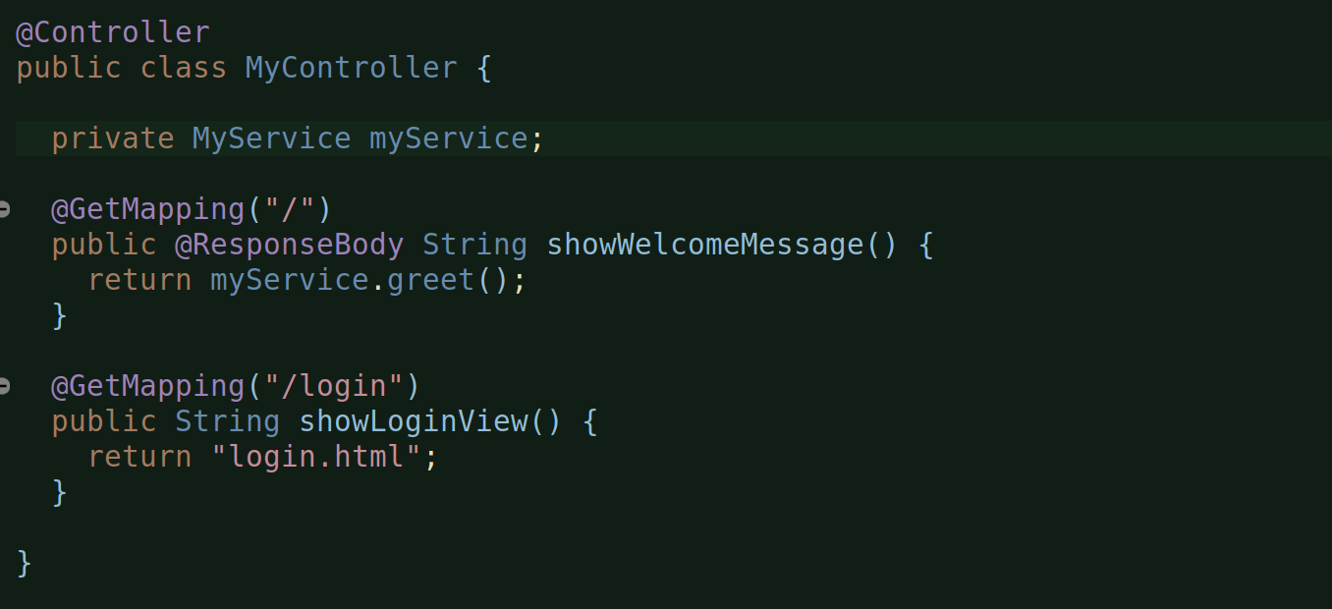
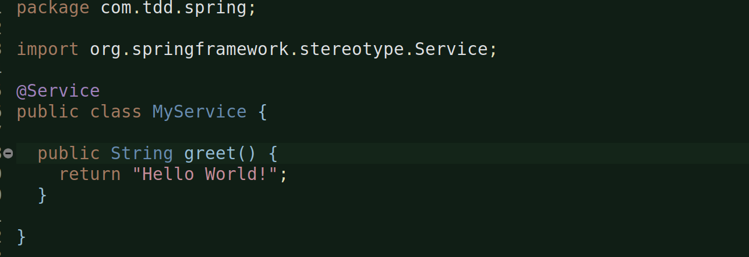
mvn test:

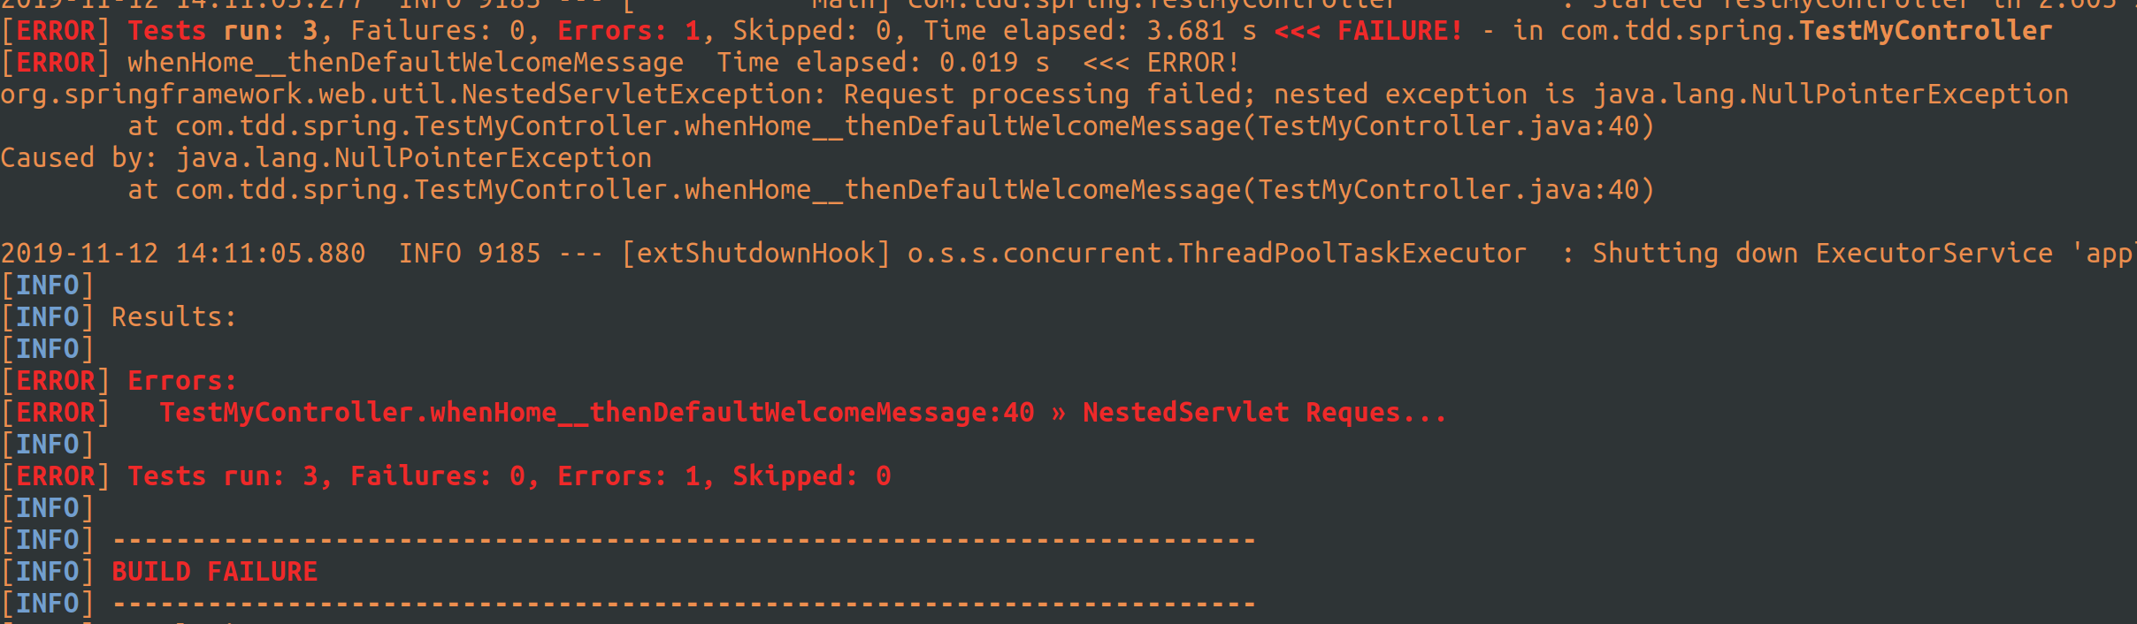
this is an error actually, a NullPointerException and it happened because i din’t autowire the service instance in controller:
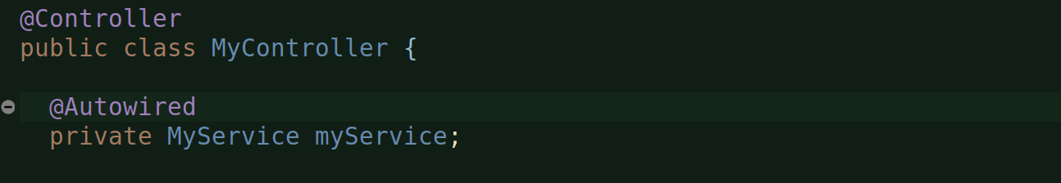
mvn test:
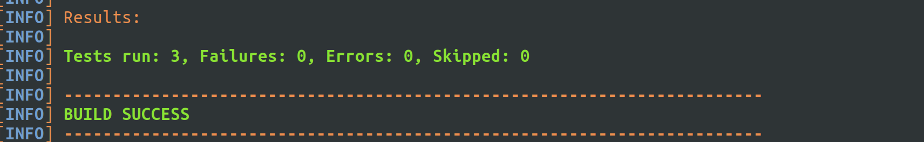
Now, this is based on field injection, which it seems for many reasons is not good:
https://dzone.com/articles/spring-di-patterns-the-good-the-bad-and-the-ugly

So, let’s rather convert this into a constructor based injection:
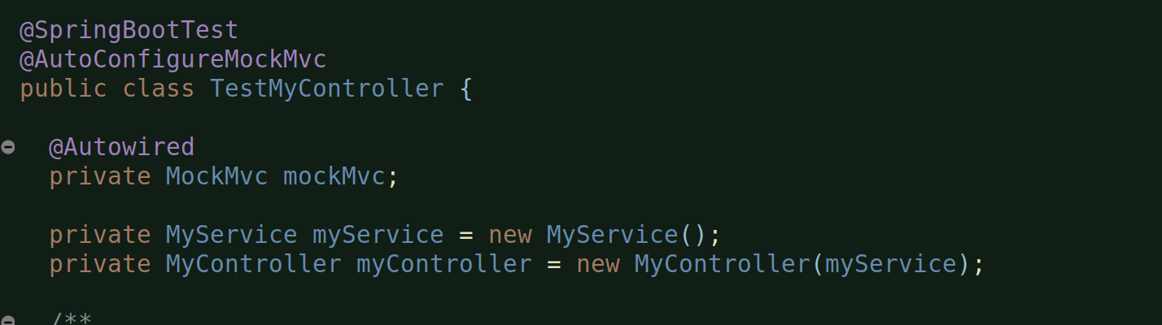
Removed @Autowired and created the instance myself and since controller depends on the service, I had to first create the service instance and then pass it to the controller.

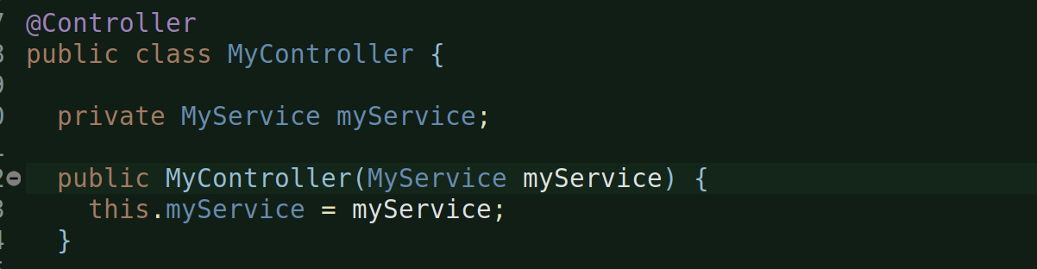
And, in the controller, I had to put in the constructor taking service instance and that’s it.

mvn test:

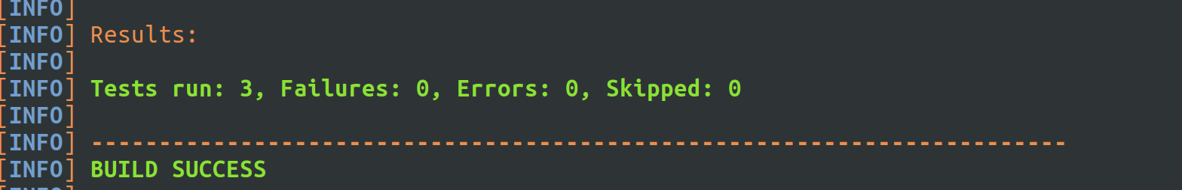
Done.

But, since we are testing the controller, we should ideally not worry (yet) about the implementation of the service, so let’s mock the service:

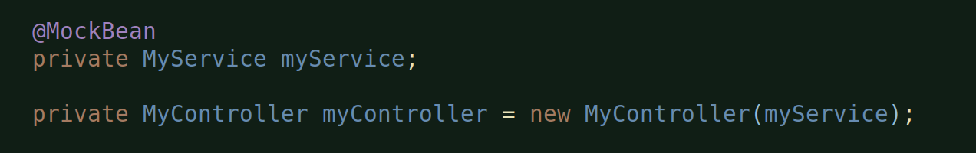
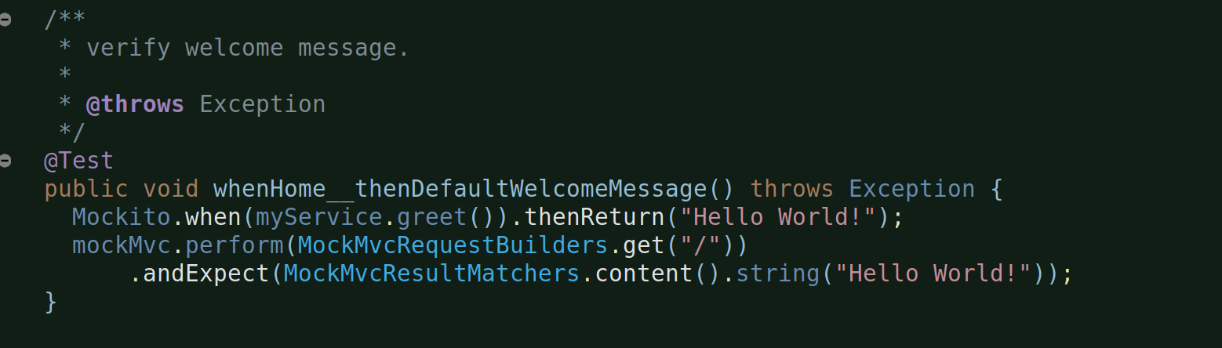
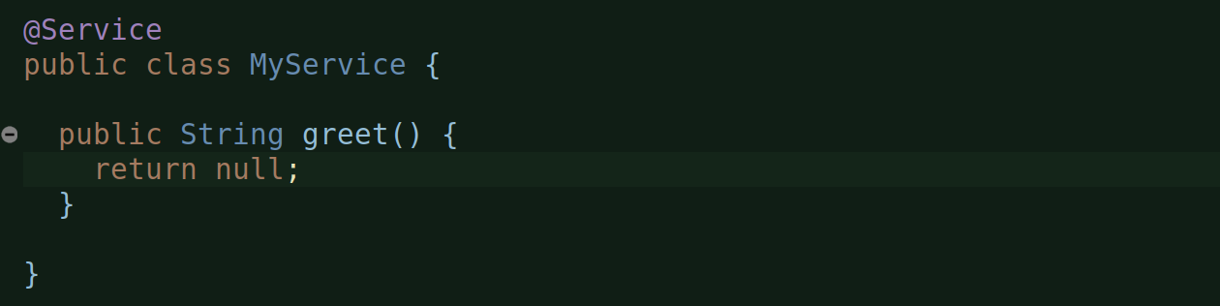
mocked the service and also used when and thenReturn of Mockito to implement the mock service. And, also just made a dummy greet() method in MyService (in order for the controller code to compile!).

Run - mvn test:
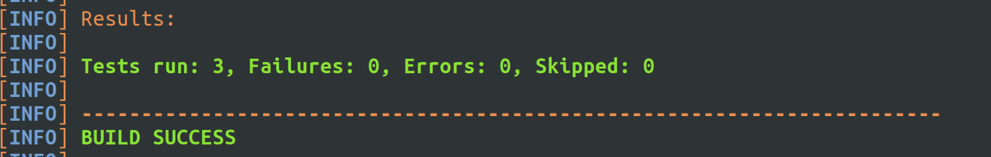
Done.

